State of Oregon
Archaeological Permit Guidance
Disclaimer: SHPO processing of an archaeological permit does not indicate agreement with the proposed level of effort for a federal undertaking or state-level project, and does not replace consultation with SHPO for a federal undertaking or state-level project. To gain compliance with federal or state law for a project all project information must be submitted to the review and compliance program [https://www.oregon.gov/oprd/OH/Pages/projectreview.aspx].
When is a permit needed
A State of Oregon Archaeological Permit is required:
- On publicly owned, non-federal lands for any subsurface archaeological investigation or collection of archaeological objects
- On privately owned lands for any subsurface archaeological investigation within or in proximity to a known archaeological site, or for any collection of archaeological objects.
- See ORS 358.920
Before applying for a permit
In order to apply for a Permit, applicants must meet the standards of an Oregon Qualified Archaeologist (OQA) and be employed by or sponsored by an organization such as an agency, Cultural Resource Management (CRM) firm, tribe, museum, or non-profit.
SHPO recommends that applicants coordinate with tribes with a connection to the project area when developing the application package. Applicants can use past knowledge or the Legislative Commission on Indian Services (LCIS) to help determine which tribes should be contacted.
We also recommend applicants review and understand OAR 736-051-0000 through 0090
Applying for a permit
Application package
Permit applications can be found on the SHPO website [https://www.oregon.gov/oprd/OH/pages/archaeology.aspx] and must be downloaded before it is filled out. Applications must include the following:
- Application form [See Appendix A for instructions on filling out the form]
- Research design [See Appendix B for instructions drafting a research design]
- Map – must be a 7.5’ USGS topo map at a resolution that makes it clear where archaeological work is within the permit area. If the permit area is large, we recommend including multiple maps to achieve an appropriate scale.
- Inadvertent Discovery Plan (IDP) – This should be specific to human remains or items protected under ORS 97.740-760. See legal obligations section for additional details. SHPO offers an IDP template for all cultural resources on their website. LCIS also hosts an IDP template along with the Tribal position paper on human remains, both of which are a valuable resource when creating an IDP.
- List of any permits issued to the applicant that have not been satisfied and that are still active. This should be in a table format and include, at a minimum: AP number, name of permit, counties and reporting due date [Example in Appendix C]
- Statement on any law violations – Applicants are required to include a statement in their application package indicating whether or not they have violated state or federal archaeological laws in the past. This can be anything from not getting a permit when one was needed, to participating in looting activities, to not meeting the terms and conditions of a previous permit. [Example in Appendix C]
- Landowner letter – A landowner letter is required for any privately-owned tax lot with a unique landowner, that is included in the permit application. The letter must include the following information [Example in Appendix C]:
  - The landowner has the right to keep the archaeological objects or donate them to a recognized curation facility.
  - If they choose to keep the archaeological objects they are not allowed to keep any objects or materials protected under 97.740-760.
- Curation letter – Only required if the curation facility is one that has not been previously approved my UOMNCH. A curation letter from UOMNCH stating that the facility can be used as an alternate repository is required.
Ensure all information is accurate and complete before submitting to prevent delays with processing. If the application package is incomplete, the application will be returned. If any terms in the application package change while the permit is in review the process will restart.
Our office no longer requires a funding letter with the permit application. However, we recommend applicants and their organizations obtain a guarantee of funding to complete fieldwork, reporting, and curation work so they can satisfy their permit obligations.
What happens a complete application is submitted
Once a permit application has been deemed complete by SHPO staff, it is entered into our permit database. Then, a notification is sent to LCIS requesting the most appropriate tribes for the permit area.
LCIS has 48 hours to respond to our request. If they do not respond, SHPO staff assign tribes based on past permits.
An email notice is then sent to entities with approval authority (EWRA) along with the permit application. The applicant is copied to provide notice that the 30-day review period has begun.
Entities with approval authority (EWAA) include: all Oregon federally recognized tribes with an interest in the permit area (as determined by LCIS) and the landowner(s) and/or land managing agency(ies). They can:
- Approve the permit
- Approve with conditions – They can condition any part of the permit to include additional terms such as for property access, research, notifications, field methods, analyses, monitoring, curation, and reporting They cannot condition the overall project the permit is in advance of or add any monetary conditions.
- Provide comments to be taken into consideration by the applicant but not legally binding them.
- Object to the permit – EWAA can object to the permit if they do not agree to any terms of the permit including but not limited to, the applicant, the curation facility (tribes only), and any proposed methods. A permit enters Dispute Status if there is an objection, see Dispute section below.
Conditions and objections are forwarded to the applicant as they are received. Any questions regarding conditions should be addressed to the appropriate EWAA. The applicant will be legally responsible for ensuring that all terms and conditions of the permit are met. If the applicant disagrees with any conditions they should inform SHPO and work with the EWAA to resolve the dispute. When the applicant and conditioning EWAA have resolved the dispute, they should inform SHPO and include any updated condition language.
During the 30-day review period SHPO recommends that any applicant who has not consulted or coordinated with tribes in the preparation of their application coordinates with the tribes during the 30-day review period. They should read each set of conditions as they are received and ensure they understand the content.
End of the review period is when either all of the EWAA have approved (with or without conditions) the permit or after 30 days without any objections. As long as the permit is not In Dispute (see dispute section below) it will be issued on the next business day (does not include weekends or state, federal, or tribal holidays) after the review period ends.

What happens after a permit is issued
Issued permits are emailed to the applicant and copied to EWAA. The final permit package contains: the signed permit, the application package, and responses provided by EWAA. The issued permit and all responses should be read and understood prior to any fieldwork. The application package should be kept as a reference until the terms and conditions of the permit have been met.
Fieldwork may begin on the date the permit is issued and is valid for fieldwork for 1 year and 1 day from its issuance. Permits are considered active for 2 years and 1 day. After that time frame they are considered outstanding if the terms and any conditions are not complete.
Completing the permit
Applicants have 2 years and 1 day to meet all the terms and conditions of the permit. Before the final report is submitted to the tribes and SHPO, ensure that all of the terms and conditions of the permit have been completed, see legal obligations below. If no work under the permit was done because the work was cancelled, see canceling a permit below.
How to amend a permit
Any terms of the permit, except the research design, can be amended while the permit is active. If the permit is no longer active or the applicant wishes to change the research design, a new permit is required. Additionally, the permit can be amended one time to add one year to the term of the permit, this includes fieldwork and reporting.
To amend a permit, the applicant must complete and submit an amendment form. To complete the form, the applicant must know the permit number, and provide specific information on the amendment request.
If amending the applicant, then written permission is needed from the original applicant and the new applicant.
With the exception of adding a one-year extension, a permit can be amended as many times as needed, while still active.
What if the permit is no longer needed
If work has not begun under the permit (i.e., excavation has not begun, archaeological objects have not been collected), then the applicant or their organization can notify SHPO that the permit needs to be cancelled. No report is needed.
If any excavation or collection of archaeological objects has begun, the applicant remains responsible for fulfilling the terms and conditions of the permit in regards to reporting and curation.
What happens if a permit is disputed
A permit can be disputed for many reasons, including but not limited to:
- Objection to the permit by any EWAA
- Disagreement with any terms and/or conditions of the permit
- Failure of an applicant to comply with a prior permit, issued on or after July 1, 2023
- Failure to address comments to a report intending to satisfy terms and/or conditions of a prior permit, issued on or after July 1, 2023.
- Violation of ORS 390.235 by the applicant for failing to obtain a permit, on or after July 1, 2023
- Choice of curational facility or temporary curation facility
- The disposition of human remains, funerary objects, sacred objects, or objects of cultural patrimony as described in ORS 97.740
Any party that wishes to dispute a permit at any point between when the application is received and when the permit terms and conditions are complete may do so in writing to the SHPO. SHPO will notify the other entity involved in the dispute and allow the parties time to reach a mutual agreement per the dispute resolution procedures in OAR 736-051-0030. If a mutual agreement cannot be found procedures around mediation and arbitration will be followed per OAR 736-051-0040 to 0050.
Summary of the applicant’s legal obligations
By applying for a permit, the applicant agrees the application package submitted is correct and shall fulfill the terms and conditions of the permit.
The terms of the permit are:
Duration: Applicant has 1 year and 1 day to complete any and all fieldwork proposed under the permit and 2 years and 1 day to complete reporting and curation stipulation and “complete” the permit.
Location: The permit only applies to lands detailed in the permit application and owned by the landowners indicated in the permit application.

Supervision: All work done under the permit is the responsibility of the applicant and organization and must be supervised by an OPAA. All OPAA that are employed by the organization or landowner during the time the permit is active are qualified to supervise work under the permit. Any additional OPAAs that do not work for the landowner or organization but will supervise fieldwork must be included in the research design.

Compliance: Applicants and organizations shall comply with all applicable federal, state and local laws, rules, regulations and ordinances including but not limited to ORS 97.740-760, ORS 358.905-961, ORS 390.235, and associated OAR 736-051-0000 to 0090.

Activities: references the application package. Be sure it is complete and thorough.

Conditions: the applicant and organization are required to meet any conditions placed upon the permit by the EWAA’s if the applicant does not agree or understand any conditions placed upon a permit they need to address it before the permit is issued.

Records: A final report must be submitted to SHPO and Tribal EWAA’s for any work undertaken under a permit. Any archaeological objects recovered during investigations under the permit must be submitted to their final curation facility within 2 years and 1 day. If the final curation facility is not UOMNCH a copy of any notes, photographs, photo log, and collection catalog must still be submitted to UOMNCH.

Custody: Before any collections are submitted to the permanent curation facility, Tribal EWAA’s must be given 30 days to view all recovered objects and materials to ensure that human remains, funerary objects, sacred objects, and objects of cultural patrimony are returned to tribal custody per state law (ORS 97.740-97.760).

The artifacts must be distributed to the final curation facility based upon landownership and any private landowners wishes.

Notification: Whether in the field, during curation processing, analysis, or tribal review; upon discovery of ORS 97.740-760 protected items, including cairns, burials, human remains, funerary objects, sacred objects, or objects of cultural patrimony; archaeological excavation and collection of archaeological objects under this permit is suspended until notification procedures under the IDP attached to this permit are followed. Work authorized by this permit may only continue when Tribal EWAA’s have agreed upon appropriate procedures and notified SHPO. In the event recovery of protected items is necessary and approved, that activity may be done separately through the process defined for the State Physical Anthropologist per OAR 736-051-0080(3).

Tribal Coordination: Applicants and organizations are encouraged to coordinate with Tribal EWAA from the development of the application materials through curation. Tribes can request additional coordination at any time.

Indemnification: Applicants and organizations are responsible for any claims, damages, or expenses for any activities tied to their permit.

Insurance: Applicants and/or organizations are required to have comprehensive or commercial liability insurance.

Failure to comply: Failure to comply with any terms and/or conditions of this Permit including, but not limited to: conditions, methods, IDPs, reporting, and curation; may lead to the permit’s suspension while dispute resolution procedures are followed per OAR 736-051-0020 through 0050, and may lead to the permit’s immediate revocation, affect the applicant’s or organization’s ability to receive archaeological permits in the future, and would be sufficient grounds for an EWAA to object to a future permit.

The applicant is responsible for ensuring that any terms and/or conditions are carried out, unless they are prevented from doing so by the organization. At which time, the organization assumes responsibility for fulfilling any permit terms and conditions.

Appendix A
Filling out a State of Oregon Permit Application
Section 1 - Applicant Information:
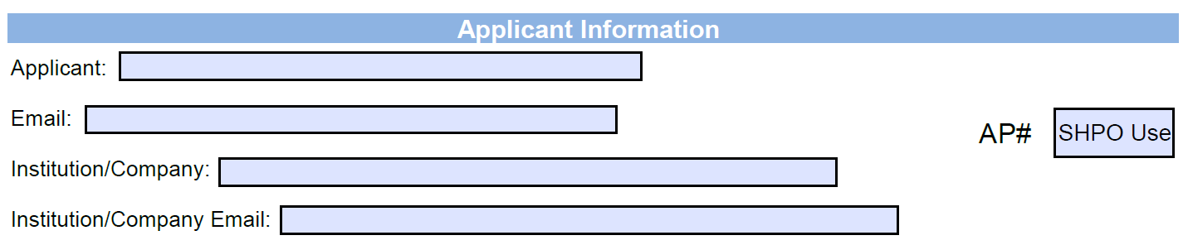
- Applicant name and contact information: the applicant must be an OPAA before submitting the application. Include a valid email where all permit related notices can be sent, including the issued permit.
- Organization (Institution/Company) name and contact information: applicants are required to be sponsored by an organization such as an agency, CRM firm, tribe, museum, or non-profit. The organization may also receive notices for any change in permit status. If the organization email would be the same as applicant email, leave this field blank.
- AP#: leave blank
Section 2 - Project Information:
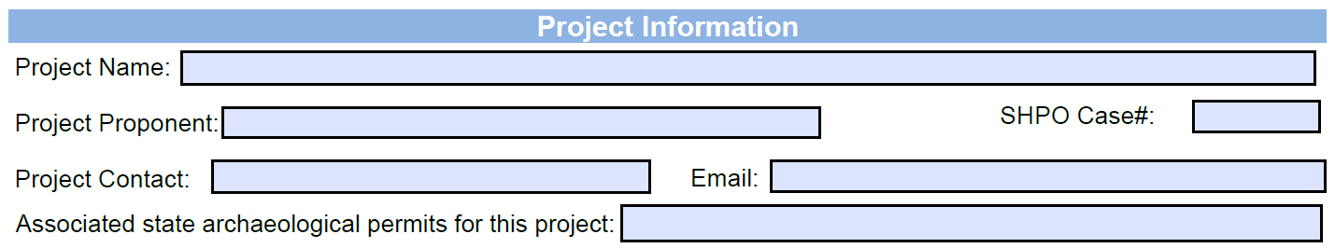
- Project information for the federal undertaking or project that the archaeological work is associated with.
  - Project Name – Naming convention should be specific to the project and then the work done under the permit (e.g. Avenger Tower remodel - electrical upgrade monitoring)
  - Proponent and a project contact – Include the name of the agency, company institution that is leading the project (not the archaeological work). Project contact should be the project manager or whoever is responsible for archaeological compliance for the project proponent
  - Any SHPO case number(s) already assigned
  - Any previous permits that have been issued for the project
Section 3: Location information:
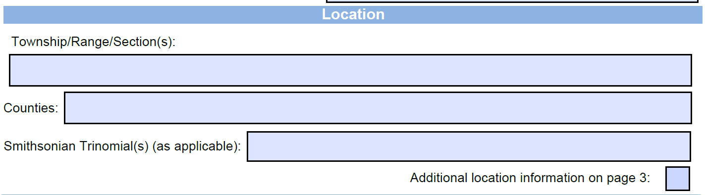
- Location information for all areas covered under the permit
  - TRS – include as many as will fit in this section. If there are more than allowed in this space select the check box and enter ADDITIONAL TRS on page 3. Do not duplicate.
  - Counties – Include all counties where the permit applies. If there are more than allowed in this space select the check box and enter ADDITIONAL counties on page 3. Do not duplicate.
  - Trinomials or Field Designations for any archaeological sites within the permit area
Section 4 – Landowners and Curation:
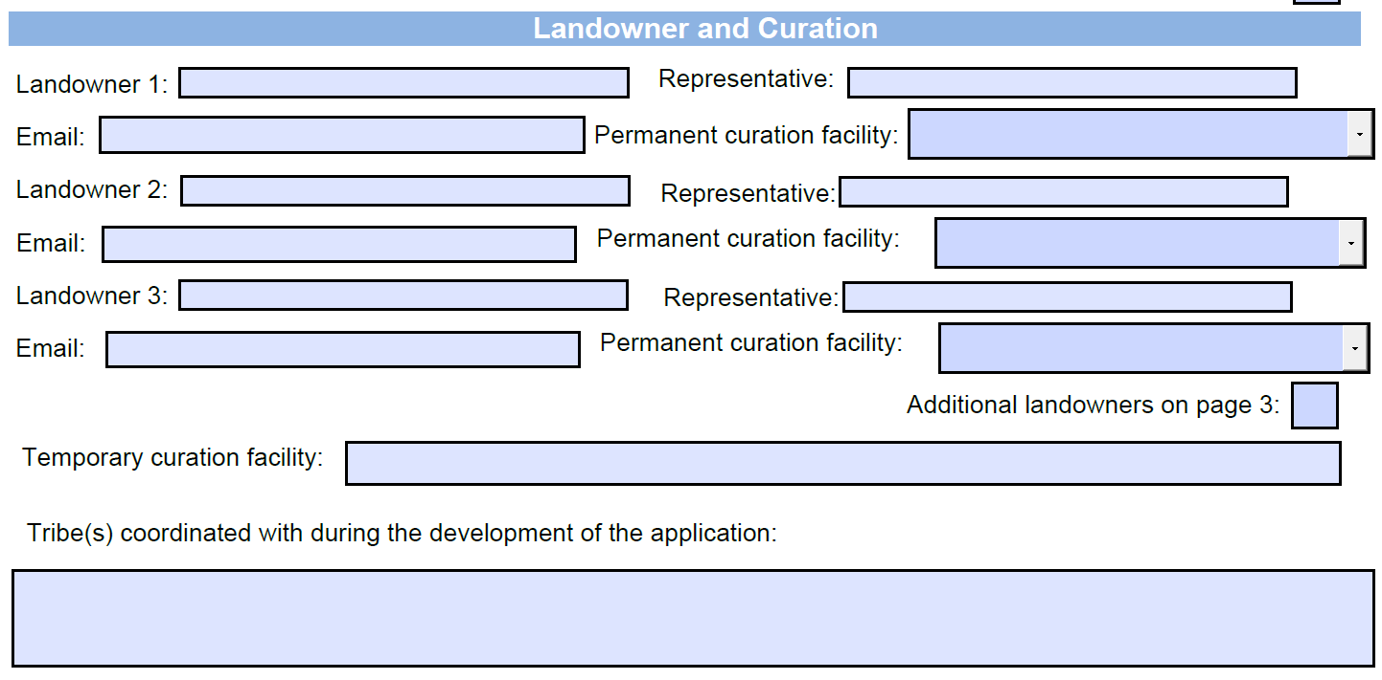
- For each tax lot within the permit area with a unique landowner, provide the following information
  - Name of landowner – can be an agency, trust, or individual
  - The landowner’s representative (as applicable) and their email. If the landowner is an agency, be sure to speak with the agency to determine the appropriate representative. If there are multiple landowners for a tax lot include only one as the representative.
  - The landowner’s curation preference (for private lands). Include a landowner letter for each privately-owned tax lot. If the land is publicly owned by an agency or any entity of the state the curation will always be UOMNCH (or approved alternate curation facility).
- Provide a location where any recovered artifacts will be temporarily stored while the permit is active. This is usually the address of the institution or company
- Indicate any tribes that were coordinated with during the development of the application.
Section 5 – Excavation Summary:
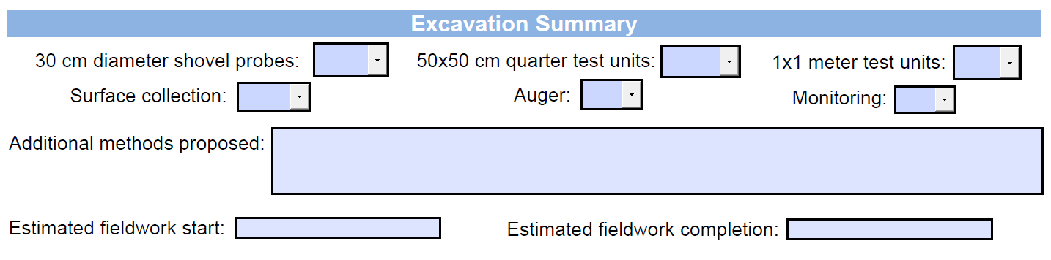
- Indicate which methods are included in the research design by selecting yes or no on the dropdown lists. The additional methods section should be brief and only include non-standard methods such as underwater excavation, trenching, Constant Volume Probe (CVP), etc.
- Proposed fieldwork dates. Regardless of what is included in this section the permitted fieldwork period will remain 1 year and 1 day. This section informs reviewers of a general fieldwork timeline.
Section 6 – Attachments:
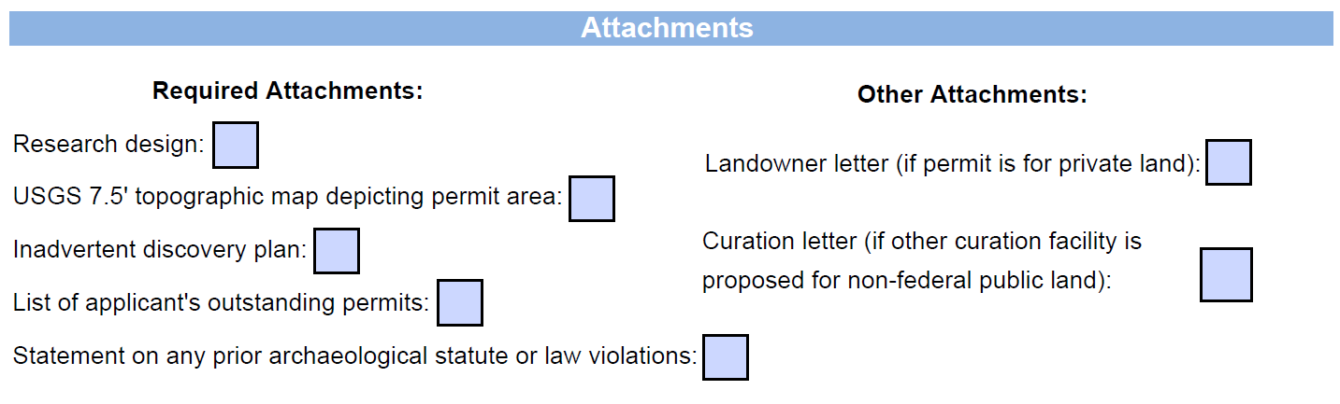
- Select boxes for the attachments that are included in the package. Note: most of the attachments are required for a complete application package.
- SHPO recommends including attachments in the order they are listed on the application form
- See above for details regarding each attachment.

Appendix B
Research Design Guidance
Research designs are required with any Oregon State Archaeological Permit application. The following explains current SHPO guidance regarding research designs and what should be in a permit research design. A well written research design gives reviewers confidence in the archaeologist and the project.
Laws:
When a permit is required, the application must include a Research Design. Oregon Administrative Rule (OAR) 736-051-0080(4)(c) states the following: “A research design that explicitly develops the rationale behind the proposed research, giving the theoretical orientation, justification for problem selection, logic and procedures for the research strategy. The design must define the universe of study, establish realistic minimal expectations and a realistic schedule of research and provide justified recovery procedures;”
Universe of Study:
This should include information regarding the location of the archaeological work along with pertinent information about the area’s history, including any previously identified archaeological materials, any previous work done to locate archaeological materials, a general history of the area including pertinent themes (e.g., mining, basketry material collection, fishing). This provides context for evaluating archaeological resources. For example, if the area falls within an area important for mining, do the archaeological resources relate to that importance. Sources can include SHPO records, historical documents, ethnographies, historical societies, local communities or group, most appropriate Tribes, etc.
Realistic Minimal Expectations and a Realistic Schedule of Research:
Minimal expectations are based on context. Researching primary sources, gray literature, maps, tribal coordination, known archaeological sites, topography, previous archaeological excavations/survey, etc. the applicant should be able to provide an informed statement on expectations based on the scope of their investigation. The ideas laid out in that section should influence the expectations. Based upon regional themes, site patterning, and past use, this section should discuss what site type(s) are expected, if any, or what additional information regarding a site may be expected to uncover. Research questions should be included that address expectations regarding the proposed archaeological investigations. Any research questions proposed by past investigations that could not be answered or found to be outside the previous scope of work, should be considered and addressed, as appropriate. There should be discussion as to what limitations or constraints are present that would prevent a full examination of the resource(s) (e.g., access, monitoring vs. excavations). Include a realistic timetable for archaeological and laboratory investigations based upon expectations.
Justified Recovery Procedures:
Include methods for surface collection, if any, and subsurface investigation. If archaeological units are being utilized there should be discussion of where the units will be placed or how unit placement will be determined, the size of the units, the proposed depth of investigation, how the unit levels will be determined, and what will be done with excavated sediments (e.g., screen size, collecting column of midden material, wet screening vs. dry screening). Curation and lab procedures should also be included in the research design.
Additionally the methods section in the research design should address (as applicable) things such as::
- How is the archaeological investigation being recorded?
- Unit/probe level forms and fields
- sketch maps
- Photographing and drawing unit profiles
- Level bags and fields
- Equipment to be used (e.g., cameras, GPS, datum, shovels, trowels, compass, GPR, Magnetometer, Total Station,…)?
- Lab procedures used to clean and process archaeological objects and samples collected.
- Photo log
- Screen size
- Excavation unit sizes
- Orientation of formal excavation units
- Levels (arbitrary/strata)
- Shovel probe intervals
- Opportunistic probes
- Excavation unit placement (what determined the location?)
- Updating site form
- Unit summary forms

Tips and Tricks:
- The best research designs are concise and do not repeat information in multiple sections.
- Project information is not required but it can help justify some methods.
- Try to group information such as methods and curation to focus on reviewers’ areas of interest.
- If the research design proposes to not collect certain materials (other than FCR or modern) applicants must to consult with UOMNCH and have a letter from them agreeing to the alternative collection procedures. Any permit proposing non-collection of materials will be considered incomplete and returned to the applicant.
- If proposing new methods outside of standard practices, please justify. If proposed new methods are rarely seen by our office please contact us before submitting the application to avoid potential delays.
- Anything that is in the research design is legally binding as a part of the permit and is subject to conditions and objections by reviewers.

Appendix C
Templates
Included here are templates for use in the permit application process. Use of them is not required, just meant to assist applicants with completing their application package.

Outstanding permits
AP | Permit | Counties | Report Due
1336 | Testing at Wayne Manor | Hood River | 12/12/2022
4426 | Collection of midden material (ODOT) | Clatsop | 2/28/2026
4427 | Collection of midden material (OPRD) | Clatsop | 2/28/2026

Statement on Law Violations
I, [applicant name] to the best of my knowledge have not violated any federal, state and local cultural resources laws, rules, regulations and ordinances including but not limited to ORS 97.740-760, ORS 358.905-961, ORS 390.235, and associated OAR 736-051-0000 to 0090.
Or
I, [applicant name] have violated federal, state and local cultural resources laws, rules, regulations and ordinances including but not limited to ORS 97.740-760, ORS 358.905-961, ORS 390.235, and associated OAR 736-051-0000 to 0090. Please include any additional specifics.

Disposition of Archaeological Materials Private Lands
I, ___________________________ , hereby grant permission for _______________________ to collect and analyze archaeological materials recovered from property I own in conjunction with the proposed ________________________ project under an Oregon Archaeological Permit. I understand that I will not be responsible for any injuries or personal damages that may result from their work. I understand that if any human remains, funerary objects, sacred objects, or objects of cultural patrimony are discovered during excavation that the applicant will report the discovery to the appropriate Native American Tribe(s), the Legislative Commission on Indian Services (LCIS), and the State Historic Preservation Office (SHPO) to arrange for their return to the appropriate Tribe(s) as per state laws (ORS 97.740-.760 and ORS 358.940). Upon completion, the archaeological materials will be:
__Donated to the state archaeological repository at the University of Oregon Museum of Natural and Cultural History (UOMNCH)
__Returned to me after the appropriate laboratory analysis has been conducted and all provisions and conditions of the permit have been completed. I understand that I have the option to donate to a museum, institution, or tribe at any time.
Name:
Signature:
Date:
Email:

