Steens Mountain Defenders is looking for an entry level associate to learn the ins and outs of a rural law practice.

Our office is directly across the street from the Harney County Courthouse.

Housing is in limited supply here but we have an opportunity to provide access to a rental about 1 mile out of town with acreage and a barn. Rents for around $1,200.00.

Give me a call!

Thanks!

JBL

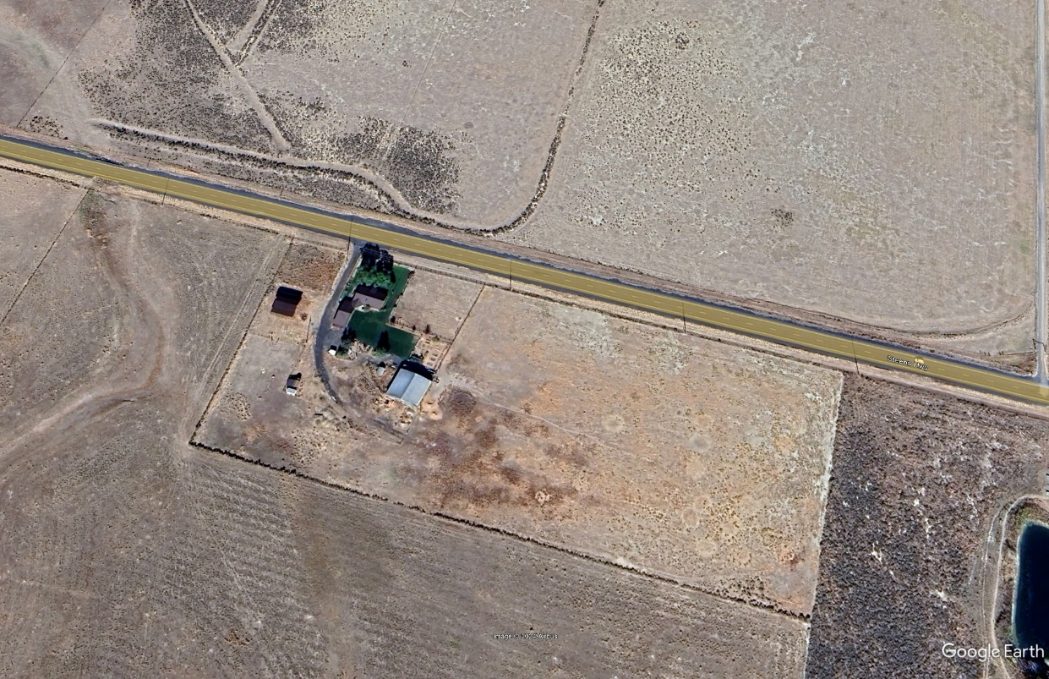

John B. Lamborn
Steens Mountain Defenders
191 West A Street
Burns, OR 97720
541 573 2066

