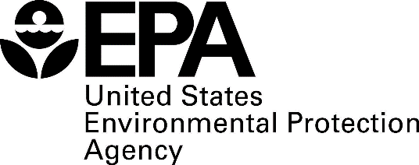**Templates for Notification of Known or Potential Service Line Containing Lead**

# 2021 Lead and Copper Rule Revisions Requirements

The Lead and Copper Rule Revisions (LCRR) were finalized in 2021. Requirements for water systems regarding the notification of known or potential service lines containing lead are outlined in 40 CFR § 141.85(e) provided for reference at the end of this document. The following pages include templates that water systems may choose to use to develop these notifications. The templates below contain mandatory text from the regulation as well as example language that you may use and/or modify for required content. Required text is provided in italics throughout the document. Bold underlined text in brackets highlight areas for water systems to fill in information specific to their individual system and other considerations.

# Notice of confirmed lead service line

**< Public Water System (PWS) name >** is focused on protecting the health of every household in our community. This notice contains important information about your drinking water. Please share this information with anyone who drinks and/or cooks using water at this property. In addition to people directly served at this property, this can include people in apartments, nursing homes, schools, businesses, as well as parents served by childcare at this property.

### **< PWS name >** has determined that **< a portion of or the entire >** water pipe (called a service line) that connects your **< home, building, or other structure *>***to the water main is made from **lead.** People living in homes with a lead service line may have an increased risk of exposure to lead from their drinking water.

**< The figure below represents a typical scenario for a residence in many cases but does not represent all scenarios. Water systems may wish to replace the image with one of their own or remove it.>**

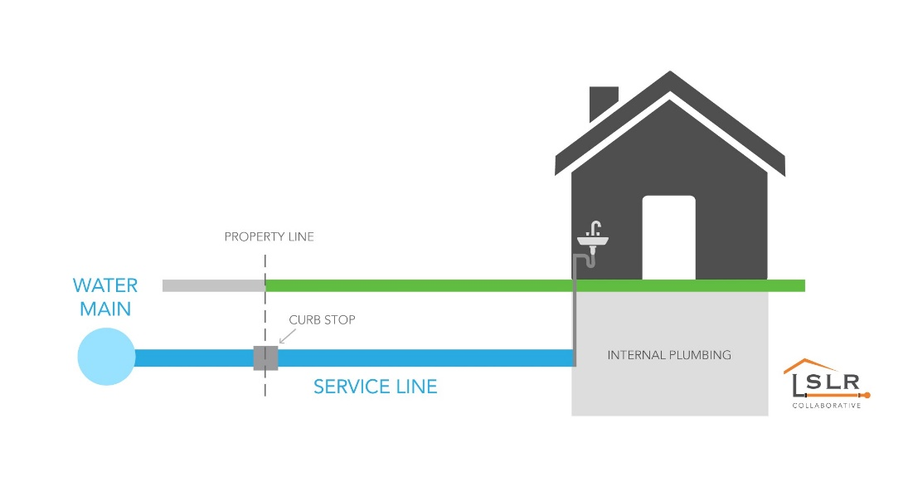

## Health effects of lead

*Exposure to lead in drinking water can cause serious health effects in all age groups. Infants and children can have decreases in IQ and attention span. Lead exposure can lead to new learning and behavior problems or worsen existing learning and behavior problems. The children of women who are exposed to lead before or during pregnancy can have increased risk of these negative health effects. Adults can have increased risks of heart disease, high blood pressure, and kidney, or nervous system problems.[1]*

## Steps you can take to reduce lead in drinking water.

Below are recommended actions that you may take, separately or in combination, if you are concerned about lead in your drinking water. The list also includes where you may find more information and is not intended to be a complete list or to imply that all actions equally reduce lead in drinking water.

**Use your filter properly**. Using a filter can reduce lead in drinking water. If you use a filter, it should be certified to remove lead. Read any directions provided with the filter to learn how to properly install, maintain, and use your cartridge and when to replace it. Using the cartridge after it has expired can make it less effective at removing lead. Do not run hot water through the filter. For more information on facts and advice on home water filtration systems, visit EPA’s website at <https://www.epa.gov/water-research/consumer-tool-identifying-point-use-and-pitcher-filters-certified-reduce-lead>.

**Clean your aerator.** Regularly remove and clean your faucet’s screen (also known as an aerator). Sediment, debris, and lead particles can collect in your aerator. If lead particles are caught in the aerator, lead can get into your water.

**Use cold water**. Do not use hot water from the tap for drinking, cooking, or making baby formula as lead dissolves more easily into hot water. Boiling water does not remove lead from water.

**< Areas prone to drought or currently experiencing scarcity of water may want to omit or edit this recommendation. > Run your water.** The more time water has been sitting in pipes providing water to your home, the more lead it may contain. Before drinking, flush your home’s pipes by running the tap, taking a shower, doing laundry, or doing a load of dishes. The amount of time to run the water will depend on whether your home has a lead service line or not, as well as the length and diameter of the service line and the amount of plumbing in your home. [Include tailored flushing information, if appropriate, or add following language] Residents may contact us at [phone number and/or email address] for recommendations about flushing times in their community.

**Learn what your service line material is.** Contact us at [phone number and/or email address] or a licensed plumber to determine if the pipe that connects your home to the water main (called a service line) is made from lead, galvanized, or other materials. [For systems replacing lead service lines consider the following text.] To find out about what we are doing to replace lead service lines, please visit [website] or contact us at [phone number and/or email address]. [Protect Your Tap: A quick check for lead](https://www.epa.gov/ground-water-and-drinking-water/protect-your-tap-quick-check-lead-0) is EPA’s on-line step by step guide to learn how to find lead pipes in your home.

**Learn about construction in your neighborhood.** Contact us at [phone number and/or email address] to find out about any construction or maintenance work that could disturb your service line. Construction may cause more lead to be released from a lead service line or galvanized service line if present.

**Have your water tested.** Contact us, your water utility, at **< insert PWS contact information – phone, email, etc.>** to have your water tested and to learn more about the lead levels in your drinking water. Alternatively, you may contact a certified laboratory to have your water tested for lead. A list of certified laboratories is available at **< provide location of list or explain your water system’s testing program and any costs to customer if one exists>.** Note, a water sample may not adequately capture or represent all sources of lead that may be present**.** For information on sources of lead that include service lines and interior plumbing, please visit <https://www.epa.gov/ground-water-and-drinking-water/basic-information-about-lead-drinking-water#getinto>.

## Get your child tested to determine lead levels in their blood.

A family doctor or pediatrician can perform a blood test for lead and provide information about the health effects of lead. State, city, or county departments of health can also provide information about how you can have your child's blood tested for lead. The Centers for Disease Control and Prevention recommends public health actions when the level of lead in a child’s blood is 3.5 micrograms per deciliter (µg/dL) or more. For more information and links to CDC’s website, please visit <https://www.epa.gov/ground-water-and-drinking-water/basic-information-about-lead-drinking-water>.

## Replacing lead service lines

**<Insert information about your water system’s lead service line replacement program, if applicable, or other opportunities to replace lead service lines.>**

If you are planning on replacing the portion of the service line that you own, please notify us at **<insert PWS contact information – phone, email, etc.>.**

**For information about potential financing solutions** to assist property owners with replacement of lead service lines, please contact us at **<insert PWS contact information – phone, email, etc.>.**

**For more information on reducing lead exposure** from your drinking water and the health effects of lead, visit EPA’s website at [*http://www.epa.gov/lead*](http://www.epa.gov/lead).

# **Notice of confirmed galvanized service line (that is or was downstream of a lead service line)**

### **<Insert PWS name>** is focused on protecting the health of every household in our community. This notice contains important information about your drinking water. Please share this information with anyone who drinks and/or cooks using water at this property. In addition to people directly served at this property, this can include people in apartments, nursing homes, schools, businesses, as well as parents served by childcare at this property.**<Insert PWS name>** has determined that **<a portion or the entire>** water pipe (called a service line) that connects your **<home, building or other structure>** to the water main is made from **galvanized material** and may have absorbed lead**.** EPA has defined these service lines as “galvanized requiring replacement”[2]. Our records either indicate that lead service line pipe may be present or might have been present in the past. If you have information that could help us better describe your service line, contact us at **<contact via phone, email and/or visit website >**, and we will **<add detail>.**

Galvanized service lines that have absorbed lead can contribute to lead in drinking water. People living in homes with a galvanized service line that has absorbed lead may have an increased risk of exposure to lead from their drinking water. **<Consider adding language based on situational knowledge, such as: The galvanized service line at this location is/was/may have been connected to a lead service line prior to <date> or is downstream of an unknown service line which may contain lead.>**



## Health effects of lead

*Exposure to lead in drinking water can cause serious health effects in all age groups. Infants and children can have decreases in IQ and attention span. Lead exposure can lead to new learning and behavior problems or worsen existing learning and behavior problems. The children of women who are exposed to lead before or during pregnancy can have increased risk of these negative health effects. Adults can have increased risks of heart disease, high blood pressure, and kidney, or nervous system problems.[3]*

## Steps you can take to reduce lead in drinking water.

Below are recommended actions that you may take, separately or in combination, if you are concerned about lead in your drinking water. The list also includes where you may find more information and is not intended to be a complete list or to imply that all actions equally reduce lead in drinking water.

**Use filters properly**. Using a filter can reduce lead in drinking water. If you use a filter, it should be certified to remove lead. Read any directions provided with the filter to learn how to properly install, maintain, and use your cartridge and when to replace it. Using the cartridge after it has expired can make it less effective at removing lead. Do not run hot water through the filter. For more information on facts and advice on home water filtration systems, EPA has developed a <https://www.epa.gov/water-research/consumer-tool-identifying-point-use-and-pitcher-filters-certified-reduce-lead>.

**Clean your aerator.** Regularly clean your faucet’s screen (also known as an aerator). Sediment, debris, and lead particles can collect in your aerator. If lead particles are caught in the aerator, lead can get into your water.

**Use cold water**. Do not use hot water from the tap for drinking, cooking, or making baby formula as lead dissolves more easily into hot water. Boiling water does not remove lead from water.

**<Areas prone to drought or currently experiencing scarcity of water may want to omit or edit this recommendation.> Run your water.** The more time water has been sitting in pipes providing water to your home, the more lead it may contain. Before drinking, flush your home’s pipes by running the tap, taking a shower, doing laundry, or doing a load of dishes. The amount of time to run the water will depend on whether your home has a lead service line or not, as well as the length and diameter of the service line and the amount of plumbing in your home. [Include tailored flushing information, if appropriate, or add following language] Residents may contact us at [phone number and/or email address] for recommendations about flushing times in their community.

**Learn about construction in your neighborhood.** Contact us at [phone number and/or email address] to find out about any construction or maintenance work that could disturb your service line. Construction may cause more lead to be released from a lead service line or galvanized service line if present.

**Have your water tested.** Contact us, your water utility, at **<insert PWS contact information – phone, email, etc.>** to have your water tested and to learn more about the lead levels in your drinking water. Alternatively, you may contact a certified laboratory to have your water tested for lead. A list of certified

laboratories are available at **<provide location of list> or <explain your water system’s testing program and any costs to customer if one exists>.** Note, a water sample may not adequately capture or

represent all sources of lead that may be present**.** For information on sources of lead that include service lines and interior plumbing, please visit <https://www.epa.gov/ground-water-and-drinking-water/basic-information-about-lead-drinking-water#getinto>.

## Get your child tested to determine lead levels in their blood.

A family doctor or pediatrician can perform a blood test for lead and provide information about the health effects of lead. State, city, or county departments of health can also provide information about how you can have your child's blood tested for lead. The Centers for Disease Control and Prevention recommends public health actions when the level of lead in a child’s blood is 3.5 micrograms per deciliter (µg/dL) or more. Please visit <https://www.cdc.gov/nceh/lead/advisory/acclpp/actions-blls.htm> for information on these actions.

## Replacing galvanized requiring replacement service lines

**<Insert information about your water system’s lead service line replacement program, if applicable, or other opportunities to replace lead service lines.>**

If you are planning on replacing the portion of the service line that you own, please notify us at **<insert PWS contact information – phone, email, etc.>.**

### **For information about potential financing solutions** to assist property owners with replacement of lead service lines, please contact us at **<insert PWS contact information – phone, email, etc.>.**

### **For more information on reducing lead exposure** from your drinking water and the health effects of lead, visit EPA’s website at [*http://www.epa.gov/lead*](http://www.epa.gov/lead).

# **Notice of unknown service line material**

### **<Insert PWS Name>** is focused on protecting the health of every household in our community. This notice contains important information about your drinking water. Please share this information with anyone who drinks and/or cooks using water at this property. In addition to people directly served at this property, this can include people in apartments, nursing homes, schools, businesses, as well as parents served by childcare at this

### **<Insert PWS name>** is working to identify service line materials throughout the water system and has determined that the water pipe (called a service line) that connects your **<home, building, or other structure>** to the water main is made from **unknown material** but may be lead. Because your service line material is unknown, there is the potential that some or all of the service line could be made of lead or galvanized pipe that was previously connected to lead. People living in homes with a lead or galvanized pipe previously connected to a lead service line have an increased risk of exposure to lead from their drinking water.



## Identifying service line material

To help determine the material of your service line, please **<contact PWS via phone, email and/or visit website>.** EPA has developed an online step-by-step guide to help people identify lead pipes in their homes called Protect Your Tap: A Quick Check for Lead. It is available at: <https://www.epa.gov/ground-water-and-drinking-water/protect-your-tap-quick-check-lead>.

## Health effects of lead

*Exposure to lead in drinking water can cause serious health effects in all age groups. Infants and children can have decreases in IQ and attention span. Lead exposure can lead to new learning and behavior problems or worsen existing learning and behavior problems. The children of women who are exposed to*

*lead before or during pregnancy can have increased risk of these negative health effects. Adults can have increased risks of heart disease, high blood pressure, and kidney, or nervous system problems.[4]*

## Steps you can take to reduce lead in drinking water.

Below are recommended actions that you may take, separately or in combination, if you are concerned about lead in your drinking water. The list also includes where you may find more information and is not intended to be a complete list or to imply that all actions equally reduce lead in drinking water.

**Use filters properly**. Using a filter can reduce lead in drinking water. If you use a filter, it should be certified to remove lead. Read any directions provided with the filter to learn how to properly install, maintain, and use your cartridge and when to replace it. Using the cartridge after it has expired can make it less effective at removing lead. Do not run hot water through the filter. For more information on facts and advice on home water filtration systems, see EPA’s <https://www.epa.gov/water-research/consumer-tool-identifying-point-use-and-pitcher-filters-certified-reduce-lead>.

**Clean your aerator.** Regularly clean your faucet’s screen (also known as an aerator). Sediment, debris, and lead particles can collect in your aerator. If lead particles are caught in the aerator, lead can get into your water.

**Use cold water**. Do not use hot water from the tap for drinking, cooking, or making baby formula as lead dissolves more easily into hot water. Boiling water does not remove lead from water.

**<Areas prone to drought or currently experiencing scarcity of water may want to omit or edit this recommendation.> Run your water.** The more time water has been sitting in pipes providing water to your home, the more lead it may contain. Before drinking, flush your home’s pipes by running the tap, taking a shower, doing laundry, or doing a load of dishes. The amount of time to run the water will depend on whether your home has a lead service line or not, as well as the length and diameter of the service line and the amount of plumbing in your home. [Include tailored flushing information, if appropriate, or add following language] Residents may contact us at [phone number and/or email address] for recommendations about flushing times in their community.

**Learn about construction in your neighborhood.** Contact us at [phone number and/or email address] to find out about any construction or maintenance work that could disturb your service line. Construction may cause more lead to be released from a lead service line or galvanized service line if present.

**Have your water tested.** Contact us, your water utility, at **<insert PWS contact information – phone, email, etc.>** to have your water tested and to learn more about the lead levels in your drinking water. Alternatively, you may contact a certified laboratory to have your water tested for lead. A list of certified laboratories is available at **<provide location of list or explain your water system’s testing program and any costs to customer if one exists>.** Note, a water sample may not adequately capture or represent all sources of lead that may be present**.** For information on sources of lead that include service lines and interior plumbing, please visit <https://www.epa.gov/ground-water-and-drinking-water/basic-information-about-lead-drinking-water#getinto>.

## Get your child tested to determine lead levels in their blood.

Although there is no confirmation of having a lead service line, you may wish to speak with a healthcare provider to see if your child’s blood lead level is elevated and/or if there is a need for blood testing, if you are concerned about potential exposure. Please visit <https://www.cdc.gov/nceh/lead/advisory/acclpp/actions-blls.htm> for information on these actions.

**For information about potential financing solutions** to assist property owners with replacement of lead service lines, please contact us at **<insert PWS contact information – phone, email, etc.>.**

**For more information on reducing lead exposure** from your drinking water and the health effects of lead, visit EPA’s website at [[*http://www.epa.gov/lead*](http://www.epa.gov/lead)](http://www.epa.gov/lead).

# Regulatory Text in Title 40, Code of Federal Regulations (CFR))

## § 141.85 (e) Notification of known or potential service line containing lead.

**(1) Notification requirements.** All water systems with lead, galvanized requiring replacement, or lead status unknown service lines in their inventory pursuant to § 141.84(a) must inform all persons served by the water system at the service connection with a lead, galvanized requiring replacement, or lead status unknown service line.

**(2) Timing of notification.** A water system must provide the initial notification within 30 days of completion of the lead service line inventory required under § 141.84 and repeat the notification on an annual basis until the entire service connection is no longer a lead, galvanized requiring replacement, or lead status unknown service line. For new customers, water systems shall also provide the notice at the time of service initiation.

**(3) Content -**

**(i) Persons served by a confirmed lead service line.** The notice must include a statement that the person's service line is lead, an explanation of the health effects of lead that meets the requirements of paragraph (a)(1)(ii) of this section, steps persons at the service connection can take to reduce exposure to lead in drinking water, information about opportunities to replace lead service lines as well as programs that provide financing solutions to assist property owners with replacement of their portion of a lead service line, and a statement that the water system is required to replace its portion of a lead service line when the property owner notifies them they are replacing their portion of the lead service line.

**(ii) Persons served by a galvanized requiring replacement service line.** The notice must include a statement that the person's service line is galvanized requiring replacement, an explanation of the health effects of lead, steps persons at the service connection can take to reduce exposure to lead in drinking water, and information about opportunities for replacement of the service line.

**(iii) Persons served by a lead status unknown service line.** The notice must include a statement that the person's service line material is unknown but may be lead, an explanation of the health effects of lead that meets the requirements of paragraph (a)(1)(ii) of this section, steps persons at the service connection can take to reduce exposure to lead in drinking water, and information about opportunities to verify the material of the service line.

**(4) Delivery.** The required notice to persons served by the water system at the service connection with a lead, galvanized requiring replacement, or lead status unknown service line must be provided by mail or by another method approved by the State.

1. Text in italics is required and cannot be changed.
2. Refers to a galvanized service line is or was at any time downstream of a lead service line or is currently downstream of a “Lead Status Unknown” service line.
3. Text in italics is required and cannot be changed.
4. Text in italics is required and cannot be changed.