

Measles Outbreak Advisory

**Local officials have identified cases of measles in the community. This disease spreads very easily.**

Please **call the number below, before entering** if you have any of the following:

* Have been near someone with measles
* Have been to exposure locations or were notified of a potential exposure
* Fever
* Rash
* Runny nose
* Cough
* Eye irritation or discharge

Phone: ___________________________________

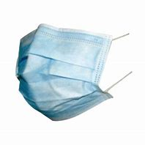Persons with these or other signs of measles illness will be asked to wear a mask. You may also need to wait in a different room while waiting for your healthcare provider. **This will help us protect you** and other patients and staff.