|  |  |
| --- | --- |
| **Medicaid Division**  Behavior Rehabilitation Services (BRS) program |  |
|  |

Request for ICD-10 Diagnosis Code Assistance

Use this form to ask the designated Licensed Practitioner of Healing Arts (LPHA) to review clinical documentation. Do this for youth who do not have an ICD-10 code that indicates a medical need for Behavior Rehabilitation Services (BRS).

* Attach all clinical documentation you have for the youth.
* Submit this form with the BRS authorization request form.

The LPHA will review all submitted documentation and, if applicable, identify an ICD-10 code for the youth or request more information for the review. This review does not guarantee the identification of a code that supports a clinical need for BRS services.

# Client information

|  |
| --- |
| Full legal name: |

# Attestation

I verify that to the best of my ability:

|  |  |
| --- | --- |
|  | I have tried to find an ICD-10 diagnosis code from a medical professional and available documentation that supports the need for BRS. |
|  | I have reviewed the attached documentation and found no ICD-10 diagnosis code that supports the need for BRS as described in Oregon Administrative Rule (OAR) [410-170-0040](https://secure.sos.state.or.us/oard/view.action?ruleNumber=410-170-0040)(3)(a). |

|  |
| --- |
| Requester’s full name: |

# How to review documentation for ICD-10 diagnosis codes

ICD-10-CM (the International Classification of Diseases, Tenth Revision, Clinical Modification) is used to code diseases and medical conditions. ICD-10-CM codes:

* Are 3 to 7 characters.
* Start with a letter, followed by a number.
* Characters 3 through 7 can be a number or a letter.

You may find ICD-10 codes listed like this. Documentation may include a related term (like “ICD10 Term” or “DSM5 Term” below) or written description of the diagnosis.

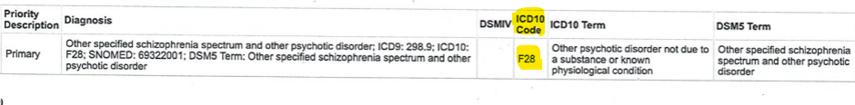

# When to ask for diagnosis code assistance

Request assistance when:

* You can only find a diagnosis term or description without an ICD-10 code.
* You can only find ICD-10 codes that relate to physical conditions (e.g., asthma, diabetes, physical pain), and not the child’s behaviors or need for BRS.
* You cannot find an ICD-10 code or a description of the diagnosis, but documentation describes socioeconomic and psychosocial circumstances that support the need for BRS. Possible examples include:
  + History of abuse in childhood
  + Non-parental custody
  + Running away from current living environment
  + Engaging in unsafe behaviors including drug use, theft, and outbursts in school
  + Conflicts with parent or guardian
  + Concerns about keeping the child safe at home

Some circumstances, such as housing instability or a court order, may not be sufficient to demonstrate the need for BRS.

# Questions:

If you have any questions about this form, contact OHA at 503-979-8354 or [BHMC@oha.oregon.gov](mailto:BHMC@oha.oregon.gov). You can also visit OHA’s BRS [website](https://www.oregon.gov/oha/hsd/ohp/pages/policy-brs.aspx) for more information and forms.