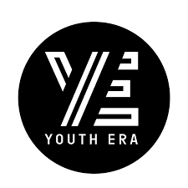  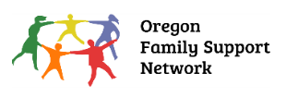  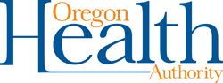  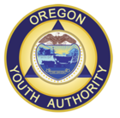  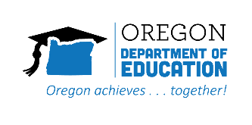 | Regional Executive Council Information
 |  | Council name: | Tri-County SOC
 |  | Date submitted: | February 2, 2023
 |  | Region: | Clackamas, Multnomah, Washington Counties
 |  | Contact name and role: | Selby Stebbins; System of Care Specialist
 |  | Email: | stebbinss@healthshareoregon.org
 | Description of the Barrier
 |  |  | Youth are often being placed, or recommended to be placed, into the Temporary Custody of OYA (Oregon Youth Authority) for either a community residential placement or for commitment to a YCF (Youth Correctional Facility). Youth need to have the opportunity (before custody or commitment) for substance abuse and mental health treatment, while keeping the community and the youth's safety and security needs in mind as a primary factor.
 | Actions Taken to Address Barrier within the local SOC:
 |  | Summary of Practice Level Work Group action steps:
June 2021: Grounded themselves in the topic with a presentation from Multnomah County’s Alternative Placement Committee (APC) facilitator, Amy Chandler, Juvenile Court Improvement Coordinator, Multnomah County Juvenile Services Division.
July 2021: Completed Impact Statement form which allows for each member to identify and describe how they have seen this barrier impact youth success and how it impacts their ability to effectively intervene in the life of a youth and family. PLWG members also provide recommendations about what they need to help families overcome this barrier.

 |  | Summary of Advisory Council action steps:
 |  | None
 |  | Summary of Executive Council action steps:
None

Lacking Executive Council action, we are submitting this barrier to the Oregon SOC Advisory Council for the following reasons:
- Our SOC is in a state of transition and not currently actively addressing barriers.
- The majority of historical barriers that were present in our governance structure and waiting for action during the past two years are being addressed in the community as a result of program and funding changes implemented during the pandemic. However, this is one barrier that remains unresolved.
- We are aware that the State Agency Standing Committee (SAS) is addressing the Birth to Prison pipeline. This barrier is a direct contributor to that pipeline. We are choosing to formally submit this barrier to SOCAC in support of the SAS committee work.
Please see attached:
PLWG Impact Statement form
PLWG Meeting Minutes
Multnomah Alternative Placement Committee Protocol and Mission Statement

 | Request of Statewide SOC Steering Committee:
In which child serving system did this barrier originate? (bold type added by submitter)
This barrier was submitted to Tri-County SOC by the Multnomah Juvenile Services Division’s Alternative Placement Committee. While this committee is hosted by Juvenile Services, it is multi-disciplinary in nature. All partners recognize the impact of the lack of secure residential placements for youth with dual diagnoses of Substance Use Disorder (SUD) and Mental Health (MH).
Impacted youth often have current involvement in multiple systems; most notably, Juvenile Justice and Mental Health. However, youth frequently also have involvement with Child Welfare and Intellectual/Developmental Disabilities (I/DD).
We have checked the box for ‘family advocacy organization’ because the Community Healing Initiative (CHI), a partnership between Portland Opportunities Industrialization Center (POIC), Multnomah Department of Community Justice, and Latino Network, are members of the APC and were partners in the original barrier submission.
For more information, see attached APC protocol document.

- Child Welfare ☒
- Juvenile Justice/OYA ☒
- Education ☐
- Behavioral Health ☒ Including Substance Use Disorder
- Intellectual and Developmental Disabilities ☒
- Physical Health ☐
- Youth advocacy org ☐
- Family Advocacy org ☒

Is this barrier specific to?
- A family ☐
- A program ☐
- Local SOC -unique within the county or neighboring counties ☐
- Statewide impacting all regions of Oregon ☒

Is this unmet need related to? (bold type added by submitter)
- Oregon Administrative Rules ☐
- Policies (lacking or existing) of state agencies, specifically program rules and eligibility ☒
- Related to a (lacking) state funded service or program ☒
- Youth of Color disproportionately impacted. Related to disparities in accessing services and supports based on race, ethnicity, ability, gender, sexual orientation or languages spoken ☒

What are the desired and possible (short & long-term outcomes) you are looking for?
Short Term and Possible Outcomes:
- Increase any and all placement types for youth.
- Training for providers on how to provide services to the I/DD population.
- Amplify the existing Oregon Health Authority MH and I/DD Training of Trainers program.
- Deep dive into the referral process for SUD treatment and explore ways to simplify the process.
- New options for support for youth with I/DD who are not able to ‘aid and assist’ themselves in court proceedings.
- Alternative funding for extra supports and services to help a youth be successful in less restrictive settings, such as:
- Those needed to stabilize and maintain safety for themselves and the community, also staff and peers in a program.
- Those needed to maintain program enrollment by following the rules of a placement; staying at the placement (not running); and not committing new law violations which often result in probation violations.
- Needed supports for behavioral health and substance abuse treatment.
- Recognition, assessment, and support for I/DD needs.
Desired Long-term Outcome: Develop and fund a secure, dual diagnosis (Substance Abuse and Mental Health) residential facility for youth that can serve ages 12 – 19, including youth who may have an Intellectual and/or Developmental Disabilities.

Please send all barriers to Statewide.SOC@odhsoha.oregon.gov . For single system barriers please send with “Single System Barrier” in the subject line.

