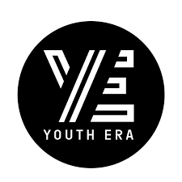  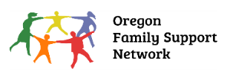       | Regional Executive Council Information
 |  | Council name: | Central Oregon Executive Council
 |  | Date submitted:
 |  | Region: | Central Oregon
 |  | Contact name and role: | Dani McCallister, SOC Coordinator
 |  | Email: | Dani.mccallister@pacificsource.com
 | Description of the Barrier
 |  |  | Central Oregon has an ongoing and increasing need for respite services for youth and families, particularly those that are not involved in ODHS cases that give access to resource families which can act as respite relief for one another, but not as an external resource. Jefferson County has expressed 5-7 youth monthly utilizing emergency department services after youth enter crises which could potentially have been avoided, had there been respite available for them and their families as the triggering situation increased and space from one another could have provided de-escalation. Deschutes County has agreed that a similar need has been experienced there as well.
 | Actions Taken to Address Barrier within the local SOC:
 |  | Summary of work and successes by the Practice Level Work Group:
 |  | The need for higher levels of care for youth in Central Oregon, encompassing a spectrum of services from respite to subacute and residential placements has been discussed frequently on an ongoing basis. The resounding response across our system of care is that the absence of these services is the barrier itself, which is inflaming the experience of crisis treatment to youth and their families in Central Oregon, and stressing our emergency departments, and other crisis services. It has been agreed upon that utilizing the stabilization center in Bend would potentially help de-escalate more crisis situations but many youth and families are not families with it and spreading the word about it amongst service providers may increase use.
 |  | Summary of work and successes by the Advisory Council:
 |  | Please see above for PLWG, as this applies to AC as well.
 |  | Summary of work and successes by the Executive Council:
 |  | Barrier was reviewed with the others submitted with the quarterly barriers. The committee discussed this ongoing need and that there is no local solution that can be identified for this need and that the state level council should be approached with a request for help in finding a solution.
 | Request of Statewide SOC Steering Committee:
Where did the barrier originate?

- Child Welfare ☒
- Juvenile Justice/OYA ☒
- Education ☒
- Behavioral Health ☒
- Intellectual and Developmental Disabilities ☒
- Physical Health x
- Youth advocacy org ☒
- Family Advocacy org ☒

Is this barrier specific to?

- A family ☐
- A program ☐
- Local SOC -unique within the county or neighboring counties ☐
- Statewide impacting all regions of Oregon ☒

Is this unmet need related to?

- Oregon Administrative Rules ☐
- Policies (lacking or existing) of state agencies ☒
- Related to a state funded service or program ☒
- Related to disparities in accessing services and supports based on race, ethnicity, ability, gender, sexual orientation or languages spoken ☐

What would a successful outcome look like?
A successful outcome would be the creation of a respite program or availability of respite providers in our area that are trained to handle high acuity youth and children. This would be a resource that is not specific only to foster care, but to all youth in need of respite services.

Please send barriers to Statewide.SOC@odhsoha.oregon.gov . For single system barriers please send with “Single System Barrier” in the subject line.

