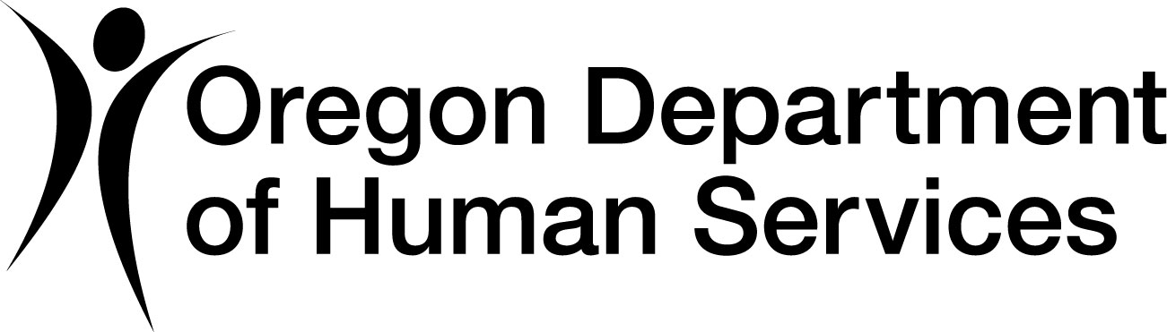 | EFT Enrollment Form for Providers, Vendors and Contractors | 
Read instructions prior to completing.
Section A ― Provider’s information
Provider name: | Provider number (if applicable):
Provider address
Mailing address: | City: | State: | ZIP code:
Phone number: | Email address:
Section B ― Provider identifier’s information
Provider Social Security Number (SSN) or Employer Identification Number (EIN):
National Provider Identifier (NPI) (Not applicable for HCW or PSW):
Section C ― Financial institution information
**COPY OF PREPRINTED CHECK OR BANK LETTER REQUIRED**
Financial institution name:
Street: |  | City: |  | State: | ZIP code:
Financial institution routing number: | Type of account at financial institution
Financial institution routing number: | Checking* or Savings |  | Personal* or Business
Account number: |  | Medicaid provider ID number:
Location of account numbers are on bottom of your check:
SAMPLE/EXAMPLE
Section D ― Submission information
Reason for submission: New enrollment (Start) Change enrollment Cancel enrollment (Stop)
Important! Please read and sign before submitting.
This form is used to authorize direct deposit to a checking or savings account. For all Oregon Department of Human Service (ODHS) and Oregon Health Authority (OHA) programs and payment systems.
- International transaction certification: certify that the entire amount of my direct deposit is NOT ultimately deposited into a financial institution outside the United States.
- Recovery of funds deposited in error: In the event an erroneous deposit occurs creating an overpayment, ODHS|OHA will reserve the right to debit your account accordingly.
I certify that I have read and understand the information contained in this form. I acknowledge that the origination of transactions to the authorized account must comply with provisions of Oregon and US law. I certify that I am authorized to enter into this agreement as the account holder.
Authorized signature:
Written signature of person submitting enrollment: |  |  |  | Submission date:
Printed name of person submitting enrollment:

Office use only | OR-Kids MMIS SFMA CBC/CEP |  | Date processed: |  |  |  | Initial:
Office use only | Original documentation on file with ODHS:
Office use only | Agency signature: |  |  | Date:
This form may contain your personal information. If you return the form by email there is some risk it could be intercepted by someone you did not send it to. If you are not sure how to send a secure email, consider using regular mail or fax.

Instructions for Providers and Contractors
Instructions for Providers, Vendors and Contractors.
Section A — Provider’s information
Provider’s name – Complete legal name of institution, corporate entity, practice or individual provider.
Provider number – List any provider/vendor identification numbers (if applicable).
Provider’s address:
- Street – The number and street name where a person or organization can be found.
- City – City associated with provider address field.
- State/province – IS0 3166-2, two character code associated with the state/province/region of the applicable country.
- ZIP code/postal code – System of postal-zone codes (ZIP stands for “zone improvement plan”) introduced in the U.S. in 1963 to improve mail delivery and exploit electronic reading and sorting capabilities.
- Telephone number – Associated with contact person (required).
- Email address – An electronic mail address at which agency might contact the provider (optional).
Section B – Provider identifiers information
- Provider’s Federal Tax Identification Number (TIN) – A federal tax identification number also known as an Employer Identification Number (EIN), is used to identify a business entity.
- National Provider Identifier (NPI) – A Health Insurance Portability and Accountability Act (HIPPAA), Administrative Simplification Standard. The NPI is a unique identification number for covered healthcare providers. Covered healthcare providers and all health plans and healthcare clearinghouses must use the NPIs in the administrative and financial transactions adopted under HIPPAA. The NPI is a 10-position, intelligence-free numeric identifier (10-digit number). This means that the numbers do not carry other information about healthcare providers, such as the state in which they live or their medical specialty. The NPI must be used in lieu of legacy provider identifiers in the HIPPAA standards transactions.
Section C – Financial institution information
Financial institution address:
- Street – The number and street name where a person or organization can be found.
- City – City associated with provider address field.
- State/province – IS0 3166-2, two character code associated with the state/province/region of the applicable country.
- ZIP code/postal code – System of postal-zone codes (ZIP stands for “zone improvement plan”) introduced in the U.S. in 1963 to improve mail delivery and exploit electronic reading and sorting capabilities.
- Financial Institution routing number – A 9-digit identifier of the financial institution where the provider maintains an account to which payments are to be deposited.
- Type of account at financial institution – The type of account the provider will use to receive EFT payments, e.g., checking or savings, personal or business.
- Provider’s account number with financial institution – Provider’s account number at the financial institution to which EFT payments are to be deposited.
- Account number Linkage to Provider Identifier – Provider preference for grouping (bulking) claim payments – must match preference for v5010 X12 835 remittance advice. (Medicaid ID number)
Section D – Submission Information
Reason for submission:
- New enrollment (Start) – Mark this box for new enrollment or re-enrolling for direct deposit after a cancellation.
- Change enrollment – Mark this box to change any information. Includes changes in bank account (canceling current deposit and starting a new one) or contact information. Note: If changing only email or mailing address, Section C may be left blank.
- Cancel enrollment (Stop) – Mark this box to withdraw authorization for direct deposit. Cancellations require a three day turnaround.
- International transactions: In order to comply with the National Automated Clearing House Association (NACHA) Rules, DHS|OHA is required to determine if direct deposit funds from DHS|OHA are moving in their entirety outside the U.S. If this is determined to be the case, DHS|OHA will not be able to remit funds electronically into your account.
- Recovery of funds deposited in error – In the event an erroneous deposit occurs creating an overpayment, DHS|OHA will reserve the right to debit your account accordingly.
- Authorized signature – The signature of an individual authorized by the provider or its agent to indicate, modify or terminate an enrollment.
- Depending on the payment cycle, it may take up to 30 days to verify your account.
When this form is complete:
- Attach to this form a copy of a voided preprinted check or official bank verification letter of the account name, routing number and account number. This information is required for all new accounts. (Deposit slips not accepted.)
- Note: Checks must be personalized or imprinted with the business name and address. Hand-written, blank checks will not be accepted.
- Return by secure email to: DHSOHA.ProvDirDep@odhsoha.oregon.gov
- Or return by fax to: 503-945-6860
- Or return by mail to: Department of Human Services/Oregon Health Authority
Office of Financial Services/Attn: EFT Coordinator
500 Summer St. NE, E-97
Salem, OR 97301-1080
- For questions contact: DHS/OHA EFT Coordinator at 503-945-6872.
Retain a copy for your records.

