Report on Portland Metro Area Clean-up 6/15/2024
For the work period of May 1-31, 2024

The Oregon Department of Transportation is a leader in Portland Metro area clean-up efforts and is responsible for maintaining the state right-of-way throughout the area.
Clean-up is accomplished through a range of tools and funding methods. The volume of litter and graffiti, and the frequency that graffiti is replaced, make these ongoing issues (not “one-and-done” clean-up efforts).
Current tools to address clean-up include the following:
  - $20M General Fund investment through SB 5701
  - Sponsor-a-Highway Pilot Program

The cumulative Portland Metro area clean-up efforts are summarized here:
 | Outcomes in May 2024 | Outcomes to date:
Litter removal | 18,740 lbs collected | 43,500 lbs collected
Graffiti removal | Over 2,300 tags removed | Over 4,000 tags removed
Camp clean-up | 106 camps cleaned up | 211 camps cleaned up
Access prevention | 2 projects completed | 4 projects completed

The following is a breakdown of clean-up efforts through 1) the SB5701 funds and 2) Sponsor-a-Highway Pilot program in the locations identified below, in the timeframes noted:

- Portland metro area-wide clean up via $20M legislative allocation
This clean-up targets state right-of-way for litter removal and graffiti removal and access prevention. Work is conducted through contractors to ODOT. Camp clean-up is conducted by the City of Portland, billed to ODOT. Money spent reflects work completed between 4/18 and 5/31.

Funding through this allocation was available April 17, 2024. The litter, graffiti and camp clean-up contracts were in place on April 18, 2024.

In this reporting cycle (May 1-31), litter was removed in the following areas:
- I-205 between mile points 0 and 26 – throughout the corridor roughly between I-5 in the Tualatin area and the Sandy Blvd exit in NE Portland.
- US26 (Sunset Highway) between mile points 55 and 65 – throughout the corridor from Dersham Rd in Cornelius to Hillsboro.
- I-5 Southbound between mile points 282 and 308 – roughly from SW Multnomah Blvd to Hayden Island.
- I-84 Both Directions MP 0 to 17 – from about I-205 to Troutdale.

In this reporting cycle (May 1-31), graffiti was removed from various locations in the following corridors:

- I-84
- I-5
- I-205

This work includes the removal of over 2,131 tag clusters and application of over 2,176 gallons of paint. Graffiti was removed from 21 signs and 14 signs were replaced.

In this reporting cycle (May 1-31), access prevention was constructed at the following 2 locations:

- Tualatin River 99W SB North End
- Tualatin River 99W NB North End
Fencing was installed under the structure to protect structures and prevent camping.

In this reporting cycle (May 1-31), camp clean-up was conducted at the following locations by City of Portland contractors:

Frequent posting & cleaning areas:
- I-405 corridor, both mainline and street level and Hwy 30 interchange areas
- I-205 MUP between Glisan and Flavel
- I-5 between N Victory and Broadway

Major projects completed:
- I-205 greenway between SWCT and Flavel
- Nine automobiles were removed (pull-behinds/trailers/ATV/motorcycle, burned car)
- Columbia Slough along I-5 on/off ramps from Columbia Blvd
- 45 tons of debris removed from impacted area.

The current agreement allows the City of Portland up to three months after work has been completed to submit invoices to ODOT for payment. Expenditures for camp clean-ups include: direct site cleanup costs, program management, property storage warehouse rental, Central City Concern support, and derelict removals from ODOT right of way (auto/RV/trailer/etc).
We anticipate that as the above-described work progresses, we will be able to track how quickly graffiti, litter and camps return following clean-up.

Summary of funding spent to date and clean-up outcomes is shown below: (thru 5/31/24)
 | Total Budget | Spent to date* | Spent this reporting cycle* | Remaining Funds | Clean-up outcomes this cycle | Clean-up outcomes to date
Litter | $4,000,000 | $779,152 | $47,264 | $3,169,496 | Pounds collected:  11,860 lbs | Pounds collected:  17,760 lbs
Graffiti | $4,000,000 | $135,068 | $5,821 | $3,864,932 | Tags Removed:  2,291 tags | Tags Removed:  3,831 tags
Camps | $4,000,000 | $305,491 | $40,129 | $3,694,509 | Total camps:  106 | Total camps:  211
Access Prevention | $8,000,000 | $88,254 | $63,018 | $7,911,746 | Projects Completed:  2 | Projects Completed:  4
Total: | $20,000,000 | $1,307,964 | $156,232 | $18,640,684

- I-405 and US26 corridor clean up through the Sponsor-a-Highway Pilot Program
This clean-up targets the following locations:
- I-405 - full length between the Marquam Bridge and Fremont Bridge
- US26 - from I-405 to the Vista Ridge Tunnel
- US30 - from I-405 to NW Nicolai Street

Litter removal is conducted through Central City Concern’s Clean Starts Program.
Graffiti removal is completed by contractors to ODOT.
This program started in March 2024.
Money spent reflects current estimated work completed 5/1-5/31.

 | Total Budget | Spent to date | Spent this reporting cycle | Remaining Funds
Litter | $250,000 | $42,161.89 | $17,810.89 | $207,838.11 | Pounds collected:  6,880 | Pounds to date:  25,740
Graffiti | $150,000 | $67,641.50 | $30,770.25 | $82,358.50

Appendix - Photos of work completed in this cycle
Portland metro area-wide clean up via $20M legislative allocation
Graffiti removal – Before / After on 5/1/24
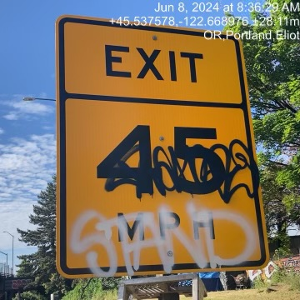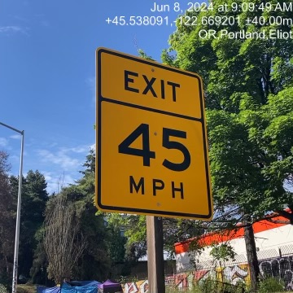
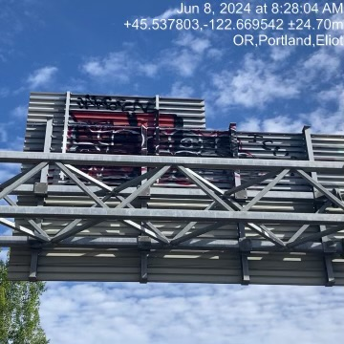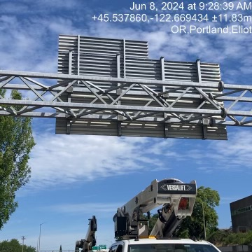
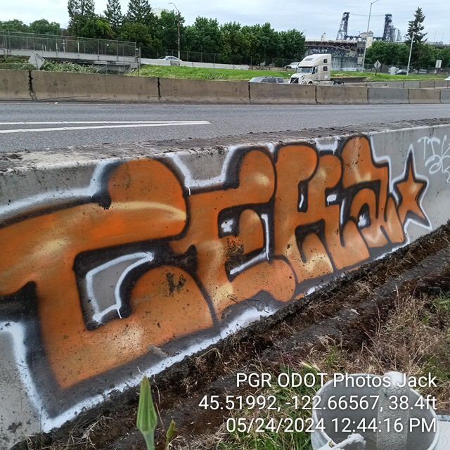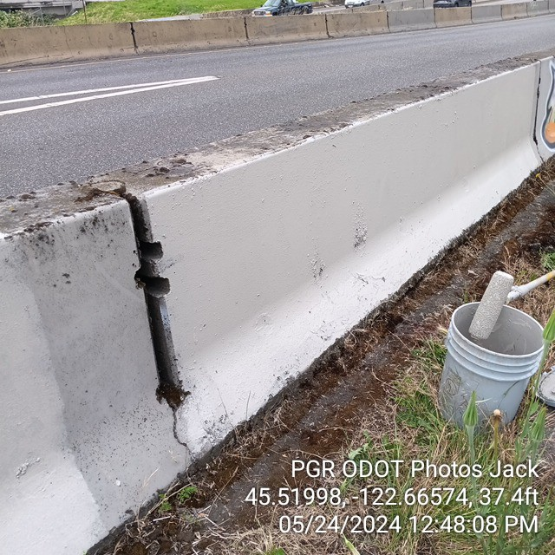
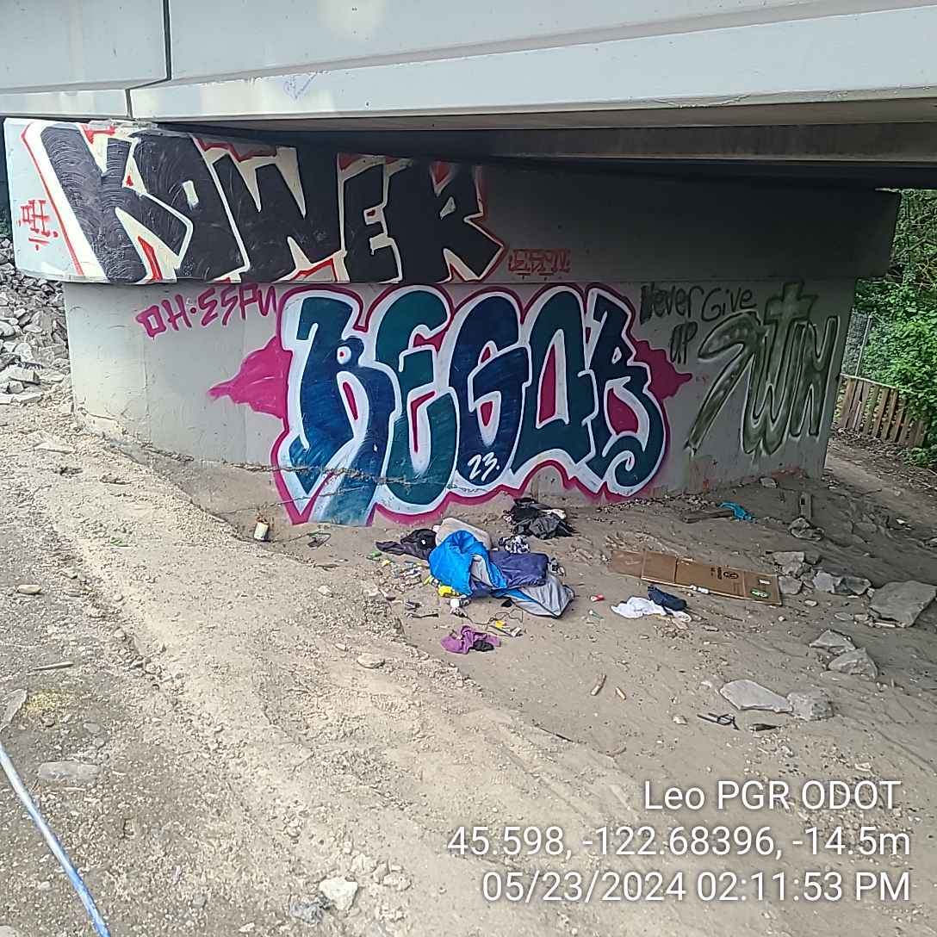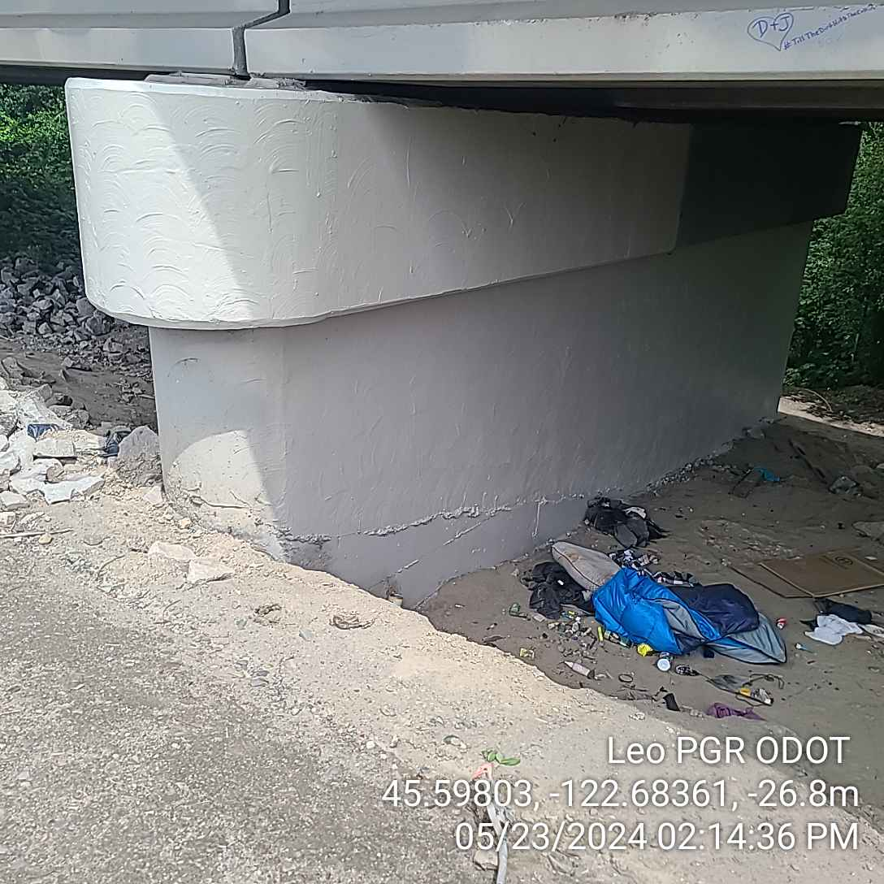
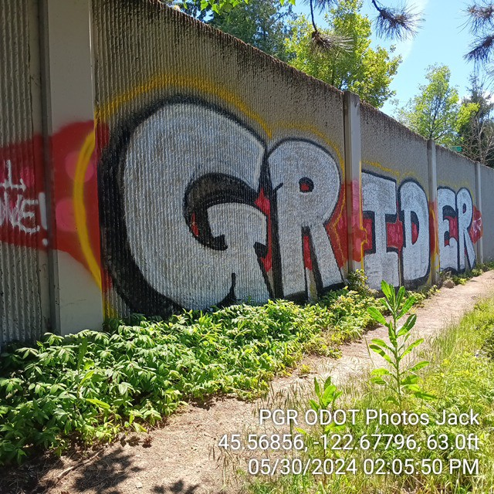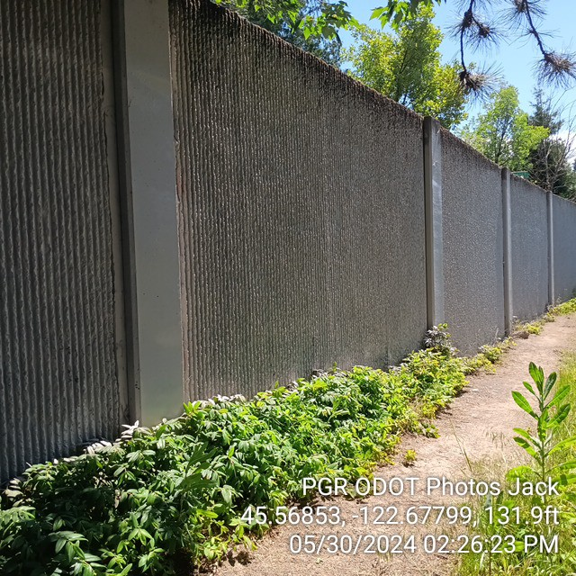

Camp removal – Before / After
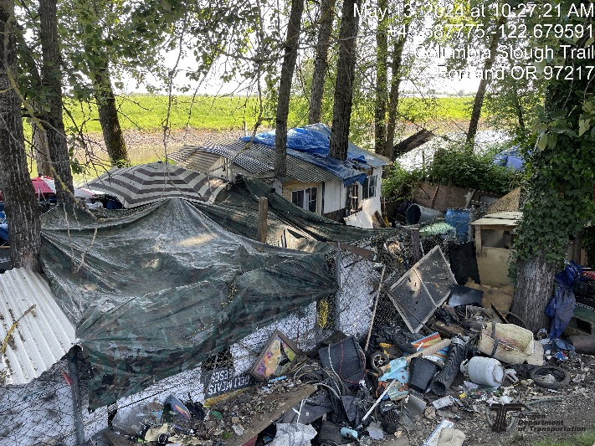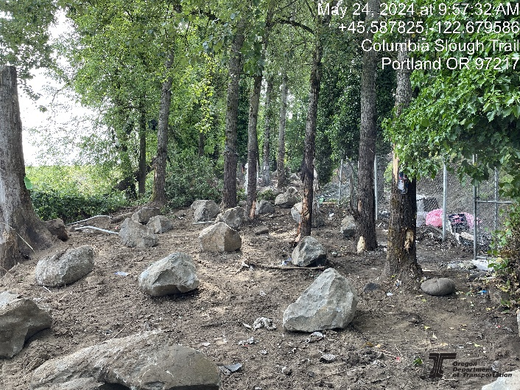
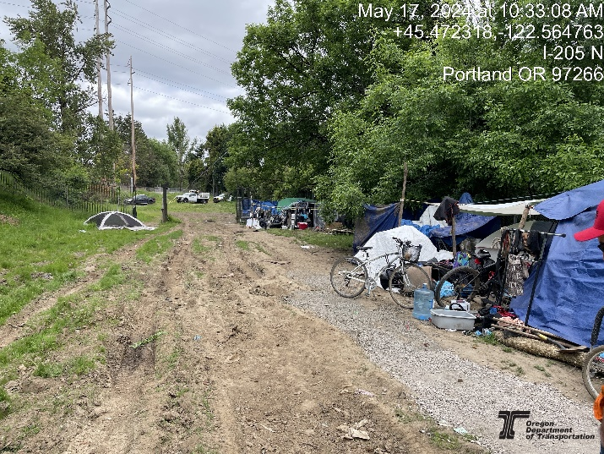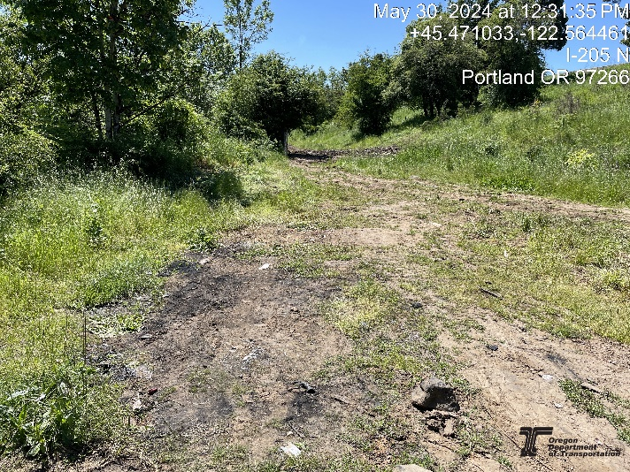
Sponsor-a-Highway Pilot Program
Graffiti removal in I-405 corridor – Before / After
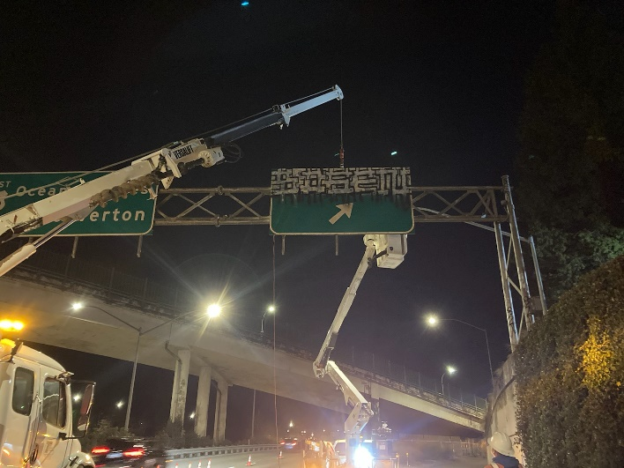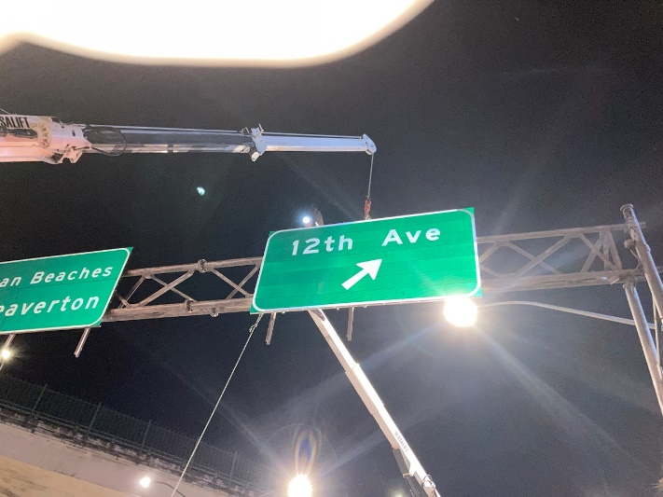

Litter removal in in I-405 corridor – Before / After
