Chapter 1. Planning & Program Development

OVERVIEW

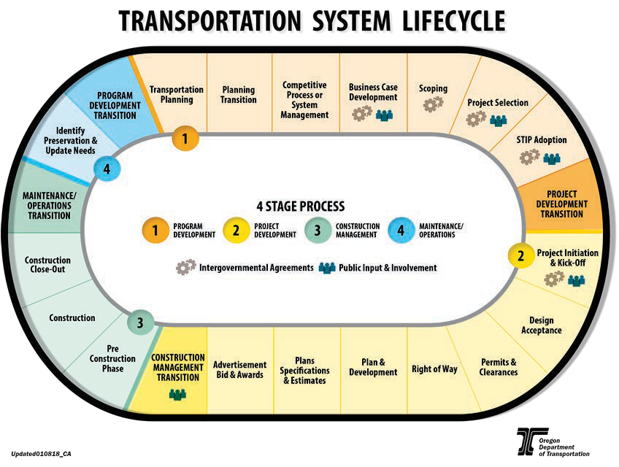
To provide an overview, ODOT’s project delivery lifecycle is shown below. LPAs may not complete every step shown, as some steps are specific to projects on the state system. Actual steps taken will vary depending on the complexity or type of project being delivered.

This chapter focuses on
Planning and Program Development, which is the planning phase for the proposed project. During this phase, projects may be accepted into the STIP.
The subsequent chapters focus on the following primary project development phases of the transportation system lifecycle:
- Project Development - In this phase, construction projects are cleared for environmental impacts, necessary permits are obtained, and design plans, specifications, schedules and estimates are completed.
- Right of Way Acquisition - There may be some overlap between the Project Development phase and the Right of Way Acquisition phase. After NEPA determinations are satisfied, right of way acquisition may start.
- Utilities - Coordination regarding utilities begins in the Project Development phase and continues throughout the life of the project. A separate utility relocation phase programmed in the STIP and federal authorization are required when the utility relocation is eligible for federal reimbursement.
- Advertisement, Bid and Award - During this phase, PS&E is approved and FHWA authorizes federal funds. At this point, the project can be advertised for bid.
- Construction Contract Administration - Upon completion of the prior phases, construction commences. Project closeout occurs in this phase.

PROGRAM DEVELOPMENT
Program development begins with transportation planning to explore needs at the state and local levels and identify projects for the Statewide Transportation Improvement Program (STIP). The STIP is a staged, multi-year, statewide capital improvement plan for transportation projects. The STIP is consistent with the statewide transportation plan as well as metropolitan transportation improvement programs (also known as TIPs or MTIPs). The STIP must be developed in cooperation with the metropolitan planning organizations (MPOs), public transit providers, and any Regional Transportation Planning Organizations (RTPO) in the state.
Projects listed in the STIP may include state and federally funded highway and bridge construction or repairs; project development activities such as environmental review; and other non-construction projects such as public transit service improvements and capital purchases. The STIP also includes federal transportation projects in national parks and forests, federal lands and Indian reservation road systems, interstate highways, state, regional and district highways, and bridges, as well as many locally funded projects of statewide or regional significance, and public and active transportation projects.

TRANSPORTATION PLANNING
Transportation planning includes development of the Oregon Transportation Plan and modal plans that provide Oregon’s strategic transportation vision and policies. Statewide policy plans also provide guidance and direction for developing other transportation system plans.
City and county Transportation System Plans (TSPs), which include all of the state highway system within their boundaries, describe existing conditions, identify roadway classification and type, size, and location transportation needs over a 20-year period and develop priorities for transportation system improvements within a defined geographic area. TSPs evaluate needs across all modes of transportation and may include portions of or whole transportation corridors. The STIP allocates funding to projects in six investment areas: Fix-It, Enhance Highway, Safety, Public and Active Transportation, ADA, Local Government and Other Functions. Each investment area or program has its own methodology for selecting projects. Program Managers may propose projects identified in TSPs for inclusion in the STIP.
Transportation Policy Planning includes:
- Oregon Transportation Plan
- Oregon Highway Plan and other modal plans
- Strategic Action Plan
- A framework to help prioritize investments for all modes of transportation
- Identification of strategic objectives and outcomes from management and investment decisions
Transportation System Planning includes:
- City and county TSPs
- ODOT facility plans
- ODOT Interchange Area Management Plans
- An assessment of future transportation system needs and recommended solutions
- Prioritized investment strategies and projects
- All modes of transportation
- Projects that are prioritized for inclusion in the STIP
ODOT’s Transportation Planning Section is responsible for managing the statewide policy planning process and the Regional Planning Units are responsible for managing the system planning process.

STIP DEVELOPMENT & ADOPTION
Resources:
- Code of Federal Regulations, 23 CFR Part 450
The STIP identifies projects to be funded, the year in which funding will be obligated (work will commence), and what state, local or federal funding sources will be used to pay for them. . See Code of Federal Regulations, 23 CFR Part 450 for additional information.
The STIP further includes:
- Sufficient scope description (type of work, termini, and length)
- Estimated total project cost, which may extend beyond the program years of the STIP
- Federal funds proposed by fiscal year
- Proposed source(s) of federal and non-federal funding
- Responsible agency
The STIP is adopted by the Oregon Transportation Commission (OTC) and is effective once approved by the Federal Highway Administration (FHWA) and the Federal Transit Administration (FTA). Identifying and planning for transportation needs is an ongoing process with periodic reviews. The STIP is updated every three to four years, and routinely amended from month to month for project-specific changes and additions.

PLANNING TRANSITION

The intent of the Planning Transition phase is to ensure that project-related information developed by the planning team during the planning phase is communicated to the project development team. Coordination is required to ensure that the project development team fully understands the purpose of the conceptual improvements identified in the completed planning documents. This includes any special commitments made to partners that need to be considered during the project development phase.

Planning Transition is part of the STIP project development process, which includes:
- STIP program and work type criteria
- Program objectives and goals
- Required Title VI and ADA considerations
- Access management
- Public involvement
- NEPA and environmental justice considerations
- System performance outcomes
- Scoping criteria
To establish realistic project delivery schedules for the STIP and to communicate critical project related information, internal communication between the LPA’s project engineering and planning staff should occur at each of the following project phases:
- Scoping
- Project selection
- Project design
It is also important to consult with the funding program-awarding agency (e.g., MPO, ODOT) regarding project delivery schedules to ensure the information programmed in the STIP is up to date. LPAs should be aware of STIP and MTIP amendment requirements and timelines. See the resources linked below for additional information.

IDENTIFYING POTENTIAL PROJECTS
A project evolves from a transportation problem or need identified through a variety of sources while ensuring the transportation system is accessible to all users. Projects may be identified by one or more of the following organizations, documents, or methods:
- Legislation
- Data Driven Management systems
- Area Commissions on Transportation
- ODOT Modal Plans
- Regional Transportation Plans
- ODOT Facility Plans
- Local Transportation System Plans

PROJECT SELECTION
The Statewide Investments Management Section allocates the annual STIP funding levels to six funding categories in support of the Oregon Transportation Commission’s goals. Regions balance their individual programs with their allotted funding targets. The OTC establishes funding targets for all programs and the criteria for identifying priorities.
The Oregon Transportation Management Systems identify and prioritize preservation, bridge and safety projects. Additional sources of information include statewide ADA compliant traffic data, Intelligent Transportation Systems data, freight movement data, fish passage culvert strategic or action plans, public transit, Intermodal Management Systems, MPOs, local governments, Area Commissions on Transportation (ACTs), regional partnerships, and public input.
ODOT funding program managers create initial business cases for projects at 150% of available funding. Region project teams scope each project to develop cost estimates and project details. ODOT also assists local governments in scoping projects that ODOT will be involved in delivering, including MPO-funded projects (for non-certified local agencies).
The funding program managers use scoping data to select projects at 100% of funding levels. STIP coordinators in each region reenter the selected projects into the STIP database, and the resulting list of projects make up the draft STIP. ODOT provides at least a 45-day public review of the draft STIP and a minimum of two open public meetings per region during this period. Region STIP coordinators summarize and send public comments to the STIP development manager.
Resources:
- Statewide Transportation Improvement Program
- ODOT Federal Highway Administration / Federal Transit Administration Amendment Matrix
- Transportation Development Planning

