Chapter 26

Contents

[26 Quick Reference 26-1](#_Toc183608555)

[26.1 General 26-1](#_Toc183608556)

[26.2 Basic Wiring Guidelines 26-2](#_Toc183608557)

[26.3 Loop Detector Information 26-3](#_Toc183608558)

[26.4 Non-Invasive Detection Information 26-4](#_Toc183608559)

[26.5 Input File Info 26-5](#_Toc183608560)

[26.5.1 Input File for 332S 26-5](#_Toc183608561)

[26.5.2 Input File for 332 26-6](#_Toc183608562)

[26.5.3 Input File for 336 26-7](#_Toc183608563)

[26.6 332S and 332 Cabinet Limitations – Output File 26-8](#_Toc183608564)

[26.7 332S and 332 Cabinet Limitations – Input File 26-9](#_Toc183608565)

[26.8 332S and 332 Cabinet Limitations – Conflict Monitor 26-10](#_Toc183608566)

[26.9 Phasing Standards 26-11](#_Toc183608567)

[26.10 Signal Pole & Signal Head Information 26-12](#_Toc183608568)

[26.11 Sign Information 26-13](#_Toc183608569)

[26.12 Junction Box & Conduit Information 26-14](#_Toc183608570)

[26.13 Electrical Crew Preferences 26-15](#_Toc183608571)

[26.14 Final Design/Drafting Checklist 26-16](#_Toc183608572)

# Quick Reference

## General

The quick references are comprised of information, tables, and charts that are contained within the manual. They are placed in this chapter without the accompanied explanation text for experienced signal designers to have quick reference to common design standards.

## Basic Wiring Guidelines

An AC positive (“hot” = “+”) wire and an AC negative (“Neutral” = “-“) wire is required to complete the circuit for each piece of equipment (from the equipment to the power source).

|  |  |  |  |
| --- | --- | --- | --- |
| **Basic Wiring Guidelines for Individual Conductors**  **Note: current standard is to use control cables**  **120V Wiring shall be sized for a maximum 3% voltage drop** | | | |
| **120 Volt AC** | Signal System Neutral: Poles over 4” in diameter | One #8 THWN  (-) | Used to complete the circuit for indications in Vehicle or Pedestrian Signals mounted on large signal poles. |
| Signal System Neutral: Pedestals 4” in diameter | One #12 THWN  (-) | Used to complete the circuit for indications in Vehicle or Pedestrian Signals mounted on pedestals. |
| Vehicle Signals | Three #14 THWN  (+) | Typically one wire for each indication color: Red, Yellow, & Green. Certain signal head types require a different number wires.  (Note: see Signal System Neutral above) |
| Pedestrian Signals | Two #14 THWN  (+) | One wire for each indication: walk & flashing don’t walk. (note: See Signal System Neutral) |
| Luminaires | Two #10 XHHW\*  (120V = + & -)  (240V = + & +) | From Service Cabinet to each luminaire (no daisy chaining). Never routed through the controller cabinet. |
| Photoelectric Cells | Three #12 THWN\*  (+ & -) | From the Service Cabinet, for the luminaire circuit. Never routed through the controller cabinet. |
| Part-Time Restriction Signs | Two #12 THWN\*  (+ & -) | For each sign. |
| Power Supply | Two #6 XHHW\*  (+ & -) | From Service Cabinet to Controller Cabinet. |
| **Low Voltage DC** | Pedestrian Pushbuttons | One #14 THWN  (+) | For each pedestrian phase. |
| Pushbutton Common | One #14 THWN  (-) | Used to complete the circuit for Pedestrian Pushbutton. |
| Interconnect | One 6 twisted pair cable  (n/a) | Unspliced from Controller cabinet to Controller cabinet. |

\*Common wire is inclusive to wire count.

## Loop Detector Information

|  |  |  |
| --- | --- | --- |
| **Loop Detector Placement** | | |
| Location | Posted Speed (MPH) | Detector Spacing (ft.) from stop bar to center of detection |
| Mainline  Note: If mainline has a shared thru-left turn lane, install stop bar detection in the lane at 5’ & 15’ in addition to the detection shown for mainline based on posted speed. | 25 | 140 |
| 30 | 180 |
| 35 | 110/220 |
| 40 | 160/320 |
| 45 | 160/320 |
| 50 | 190/380 |
| 55 | 225/450 |
| Right Turn Lane (mainline)  Note: not applicable to unsignalized slip lanes |  | 140  (115 if lane is short) |
| Side Street & Left Turns |  | 5/15/75 |
| Interchange Ramps | Low volume &/or low exit speed | 5/15/75/150 |
| High volume &/or high exit speed | 5/15/110/220 |
| Bike Lane (mainline) | 15 | 50 |
| Bike Lane (side street) | 10 | 5/50 |
| Mainline Temporary Bridge  (one lane/two-way) |  | 5/15/100 &  65 for bypass loop in opposing lane |

\*Note: Regions may have a minimum value that is larger than the statewide minimum standard. Verify with Region Traffic and Region Electrical.

|  |  |
| --- | --- |
| **Loop Wires Allowed in Loop Wire Entrance Conduit** | |
| **Number of Loops (one loop has 2 loop wires entering the loop wire entrance conduit)** | **Loop Wire Entrance Conduit Size** |
| 1-2 Preformed Loops | 2” |
| 3-4 Preformed Loops | 2 ½“ |
| 1-4 Standard Loops | 2” |
| 5-8 Standard Loops | 2 ½“ |
| Note: If more than 4 preformed loops or more than 8 standard loops need to enter at one location, install multiple loop wire entrances. | |

|  |  |
| --- | --- |
| **Loop Feeder Cables Allowed in Conduit** | |
| **# of Loop Feeders** | **Conduit Size\*** |
| 1-5 | 1 ½“ |
| 6-9 | 2” |
| 10-13 | 2 ½“ |
| 14-21 | 3” |

## Non-Invasive Detection Information

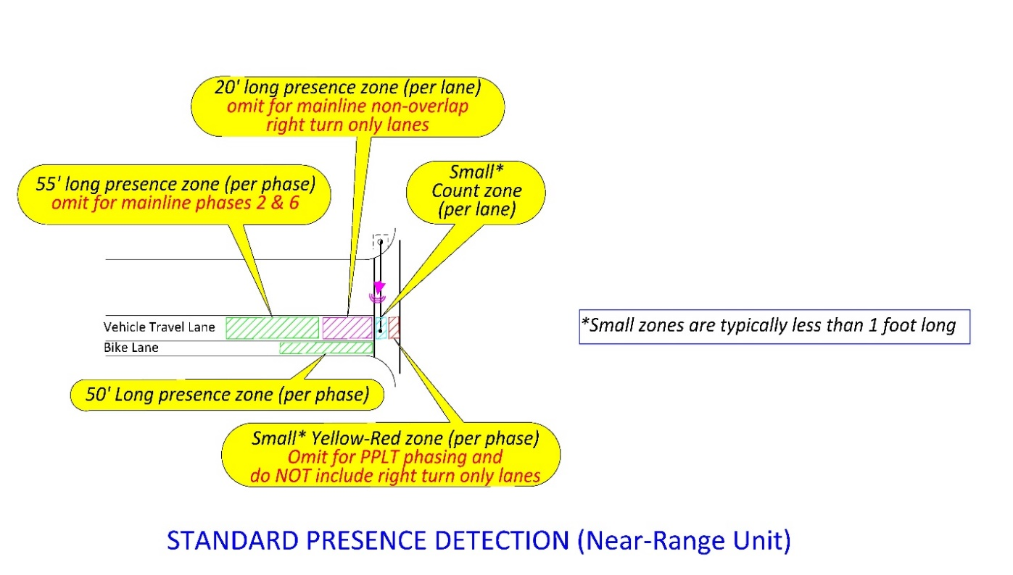

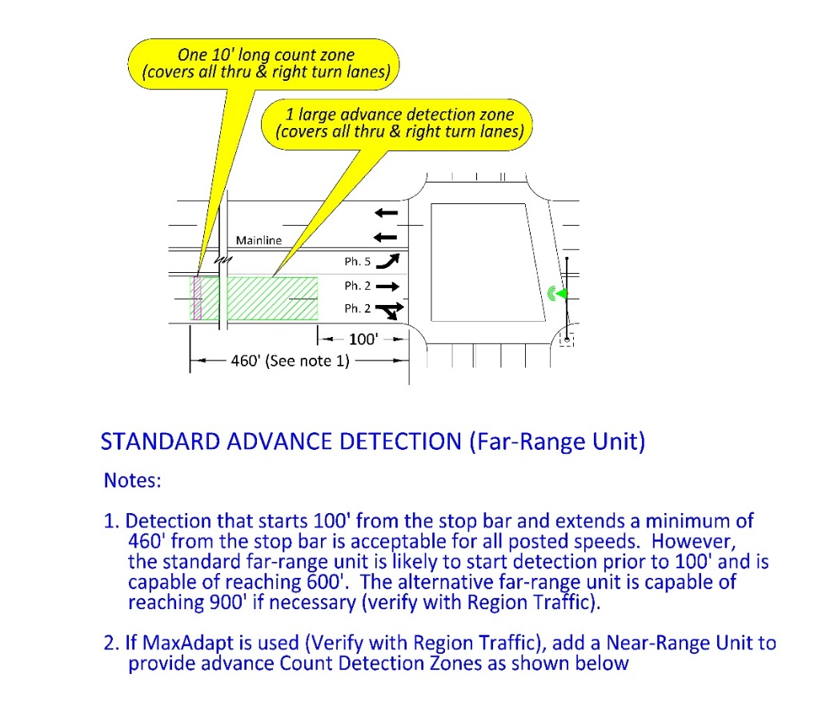

## Input File Info

### Input File for 332S

**DEFAULT STANDARD FOR VIDEO DETECTION EQUIPMENT LAYOUT**

### Input File for 332

**DEFAULT STANDARD FOR VIDEO DETECTION EQUIPMENT LAYOUT**

Note: video layout phase assignment is different than the default standard phase assignment shown above.



### Input File for 336

## 332S and 332 Cabinet Limitations – Output File

1. 18 switch packs
2. 16 are conflict monitored
   1. Switch packs A3 and A6 are not monitored
   2. 2018 monitor can be used in extreme cases for all 18 switch packs
3. 12 have the ability to cabinet flash via flash plugs
   1. Switch packs 3, 6, 9, 12, A3, and A6 go dark in cabinet flash





## 332S and 332 Cabinet Limitations – Input File

1. 28 vehicle inputs for a 332 using 9 slots and 2 input files
   1. Slots 10, I11, and 14 have no inputs
      * Slots 1, 4, 5, and 8 have one input per slot (not two)
      * 4 ped
      * 4 EV
      * 2 rail – indirect via 4 C1 pins using a 252 Isolator
      * 0 spares
2. 40 vehicle inputs for a 332S using 10 slots and 2 input files
   1. All 14 slots are populated with C1 and C11 pins
      * 4 ped
      * 4 EV
      * 2 rail – direct via 2 C1 pins using inverting a 255 Isolator
      * 1 GPS
      * 5 spares

**332 cabinet**



**332S cabinet**



## 332S and 332 Cabinet Limitations – Conflict Monitor

1. 16 channels with 32 outputs of conflict monitoring (green & yellow)
   1. Monitor all green, flashing yellow arrow, and walk indications
   2. Do not monitor solid yellows (exception: solid yellow cannot be separated from the flashing yellow arrow when using a center flash signal head and therefore will be monitored)
2. Flashing yellow arrow
   1. Use the overlap green outputs

Example

* + - 3 section FYA signal head on Phase 1 (center flash)
      * Use R & G outputs on switch pack 1 (phase 1)
        + Monitor G on channel 1
      * Use G output on switch pack A1 (OLA) for FYA and solid YA
        + ****Monitor FYA/YA on channel 9

## Phasing Standards

signal_design_manual_figures

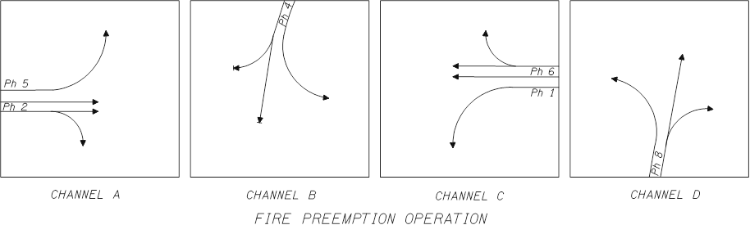signal_design_manual_figuressignal_design_manual_figuressignal_design_manual_figuressignal_design_manual_figures

## Signal Pole & Signal Head Information

|  |  |
| --- | --- |
| **Signal Head Placement/Spacing Dimensions** | |
| From the stop line to signal face | 45’ minimum |
| From the stop line to signal face | 180’ or greater requires a near-side head |
| Spacing of heads for the same phase | 8’ minimum, 10’ desirable |
| Spacing of heads to adjacent phase | 6’-12’ desirable |
| Spacing of heads (except Type 4L head) to adjacent sign | 3’ minimum |
| Spacing of Type 4L head to adjacent sign | 4’ minimum |
| **Signal Pole Placement** | |
| 18” minimum from face of curb to any equipment mounted on pole. | |
| 5’ recommended minimum from face of curb | |
| 6’ recommended minimum from EP | |
| 5’ recommended minimum clearance on all sides of a raised island | |

|  |  |  |
| --- | --- | --- |
| **Mast Arms** | | |
| **Mast Arm Length** | **Std. Dwg. TM650** | |
| **Pole Type** | **Pole Type w/Illum.** |
| 15’ | SM1 | SM1L |
| 20’ | SM2 | SM2L |
| 25’ | SM2 | SM2L |
| 30’ | SM3 | SM3L |
| 35’ | SM3 | SM3L |
| 40’ | SM4 | SM4L |
| 45’ | SM4 | SM4L |
| 50’ | SM5 | SM5L |
| 55’ | SM5 | SM5L |
|  | **Std. Dwg TM655** | |
| 60’ | N/A | SM6L |
| 65’ | N/A | SM6L |
| 70’ | N/A | SM7L |
| 75’ | N/A | SM7L |

## Sign Information

## Junction Box & Conduit Information

|  |  |  |  |  |  |  |
| --- | --- | --- | --- | --- | --- | --- |
| **Minimum Junction Box Type/Size** | | | | | | |
| **Type/Size** | | | **Location/use** | | | |
| JB-3T: Two (Tandem) 30”x17”x12” boxes | | | The same quadrant as the signal controller: first access point for all signal, detector, and interconnect circuits. | | | |
| JB-2: Single 22”x12”x12” box | | | All quadrants without the signal controller: secondary access point for signal, detector, and/or interconnect circuits | | | |
| JB-1: Single 17”x10”x12” box | | | All approach legs: detector and/or interconnect circuits | | | |
| **Type** | **Size** | **Total Conduit Diameters Allowed (Inches)** | | **Remarks** | | **Material** |
| JB-1 | 17”x10”x12” | 12 | | Non-traffic areas only | | Concrete |
| JB-2 | 22”x12”x12” | 18 | | Non-traffic areas only | | Concrete |
| JB-3 | 30”x17”x12” | 34 | | Non-traffic areas only | | Concrete |
| **Junction Box Spacing** | | | | | | |
| 300’ maximum spacing. Check with the region electrical crew for the preferred spacing. | | | | | | |
| **Conduit Requirements\*** | | | | | | |
| Conduit crossing mainline or side street | | | | | 2” minimum | |
| Spare conduit from large signal pole to nearest junction box (if alternative detection is NOT used on project) | | | | | 2” | |
| Spare conduit from controller cabinet to nearest junction box | | | | | 2” | |
| Minimum conduit size allowed | | | | | 1 ½“ | |
| Maximum conduit size allowed | | | | | 3” | |
| Max wire fill for new conduits | | | | | 70% of NEC maximum | |
| Max wire fill for existing conduits | | | | | 100% of NEC maximum | |

\*Note: Regions may have a minimum value that is larger than the statewide minimum standard. Verify with region traffic and region electrical crew.

## Electrical Crew Preferences

The electrical crew that will be maintaining the signal (ODOT or local agency) shall have a chance to review and comment on signal plans during the design phase. Send plan sheets directly to the electrical crew lead/manager or ensure that they are included on the plan distribution list for project milestone reviews. Use the following checklist as a guide for verifying the electrical crew preferences.

|  |  |  |
| --- | --- | --- |
| **Electrical Crew Design Preferences to Verify** | | **Section in Manual for More Information** |
| 1 | Any existing equipment that should be removed and/or replaced | 4.2 |
| 2 | Equipment to salvage and location to stockpile | 4.2 & 10.2 |
| 3 | Equipment that may be removed and relocated | 4.2 & 10.5 |
| 4 | Need for a maintenance pad | 5.1.7 |
| 5 | Vehicle and pedestrian signal material (aluminum or polycarbonate) | 5.2.2 & 5.4.13 |
| 6 | Utility clearances below ODOT default standard, but still meeting NESC requirements | 5.5.4 |
| 7 | Illumination mounting height, LED fixture, and fixture wattage | 5.6 & 5.6.1 |
| 8 | Need for battery back-up | 5.9 |
| 9 | Controller cabinet location | 5.10.1 |
| 10 | Junction box location and preferred spacing of junction boxes | 5.12.2 |
| 11 | Feasibility of reusing any existing wiring, splicing new conduit to existing conduit, or adjustments of existing junction boxes | 5.12.4 & 5.13.5 |
| 12 | Feasibility of adding new wire to existing conduit (conduit condition and wire fill) | 5.13.1 |
| 13 | Need for conduit sizes above the ODOT default standard | 5.13.1 |
| 14 | Need for any unique site specific bonding/grounding | 5.14.4 |
| 15 | Terminal cabinet orientation (when it cannot be placed at the default standard 180 degrees) | 9.3.2 |
| 16 | Flashing beacon power source of commercial or solar | 12.4 |

## Final Design/Drafting Checklist

Before submitting plans for design review/approval (see chapter 2), use the following checklist.

