Chapter 18

Contents

18 Standard Drawings and Standard Details 18-1

18.1 Standard Drawings 18-1

18.1.1 Effective Dates and Updates 18-2

18.1.2 Standard Drawing Reports 18-3

18.2 Standard Details 18-5

# Standard Drawings and Standard Details

## Standard Drawings

Standard drawings provide micro detail construction information for typical installations and are referenced by the contract plans via the signal plans. The signal designer is responsible for selecting the appropriate standard drawings that are applicable to the project. The applicable signal related standard drawings are listed only on the first sheet of the signal plan set. See Figure 18‑1. The entire set of applicable standard drawings for the whole project is shown in the main index (usually the second sheet of the contract plans). Verify the main index to ensure signal related standard drawings are listed correctly.

The standard drawings that are applicable to signal design are found in the TM400 series (signal design) and TM600 series (traffic structures). Standard drawings for temporary work zones (temp. bridge signals) are found in the TM800 series (work zone).

Standard drawings cannot be modified by the designer. However, if a standard drawing doesn’t quite work for a particular project due to a non-typical condition, the standard drawing content can be used to create a details plan sheet that is then signed and sealed by the engineer of record.

All standard drawings and standard details can be found at this [website](http://www.oregon.gov/ODOT/Engineering/Pages/Standards.aspx).

Figure 18‑1 | List of Applicable Standard Drawings on Signal Plan Sheet

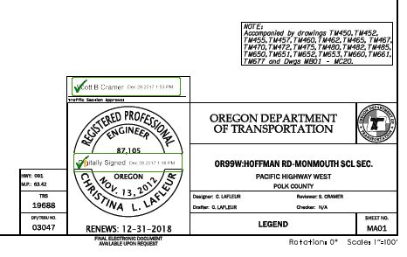

### Effective Dates and Updates

An effective date is placed on each standard drawing. The bid date of the project will be within the range of the effective date. This assists with identifying the correct drawing for the project. The standard drawings used on the project are valid for the life of the construction.

Standard drawings are maintained by the traffic engineering section and are updated twice a year, once in January and once in July. At each revision update, every standard drawing will get a new effective date, regardless of any content changes. If any content changes are made, they will be listed and dated in the standard drawing title block. See Figure 18‑2. Always check to make sure the standard drawing effective date falls within the project bid let date and be aware of the status of content changes. The effective dates for each revision update are shown below:

* January update – effective date from June 1 to November 30
* July update – effective date from December 1 to May 31 of the following year

Figure 18‑2 | Standard Drawing Effective Date and Content Change Information



This standard drawing was updated with a new effective date and posted to the website in January 2013.

The content of this standard drawing was last updated in January 2011

### Standard Drawing Reports

Each standard drawing has been signed and sealed by an ODOT engineer of record and are backed by engineering analysis, calculations, and/or other justification to support the content contained within. The engineering analysis, calculations, assumptions, and other information used in the development of the standard drawing is documented in the standard drawing report (formally called the baseline report). See Figure 18‑3 showing standard drawing report information in the standard drawing title block. See Figure 18‑4 for an example of a standard drawing report. If content changes are made during the revision update periods, the standard drawing report is also updated.

Standard drawing reports are available on the [standard drawings website](https://www.oregon.gov/odot/Engineering/Pages/Standards.aspx) next to the actual standard drawing dgn and pdf files. The signal designer should review the reports to ensure proper application of the standard drawings on the project.

Figure 18‑3 | Standard Drawing Baseline Report Info in Title Block

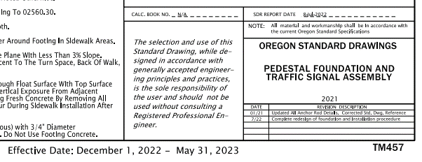

Calc. book referenced in standard drawing report

Standard drawing report date (should match same month and year as last content revision)

Figure 18‑4 | Baseline Report Example

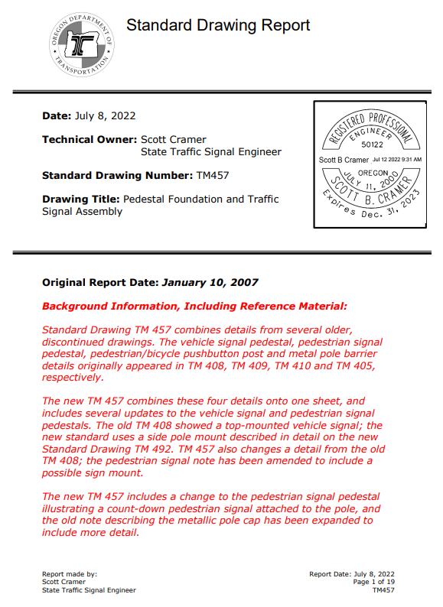

Note: the report may be long, depending on the history, number of changes made over time, and type of changes made.

## Standard Details

Standard details typically contain construction installation information that:

* Is used infrequently,
* Is used on non-state highway roadways,
* Requires modification based on the project specific location, and/or
* Is brand new/unproven technology that needs refinement prior to becoming a standard drawing.

Standard details are used by the designer to create a project specific details plan sheet that will be included in the project contract plans set and stamped by the engineer of record. The standard details can and should be modified by the designer to fit the unique, project specific requirements. Often there are notes to the designer in the standard detail containing further information/instruction on the appropriate use and modification of the detail. See Figure 18‑5. Do not include these notes to the designer on the details plan sheet. Unlike the standard drawing report required for standard drawings, there is no formal report produced for standard details.

Figure 18‑5 | Standard Detail – Notes to the Designer



Instructions to designer for proper use of the detail. Delete these notes when creating the details plan sheet.

Standard details are maintained and updated by the traffic engineering section and can be updated at any time, so the designer should always download a copy from the [website](https://www.oregon.gov/odot/Engineering/Pages/Standards.aspx) to ensure the most up-to-date detail. The standard details from DET4400 to DET4499 are used for signal design.