Chapter 17

Contents

[17 Fire (Emergency) Signal Plan 17-1](#_Toc153870336)

[17.1 General 17-1](#_Toc153870337)

[17.2 Operational Approval 17-1](#_Toc153870338)

[17.3 Fire Signal Located at an Intersection 17-1](#_Toc153870339)

[17.3.1 Solutions for Existing Fire Signals Located at Intersections 17-1](#_Toc153870340)

[17.4 Fire Signal Located at Mid-Block Access 17-3](#_Toc153870341)

[17.4.1 Operation 17-3](#_Toc153870342)

[17.4.2 Controller and Service 17-3](#_Toc153870343)

[17.4.3 Signal Head Type and Layout 17-4](#_Toc153870344)

[17.4.4 Signs 17-7](#_Toc153870345)

[17.4.5 Tattletale Indicators 17-9](#_Toc153870346)

[17.4.6 Preemption Devices 17-10](#_Toc153870347)

[17.4.7 Detection 17-12](#_Toc153870348)

[17.4.8 Pedestrian Accommodation 17-12](#_Toc153870349)

[17.5 Emergency-Vehicle Hybrid Beacon 17-12](#_Toc153870350)

# Fire (Emergency) Signal Plan

## General

A fire signal is a special type of traffic control signal that assigns the right-of-way to an authorized emergency vehicle (typically fire trucks). This type of signal is usually installed at a location that doesn’t meet other traffic signal warrants, such as the access for the emergency vehicle. They are not used at roundabouts.

Actuated flashing beacon systems for emergency vehicles are a good alternative to the traditional fire signal described in this chapter.

Traditional fire signals are typically more expensive than actuated flashing beacon systems (mast arms vs. pedestals), especially if the fire signal will be located at an intersection (where a fully actuated signal is then required).

**See chapter 12 for design information on actuated flashing beacon systems for emergency vehicles.**

## Operational Approval

A fire signal requires STE operational approval.

## Fire Signal Located at an Intersection

When a fire signal is located at the intersection of a public road, a standard fully actuated signal shall be provided. While the purpose of the fire signal is to help emergency vehicles access the mainline, a standard fully actuated signal is not technically a fire signal from a design standpoint and chapters 5 and 6 of this manual should be consulted for design information.

### Solutions for Existing Fire Signals Located at Intersections

Recently developed requirements for ADA ramps, crosswalks, and pushbuttons due to the ODOT ADA litigation settlement have highlighted a need to address existing fire signals (that are not standard fully actuated signals) installed at intersections. The case study shown in Figure 17‑1 illustrates the problems created when a fire signal is located at an intersection.

Figure 17‑1 | Existing Fire Signal Located at Intersection – Case Study

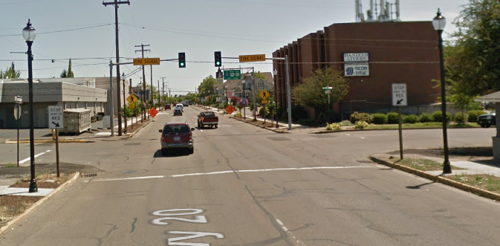

Legal crosswalks shown in red unless officially closed (by the STE) with signing.

Pedestrians wanting to cross have no way to change right-of-way from vehicles to pedestrians.

Green signal indications assign the right-of-way to drivers. Indications only turn red upon emergency vehicle preemption.

The five solutions listed below are acceptable in order of preference (note: all of them require STE operational approval):

1. Removal of the existing fire signal.
2. Removal of the existing fire signal and installation of actuated flashing beacons with sign W11-8. See chapter 12 for design information.
3. Removal of the existing fire signal and installation of fully actuated traffic signal.
4. Change solid green indications of existing fire signal to flashing yellow indications.
5. Retain existing fire signal and officially close the crosswalks that are in conflict with the green indications (because there is no way for the pedestrians to change the green indications which are assigning right-of-way to the vehicle, the crosswalks within the stop bar locations are effectively closed).

The appropriate solution to implement will be based on site-specific factors (e.g., volumes, warrants, etc.) and the scope of the project that is impacting the existing fire signal. Solutions 1 thru 3 meet current standards and should be implemented if possible. Solutions 4 and 5, while acceptable, are not desirable and should only be considered if solutions 1 thru 3 are not feasible.

Two other solutions were considered, but deemed unacceptable for the following reasons:

1. Adding pushbuttons and pedestrian heads to the existing fire signal - this creates a half-signal which is prohibited by the MUTCD.
2. Keeping the crosswalks open that are in conflict with the green indications - this creates a conflict with the appropriate driver response when considering ORS 811.260 (appropriate driver responses to traffic control devices) and ORS 811.028 (failure to stop and remain stopped for pedestrians).

## Fire Signal Located at Mid-Block Access

Fire signals are typically located at a mid-block access used only by emergency vehicles. The following section discusses specific design requirements for mid-block fire signals.

### Operation

The operation of a fire signal located mid-block will remain green on mainline until the emergency vehicle preempts the signal. In the past, flashing yellow was commonly used, but is no longer allowed unless it is documented in the STE operational approval. The preemption can be either a manual input (e.g., pushbutton at the fire station) that is pre-timed or a standard preemption detector unit that will wirelessly provide and hold the input until the emergency vehicle has cleared the access.

The mainline phases are 2 and 6. The preemption phase is phase 4 on channel B. The normal phase rotation and fire preemption operation should be shown on the plan sheet. See Figure 17‑2.

Figure 17‑2 | Phase Rotations for Fire Signal

signal_design_manual_figures

### Controller and Service

A 332S controller cabinet with a base mounted service (BMC) should be used.

### Signal Head Type and Layout

The mainline approach is required to have at least two type 2 signal heads. See Figure 17‑3.

Figure 17‑3 | Signal Head Layout for Mid-Block Fire Signal

signal_design_manual_figures

The default standard is NO signal indications for the emergency access approach. This is because it is important for the emergency vehicle driver to watch traffic, not a signal indication when accessing the mainline. This is especially critical at a fire signal, where the mainline phase is normally green and local drivers don’t expect the signal to change. However, if the fire department requests a form of preemption confirmation on the access approach, a tattletale indicator may be used. See section 17.4.5 for more information.

The tattletale indicator can clearly inform the fire department that the preemption is working (the tattletale will be ON when the mainline indications are red) by a simple, direct hardwire vs. more complex systems that have been used in the past that required additional phases/outputs in a controller cabinet (e.g., a type 2 signal head, a single green circular indication, and flood lights). As such, these more complex systems are no longer allowed. See Figure 17‑4 thru Figure 17‑6.

Figure 17‑4 | Confirmation Indication – NO LONGER ALLOWED

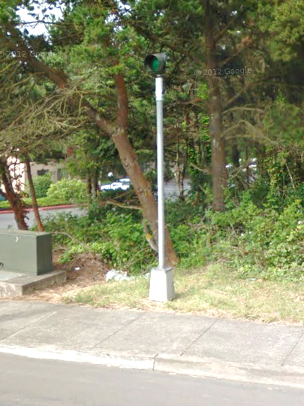

Single circular green indication (mounted on a pedestal) is NOT ALLOWED

Figure 17‑5 | Confirmation Indication – NO LONGER ALLOWED

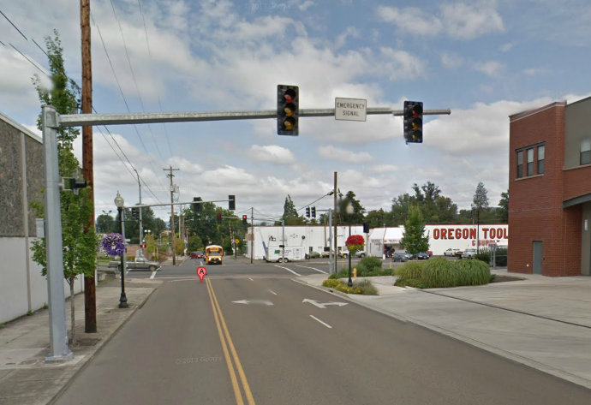

Single circular green indication (mounted on signal pole) is NOT ALLOWED.

Figure 17‑6 | Confirmation Indication – NO LONGER ALLOWED

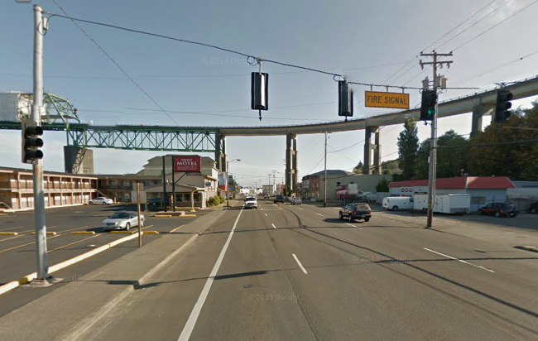

Type 2 signal head is NOT ALLOWED

### Signs

Several specific signs are required for a fire signal. Coordinate with the sign designer for any ground mounted signs.

An emergency vehicle sign (W11-8) with an EMERGENCY SIGNAL AHEAD supplemental plaque (W11-12p) is required to be installed in advance of the fire signal. See Figure 17‑7. A warning beacon may be used to supplement this advance warning sign if deemed necessary by the operational approval.

Figure 17‑7 | Emergency Vehicle Sign (W11-8) with Emergency Signal Ahead Plaque (W11-12p)

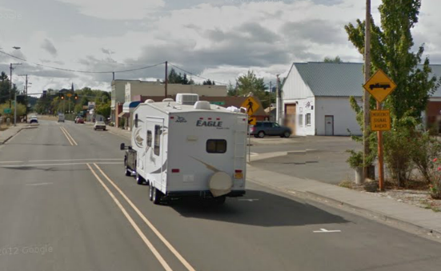

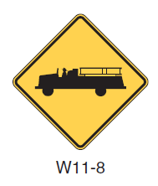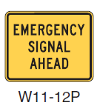

An EMERGENCY SIGNAL sign (R10-13) shall be mounted overhead, typically between the two signal heads. See Figure 17‑8.

Figure 17‑8 | Emergency Signal Sign (R10-13)





A STOP HERE ON RED sign (R10-6) shall be mounted near the stop line. See Figure 17‑9.

Figure 17‑9 | Stop Here on Red Sign (R10-6)

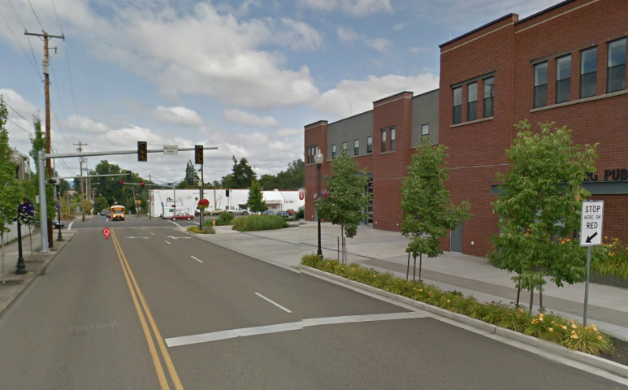

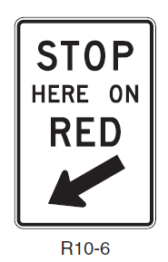

### Tattletale Indicators

Tattletale indicators are typically used at the request of law enforcement to aid in enforcing red light running violations by clearly indicating a red indication is active from certain viewing angles. The tattletale light is directly hardwired to the RED indication. This simple direct hard-wire design also works well for a fire signal confirmation indication. If a confirmation indication is requested, use standard detail DET4400 and coordinate with the fire department to determine the best placement for the tattletale, as it is a directional device.

### Preemption Devices

Two types of preemption can be used:

* Pushbutton located inside the fire station
* Preemption detection devices

Pushbuttons are not as common anymore due to the invention of preemption detection devices and their widespread use. However, this is the only option if the fire department is not using the standard preemption detection devices, or they wish to maintain their legacy preemption system. Coordination with the fire department is critical to determine the proper location and mounting for the pushbutton and the conduit routing to the pushbutton. Multiple pushbuttons may also be needed. See Figure 17‑10.

Figure 17‑10 | Pushbutton Preemption – Placement and Conduit Routing Example



Installation of pushbuttons, conduit and wiring is allowed to be installed off of right-of-way via an intergovernmental agreement (IGA) for this type of preemption. The IGA is with the associated city or county, who then have an agreement with the fire department. Typically, the region electrical crew will maintain the entire installation, including the equipment that is located off right-of-way. Therefore, it is necessary to show the conduit, wire, junction boxes and pushbutton(s) located off right-of-way on the plan sheet.

Preemption detection devices are the most common type of preemption used for new construction. The device should be placed such that emergency vehicle leaving the station will activate it as soon as possible. This will depend on the configuration of the property and the typical path of the emergency vehicle when it uses the access. Multiple devices may be used at different locations to properly hold the preemption input, or a single preemption device may be used in conjunction with a pre-set time if the device would lose the input too soon. Coordinate with the fire department and region signal timer to determine the best preemption operation. See Figure 17‑11 for an example of placement.

Figure 17‑11 | Preemption Detection Device – Placement Example

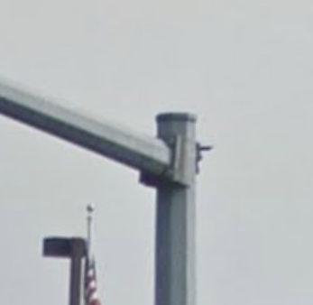

Preemption detection device mounted on pole and aimed back at access

Typical vehicle detection (loops, radar, video, etc.) shall NOT be used as a preemption device. This is due to the fact that when vehicle detection fails, the fire signal will remain preempted until it is fixed. This would cause enormous traffic back-ups and disrespect for the fire signal.

### Detection

Vehicle detection is not needed for a fire signal.

### Pedestrian Accommodation

Pedestrian phases shall not be used for a fire signal.

## Emergency-Vehicle Hybrid Beacon

Emergency-vehicle hybrid beacons shall not be used as an emergency traffic signal.