Chapter 14

Contents

14 Pedestrian Signal Plan 14-1

14.1 General 14-1

14.1.1 Controller and Service 14-3

14.1.2 Striping and Signing 14-3

14.1.3 Detection 14-3

14.1.4 Phasing and Fire Preemption 14-3

14.1.5 Bicycle Design Considerations 14-4

14.2 Half Signals 14-4

# Pedestrian Signal Plan

## General

A pedestrian signal is a very specific type of traffic signal. It is installed mid-block, consisting of type 2 signal heads mounted overhead to control vehicles and pedestrian signals with pushbuttons to control pedestrians. The signal heads remain green until the pushbutton is activated. See Figure 14‑1, Figure 14‑2, and Figure 14‑3 for examples. Design of pedestrian signals (mast arm poles, signal heads, pushbuttons, conduit, junction boxes, wiring, detection, etc.) should follow the applicable parts of chapter 5 and chapter 6.

Pedestrian signals require STE operational approval. See the ODOT Traffic Manual and contact the state traffic operations engineer for more information about completing the engineering study and requesting operational approval for pedestrian signals.

Note that many of the old archived “pedestrian signal” plan sheets in FileNet are actually overhead continuous operation warning beacons with pedestrian crossing signs, not true pedestrian signals.

Figure 14‑1 | Pedestrian Signal Installed Mid-Block, Example 1

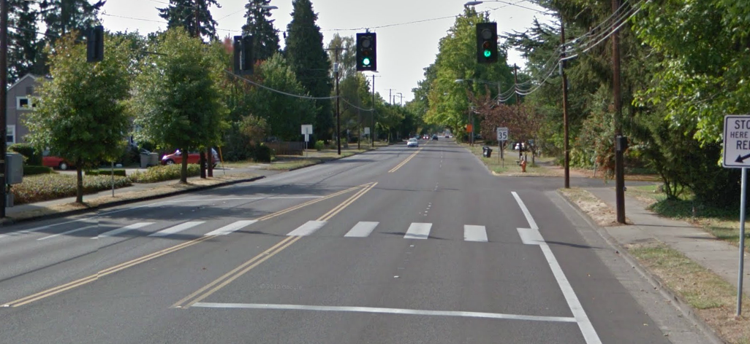

Figure 14‑2 | Pedestrian Signal Installed Mid-Block, Example 2

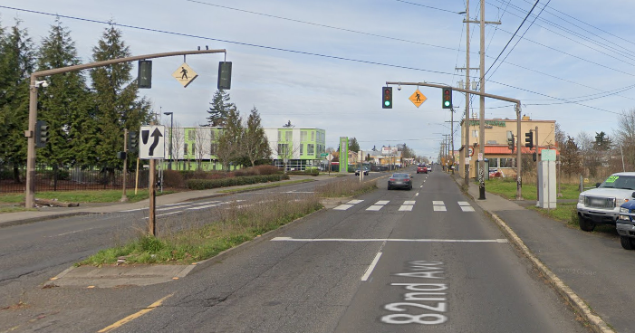

Figure 14‑3 | Pedestrian Signal Installed Mid-Block, Example 3

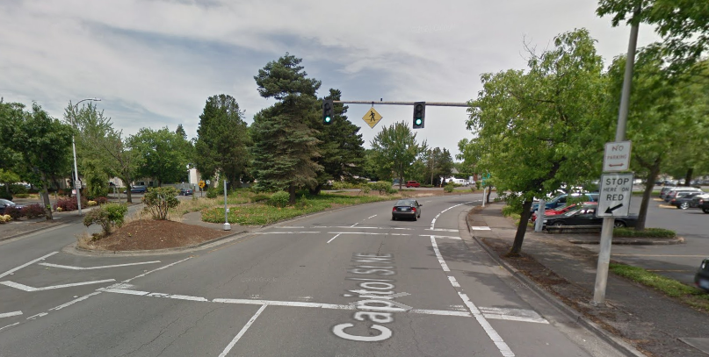

### Controller and Service

Pedestrian signals use a standard base mounted service cabinet (BMC) and 332S signal controller cabinet with an ATC controller.

### Striping and Signing

Pedestrian signals require a marked crosswalk with a stop line installed at least 45 feet in advance.

A minimum of one CROSSWALK STOP ON RED (R10-23) sign per approach shall be mounted between the type 2 signal heads. Note that the pedestrian warning sign (W11-2) used in the past is no longer used for new construction.

A STOP HERE ON RED (R10-6) sign shall be used near the stop line.

### Detection

The operational approval will specify if the pedestrian signal needs to be coordinated with other nearby signals and/or needs advance detection to better protect the dilemma zone. If the pedestrian signal will always be in coordination, detection is not necessary. Other detection functions, such as count detection may also be desirable. See chapter 6 for more info on detection design. Work with region traffic to determine the appropriate detection needs.

### Phasing and Fire Preemption

A ring and barrier diagram on the plan sheet is required, typically with phase 1 as the vehicle phase and phase 2 as the pedestrian phase for a single-stage pedestrian crossing with no raised median. If a two-stage crossing with a raised median is used, phase 5 (for vehicles) and phase 6 (for pedestrians) are added for the second stage. See Figure 14‑4. Fire preemption is also typically installed if the jurisdiction is approved for use of fire preemption.

Figure 14‑4 | Typical Pedestrian Signal Phasing

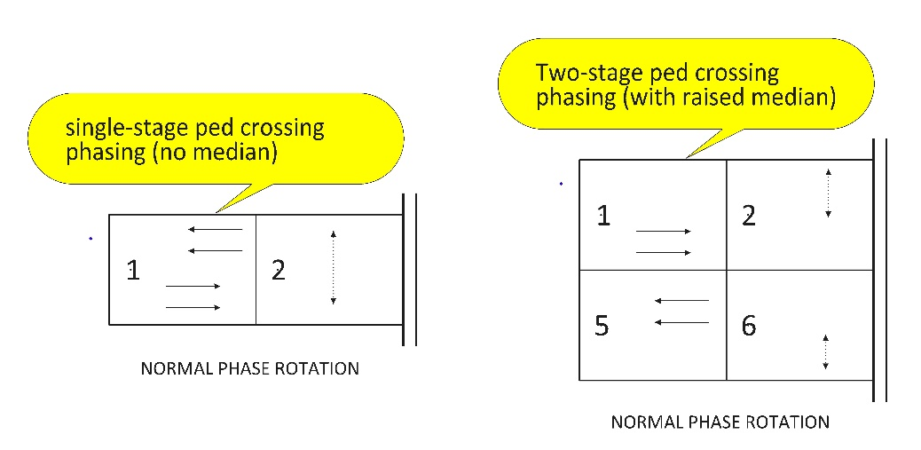

### Bicycle Design Considerations

If the pedestrian signal will be serving higher numbers of people riding bicycles, the operational approval may require a bike phase that operates concurrent to the pedestrian phase. A bike phase can improve the user experience and reduce minimum green times when only a bicyclist is present.

When bicycle phases are used, a type 2B signal head is required. Type 2BM signal heads are optional and used when engineering judgement indicates a need.

Bicycle-specific detection buttons or passive detection zones (with bicycle detection pavement marking) should be used.

## Half Signals

In the past, some pedestrian signals were installed at intersections and are commonly referred to as “half-signals” as the mainline traffic is controlled by signal indications that cycle based on pedestrian actuations while traffic on a full-access side street is controlled by STOP signs. Half-signals are prohibited on the state highway system. See Figure 14‑5 for an example of a half signal.

Figure 14‑5 | Pedestrian Signal Installed at Intersection (Half-Signal), Prohibited

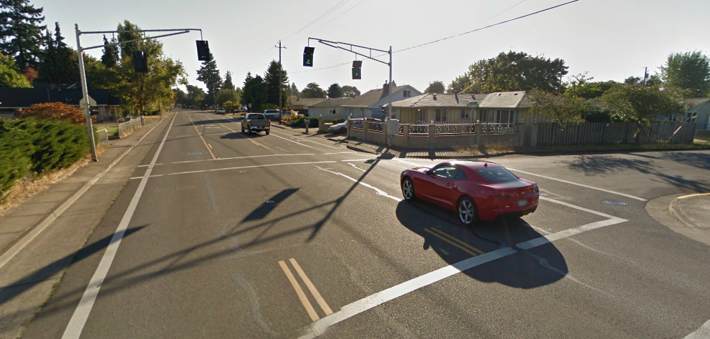

Half-signals are PROHIBITED on the State Highway.

STOP sign on side street