Chapter 4

Contents

[4 Starting the Design 4-1](#_Toc153868023)

[4.1 Scoping 4-1](#_Toc153868024)

[4.1.1 Traffic Signal Asset Management 4-4](#_Toc153868025)

[4.1.2 Statewide Goals, Priority, and Implementation 4-4](#_Toc153868026)

[4.2 Starting the DAP Design 4-7](#_Toc153868027)

[4.3 What Standards Will Be Used? 4-8](#_Toc153868028)

[4.4 Intergovernmental Agreements (IGA) and Jurisdictional Transfers 4-9](#_Toc153868029)

[4.5 Background Information to Gather 4-10](#_Toc153868030)

[4.5.1 As-Built Drawing Archive (FileNet) 4-10](#_Toc153868031)

[4.5.2 Electronic Information 4-10](#_Toc153868032)

[4.5.3 Field Verification 4-11](#_Toc153868033)

[4.6 Background Information from Others 4-12](#_Toc153868034)

[4.6.1 Base Map and Survey Information 4-12](#_Toc153868035)

[4.6.2 Roadway Design 4-13](#_Toc153868036)

[4.6.3 Geotechnical Report 4-13](#_Toc153868037)

[4.6.4 Utility Hook-ups 4-13](#_Toc153868038)

[4.6.5 Rail Crossing Order 4-13](#_Toc153868039)

[4.7 Signal Design Project File 4-14](#_Toc153868040)

# Starting the Design

## Scoping

Scoping is the very first step to forming and funding projects. The formal scoping process involves multiple disciplines working together and requires the signal designer and signal operations staff to provide a detailed assessment of needs, requirements, risks, and cost estimates for all traffic signal work within the defined project limits. A project leader coordinates the scoping effort. Each region has specific processes/forms that should be used.

When scoping traffic signal work, the following guidance should be used:

* Note any operational approvals that will be required
* Verify the condition rating of existing traffic signals (see section 4.1.1)
  + A condition rating of less than 70% should be scoped for complete replacement.
  + A condition rating of 70% or greater may be scoped for modifications in lieu of complete replacement.
* Signal work that requires extensive modification (e.g., moving three out of four poles, replacing/rerouting majority of conduit, etc.) should be scoped for complete replacement regardless of the condition rating.
* Verify existing signals meet current statewide goals (see section 4.1.2)
  + Signals that do not meet current statewide goals and priority improvements should be scoped to include every listed upgrade.
* Review the intersection geometry and note any roadway work that will improve traffic signal operation and safety. For example:
  + Accommodating or designing for truck turning swept path(s)
  + Reducing or eliminating lane shifts through the intersection
  + Consolidating, eliminating, or restricting turn movements of nearby accesses
  + Adding or improving existing pedestrian/bicycle facilities
  + Reducing or eliminating skewed roadway alignments
  + Removing or adding lanes
  + Modifying existing lane use
  + Extending turn lane storage distance
  + Modifying stop bar/crosswalk location (i.e., curb ramp location)

See chapter 5 for more details. Identifying and addressing non-ideal roadway geometry issues whenever feasible is preferred vs. using traffic control devices to mitigate the issue.

* Verify curb ramps, pushbuttons, and pedestrian signal heads meet current ADA requirements (see section 5.4, [Engineering For Accessibility website](https://www.oregon.gov/odot/Engineering/Pages/Accessibility.aspx) and [Accessibility at ODOT website](https://www.oregon.gov/odot/About/Pages/ADA.aspx)). This also includes verifying CQCR requests (a typical request is for audible pedestrian signals) and incorporating the goals and features outlined in ODOT policy to meet the ADA transition plan for ODOT. Contact the state traffic signal engineer for any questions, as issues and solutions are often site specific.
  + Signal equipment that does not meet current ADA requirements should be scoped to include upgrading all necessary features. Note: this can often trigger other work that may result in the need for a complete signal replacement.

Scoping for projects usually takes place several years before the DAP design work begins. As such, it is important to clearly document the design features, assumptions, and judgement used in the scoping notes to ensure they are useful for future reference. It is highly recommended to provide a basic sketch of the proposed design(s) or to clarify assumptions used (in addition to text only descriptions that are provided in the scoping notes). Sketches may not be necessary for all scoping projects, but they can help other disciplines better visualize how the traffic signal equipment impacts their features, improve the accuracy of the cost estimate, and convey design information more efficiently than text only. See Figure 4‑1 and Figure 4‑2.

Figure 4‑1 | Scoping Sketch Example 1

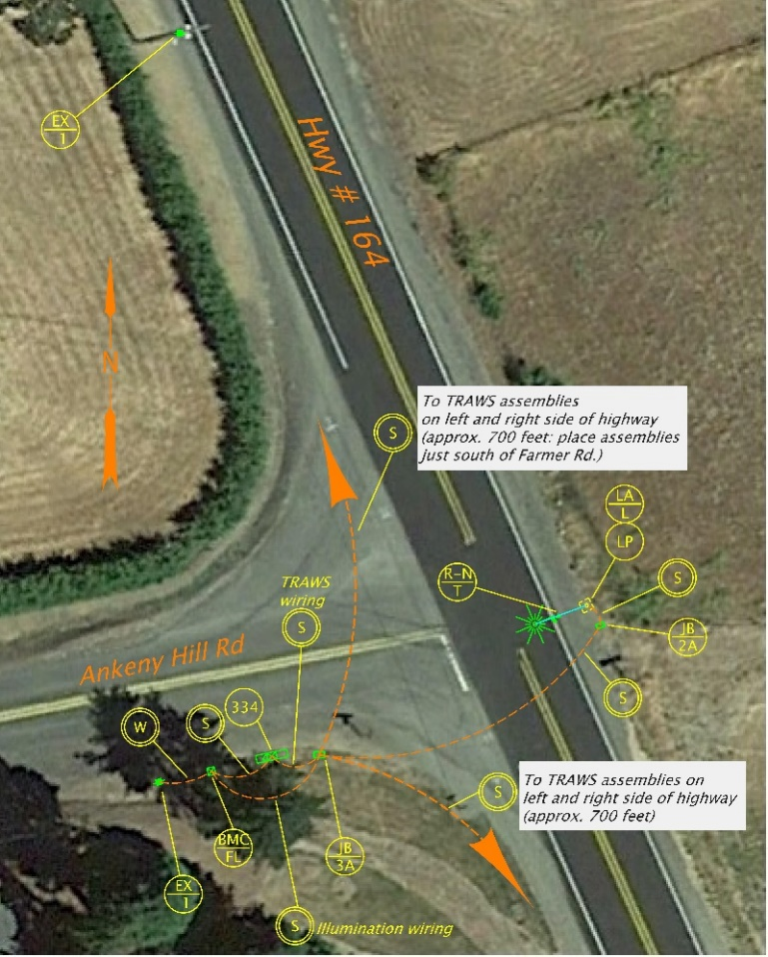

Basic placement of traffic features helps other disciplines determine impacts and facilitate discussion (e.g. is right-of-way is needed? Does this effect drainage? Is there another location this pole can be placed, etc.?)

Figure 4‑2 | Scoping Sketch Example 2



Decision that one pedestal per corner (rather than 2) should be used is clearly documented for future reference

### Traffic Signal Asset Management

The traffic standards crew produced the first traffic signal condition report in 2017. This report is updated every year in September. It contains a condition rating for every ODOT owned or maintained traffic signal expressed as a percentage (from 0% to 100%) with three classification categories:

* Fair or better (70% +)
* Poor (50-69%)
* Very poor (49%)

You can find the traffic signal condition reports on the ODOT [Traffic Signal website](https://www.oregon.gov/ODOT/Engineering/Pages/Signals.aspx). The ODOT TransGIS also has the condition rating of each signal under the “Equipment-Highway” category, then “signals” layer.

The roadway crew maintains the ADA ramp and pushbutton conditions which can be found on the ODOT TransGIS under the “roadside” category, then “ADA ramps” and “ADA pushbuttons” layer.

### Statewide Goals, Priority, and Implementation

Planning traffic signal upgrades and replacement requires consideration of many factors, such as crash data, operational data, annual maintenance costs, planning documents, etc. Completing all of the recommended upgrades listed in Table 4‑3, Table 4‑4, and Table 4‑5 below in one project is desirable, but may not be possible due to limited scope or funding. Therefore, each upgrade has been prioritized (high, medium and low), given associated design impacts, and reasons to implement goal to help assist in decision making. The region traffic engineer/manager should determine how the priorities are implemented and secure funding as necessary.

Table 4‑3 | Statewide Goals High Priority

|  |  |  |  |  |
| --- | --- | --- | --- | --- |
| **Statewide Goals** | | | **Potential Design Impacts** | **Reason for Goal** |
| High Priority | 1 | Change existing controller cabinet with a PDA1 to a 332S cabinet | May require a signal rebuild to properly address all impacted features | Safety: PDA1 is fire hazard |
| 2 | Change existing controller (170, 2070, etc.) to an ATC controller | N/A | Safety and operations: 170 and 2070 controller software is unsupported and unmaintainable |
| 3 | Change existing “words” or non-countdown pedestrian signals to countdown LED modules | Likely to require a signal rebuild to address ADA issues | Safety: FHWA Crash Reduction Countermeasure |
| 4 | Replace existing loop detection with non-invasive detection (radar or video) | May require a signal rebuild to address conduit issues | Safety and operations: See chapter 6 & FHWA Every Day Counts 4 Initiative (ATSPM) |
| 5 | Replace existing copper interconnect with fiber optic and install network communication | May require a signal rebuild to address conduit issues | Safety and operations: FHWA Every Day Counts 4 Initiative (ATSPM) |
| 6 | When required, install type 7 signal heads at railroad interconnected signals | May require a signal rebuild to address structural issues | Safety: Clears the RxR tracks faster during a preemption |
| 7 | Change existing 8” lens vehicle signals to 12” lens | May require a signal rebuild to address structural issues | Safety: FHWA Crash Reduction Countermeasure |
| 8 | Add backplates or change existing backplates to reflectorized backplates for the vehicle signals | May require a signal rebuild to address structural issues | Safety: FHWA Crash Reduction Countermeasure |

Table 4‑4 | Statewide Goals Medium Priority

|  |  |  |  |  |
| --- | --- | --- | --- | --- |
| **Statewide Goals** | | | **Potential Design Impacts** | **Reason for Goal** |
| Medium Priority | 9 | Change existing ¼” pushbuttons and H-frame to standard mounts & buttons | Likely to require a signal rebuild to address ADA issues | Accessibility and uniformity |
| 10 | Change existing controller cabinet (336, 336S, 337) to a 332S cabinet | May require a signal rebuild to properly address all impacted features | Operations, uniformity, and lower maintenance costs (less labor, less materials) |
| 11 | Condition rating of signal is 70% or greater | May require a signal rebuild depending on deficiencies | Lower maintenance costs (less labor, less materials) |

Table 4‑5 | Statewide Goals Low Priority

|  |  |  |  |  |
| --- | --- | --- | --- | --- |
| **Statewide Goals** | | | **Potential Design Impacts** | **Reason for Goal** |
| Low Priority | 12 | Replace 4 bolt base vehicle signal poles (mast arm and strain poles) with 8 bolt mast arm poles. Note: strain poles no longer an option for permanent traffic signals due to new 75’ mast arm length. | Likely to require a signal rebuild to address all poles at an intersection | Lower maintenance costs (less labor, less materials) |
| 13 | Change existing power service (RPS & service/meter base mounted to poles, etc.) to BMC/BMCL service | May require a signal rebuild to properly address all impacted features | Lower maintenance costs (less labor, less materials) |
| 14 | Install battery back-up at railroad interconnected traffic signals with a history of frequent & relatively short duration power outages (see Chapter 5) | May require a new controller cabinet, which then may require a signal rebuild to address all impacted features | Safety: allows preemption sequence to occur during a power outage (note: power outages of this type are historically a very low risk). |

## Starting the DAP Design

Before starting the design, follow the simple check-list below. Design work should not begin until every item on the check list is complete. Starting a design with incomplete check-list items usually results in wasted time through unnecessary rework.

* Operational approval is complete (see chapter 3),
* Standards applied to the project are known (see section 4.3), and
* Applicable background information has been compiled (see sections 4.5 and 4.6)

The signal designer should also take a few moments to plan out what design work will be required:

* Will there be any unique details that are not covered in the standard drawings? The most current standard drawings (updated every 6 months in January and July) should be reviewed for any changes that may affect the design. If unique details are anticipated, these details will need to be included in plan set. See chapter 9 and chapter 18 for more information.
* Will any existing signal equipment need to be removed? If equipment will be permanently removed, where will ODOT want that equipment stockpiled? Check with the region electrical crew.
* Will a temporary signal be needed for any stage of construction? Existing signals need to remain in service until the re-built signal is turned on and certain lane use configurations should not be open to traffic unless they have proper signalized control (e.g. dual turn lanes). Check with the roadway designer and workzone traffic control designer. See chapter 11 for more information.

## What Standards Will Be Used?

This question MUST be answered before starting the design and specifications. Failure to determine which standards will be used could result in complete failure of the project. In extreme cases, plans and specification will not be approved for construction and the entire project might be terminated. Every traffic signal within the state of Oregon, regardless of jurisdiction, is required to meet the minimum standards as stated in current, adopted editions of the Manual on Uniform Traffic Control Devices (MUTCD), the Oregon Supplement to the MUTCD, and the National Electric Code. There are levels of standards that apply to signal design:

* **Full ODOT design standards and specifications:** This is required if ODOT owns and maintains the traffic signal. Full ODOT standards are contained in the ODOT Traffic Signal Design Manual and the ODOT Traffic Signal Policy and Guidelines.
* **Partial ODOT design standards and specifications:** This is allowed if a local agency maintains an ODOT owned traffic signal. This also applies to local agency owned traffic signals maintained by ODOT. The portions of the design and specifications that are not full ODOT standard are negotiated in the intergovernmental agreement (IGA) or directly with the traffic engineering section during the design approval process. Generally the variance to ODOT standards is minor (e.g., the use of interior illuminated lane use signs).
* **Full local agency design standards and specifications:** This standard only applies to local agency owned and maintained traffic signals. As stated above, if the local agency will maintain an ODOT owned traffic signal then some of the local agency standards might be allowed through negotiation.

## Intergovernmental Agreements (IGA) and Jurisdictional Transfers

An intergovernmental agreement (IGA) is a legally binding document that defines the obligations of each party involved in a project. An IGA is typically needed for a state highway intersection with a local county road or city street. Depending on the scope and nature of the project there could be a lot of responsibilities to define, some of which have a direct impact on the design of traffic signal, for example; maintenance responsibility (what design standards should be used), signal timing responsibility (what type of controller and type of detection should be used), and aesthetics (what decorative treatments are to be used).

Jurisdictional transfers allow agencies to legally redefine who has ownership of the roadway (typically changing from ODOT owned to local agency owned). They are rare, but if one is being considered on the project, it is imperative that jurisdictional transfer agreement is complete and final prior to any design work. The fundamental question of what design standard should be used cannot be answered until then.

Unfortunately, the IGA or the jurisdictional transfer is sometimes processed simultaneously with the design the traffic signal. If this is the case, the signal should be designed using the standards that currently apply, not the standards that are anticipated as past history has shown IGAs and especially jurisdictional transfers often do not go forward as expected given the many negotiated factors and political nature. Also, the design approval process becomes more complicated due to the uncertainty of the standards that should be applied.

Designing a signal according to anticipated standards is risky. This will result in wasted time and effort should the IGA or jurisdictional transfer fall through.

## Background Information to Gather

### As-Built Drawing Archive (FileNet)

As-built PDF plan sheets should be downloaded from FileNet at the [signal standards website](http://www.oregon.gov/ODOT/Engineering/Pages/Signals.aspx) under “Drawing Archive”. There is a “Getting Started Guide” for help in using FileNet.

When searching for drawings, it best to search with the ODOT highway number. Note that ODOT uses a unique numbering system for all the highways; use the [cross-reference guide](http://www.oregon.gov/ODOT/Data/Documents/Routes-to-Highway-Cross-Reference-Table.pdf) to find the ODOT highway number. Also, leave the search as generic as possible. This is because many of the more specific fields are not consistently populated. Searching these specific fields may result in missing certain drawings.

If you need the dgn file(s) of a particular project, they can usually be found either in projectwise (for newer projects) or in the [ODOT engineering archive](file:///\\scdata\ENG_ARC). You will need the key number of the project to be able to search in projectwise and the ODOT engineering archive, which is located in lower left corner of the plan sheet outside the border. See Figure 4‑6. Note that archived dgn files are not directly available to staff outside of ODOT. If you are unable to find archived dgn files, contact the EOR or designer of the project for assistance.

Figure 4‑6 | Key Number of Project

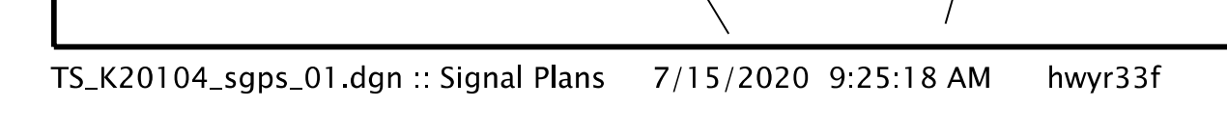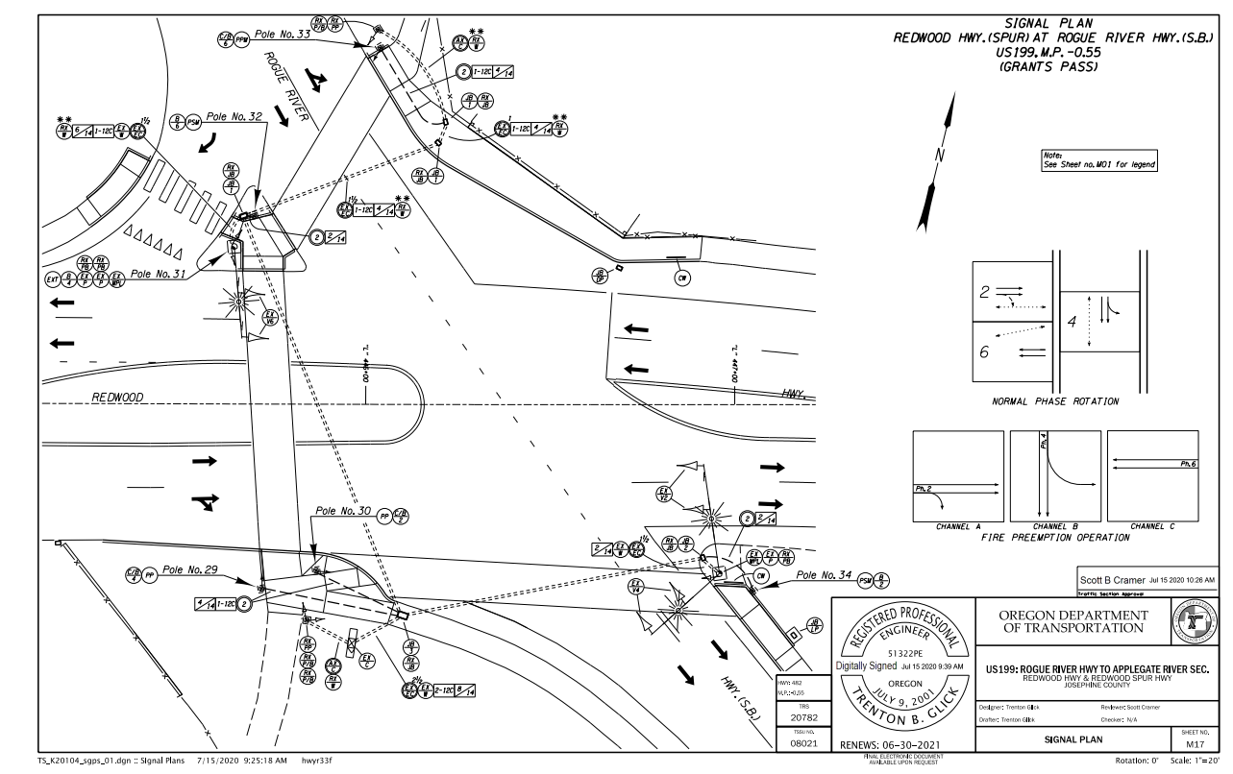

File name should contain 5-digit project key number

### Electronic Information

Prior to the field verification discussed in section 4.5.3 below, it is good to get familiar with the project area using the available electronic sources of information: [ODOT digital video log](https://dvlprod-ordot.msappproxy.net/cf/dvl/) and google/bing maps. This can help the signal designer zero in on issues/questions to address during the field verification, resulting in an efficient use of time when on-site. Note that ODOT uses a unique numbering system for all the highways; use the [cross-reference guide](http://www.oregon.gov/ODOT/Data/Documents/Routes-to-Highway-Cross-Reference-Table.pdf) to find the ODOT highway number.

### IMG_2550Field Verification

Field verification is the one of the most important steps in the process of traffic signal design and should not be skipped. Thousands or tens of thousands of dollars can be saved during construction by simply making a field visit during the design phase and verifying the existing conditions. Being on-site is more valuable than just looking at photos or a base map because photos and drawings only provide limited perspective and can be incomplete.

When conducting the field visit, bring a camera and take a lot of photos. Photos will be helpful throughout the design and construction support phase the project. If in doubt, take a photo; something that seems insignificant now may prove to be extremely useful in the future. Photos can save an additional trip in the field to re-verify or might be useful in resolving a construction claim. Some tips for taking photos:

* Take photos of the same area from different perspectives
* Get specific, micro detail photos – inside of junction boxes (conduits and wire), inside the controller cabinet (front and back), existing signal equipment and attachments
* Get “bigger picture” photos – each approach (approximately 500’ feet back from the intersection), each quadrant of the intersection, slopes, and utility locations

Measurements are also helpful, especially if the project has limited or no survey information:

* Existing conduit sizes and number of wires (critical if attempting to re-use them or add additional wire)
* Pushbutton and pedestrian head mounting heights (if the project will be adjusting or adding ADA ramps)
* Sight distance measurements

Other useful information to gather in the field includes:

* Posted speed in the vicinity
* Location and nature of any accesses/streets that are close by
* Potential locations for all of the signal hardware (poles, pedestals, & cabinets)
* Power source location (typically nearest transformer)
* The driver’s perspective – drive each approach, note any sight distance issues (e.g., vegetation that may block sight distance when leaves return).
* Information on the signal pole tag

A field visit is ALWAYS cost effective and well worth the effort. At least one field visit should be done during the design phase.

## Background Information from Others

### Base Map and Survey Information

Survey data is needed on most projects. To determine the amount and type of survey needed, the scope of the design must be defined. Below are a few examples:

* **Rebuild of detection system** – Typically as-built plans and field visit are all that is needed. If utilities appear to be an issue a simple survey is needed.
* **Installation of pedestals, controller cabinets, service cabinets** – A simple survey is needed
* **Installation of SM poles** – Full survey is needed with geotechnical report

Figure 4‑7 below shows the recommended minimums for a survey within the intersection area. If the intersection has not yet been surveyed or additional information is required, this figure will help guide you in getting the necessary data.

Figure 4‑7 | Survey Area For Traffic Signal

signal_design_manual_figures

Data to collect within the survey area shown in Figure 4‑7:

* Underground utilities in the 16’ wide survey areas around the radii (pole foundation conflicts)
* Underground utilities less than 3’ deep in the 3’ wide survey areas beyond edge of pavement or back of walk (conduit and junction box conflicts)
* Above ground utilities and wire attachment heights in 16’ wide survey areas around the radii (mast arm and span wire conflicts)
* Power poles/cabinets with transformers (potential power source). Note: this may be located outside of survey area
* All striping within survey area: lane lines, centerline, fog lines, crosswalks, stop bars, and legends
* Any existing signal features within survey area: controller cabinet, poles, junction boxes, loops, etc.

### Roadway Design

If the project is rebuilding the roadway, then there will be a roadway design base map. The signal designer must communicate with the roadway designer throughout the entire design phase. The roadway designer’s final product is the base for the traffic signal design. Good communication will help ensure the most current roadway design base map is always used for the traffic signal design.

### Geotechnical Report

If new SM poles are proposed, then a geotechnical report is required to determine the foundation depths. Standard loading, not actual loading, is shown in the TM600 series standard drawings. The geotechnical report in conjunction with the standard drawings are used by the bridge designer to determine the foundation depth. The foundation depth with a reference to the geotechnical report is shown on pole entrance chart. See chapter 9 for more information.

As soon as the pole locations are defined, contact the region geo/hydro manager for a foundation investigation of the proposed site.

### Utility Hook-ups

New signals require a connection to commercial power and may require other connections (e.g. telephone). The project may also involve moving existing utilities. The signal designer must coordinate with the region utility specialist when connecting to a power source (or any other utilities) as early as possible in the design process.

### Rail Crossing Order

If a rail crossing order is required for an intersection, it will be processed simultaneously with the design the traffic signal. The final rail crossing order will be issued prior to letting the project. The signal designer will provide a sealed railroad preemption plan sheet early in the design phase (DAP) for inclusion into the rail crossing order. See chapter 16 for more detailed information.

## Signal Design Project File

A project file for the signal designer’s personal use should be created and maintained for the project in ProjectWise. It should contain all the supporting documentation, calculations and major decisions related to the traffic signal design and construction. The items listed below, if applicable, are typically included in the signals file:

* Project narratives
* Operational approval letters
* Photometric data for illumination
* Calculations for:
  + Wire size
  + Wire fill
  + J-Box size
  + Wire count
  + “AH” for strain poles
* Cost estimates (itemized breakdown for each bid item, total bid item cost, and anticipated item cost)
* E-mails and memos concerning design decisions
* Photos
* Field verification information
* Geotechnical report
* Rail crossing order
* Pole submittals and shop drawings
* Manufacturer’s cut sheet or submittals
* Correspondence between project managers, consultants or contractors
* Existing as-builts

Other documentation related to signals, such as special provision boiler plates, review comments and their resolution, etc. will be also created and maintained in ProjectWise, but will not be stored in the signals file. They will be stored in the appropriate folders as designated by the ProjectWise standards.

Good record keeping can save time and effort when issues/questions arise during the design, construction, or even maintenance phase.