Chapter 3

Contents

[3 Signal Operations and Operational Approval 3-1](#_Toc153867915)

[3.1 Operational Approval 3-1](#_Toc153867916)

[3.2 Number of Lanes and Lane Use 3-2](#_Toc153867917)

[3.3 Normal Phase Rotation 3-3](#_Toc153867918)

[3.3.1 Ring and Barrier Diagram 3-4](#_Toc153867919)

[3.3.2 Flashing Yellow Left Turn Arrow 3-6](#_Toc153867920)

[3.3.3 Flashing Yellow Left Turn Arrow with Negative Ped 3-6](#_Toc153867922)

[3.3.4 Vehicle Overlap Phases 3-7](#_Toc153867923)

[3.3.5 Negative Ped Overlap Phases 3-8](#_Toc153867924)

[3.3.6 Pedestrian Overlap Phases 3-9](#_Toc153867925)

[3.3.7 Split Phases/Exclusive Phases 3-10](#_Toc153867926)

[3.3.8 Incompatible Left Turn Phases 3-12](#_Toc153867927)

[3.3.9 Multiple Intersections using a Single Controller 3-13](#_Toc153867928)

[3.3.10 Dummy Phases 3-16](#_Toc153867929)

[3.3.11 Overlap Phase with Green Extension Clear-Out 3-17](#_Toc153867930)

[3.3.12 Unconventional Phases & Sequences 3-19](#_Toc153867931)

[3.4 Emergency Preemption 3-20](#_Toc153867932)

[3.5 Railroad Preemption 3-21](#_Toc153867933)

[3.6 Transit Priority 3-22](#_Toc153867934)

[3.7 Crosswalk Closures 3-23](#_Toc153867935)

[3.8 Traffic Signal Communications 3-23](#_Toc153867936)

[3.9 Other Unique Requirements 3-23](#_Toc153867937)

[3.10 Example of Operational Approval 3-23](#_Toc153867938)

# Signal Operations and Operational Approval

## Operational Approval

Traffic signal operational approvals come in two forms:

* State traffic engineer (STE)
* Region traffic engineer (RTE)

The STE can approve any operation on state highways. The STE has delegated some authority to the RTE. For more information on what design features require STE or RTE approval, see the ODOT Traffic Manual. The ODOT Traffic Manual also contains valuable information on many ODOT traffic policies, including the process for obtaining the necessary traffic signal operational approvals. The ODOT Traffic Signal Policy and Guidelines also contains information on signal operations and approvals. These two documents can be viewed online at the [engineering manuals website](https://www.oregon.gov/odot/Engineering/Pages/Manuals.aspx?wp7138=l:100).

Region traffic is responsible for processing any necessary signal operational approvals:

* All RTE approvals are completed by region traffic
* All requests for STE approval are submitted by region traffic to the STE for completion.

The signal designer is responsible for obtaining a copy of the operational approval and designing the signal according to the requirements as stated within. Contact either the region traffic section or the traffic engineering section to obtain a copy of the operational approval. STE operational approvals, both final signed approvals and current requests in the queue, can also be accessed from the [traffic approvals website](https://ordot.sharepoint.com/sites/TrafficRoadway/SitePages/Traffic-Approvals.aspx).

**The signal designer needs the operational approval(s) before design work is started.** Operational approvals generally come in the form of a letter which will outline specific constraints and parameters to be used in the design of the traffic signal. They are typically accompanied by an engineering study and the preliminary signal operations design (PSOD) form. This form provide a quick glance summary of the operational requirements, which is useful during the design process. The full engineering study is available upon request if more in-depth information regarding the operational requirements is desired. See section 3.10 for examples of operational approvals.

NOTE: The operational approval is **not** the design approval of the plans. See chapter 2 for information on design approval.

The operational approval letter and/or PSOD form contains the following information, as applicable to the project:

* Specific location (highway, milepoint, county)
* Number of lanes & lane use for each approach
* Normal phase rotation
* Crosswalk closures
* Opening of existing closed crosswalks
* Traffic signal communications (Interconnect)
* Emergency preemption
* Railroad preemption
* Transit priority
* Other unique requirements (e.g. the signal at 1st and Main must be removed before the construction of a new signal at 2nd and Main)

It is critical that the signal design, roadway geometry, signing, and striping at the intersection match the requirements shown in the operational approval. Any discrepancies between the design plans and the operational approval must be resolved by either a revision to the operational approval or by modifying the design plans.

NOTE: Failure to have an operational approval or failure to have a signal plan that matches the operational approval is a fatal flaw and will result in major delays to the project.

## Number of Lanes and Lane Use

The number of lanes and lane use needed for each approach of the intersection will be detailed in the engineering study and shown in the PSOD form that accompanies the STE or RTE operational approval letter. Depending on the type of project, projected traffic volumes, and phasing requirements, there are a couple of options:

* No change to the existing number of lanes,
* No change to the existing number of lanes, but a change to the existing lane use,
* Increase in the existing number of lanes; or
* Decrease in the existing number of lanes.

If changes to the number of lanes are necessary on the project, it is important to be in communication with the roadway designer early in the design process as the roadway design is the foundation of the signal design. Also, communication with the striping designer and the sign designer will be important.

If changes to existing lane use (but not to the existing number of lanes) are necessary on the project, it is important to be in communication with the striping designer and the sign designer early in the design process as these types of changes usually necessitate the need for a striping plan and a signing plan.

## Normal Phase Rotation

A basic understanding of traffic operations and phasing is required to design a traffic signal. For more detailed information, consult the following resources:

* State traffic operations engineer
* Region traffic operations engineer
* ODOT Traffic Signal Policy and Guidelines

The phasing of the traffic signal is shown on the signal plans. Figure 3‑1 shows the standard 8-phase signal configuration used on the state highways and Figure 3‑2 shows the corresponding ring & barrier diagram. The standard 8-phase signal configurations have the following characteristics:

* Protected left turns are odd numbered phases (ø1, ø3, ø5, and ø7).
* Through movements and permissive right (or left turns) are even phases (ø2, ø4, ø6, and ø8). Phase 6 is mainline northbound (or westbound).
* Pedestrian phases are even phases corresponding to the compatible through phase (ped 2, ped 4, ped 6, and ped 8).
* The mainline through phases are 2 and 6, with left turn phases 1 and 5. The sum of the phases for each mainline approach equals 7 (2+5=7, and 1+6=7).
* The side street through phases are 4 and 8, with left turn phases 3 and 7. The sum of the phases for each side street approach equals 11 (4+7=11, and 3+8=11).

Figure 3‑1 | Standard 8-Phase Signal Configuration

signal_design_manual_figures

### Ring and Barrier Diagram

Modern U.S. practice for signal control organizes phases by grouping them in what is called a ring and separating the crossing or conflicting traffic streams with time between when they are allowed to operate, either by making the movements sequential or adding a barrier between the movements.

A ring consists of two or more sequentially timed and individually selected conflicting phases arranged so as to occur in an established order. In ring A of the normal phase rotation diagram shown in Figure 3‑2, phase 1 must terminate prior to phase 2, which must terminate prior to phase 3, which must terminate prior to phase 4, which must terminate prior to returning to phase 1. The majority of traffic signals use two rings.

Barriers assure there will be no concurrent selection and timing of conflicting phases for traffic movement in different rings. Both ring A and ring B cross the barriers simultaneously to select and time phases on the other side. These barriers separate the mainline phases (ø1, ø5, ø2, and ø6) from the side street phases (ø3, ø7, ø4, and ø8). In this example, phase 2 and 6 must terminate at the same time before the next phases (ø3 and ø7) can be serviced. Similarly, phase 4 and phase 8 must terminate at the same time before the next phases (ø1 and ø5) can be serviced. There is no barrier between phases 1 & 5 and 2 & 6; therefore, phase 1 and 5 do not have to terminate at the same time. If phase 1 terminates prior to phase 5, the next phase in ring A may be serviced (phase 2), resulting in phase 2 and 5 being serviced together. Using this same logic, compatible phases can be determined. For example: phase 1 may operate concurrently with phase 5 and phase 6 (but not with phase 2 which is in the same ring as phase 1, and not with any phases located beyond the barrier: 3, 4, 7 & 8), phase 2 may operate concurrently with phase 5 and phase 6 (but not with phase 1, 3, 4, 7, & 8), phase 8 may operate concurrently with phase 3 and phase 4 (but not with phase 7, 1, 2, 5, & 6).

Figure 3‑2 | Standard 8-Phase Ring and Barrier Diagram

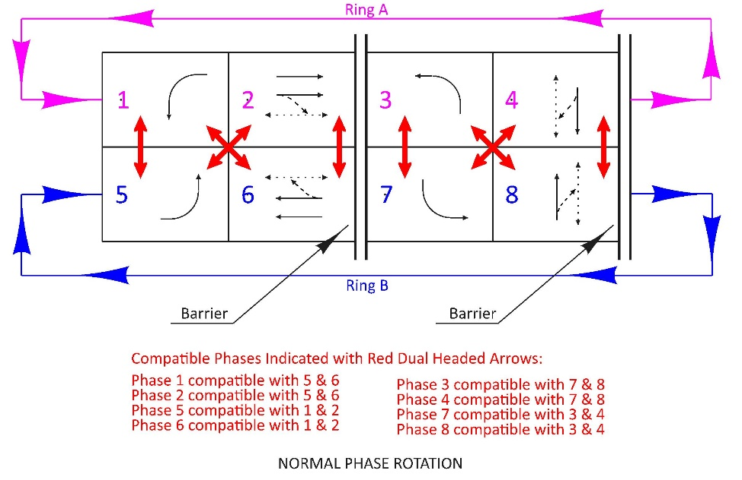

When reading a ring and barrier diagram, vehicular movements drawn with solid lines do not have any conflicting movements associated with them. In Figure 3‑2 that would be phases 1, 3, 5, 7, and thru movements for phase 2, 4, 6, 8. Vehicular movements drawn with large dashed lines have conflicting movements associated with them that require the motorist to yield during a green indication (permissive movement). In Figure 3‑2 that would be the right turn movement for phases 2, 4, 6, and 8 (the conflicting movement that the right turn must yield to is the associated pedestrian phase). Pedestrian movements are drawn with small dashed lines with dual arrow heads, because pedestrians can move either direction in a crosswalk. Barriers are indicated by dual vertical lines.

Depending on the operational requirements of the traffic signal, there can be many variations to the phasing and signal timing, and some of these variations might change by time-of-day or day-of-week. It is important to obtain the current STE or RTE approval and to work with the region signal operations engineer regarding proper phasing. If the project has a signal that will have multiple signal timing configurations based on time-of-day/day of week, only the ring and barrier diagram that will be used the majority of the time is shown on the plan sheet (multiple normal phase rotation diagrams are NOT shown on the plan sheet).

NOTE: The main purpose of the ring and barrier diagram is to clearly show which movements are compatible and which movements require conflict monitoring. This diagram is critical for developing proper signal timing and the proper conflict monitor configuration. See chapter 20 for conflict monitoring information.

### Flashing Yellow Left Turn Arrow

The flashing yellow arrow display is the current standard for protected/permissive left turn movements. The permissive phase is shown in the opposing through phase box and labeled “FY”. See Figure 3‑3.

Figure 3‑3 | Ring and Barrier Diagrams: Flashing Yellow Left Turn Arrow

Flashing yellow arrow shown and labeled in opposing through phase box

### Flashing Yellow Left Turn Arrow with Negative Ped

Flashing yellow arrow with negative ped refers to timing that restricts the permissive left turn (flashing yellow arrow) from being served if the pedestrian phase crossing the lane used by the permissive left turn is active (active ped phases options include: 1.) The walk indication only, 2.) The walk indication and a portion of the flashing don’t walk indication, or 3.) The walk indication and the entire flashing don’t walk indication). For example, if pedestrian phase 2 is displaying the walk indication (or flashing don’t walk indication), the phase 1 left turn indication will display a solid red arrow.

The flashing yellow arrow negative ped timing feature is NOT shown in the ring and barrier diagram as it is not a conflict that results in inappropriate signal operations if the flashing yellow arrow and pedestrian phase are served together (MUTCD section 4D.17 paragraph 04 allows a permissive left turn phase and the pedestrian phase crossing the lane used by the permissive left turn to be active at the same time). See Section 3.3.2 for how to show the ring and barrier diagram.

### Vehicle Overlap Phases

Overlap phases are typically associated with right turns and become beneficial when right turn traffic volumes are high. They may also be used in other circumstances to address unique intersection geometry or improve signal timing efficiency.

An overlap phase is assigned to “parent phases” such that whenever the parent phase is green, the overlap phase is also green. As shown in Figure 3‑4 below, the parent phases for a right turn overlap are the adjacent thru phase (side street thru phase 8) and the non-conflicting left turn phase (mainline left turn phase 1). The overlap phase is shown in each parent phase box and labeled with the appropriate letter (A, B, C, D, etc.). Below the ring and barrier diagram in text, the overlap parent phases are listed.

Figure 3‑4 | Ring and Barrier Diagrams: Overlap Phases

OLA is shown with each parent phase (phase 1 and phase 8) and labeled "A"

OLA parent phases are defined in text below the ring & barrier diagram

### Negative Ped Overlap Phases

Another common overlap phase is called a negative ped overlap. This is used with a right turn overlap when there is a conflicting pedestrian phase (the pedestrian phase located to the right of the right turn lane). A negative ped overlap phase will restrict the right turn green arrow from being served when the conflicting pedestrian phase is active (walk indication and flashing don’t walk indication).

Negative ped overlaps are shown by separating out the two possible conditions in the ring and barrier diagram. Below the ring and barrier diagram in text, the negative ped overlap phase is defined. See Figure 3‑5.

**Note: A negative ped overlap phases is NOT the same as a negative ped used with flashing yellow arrow. See Section 3.3.3 for information about flashing yellow arrow with negative ped.**

Figure 3‑5 | Ring and Barrier Diagrams: Negative Ped Overlap Phases

Negative ped overlap is defined with a parent phase and a “-“ ped phase.

Ped ph. 8 is served first if there is demand, then OLA (right turn) is served next.

### Pedestrian Overlap Phases

Pedestrian overlap phases are typically used when the geometry of the intersection allows the pedestrian crossing to be served by 2 (or more) phases, which can decrease the amount of wait-time for the pedestrian.

The pedestrian overlap phase is assigned to “parent phases” such that whenever the parent phase is green the overlap pedestrian phase is also active (when the pushbutton has been activated). As shown in Figure 3‑6 below, the parent phases for a pedestrian overlap that crosses a signalized right turn lane are the non-conflicting mainline left turn phase (phase 1) and the non-conflicting side street thru phase (phase 4).

The pedestrian overlap is shown in each parent phase box and labeled with the appropriate letter (Ped A, Ped B, Ped C, Ped D, etc.). Below the ring and barrier diagram in text, the pedestrian overlap parent phases are listed. See Figure 3‑6.

Figure 3‑6 | Ring and Barrier Diagrams: Pedestrian Overlap Phases



### Split Phases/Exclusive Phases

Split phasing describes an operation where all movements on one approach are served prior to all movements on the opposing approach. This is typically used if the geometry of the intersection, traffic volumes and/or crash history creates a conflict with normally non-conflicting movements. Split phasing requires STE operational approval. Use of split phasing requires specific signal indications depending on the lane use. See chapter 5 for signal head layout examples.

Split phases may be shown as either sequential without a barrier or sequential with a barrier. See Figure 3‑7. However, there are cases where exclusive phases shall be shown with a barrier to avoid confusion. See Figure 3‑8.

Figure 3‑7 | Ring & Barrier Diagrams: Exclusive Phases That Can be Shown With or Without a Barrier

signal_design_manual_figures

Figure 3‑8 | Ring & Barrier Diagrams: Exclusive Phases That Shall be Shown With a Barrier

signal_design_manual_figures

### Incompatible Left Turn Phases

Opposing left turn phases are typically compatible, however if the intersection geometry cannot accommodate the truck turning templates from opposing left turns concurrently, then the left turning phases must be separated from each other (either by split phasing - see section 3.3.7, or by lead-lagging the left turn phases and maintaining separation between them). If the lead-lag method is used, it is shown by a physical separation of the ring and barrier phase boxes. It may also be noted in text, below the ring and barrier diagram, if extra emphasis is desired. See Figure 3‑9.

Figure 3‑9 | Ring & Barrier Diagrams: Incompatible Left Turn Phases

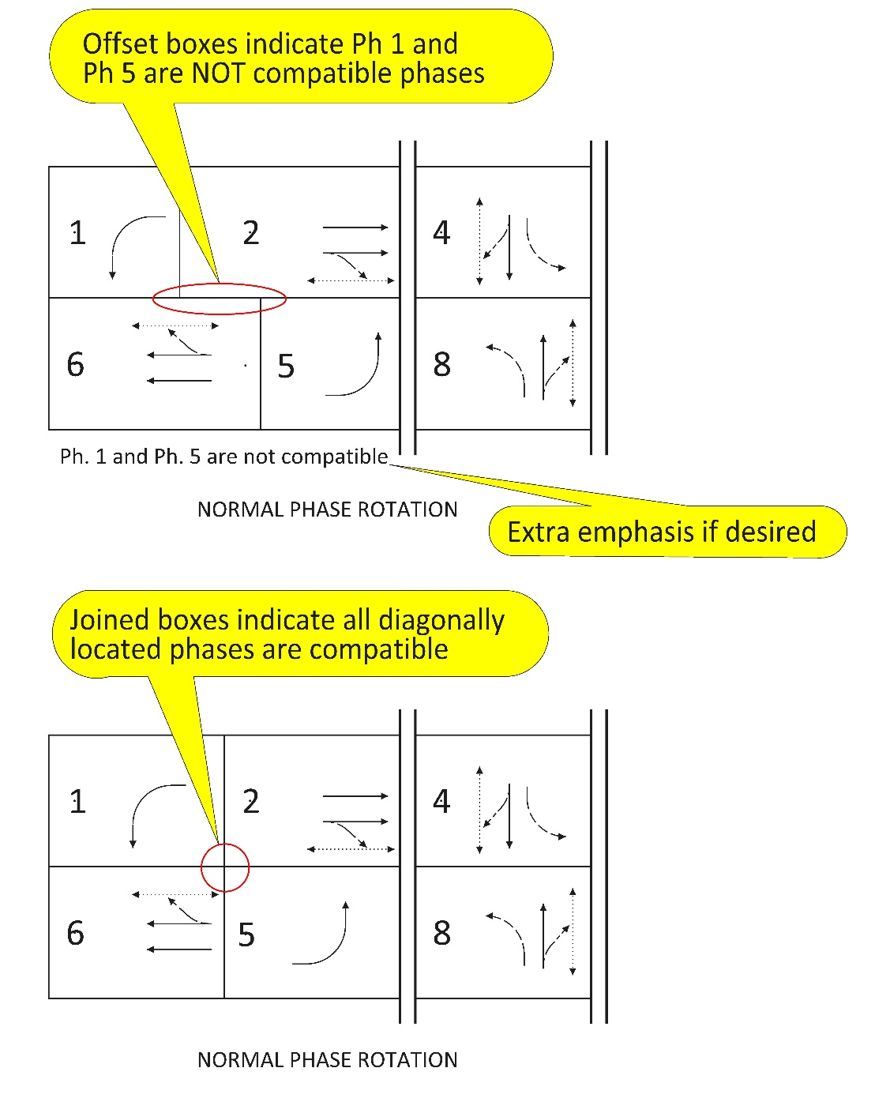

### Multiple Intersections using a Single Controller

Two intersections are sometimes operated with a single controller if the intersections are very close together. The intersection of a divided highway typically operates like two very closely spaced intersections using a single controller. The ring and barrier diagram should combine both intersections into one ring and barrier diagram, with each intersection’s cross street labeled in the phase rotation boxes. See Figure 3‑10, Figure 3‑11, Figure 3‑12.

Figure 3‑10 | Ring & Barrier Diagrams: Multiple Intersections with a Single Controller, Example 1

****

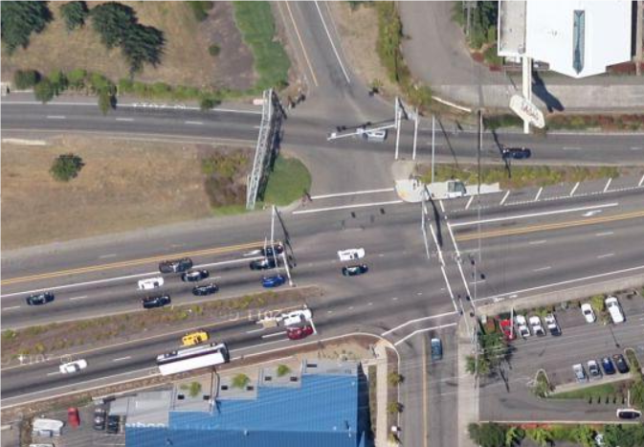

On-Ramp

Off-Ramp

Barbur

64th

Figure 3‑11 | Ring & Barrier Diagrams: Multiple Intersections with a Single Controller, Example 2





Bridge Ramp

Basin St.

Figure 3‑12 | Ring & Barrier Diagrams: Multiple Intersections with a Single Controller, Example 3



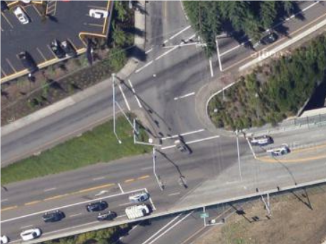

Off-Ramp

Barbur

### Dummy Phases

A dummy phase is defined as a phase that does not have an output, but is still used in the controller software to achieve a certain operation. Typical applications are complex geometry with overlaps (see Figure 3‑13) and one-lane, two-way temporary traffic signals (see Figure 3‑14). The movements (or all-red time clearance time, in the case of a one-lane, two-way temporary traffic signal) are shown in the appropriate phase block. Below the ring and barrier diagram in text, the dummy phases are listed. See Figure 3‑13 and Figure 3‑14.

Figure 3‑13 | Ring & Barrier Diagrams: Dummy Phases, Example 1



Figure 3‑14 | Ring & Barrier Diagrams: Dummy Phases, Example 2



### Overlap Phase with Green Extension Clear-Out

Overlap phases are typically timed to start and end their green phase in sync with their parent phases. For certain complex intersection geometries, it may be necessary to extend the overlap phase green after the parent phase is terminated to clear out the intersection. If the overlap phase green extension clear-out is documented in the operational approval, it is not shown in the ring and barrier diagram, but should be noted below in text. See Figure 3‑15 and Figure 3‑16.

Figure 3‑15 | Overlap Clear Out Interval, Example 1

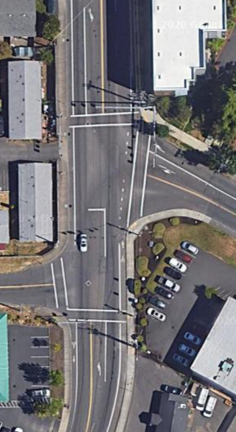

ACCESS

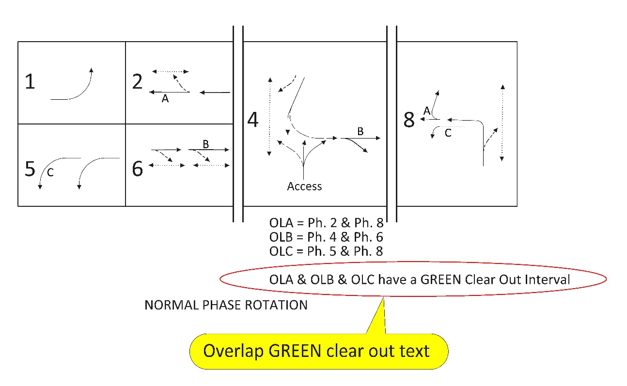

Figure 3‑16 | Overlap Clear Out Interval, Example 2

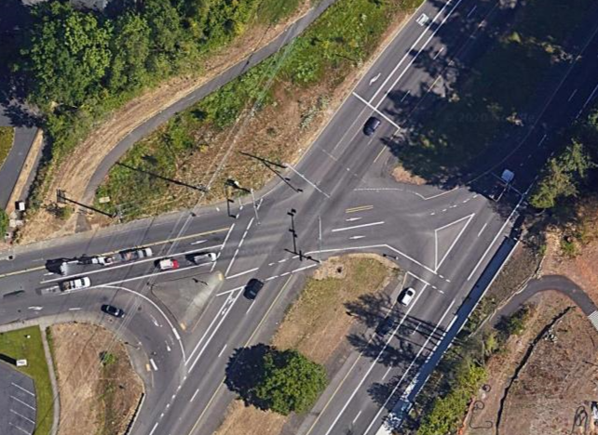

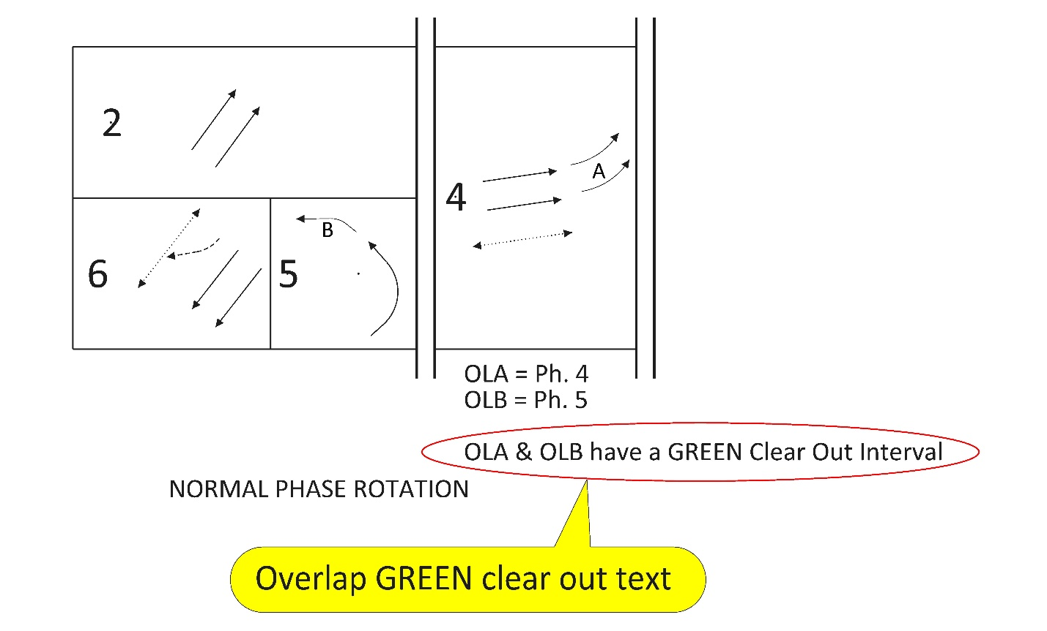

### Unconventional Phases & Sequences

Signal timing software now allows the use of phase assignments and sequences that do not follow the traditional, basic ring and barrier phase structure. These unique phases/sequences have the potential to improve the signal efficiency at locations with unusual intersection geometry. Because these unique sequences are rare and may appear to be an error in the plans at first glance (and require extra attention to the signal timing parameters), they shall be noted in text below the ring and barrier diagram to indicate it is intentional. See Figure 3‑17.

There is a high variability of unconventional phases or sequences that could be used based on site specifics, therefore it is important to work with the state traffic signal engineer and the state traffic operations engineer on a case-by-case basis to ensure it is the right solution, works properly in the software, works properly with the hardware, and the ring and barrier is drawn correctly to enable proper programming of the conflict monitor.

Figure 3‑17 | Unconventional Phase Sequence Example

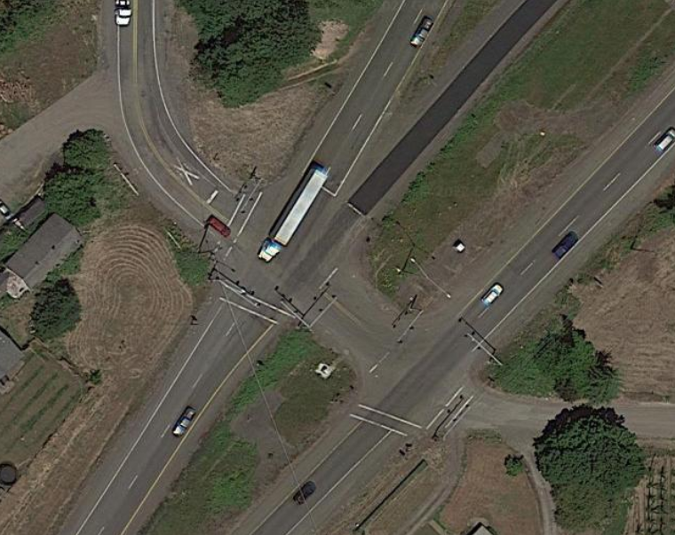

99E Northbound

Wilsonville-Hubbard Hwy

99E southbound

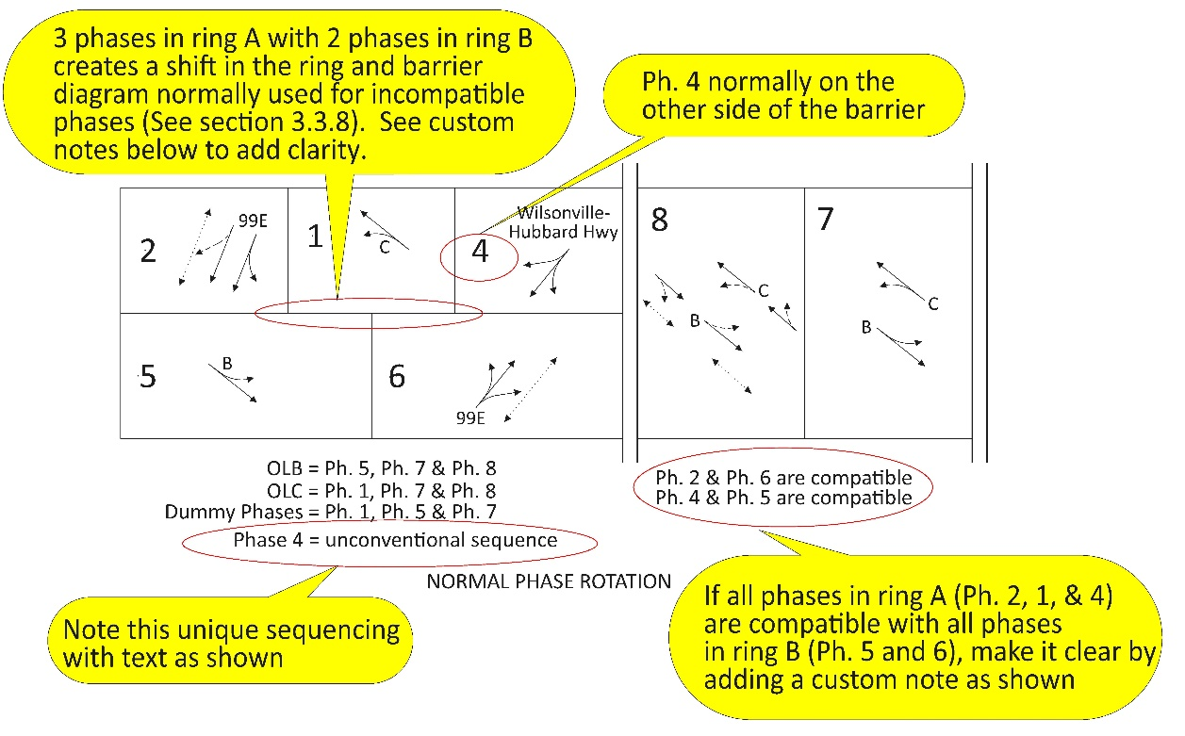

## Emergency Preemption

When an emergency service provider is granted permission by ODOT to use emergency preemption, the traffic signals within the geographic area of service will require emergency preemption. The majority of ODOT signals are within areas requiring emergency preemption. To check if an area has permission to use emergency preemption, contact the state traffic operations engineer.

Emergency preemption alters the normal phasing of the traffic signal to allow green indications for an emergency vehicle (typically fire or ambulance) approaching the intersection. This is shown on the signal plan sheet. Figure 3‑18 below shows the standard channel assignments for fire preemption operation:

* Channel A = phase 2 & 5
* Channel B = phase 4 & 7
* Channel C = phase 6 & 1
* Channel D = phase 8 & 3

Figure 3‑18 | Standard Fire Preemption Channel Assignments

signal_design_manual_figures

When reading a fire preemption operation diagram, all vehicular movements are drawn as solid lines, indicating that that movement is protected (no conflicting movements requiring the motorist to yield). Pedestrian phases are not serviced during preemption.

There are times when non-standard channel assignments are preferred, such as an intersection that requires use of only two channels. See Figure 3‑19. This is due to the termination layout for the fire preemption discriminators located inside the controller cabinet. Each discriminator is able to monitor up to two channels. One discriminator is always used for channels A & C, and one discriminator is always used for channels B & D. To save the expense of installing two discriminators for only two channels (using the standard channel assignments), the phases assigned to the channels will be reassigned in the controller software, thus only requiring one discriminator. For example, if an intersection only had phase 2 and phase 4 (downtown, one-way grid system), channel A should be assigned to phase 2 and channel C should be reassigned to phase 4 (uses 1 discriminator) vs. using the standard channel assignments of A and B (uses 2 discriminators).

signal_design_manual_figuresFigure 3‑19 | Two Channel Fire Preemption Channel Assignments

signal_design_manual_figures

Reassigned Channel Assignment

Requires 1 Discriminator

PREFERRED

Standard Channel Assignment

Requires 2 Discriminators

NOT PREFERRED

## Railroad Preemption

If a signalized intersection is located within 215 feet of a rail crossing, rail preemption is required. If a signal requires rail preemption, a rail crossing order is needed. The rail crossing order will state specific design and operational requirements that must be met.

Rail preemption alters the normal phasing of the traffic signal to allow pedestrians to clear the intersection and vehicles to clear the tracks prior to the train arrival. This is the highest order of preemption and takes precedence over all other forms of preemption. See chapter 16 for detailed information on rail preemption operation and how it is shown on the plan sheets.

## Transit Priority

When a transit provider is granted permission by ODOT to use transit priority, the traffic signals within the service routes will require transit priority signal timing. This typically occurs in large metropolitan areas (e.g., Eugene, Portland).

Transit priority does not have the ability to alter the normal phasing of the traffic. Instead, transit priority just alters the cycle of the normal phasing by extending or delaying green time for the appropriate approach or using transit only phasing to allow minimal to no delay for the transit vehicle. Transit priority that extends or delays the green time is NOT shown in the phase rotation diagram. Transit phasing is shown in the phase rotation diagram and may also require the use of special custom vehicle signal indications (strictly for the use of the transit driver) similar to the LRT signals shown in the Oregon Supplements to the MUTCD. See Figure 3‑20.

Figure 3‑20 | Queue Jump Phasing with LRT Vehicle Signal Head Example

Phases 9 and 10 (for buses only) use a custom LRT vehicle signal head: 

## Crosswalk Closures

It is ODOT policy to provide pedestrian crossings for all approaches at a signalized intersection unless an engineering study and STE approval deem a crosswalk closure is necessary. Often, the need to close a crosswalk is due to unusual roadway geometry, certain lane use (such as dual turn lanes), certain signal phasing (such as a single point urban interchange), and/or crash history. Closing a crosswalk requires specific signing and detectable treatments. The details for this signing are typically shown on the signal plan. See the crosswalk section in chapter 5 for more information.

## Traffic Signal Communications

Closely spaced signals in a corridor typically require central or local communications for the signals to function in a coordinated manner. When communications are required, either an interconnect plan or communication plan is needed. See the chapter 7 for more information.

## Other Unique Requirements

Other requirement may be listed on the operational approval, specific to the project. Some unique requirements in the operational approval include the following:

* Audible pedestrian signals
* Channelized right turn lane control (yield, stop, or signal control)
* Non-traversable medians/island to restrict/channel turn movements
* Advanced flashing beacons on signs
* U-turns

## Example of Operational Approval

See Figure 3‑21 through Figure 3‑23 for an example of an STE operational approval.

Figure 3‑21 | STE Approval Example Page 1 of 3 – Memo Stating Requirements

Figure 3‑22 | STE Approval Example Page 2 of 3 – PSOD Form, Existing Conditions

Figure 3‑23 | STE Approval Example Page 3 of 3 – PSOD Form, Recommended Signal Design

