Chapter 2

Contents

2 Design Approval Process 2-1

2.1 Traffic Engineering Organizational Structure 2-2

2.2 Design Exceptions, Non-Standard Design, and Experimental Design 2-3

2.3 Overhead Structures and Vertical Clearance Standards 2-4

2.4 Project Types That Require Design Approval 2-4

2.5 Plan Sheets That Require Design Approval 2-5

2.6 Design Approval Process 2-5

2.6.1 ODOT Let Projects 2-9

2.6.2 Non-ODOT Let Projects & Consultant Signal Designers 2-9

2.7 Getting Drawing Numbers & TSSU ID numbers 2-9

2.8 Getting the Design Approval Signature 2-12

2.9 Review by Others 2-13

# Design Approval Process

The traffic engineering section has reviewed and approved traffic signal plan sheets for many years with the effort becoming formalized in the mid 2000’s when ODOT decentralized the design functions of the agency. The main focus of the traffic engineering section’s design review and approval is to identify and resolve any errors/omissions so that the design as shown in the plan sheets:

* Is safe for the public
* Meets the requirements of the operational approval documentation
* Meets the requirements of the MUTCD and other applicable ODOT design, policy and guideline documents.
* Is maintainable (ease of maintenance and economical)
* Is constructible (staging, schedule, and economical)
* Is readable and can be understood by those in the industry (drafting standards)
* Contains clear, non-conflicting information
* Results in zero to minimal construction change orders

The traffic engineering section’s design review will look at big picture issues as well as the details of the design, down to the conduit sizes and wire counts. The design review also includes a review of the signal operation details. As expected, reviews during the early phases of the design process will be more focused on big picture issues, becoming more focused on the details as design phase progresses. Typically a detailed review of the plans cannot be completed until the big picture issues are resolved, so it is important to address the big picture issues as early as possible.

Note: There are two separate types of approvals for traffic signal work – the operational approval and the design approval. See chapter 3 for information on the operational approval.

## Traffic Engineering Organizational Structure

It is helpful to understand how the traffic engineering section is organized and how the key positions will interact with the signal designer during the design review process. The organization chart below shows only the traffic signal related positions.

Figure 2‑1 | Organization Chart

## Design Exceptions, Non-Standard Design, and Experimental Design

All traffic control devices installed in the state of Oregon are required to conform to the Manual on Uniform Traffic Control Devices (MUTCD) and the Oregon Supplement to the MUTCD as established by ORS 810.200 and OAR 734-020-0005.

The MUTCD, as well as this manual, contains shall, should, and may language which indicates what is required, recommended, and optional. Traffic design should not deviate from a shall or should statement unless it is prudent to do so, as per section 1A.13 of Oregon Supplement to the MUTCD.

Section 1A.13 of the Oregon Supplement to the MUTCD: “The decision to use a particular device at a particular location is typically made on the basis of an engineering study at the location. Thus, while this Manual provides standards for design and application of traffic control devices, the Manual is not a substitute for engineering judgment. It is the intent that the provisions of this Manual be standards for traffic control devices installation, but not a legal requirement for installation.”

If the design or operation of a traffic control device must deviate from a shall or should statement, the deviation will be addressed by the traffic engineering section in the form of either an operational approval (see chapter 3) or through the design approval process (see section 2.6) depending on the nature of the deviation. The design exception process, used in other disciplines like roadway design, is NOT used for traffic design. However, new requirements for pushbutton accessibility are an exception and will require a roadway ADA curb ramp exception if they cannot be met. See section 5.4, the Highway Design Manual, and the [website for roadway design exceptions and forms](https://www.oregon.gov/ODOT/Engineering/Pages/Design-Exceptions.aspx) for detailed information.

Certain deviations may be considered experimental and require an additional approval from FHWA. All requests for FHWA experimental approval are processed by the traffic engineering section. See the ODOT Traffic Manual for more information on exceptions, deviations, and requests to experiment.

## Overhead Structures and Vertical Clearance Standards

Contact the region mobility liaison when any proposed project (new construction, reconstruction, preservation, or maintenance) adds a new or modifies an existing overhead structure (truss sign bridge, monotube cantilever, signal mast arm, and signal strain pole) regardless of meeting the existing minimum vertical clearance standards. In addition, contact the region mobility liaison for any project that reduces the existing vertical clearance regardless of meeting the minimum vertical clearance standards. The region mobility liaison will provide the appropriate coordination with the region, and MCTD. This coordination should address not only project specific mobility requirements, but also any corridor level vertical clearance and mobility needs. Vertical clearance greater than 19’-0” for sign, VMS, and signal support structures are considered non-standard and require a design exception. The signal designer is to follow the procedures outlined in chapter 14 of the HDM. The design exception request process for increasing the vertical clearance greater than the above mentioned 19’-0” will need to consider safety, operations, and impact to other design features in order to support the approval of the design exception.

## Project Types That Require Design Approval

There are four different types of projects which might contain traffic signal work that requires review and design approval of the traffic engineering section:

1. **Projects let for bid by ODOT:** This is the typical method ODOT uses. The plans and specifications are developed within a project team. The work is reviewed and approved by the traffic engineering section before the project is let for bid.
2. **Projects let for bid by a local agency:** The local agency, typically a city or county, lets the contract for bid. The ODOT local agency liaison coordinates reviews of the plans and specifications within ODOT. The work is reviewed and approved by the traffic engineering section before the local agency is allowed to let the contract for bid.
3. **Projects by ODOT permit:** ODOT will issue a permit to work on state right-of-way. A common scenario is a developer wants to improve an area such as building a large retail store. This large retail store will impact the state highway and typically some sort of mitigation is required. The ODOT district office coordinates with the ODOT region traffic engineer and the developer and issues a permit for construction once the work is reviewed and approved by the traffic engineering section.
4. **Projects by state forces:** Plans and specification are created and given directly to state forces for construction. Typically these projects are simple in scope such as upgrading to countdown pedestrian signals or changing left turn phasing. The project is developed similar to “projects let for bid by ODOT” described above, but considerably less formal. See chapter 23 for more information on state force work.

## Plan Sheets That Require Design Approval

Design approval is required for each plan sheet that contains signal work. The traffic engineering section shall approve the following plan sheets for all ODOT owned **or** maintained traffic signals before the project is let for bid:

1. Permanent signals, both new installations and modifications to existing signals. This includes all components of a traffic signal: signal, detector, interconnect, details, railroad preemption, existing utilities, etc.
2. Temporary signals (excluding portable temporary signals)
3. Ramp meters
4. Actuated flashing beacons (includes RRFB, tunnel, and bridge applications)
5. Flashing beacons mounted overhead
6. Pedestrian signals
7. Fire signals
8. Red light enforcement

Review and approval is NOT required for local agency owned **and** maintained traffic signals. However, federally funded local agency projects may request a courtesy review from the traffic engineering section for compliance with federal and state minimum requirements.

## Design Approval Process

Plan sheets should be submitted to the state traffic signal engineer for review at all major project milestones; DAP (design acceptance package), preliminary, advanced, and plans-in-hand. Plans may also be submitted for review independently of the project’s major milestones or project leader’s official schedule if it makes sense to do so. The design plans should progress in level of detail and completeness at each milestone. The requirements for each milestone, as detailed below, will enable efficient traffic engineering section reviews (faster turnaround, with fewer comments to address) and also should result in less re-work for the signal designer between reviews.

Use the “final design/drafting checklist” in chapter 21 before submitting plans for traffic engineering section review. This will drastically reduce the number of comments to address during the review periods!

1. DAP plans (60% complete):
   1. Signal plan sheet
      1. Number of lanes & lane use (as per the completed operational approval)
      2. Crosswalks/crosswalk closures (as per the completed operational approval)
      3. ADA ramps (e.g. basic style to be used to identify the amount of right-of-way needed to accommodate proper placement).
      4. Normal signal phasing diagram (as per the completed operational approval)
      5. Location of mast arm poles, strain poles, pedestals, controller cabinet, and service cabinet (used to identify the amount of right-of-way needed to accommodate proper placement)
      6. Location of potential commercial power source
      7. Existing and proposed right-of-way lines shown
   2. Detector plans (Note: non-invasive detection doesn’t require a separate detector plan and the detection zones are shown on the cabinet print instead of a detector plan. See chapter 6 and chapter 20 for more information.)
      1. Location and type of detection
      2. Loop numbers
      3. Loop wiring diagram
   3. Identification of lane reductions occurring within ½ mile of the intersection and verification that the length before reduction can accommodate standard traffic control devices/signal operation (used to identify the amount of right-of-way needed to accommodate proper placement).
   4. Identification of the basic temporary workzone strategy and need for temporary signals. If a temporary signal plan sheet will be required, the DAP requirements listed above for the signal plan sheet also apply to the temporary signal plans.
   5. Placeholder signal plan sheets that will be needed with appropriate titles and intersection info (legend, detector plan, interconnect plan, existing utilities, details, removal, railroad preemption plan sheet, temporary signal plan, etc.)
2. Preliminary plans (90% complete):
   1. The signal appurtenances should all be detailed with bubble notes for each plan sheet at this stage:
      1. Signal heads, pedestrian heads, pushbuttons
      2. Regulatory signs
      3. Junction boxes
      4. Conduit
      5. Wiring (signal, detector, and interconnect)
      6. Illumination and photoelectric cell
      7. Fire preemption detectors
      8. Crosswalk closure supports
      9. Detector layout and detector wiring diagram (For loops only)
      10. Fire preemption diagram
      11. Right-of-way lines established
   2. Photometric analysis complete
   3. Railroad preemption plan sheet complete
   4. Place holder signal plan sheets for temporary/stage construction
3. Advance plans (99% complete):
   1. Label all poles and pedestals on project
   2. Pole entrance chart completed
   3. Geotech report finished and referenced near pole entrance chart
   4. List of applicable standard drawings in the first sheet of the plan set
   5. TSSU number
   6. Custom notes
   7. Temporary/stage construction plan sheets detailed
4. Final plans (100% complete)
   1. TRS dwg. numbers

The traffic engineering section is available at every step of the way during the design process to help answer questions, evaluate alternatives, and provide assistance.

For projects that are stored in ProjectWise, the designer should forward the distribution set at each project milestone to the state traffic signal engineer. The traffic engineering section will access the design documents from ProjectWise and provide review comments in the project’s comment log. The traffic engineering section will inform the designer when all their comments have been entered in the comment log for the designer to address by the project milestone (or sooner).

For projects that are NOT stored in ProjectWise, the designer shall submit plans electronically to the state traffic signal engineer. The preferred format is a single PDF of the entire plan set as other discipline’s plan sheets for the project (temporary workzone, roadway, signing, striping, illumination, etc.) can be helpful when reviewing the traffic signal plans. Once the review is complete, a list of comments is sent to the signal designer to be addressed by the next project milestone (or sooner).

It is very beneficial to provide a design narrative along with the plan sheets. For complex projects or when the constraints/scope of the project requires non-standard design, the signal designer should set up a meeting with the traffic engineering section to discuss the project and constraints, as this can greatly reduce the amount of time needed for review and the number of comments/questions resulting from the review.

The standard time frame for the traffic engineering section review is two weeks, but this could be more or less depending on the workload/deadlines at the time. There is no limit to the number of reviews that are conducted and they may not correspond to the number of official major project milestone reviews; some projects may only require one (simple, small project) while some projects may require many more (complex, large project or projects with non-standard design).

The comments from the traffic engineering section review are contained in either the project comment log or listed in an e-mail. See Figure 2‑2. Red line mark-ups of plan sheets are not provided. All of the comments must be resolved to the state traffic signal engineer’s satisfaction prior to getting the approval signature.

Complex project? Constraints requiring non-standard signal design?

Schedule a meeting with the traffic engineering section to discuss.

Figure 2‑2 | Project Comment Log Example

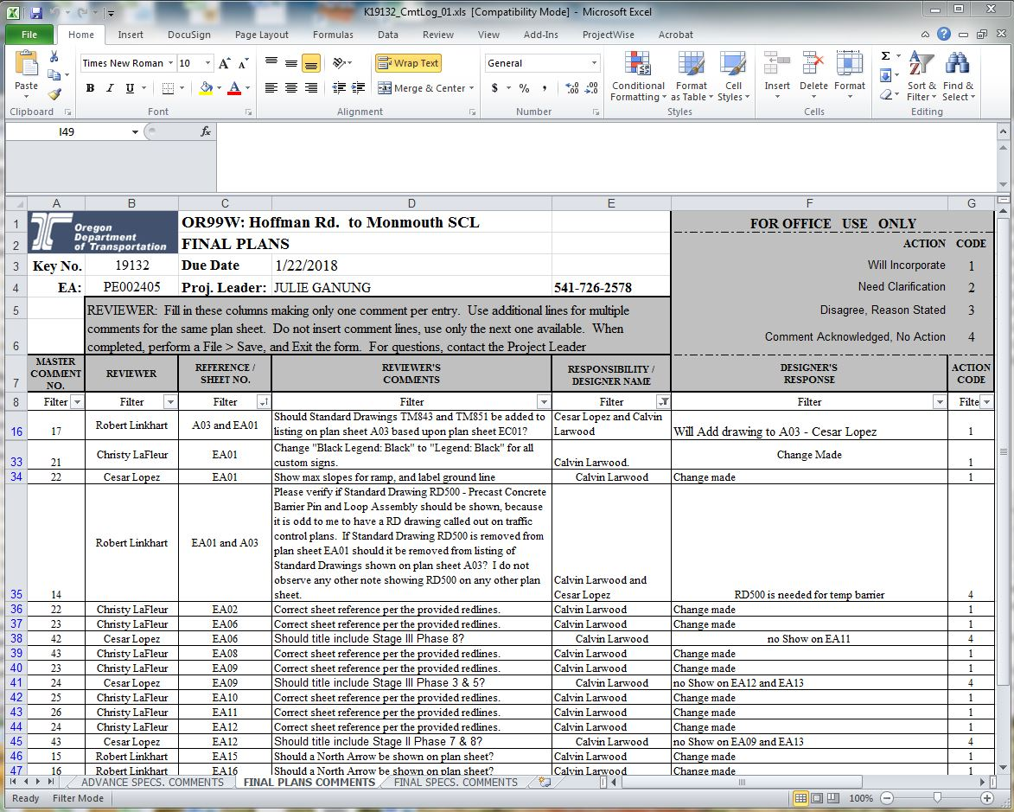

### ODOT Let Projects

For ODOT let projects the project leader or consultant project manager will be in charge of the schedule and plan review distribution for each milestone. In this case, follow the process as stated by the project leader or consultant project manager for plan review distribution. The signal designer should check with traffic engineering section to ensure the distribution has been received. For state force projects, the design phase is not as formal as a standard STIP project and the signal designer will likely be in charge of the schedule for plan review distribution.

It is the signal designer’s responsibility to make sure that a set of the plans makes it to the state traffic signal engineer for review; either by adding the state traffic signal engineer to the project leader’s plan review distribution list or by sending the plan sheets to the state traffic signal engineer directly.

### Non-ODOT Let Projects & Consultant Signal Designers

For non-ODOT let projects (local agency or development projects) and consultant designed plans (ODOT let project that is designed by a consultant) an ODOT point of contact will be responsible for plan review distribution of plans to other ODOT personnel. They are typically not responsible for maintaining the project development schedule, only coordinating the review period when the designer deems the plans ready for review. The main point of contact (region traffic, local agency liaison, project leader, or district office) will vary depending on the project type and which region and district the project is located in.

Submit the plans to the designated ODOT point of contact who will forward the plans to the state traffic signal engineer for review. The traffic engineering section will then submit comments back to the signal designer through the designated ODOT point of contact. Direct contact can be made to the traffic engineering section regarding the plan review and traffic engineering section comments; in fact, the designated ODOT point of contact may encourage direct contact regarding the technical details of traffic signal design rather than being a “middle man”. However, the ODOT point of contact should always be kept in the loop of decisions made.

## Getting Drawing Numbers & TSSU ID numbers

Each signal related plan sheet is issued a unique drawing number that is assigned by the traffic engineering section (referred to as either “TRS drawing number” or “unit file code”). This is how the plan sheets are archived. The sheet number directly relates to the age of the project; the lower the number, the older the plan sheet.

TRS drawing numbers should be requested by the signal designer once the final number of plan sheets for a project is known and highly unlikely to change (typically near the end of the design process). For projects stored in ProjectWise, this is done by sending the state traffic signal engineer a link to the current signal plans in ProjectWise. For projects outside of ProjectWise, this is done by contacting the state traffic signal engineer and sending a separate PDF for each plan sheet on the project that needs a drawing number. Drawing number requests are a high priority; they are processed as soon as possible, often within hours of the request.

TSSU ID numbers are assigned by the traffic engineering section for all new ODOT owned & maintained, ODOT owned & local agency maintained, and local agency owned & ODOT maintained traffic signals and flashing beacon installations. This info is used for maintenance and asset management purposes. For signals, the TSSU ID number is assigned to the entire intersection (e.g. one controller cabinet operates the intersection) and there is a space in the standard title block to enter this info. For flashing beacons, a TSSU ID number is assigned to each pole/pedestal used. See chapter 21 for information on where and how to show TSSU ID numbers on the plan sheets.

TSSU ID numbers for existing signals and flashing beacons can be found in [TransGIS](http://gisintra.odot.state.or.us/TransGIS/) using the “equipment-highway” layers which contains “signals” and “flashing beacons”. See Figure 2‑3 and Figure 2‑4.

Figure 2‑3 | TransGIS Signal Layer

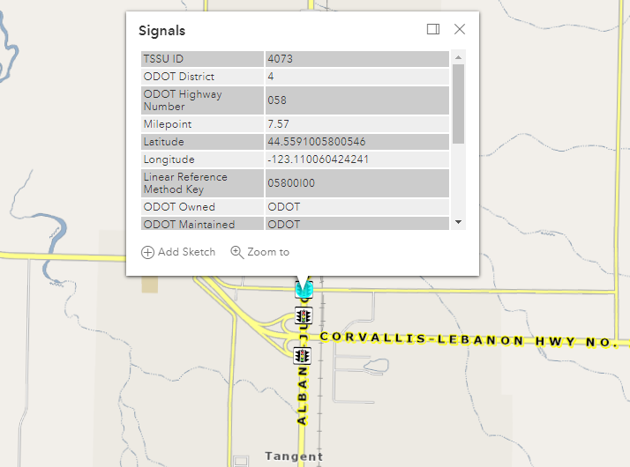

TSSU ID number is the first piece of info about this asset

Traffic signal ICON

Figure 2‑4 | TransGIS Flashing Beacon Layer

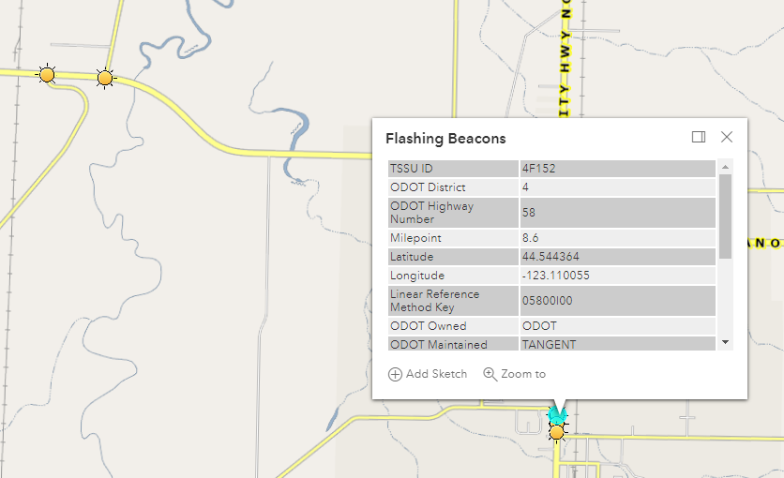

Flashing beacon ICON

TSSU ID number is the first piece of info about this asset

## Getting the Design Approval Signature

Each signal related plan sheet shall contain a signature block for “traffic section approval”. When all comments on the signal plans have been resolved to the state traffic signal engineer’s satisfaction the final plans are digitally signed by the engineer of record and submitted to the traffic engineering section for the approval signature via a ProjectWise link or PDF. See Figure 2‑5 for example and chapter 21 for more information on the traffic section approval signal block and placing the digital signatures.

The approval signature is required to be either the state traffic signal engineer or person(s) that are authorized by the state traffic signal engineer (typically a member of the traffic standards crew). Once signed, the traffic engineering section will inform the designer (ODOT let projects) or send the approved plan sheets back to the signal designer (non-ODOT let projects).

Figure 2‑5 | Design Approval Signature Example

EOR stamp with digital signature

Approved plan sheet: Traffic section approval signature block with digital signature.

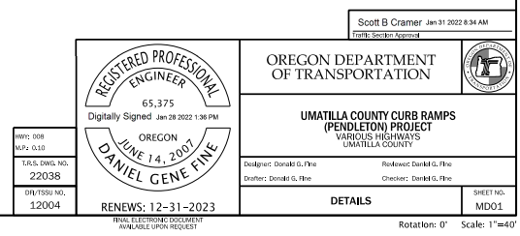

Not having an authorized signature on your plan sheets can delay the project bid let date

## Review by Others

In addition to the review and approval from traffic engineering section, plan sheets should also be reviewed by region traffic, region electricians, the construction office, and any other interested parties (e.g. local agency, historic committees, etc.). Due to the flexibility for some design elements based on region electrical crew preferences (as described in this manual), it is critical to coordinate with the electrical crew during the design phase to ensure maintenance concerns are addressed.

The signal designer is responsible for ensuring the plans are distributed to the appropriate parties for review, with one exception; a consultant signal designer working on ODOT let project or a project by permit (e.g. development project) where an ODOT point of contact has been established. The ODOT point of contact will be responsible for ensuring the plans are reviewed by the appropriate **ODOT** personnel.

While the traffic engineering section makes every attempt to produce comments that do not conflict with other ODOT review comments, it does happen occasionally. If other reviewer’s comments conflict with the comments received from the traffic engineering section, it is best to discuss the issue with both parties to determine the appropriate action to take.

A review by either the signal designer’s crew lead or another designer is recommended for the following items, as they are not included in the traffic engineering section review:

* Quantities and cost estimate
* Special provision boiler plates. Note that the special provision boiler plates are only checked and approved by the state traffic signal engineer (technical owner of the traffic signal specifications) if you have made any non-standard changes. The state traffic signal engineer only reviews and approves the portion of the special provisions where the non-standard change was made. See chapter 19 for more information on specifications.