TO: Users of ODOT Crash Data in Geo-spatial Formats

RE: New Fields added to Annual Statewide Crash geodatabase and TransGIS crash data layer Schemas effective 2017, with updates available retroactively to 2013-2016.

The Crash Analysis and Reporting (CAR) Unit added the following three fields to the schema for the annual file geodatabase and the TransGIS crash data layer. The fields and their specifications are:

|  |  |  |  |  |  |  |  |
| --- | --- | --- | --- | --- | --- | --- | --- |
| TABLE | FIELD NAME | SHAPEFILE FIELD NAME | ALIAS | CODE VALUES | EFFECTIVE YEAR | REPLACES | AVAILABLE in CDS |
| CRASH | HIGHEST_INJ_SVRTY_CD | HIGHEST_IN | Highest Injury Severity Code | 1, 2, 3, 4, 5 | Calculated field retroactive to 2013. | INJ_SVRTY_CD | No |
| CRASH | HIGHEST_INJ_SVRTY_DESC | HIGHEST__1 | Highest Injury Severity Description | Fatal Injury (K),  Suspected Serious Injury (A),  Suspected Minor Injury (B),  Possible Injury (C),  No Apparent Injury/PDO Crash (O) | Calculated field retroactive to 2013. | INJ_SVRTY_LONG_DESC | No |
| CRASH | MJ_INVLV_FLG | MJ_INVLV_F | Marijuana Involved Flag | 0/1 | 2016 |  | Yes |

EXPLANATION and RISKS

The Highest Injury Severity fields are generated *during the geodatabase development process*. They’re not available from the Crash Data System. Querying these fields will output the “*crashes*” based on the code(s) selected, **not** the number of “*injuries*”.

HOW TO INTERPRET RESULTS

When querying HIGHEST_INJ_ SVRTY_CD or HIGHEST_INJ_SVRTY_DESC:

* Code 1, Fatal Injury (K) will output all crashes that involved a fatal injury;
* Code 2, Suspected Serious Injury (A) will output crashes where the highest injury severity was INJ-A. *This excludes fatal crashes in which a participant was seriously injured.*
* Code 3, Suspected Minor Injury (B) will output crashes where the highest injury severity was INJ-B. *This excludes fatal and suspected serious injury crashes in which a participant had a suspected minor injury.*
* Code 4, Possible Injury (C) will output crashes where the highest injury severity was INJ-C. *This excludes fatal, suspected serious, and suspected minor injury crashes in which a participant had a possible injury.*
* Code 5, No Apparent Injury/PDO Crash (O) will output property damage only crashes; i.e., there were no apparent injuries.

Advanced GIS software users can create symbology to represent crashes based on HIGHEST_INJ_SVRTY_CD, such as:

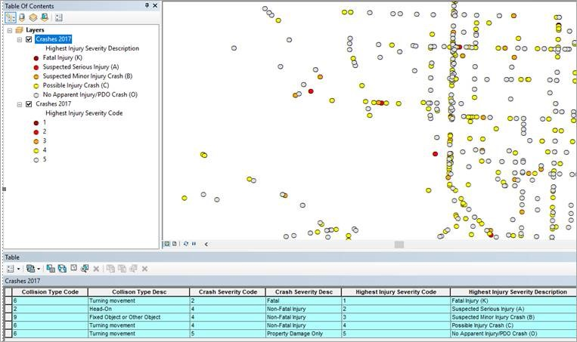

How to interpret results when querying MJ_INVLV_FLG:

* Code 0: Crash did not involve use of cannabis product(s) by an active participant*; or use is not suspected; or use is unknown.
* Code 1: An active participant in the crash had either:
  + a positive blood test result for tetrahydrocannabinols (THC) or Delta-9 THC; or
  + a DRE evaluation that indicated use of cannabis products use, or
  + an ARIDE evaluation that indicated use of cannabis products

*\*an active participant is a driver, pedestrian, bicyclist, or other non-motorist who had a measure of control over the crash circumstances*

AVAILABILITY

The TransGIS crash data layers for years 2013-2016 have been recreated using the new schema to allow customers to query five years of data by highest injury severity. Data collection for Marijuana Involvement began with the 2016 crash data file, so marijuana involvement data doesn’t exist in CDS prior to 2016.