**APD MFE Training**

**Case Manager Homepage and Case Alert Overview**

# Contents

Contents 2

Overview 4

How Case Manager Information is Sent to ONE from Oregon ACCESS 4

Accessing the Case Manager Alerts 5

Case Manager Homepage 5

My Case Load 5

Alerts Follow the Oregonian, Not the Worker 6

Case Manager Alert Log 7

Retrieve Cases 9

Tooltips 10

Reviewing Information on Homepage or Case Manager Alert Log 12

View Authorization History Button 12

Open Case Summary Button 13

View Case Notes Button 13

Other Payments Button 14

Mark as Complete Button 15

Patient Liability Information Button 15

Individual # Hyperlink 15

ONE Updates 17

March 2024 Updates 17

July 2024 Updates 17

November 2024 Updates 17

## Overview

The Case Manager Homepage provides information to case managers about specific actions taken in ONE that may require the case manager’s attention.

The alerts that are shown on the Case Manager Homepage do not generate automatic notification to case managers in Oregon ACCESS. Case managers will need to go into ONE and review this information. It is recommended that the homepage be checked every day, or at least weekly, for changes occurring on the caseload.

By continually monitoring the Homepage, case managers can prevent provider payment issues and provide timely notice for adverse actions.

See the [Case Manager Alert Descriptions](https://www.oregon.gov/odhs/providers-partners/seniors-disabilities/Documents/cm-alert-descriptions.docx) document for a description of all the alerts.

## How Case Manager Information is Sent to ONE from Oregon ACCESS

Information about which case manager is assigned to a case is sent to ONE from Oregon ACCESS.

On the benefit screen in Oregon ACCESS on the Case Overview tab, case managers can see the Workers and their roles. The worker whose name has a checkmark in the ONE CM checkbox will have this individual on their caseload in ONE. Only one worker can have the ONE CM checkbox checked.

The ONE CM checkbox cannot be modified while the case is checked out in Remote

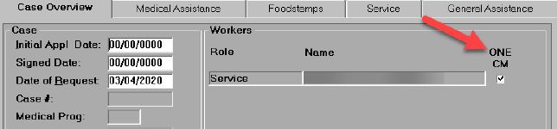

The Primary Applicant on the case must be Client Index (CI) Registered, which assigns a prime number, for the information to be sent to ONE.

The ONE CM worker’s Oregon ACCESS security profile must contain either an OR # or a P # for information to be sent to ONE.

If the ONE CM checkbox is checked but the case is not listed as assigned to the selected case manager on the Case Manager Homepage, please have the local security administrator verify that the case manager’s OR# or P# in their Oregon ACCESS security profile is valid. Please take this step prior to submitting a [CA ticket](https://dhsoha.sharepoint.com/teams/Hub-DHS-ET/SitePages/CA-Ticket-Resources.aspx) to the ONE Helpdesk.

Changes to the ONE case manager information accumulates during the day and is sent to ONE each evening. Keep in mind, the individual will not be displayed on the My Case Load section of the new case manager’s homepage until the next day.

## Accessing the Case Manager Alerts

There are two ways to access the case manager alerts in ONE: on the Case Manager Homepage or using the Case Manager Alert Log.

### Case Manager Homepage

When a case manager first logs into the ONE System, their Homepage will look similar to the screen capture below. There are two sections, Retrieve Cases and My Case Load.

### My Case Load

A case manager can see alerts on their Homepage by clicking the arrow to the left of My Case Load (outlined in a red box in the screen capture below). When the arrow faces down the case manager will see their case load and any alerts on the cases.

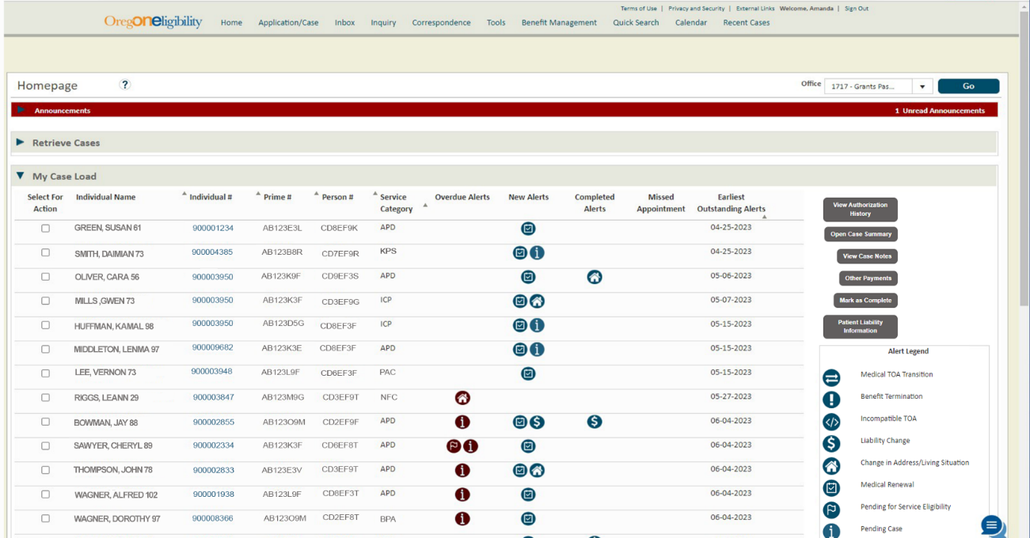

The My Case Load section of the Homepage has several columns. The Individual Name, Individual #, Prime #, and Person # are all ways to identify an individual. The case load is normally listed alphabetically by the individual’s last name upon login, unless there are alerts on the case.

If there are alerts on a case, those cases will be at the top the My Case Load section and in order of Earliest Outstanding Alert date, starting with oldest date to newest date. If there are multiple alerts on the same date, those will be alphabetized by last name. Once the alert is marked as complete, the name will go back into alphabetical order.

The Service Category column displays the service category from the SELG record.

The next four columns display alerts: Overdue Alerts, New Alerts, Completed Alerts, and Missed Appointments.

Overdue alerts show when an alert is past due. Alerts are considered overdue when they have not been marked complete within 45 days of being generated. They also change to red text when overdue.

New alerts are when an alert has been created. “New” means 44 days or newer.

Completed Alerts are ones that have been marked as complete and are still within 60 days of the alert being generated.

The Missed Appointment column is specific to alerts for the Missed Appointment. In this column you will see the Missed Appointment Icon in black. This alert can be generated for medical or any other programs.

After 61 days an alert will expire, which means it will disappear from all alert columns.

### Alerts Follow the Oregonian, Not the Worker

Alerts will not transfer when a there is a case manager change. Alerts follow the person not the worker.

If there is no alert icon displayed in any of the columns but there is an Earliest Outstanding Alert date, as we see for Vernon Lee in the screen capture below, then there is an alert that has been generated on the case when another case manager was assigned to the case or the case was unassigned. The case manager will need to search for this alert using the Case Manager Alert Log.

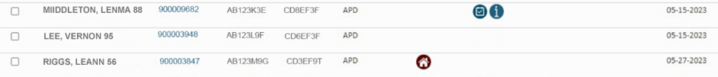

### Case Manager Alert Log

The Case Manager Alert Log offers the most search criteria to view alerts. To access the log, select the Tools tab on the top of the ONE Homepage then select Case Manager Alert Log (outlined in a red box in the screen capture below).

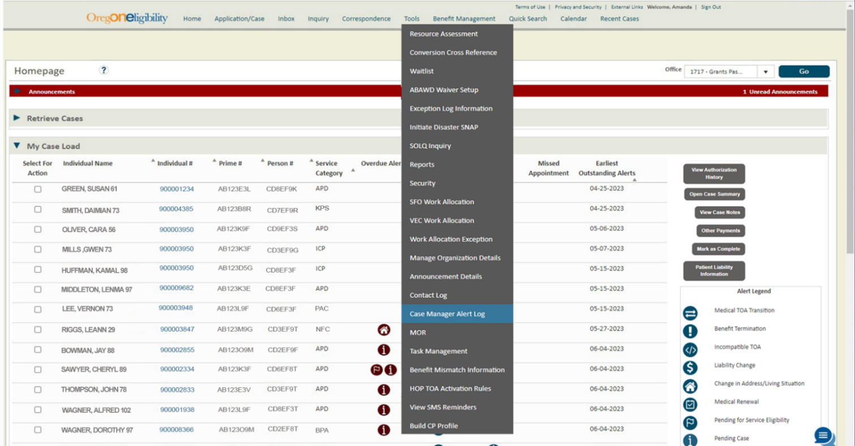

Accessing the Case Manager Alert Log (see screen capture below) through the Tools tab allows you to search by specific criteria including:

* Case Manager Office
* Case Office
* Case Manager Name

A search from this screen must include at least one of the following fields:

* Case Manager Office
* Case Manager Name
* Person #
* Individual #

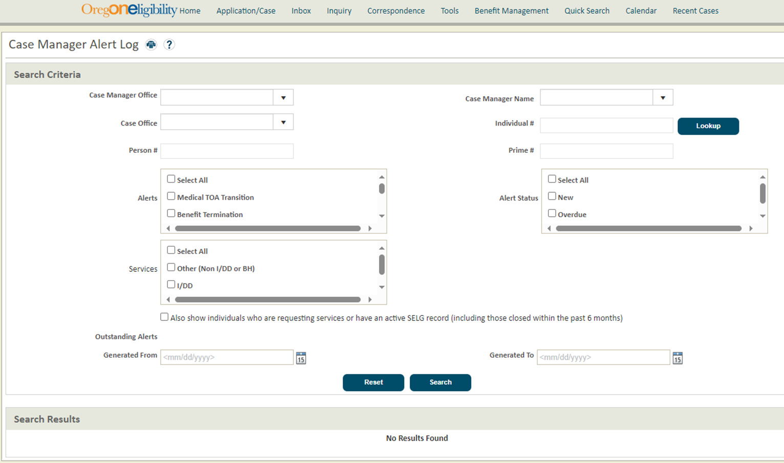

Using the Case Manager Alert Log from the Tools tab allows workers to search by any Case Manager Name and for alerts that did not have an assigned case manager when the alert was generated.

Search results can be refined to include only certain Alerts, Alert Status or Services by selecting preferences using the checkboxes.

The Reset button can be used to reset all the search criteria to the default values, if a change to the search criteria is needed.

After selecting all search criteria, press the Search button to see the results.

In the example in the screen capture below, the search criteria will include the Liability Change alert using the Case Manager Name of Unassigned and Services of Other (Non I/DD or BH). This will show APD individuals with a Liability Change that do not have an assigned case manager in ONE.

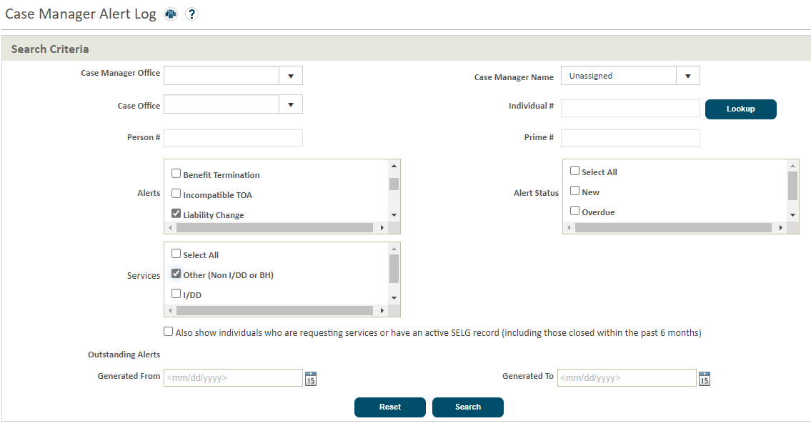

Local Offices could use a search like this to review cases that had an alert before a case manager was assigned to the individual using the ONE CM checkbox in Oregon ACCESS.

The search results could be used to identify cases for which the 512 needs to be touched or to check MMIS to make sure the liability was updated as expected.

### Retrieve Cases

Another way to search for alerts is by using the Retrieve Cases section of the Case Manager Homepage (outlined in a red box in the screen capture below). This section will only display alerts for the case manager that is logged into ONE. It can be used to focus on alerts that are higher priority and filter their caseload.

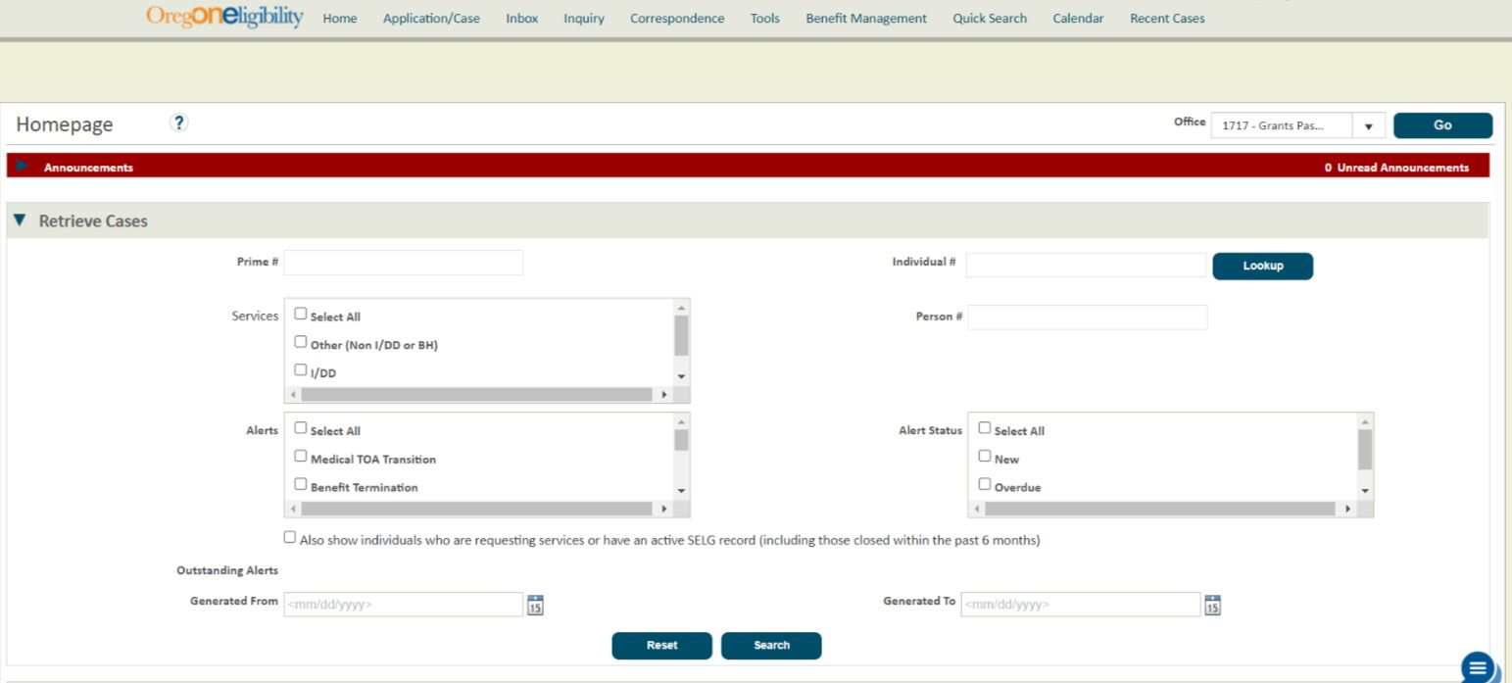

## Tooltips

Case managers can get a quick look at why an alert has been generated by hovering over the alert icon. A tooltip will be displayed. The tooltip displays more information about the alert.

An example is shown in the screen capture below. In this example, the case manager hovered over the Missed Appointment icon, the tooltip displayed was Missed Appointment – 1 Program 12345609 Medical, 07/11/2023 : 4:30 PM.

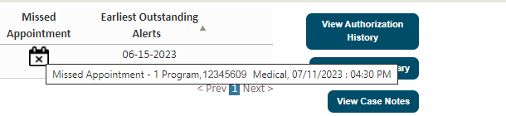

In this example, the case manager hovered over the Missed Appointment icon, the tooltip displayed was Missed Appointment – 1 Program 12345609 Medical, 07/11/2023 : 4:30 PM.

Tooltips usually include the effective date of the change that created the case alert. This date is helpful when reviewing the case for more details about the alert.

But be aware, these tooltips aren’t updated after the alert is generated. They are showing the status only on the date the alert was generated, and the case may have had a change since then. You need to look at the case to see current information and benefits.

The table below shows the alert details that will be shown when hovering over an alert.

| Alert Name | Alert Details |
| --- | --- |
| Medical TOA Transition | <Previous TOA> to <New TOA>, <Effective Date> |
| Benefit Denial/Termination | For terminations: <Termination date of closing TOAs>, <Case Mode/Status>, <Effective Date>.  For denials: ‘Termination date of closing TOAs' field will be printed as "N/A" |
| Incompatible TOA | <Mismatched TOA1>/<Mismatched TOA2>, <Effective Date> |
| Liability Change | <Previous Amount> to <New Amount>, <Effective Date> |
| Change in Address/Living Situation | <Effective Date>, <Old Address/L.A.> to <New Address/L.A.> |
| Medical Renewal | <Current Renewal status>, <Renewal due date> |
| Pending for Service Eligibility | <Current Service TOA Pending SELG>, due <Date SELG record is due> |
| Pending Case | <RFI Details, due <F=RFI due date> or Agency Pend or Non-Financial pend. |
| Missed Appointment | <Appointment Details>, <Case/Program>, <Appointment Date> |
| Disqualifying Asset Transfer | <current Service TOA with disqualifying transfer penalty> - <disqualifying transfer penalty begin date> - disqualifying penalty end date> |

## Reviewing Information on Homepage or Case Manager Alert Log

Case managers need to review screens within ONE to view the current information on the case, before taking action on an alert. See the [Case Manager Steps to Take Before Marking Alerts as Complete](https://www.oregon.gov/odhs/providers-partners/seniors-disabilities/Documents/cm-alert-completion-steps.docx) document for more information on suggested steps.

This can be done by selecting the case in the select for action column and then selecting a button. See the screen capture below. These buttons will be grey until you check the Select for Action checkbox next to an individual’s name, then they will turn blue and can be selected.

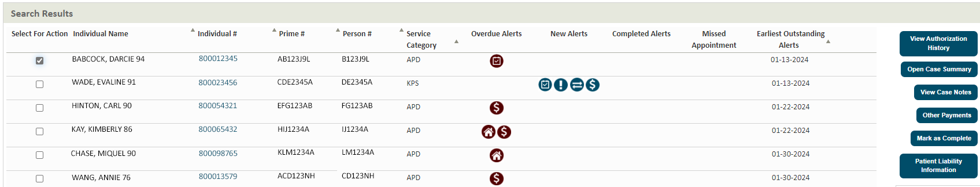

Some buttons open a new screen, and you lose your search results. Other buttons open a window over your caseload or search screen, and after reviewing the information you can return to the list of individuals you were viewing.

The View Authorization History, View Case Notes, and Patient Liability Information buttons open in a new window. You can use these screens and then close them and return to your dashboard or search results.

The Open Case Summary and Other Payments buttons open to that screen in the case, in the current browser tab. Any search results will be lost, and the search will need to be repeated when the review is finished.

Below you will find more information about each of the buttons.

### View Authorization History Button

The View Authorization History button will open the Authorization History screen (see the screen capture below). You can search and view the authorization history information for the individual you selected to review the benefits that have been authorized along with the Notice Reasons, RFIs, Financial Summary, Liability Summary, and disqualifications. When you close the window, you will be returned to the Case Manager Alert Log or your Dashboard, depending on where you started.

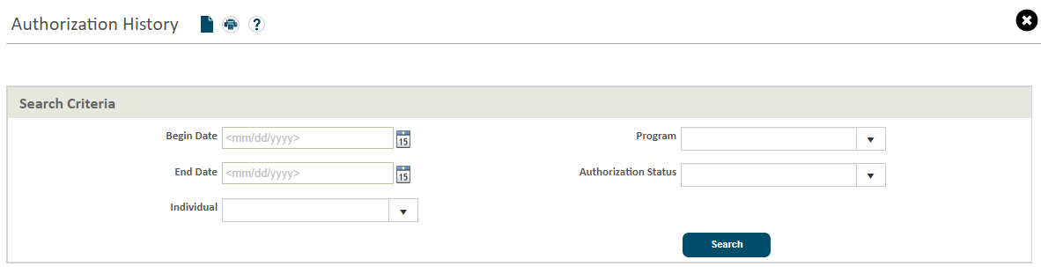

### Open Case Summary Button

The Open Case Summary button will open the Case Summary screen (see below) in ONE. It will not be a window over the Dashboard or Case Manager Alert Tool.

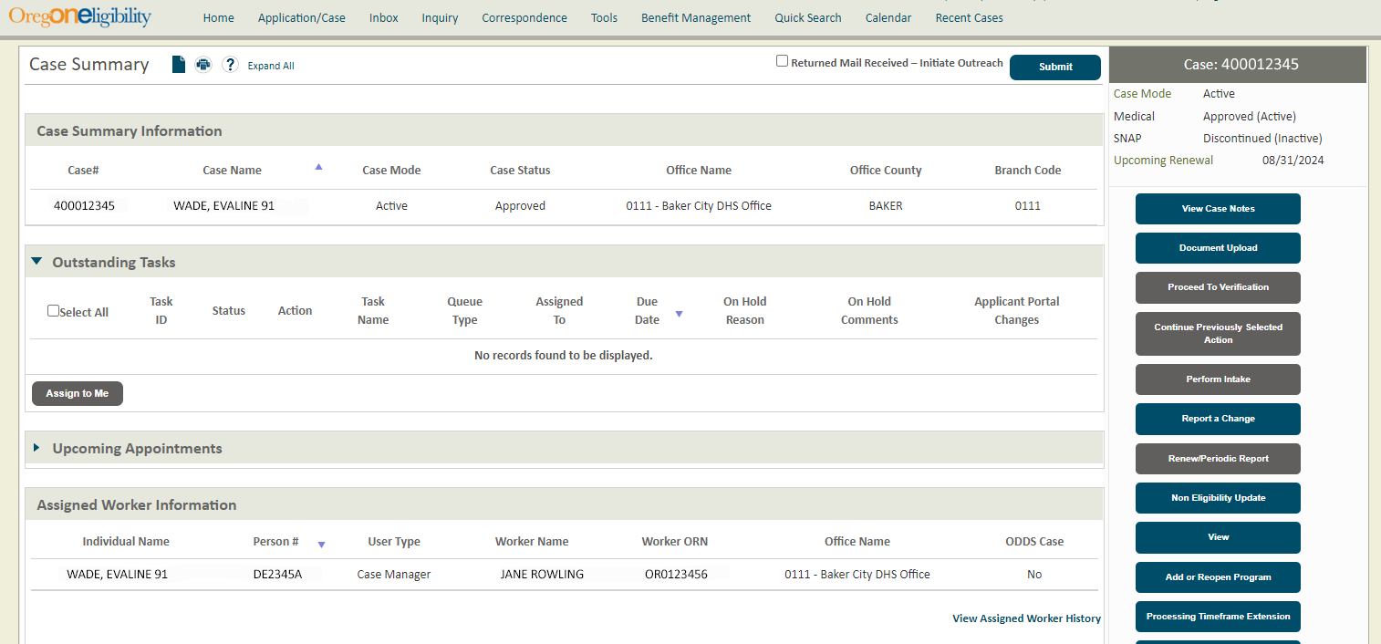

### View Case Notes Button

The View Case Notes button will open a window (see below) on top of the search results. It will allow you to search and view the case notes. This is a quick way to see the latest actions that have been taken on a case.

When you close the window, you will be returned to the Case Manager Alert Log or your Dashboard, depending on where you started.

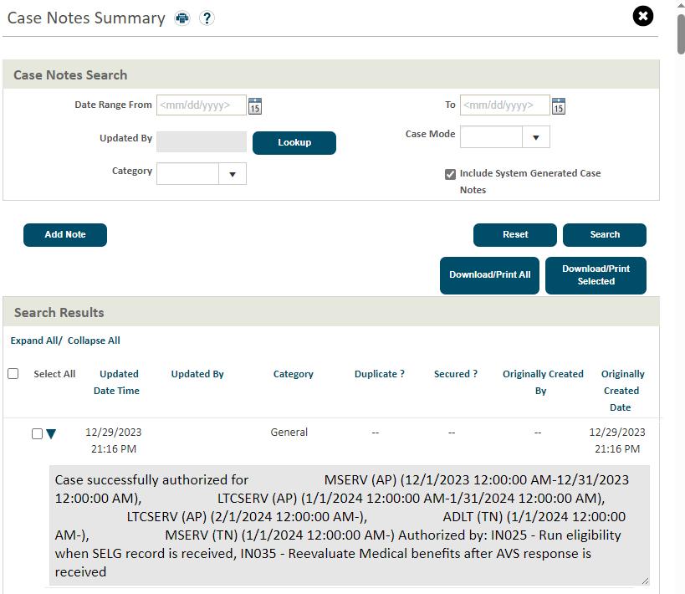

### Other Payments Button

The Other Payments button will open the Other Payments Summary in ONE (see below). Here you can review or process medical related payments for the individual. To learn more about medical related payment refer to the [Program Payments and Supports QRG](https://dhsoha.sharepoint.com/teams/Hub-DHS-ET/SiteAssets/Forms/AllItems.aspx?id=%2Fteams%2FHub%2DDHS%2DET%2FSiteAssets%2FSitePages%2FQuick%2DRef%2FQRG%5FProgram%20Payments%20and%20Supports%2Epdf&parent=%2Fteams%2FHub%2DDHS%2DET%2FSiteAssets%2FSitePages%2FQuick%2DRef).

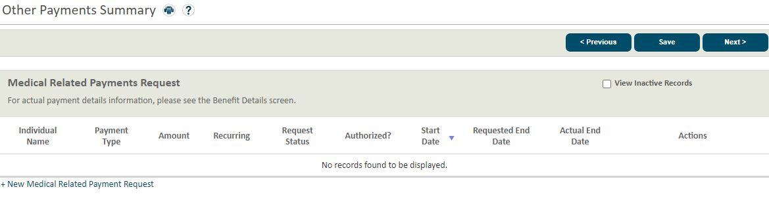

### Mark as Complete Button

The Mark as Complete button immediately moves the alert to the Completed Alerts column, there is no confirmation required for this action. So, don’t select that button until all recommended actions have been completed. As shown in the screen capture below, multiple search results can be selected to Mark as Complete at one time.

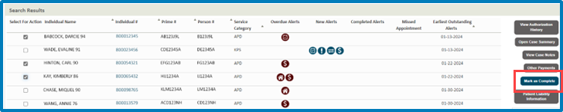

### Patient Liability Information Button

The Patient Liability Summary button opens a window over the search results (see below). This is a quick way to review liability information on the case. 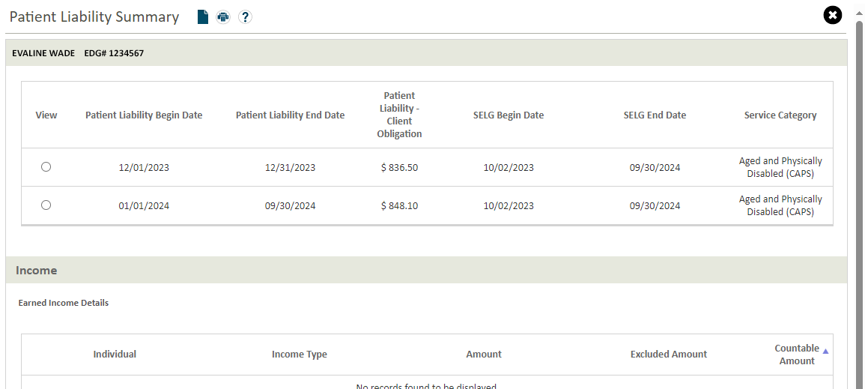

### Individual # Hyperlink

There is also an Individual # hyperlink on both the Case Alert Log and the case manager Dashboard. This is a helpful way to open a new tab in your browser and navigate to the Case Summary.

When you select the hyperlink, see red box in the screen capture below, the Individual Summary opens in a new tab 

The search results are still available in the original tab.

Once the Individual Summary is open you can select the hyperlink for the Case #, see red box in the screen capture below.

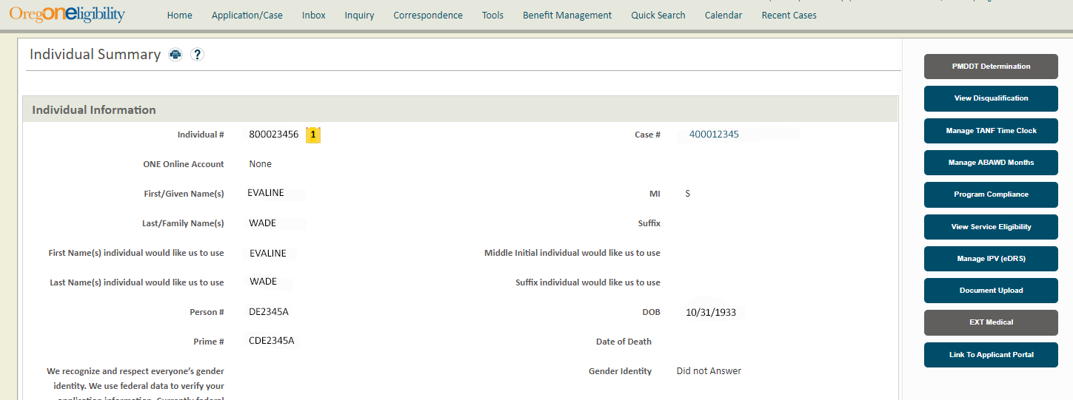

After you select the Case #, the Case Summary screen will be displayed, just as if you had completed a quick search for the case.



## ONE Updates

The updates listed below are described in the document above but listed here as well as a convenience to experienced workers.

### March 2024 Updates

* Names, on both the Case Manager Homepage and in the Case Manager Alert Log, will be displayed as Last Name, First Name Age.
* The individual number hyperlink will open the Individual Summary screen in a new tab. In earlier versions the window opened in a screen over the search results.
* There is a new button labeled Patient Liability Information. When the individual checkbox is checked and this button is selected, a window will open over the search results displaying the Liability Summary screen.

### July 2024 Updates

* A new condition for the Benefit Termination alert on the Case Manager Dashboard was added to ONE. The Benefit Termination alert for the Case Manager’s dashboard will now generate at authorization when the primary Medical Type of Assistance and/or services Type of Assistance is terminated or transitions to BHP or PME for the Individual who has an active SELG record and the SELG end date is later than or equal to the Eligibility Run date, or is pending for a SELG record. The Case Alerts Descriptions document has been updated to describe this change

### December 2024 Updates

* The Benefit Termination alert is now the Benefit Denial/Termination alert. The CM Alert Description document has been updated to note that this alert is now generated for a denial, in addition to a termination.

Contact [APD Medicaid Financial Eligibility Training](Mailto:%20APD.Training@odhsoha.oregon.gov) with any questions, accessibility requirements, or clarification needs.