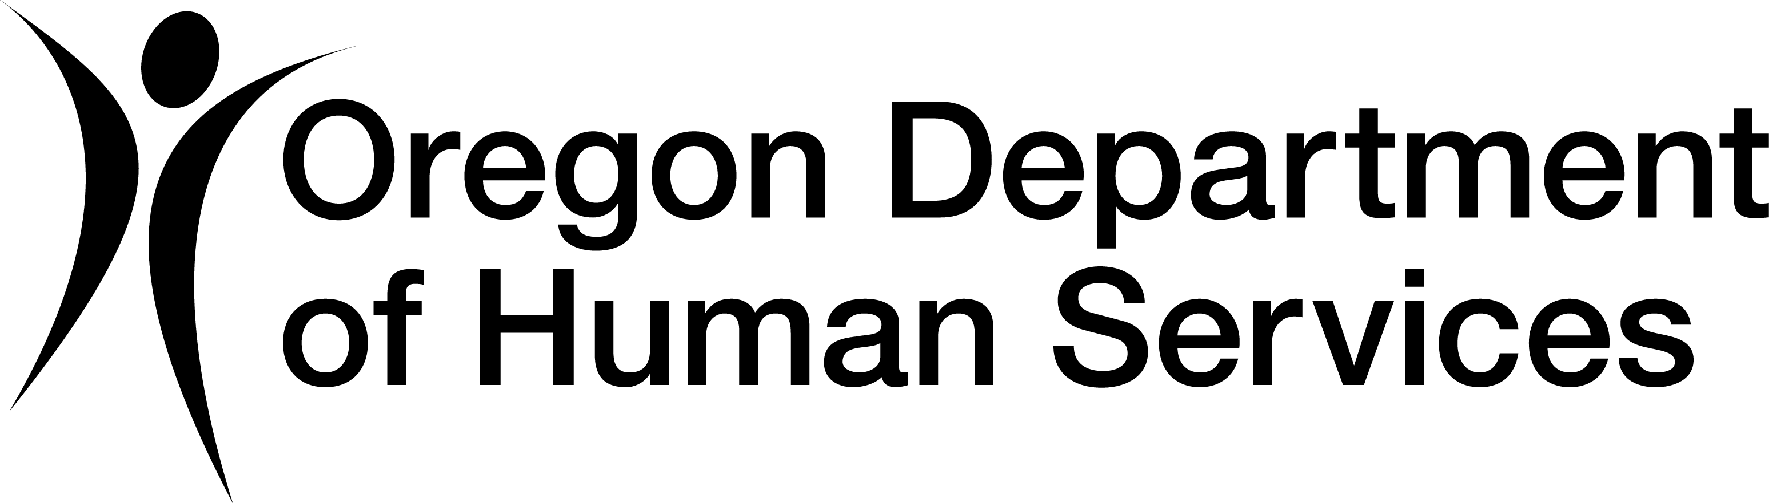 **Oregon Aging & People with Disabilities – Community Services & Supports Unit**

**OAA Disease Prevention/Health Promotion**

**Assessment Tool 2024-25**

**Due January 31, 2025. Please submit only to** [SUA.Email@odhs.oregon.gov](mailto:SUA.Email@odhs.oregon.gov).

AAA:       Date submitted:

Contact person for assessment questions:       Contact phone number:

**Part 1: Area Agency on Aging Review**

Please complete the following section for programs supported by the AAA using OAA Title IIID Health Promotion/Disease Prevention funds. Page numbers refer to Oregon’s Disease Prevention and Health Promotion Program Standards (updated 2020) found on the Community Services & Supports website. <https://www.oregon.gov/odhs/providers-partners/community-services-supports/Pages/default.aspx>

| **Disease Prevention & Health Promotion Standards** | **Yes** | **No** | **Comments or description** |
| --- | --- | --- | --- |
| 1. The AAA targets health promotion programs and outreach to elders living in medically underserved areas or who are at greatest economic need. *p. 1* |  |  | Please describe how programs prioritize those at greatest need: |
| 1. As required by the Older Americans Act, IIID funds are only used to support programs that meet ACL’s evidence-based requirements. *p. 2-3* |  |  |  |
| 1. The AAA contracts with community partners to deliver health promotion programs. *p. 3* |  |  | If the AAA self-provides any programs supported with IIID health promotion funds, please indicate why: |
| 1. The AAA uses Title IIIB or other funding to support other non-evidence-based health promotion/disease prevention such as health screenings or medication reviews. *(not required of AAAs)* *p. 4* |  |  | Please explain what types of activities and the funding source. |
| 1. In addition to in-person options, the AAA provides alternate formats for health promotion programming for consumers to access. Ex. Virtual, Hybrid.   *(not required of AAAs) p. 1* |  |  | Please explain what other health promotion programing formats are offered in addition to In-Person: |
| 1. AAA staff routinely refer consumers to appropriate community programs and preventive services to support healthy aging, documenting referrals in GetCare. *p. 6* |  |  | Please explain how this is accomplished: |
| 1. The ADRC resource database includes information that is updated at least annually on community programs and resources that support healthy aging. *p. 6* |  |  | Please explain how this is accomplished: |

1. List each evidence-based supported with OAA Title IIID funds. For each program, please indicate if the AAA contracts with a partner to provide the program, or directly provides the program using their own staff/volunteers. Please also indicate if the AAA uses any other funds in addition to IIID to support each program (e.g., state health promotion funds, IIIB, funds from healthcare partners).

|  |  |  |  |
| --- | --- | --- | --- |
| **List each evidence-based program your AAA supports with OAA Title IIID funds:** | **Partner provides program** | **AAA provides program** | **Name of partner implementing each program, and any additional funding used to support each program.** |
|  |  |  |  |
|  |  |  |  |
|  |  |  |  |
|  |  |  |  |
|  |  |  |  |
|  |  |  |  |
|  |  |  |  |

1. Please briefly describe any substantial changes in how the AAA supports health promotion programs since monitoring was last completed in February 2023, including changes to partnerships and/or delivery of health promotion programs.

1. Please describe if the AAA coordinates with other community partners to support community policies or strategies such as age-friendly communities, health policies to support health of older adults.

1. Please describe if the AAA has developed contracts to obtain reimbursement from health plans or CCOs, or is working towards agreements as a AAA or as part of the Oregon Wellness Network (OWN).

1. What are the AAA’s top unmet needs or challenges in providing health promotion/disease prevention services?

1. Any additional comments?

**Part 2: Successes/Best Practices and Plans to Address any Identified Gaps**

1. Please note any successful strategies, tools, or best practices that the AAA feels are worth celebrating and might be willing to share with other AAAs.

1. Please identify any areas where your AAA or program partners are not fully meeting the standards, need assistance to meet the standards, or need to take further steps to reach a program goal.

| **Issue where AAA is not yet meeting standards, or facing challenges** | **Proposed plan or steps the AAA will take.** | **Lead or responsible person** | **Goal date for completion** |
| --- | --- | --- | --- |
|  |  |  |  |
|  |  |  |  |
|  |  |  |  |
|  |  |  |  |

**Due January 31, 2025. Please submit to** [SUA.Email@odhs.oregon.gov](mailto:SUA.Email@odhs.oregon.gov). Thank you!