Oregon Vegetation Zones
Vegetation zones are areas with similar groups of plants.
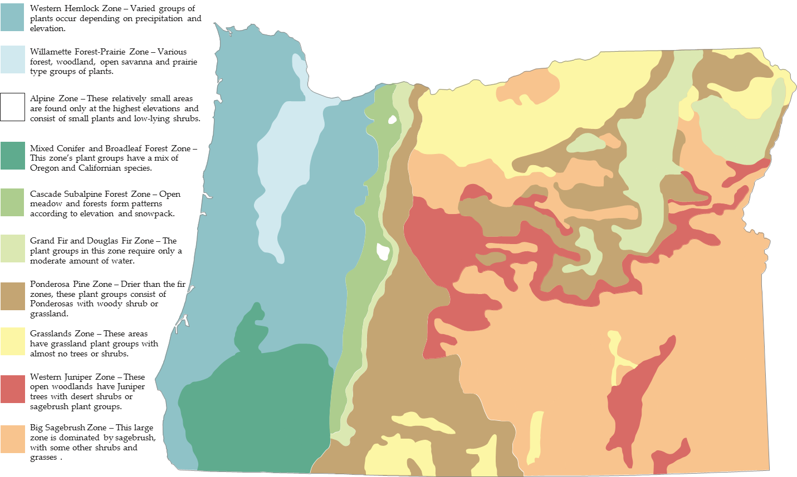

Source: Center for Geography Education in Oregon, Portland State University. The Student Atlas of Oregon. Used with permission.

