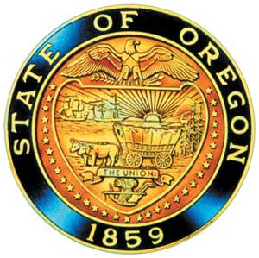
Kate Brown, Governor

AI/AN Advisory Committee Members

Chair Tamara Henderson
Vice Chair Leilani Sabzalian
Angie Fasana
Portland, Position Open
Beaverton/ Hillsboro, Open
Sonya Moody-Jurado
Molly Hockema
Alternate: Marsha Frost
Chris Mansayon
Juliana Marez
Julie Bettles
Luhui Whitebear
Modesta Minthorn
Alternate: Pamela Shippentower
Nicole Butler-Hooten
Robin Butterfield
Sandy Henry
Shelby Maerz
Valerie Switzler
Diane Teeman

Office of Indian Education
April Campbell, Director
Renee Roman Nose, Native American Student Success Coordinator
Brent Spencer, Indian Education Coordinator
Brandon Culbertson, Education Engagement Coordinator
Stacy Parrish, Indian Education Specialist
Raina Reece, Executive Support Specialist
Jennifer Belle, Office Specialist
Natalie Altermatt, Executive Support Specialist

2023 Meeting Dates
March 14th, 2023

American Indian/Alaska Native Advisory Committee
February 14th, 2023
9:30 a.m. – 12:00 p.m.
Oregon Department of Education
Join by Zoom

AGENDA

9:30 1.0 Call to Order, Opening Remarks Chair Henderson
1.1 Opening Blessing TBD
1.2 Committee Roll Call/Introductions
1.3 Introductions & Welcome to Partners Chair Henderson

9:40 2.0 Review of January 2022 Minutes All

9:45 3.0 AI/AN Advisory Committee Business
3.1 Open Seats: Potential Applicant Introduction
Kainoa Sandberg – Beaverton

9:55 4.0 Updating AI/AN Student Success Plan
Full Group:
4.1 Jamboard and SSA Plan Discussion
4.2 Breakout Session: Goal 4 Objective 2 10:15
4.3 Breakout Session: Goal 4 Objective 3 10:35
4.4 Breakout Session: Goal 4 Objective 4 10:55

10:55 Break

11:05 4.5 Breakout Session: Goal 5 11:25
4.6 Community Discussion – 1 hour open review

11:45 5.0 Community Comment Chair Henderson
Public testimony may be submitted ahead of time in writing to
AIAN.AdvisoryCommittee@OregonLearning.org
11:50 6.0 Other Business and Next Meeting Agenda Items All
6.1 Proposed March 14th meeting 9:30 a.m. – 12:00 p.m.
6.2 AI/AN Advisory Committee letters
6.3 Next Steps

12:00 Adjourn

