Submit a Claim by Upload – for Centers

To submit a monthly site-level reimbursement claim using an upload file for the Child and Adult Care Food Program:

**Contents of this document:**

* Prepare your claim upload file
* Upload Prepared File to a Monthly Claim
* To See Reimbursement Value for your Monthly Claim
* To Submit Monthly Claim for Payment
* Troubleshooting

## Prepare your claim upload file

(For full technical specifications, see our File Upload Technical Specifications document)

**Step 1:** Open the CACFP Claim Upload Template for Centers in Excel. **Step 2:** Enter your sponsor data in row 10, referring to the Header Information line (3) and Sample Header line (4) for what to enter for each field.

**Step 3:** Enter data for each Center, one row per Center, and beginning with row 11. Refer to the Site Record information line (7) and Site Record Sample row (8) for what to enter in each field.

**Step 4:** Delete rows 1-9. (Highlight these rows, right click on highlighted area, click Delete)

**Step 5:** Click on **File**, then **Save As…**

Excel opens a **Save As…** dialogue box

**Step 6:** Select the location on your computer or network drive where you want to save the file. Make sure you remember where it is saved.

**Step 7:** Type a name for your file in the **File Name** field.

Suggestion: name your file something that tells you what it is, and is easy to remember. One idea would be to use the initials of your sponsor name, the month and year, and the word claim: KLR112007claim

**Step 8:** In the **Save As Type** Field, click the down arrow to the right and select “CSV (Comma Delimited) (*.csv)”

**Step 9:** Click **Save**

Excel will save the file as a CSV (the file must be in this format in order to upload). Note: the csv format is more limited than excel (such as it can only have 1 worksheet) so the file may be saved slightly differently from what you expect.

## Upload Prepared File to a Monthly Claim

**Step 1:** In the address bar of your internet browser, enter the website: <https://cnp.ode.state.or.us>

*CNPweb* Login page displays

**Step 2:** Enter your CNPweb user ID and password

**Step 3:** Click **Login**

**Step 4:** click on the **CACFP puzzle piece**

*CNPweb* displays the **“Splash”** page. (review the announcements posted here before entering CNPweb)

**Step 5:** Click **“Continue”** on the Splash page

CNPweb displays the **Program Year Selection** page

**Step 6:** Select the program year that needs a monthly claim submitted

* If you are assigned to only 1 Sponsor, *CNPweb* will display the **Sponsor Summary** page for your Sponsor
* If you are assigned to more than 1 sponsor, *CNPweb* will display the **Select Sponsor** page. At this page, select the sponsor that you wish to submit a claim for. *CNPweb* will then display the **Sponsor Summary** page for the selected Sponsor

**Step 7:** On the **Sponsor Summary** page,Click on the Claims tab to display the **Sponsor Summary-Claims** page.

**Step 8:** Locate the claim month.

**Step 9:** Click the icon of a stack of papers with an arrow by it  in the Action Column on the far right. (the icon should appear directly to the left of the Add option)



CNPweb will display the **Claim File Upload** page.

**Step 10:** Click **Browse**

CNPweb will open a File Selection dialog box

**Step 11:** Locate the claim upload file for this claim month and highlight it.

**Step 12:** Click **Open** in the dialogue box.

The highlighted file name appears on the Claim File Upload window.

**Step 13:** Click **Upload File**.

The CNPweb uploads the file and evaluates the file format.

* If the file format does not match the file layout technical specifications, the CNPweb reports a list of errors on the **Claim File Upload** page. You must fix the errors and try again, or manually create the claim by site. For assistance in correcting errors or if you’re not sure why your file was not acceptable, please see the Troubleshooting Section.
* If the CNPweb successfully creates the claim from the upload file, it displays the Claim File Upload page with the message “Claim Created.”

**Step 14:** Click “**here**” in last line of text to display the **Sponsor Summary**.

The CNPweb displays the Sponsor **Claim Entry - Claims** page.

* If the file was uploaded without errors the status is “**Pending Submission**”. At this point, it is a good idea to open (View) each site claim to double-check that the file was uploaded properly. If the sites are correct, go to Step 21.

**Step 15:** Click folder +/- icon to the left of the claim month to expand list of sites.



* Sites with a status **Complete** have been successfully uploaded and passed the business rules and need no further editing. Go to Step 21.
* Sites with a status **Errors** have been successfully uploaded but have failed some business rules that must be corrected before the Sponsor claim can be submitted for payment.

**Step 16:** Click **Edit** for a site with errors.

The CNPweb displays the **Site Claim** page.

**Step 17:** Review the error messages and make corrections as needed

**Step 18:** Click **Submit**

The CNPweb checks the claim form for input errors.

* If the CNPweb finds errors, it displays the appropriate post confirmation page with the **Errors** status. You must correct all errors and resubmit your claim. For assistance in correcting errors, please see the Troubleshooting Section.
* If the CNPweb finds no errors, it displays the appropriate post confirmation page with the Complete status

**Step 19:** Click the “**here**” link to display the claims listing page.

**Step 20**: Repeat Step 16 through Step 19 for each site claim with errors.

**Step 21:** Locate the sponsor claim for this month on the **Sponsor Summary -**

**Claims** page.

**Step 22:** Click **Edit** in the “Action” column on far right.

The CNPweb displays the filled –in **Sponsor Claim** form.

**Step 23:** Check meal counts to ensure they are correct.

**Note – Even if the file uploaded was error-free and the Sponsor claim has no errors, it will only have a status of **Pending Submission** until the Certify checkbox is checked on the Sponsor Claim. At this point, the claim is not submitted to ODE for Approval.

## To See Reimbursement Value for your Monthly Claim

**Step 24:** Scroll to the bottom of the claim form.

The CNPweb displays the bottom of the claim form with the Submit button.

**Step 25:** Click **Submit**.

The CNPweb displays the Sponsor Claim Summary page with the claim payment information.

**Step 26:** Click the “**here**” link at the bottom of the page to display the Sponsor

Summary - Claims page.

## To Submit Monthly Claim for Payment

**(Once you do this any revision must wait until the claim has a status of “Paid”)**

**Step 27:** Click **Edit** in the “Action” column on far right.

The CNPweb displays the filled –in Sponsor Claim form

**Step 28:** Scroll to the bottom of the claim form.

The CNPweb displays the bottom of the claim form with the Submit button.

**Step 29:** Check the payment checkbox and click **Submit**.

The CNPweb displays the Sponsor Claim Summary page with the claim information and status.

## Troubleshooting

**Common Problems and Solutions:**

|  |  |
| --- | --- |
| **Problem** | **Steps to solve** |
| My **file will not upload**. When I try to upload my file, I get a message saying Claim Not Created. | There is something wrong with the format or creation of your document. Double check these common problems, and re-try your upload:   1. Document is saved as .xls type    * Save As… a .CSV file type before uploading 2. Data was entered in the wrong field in document    * Consult the Upload Template or Upload Technical Specifications document you used to create the file 3. The Template “example” fields were left in the file    * Delete all rows and columns except those with your data, and resave file   The error message listed on the “claim not created” page should also provide some assistance in determining how to resolve an error. |
| My **data uploaded into the wrong fields.** | Sometimes a file will still be accepted by CNPweb even if you accidentally placed the data in the wrong fields. In this case, you can either fix the mistake in each Site Claim manually, or you can delete the monthly claim and re-upload it with a corrected file. Since an upload is only accepted for the original claim for each month, you will need to Delete each Site Claim and the Sponsor claim before re-uploading the corrected monthly claim file. |
| **Validation error** (this is an error found by comparing one field with other data either on this form or on a form in the approved Application Packet. Example: you’ve claimed suppers, but your approved Site Information Sheet lists your site as serving only Breakfast and Lunch.) | 1. Find the field or field number highlighted in red 2. Read the error message relating to this highlighted field 3. Review the requirements for this field in the detailed field descriptions included in Step 16 of the To Complete a Monthly Reimbursement Claim section. 4. Make the appropriate changes. 5. If Error still is not resolved, continue to next question below: “Validation error won’t go away…” |
| **Validation error won’t go away**, and the data I entered is correct! (most commonly caused when the approved Site Information Sheet has incorrect information. Example: the Site information sheet lists that this Site only serves Breakfast, but it really serves Breakfast and Lunch.) | 1. Find the field or field number highlighted in red 2. Double check that the data you entered is correct 3. Exit claim, and click on Applications tab on the Sponsor Summary 4. Find the Site Information Sheet for the Site in question 5. Review the Information Sheet to make sure the information there is correct |
| A **Site** I need to claim for **is not listed** (when Sponsor Claim is expanded to display Sites expected to submit a claim) | 1. Exit claim, and click on Applications tab on the Sponsor Summary 2. Find the Site Information Sheet for the Site in question 3. Review the Information Sheet to make sure the information there is correct (the most common mistake is that the checkbox for the month in question is unchecked on the Site Information Sheet) 4. Work with your ODE Specialist to make the necessary revisions to the Site Information Sheet. 5. Return to Claims tab – Site should now be included on displayed list |
| A **Site is listed which was not operational** or for which I do not intend to submit a claim for this month (when Sponsor Claim is expanded to display Sites expected to submit a claim) | ** If it is a For-Profit site which simply did not meet the eligibilty requirements this month, fill out all fields as usual, but click the second option on field #17.  *For all Others:   1. Exit claim, and click on Applications tab on the Sponsor Summary 2. Find the Site Information Sheet for the Site in question 3. Review the Information Sheet to make sure the information there is correct (the most common mistake is that the checkbox for the month in question is checked on the Site Information Sheet when it should be unchecked) 4. Work with your ODE Specialist to make the necessary revisions to the Site Information Sheet. 5. Return to Claims tab – Site should no longer be included on displayed list |
| The instructions say **I should get a Post Confirmation message**, but I do not get that message at this step. | You may have triggered an input error. This type of error will not allow you to submit the form. When you click Submit, it will bring you to the top of the form, and the error message will display. If this is the case, See Input Error section above  You may be getting a message that states that a record has not been created (often, this will state that this submission is a duplicate submission). In this case, click the “here” link provided to return to the Sponsor Summary-Claims page. Review the claim status on this page and add or edit the Site Claim as needed. |
| **Sponsor Claim is in Error** Status | Not all Site claims have been submitted. When first creating the monthly claim you will be purposefully creating an incomplete Sponsor Claim, in order to open and add a monthly claim for each Site. It is fine for the Sponsor claim to remain in Error status until all Site claims have been entered and are in **Complete** status. Once all Site claims are entered, and all data is correct, check the Certify checkbox and Submit the Sponsor claim. |
|  |  |

**Miscellaneous Tips, Hints and Guides:**

**Quick hint: when viewing a form with errors displayed, the *CNPweb* highlights (in red) either the edges of the problem field or the field number. In most cases, this field that is marked with the highlight is the one that needs to be changed.

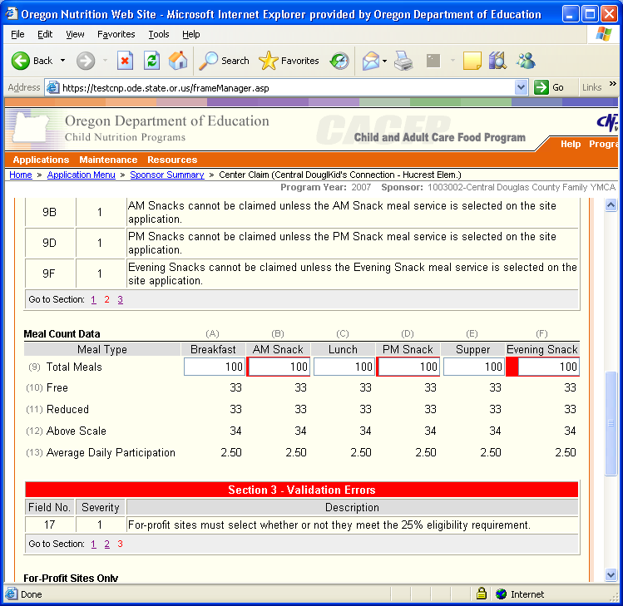

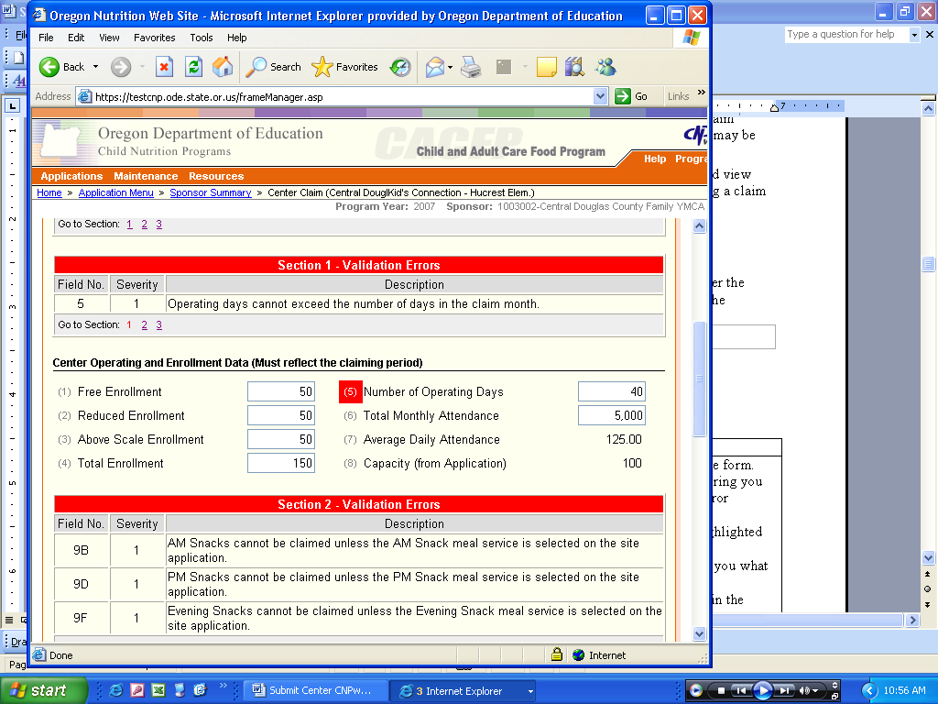

**Guide to a typical Error display:**

|  |  |
| --- | --- |
| **Section of Display** | **Description** |
| Field Number | Provides the unique field number where the error occurs. (the field or field number will be highlighted as noted above) |
| Severity (most errors will be Severity 1 and must be corrected in order to submit the form) | The CNPweb rates the severity of error.  **Severity 1** - Errors that you must correct before you submit the form approval.  **Severity 2** - Errors that you should correct before you submit the form for approval.  You must correct all errors on this form. |
| Description | A statement of the error condition, with information designed to help you fix the error. |
| Go to Section | Click on these hyperlinked numbers to quickly jump to each section with errors |

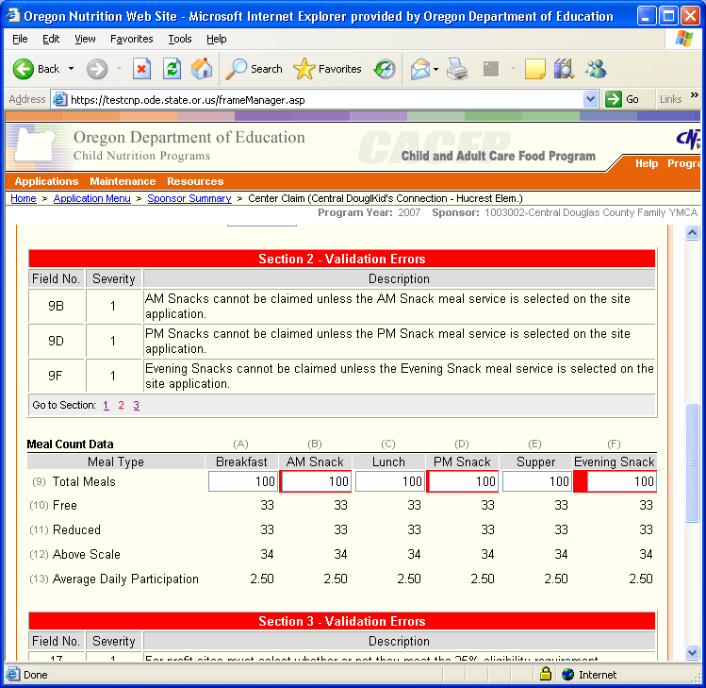

* What’s the difference between “Edit” and “Revise”?? Both are used to refer to making changes to a Claim, but the differences are based in what “change history” is saved and when in the process each one can be used.
  + When in Edit mode, changes are not tracked. The Edit option is only available until the claim is submitted.
  + When in Revise mode, changes are tracked and each version is saved. When displaying a revised form, fields that were changed the last revision are highlighted in yellow, and hovering the cursor over the highlighted field will display what information was previously entered. The Revise option is only available once a claim has reached **Paid** status.
* The CNPweb does not submit a claim to ODE for approval unless you check the Certify checkbox in the Sponsor claim - even if the claim contains no errors.

My claim has a status of ____________. What do I have to do to reach **Paid** Status???

| Current Status | Action |
| --- | --- |
| Errors | Click Edit in the “Action” column; correct each highlighted error; Click Submit; repeat as needed to correct all errors. |
| Complete | No action required on the site claim.  You must submit the sponsor claim (claim summary) to submit the site claims. |
| Pending Submission | Click Edit in the “Action” column for the Sponsor Claim; review the claim and check the payment checkbox if all is correct; Click Submit. |
| Pending Approval | No action required.  Your organization cannot change claims in this status. The OR Department of Education must review your claim if to move it forward.  If the state agency automatically approves claims from your organization, the CNPweb never assigns the **Pending Approval** status to your claims, and your claim will go directly to **Approved** status. |
| Approved | No action required.  Your organization cannot take any action on a claim with the **Approved** status. |
| Paid | No action required.  Your organization cannot edit a paid claim. If you need to submit a claim adjustment, you must revise the paid claim. |

My claim has a status of ____________. How can I **make a change** to my claim???

| Current Status | Action |
| --- | --- |
| Errors | Click Edit in the “Action” column; correct each highlighted error; Click Submit; repeat as needed to correct all errors. |
| Complete | Click Edit in the “Action” column; make corrections as needed; Click Submit. |
| Pending Submission | Click Edit in the “Action” column; make corrections as needed; Click Submit. |
| Pending Approval | No changes allowed.  Your organization cannot change claims in this status. You will have to wait until claim has the status of **Paid** in order to make any revisions.  If the state agency automatically approves claims from your organization, the CNPweb never assigns the **Pending Approval** status to your claims. |
| Approved | No changes allowed.  Your organization cannot make any changes to a claim with the **Approved** status. |
| Paid | Click Revise in “Action” column for Sponsor claim; make sure Certify checkbox is cleared and click Submit; Click Revise in the “Action” column for each Site needing revision; make changes as necessary; when you are finished revising Site claims and all Site claims have a status of **Complete**, click Edit in the “Action” column for the Sponsor claim; review Sponsor claim and check the Certify checkbox if all is correct; Click Submit. |

If, after reviewing this Troubleshooting section, you are unable to solve a problem with your Claim submission, please contact your assigned ODE Specialist. If your assigned Specialist is not available, please press zero to be redirected to another Specialist.

This institution is an equal opportunity provider