ODE USDA **DoD Fresh** Fruit and Vegetable Program:

**Allocation and Participation Policy**

Revised July 2024

Through this policy, ODE provides information and guidance to all Oregon USDA Foods Recipient Agencies (RAs) participating in the USDA DoD Fresh program regarding:

* DoD Fresh Initial Allocation Request in Feb-March
* 80/20 spending rule and April 1st cutoff
* DoD Fresh Additional Allocation Request 3 times a year
* DoD Fresh funds Adjustments and Redistribution
* Program Participation Requirements

**DoD Fresh Initial Allocation Request**

When RAs receive their new school year USDA Foods Entitlement Dollars in WBSCM (USDA Web-Based Supply Chain Management), they can choose to spend any portion of entitlement towards the USDA DoD Fresh program. This will result in less dollars available to spend on other USDA food products.

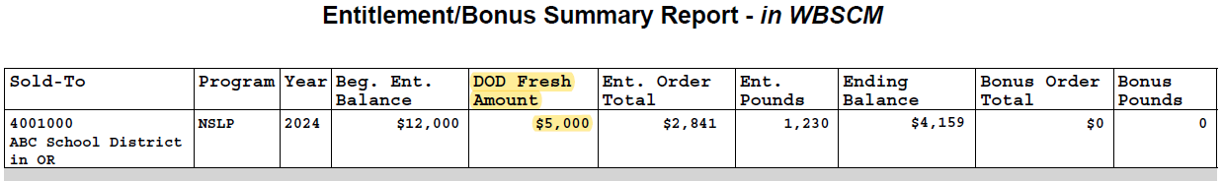In February-March, during the Annual ODE USDA Foods Ordering Period, RAs submit their DoD Fresh Initial Allocation to ODE through the Set Aside Entitlement Request form link which will be provided in the ODE USDA Foods Ordering Period Memo and emailed to all RAs in advance of the ordering season. The minimum set aside is $150. ODE reviews and approves requests, then enters the DoD Fresh requested amount in WBSCM. RAs should log in to [WBSCM](https://portal.wbscm.usda.gov/) and run an [Entitlement/Bonus Summary Report](https://www.oregon.gov/ode/students-and-family/childnutrition/USDAFoods/Documents/ODE_WBSCM_RA_Manual.pptx) to verify the DoD Fresh Amount – as illustrated in the example below:

RAs should request what they can use. We recommend RAs calculate a DoD Fresh funds spending budget they can commit to, to ensure adequate and regular spending throughout the entire school year. **Please use the** [**ODE USDA DoD Fresh Budgeting Tool**](https://www.oregon.gov/ode/students-and-family/childnutrition/USDAFoods/SiteAssets/Pages/DOD%20Fresh/DoD%20Fresh%20Budgeting%20Planner.xlsx) **to help with calculating how much set aside to request.**

**80/20 spending rule** **Back to page 1**

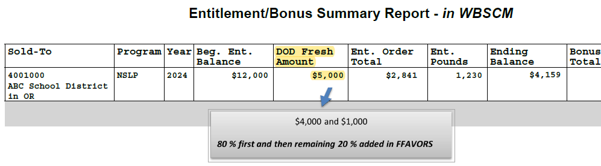DoD Fresh produce is ordered in FFAVORS, the USDA DoD Fresh Fruit and Vegetable Order Receipting System. Per regulations, ODE first distributes in FFAVORS 80% of the DoD Fresh Initial Allocation that was entered in WBSCM. Once the first 80% DoD funds are spent, the remaining 20% is added in FFAVORS as illustrated in the example below:

The DoD Fresh Initial Allocation for one school year should be spent based on the 80/20 spending rule between July 1st and June 30th (last delivery day).

RAs should check their current DoD funds balance from within the [FFAVORS](https://www.eauth.usda.gov/eauth/b/usda/login?TRYIWA=TRUE&TYPE=33554433&REALMOID=06-e76a01d1-4e49-44b9-86bd-23921f5d5a49&GUID=&SMAUTHREASON=0&METHOD=GET&SMAGENTNAME=-SM-ruBZk6iJyoW3jD0lLcHekpimqvbENzLTwvTtqQW%2B3G3lZQA8cGaijwfBKZQkCV5eQAIESicIQDFMxoy%2BouW4Ia9TPaD3rBA5YUxQgLAPXaEeIfaRe675rnzWuyJZB1xc&TARGET=-SM-https://ffavors.fns.usda.gov/ffavors_web/usdaproduce/default.aspx) ordering process to keep track of their spending as shown in the example below: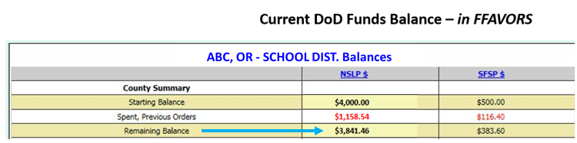

RAs participating in DoD Fresh Summer Food Program will have the SFSP $ column next to the NSLP $.

**April 1st cutoff**

Although ODE monitors spending and adds remaining 20% amounts regularly in FFAVORS, RAs should contact ODE to request their remaining 20% up to 2 weeks prior to running out of DoD funds, before April 1st or it will be swept on April 1st and redistributed to other DoD sponsors that can use it.

**DoD Fresh Additional Allocation Request**  **Back to page 1**

When RAs have remaining entitlement available, they may request a DoD Fresh Additional Allocation two times during the year: December 1 and March 1 each time opening for a period of approx. 2 weeks. ODE will notify RAs if the DoD Fresh Additional Allocation Request form opens, which is also contingent on ODE funding levels with USDA. ODE reviews and approves requests. When approved, ODE enters the amount in WBSCM and notifies RAs which should then verify their DoD Fresh Amount in WBSCM. The additional allocation is not added to FFAVORS until the initial 80% has been spent.

**DoD Fresh funds Adjustments and Redistribution**

DoD Fresh funds do not rollover to the next school year. To avoid waste at the end of the school year, ODE monitors spending in FFAVORS throughout the year. ODE will notify RAs that show little or no usage, or spending is not on track, and adjust their RAs’ DoD budgets. Their unused committed DoD Dollars will then be redistributed to other RAs that can utilize them. If you are not familiar with readjusting your budget based on actual spending, click [here](https://www.oregon.gov/ode/students-and-family/childnutrition/USDAFoods/Documents/DoD%20budget%20ABC%20School%20District.pdf). RAs that plan on beginning spending their DoD Dollars ‘later’ in the year should communicate their usage plan to ODE as soon as possible.

**DoD Fresh Program Participation Requirements**

* Minimum order $150
* Email contact and delivery site updates as soon as changes occur to: [ode.usdafoods@ode.oregon.gov](mailto:ode.usdafoods@ode.oregon.gov)
* Process receipts in FFAVORS within 7 days after delivery *(counting 7 days starting from the requested delivery day)*:
  + When RAs receive a ‘past due’ reminder email from ODE, they should take action and process their receipts promptly. Lack of response or continued delinquent receipts will result in technical assistance and/or corrective action such as DoD funds suspension and participation discontinued.

All program information including vendor information, poor quality reporting/complaints and crediting methods are posted in the [ODE USDA DoD Fresh website](https://www.oregon.gov/ode/students-and-family/childnutrition/USDAFoods/Pages/DOD%20Fresh.aspx).

***Questions?***

***Please email the Oregon Department of Education USDA Foods Program Team at*** [***ode.usdafoods@ode.oregon.gov***](mailto:ode.usdafoods@ode.oregon.gov)***, do not contact USDA or FFAVORS.***

Back to Top of Document