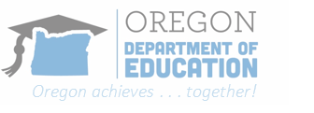
Child Nutrition Programs/School Nutrition Programs

National School Lunch Program
FY 2022-2024 Equipment Assistance Grant
Cover Page

SFAs must complete a separate Equipment Application for each equipment unit
Must submit to: Bethany.Moreland@ode.oregon.gov before Thursday February 16, 2023 by 1:00 pm

Program Sponsor Name: | NSLP Sponsor Agreement #: | Total # of Schools Applying for:
Contact Name and Title: | Email: |  | Phone #:

- List the school site(s) for which you are applying for funding.
- Note that each single equipment unit for each school/site is scored individually.
- There is no limit to the number of schools you may apply for, but it is not guaranteed.
- Priority will be given to high need schools.
- The requested equipment must have a useful life of more than one year and a per-unit acquisition with a value of greater than $1,000 but less than $50,000.
Please indicate in the priority left column below, 1, 2, 3 etc. in order of what is the priority for you.
Priority | Equipment | Equipment Amount | School

