Oregon’s Farm to School and School Garden Resource People

Topic (not in any particular order) | Who to contact  (see next pages for contact info)
Getting started with or expanding local purchasing | Melina Barker
Finding farmers, Farmers selling to schools | Amy Gilroy
Food safety for school gardens | Rick Sherman
Food safety for farms | Amy Gilroy
School gardens & chickens/pollinators | Rick Sherman
Regional Education and Procurement Hubs | Melina Barker
Farm based education, farm field trips | Melina Barker
Starting and maintaining school gardens | Amoreena Guerrero, Mindy Bell,  Betsy Lattig, Rick Sherman
School garden curriculum | Amoreena Guerrero, Betsy Lattig,  Mindy Bell
Garden-based after school programs | Amoreena Guerrero, Betsy Lattig,  Mindy Bell
Afterschool Garden Clubs | Matt Laughter
Oregon’s Farm to School and School Garden Grants | Rick Sherman, Amy Lahrman, Emily Griffith
Oregon Harvest for Schools | Rick Sherman, Amy Lahrman, Emily Griffith
Farm to Summer | Rick Sherman, Amy Lahrman, Emily Griffith
ODE’s Fresh Fruit & Veggie Program | Rick Sherman, Amy Lahrman, Emily Griffith
Farm to early care and education | Angela Hedstrom
Higher Ed. And Extension | Michelle Markesteyn
Geographic preference rules | Rick Sherman
Advocating for state policies | Melina Barker
Research and evaluation | Michelle Markesteyn
Media, communications & marketing | Michelle Markesteyn
Oregon Farm to School Producer Awards  Oregon Farm to School Infrastructure Grant | Amy Gilroy
FoodCorps | Aaron Poplack
Oregon Farm to School and School Garden Network | Melina Barker
National Farm to School Network | Rick Sherman
Farm to School with Oregon Dairy  Fuel Up resources Learning plans that align with NGSS. | Crista Hawkins
Oregon Agriculture in the Classroom | Jade Davidson
Future Farmers of America | Reynold Gardner
4H | Kelly Noack
Adopt-a-Farmer | Mallory Phelan
USDA Farm to School Program | Kari Kramer
OSU Master Food Preservers, | Jared Hibbard-Swanson
Grow This, Seed to Supper, OSU Master Gardeners | Tyler Spofford
Food Hero: Recipes/ingredients for home and school | Lauren Tobey
Farm to School Podcast | Rick Sherman, Michelle Markesteyn
Other questions? | Melina Barker

Contact Information for Resource People
Melina Barker 541-890-7004
Program Manager, Oregon Farm to School and School Garden Network
melina@oregonfarmtoschool.org www.oregonfarmtoschool.org
Amy Gilroy  Farm to School Program Manager  Oregon Department of Agriculture  amy.gilroy@oda.oregon.gov 503-709-5360 | 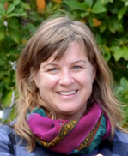
Michelle Markesteyn, PhD
Farm to School Coordinator
Oregon State University Extension
Founder, Rootopia
michelle.markesteyn@oregonstate.edu 503-476-6080 https://extension.oregonstate.edu/farmtoschool
Rick Sherman  Farm to School Analyst  Oregon Department of Education  Rick.Sherman@ode.oregon.gov 503-385-6998 bit.ly/f2sor | 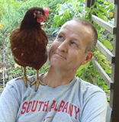
Wren Huff
Admin Support, Oregon Farm to School and School Garden Network
wren@oregonfarmtoschool.org www.oregonfarmtoschool.org

Amy Lahrman  Farm to School Administrative Assistant,  Oregon Department of Education  amy.williams@ode.oregon.gov 971-273-9978 bit.ly/f2sor | 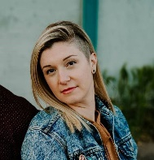
Emily Griffith
Farm to School Administrative Assistant,
Oregon Department of Education
Emily.griffith@ode.oregon.gov 971.720.9611 bit.ly/f2sor
Angela Hedstrom
Farm to School Coordinator
Ecotrust
ahedstrom@ecotrust.org 503.467.0790 www.ecotrust.org
Kari Kramer
Farm to School Program Specialist, USDA Food and Nutrition Services
Western Regional Office, San Francisco CA kari.kramer@usda.gov 202.956.9022
https://www.fns.usda.gov/farmtoschool/farm-school
Amoreena Guerrero
Youth Grow Director, Growing Gardens
amoreena@growing-gardens.org 503-284-8420
www.growing-gardens.org
Betsy Lattig
Youth Grow Lead Educator, Growing Gardens
betsy@growing-gardens.org 503-284-8420
www.growing-gardens.org
Matt Laughter  Youth Grow Lead Coordinator, Growing Gardens  matt@growing-gardens.org 503-284-8420  www.growing-gardens.org | 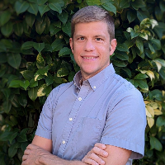
Reynold Gardner
(FFA Advisor) Agricultural Education - Natural Resource Education Specialist Oregon Department of Education
Reynold.gardener@ode.oregon.gov 503.947.5615
Mindy Bell
Executive Director, School Garden Project of Lane County
mindy@schoolgardenproject.org 541.284.1001
https://www.schoolgardenproject.org/
Crista Hawkins
Director of School Programs, Oregon Dairy & Nutrition Council
chawkins@odncouncil.org 503.229.5033
https://odncouncil.org/
Jared Hibbard-Swanson, PhD  Program Manager for Food Security and Safety  hibbajar@oregonstate.edu  https://health.oregonstate.edu/people/jared-hibbard-swanson | 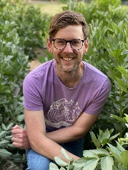
Jade Davidson
Executive Director, Oregon Ag in the Classroom
Jade.davidson@oregonstate.edu
https://oregonaitc.org/
Mallory Phelan
Director of Community Outreach, Oregon Adopt a Farmer
info@aglink.org (503)595-9121 http://www.aglink.org/
Kelly Noack  Professional Faculty, Outreach Coordinator, Oregon State University  kelly.Noack@oregonstate.edu (503)373-3751 https://extension.oregonstate.edu/4h/marion | 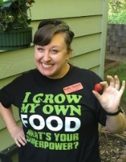
Aaron Poplack  Oregon Program Manager, FoodCorps  aaron.poplack@foodcorps.org  503-558-6374  https://foodcorps.org/ | 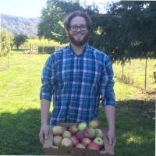
Tyler Spofford  SNAP-Ed Gardening Program Coordinator  sporrort@oregonstate.edu  https://extension.oregonstate.edu/people/tyler-spofford | 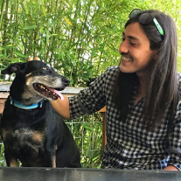
Lauren Tobey
Associate Professor of Practice, Food Hero Social Marketing Coordinator
Oregon State University Extension lauren.tobey@oregonstate.edu
541-737.1017 Food Hero

