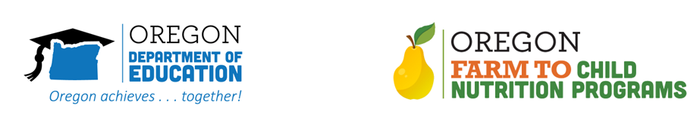

Tell Your Story - Social Media

School districts can share their stories about the impact of their farm to school program by using multiple communication strategies.

Photos & Video - Photos or videos are easy to film using your mobile phone, simple to edit and cost nothing to distribute. Photos and videos can highlight students in action, learning or making healthy food choices.

Social Media - Suggested social media posts related to your school/district program.
(SAMPLE SOCIAL MEDIA POSTS) -

In [DISTRICT] we are using our #farmtoschool program to create valuable hands-on learning for students in XXXX community. Read more [LINK TO DISTRICT PAGE]

Kids are excited and ready to learn about healthy food thanks to DISTRICT #farmtoschool program.

By investing in #farmtoschool we can increase student attendance, reduce dropout rates, and promote engagement. Learn more: [LINK]

