School Age: Individual Procedural Compliance Review (PCR)

SPR&I 2021-2022

Contents
Overview 4
Getting Ready to Review PCR Data 4
Step 1: Log In 4
Step 2: View the SPR&I dashboard 4
Step 3: Student File Selection 4
Verification Prior to Reviewing File 5
Step 4: Student File Confirmation 5
Step 5: Lock-In Criteria 5
Step 6: Notes on lock-in items (A-L): 5
Step 7: Eligibility and Census Verification 6
Step 8: To Replace Student 6
Step 9: Lock In 6
PCR File Review 6
Step 10: PCR Review Form 6
Step 11: Data Entry 6
Step 12: Submit All PCR Files 7
Standard 16: Transition Age Student Invited… IEP Team Meeting Notice 7
Guidance for Standard 7
Corrective Action Required for Standard in the Event of Non-Compliance 7
Standard 22: Agency Participation… IEP Team Members 7
Guidance for Standard 7
Corrective Action Required for Standard in the Event of Non-Compliance 7
Standard 26: PLAAFP Contains Academic Performance and Functional Performance (IEP Content) 8
Guidance for Standard 8
Corrective Action Required for Standard in the Event of Non-Compliance 8
Standard 27: PLAAFP Contains AATA and PINS 8
Guidance for Standard 8
Corrective Action Required for Standard in the Event of Non-Compliance 8
Standard 31: Annual Goals 8
Guidance for Standard 8
Corrective Action Required for Standard in the Event of Non-Compliance 9
Standard 33: Goals Align to Transition Services 9
Guidance for Standard 9
Corrective Action Required for Standard in the Event of Non-Compliance 9
Standard 34: Appropriate Post-Secondary Goals 9
Guidance for Standard 9
Corrective Action Required for Standard in the Event of Non-Compliance 10
Standard 35: Post-Secondary Goals Updated Annually 10
Guidance for Standard 10
Corrective Action Required for Standard in the Event of Non-Compliance 10
Standard 36: Transition Services Included 10
Guidance for Standard 10
Corrective Action Required for Standard in the Event of Non-Compliance 11
Standard 37: Course of Study 11
Guidance for Standard 11
Corrective Action Required for Standard in the Event of Non-Compliance 11
Corrective Action Guide 11
Step 13: Individual Corrections 11
Guidance 11
Step 14: Additional File Review 12
Step 15: Systemic Issues 12
Guidance 12
Discipline Files 13
Standard 1: Procedural Safeguards 13
Guidance for Standard 13
Corrective Action Required for Standard in the Event of Non-Compliance 13
Standard 3: Prior Written Notice 13
Guidance for Standard 13
Corrective Action Required for Standard in the Event of Non-Compliance 14
Standard 24: Special Factors 14
Guidance for Standard 14
Corrective Action Required for Standard in the Event of Non-Compliance 14
Standard 46: Manifestation Determination 14
Guidance for Standard 14
Corrective Action Required for Standard in the Event of Non-Compliance 15
Standard 47: Manifestation Determination 15
Guidance for Standard 15
Corrective Action Required for Standard in the Event of Non-Compliance 15
Individual PCR Form 16
Discipline PCR Form 17
Screen Shots 18
Screen Shot #1… Log In 18
Screen Shot #2… View the SPR&I Dashboard 18
Screen Shot #3… Student File Selection 19
Screen Shot #4… Student File Selection More Information/Less Information 19
Screen Shot #5…. Student File Confirmation…. Lock in Criteria 20
Screen Shot #6… Replace a File 20
Screen Shot #7… PCR Review Form 21
Screen Shot #8… Data Entry 21
Screen Shot #9… Submit all PCR Files 22
Screen Shot #10… Individual Corrections 22
Screen Shot #11… Individual Correction… Individual Students 23
Screen Shot # 12… Verify Status & Next… Making Corrections 23
Screen Shot #13… Additional Reviews 24
Screen Shot #14… SSID Master List 24
Screen Shot #15… Additional File Reviews 25
Screen Shot #16… Systemic Issues 25
Screen Shot # 17…Intervention Master List… Systemic Issues List 26

Overview

Districts and programs must conduct special education programs and provide special education services according to applicable federal and state laws and regulations, primarily the Individuals with Disabilities Education Act (IDEA), Part B (34 CFR Part 300), Oregon Revised Statutes (ORS) Chapter 343, and Oregon Administrative Rules (OAR) Chapter 581, Division 15.
- This form is used to review student file information for compliance with these requirements as one component of the state’s general supervision responsibilities.
- This document contains selected IDEA and OAR requirements, referred to as “compliance standards” or “standards” and file review guidance to help ensure consistent understanding and application of federal and state law, as well. The document also indicates the required corrective action for each standard marked out of compliance.
- This form contains standards in each of the following categories:
- IEP Meeting Notice
- IEP Team Members
- IEP Content
- Discipline Removal

Getting Ready to Review PCR Data

Step 1: Log In
- Using the district’s secure password, log into the system via the ODE District website.

See Screen Shot #1…. Log In

Step 2: View the SPR&I dashboard
- The SPR&I dashboard will appear. Check the dashboard for any notices or updates. Always check to make sure you are working in the correct school year. During a district’s initial login each school year, they will need to answer questions related to IEPs within the district (i.e., “What IEP Form are you using?” and “What IEP system/program are you using?”) before the dashboard appears.
- Click on Individual Corrections.
- NOTE: The dashboard light will remain red until the PCR is submitted. During the ODE verification period, the light will remain yellow. The light will turn green when the ODE verification process is complete and all noncompliance within individual files has been corrected.

See Screen Shot #2…. View the SPR&I Dashboard

Step 3: Student File Selection
- The system will automatically select the required number of students for each district. Additional files will be added for district charter schools and when a district has a contract with ODE to provide education services to a program [examples include: Long Term Care & Treatment (LTCT) and Youth Corrections (YCEP)]. Files listed in bold print require action.
- For further demographic information regarding the students, click on More Detail located in the File Info box. Student information is based on the December 2019 SECC data collection. Click on Less Detail to remove all demographic information except for the student name.

See Screen Shot #3…. Student File Selection
See Screen Shot #4…. Student File Selection, More Information/Less Information

Verification Prior to Reviewing File

Step 4: Student File Confirmation
- The PCR review begins with district confirmation of the student file selection. Click on the name of the student whose file is to be reviewed.
- Lock in students through SPR&I. Only lock in and review students who are currently IDEA eligible and are currently being served by the district/program.
- Once a student is locked in, print a file review form for that student using the “Print Blank Form” function. This blank form will have the student’s name and SSID number, and will contain only those standards that apply to the student based on the information provided during the lock in process. Alternatively, one can review the standards unique to the file being reviewed electronically, by using the system screen to directly review and mark the standards specific to that file.
- OAR 581-015-2010 (Census and Data Reporting); OAR 581-015-2120 (Determination of Eligibility); OAR 581-015-2200 (Content of IEP); OAR 581-015-2220 (When IEPs Must be in Effect)

Step 5: Lock-In Criteria
- List the Student’s SSID and disability code: _________________/________
- List the student’s date of birth: ____________
- List the date range of the current IEP in effect and used for the review:
Start date: ______/______ End date: ________/____
- List the student’s current grade (for the IEP in effect at the time of review, not census year grade): ____________
- Has the student been reevaluated (3 year reevaluation) since initial eligibility? O Yes O No
- Did the district establish current eligibility? O Yes O No
- Did the student transfer into district from another Oregon district with eligibility? O Yes O No
- Did the student transfer from out of state with eligibility? If yes, district must have established Oregon eligibility since the transfer. O Yes O No
- Will the student be taking all general assessments? O Yes O No
- Will the student be taking all alternate assessments? O Yes O No
- Will the student be taking a mix of general and alternate assessments? O Yes O No
- For the IEP in effect at the time of review, is this an initial IEP (1st year IEP)? O Yes O No

Step 6: Notes on lock-in items (A-L):
- Items A and B will be populated in SPR&I by the system since this information comes directly from the SECC.
- Item C is used with Item B to determine if transition standards apply to the student (e.g., if the student will turn 16 while the current IEP is in effect).
- Item D is used to determine if assessment standards apply for the current IEP in effect. Assessment grades include 3-8 and 11.
- Item E is used to determine if the standard for the three year reevaluation applies.
- Items F, G and H are used to determine if the current district is responsible for noncompliance during the initial evaluation-eligibility process, or if it occurred in a previous district.
- In cases where noncompliance occurred in a previous district, the current district has a responsibility to ensure the file is complete and compliant at the time of transfer. If not, the district must take appropriate action to make it compliant.
- Items I, J, and K are used to determine which assessment standards apply to the student.

Step 7: Eligibility and Census Verification
The student file being reviewed includes each of the following:
- Documentation that the student was enrolled in the district on December 1st of the census review year;
- A statement of Oregon eligibility, signed by an Eligibility Team, that was in effect on December 1st of the census review year;
- An Oregon Individualized Education Program (IEP) that was in effect on December 1st of the census review year;
- The IEP in effect on December 1st of the census review year contained specially designed instruction; and,
- The student is still enrolled in the district and eligible for special education at the time of review.
- If the answer is "No" to any one of these, the file should not be reviewed and an alternate file must be selected for review, except for LTCT, YCEP, and JDEP programs. Because these programs specialize in the temporary placement of students, the student files must still be reviewed. Mark "yes" for LTCT, YCEP, and JDEP student files and enter the student information in order to complete the lock-in process even when the student was not enrolled in the district on December 1st of the census review year.
- NOTE: For compliance purposes, the CURRENT IEP in effect must be used for the PCR review, not the IEP in effect during the December 1st SECC census.

See Screen Shot #5…Student File Confirmation

Step 8: To Replace Student
- Use “replace” function in the SPR&I system
- Select reason for replacement using the drop-down options
- Contact ODE county contact if you have questions.

Step 9: Lock In
- To ensure the student continues to meet all criteria, the lock-in process should be completed close to the time the student file will be reviewed.
- If the student no longer meets all criteria during the PCR review process (e.g. the student is no longer eligible or has transferred to a different district), the file should be unlocked and a new student file selected. If a file needs to be unlocked, contact the ODE county contact.

See Screen Shot #6…Replace a File

PCR File Review

Step 10: PCR Review Form
- After the student has been locked in, print a copy of the PCR review form. Click on the student name and then click on Print Blank Form in the information box. The PCR form will show only the applicable standards for the student, ODE guidance, and the required corrective actions if the standard is not in compliance.
- Hint: At any time during this process, click on More Detail to pull up the demographic information for the student. If demographic information was entered incorrectly and a standard does not apply to the student, contact the ODE county contact and they will be able to edit the demographic information.

See Screen Shot #7…PCR Review Form

Step 11: Data Entry
- For each standard on the file review form:
- Read the standard.
- Review guidance included below the standard.
- Locate required information in the student file and review according to guidance. Some standards require reviewing the INITIAL while some require the MOST RECENT document.
- Rate each standard by marking the appropriate response:
  - Yes (Meets Requirement)
  - No (Does Not Meet Requirement)
  - N/A (Not Applicable)
- Include an explanatory comment for every standard identified as No or N/A.

See Screen Shot #8…Data Entry

Step 12: Submit All PCR Files
- Once all PCR file reviews are completed, submit PCR files to ODE for review

See Screen Shot #9… Submit all PCR Files

Standard 16: Transition Age Student Invited… IEP Team Meeting Notice

Guidance for Standard
- OAR 581-015-2190 (Parent Participation – General); OAR 581-015-2195 (Additional Parent Participation Requirements for IEP and Placement Meetings)
- Check most recent Team Meeting Notice to ensure the student was invited.
- Beginning with the first IEP in effect when the student turns 16, the IEP Team Notice:
- Invited the student; 34 CFR § 300.322
- For a student who is 15 and turns 16 while the IEP is in effect, the student must be invited. 34 CFR 300.322(b)(2)

Corrective Action Required for Standard in the Event of Non-Compliance
- Review additional files where this event occurred after incidence of noncompliance and list in SPR&I compliance status for each.

Standard 22: Agency Participation… IEP Team Members

Guidance for Standard
- For transition age students, the most recent IEP meeting also included, to the extent appropriate, and with the consent of the parent or adult student, a representative of any participating agency that was likely to be responsible for providing or paying for transition services. 34 CFR § 300.321
- OAR 581-015-2195 (Additional Parent Participation Requirements for IEP and Placement Meetings); OAR 581-015-2210 (IEP Team)
- Agency participation requires the consent of the parent (or adult student) before inviting these representatives. OAR 581-015-2210(2)(b)
- This standard does not apply to representatives the parent have invited.
- This standard does not apply to YTP transition specialists who are employees of the district or ESD.
- Check the IEP notice or other correspondence for evidence that an agency representative was invited.
- If invited, check student records for written evidence that the parent or adult student consented to the inclusion of the agency representative.
- Check IEP for evidence that an agency representative attended.
- Mark the standard Yes if the IEP team decided an agency representative was not appropriate.
- Mark the standard Yes if the invited agency representative was invited, but failed to attend the meeting (district cannot compel their attendance).

Corrective Action Required for Standard in the Event of Non-Compliance
- Reconvene team with required members or gather required documentation. Document in SPR&I the date the team met or documentation gathered.
- Review additional files where this event occurred after incidence of noncompliance and list in SPR&I compliance status for each.

Standard 26: PLAAFP Contains Academic Performance and Functional Performance (IEP Content)

Guidance for Standard
- OAR 581-015-2200 (Content of IEP); OAR 581-015-2205 (IEP Team Considerations and Special Factors); OAR 581-015-2215 (Oregon Standard IEP); OAR 581-015-2235 (School District and Participating Agency Responsibilities for Transition Services)
- The most recent IEP includes a statement of Present Levels of Academic Achievement and Functional Performance including all of the following:
- Input from parent(s) in the areas of academic achievement and functional performance, including concerns for enhancing the education of their child;
- Present level of academic performance, including strengths, needs, and how the student’s disability affects involvement and progress in the general education curriculum, and including the student’s most recent performance on State or district-wide assessments; and
- Present level of functional performance, including strengths, needs, and how the student’s disability affects involvement and progress in the general education curriculum, and including the results of the initial or most recent evaluation. 34 CFR §300.320 §300.324
- Check the Present Levels of Academic Achievement and Functional Performance to be sure each bullet point above has been included.
- If the parent expressed no concerns, a statement of this should be noted in the Present Levels.
- As it relates to “parent input”, mark Yes, if multiple attempts were made to obtain parent input in the development of the IEP document; attempts should occur in a variety of ways, such as telephone calls and copies of correspondence sent to parent; documentation of the attempts and results of those attempts.

Corrective Action Required for Standard in the Event of Non-Compliance
- Reconvene IEP team to review and revise IEP, or enter into written agreement with parent to amend IEP without a meeting and revise it. Document in SPR&I the date IEP was revised (and if written agreement was used, the date parent signed agreement)
- Review additional files where this event occurred after the incidence of noncompliance and list in SPR&I compliance status for each.

Standard 27: PLAAFP Contains AATA and PINS

Guidance for Standard
- For students who turn 16 when the most recent IEP is in effect or who are older than 16, the IEP contains Present Levels of Academic Achievement and Functional Performance including all of the following:
- Results of age-appropriate transition assessments. 34 CFR § 300.320(b)(1)
- Student’s preferences, needs, interests, and strengths 34 CFR § 300.43(a)(2)
- Review results of age-appropriate transition assessments (e.g. results of interest inventories, interviews, surveys) and review the IEP, meeting minutes or notes, to verify that the student’s preferences and interests are considered.

Corrective Action Required for Standard in the Event of Non-Compliance
- Reconvene IEP team to review and revise IEP, or enter into written agreement with parent to amend IEP without a meeting and revise IEP. Document in SPR&I the date the IEP was revised (and if written agreement was used, date parent signed agreement)
- Review additional files where this event occurred after the incidence of noncompliance and list in SPR&I compliance status for each.

Standard 31: Annual Goals

Guidance for Standard
- The most recent IEP contains a statement of measurable Annual Goals including academic & functional goals. 34 CFR §300.320
- Check the IEP for annual goals, written in measurable terms that describe what the student can reasonably accomplish in a 12-month period.
- Check the IEP for evidence of a direct link between goal(s) and the student’s present levels of academic achievement and functional performance.
- The annual goals must relate to meeting student’s needs that result from the disability, meeting the student’s needs to enable involvement in and progress with the general education curriculum, and meet other education needs that result from the disability.
- Measurable short-term objectives for students working towards regular achievement standards may be included on the IEP, but are not required.

Corrective Action Required for Standard in the Event of Non-Compliance
- Reconvene IEP team to review and revise IEP, or enter into written agreement with parent to amend IEP without a meeting and revise IEP. Document in SPR&I date the IEP was revised (and if written agreement was used, the date parent signed agreement)
- Review additional files where this event occurred after incidence of noncompliance and list in SPR&I compliance status for each.

Standard 33: Goals Align to Transition Services

Guidance for Standard
- For students who turn 16 when the most recent IEP is in effect or who are older than 16, the annual IEP goals are related to the student’s transition services. 34 CFR § 300.320
- Check annual IEP goals for alignment to transition services.
- Check the IEP for annual goals, written in measurable terms that describe what the student can reasonably accomplish in a 12-month period.
- Check the IEP for evidence of a direct link between goal(s) and student’s present levels of academic achievement and functional performance.
- The annual goals must relate to meeting student’s needs that result from the disability, meeting the student’s needs to enable involvement in and progress with the general education curriculum, and meeting other educational needs that result from the disability.
- Measurable short-term objectives for students working toward regular achievement standards may be included on the IEP, but are not required.

Corrective Action Required for Standard in the Event of Non-Compliance
- Reconvene IEP team to review and revise IEP, or enter into written agreement with parent to amend IEP without a meeting and revise IEP. Document in SPR&I date IEP was revised (and if written agreement was used, date parent signed agreement)
- Review additional files where this event occurred after incidence of noncompliance and list in SPR&I compliance status for each.

Standard 34: Appropriate Post-Secondary Goals

Guidance for Standard
- For students who turn 16 when the most recent IEP is in effect or who are older than 16, the IEP includes appropriate measurable post-secondary transition goals related to training, education, employment, and, where appropriate, independent living skills, based upon age-appropriate transition assessments. 34 CFR § 300.320
- Postsecondary goals refer to goals that a student hopes to achieve after leaving secondary school. Check to verify that the IEP includes all of the following:
- Postsecondary goals were developed based on the student’s preferences and interests, and age-appropriate transition assessment(s).
- Postsecondary goals were considered and developed in the areas of education, training, employment and independent living skills (e.g. financial management, transportation, housing, interpersonal relationships, recreation/leisure activities, and personal care) as determined by the IEP team.
- There MUST be a goal in the areas of employment, education and/or training, and independent living skills, where appropriate.
- Post-secondary goals are measurable and can be observed.
- Post-secondary goals support post-graduation activities.
- Post-secondary goals identify outcomes after graduation, exiting, or aging out of school.

Corrective Action Required for Standard in the Event of Non-Compliance
- Reconvene IEP team to review and revise IEP, or enter into written agreement with parent to amend IEP without a meeting and revise it. Document in SPR&I the date IEP was revised (and if written agreement was used, the date parent signed agreement)
- Review additional files where this event occurred after incidence of noncompliance and list in SPR&I compliance status for each.

Standard 35: Post-Secondary Goals Updated Annually

Guidance for Standard
- For students who turn 16 when the most recent IEP is in effect or who are older than 16, the post-secondary transition goals related to training, education, employment, and where appropriate, independent living skills were updated annually. 34 CFR § 300.320(b)
- Check current IEP date and compare to previous year’s IEP to verify that IEP was reviewed and revised within 365 days. There are NO allowable exceptions to the 365-day requirement.
- Check IEP present levels, transition planning and/or meeting notes for evidence that post-secondary goals were reviewed and updated annually.

Corrective Action Required for Standard in the Event of Non-Compliance
- Reconvene IEP team to review and revise IEP, or enter into written agreement with parent to amend IEP without a meeting and revise it. Document in SPR&I the date IEP was revised (and if written agreement was used, the date parent signed agreement)
- Review additional files where this event occurred after the incidence of noncompliance and list in SPR&I the compliance status for each.

Standard 36: Transition Services Included

Guidance for Standard
- For students who turn 16 when the most recent IEP is in effect or who are older than 16, the IEP includes transition services needed to assist the student in reaching the post-secondary goals. 34 CFR § 300.320; 34 CFR § 300.43
- Transition services are defined as a “coordinated set of activities for a child with a disability…to facilitate movement from school to post-school activities” including independent living and community participation.
- Check the IEP to verify that transition services assist the student in meeting postsecondary goals.
- Evidence may be found in various parts of the IEP, including: present levels, service summary, transition planning.
- Transition services should be based on the individual child’s needs, taking into account the child’s strengths, preferences, and interests; and may include:
  - Instruction;
  - Related services;
  - Community experiences’
  - The development of employment and other post-school adult living objectives;
  - If appropriate, acquisition of daily living skills and provision of a functional vocational evaluation.
- Transition services for children with disabilities may be special education, if provided as specially designed instruction, or a related service, if required to assist a child with a disability to benefit from special education.

Corrective Action Required for Standard in the Event of Non-Compliance
- Reconvene IEP team to review and revise the IEP, or enter into written agreement with parent to amend IEP without a meeting and revise IEP. Document in SPR&I date IEP was revised (and if written agreement was used, the date parent signed agreement).
- Review additional files where this event occurred after the incidence of noncompliance and list in SPR&I the compliance status for each.

Standard 37: Course of Study

Guidance for Standard
- For students who turn 16 when the most recent IEP is in effect or who are older than 16 the IEP includes courses of study needed to assist the student in reaching the postsecondary goals. 34 CFR § 300.320(b)(2)
- A multi-year description of coursework to achievement student’s desired post-secondary goals, from student’s current year to anticipated exit year
- A course of study, the course of study is a list or a description of the type of courses students will take from the date of the current IEP to their anticipated exit year. It is not simply the coursework required to attain a specific high school diploma or a listing of courses the students have already taken. Courses of study must be correlated to the post-secondary goals.

Corrective Action Required for Standard in the Event of Non-Compliance
- Reconvene IEP team to review and revise the IEP, or enter into a written agreement with parent(s) to amend IEP without a meeting and revise IEP. Document in SPR&I date IEP was revised (and if written agreement was used, the date parent signed agreement).
- Review additional files where this event occurred after incidence of noncompliance and list in SPR&I compliance status for each.

Corrective Action Guide

Step 13: Individual Corrections

Guidance
- For each are of noncompliance noted during the PCR file review, complete the tasks needed to correct the file.
- See corrective action required for each PCR standard.
- Please work closely with your County Contact for additional guidance in the procedure used to complete additional PCR file reviews and Systemic Issues process.
- Given the integral nature of the components that constitute FAPE and districts general supervision responsibilities combined with the potential or real adverse impact on the educational opportunity of a student experiencing disabilities, the SEA will support districts in correcting noncompliance as soon as noncompliance is identified.
- Whenever possible, noncompliance must be corrected at the individual student file level. In addition, ODE requires evidence of current compliance through additional file reviews.
- Some noncompliance cannot be corrected (e.g., missed timelines, student no longer eligible, student moved out of district, student graduated with a regular diploma). In those cases, additional files need to be reviewed to establish evidence of current compliance.
- To establish correction and current compliance, the additional files reviewed must include files where the evidence of compliance occurs after the noncompliance reported in the initial student file review.
- In cases where noncompliance occurred in a previous district, the current district has a responsibility to ensure the current file is complete and compliant at the time of student transfer. If the file is not compliant at the time of student transfer, the current district must take appropriate action to make the file complaint as soon as possible.
- If further noncompliance is identified during the additional file review process, the noncompliance is considered systemic and additional follow-up is required.

See Screen Shot #10… Individual Corrections
See Screen Shot #11… Individual Corrections… Individual Students
See Screen Shot #12… Verify Status & Next… Making Corrections

Step 14: Additional File Review
See Screen Shot #13… Additional Reviews
See Screen Shot #14… SSID Master List
See Screen Shot #15… Additional File Reviews

Step 15: Systemic Issues

Guidance
- In the case of systemic noncompliance (>33% of files out on any single standard or additional noncompliance found through additional file review), ODE requires LEAs to:
  - Report required corrective action and date corrected in SPR&I for standards that can be corrected at the individual student file level;
  - Conduct an analysis of the cause(s) for the noncompliance and choose appropriate intervention;
  - Document the projected and actual dates of completion of the intervention in SPR&I;
  - Conduct a second review of files on the same standard where the evidence of compliance occurs after intervention; and,
  - Report number of compliant files in SPR&I - must be 100% of files reviewed after intervention for ODE to verify correction.

- In the case of non-systemic noncompliance (<33% of files show noncompliance for any single standard), ODE requires LEAs to:
- Report the required corrective action and the date it was corrected in SPR&I for standards that can be corrected at the individual file level; and,
- For all standards with noncompliance, including those that cannot be corrected at the individual student file level, conduct an analysis for the cause(s) of noncompliance and review additional files. Report the SSID and compliance status for each additional file reviewed in the SPR&I database.

See Screen Shot #16… Systemic Issues

See Screen Shot #17…. Intervention List

Discipline Files

Lock in student discipline files through the SPR&I system used to lock in all PCR files. Once a Discipline File is validated via the lock-in process, the file is ready to review. Please review the student file information for compliance with these requirements as one component of general supervision responsibilities:

Standard 1: Procedural Safeguards

Guidance for Standard
- 34 CFR §300.520
- The District provided Procedural Safeguards to parents at least one time a year, except that a copy must also be given to the parents:
- Upon Initial referral or parent request for evaluation;
- Receipt of the first State complaint and upon receipt of the first due process complaint in a school year;
- In accordance with the discipline procedures; and
- Upon request by a parent.
- Look for documentation that Procedural Safeguards were provided within the last school year or at the time of one of the additional required events listed above within the standard.

Corrective Action Required for Standard in the Event of Non-Compliance
- Send Procedural Safeguards to parents immediately. Document date safeguards were provided to parents in SPR&I.
- Review additional files where this event occurred after incidence of noncompliance and list in SPR&I compliance status for each.

Standard 3: Prior Written Notice

Guidance for Standard
- 34 CFR §300.503
- The District gave prior written notice to the parent within a reasonable time before district:
- Proposed to initiate or to change the identification, evaluation, placement, or provision of FAPE.
- Refused to initiate or to change the identification, evaluation, placement or provision of FAPE.
- The prior written notice contained all the required content:
- A description of the action proposed or refused;
- An explanation of why the action was proposed or refused;
- A description of any options considered and the reasons these options were rejected;
- A description of each evaluation procedure, test, record, or report used as a basis for the proposal or refusal;
- A description of any other factors relevant to the proposal or refusal;
- A statement that parents of a child with a disability have protection under Procedural Safeguards and the means by which a copy of the notice of Procedural Safeguards may be obtained;
- Sources for parents to contact to obtain assistance in understanding their Procedural Safeguards;
- Written in a language understandable to the general public;
- Provided in the native language of the parent or other mode of communication used by the parent unless it is clearly not feasible to do so; and,
- If the native language or other mode of communication used by the parent is not a written language:
  - Reasonable effort is made to aid the parent in understanding the content of the notice; and,
  - There is written evidence that the requirements in this section have been met.
- Review the most recent prior written notice.
- Check for evidence that most recent notice meets all content requirements, if not, identify in comments the item(s) of concern. (a), (b), etc.
- Check for evidence that the notice was provided after a decision and before implementation of that decision. Compare the most recent IEP to the previous IEP for changes related to FAPE (e.g., SDI, related services, goals, special factors)
- Enter the date of the most recent prior written notice.

Corrective Action Required for Standard in the Event of Non-Compliance
- Review additional files where this event occurred after the incidence of noncompliance and list in SPR&I the compliance status for each.

Standard 24: Special Factors

Guidance for Standard
- The most recent IEP indicates the team considered the special factor in the case of a child whose behavior impedes the child's learning or that of others, considered the use of positive behavioral interventions and supports and other strategies to address that behavior.
- Check the student's records, reports, and most recent IEP documents to identify that the IEP team, as appropriate, included consideration of:
  - Behavior: If behavior impedes learning, the IEP reflects approaches, including positive behavioral interventions, strategies and supports, to address those behaviors. A functional behavioral assessment is not required, but should be considered for such a student to provide information on why a student engages in a behavior, when the student is most likely to demonstrate the behavior, and situations in which the behavior is least likely to occur. Look for alignment between the present levels and this special factor.

Corrective Action Required for Standard in the Event of Non-Compliance
- Reconvene the IEP team to review and revise the IEP, or enter into a written agreement with the parent to amend the IEP without a meeting and revise the IEP. Document in SPR&I the date the IEP was revised (and if written agreement was used, the date parent signed agreement)
- Review additional files where this event occurred after the incidence of noncompliance and list in SPR&I the compliance status for each.

Standard 46: Manifestation Determination

Guidance for Standard
- 34 CFR 300.20, OAR 581-015-2420 (1)
- Within 10 school days of any decision to change the placement of a child with a disability because of a violation of a code of student conduct, the school district, the parent, and relevant members of the IEP team (as determined by the parent and the district) must review all relevant information in the student's file, including the child's IEP, any teacher observations, and any relevant information provided by the parents to determine:
- If the conduct in question was caused by, or had a direct and substantial relationship to, the child's disability; or
- If the conduct in question was the direct result of the school district's failure to implement the IEP. OAR 581-015-2420 (1)
- Select Yes, if the Manifestation Determination meeting was held within 10 school days of the removal resulting in more than 10 consecutive school days (e.g. suspension or expulsion) or more than 10 cumulative school days from the current educational placement in a school year and those removals constitute a pattern.
- Enter the date of the removal.
- Enter the date of the Manifestation Determination.
- Check the student's record and Manifestation Determination document to determine that the IEP team reviewed all relevant information in the student's file, including but not limited to, the child's IEP, any teacher observations, and any relevant information provided by the parents.
- Other relevant information might include evaluation reports and/or medical information/reports.
- Check the Manifestation Determine document to identify the outcome of the team's decision and enter the outcome by selecting:
  - Behavior was a manifestation of the student's disability
  - Behavior was not a manifestation of the student's disability.

Corrective Action Required for Standard in the Event of Non-Compliance
1. Review additional files where this event occurred after the incidence of noncompliance and list in SPR&I the compliance status for each.

Standard 47: Manifestation Determination

Guidance for Standard
- 34 CFR 300.530(f) and 581-015-2415(4)(b)
- If the district, the parent, and relevant members of the IEP Team make the determination that the conduct was a manifestation of the child's disability, the IEP team must either:
- Conduct a functional behavioral assessment, unless the school district conducted a functional behavioral assessment before the behavior occurred that prompted the disciplinary action, and implement a behavior intervention plan; or
- If a behavioral intervention plan already has been developed, review the behavioral intervention plan and modify it, as necessary, to address the behavior; OAR 581-015-2415(4)(b) and
- Except for special circumstances related to weapons, illegal substances, return the child to the placement from which the child was removed, unless the parent and the district agree a change of placement as part of the modification of the behavioral intervention plan.
- Check the Manifestation Determination document to determine if the IEP team:
- Conducted a functional behavioral assessment
- Reviewed and modified a behavior intervention plan, as necessary
- Returned the child to the placement from which the child was removed, unless the parent and district agree a change of placement as part of the modification of the behavioral intervention plan
  - Select Yes, if the IEP Team took action according to the specific situation.
  - Select NA, if the IEP Team determined the behavior was not a result of the student's disability.

Corrective Action Required for Standard in the Event of Non-Compliance
- Review additional files where this event occurred after the incidence of noncompliance and list in SPR&I the compliance status for each.

Individual PCR Form

Student Information
Student Name:
Student SSID:
Student DOB:
Student Disability Code:
Grade:
IEP Start Date:
IEP End Date:
Lock-In Criteria Questions
E | Has the student been reevaluated (3 year reevaluation) since initial eligibility? |  |  | Y |  | N
F | Did the district establish current eligibility? |  |  | Y |  | N
G | Did the student transfer into district from another Oregon district with eligibility? |  |  | Y |  | N
H | Did the student transfer from out of state with eligibility? If yes, district must have established Oregon eligibility since the transfer. |  |  | Y |  | N
I | Will the student be taking all general assessments? |  |  | Y |  | N
J | Will the student be taking all alternate assessments? |  |  | Y |  | N
K | Will the student be taking a mix of general and alternate assessments? |  |  | Y |  | N
L | For the IEP in effect at the time of review, is this an initial IEP (1st year IEP)? |  |  | Y |  | N
IEP Team Meeting Notice
16 | Transition Age Student Invited |  | Y | N | N/A
IEP Team Members
22 | Agency Participation |  | Y | N | N/A
Section VI – IEP Content
26 | PLAAFP Contains Academic Performance and Functional Performance |  | Y | N | N/A
27 | PLAAFP Contains AATA and PINS |  | Y | N | N/A
31 | Annual Goals |  | Y | N | N/A
33 | Goals Align to Transition Services |  | Y | N | N/A
34 | Appropriate Post-Secondary Goals |  | Y | N | N/A
35 | Post-Secondary Goals Updated Annually |  | Y | N | N/A
36 | Transition Services Included |  | Y | N | N/A
37 | Course of Study |  | Y | N | N/A
Comments

Discipline PCR Form

Discipline File Reviews
1 | Procedural Safeguards | Y | N | N/A
3 | Prior Written Notice:  - Enter the date of the most recent prior written notice: __________ | Y | N | N/A
24 | Special Factor: Behavior | Y | N | N/A
46 | Manifestation Determination  - Enter the date of the removal: __________  - Enter the date of the Manifestation Determination: __________ | Y | N | N/A
47 | Manifestation Determination | Y | N | N/A
Comments

Screen Shots

Screen Shot #1… Log In
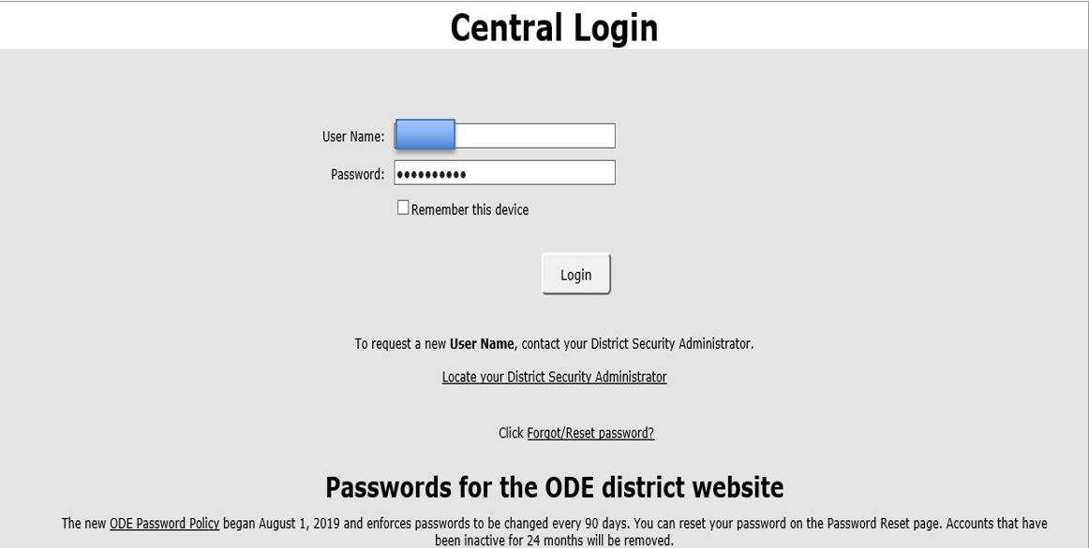

Screen Shot #2… View the SPR&I Dashboard
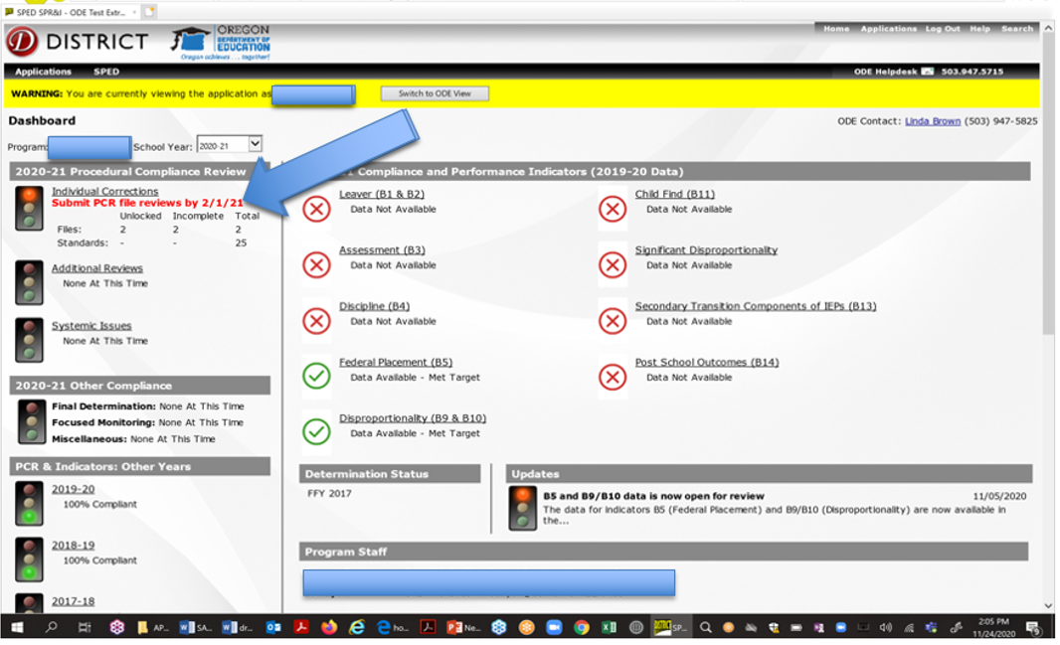

Screen Shot #3… Student File Selection
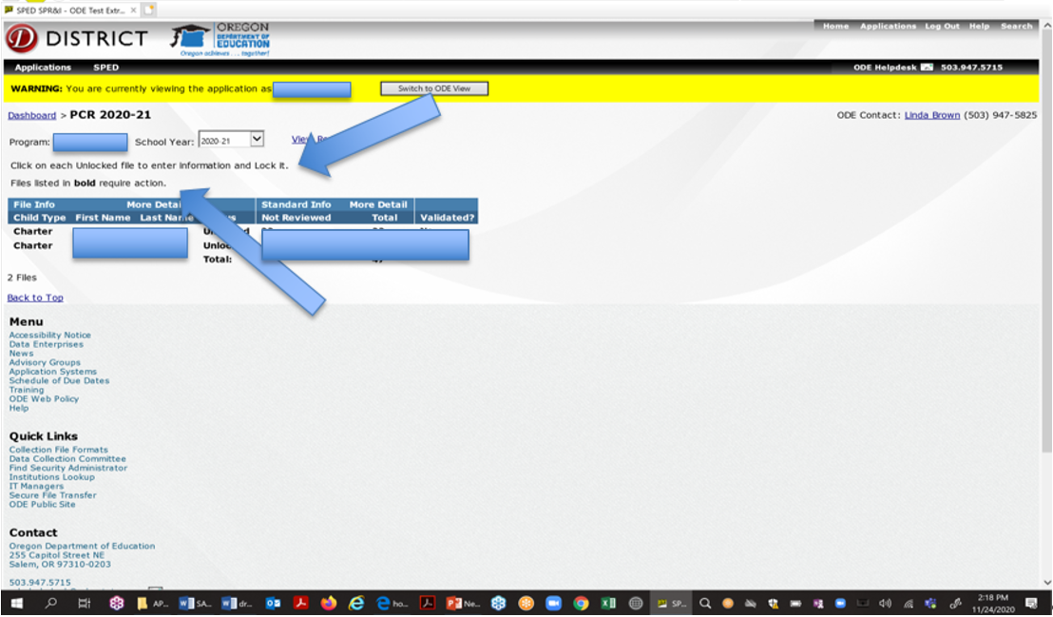

Screen Shot #4… Student File Selection More Information/Less Information

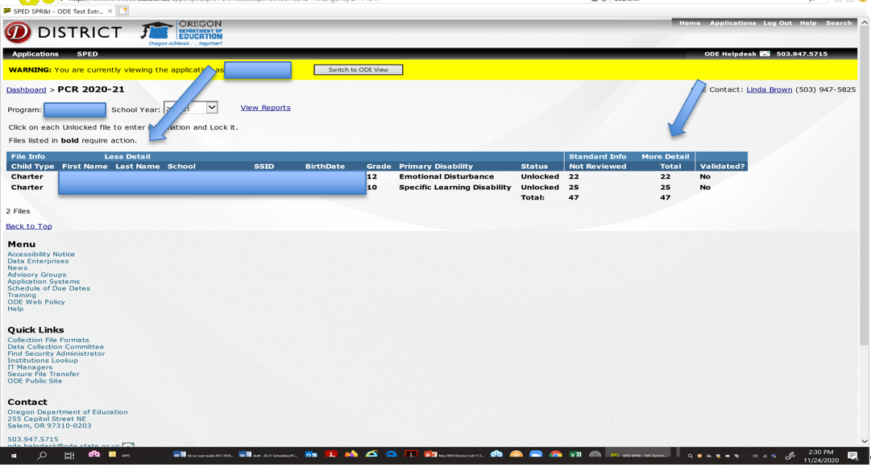

Screen Shot #5…. Student File Confirmation…. Lock in Criteria

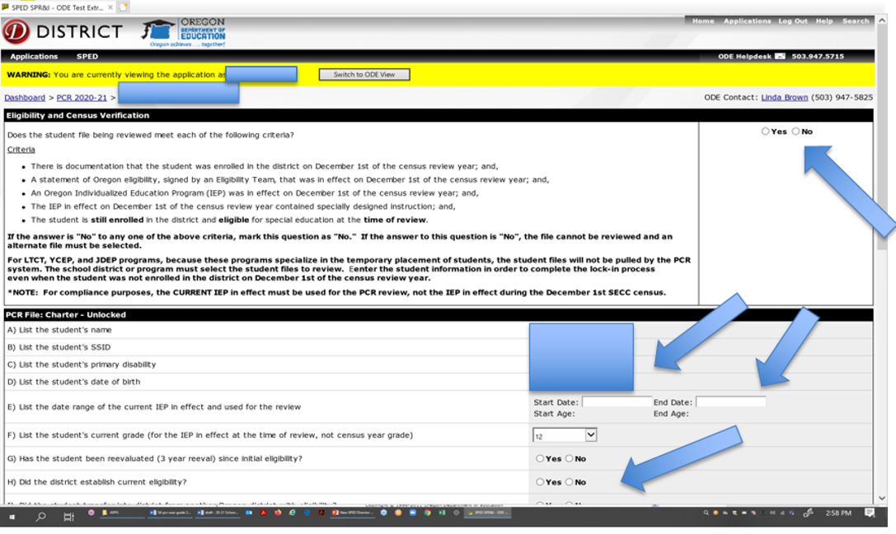

Screen Shot #6… Replace a File
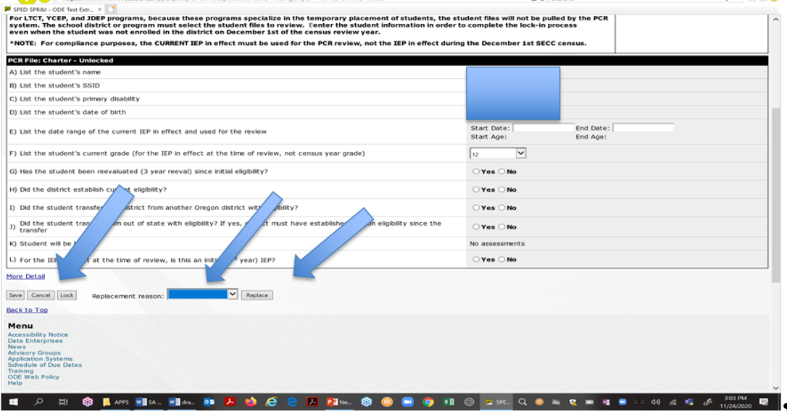

Screen Shot #7… PCR Review Form

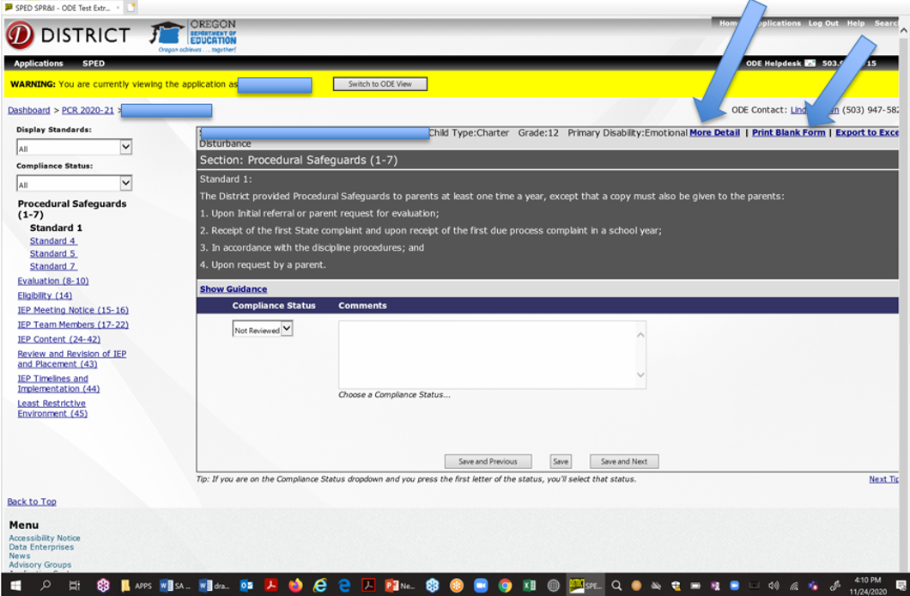

Screen Shot #8… Data Entry
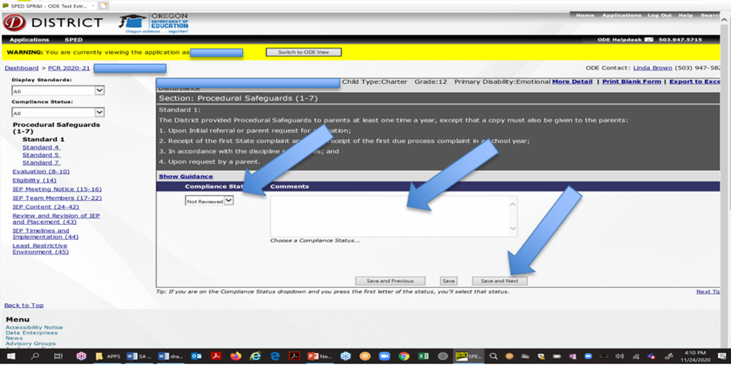

Screen Shot #9… Submit all PCR Files
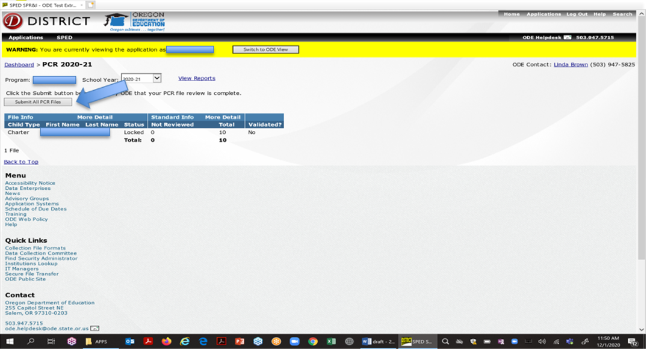

Screen Shot #10… Individual Corrections
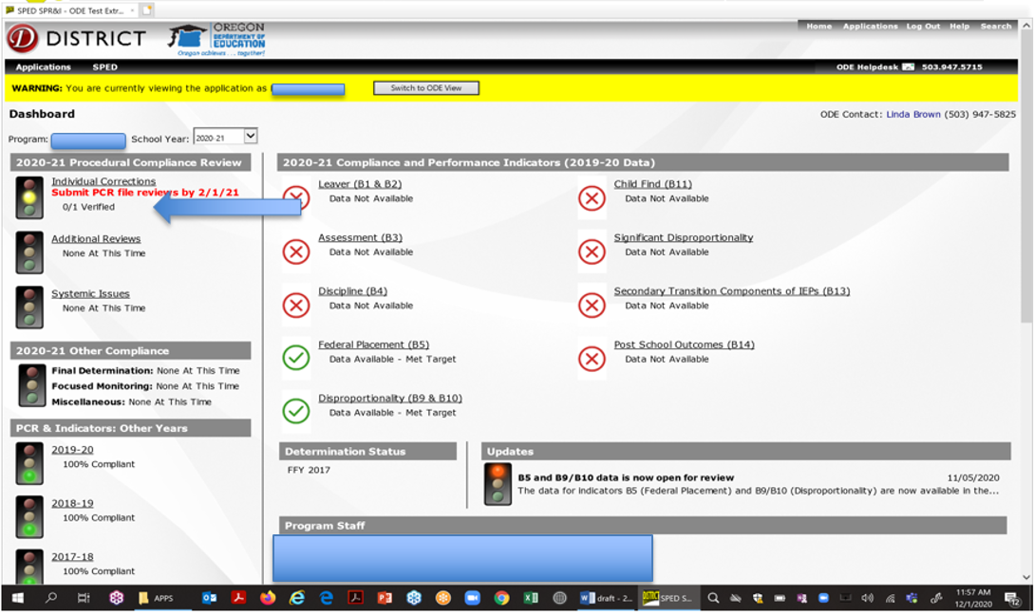

Screen Shot #11… Individual Correction… Individual Students
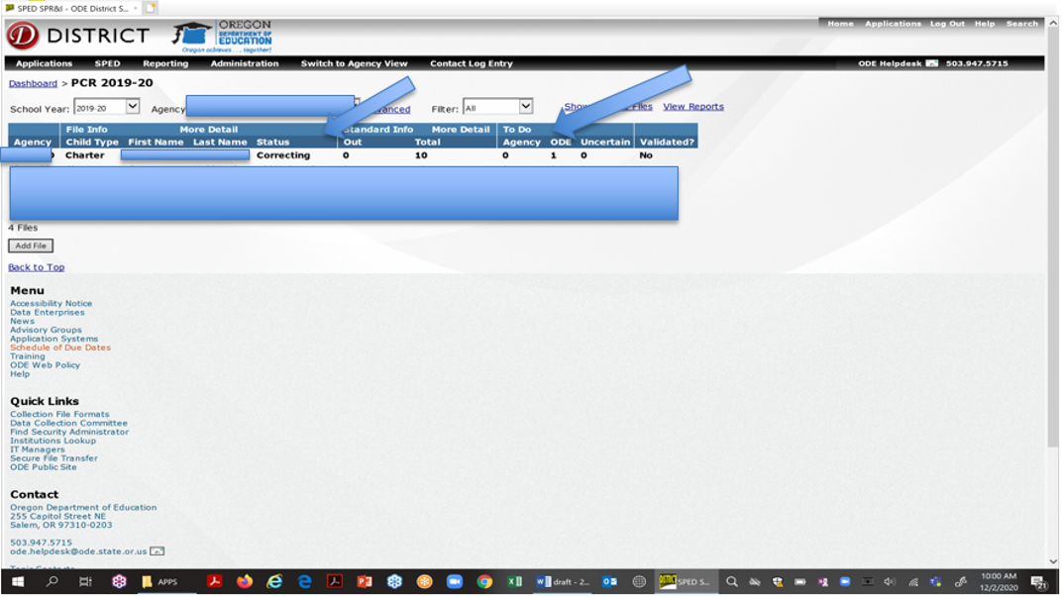

Screen Shot # 12… Verify Status & Next… Making Corrections
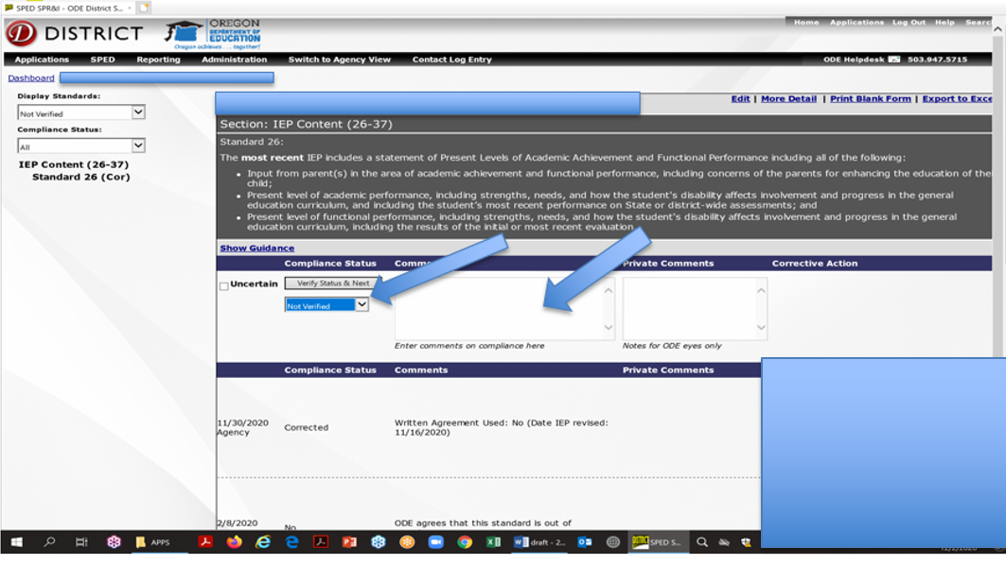

Screen Shot #13… Additional Reviews
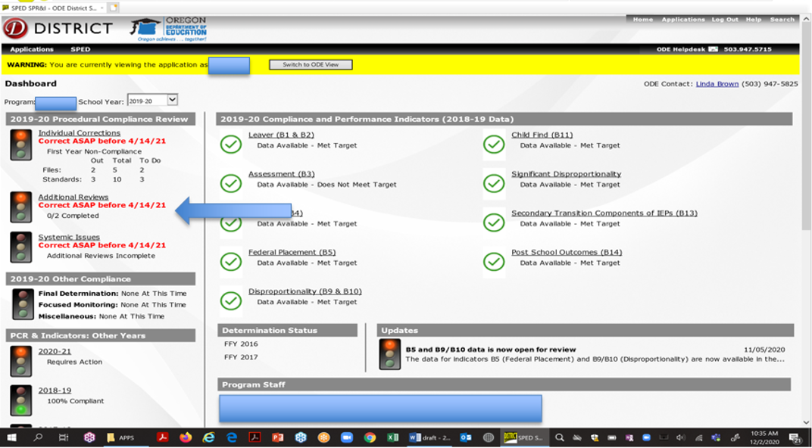

Screen Shot #14… SSID Master List
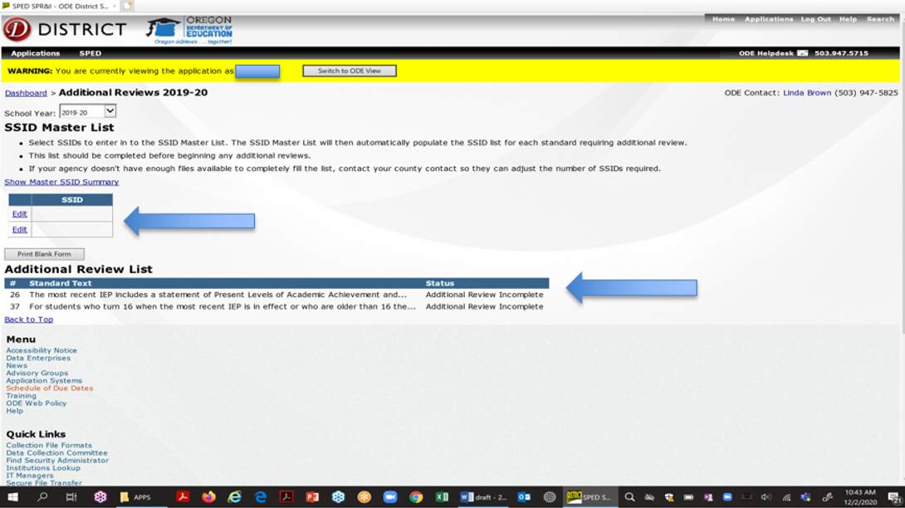

Step 14: Additional File Review

Screen Shot #15… Additional File Reviews
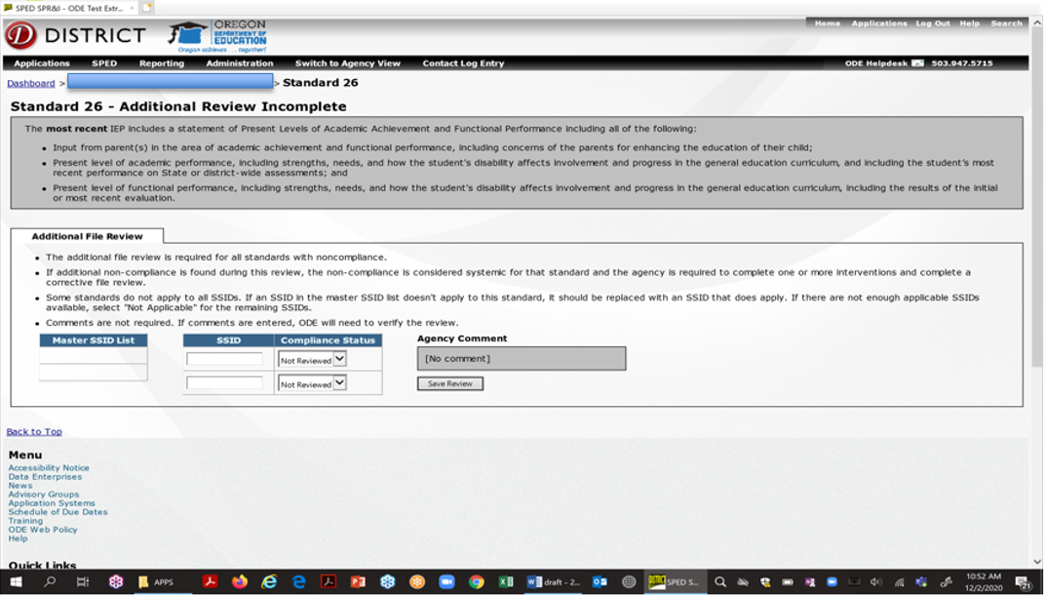

Screen Shot #16… Systemic Issues
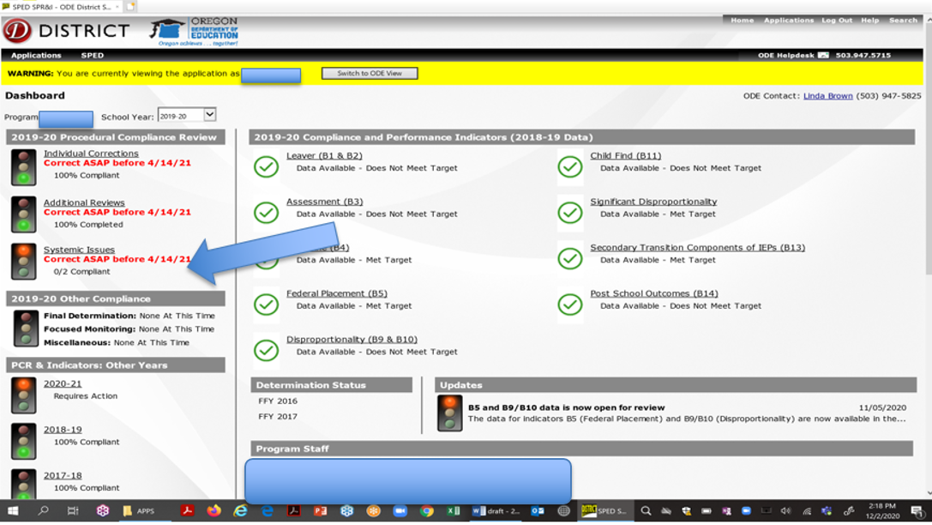

Screen Shot # 17…Intervention Master List… Systemic Issues List
