Oregon Department of Education
ESEA Title III:
English Learner Data Collection
Frequently Asked Questions
2023-24
Note: Information updated for 2023-24 is in red font
Any items removed in 23-24 are denoted in double strikethrough

TABLE OF CONTENTS

Page

What timeline is reported? 1
Q: What school year is being collected in the ESEA Title III: EL Data Collection? 1
Q: Is this collection a true “as of” collection (i.e., a snapshot in time), or does it cover a period of time? 1
What resources are available? 1
Q: Where can I get information online regarding submission of 2023-24 data? 1
Which records are reported? 1
Q: Which student records should be reported? 1
Q: Who are English learner students? 2
Q: If a student has attended several schools within the district, should a separate record be reported for each building? 3
Q: If a student was reported to the fall collection, do I have to report the student to the Spring Collection? 3
Q: Our district does not have any EL students to report? How do we notify the ODE that the district will not be submitting records to this collection? 3
Charter and Alternative School Reporting Requirement 3
Q: Are charter schools required to report to this collection? 3
Q: Are alternative schools/programs required to report to this collection? 4
Data submission and retrieval options 4
Q: I can run a query from my student database that will have the majority of the information requested, and put it into a spreadsheet to upload to ODE. Will this function be available for this collection? 4
Q: Can I run a report of the data submitted to ODE to verify all my student records have been received? 4
Q: What reports are available for the 2022-23 Collection? 4
What data is needed for this report? 5
Q: What information do I need to have in order to fill out the fields in this collection correctly? 5
Q: Which groups will still need to have local assessment data reported? 6
Q: If a student is exited from the program as proficient, does an exit date need to be reported? 6
Q: Our district has course codes that are more specific than the ODE codes for program model type. Can we add another field for the local course codes, or allow multiple submissions for the same program model combination? 6
What code do I use for this scenario? 6
Q: I’m not sure what EL Record Type code to use for a student, where can I get help? 6
Q: We have an EL student who is being tutored at home because he is very ill. He is unable to come to school due to his health. He will not be able to take ELPA summative. He is not on an IEP. Where do I put the information on that student? 7
Q: If a student moves from our district after the student has taken ELPA summative, should that student be reported as having taken ELPA summative in our district? Or, will the receiving district be administering ELPA summative to the same student during the same academic year? 7
Q: If a student withdraws prior to the ELPA summative testing window being opened, what record type is this student? 7
Q: We have a student who does not receive services; do I have to enter this student in the EL Collection? 7
Q: A student not receiving services has scored proficient on ELPA summative, how do I exit this student? 8
Q: A student not exited at the end of the prior school year and should have been, how do I code the student? 8
Data Submission Timeline 8
Q: The district has students who enroll annually in June, are we required to report these students? If so, how will the records be submitted after the close of the EL Collection? 8
Q: May districts get an extension and submit EL Collection data later than May 24, 2024? 9
Special Circumstances 9
Q: If a student has an IEP for writing (for example), who determines if the student takes ELPA summative? 9
Q: A new student enrolled today from another Oregon school district, how do we know if this student has participated in ELPA summative? 9
Q: A student currently served by the program has submitted a waiver at the end of the school year for the following school year, what EL record type code do we use to submit this student? 10
Mobility Scenarios: What to do when a student moved into your district 10
These scenarios are to be used for students whose responses on the Language Use Survey leads to the administration of the ELPA screener. 10
EL Record Types: Decision Chart 12
Resources 15

What timeline is reported?

Q: What school year is being collected in the ESEA Title III: EL Data Collection?

A: The current school year of 2023-24.

Q: Is this collection a true “as of” collection (i.e., a snapshot in time), or does it cover a period of time?

A: The Fall 2023-24 EL Collection is a “as of” collection – the as of date is October 1, 2023.

The Spring 2023-24 EL Collection data is gathered by the district from the schools over the course of the entire 2023-24school year. This is not a “snapshot collection” because there is no “as of” date. This collection is used for accountability reports and Title III allocations.

Please submit a student record for each EL student enrolled in the district anytime during the 2023-24 school year to the Spring Collection.

What resources are available?

Q: Where can I get information online regarding submission of 2023-24 data?

A: All documentation for the ESEA Title III: EL Data Collection will be available in the documentation section for this collection on the Schedule of Due Dates on the district web page. As soon as documentation is available, it will be posted there. The district web page is located at ODE District Secure web page

The data owner has an email address and phone number listed on the Schedule of Due Dates (linked from the district web page above).

Training presentations are posted to the Title III Meetings and Events web page, and the EL data collection web page.

Which records are reported?

Q: Which student records should be reported?

A: The following groups of EL are submitted to the collection:
- Current ELs -- All students identified as an EL are reported, including EL students attending charter schools and alternative program(s).
  - Record Types (1-A, 1-B, 1-C, 1-D, 1-E, 4-N, 4-O, and 4-P)
- All students found ineligible to receive services on the initial identification screener assessment during the 2023-24 school year (ELPA Screener)
  - Record type – 3-H (Not eligible for EL services)
- All students who have a disability and the identification screener could not be made accessible to determine EL status
  - Record type – 2-J (Potential EL)
- Monitored ELs -- students who exited as proficient in 2019-20, 2020-21, 2021-22, 2022-23
  - Record type – 5-M
- Former ELs -- students who exited in 2018-19 or prior to 2018-19
  - Record type 5-F
- State of Emergency – students who enrolled during a declared State of Emergency who could not be given an identification screener (ODE does not anticipate the need to use this code in the 2023-24 school year.)
  - Record Type SE
- Erroneously Identified English Learners – students who were identified in error in any school year prior to the current school year
  - Record Type EI

All students identified as ELs must take an ELPA Summative this year. This group includes students served in the ELD program, and students identified as ELs whose parents waived services (EL Record Type Code 4-N, 4-O, 4-P).

ELPA Summative refers to:
- ELPA summative in person (Test code 06)
- ELPA summative remote (Test code 09)
- Alt-ELPA summative (Test code 10)

The most recent guidance from the USDOE states:
In section 1111 (G) (1) – Assessments of English Language Proficiency, all EL children are assessed on the ELP assessment annually. As far as Title I is concerned, a parent request to opt out of an assessment is not authorized. (USDOE)

Q: Who are English learner students?

A: All students who meet the Office of Civil Rights definition for English learner student: [ESEA Title VIII-General Provisions Part A – Definitions Sec 8010 (20)].

- English Learner (EL) – The term “English learner” when used with respect to an individual, means an individual:
- who is aged 3 through 21;
- who is enrolled or preparing to enroll in an elementary school or secondary school;
  - (i) who was not born in the United States or whose native language is a language other than English;
  - (I) who is a Native American or Alaska Native, or a native resident of the outlying areas;
AND
    - who comes from an environment where a language other than English has had a significant impact on the individual’s level of English language proficiency; or
  - who is migratory, whose native language is a language other than English, and who comes from an environment where a language other than English is dominant; and
  - whose difficulties in speaking, reading, writing, or understanding the English language may be sufficient to deny the individual --
    - the ability to meet the State’s proficient level of achievement on State assessments;
    - the ability to successfully achieve in classrooms where the language of instruction is English; or
    - the opportunity to participate fully in society.

Note: A language other than English spoken at home does not automatically qualify a student as an English learner; likewise, a home with only English spoken in the home does not automatically exclude a student from being an English learner, refer to American Indian/Alaska Native.

Q: If a student has attended several schools within the district, should a separate record be reported for each building?

A: NO. A single student record per district is submitted reflecting the status of the student at the school where the student was enrolled.
- Fall 2023-24 as of October 1, 2023, or the closest business day to 10/1.
- Spring 2023-24 at the end of the school year for the entire school year.

Q: If a student was reported to the fall collection, do I have to report the student to the Spring Collection?

A: YES. The Fall EL Collection is a point in time, but the Spring EL Collection is a school year snapshot and the Spring EL Collection is the one that is used for all accountability/reporting and Title III allocations.

Q: Our district does not have any EL students to report? How do we notify the ODE that the district will not be submitting records to this collection?

A: Please click on the verify submission button on the status tracking page of the EL Collection or Email the data owner directly.

Charter and Alternative School Reporting Requirement

Q: Are charter schools required to report to this collection?

A: YES. Charter schools who receive state funds are obligated to comply with all reporting requirements. The district in which the charter school is located is responsible for ensuring compliance. Charter schools that are state sponsored are responsible for their own submission.

Q: Are alternative schools/programs required to report to this collection?

A: Alternative schools/programs are required to report to the data collection based on their agreements with the resident district. ODE will cross validate this collection with ADM to ensure all identified ELs (current, monitored, and former) are included in the collection.

Data submission and retrieval options

Q: I can run a query from my student database that will have the majority of the information requested, and put it into a spreadsheet to upload to ODE. Will this function be available for this collection?

A: Yes, you can upload an Excel spreadsheet as a CSV file. A preformatted CSV template is available on the file format page linked from the ODE District secure web page.

Make sure you run queries that will give you all the varies types of students included in this collection (identified ELs, monitored ELs, former ELs, Initially Fluent- 3H, Potential ELs -2J, State of Emergency(SE), and Erroneously Identified ELs (EI).

Q: Can I run a report of the data submitted to ODE to verify all my student records have been received?

A: Yes, you can run a production download for this collection. Production downloads are available for previous years as well. This download is a record of the records accepted by ODE. Any records with errors will not be included in this download.

It is strongly recommended that the district run and verify their data submission.

Q: What reports are available for the 2023-24 Collection?

A: The production download is one report available from this collection. This report will provide the districts a copy of all EL student records submitted and received by the ODE data system.

B. Another report is the EL Student History Report. This report is linked to SSID; whenever a district updates their SSID files with ODE, then this report will provide a list of all students enrolled in that district who have ever been reported to the EL data collection. Start dates, exit dates, and language of origin, most recent ELP assessment data is included in the report.

C. EL-Recent Arrivers report - This is a report of all ELs reported who also have a report in the Recent Arrivers data collection. There is a similar report in the Recent Arrivers data collection.

NOTE: All records with errors are not included in the production download report until the error is cleared.

What data is needed for this report?

Q: What information do I need to have in order to fill out the fields in this collection correctly?

A: The data fields specific to the 2023-24 ESEA Title III: English Learner Data Collection are:
  - EL Record Type
  - Program Model 1
  - Program Model 2
  - Program Model 3
  - Proficiency Test Name Code –
    - 06 ELPA summative for in-person assessment participants (for 1-B, 1-C, 1-D, 4-N, 4-P)
    - 07 ELPA screener for students identified as EL in 2022-23 and for students who are not qualified as an EL- 3-H)
    - 09 Remote ELPA Summative for students participating virtually (1-B, 1-C, 1-D, 4-N, 4-P)
    - 10 ALT-ELPA Summative – for students participating in the alternate ELPA assessment for students with significant cognitive disabilities.
    - 00 Did not test (1-E and 4-O)
    - 05 for 2-J(Potential EL)
    - 11 Identified as an EL in another state this school year

  - Proficiency Test Administration Date
    - Blank for students who participated in ELPA summative
    - Required entry for students identified as ELs in 2023-24 (1-A, 4-N), and students not eligible to receive services EL Record Type 3-H
    - Blank for students identified as Potential EL (2-J)
    - Required BLANK Proficiency Test Code - 11
  - Required: EL Start Date (all identified EL students, regardless of service)
  - Required: EL Start Date for 5M and 5F records
  - Required: EL Exit Date (all students the district has deemed as proficient):
    - 1-C (served and exited),
    - 1-E (Exited in fall based on prior year’s ELPA summative),
    - 4-N (Exited with waiver for service),
    - 4-O (Exited in fall based on prior year’s ELPA and student has a waiver for service
    - 5M (exited within the last four school years as proficient)
    - 5F records (exited more than four schools prior to the current school year).

Additional fields required in the EL Collection:
  - Language of Origin
  - EL Flag
  - SPED Flag
  - Migrant Flag
  - SIFE Flag
  - 504 Flag
  - Waiver Effective Date (for all 4-N, 4-O and 4-P records)

These data fields are submitted along with district, school, and student demographics, which conform to the Consolidated Student Collections file format.

Q: Which groups will still need to have initial assessment data reported?

A: All students identified by ELPA Identification Screener as EL in 2023-24, and students found ineligible for ELD services on the (Category 3), need to have their local assessment data reported.

The following specific local proficiency test information is required:
  - Test Name Code
  - Test Administration Date

Q: If a student is exited from the program as proficient, does an exit date need to be reported?

A: YES. The exit date field is required in the 2023-24 data collection. If an exit date is not entered, the student is not exited on ODE records, and will not be included in EL accountability calculations as exited. The student will have to have an exit date the next school year. This will impact the student’s data with regarding to monitoring status.

Q: Our district has course codes that are more specific than the ODE codes for program model type. Can we add another field for the local course codes, or allow multiple submissions for the same program model combination?

A: NO on both accounts. Please report the course only once with the appropriate ODE code. All our calculations and reporting requirements are keyed from these specific codes. We do allow up to three program model codes that allow for various program model combinations.

What code do I use for this scenario?

Q: I’m not sure what EL Record Type code to use for a student, where can I get help?

A: At the end of this document is a chart that helps determine EL Record Type codes. You can also contact the data owner. Data owner contact information is located on the Schedule of Due Dates.

Q: We have an EL student who is being tutored at home because he is very ill. He is unable to come to school due to his health. He will not be able to take ELPA summative. He is not on an IEP. Where do I put the information on that student?

A: If this student is participating in the EL instructional program, this student will be category 1E on the collection - Did not take ELPA summative, but participated in an ELD program. If this student is not being served by the EL program (student has a signed parent waiver – then code as 4-O)

Q: If a student moves from our district after the student has taken ELPA summative, should that student be reported as having taken ELPA summative in our district? Or, will the receiving district be administering ELPA summative to the same student during the same academic year?

A: The district administering ELPA summative reports the student as having taken ELPA summative in that district.

The receiving district will not be able to administer ELPA summative to the same student during the same academic year. The receiving district will have the student’s ELPA summative proficiency level applied to their EL accountability calculations, even though the test was administered in another district.

The receiving district codes the student as 1-E (served no ELPA) or 4-O (waiver no test), because the district did not administer the ELPA summative.

Q: If a student withdraws prior to the ELPA summative testing window being opened, what record type is this student?

A: This student is coded is a 1-E if the student was served by the program or code 4-O if the student had a waiver for EL program service. ODE will compare the EL Collection to Cumulative ADM to ensure that the student was unable to test due to not being enrolled during the official ELPA summative testing window.

A "virtual" test record indicates the student did not test. This student may be included in the EL accountability calculations, as participation in ELPA summative is required by all EL students.

Q: We have a student who does not receive services; do I have to enter this student in the EL Collection?

A: YES. If the student is identified as an EL student, this student needs to be included. Students who do not receive services by parent/guardian request are coded as either 4-N, 4-O, or 4-P.
- 4-N students are students who have a waiver for services and participated in ELPA summative; OR
- 4-O students are students have a waiver for services and did not participate in ELPA summative testing; OR
- 4-P students who previously exited the ELD program and have a waiver for service. (Only use the 4-P code for the year the student re-enters as a current EL).

Q: A student not receiving services has scored proficient on ELPA summative, how do I exit this student?

A: An EL Exit Date needs to be entered for a student with a 4-N or 4-P EL Record Type.

The EL Record Type for this student is not changed to a 1-C (exited from services); simply enter an EL Exit Date in the 4-N or 4-P record. This student will be included in the EL accountability calculations as exiting.

Students must have a proficient score on the ELPA summative to be exited from the program.

Q: A student not exited at the end of the prior school year and should have been, how do I code the student?

A: Code the student as a code 1-E (if the student would have been served by the program);
- include the exit date in the exit date field;
- include the student was not participating in the program (if the exit is at the beginning of the school year),
- or code the appropriate program model codes (if the student was served by the program for 1 or more days)

For students with waivers of service (code 4-O)
- just include the exit date
- do not change the record type to 1-C or 1-E.

Note: The exit date for these students will need to be in the current school year (August 1 or later). Code these students as 1-E (4-O) for the entire school year and coded as monitor year 1 the school year following exit.

These exit dates must be between August 1 and June 30 in order for the exit dates to be included in On Track to ELP accountability calculations and included in the Title III allocations calculations.

Data Submission Timeline

Q: The district has students who enroll annually in June, are we required to report these students. If so, how do we submit the student after the close of the EL Collection?

A: YES. The ODE will reopen the EL Collection for a complete review. Please add these students during this review window of June 6-21, 2024

During this time, districts will be able to add student records for students enrolling or identified after the May closing.

Districts will also have the opportunity to edit any student records submitted to the EL Collection.

Q: May districts get an extension and submit EL Collection data later than May 24, 2024?

A: NO. The data collected in the EL Collection is used in accountability reports, which include reports on the EL subgroup. Districts should plan submission time for the EL Collection to ensure all records are submitted and error-free by 11:59 pm on May 24, 2024.

The first extract of data from the Spring Student Membership 2022-23 and ESEA Title III: English Learner 2023-24 collections for use in pre-preliminary report card computations is scheduled immediately following the close of the EL Collection.

Special Circumstances

Q: If a student has an IEP for writing (for example), who determines if the student takes ELPA summative?

A: The student's IEP team may determine that the written component of ELPA summative is not accessible for that student, and should code the student's file accordingly (on the IEP, in TIDE, using appropriate– Test Administration Codes).

For ELs, members of the IEP team for those students with disabilities should include speech language pathologists and other professionals with an understanding of how to differentiate between English proficiency and a disability.

Q: A new student enrolled today from another Oregon school district, how do we know if this student has participated in ELPA summative?

A: One way to find out is to have the student attempt to login to ELPA summative. If the student has completed ELPA summative, the student will not be able to complete the login process. If the student has not completed the ELPA summative, or has not participated, the student will be able to login.

(This restriction will only occur if the original SSID is used to log in; if your district issued a new SSID number the student may be able to login and take the ELPA summative again. This may be a test impropriety.)

NOTE: The SSID file may take a couple days to reflect the resident district change. Please allow a couple business days for this process to occur.

The receiving district could ask if the student had been administered ELPA summative while requesting permanent education records.

Q: A student currently served by the program has submitted a waiver at the end of the school year for the following school year, what EL record type code do we use to submit this student?

A: Report the EL record type code that accurately reflects the student’s status during the current school year; in the case above this would be served by the program.

Mobility Scenarios: What to do when a student moved into your district

These scenarios are to be used for students whose responses on the Language Use Survey leads to the administration of the ELPA screener.

Scenario | Was the student an identified EL in prior district | Was the student exited by the prior district | Does your identification assessment identify the student as initially fluent English | Code the student in the collection:
Student moved into my district from another ELPA district this school year | Yes | No | NA | Student enters your district as an identified EL, unless the ELPA summative scores were 4s and 5s in all domains; if so, the student is exited (1-E) as of the beginning of the school year.
Student moved into my district from another ELPA district this school year | Yes | Yes | NA | Enter the student as a monitored or a former EL based on the exit date from the prior school district.(the district must have start and exit date from prior district).  IF the district does not have these dates within the federal timeline to identify the student as an EL, the district must administer the ELPA screener. Whatever assessment is the most recent is the determination of the student’s EL status.
Student moved into my district from a NON-ELPA district/state this school year | YES | YES | NA | The district must have both the EL start and exit date (for monitored/former ELs) – IF the district does not have these dates within the federal timeline to identify the student as an EL; the district must administer the ELPA screener. Whatever assessment is the most recent is the determination of the student’s EL status.
Student moved into my district from a NON-ELPA disttict state this year. | YES | NO | NA | IF the district does not have the EL start date within the federal timeline to identify the student as an EL, the district must administer the ELPA screener. Whatever assessment is the most recent is the determination of the student’s EL status. If the district is able to get the student’s original EL start date than the student is coded based on that date.
Student was enrolled in another ELPA school district last school year | Yes | No | NA | Student enters your district as an identified EL, unless the student’s ELPA summative scores were 4’s and 5’s in all domains; if so, the student is exited (1-E) as of the beginning of the school year.
Student was enrolled in another ELPA school district last school year | Yes | Yes | NA | Enter the student as a monitored or a former EL based on the exit date from the prior school district.
Student was enrolled in a NON-ELPA district/state last school year OR;  Student was enrolled for fewer than 30 calendar days in an ELPA district/state AND did not participate in ELPA Screener or Summative testing in the previous school year | NA | NA | This student must be given the identification screener | Please follow your district’s identification process and administer the district’s identification screener to determine if the student is an EL.
Student was enrolled in another school district 2 or more prior school years | Follow your district's identification plan based on the responses from the Language Use Survey.

EL Record Types: Decision Chart

Student  Examples | Description of Student | Include in EL Collection | EL Flag | EL Record Type | EL Start Date Required | EL Exit Date Required
1 | Student is identified as an EL for the first this time this school year. | YES | Y | 1-A | YES | N/A
2 | Student is continuing EL services this school year. | YES | Y | 1-B | YES | N/A
3 | Student participated in the EL instructional program, scored proficient on the ELPA summative and exited from EL program this school year. | YES | Y | 1-C | YES | YES  Exit date within the current school year is required.
4 | Student was not exited in the previous school year, but is exited the beginning of the current school year. The student did not participate in the EL Program this year. | YES | Y | 1-E (if served previously)  4-O (if waiver) | YES | YES  Exit date within the current school year is required.  Report the student as exited for the entire school year.
5 | Student previously exited for proficiency, but has returned to the ELD program this school year. | YES | Y | 1-D | YES | N/A
6 | Student was enrolled and participated in EL instructional program but did not participate in ELPA summative. | YES | Y | 1-E | YES | N/A
7 | Student is identified as EL, participated in the EL Program, but withdrew from the district prior to the ELPA summative Testing Window. | YES | Y | 1-E | YES | N/A
8 | Student is identified as EL, participated in EL program, but enrolled in the district after the close of the ELPA summative Testing Window | YES | Y | 1-E | YES | N/A
Student  Examples | Description of Student | Include in EL Collection | EL Flag Marked | EL Record Type | EL Start Date Required | EL Exit Date Required
9 | Student is an identified EL student, but is not receiving services due to parent waiver and participated in ELPA summative. | YES | Y | 4-N | YES | DEPENDS  If the student is ready to exit – include an exit date, otherwise leave blank.
10 | Student is an identified EL student, is not receiving services, and withdrew from the school district prior to the ELPA summative Testing Window. | YES | Y | 4-O | YES | No. Student did not participate in the ELPA summative – the student may not be exited.
11 | Student is an identified EL student, is not receiving services, and enrolled in the district after the close of the ELPA summative testing window. | YES | Y | 4-O | YES | No. Student did not participate in the ELPA summative – the student may not be exited.
12 | Student was returned to the ELD program after exiting as proficient and parents have signed a waiver for service. | YES | Y | 4-P | YES | DEPENDS  If the student scored Proficient on the ELPA Summative in the Spring then the student is exited.
13 | Student was assessed to see if the student qualified as EL, but student was found ineligible on the initial assessment. | YES  For the current SY only. You must include name of assess-ment, date administered, and score received. | N | 3-H | NO  This field is left blank.  This student is not an EL
14 | Student exited as proficient in 2022-23 | YES | N | 5-M | YES | YES
15 | Student exited as proficient in 2021-22 | YES | N | 5-M | YES | YES
Student  Examples | Description of Student | Include in EL Collection | EL Flag Marked | EL Record Type | EL Start Date Required | EL Exit Date Required
16 | Student exited as proficient in 2020-21 | YES | N | 5-M | YES | YES
17 | Student exited as proficient in 2019-20 | YES | N | 5-M | YES | YES
18 | Student exited in 2018-19 or any school year prior to 201-19 | YES | N | 5-F | YES | YES
19 | Student with a disability or suspected disability enrolled – school team determined the ELPA identification screener could not be made accessible | YES | N | 2-J | NO | NO
20 | Student identified as an EL in error in a school year prior to the current school year.  Note if the identification occurred in the same school year – request the data owner to reopen that colelction and delete the student’s EL record. | YES – the year that this error is determined | N | EI | NO | NO
21 | Student enrolled during a State of Emergency where the student could not be screened by the ELPA screener. (NOTE: ODE staff does not anticipate the need for this record type in 23-24 at this time) | YES – the year that this occurred | N | SE | NO | NO

Resources

Please use the EL Student History Report to gather additional information about your students.

EL History Report Steps:

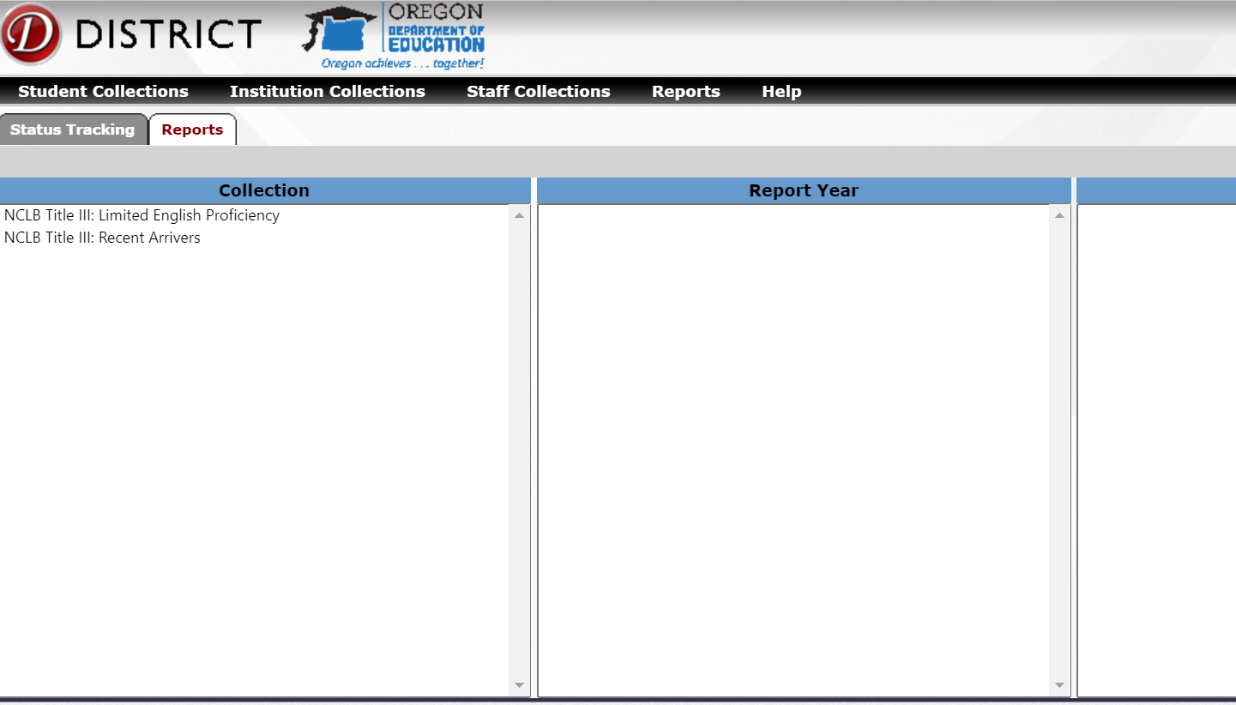

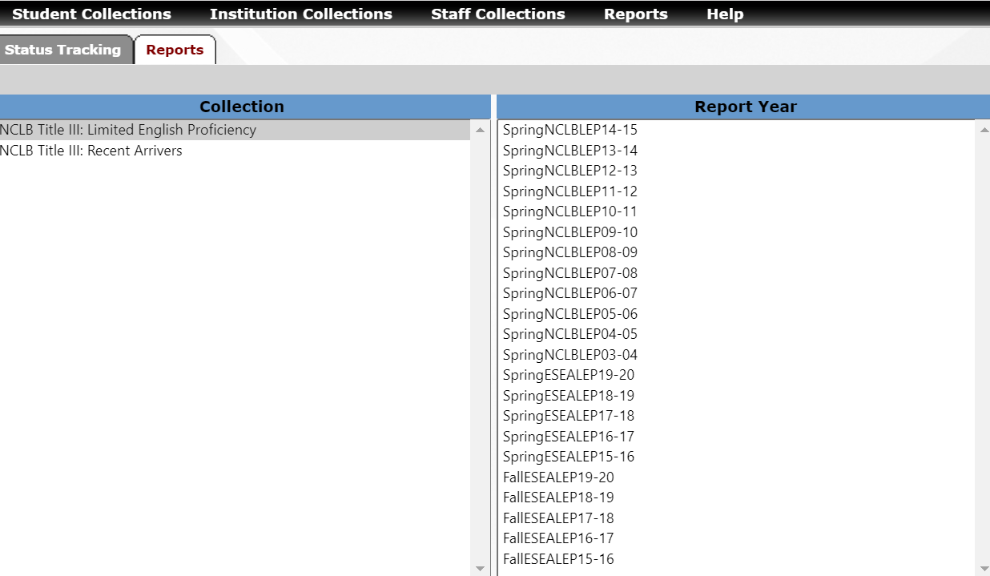

3.

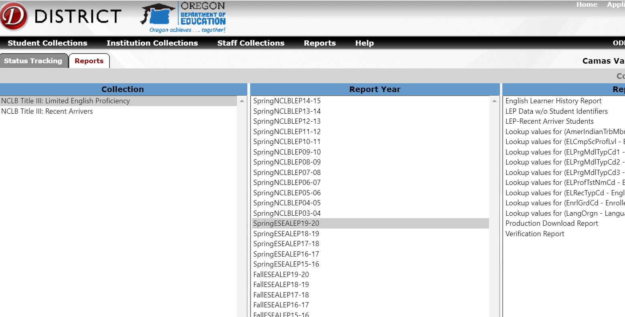

This report will provide a spreadsheet of all students currently enrolled in your district who have an EL record in a previous EL data collection. Once another district reports a student’s SSID as attending that district, the record will be removed from your district’s EL Student History Report.

Contact the EL Data Collection – Data Owner – Kim Miller

