State Performance Plan (SPP)

Fact Sheet

Indicator C3: Early Childhood Outcomes

Oregon State Performance Plan
Under the Individuals with Disabilities Education Act of 2004 (IDEA), the Oregon Department of Education (ODE) is required to submit a six-year State Performance Plan (SPP) to the Office of Special Education (OSEP). The OSEP has developed key performance measures, known as indicators, to measure both compliance and results. The OSEP sets the targets for compliance indicators and the ODE sets targets for the results indicators. The SPP must include targets for each results indicator. The ODE reports on progress made toward these indicators each year in the Annual Performance Report (APR). Every six years the ODE must review results targets and engage key partners in the development of new targets. Please see the ODE State Performance Plan and Annual Reports for Special Education webpage for more information.

What does this indicator measure and why is it important?
Indicator C3 measures the percentage of infants and toddlers with Individualized Family Service Plans (IFSP) who demonstrate improved:
- A. Positive social-emotional skills (including social relationships);
- B. Acquisition and use of knowledge and skills (including early language/ communication); and
- C. Use of appropriate behaviors to meet their needs. (20 U.S.C. 1416(a)(3)(A) and 1442)
This Indicator shows developmental and educational results for infants and toddlers in our EI/ECSE programs. These results are tied to Student Success Act funding as individual county EI/ECSE programs use these data to prioritize improvement in selected outcomes.

What is the data source?
State selected data source.

How has Oregon performed over time?
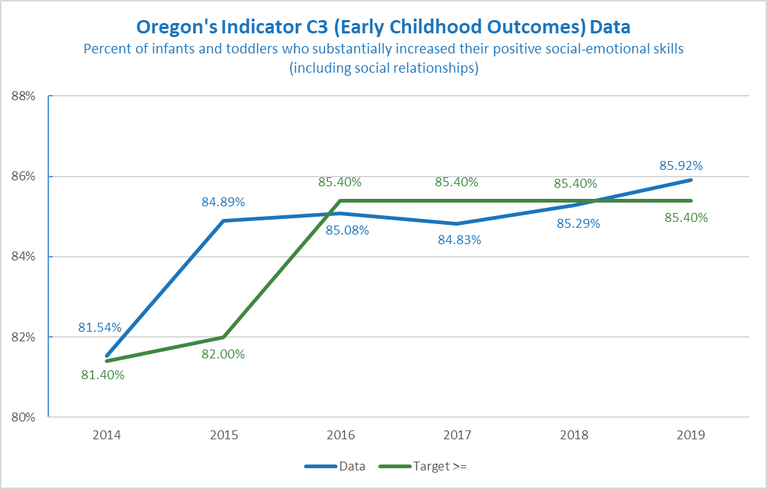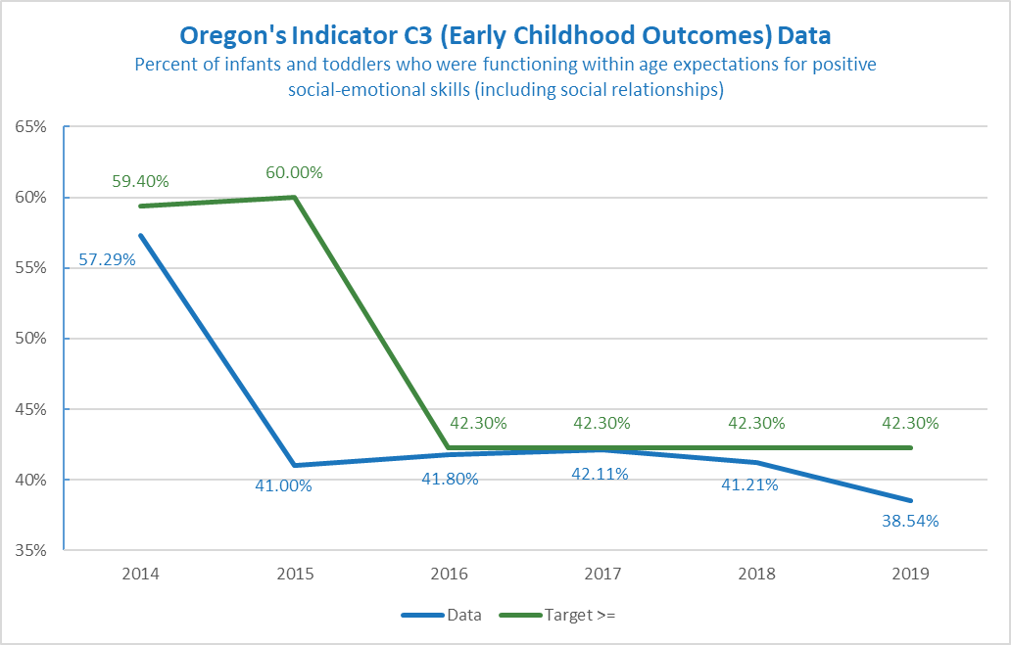

Outcome | Baseline | FFY | 2014 | 2015 | 2016 | 2017 | 2018
A1 | 2015 | Target>= | 81.40% | 82.00% | 85.40% | 85.40% | 85.40%
A1 | 84.89% | Data | 81.54% | 84.89% | 85.08% | 84.83% | 85.29%
A2 | 2015 | Target>= | 59.40% | 60.00% | 42.30% | 42.30% | 42.30%
A2 | 41.00% | Data | 57.29% | 41.00% | 41.80% | 42.11% | 41.21%
B1 | 2015 | Target>= | 64.20% | 64.30% | 66.70% | 66.70% | 66.70%
B1 | 66.42% | Data | 61.33% | 66.42% | 64.32% | 61.85% | 61.40%
B2 | 2015 | Target>= | 7.60% | 8.00% | 36.00% | 36.00% | 36.00%
B2 | 35.69% | Data | 8.51% | 35.69% | 34.82% | 34.39% | 34.50%
C1 | 2015 | Target>= | 64.90% | 65.00% | 77.80% | 77.80% | 77.80%
C1 | 77.28% | Data | 65.97% | 77.28% | 75.83% | 75.75% | 74.62%
C2 | 2015 | Target>= | 18.40% | 18.50% | 40.60% | 40.60% | 40.60%
C2 | 40.33% | Data | 13.29% | 40.33% | 38.95% | 36.61% | 36.38%

FFY 2019 | Target | Data
A1 | 85.40% | 85.92%
A2 | 42.30% | 38.54%
B1 | 66.70% | 61.98%
B2 | 36.00% | 31.72%
C1 | 77.80% | 74.85%
C2 | 40.60% | 33.87%

Does the baseline need to be set or reset for this indicator? If yes, what is the new baseline?
No, the baseline will not be reset this year. The current baseline data year is 2015 when Oregon switched to the Brookes Publishing Company Sort for AEPS I and II for the C3 Child Outcomes. Data performance since 2015 has been mixed and has been even more volatile during the pandemic. The agency will continue with the 2015 baseline data. Since Oregon will adopt the AEPS-3 for the C3 child outcome data in 2022 or 2023, targets set this year will be difficult to use in the data performance in the subsequent years.

What are the new targets?
The ODE will not set new targets until we hear from our partners. There are several ways to set new targets. It could be a percentage increase, start with the end game in mind, or examine trends over time and make predictions based on trends. Some helpful information about setting targets:
- Targets are meant to support improved results and outcomes for children and families. They should be within reach but still show growth.
- Change takes time. Targets can be created with this understanding in mind. For example, targets may stay the same for several years in a row, and then increase slightly during the final target year (FFY 2025). Or show a slight increase each year.
- The goal for this indicator is to be at or above the target.
Example A
FFY | 2020 | 2021 | 2022 | 2023 | 2024 | 2025
A1 Targets ≥ | 85.40% | 85.50% | 85.50% | 85.60% | 85.60% | 85.70%
A2 Targets ≥ | 42.30% | 42.40% | 42.40% | 42.50% | 42.50% | 42.60%
B1 Targets ≥ | 66.70% | 66.80% | 66.80% | 66.90% | 66.90% | 67.00%
B2 Targets ≥ | 36.00% | 36.10% | 36.10% | 36.20% | 36.20% | 36.30%
C1 Targets ≥ | 77.80% | 77.90% | 77.90% | 78.00% | 78.00% | 78.10%
C2 Targets ≥ | 40.60% | 40.70% | 40.70% | 40.80% | 40.80% | 40.90%
Example A shows a gradual increase.
Example B
FFY | 2020 | 2021 | 2022 | 2023 | 2024 | 2025
A1 Targets ≥ | 85.40% | 85.60% | 85.80% | 86.00% | 86.20% | 86.40%
A2 Targets ≥ | 42.30% | 42.50% | 42.70% | 42.90% | 43.10% | 43.30%
B1 Targets ≥ | 66.70% | 67.90% | 68.10% | 68.30% | 68.50% | 68.70%
B2 Targets ≥ | 36.00% | 36.20% | 36.40% | 36.60% | 36.80% | 37.00%
C1 Targets ≥ | 77.80% | 78.00% | 78.20% | 78.40% | 78.60% | 78.80%
C2 Targets ≥ | 40.60% | 40.80% | 41.00% | 41.20% | 41.40% | 41.60%
Example B shows more growth.
If you need more information about this indicator in order to provide input, please contact Bruce Sheppard, Education Specialist, at bruce.sheppard@ode.state.or.us .

