State Performance Plan (SPP)

Fact Sheet

Indicator B6: Preschool Environments

Oregon State Performance Plan
Under the Individuals with Disabilities Education Act of 2004 (IDEA), the Oregon Department of Education (ODE) is required to submit a six-year State Performance Plan (SPP) to the Office of Special Education Programs (OSEP). The OSEP has developed key performance measures, known as indicators, to measure both compliance and results. The OSEP sets the targets for compliance indicators and the ODE sets targets for the results indicators. The SPP must include targets for each results indicator. The ODE reports on progress made toward these indicators each year in the Annual Performance Report (APR). Every six years the ODE must review results targets and engage key partners in the development of new targets. Please see the ODE State Performance Plan and Annual Reports for Special Education webpage for more information and to register for the public input session. You can also provide input without attending the session through this survey.

What does this indicator measure and why is it important?
Indicator B6 addresses a Free Appropriate Public Education (FAPE) in the Least Restrictive Environment (LRE) by measuring Preschool environments: Percent of children aged 3 through 5 with Individualized Education Programs (IEP) attending a:
- A. Regular early childhood program and receiving the majority of special education and related services in the regular early childhood program.
- B. Separate special education class, separate school or residential facility.
- C. Receiving special education and related services in the home. (This is a new target setting area and 2020 is the baseline year.)
One of the primary tenets of IDEA is the right to a Free Appropriate Public Education (FAPE) in the Least Restrictive Environment (LRE). Over thirty years of research indicates that when children with disabilities are educated in the Least Restrictive Environment with classmates of the same age, there are improved learning, behavioral, social and health outcomes that last through their lifetime. Programs, in partnership with Early Care and Education providers, can work together to ensure the majority of services and support are provided in the regular early childhood program. This ensures that from an early age the child and family build relationships and a keen sense of belonging in their community.

What is the data source?
Same data as used for reporting to the Department under section 618 of the IDEA, using the definitions in EDFacts file specification FS089.

Does the baseline need to be set or reset for this indicator?
Yes, given changes in which students have been historically included in this data collection (until 2019, kindergarten students were included in the data collection), a new baseline must be established for Target area A and B. This new baseline reflects the number of preschool aged children (3-5 years old) receiving early childhood special education services across the continuum of placement options outlined above. Furthermore, Target area C is new in 2020 and 2020 is the baseline year.

How has Oregon performed over time?
- Regular early childhood program and receiving the majority of special education and related services in the regular early childhood program.
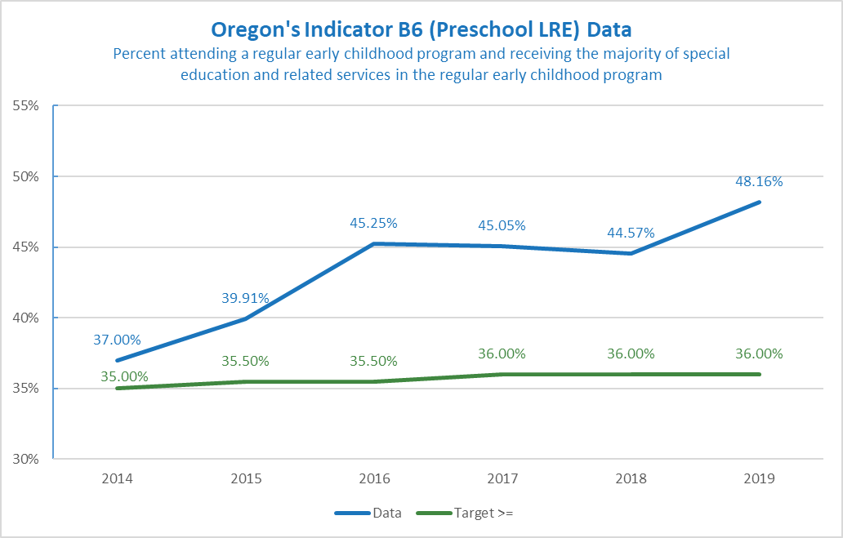
FFY | 2011 | 2014 | 2015 | 2016 | 2017 | 2018 | 2019
Targets ≥ | Baseline | 35.00% | 35.50% | 35.50% | 36.00% | 36.00% | 36.00%
Data | 32.70% | 37.00% | 39.91% | 45.25% | 45.05% | 44.57% | 48.16%
- Percent attending a special education class, separate school, or residential facility.
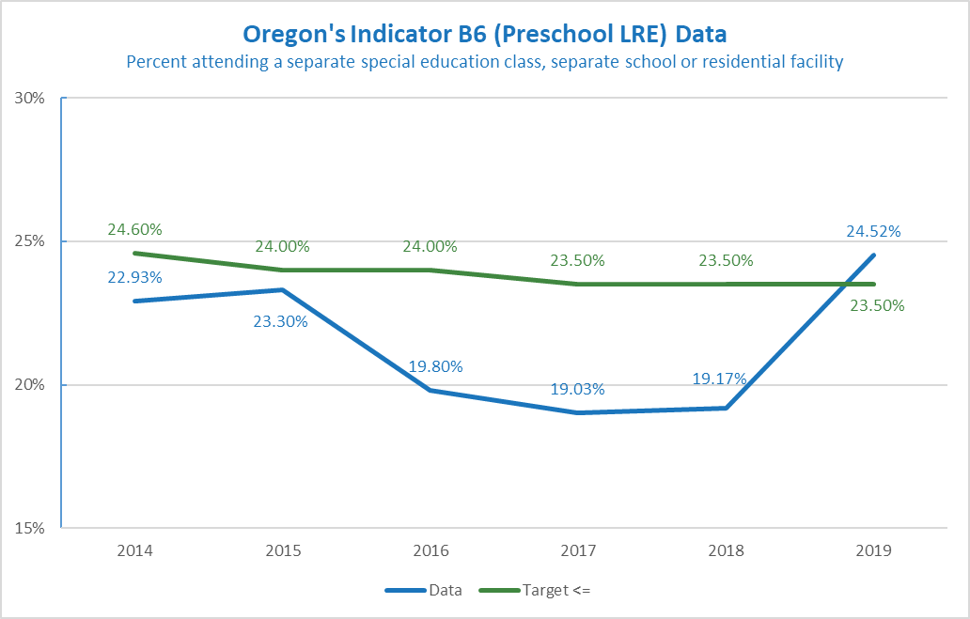
FFY | 2011 | 2014 | 2015 | 2016 | 2017 | 2018 | 2019
Targets ≥ | Baseline | 24.60% | 24.00% | 24.00% | 23.50% | 23.50% | 23.50%
Data | 25.56% | 22.93% | 23.30% | 19.80% | 19.03% | 19.17% | 24.52%

What are the new targets?
The ODE will not set new targets until we hear from our partners. There are several ways to set new targets. It could be a percentage increase, start with the end game in mind, or examine trends over time and make predictions based on trends. Some helpful information about setting targets:
- Targets are meant to support improved results and outcomes for children and families. They should be within reach but still show growth.
- Change takes time. Targets can be created with this understanding in mind. For example, targets may stay the same for several years in a row, and then increase slightly during the final target year (FFY 2025). Or show a slight increase each year.
- The goal for this indicator is to be at or above the target for area A, and at or below target for areas B and C.
- Currently the placement in the home setting for delivery of special education services is at 10.25%. Targets for the future should be at or below this level.
- This indicator has been affected by COVID-19 restrictions and there was a reduction of placements in community sites and an increase in placements in other sites this past year.
Example A
FFY | 2020 | 2021 | 2022 | 2023 | 2024 | 2025
A: Targets ≥ | Baseline: 48.16% | 48.16% | 48.16% | 48.50% | 48.50% | 49.00%
B: Target ≤ | Baseline: 23.50% | 23.50% | 23.50% | 23.00% | 23.00% | 22.50%
C: Target ≤ | Baseline: 10.25% | 10.25% | 10.25% | 10.00% | 10.00% | 9.75%
Example A shows a gradual increase.
Example B
FFY | 2020 | 2021 | 2022 | 2023 | 2024 | 2025
A: Target ≥ | Baseline: 48.16% | 48.16% | 48.00 % | 48.00% | 49.00% | 50.00%
B: Target ≤ | Baseline: 23.50% | 23.50% | 23.00% | 23.00% | 22.00% | 21.00%
C: Target ≤ | Baseline: 10.25% | 10.25% | 10.00% | 10.00% | 9.50% | 9.00%
Example B shows a more robust set of targets.
If you need more information in order to provide input, please contact Meredith Villines at meredith.villines@state.or.us.

