Review Window Audits

Introduction
The Review Window for each collection is an opportunity for users to clean up their data without penalty. These windows are provided to catch possible duplicates, miscodes, under reported students, over reported students, etc. Users have about four weeks for data clean-up, including reviewing and addressing ODE audits. The respective Review Windows are as follows:
- Child Find and June Exit – In Autumn (August/September)
- December Child Count – After New Year’s (January/February)

Contact List
For assistance, please contact us at the information below.
Jackie McKim Research Analyst (503) 947-5629 jackie.mckim@ode.oregon.gov
Cynthia Garton Research Analyst (503) 947-5817 cynthia.garton@ode.oregon.gov
Josie Velasco Research Analyst (503) 510-8329 josie.velasco@ode.oregon.gov

Login Information
Go to the District website and click Central Login Application. From there, enter your User Name and Password.
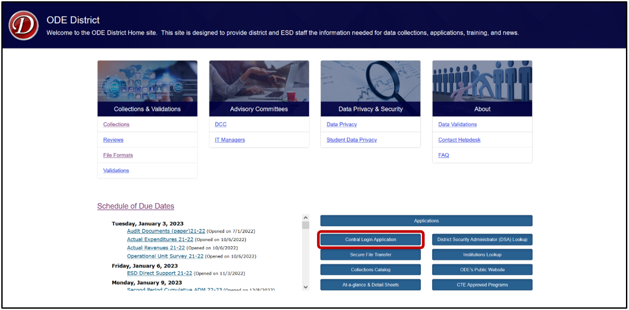

Logging in takes Users to their Applications List, (yours might appear different).
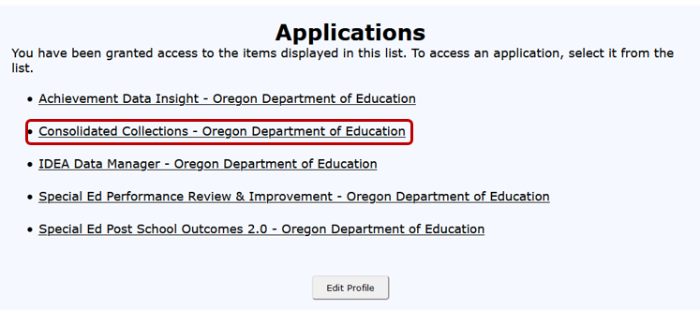

Correcting Audits in Consolidated Collections
To view and correct audits, hover your mouse over Student Collections in the top menu bar. For this example, screenshots show December Child Count. The process is the same for June Special Education Exit and Special Education Child Find.
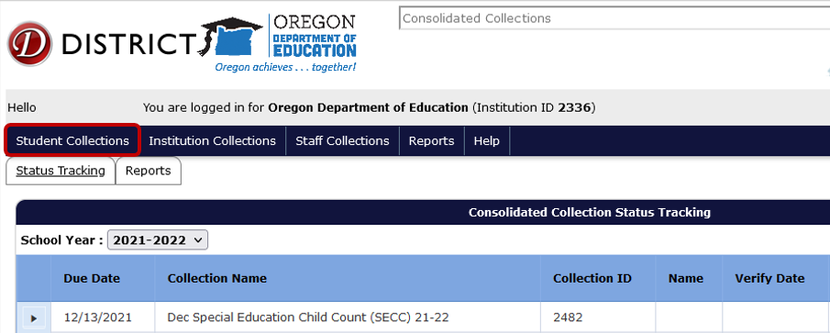
A drop menu will appear, containing a list of open collections. To review audits, hover over the collection name. In this case, Dec Special Education Child Count (SECC) 21-22.
A fly out will appear with a three options. Hover over Error Management to access the next fly out menu.
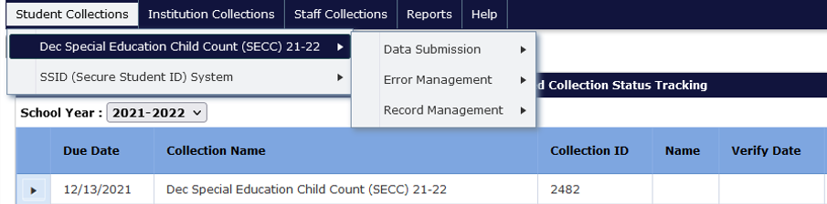

The final fly out menu will have seven options. Here users will click Review Audits.
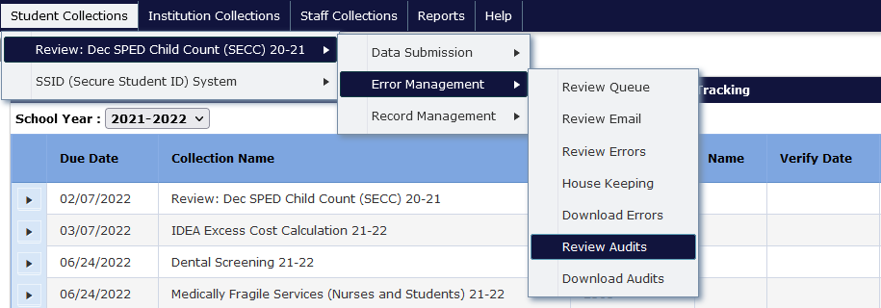
The Audit Screen shows a list of audits by type, the count of each type, and an audit description. The Audit Count is the number of records that have that respective audit type. Audit Type indicates the type of potential error. Audit Description provides a broad description of the audit. A student’s record may have multiple audits and appear under more than one audit type.
To access the audits, click on the expand triangle button to see the audit details.
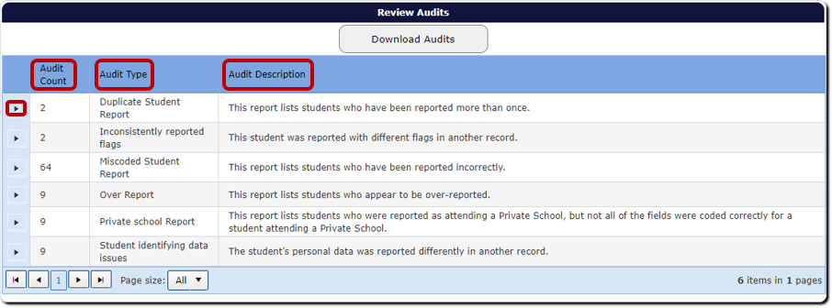
In audit details, the Comment is a message from the Data Team, indicating why the record is flagged as an error or warning. If the record needs a correction, click on the green checkmark under the Fix column. This will allow users to review the record.
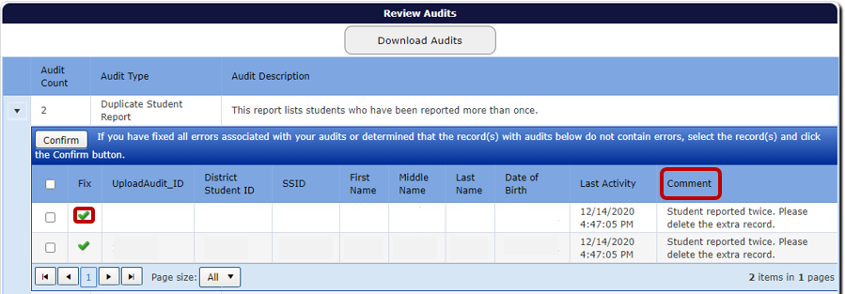
Once corrected, click the Save and Confirm button. This will save the corrections, and the system will remove the record from the audit list. The Last Activity column will reflect the date and time the last change was made.
The Cancel button will undo any changes made to the record. The Return to Search takes the user back to the audit list, with the respective Audit Type expanded.
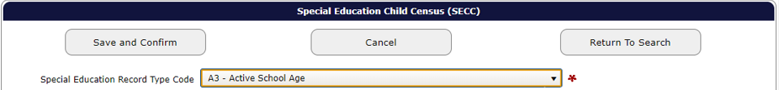
If the record is correct, users can confirm the record by clicking the Save and Confirm button while in the record. Or, if on the Audit List page, users can click on the box for the record, to the left of the Fix column, and then click the Confirm button. Users should not confirm any record(s) until they are sure it is not an error. When users Confirm a record, it disappears from the audit report permanently.
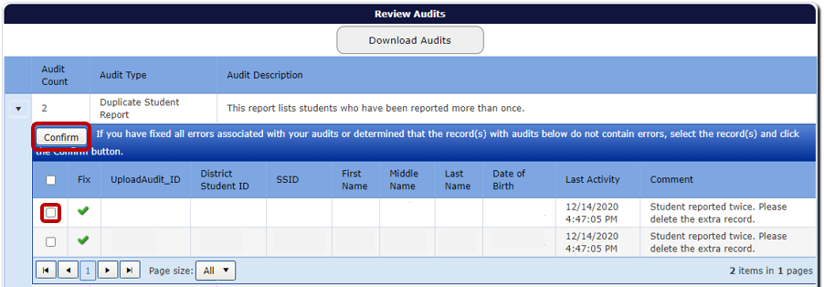
Users can also confirm all audits for the Audit Type, by clicking on the Select All box next to the Fix column, and then clicking the Confirm button. Do not Save and Confirm any records until you are sure there are no errors. When records are confirmed, they will disappear from the report.
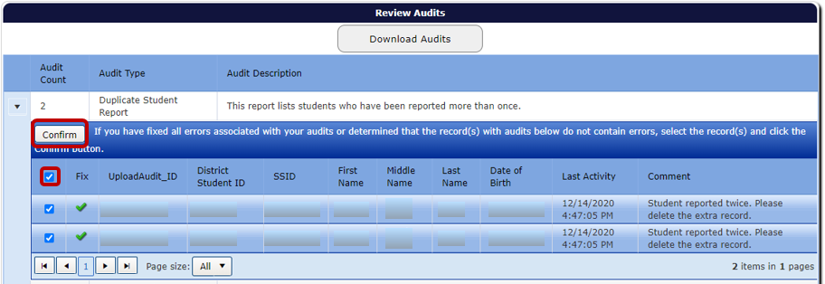

If the audit comment is unclear or the user is unsure how to resolve it, please contact a member of the Data Team for assistance. It is best not to confirm an audit if the user is unsure what it is. If the audit is regarding an error, this could lead to being flagged for inaccurate data in SPR&I.
After clearing all audits, users will go to the Status Tracking page to verify the reports. See Verification Reports.
While the collection is open, users may add, change and remove records.

Adding, Editing and Removing Records

Add a Record
The following steps will add a record:
- Select Consolidated Collections from the Application menu.
- Hover over Student Collections from the top menu bar.
- Hover over the appropriate collection, then Data Submission, and then Web Submission.
- Enter either the student’s SSID, or First and Last Name.
- Click Search.
- Select the appropriate student if a list is provided, otherwise enter the student’s information and click the Save button.
- Make sure to check for errors (Error Management/Review Errors).

Change/Edit a Record
The following steps will change a record that is not on the Audit report:
- Select Consolidated Collections from the Application menu.
- Hover over Student Collections from the top menu bar.
- Hover over the appropriate collection, then Record Management, and then Record Maintenance.
- Enter either the students SSID, or First and Last Name.
- Click Search.
- Select the appropriate student if a list is provided, by clicking the green checkmark on the left side of the screen.
- Edit the appropriate fields and click the Save button.
- Make sure to check for errors (Error Management/Review Errors).

Remove a Record
The following steps will remove a student:
- Select Consolidated Collections from the Application menu.
- Hover over Student Collections from the top menu bar.
- Hover over the appropriate collection, then Record Management, then Record Maintenance.
- Enter either the students SSID or First and Last Name.
- Click Search.
- Select the appropriate student if a list is provided, and click the red “X” on the right side of the screen.

Verification Reports
After all audits and/or errors have been addressed and fixed, users need to verify the records submitted, then print and sign the Final Submission Form.
From anywhere in the Consolidated Collections application, click the Status Tracking tab to go to the list of collections.
Make sure the School Year dropdown is showing the correct school year. This dropdown will automatically advance to the next school year on July 1. If the school year is incorrect, select the current school year by clicking the dropdown arrow.
Click the black expand arrow next to the collection to be verified. This example uses December Special Education Child Count. The process is the same for June Special Education Exit and Special Education Child Find.
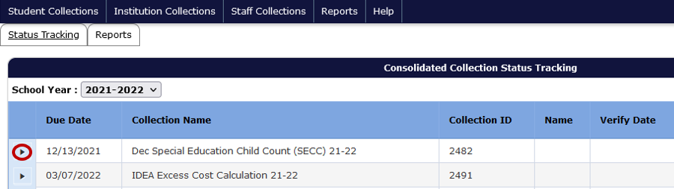
After clicking on the black expand arrow next to the collection, users will see the following screen. Clicking the checkboxes next to each verification report displays the data tables to be reviewed and verified by the user. The red “X” in the Current Status column indicates the report has not been verified. Review each verification report to ensure the count of records is correct.
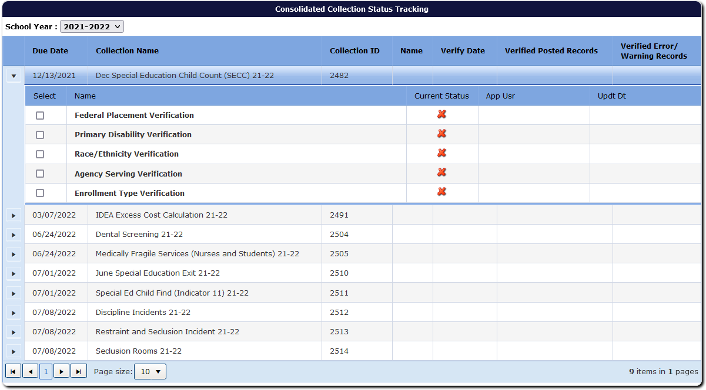
After selecting the checkbox, the screen will display the aggregated data with options for approving the report and exporting the data to Excel. Next, click the Approve Report button. Users verify each report one at a time.
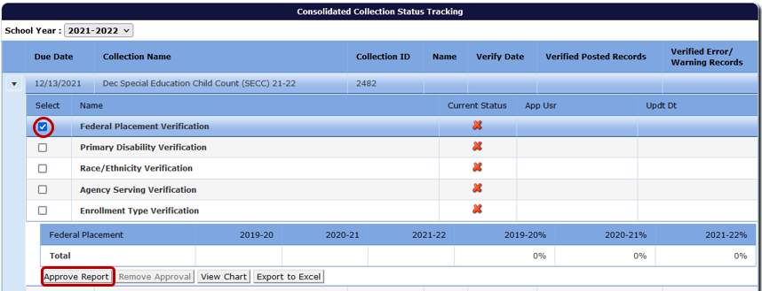
As users verify, the system adds the user name and date of verification in the row for each report. The system also displays the user name and date in the row for the collection name, but there is a delay and it may display after the second report. Warning: system will display name and time in the collection name row, even when not all reports are verified.
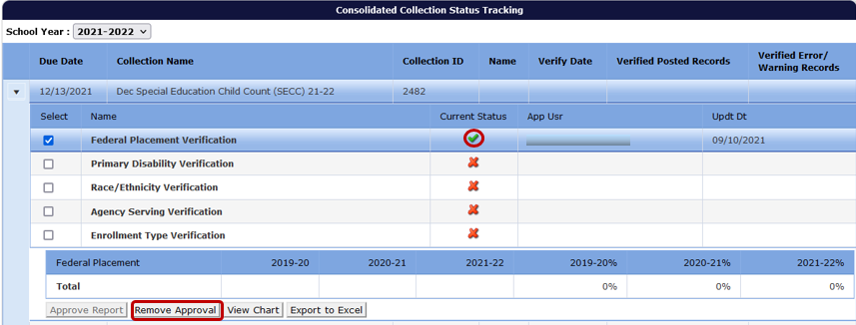
Continue through the list of Verification Reports. Once all reports are approved, the Final Submission Form button becomes available. When this button is clicked, the system generates a PDF for submitting agencies (School District, ESD and EI/ECSE) to sign, date, and return to ODE.
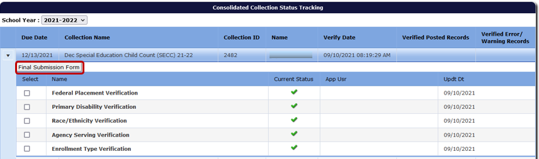
Print the form, have it signed and either email or mail it as indicated on the form. Please pay attention to when the Final Submission Form is due, and check that the agencies listed on the form are accurate and complete.
Once the Final Submission Form has been received by ODE, the collection is complete. Note, there is no Final Submission Form for Special Education Child Find. This is only applicable to December Special Education Child Count and June Special Education Exit.
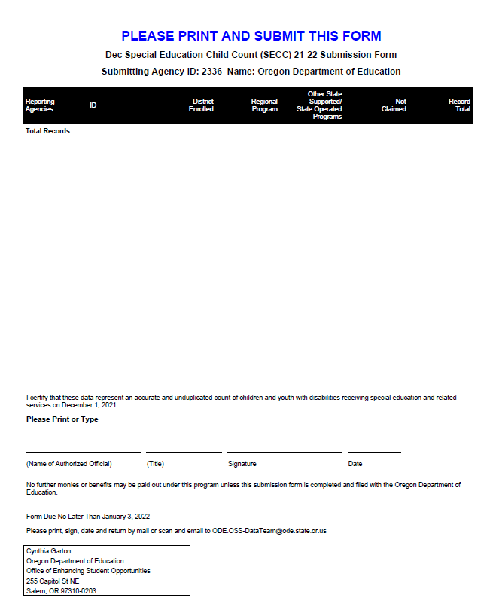
The submission process is not final until ODE receives the signed Final Submission Form. Agencies will be marked late if forms are not received by the end of the day of the due date. Email is preferred. Faxed forms will not be accepted.

