Enhancing Student Opportunities Data Collections

IDEA Data Manager Application

User Guide
Revised – September 2023
OREGON DEPARTMENT OF EDUCATION
Office of Enhancing Student Opportunities
255 Capitol Street NE
Salem, OR 97310-0203

Table of Contents
What’s New 1
September 2023 1
- Coordinated Early Intervening Services 1
- Private School Data 1
- General 1
Introduction 2
Acronyms 2
Contact List 2
Security 2
Getting Access 3
Login Information 4
IDEA Data Manager 6
SECC 6
- Dashboard 7
- Entering Student Data Manually 7
- Importing Student Records 11
- Validating SECC and Exit 15
- Error Reports 17
- Exporting Data 20
Child Find 22
- Dashboard 22
- Entering Student Data Manually 22
- Importing Student Records 26
- Validating Child Find 29
- Error Reports 31
- Exporting Data 34
Reports 35
- Reports Background 35
- Grouping 35
- Exporting Reports 36
- Filtering Reports 37
- Sorting 37
- SECC Reports 38
- Child Find Reports 46
- CEIS Reports 50
- Private School Reports 50
Coordinated Early Intervening Services 51
- Getting Access for CEIS 51
- Collection Overview 51
- Submission Steps 52
- Contact Information 57
Private School Data 58
- Getting Access for Private School 58
- Collection Overview 59
- Submission 60
- Review 70
- Contact Information 70
Utilities 71
- Advance SECC Grade 72
- Remove Exited Records 72
- Migrate Child Find Records 73
Agency 74
- Instructions 75
- Agency 76
- Staff Contacts 80
- SECC Consortium 82
- Late & Inaccurate 84
- State Programs 88
Help 89
- Help Background 89
- FAQs 89
- Resources 90
ODE Help Desk & Data Security and Privacy Overview 92
Contact Information 92
Services 92
Help Desk vs. Data Team – who to call? 92
ODE Help Desk: What to Expect 92
Data Security and Privacy 93
Student Data Security: Handle with Care 93
ODE Policies 93
Information Security Questions 94
Secure File Transfer 95

What’s New

September 2023

Coordinated Early Intervening Services
- The Use of Funds for CEIS tab changes:
  - Renamed Field: Projected count of students without disabilities (allowed for CEIS and CCEIS)
  - New Field: Projected count of students with disabilities (allowed for CCEIS only)
  - New Calculated Field: Projected count of students who will receive the academic or behavioral services and supports (locked field that is the calculation of fields 1 and 2)
- No changes to the CEIS Data tab.

Private School Data
- The Proportionate Share Screen changes:
  - Only the carryover fund fields will be edited for districts. All other fields are locked.
- No changes to the Private School Enrollment Screen.

General
- Added sections for ODE HelpDesk/Data Security/Privacy.
- Updated layout of the left navigation menu, organized by category.

Introduction
The IDEA Data Manager Application is a web-based application that contains tools and serves as the submission site for certain special education data collections.
- Tools: The application provides tools for districts to clean and validate their December Child Count, June Exit and Child Find data prior to submitting to the Consolidated Collections Application.
- Reports: The Reports tab will generate reports using SECC, June Exit or Child Find data entered in to the IDEA Data Manger.
- Submission Site: The application serves as submission site for Coordinated Early Intervening Services (CEIS/CCEIS), Parentally Placed Private School Enrollment, Parentally Placed Private School Proportionate Share and Agency information such as general agency information, staff contacts and SECC Consortium status.
This manual serves as a guide to understanding the functions and features of this application.

Acronyms
Abbreviations frequently used throughout this document include:
Acronym | Name
CSV | Comma Separated Values
IDEA | Individuals with Disabilities Education Act
ODE | Oregon Department of Education
ESO | Office of Enhancing Student Opportunities
SECC | Special Education Child Count

Contact List
The Office of Student Services Data Team supports, maintains and provides technical assistance for the IDEA Data Manager Application and the respective collections it supports.
For assistance with this application or help with the respective collections it supports, please contact us at the information below.
Jackie McKim Research Analyst 971-240-0234 jackie.mckim@ode.oregon.gov
Cynthia Garton Research Analyst 503-508-7492 cynthia.garton@ode.oregon.gov
Maxwell Swope Research Analyst 971-208-0259 maxwell.swope@ode.oregon.gov

Security
Student information is confidential, so keeping it secure is important. For information on data security, privacy and secure file transfer, see ODE Help Desk & Data Security and Privacy Overview.

Getting Access
The IDEA Data Manager is accessed within the District Website. If you do not already have access, please contact your district’s Security Administrator.
If you do not know who your District Security Administrator is, go to the District Home page, and on the center right-hand side beneath FAQ, click District Security Administrator (DSA) Lookup.
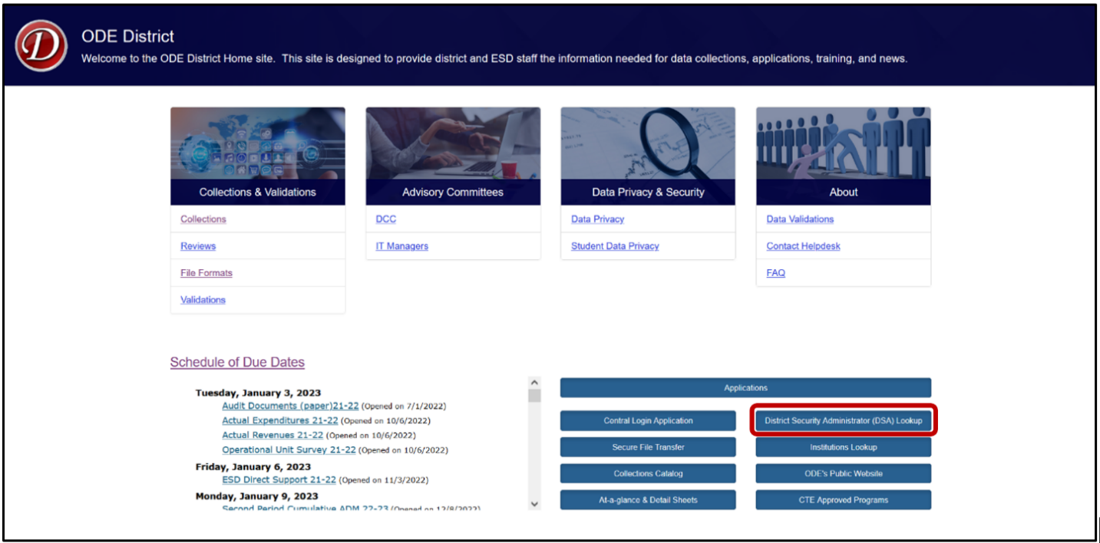
On the Search for Security Administrator page, follow the instructions on the screen.
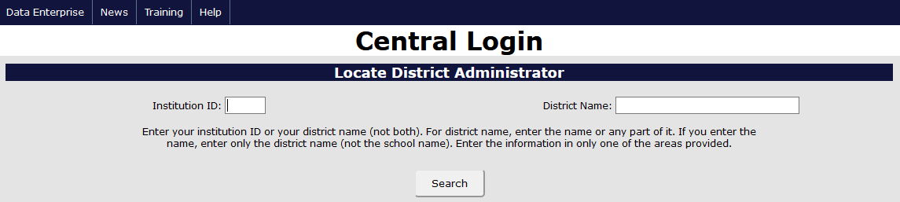
When requesting access to collections, and applications such as the IDEA Data Manager, data submitters must request Primary rights and Modify rights. Users should verify with their District Security Administrator that they have both permissions. Without both, users will not have the ability to view, submit or edit data.
The following components within the application require permissions to access: SECC, Child Find, Coordinated Early Intervening Services, Private School and Agency. Users should request Primary rights and Modify rights only for the applicable collection(s).

Login Information
Users will access the IDEA Data Manager on the ODE District site (https://odedistrict.oregon.gov/Pages/default.aspx). Users will click on the Central Login Application color block link.
Warning: Applications is a link to the list of ODE’s applications and not a link the applications assigned to a user.
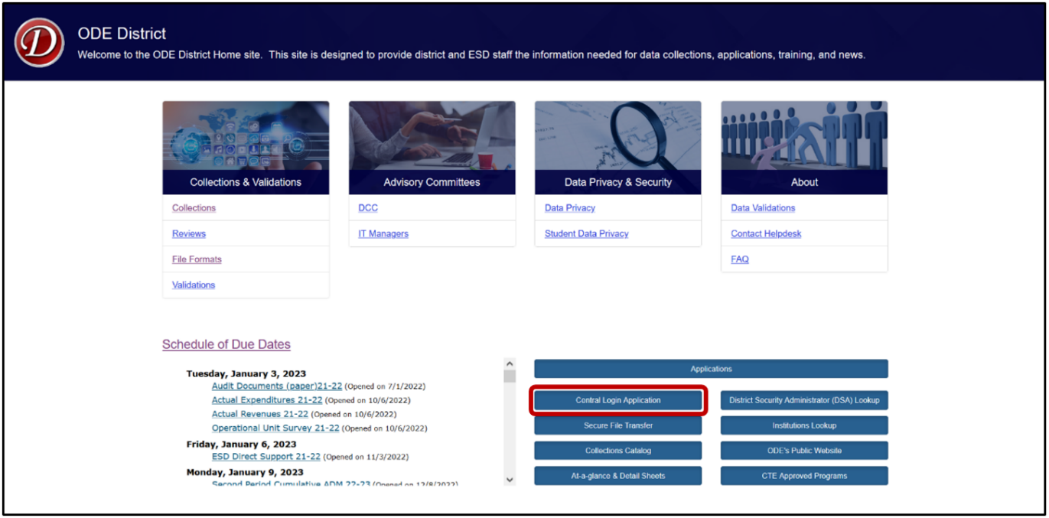
Login to the District website by entering your User Name and Password, then press enter or click on the Login button.
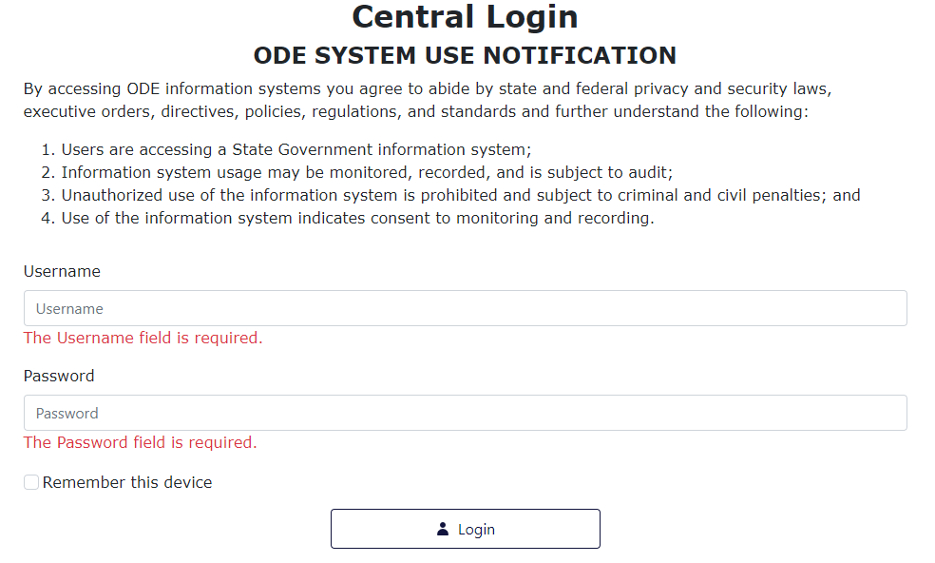
Next, users will click on the IDEA Data Manager in the Applications List (yours might appear differently).
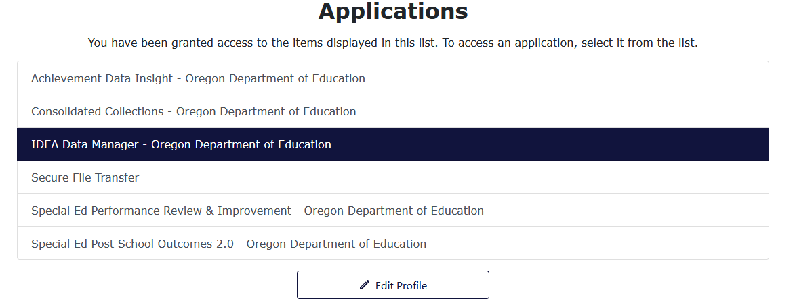

IDEA Data Manager
After logging in, the webpage will load the IDEA Data Manager Web application dashboard.
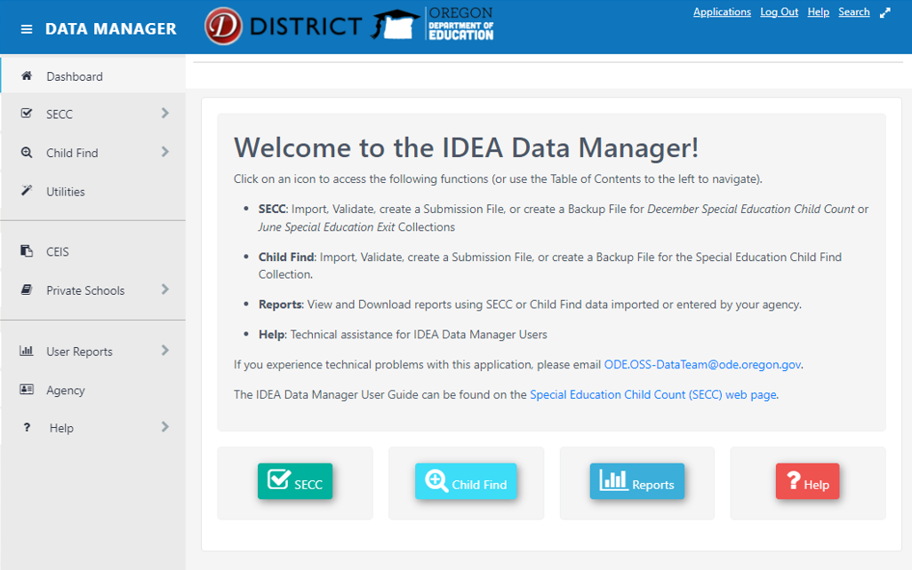Users can navigate through the application using the navigation menu on the left-hand side of the screen, or by using the color buttons at the bottom of the dashboard.

SECC
The SECC function of the IDEA Data Manager is to assist districts in cleaning and validating their December Special Education Child Count or June Special Education Exit data prior to submitting to ODE. There are four steps in this process. First, users will either enter individual student records or import groups of student records from a CSV file. Next, users will validate the student records using the Validate function in the application. Then, users will address any errors or warnings identified during the validation process. Finally, users will create a submission file for uploading to Consolidated Collections.
Within the application, the school year will change in the fall, October/November, to allow users ability to validate June Exit through the review window. December Child Count will be active from November to May and June Exit will be active from May to November.

Dashboard
To view a summary of the collection, click SECC in the left menu, then click Dashboard. The summary contains a count of records for the collection, as well as the due date for the collection period.
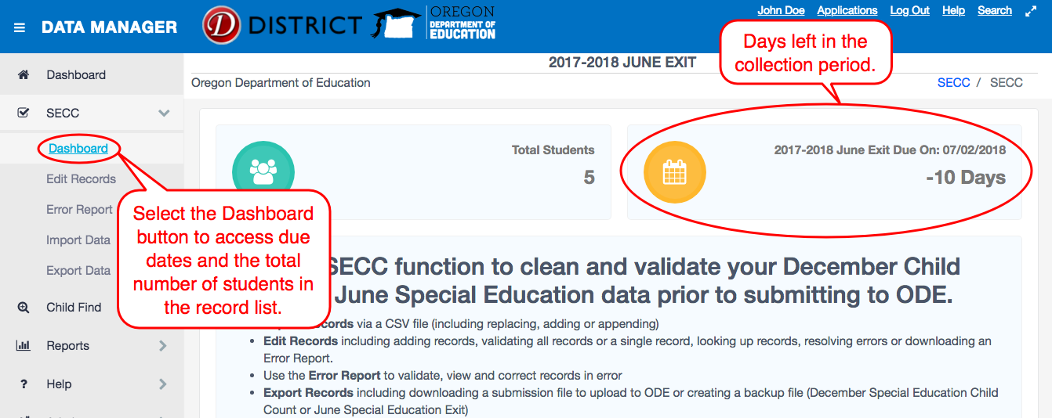

Entering Student Data Manually
To enter or edit an individual student record, either click Edit Records on the sidebar menu under SECC or click the SECC button from the main Dashboard page.
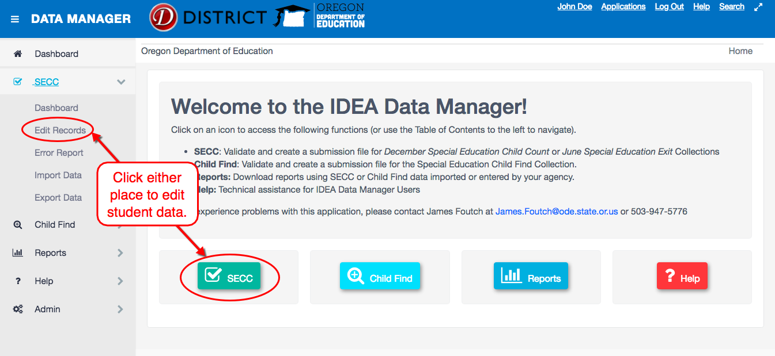

From the Edit Records page, users can complete four different tasks: add a new record, view the error report for entered records, Validate Exit or Validate SECC. To enter individual student data, click the + New Record button.
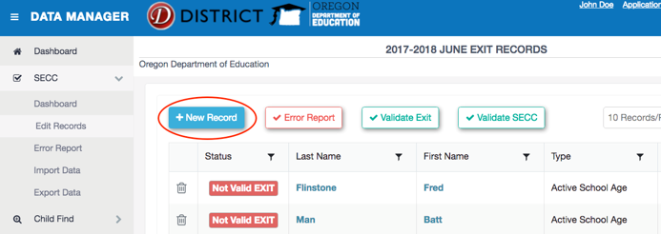
The New Record screen contains fields for the user to input the student’s information. Users must enter the Special Education Record Type to enable the remaining fields. All fields with a red asterisk are required fields and cannot be blank.
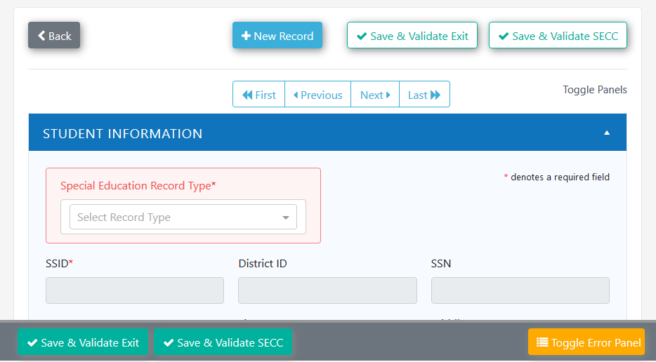
Once the record is complete, the user will click either Save and Validate Exit or Save and Validate SECC, which validate June Exit and Child Count respectively. These are two separate validation functions, depending on the chosen data collection.
The Save and Validate Exit button reviews the data compared to a list of requirements for all June Exit records. These requirements ignore records marked as Not Reported. The Save and Validate SECC button reviews the data compared to a list of requirements for all SECC (Child Count) records. These requirements ignore Exit records and records marked with Agency Serving Code 80 – Not Claimed.
The error panel located below the record will list any errors or warnings found. Users can show or hide the list of errors by clicking the Toggle Error Panel button. Users can also utilize the Edit Record home screen to validate all records in the list and resolve errors within individual student records.
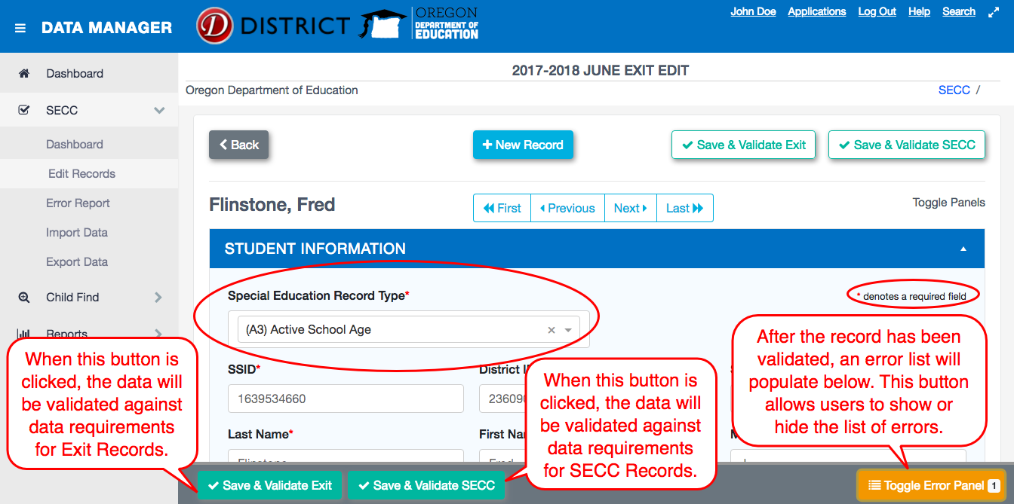
In the student record, clicking the section headings, such as Student Information, will collapse or expand the views. The images below are examples of expanded and collapsed section headings. Click the triangle to collapse the section. Click the triangle again to expand the section and view the content.

Collapsing Example 1
The image below is an example of an expanded section heading. Click on the triangle toggle to collapse.
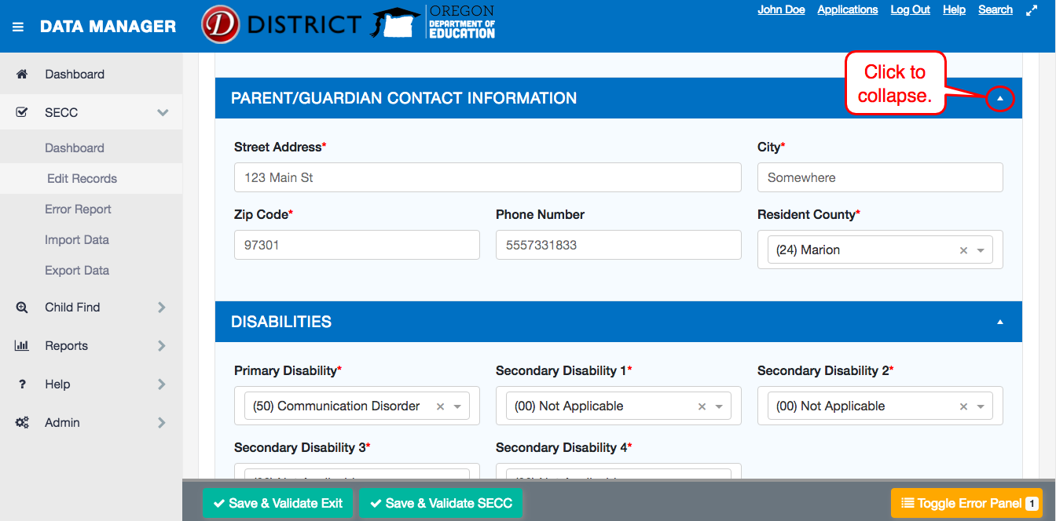

Collapsing Example 2
The image below is an example of a collapsed section heading. Click on the triangle toggle to expand.
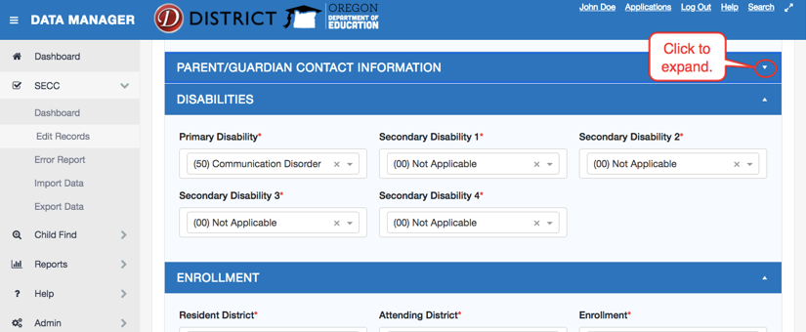

Collapsing Example 3
You can also click the Toggle Panels link to expand or collapse all the sections at once.
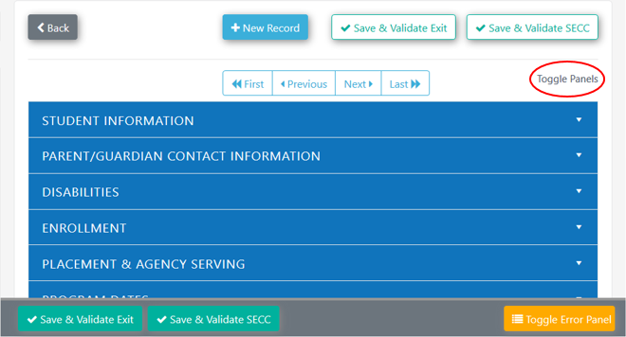

The Edit Records screen will contain a list of all records added. Once records are in the record list, there are tools available to help users find or remove records.
The trashcan deletes records and the funnels in the header row are filters.
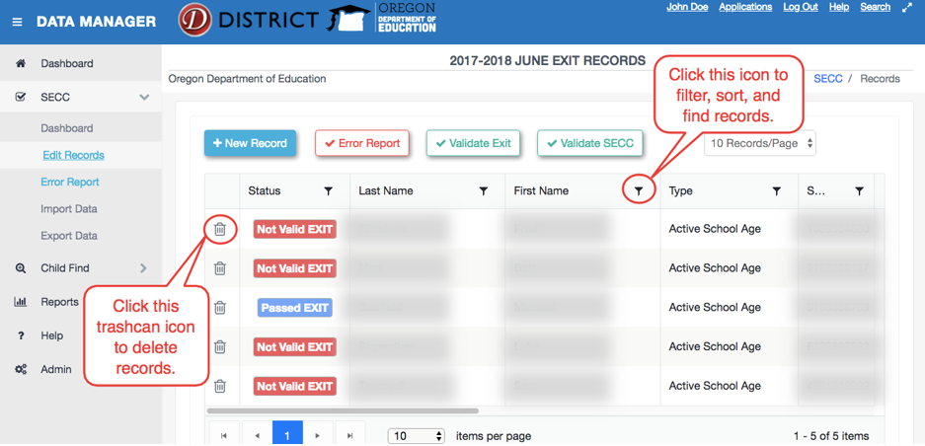

Importing Student Records
Users can import several records at once using the Import Data function. Click either Import Data in the left navigation menu under SECC or the Import Records button from the SECC dashboard.
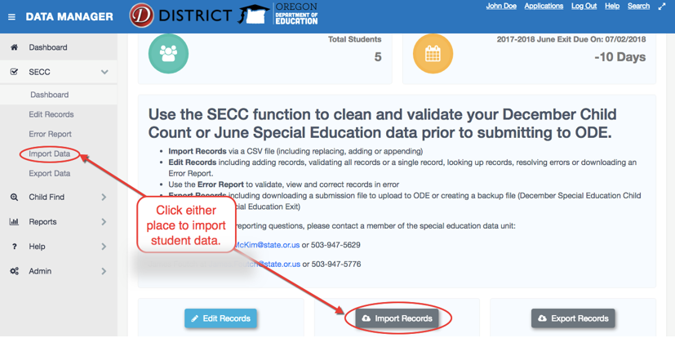
Data must be in a Comma Separated Values (CSV) file format. The Import Data page provides a file template to download; it is below the Upload Options. This template is for both SECC/Child Count and June Exit records.
There are four file upload options to select in the import data function:
- Update Matching Records: When selected, if an existing record has the same SSID number as an imported record, then all of the existing record’s values will be replaced with the imported records values. This is the default selection.
- Remove ALL Existing Records: When selected, all of the existing records will be deleted and replaced with the contents of the uploaded file.
- Append Records: This option will append all imported records to the existing data set without attempting to update any existing records. This may cause duplicates to appear!
- New Records Only: This option will only import records that are not already present in the district’s dataset, based on SSID matching.
The first step when importing student records is to select one of the options and click the Next button. If you do not already have a data file to work with, you may download a template file by clicking the link below the four import options.
There is a question mark next to each import option. Hover over to see a definition of the respective option.
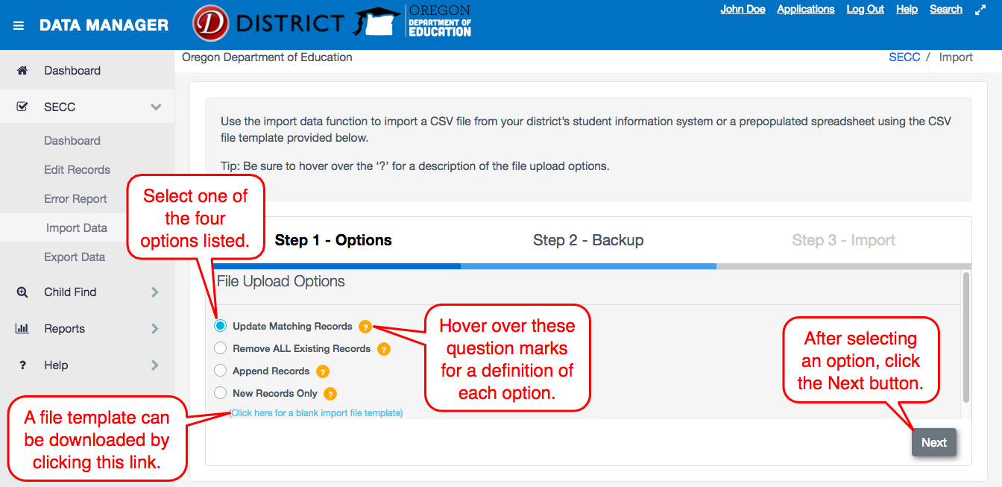
The second step in the import process is to download a backup file of existing data. This is done by clicking the Download Backup button on the Step 2 - Backup page. This is not required, but strongly suggested. Finally, click the Next button to continue the import process.
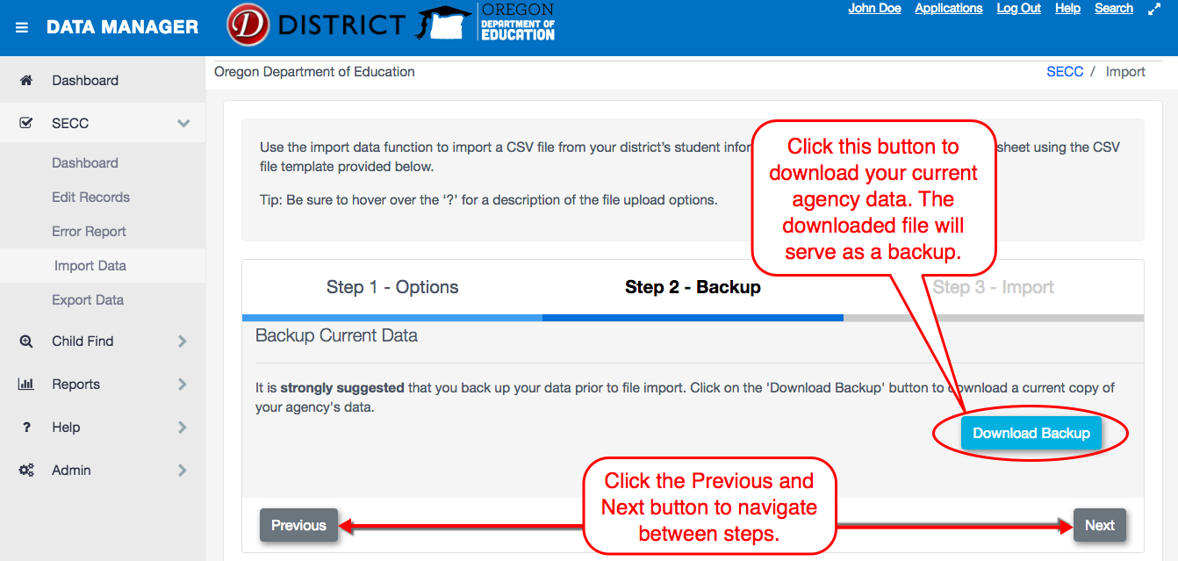
Step 3 in the import process is to select an import file by clicking the Select Import File button. After selecting a file, the records will be processed and imported into the system. This process only checks whether the columns have valid information in them (i.e., number columns do not contain text, or limited choice columns do not have valid options, etc.). Please see the SECC File Format document on the District site for more details on each column.
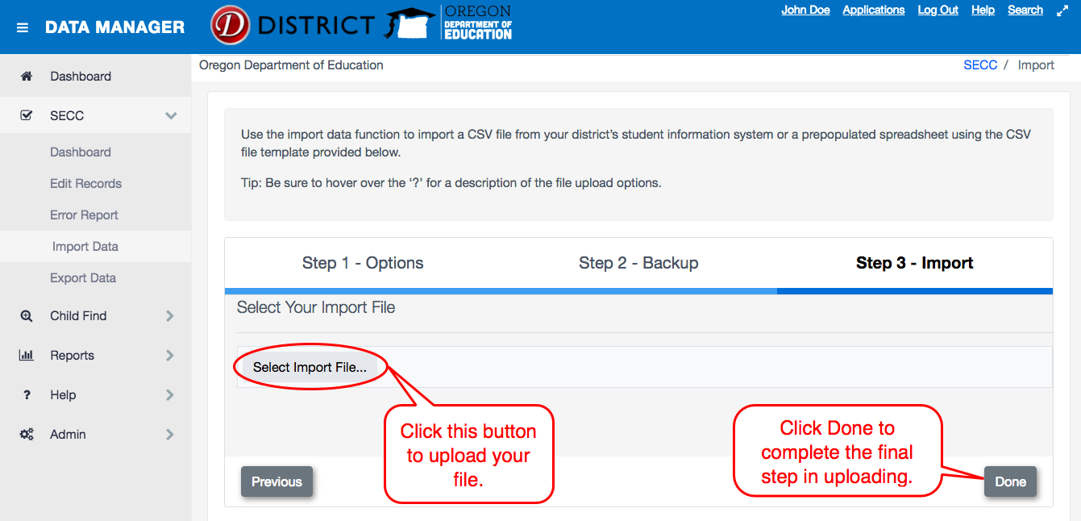

The final step shows the file upload results, indicating the number of records added, the number of records updated, the number of records skipped and the number of errors. A list of all errors is displayed in the Import Errors table at the bottom of the screen. Users can export this list to an Excel Spreadsheet by clicking the Export to Excel button. Users can go to the imported records by clicking the Edit Data button. If you want or need to start over, click the Reset button.
Please note: clicking the Reset button does not remove imported records. This function only starts the import process back to Step 1.
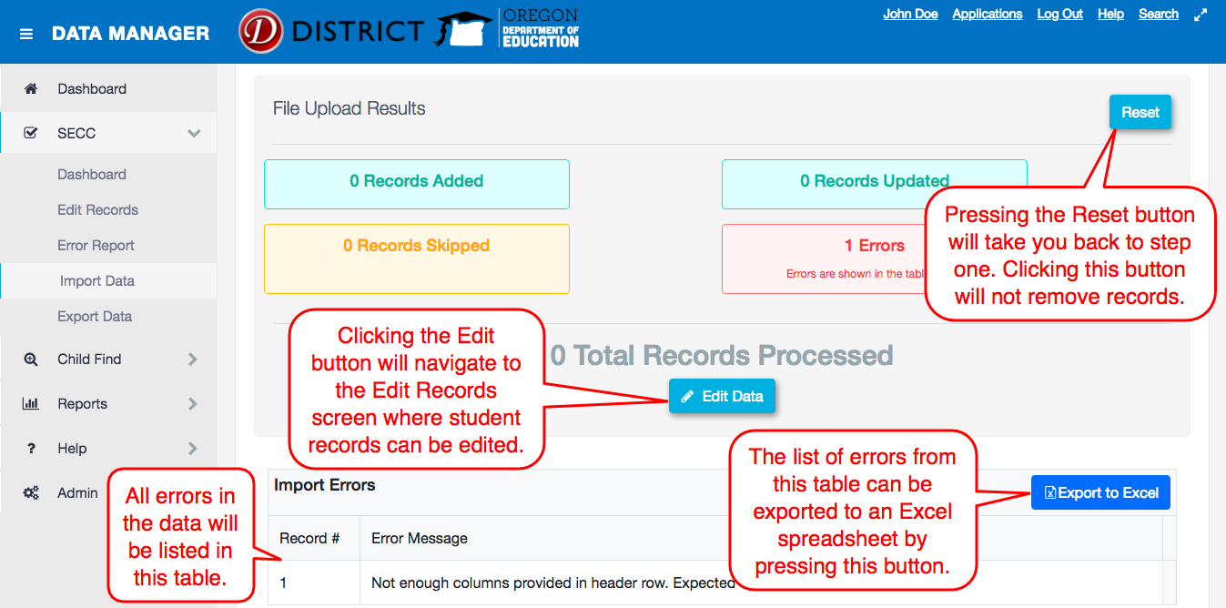

Validating SECC and Exit
After entering or importing the district’s SECC records, users will use one of the Validate buttons to have the application review the records for any errors. Records can be validated as a group on the Edit Records page, or individually by clicking on the individual student record in the record list. Validating Exit will review the data against the list of requirements for June Exit. These requirements ignore records marked as Not Reported. Validating SECC will review the data against the list of requirements for SECC. These requirements ignore records reported as Exit and Agency Serving Code 80 – Not Claimed. To see all the errors for a single record, click on a student name.
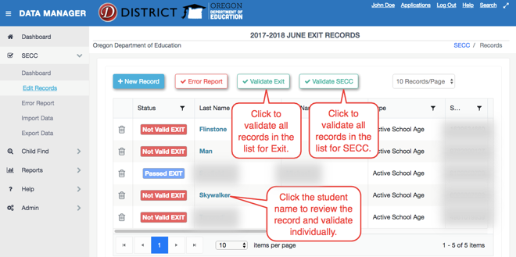
After clicking one of the Validate buttons, the student record list will show the validation status for each record.
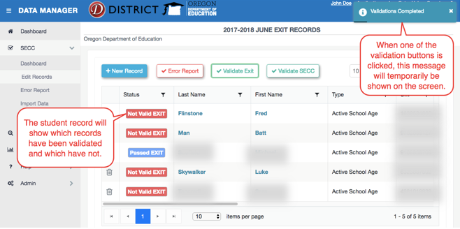
In the individual student record, users can validate Exit data, validate SECC data, add a new record, and navigate between records. A validated record will show the error panel by default. The Toggle Error Panel button will show the total errors and warnings for the given record.
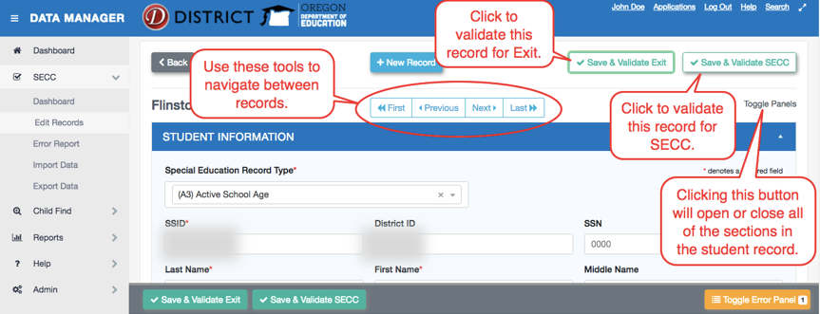
After validating a record, a list of any errors or warnings found will show in the error panel below the record. Use this list as a guide in making changes to the record. Once finished, click the Save & Validate button for the specific collection you are working on to check whether the updates have fixed the issue or if the record needs more updates. A message will appear in the top right corner when the validation check is complete. Users will see either a green pop-up that states “Success” or an orange pop-up that says “Validation Errors” with number of errors or warnings.
Clicking the Toggle Error Panel button will show or hide the list of errors in the record.
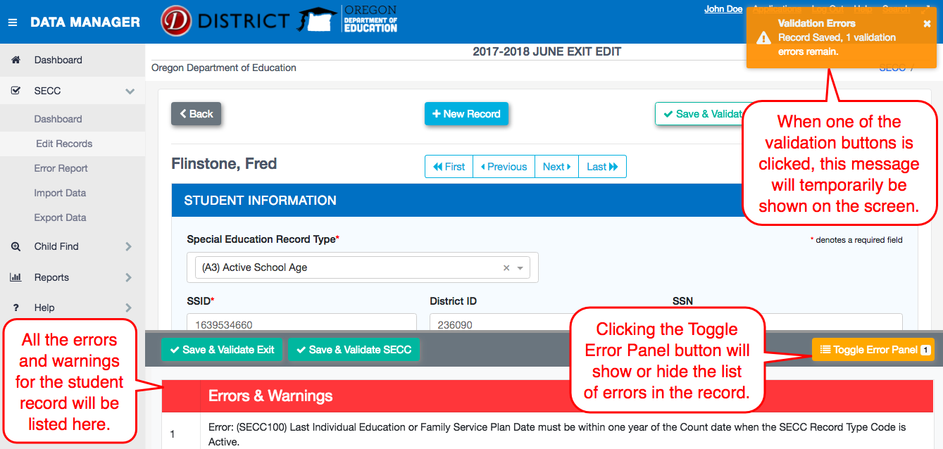
Once finished, click the Save & Validate button for the collection you are working on to check whether the updates have fixed the error or warning, or if the record needs more updates.

Error Reports
After the application has completed validation checks on the data, errors will appear on the Error Report page. Districts should correct all errors before submitting data to ODE. Navigate to the Error Report page by clicking on Error Report in the left menu under SECC or the Error Report button from the Edit Records screen.
Users can export the Error Report to an Excel Spreadsheet from the Error Report page, by clicking on the Export to CSV button or Export to Excel button.
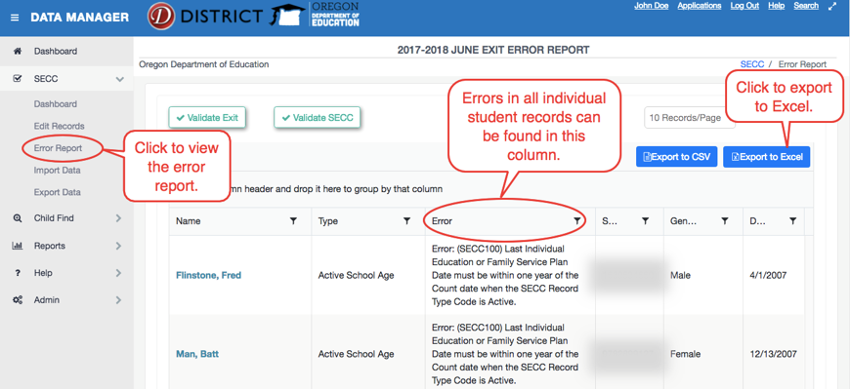
The Error Reports page will show each error or warning. If a student has multiple errors, that student will be listed once for each error or warning. From this screen, users can sort or filter by error, group by a column, export to CSV, and/or export to Excel.
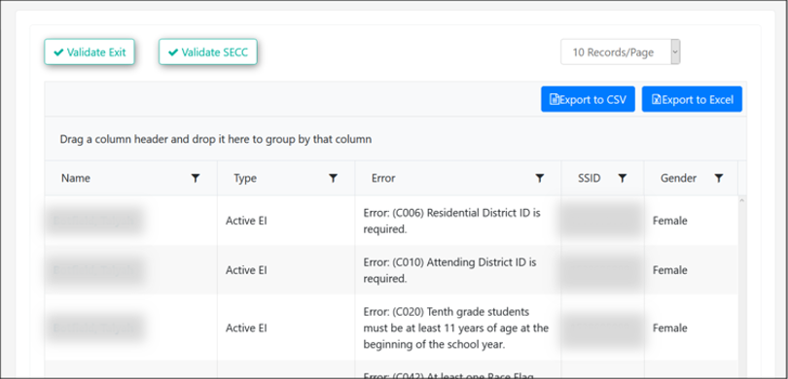

Grouping
Users can group by columns in the Error Report. By doing this, you can view records grouped by the same error type. Users can also export the grouped list to Excel.

Grouping Step 1
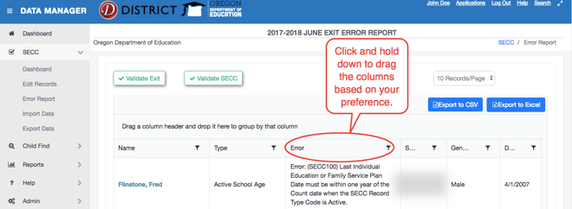

Grouping Step 2
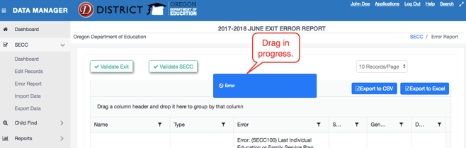

Grouping Step 3
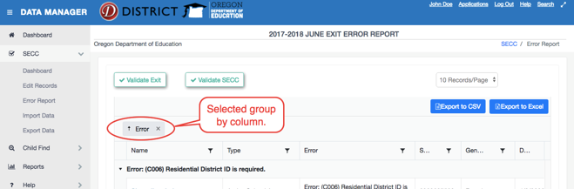

Exporting Errors
Users have two options when exporting errors: Export to CSV and Export to Excel. Exporting to Excel maintains the visual appearance of the grouping in an Excel file. Exporting to CSV sorts the records by error type in a CSV file. Because it’s a CSV file, the user does not need to change the file type/extension when importing after fixing the records.

Grouped Report in Excel
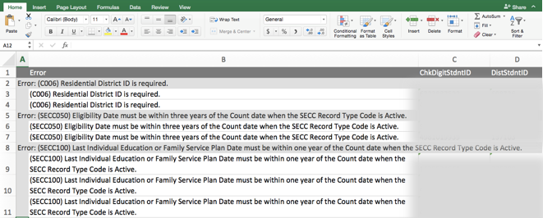

Exporting Data
Use the Export Data function to download a submission file for December Special Education Child Count or June Special Education Exit to import into the ODE Consolidated Collections application. Users can also create a backup file of all SECC data.
To export a file, click on the Export Data link from the Export Data link in the left sideboard navigation menu or the Export Records button from the SECC Dashboard.
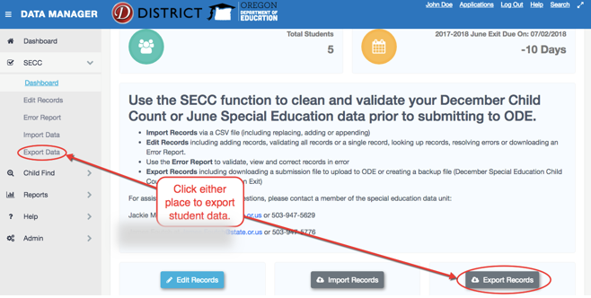
When on the Export Data screen, select the file type needed to be downloaded, and then click on the coordinating button. Note that each download option will include different records.
- December Child Count Submission File – Includes all Active Records (A1, A2, A3), but not Agency Serving Code 80 – Not Claimed.
- June Exit Submission File – Includes all Exit Records (E1, E2, E3) and those coded as A2.
- Backup File – Includes all records, including Code 80 and Not Reported.
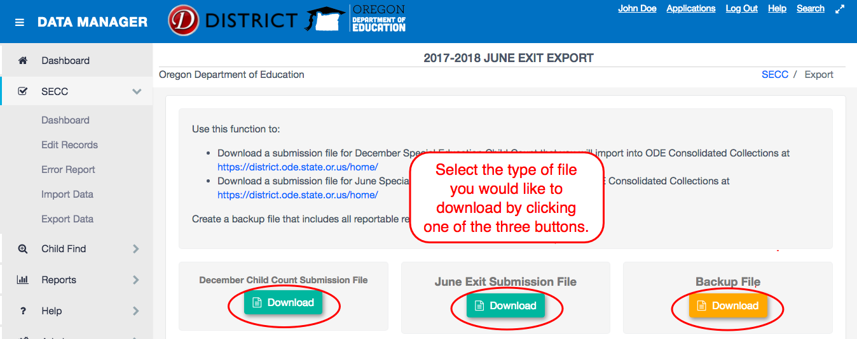
For December Child Count and June Exit submission files, a warning will pop up if there are any records that either have not been validated, or still have errors or warnings. The files will download with the un-validated records, as well as the records with errors and/or warnings.
For instructions on uploading the Submission File to Consolidated Collections, please refer to the OSS Consolidated Collections User Guide.

Child Find
The Child Find function of the IDEA Data Manager is to assist districts in cleaning and validating their Special Education Child Find data prior to submitting to ODE. There are four steps in this process. First, users will either enter individual student records or import groups of student records from a CSV file. Next, users will validate the student records using the validate function in the application. Then, users will address any errors identified during the validation process. Finally, users will create a submission file for uploading to the Consolidated Collection application.
Within the application, the school year will change in the fall, October/November, to allow users ability to validate Child Find through the review window.

Dashboard
To view a summary of the collection, click Child Find in the left menu, then click Dashboard. The summary contains a count of records for the collection, as well as the due date for the collection period.
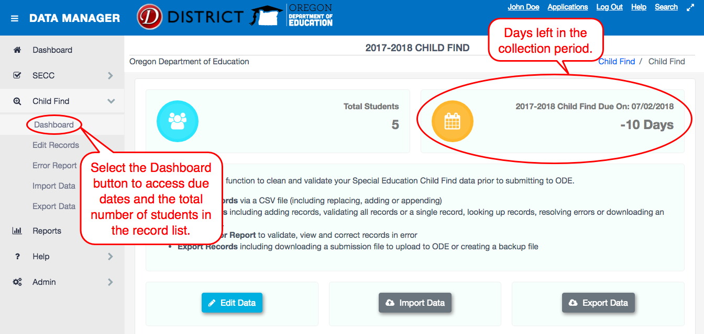

Entering Student Data Manually
To enter or edit an individual student record, either click Edit Records on the sidebar menu under Child Find or click the Child Find button from the main Dashboard page.
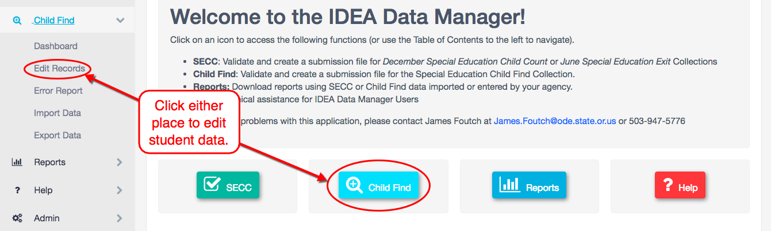
From the Edit Records page, users can complete three different tasks: add a new record, view the error report for the entered records, or validate all records. To enter individual student data, click the + New Record button.
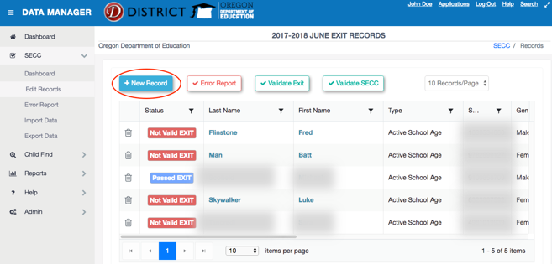
The New Record screen contains fields for the user to input student information. All fields with a red asterisk are required and cannot be blank.
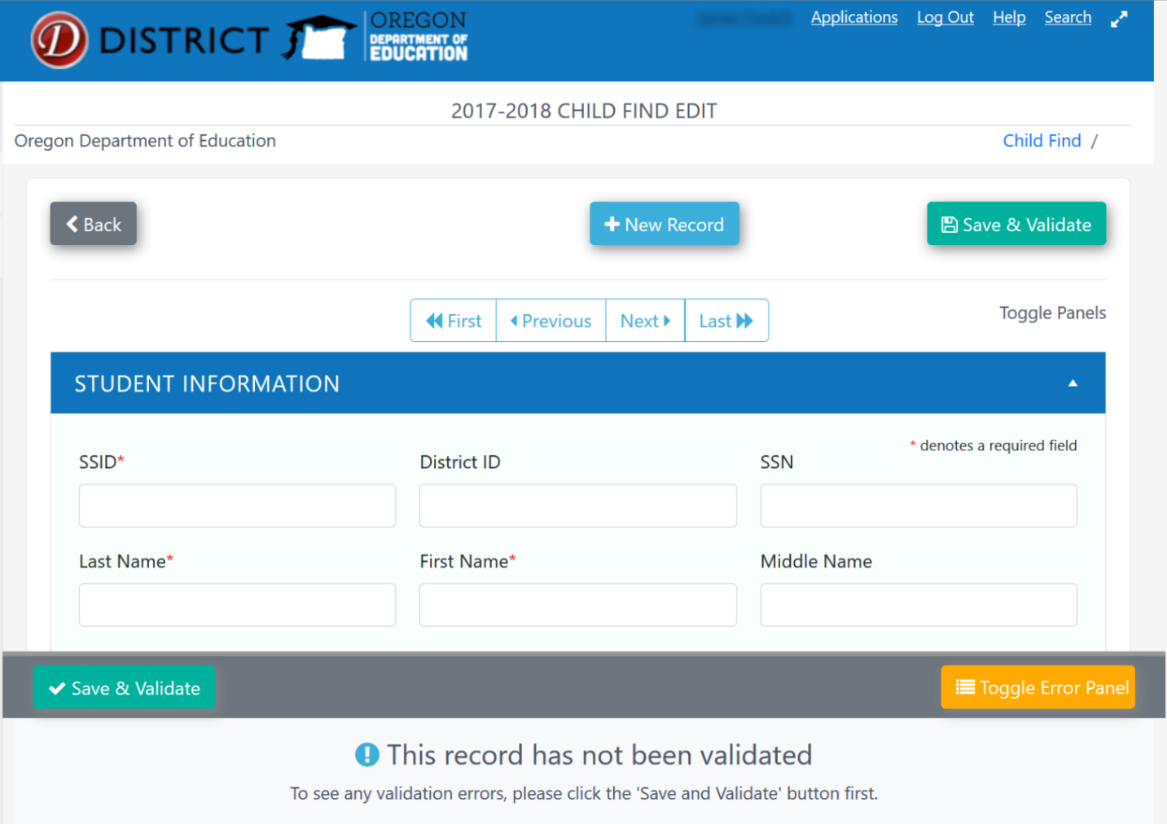
Once the record is complete, the user will click the Save and Validate button. The Save and Validate button reviews the data compared to a list of requirements for all Child Find records. The error panel below the record lists any errors or warnings found. Users can show or hide the list of errors by clicking the Toggle Error Panel button. Users can utilize the Edit Record home screen to validate all records in the list and resolve errors within individual student records.
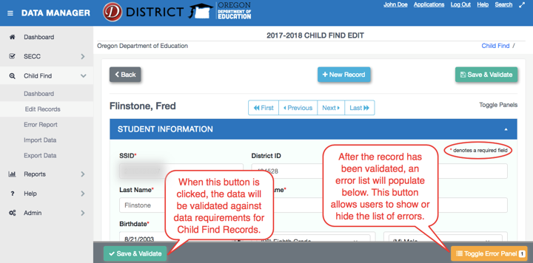
In the student record, clicking the section headings, such as Student Information, will collapse or expand the views. The images below are examples of expanded and collapsed section headings. Click the triangle to collapse the section. Click the triangle again to expand the section and view the content.

Collapsing Example 1
The image below is an example of an expanded section heading.
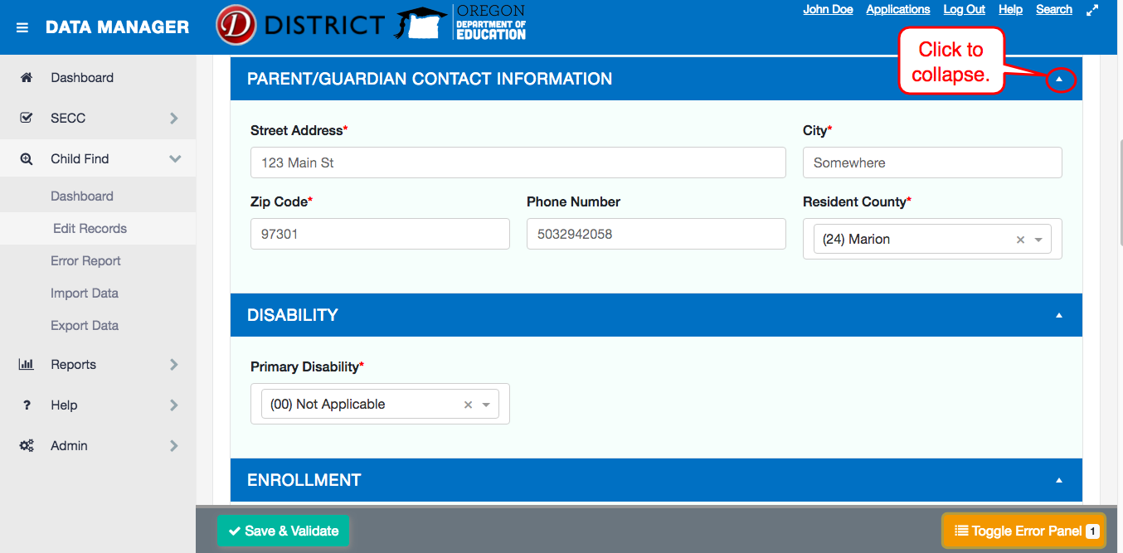

Collapsing Example 2
The image below is an example of a collapsed section heading.
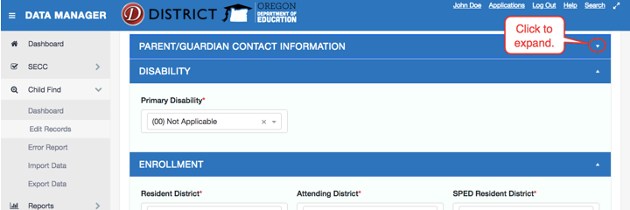

Collapsing Example 3
You can also click the Toggle Panels link to expand or collapse all the sections at once.
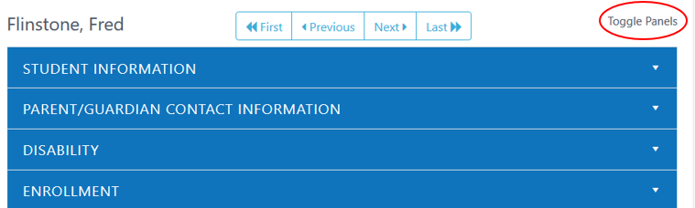
The Edit Records screen will contain a list of all records added. Once records are in the record list, there are tools available to help users find or remove records. The trashcan deletes records and the funnels in the header row are filters.
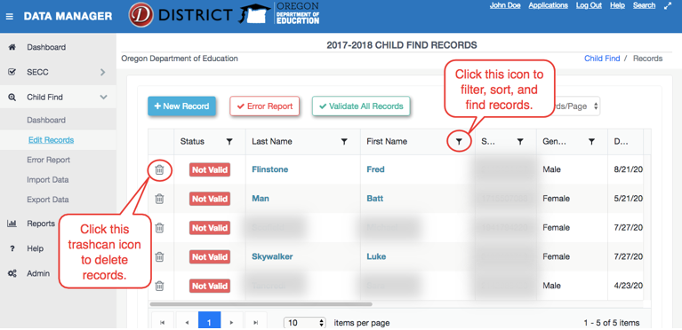

Importing Student Records
Users can import several records at once using the Import Data function. Click either Import Data from the left navigation menu under Child Find or the Import Data button from the Child Find dashboard.
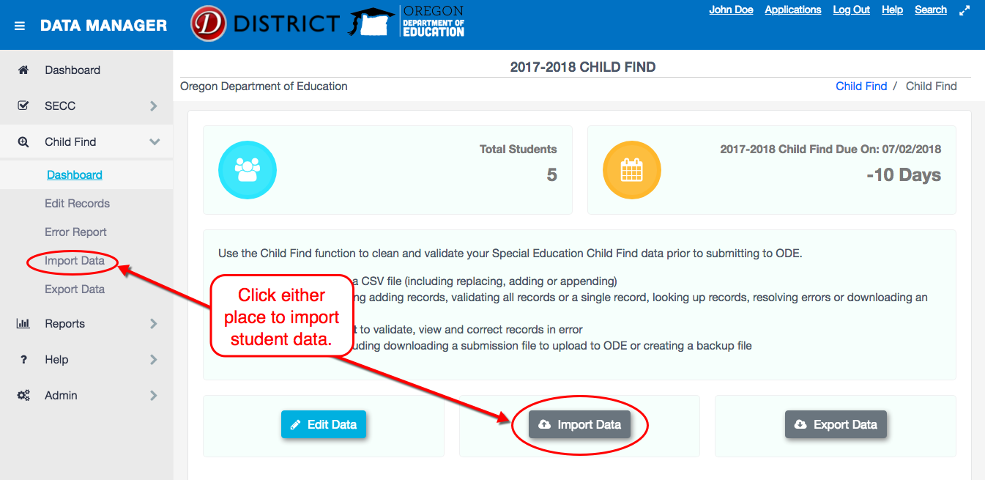
Data must be in a Comma Separated Values (CSV) file format. The Import Data page provides a file template to download; it is below the Upload Options.
There are four file upload options to select in the import data function:
- Update Matching Records: When selected, if an existing record has the same SSID number as an imported record, then all of the existing record’s values will be replaced with the imported records values. This is the default selection.
- Remove ALL Existing Records: This selection deletes all of the district’s existing records and replaces them with the contents of the uploaded file.
- Append Records: This option will append all imported records to the district’s existing data set without attempting to update any existing records. This may cause duplicates to appear!
- New Records Only: This option will only import records that are not already present in the district’s dataset, based on SSID matching.
The first step when importing student records is to select one of the options and click the Next button. If you do not already have a data file, you may download a template file from the link below the options.
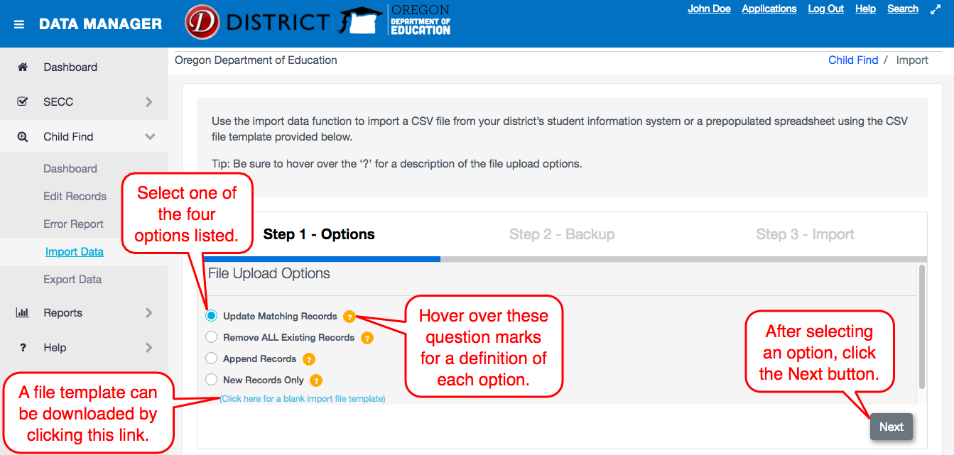
The second step in the import process is to download a backup of the existing data. This is done by clicking the Download Backup button on the Step 2 - Backup page. This is not required, but strongly suggested. Finally, click the Next button to continue the import process.
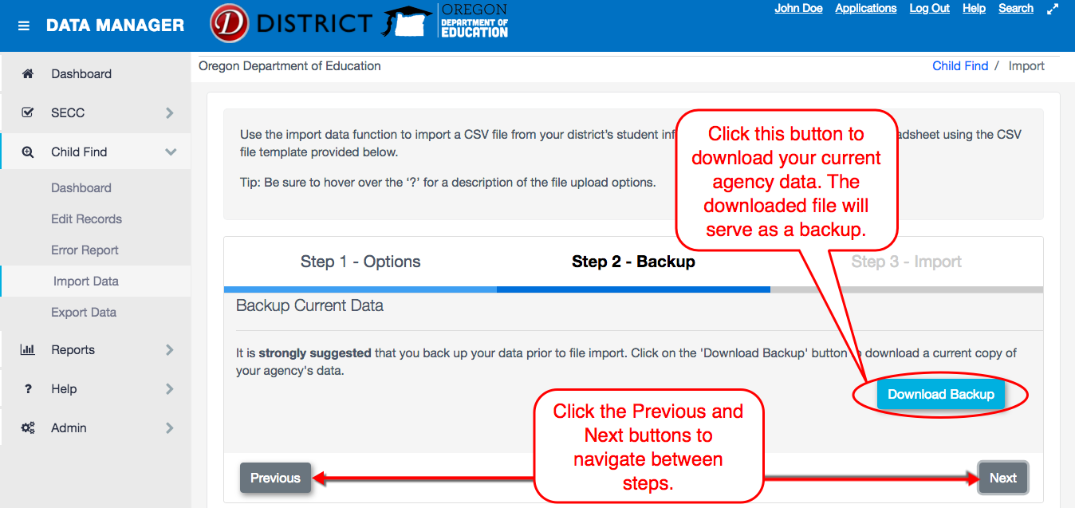

Step 3 in the import process is to select an import file by clicking the Select Import File button. After selecting a file, the records will be processed and imported into the system. This process only checks whether the columns have valid information in them (i.e., number columns do not contain text, or limited choice columns do not have invalid options, etc.). Please see the Child Find File Format document on the District site for more details on each column.
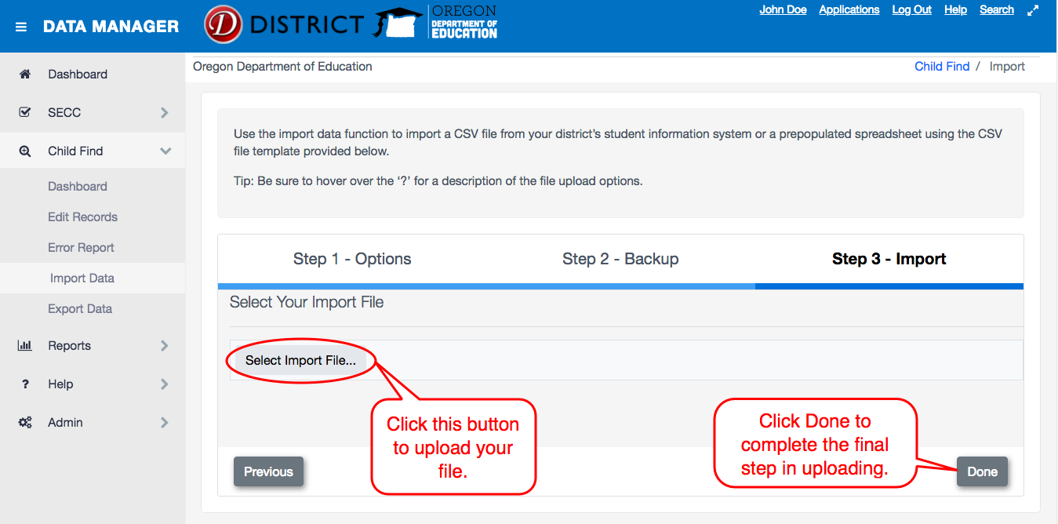
The final step shows the file upload results, indicating the number of records added, the number of records updated, the number of records skipped and the number of errors. A list of all errors is displayed in a table at the bottom of the screen. Users can export this list to an Excel Spreadsheet by clicking the Export to Excel button. Users can go to the imported records by clicking the Edit Data button. If you want or need to start over, click the Reset button.
Please note: clicking the Reset button does not remove imported records. This function only starts the import process back to Step 1.
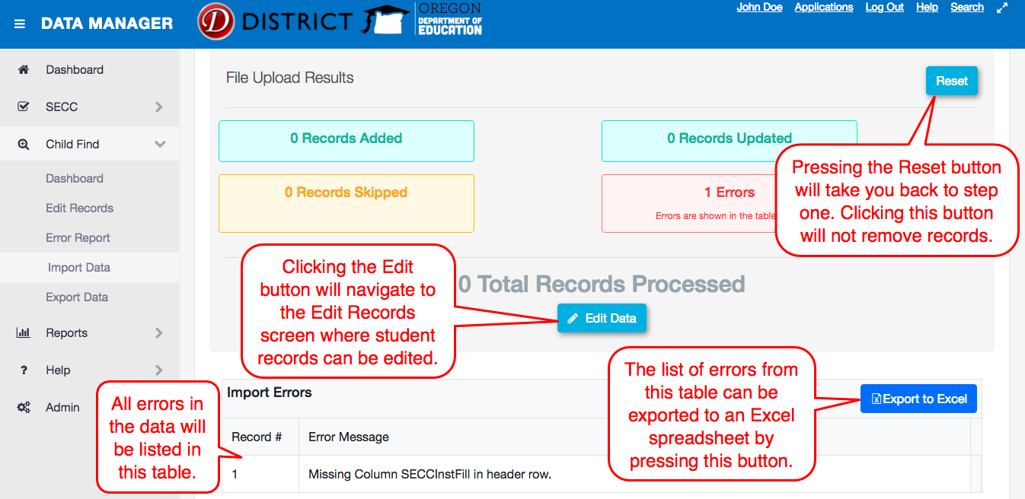

Validating Child Find
After entering or importing the district’s Child Find records, users will use the Validate All Records button to have the application review the records for any errors.
Records can be validated as a group on the Edit Records page, or individually by clicking on the individual student record in the record list. This can be done by clicking the student name. Validating Child Find will review the data against the list of requirements for Child Find data.
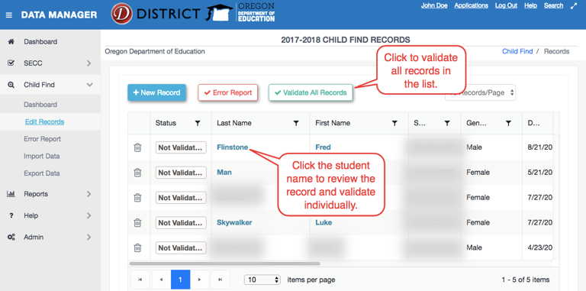
After clicking Validate All Records, the student record list will show the validation status for each record.
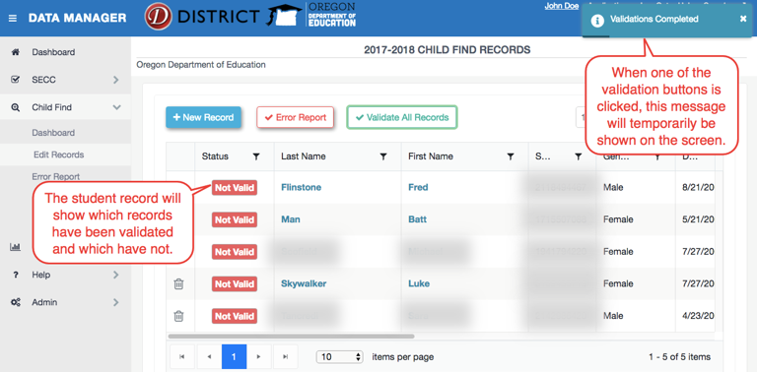

In the individual student record, users can validate Child Find data, add a new record, and navigate between records. A validated record will show the error panel by default. The Toggle Error Panel button will show the total errors and warnings for the given record.
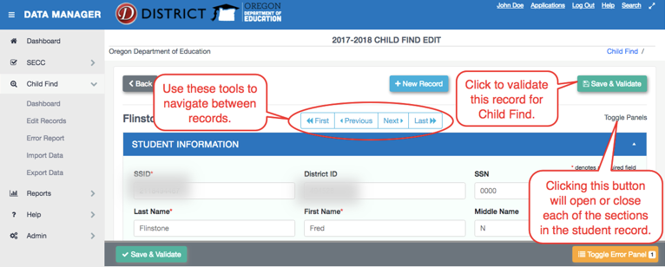
After validating a record, a list of any errors or warnings found will show in the error panel below the record. Use this list as a guide in making changes to the record. Once finished, click the Save & Validate button to check whether the updates have fixed the issue or if the record needs more updates. A message will appear in the top right corner when the validation check is complete. Users will see either a green pop-up that states “Success” or an orange pop-up that says “Validation Errors” with number of errors or warnings.
Clicking the Toggle Error Panel button will show or hide the list of errors in the record.
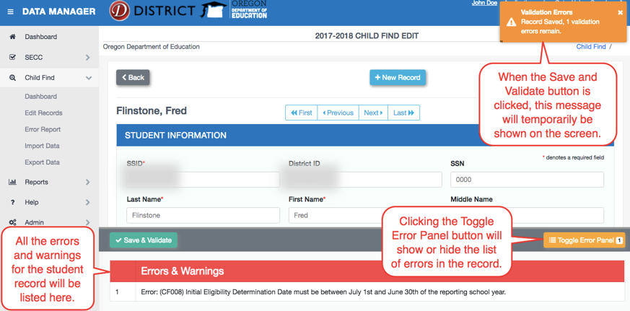
Once finished, click the Save & Validate button for the collection you are working on to check whether the updates have fixed the error or warning, or if the record needs more updates.

Error Reports
After the application has completed validation checks on the data, errors will appear on the Error Report page. Districts should correct all errors before submitting data to ODE. Navigate to the Error Report page by clicking on Error Report in the left menu under Child Find or the Error Report button from the Edit Records screen.
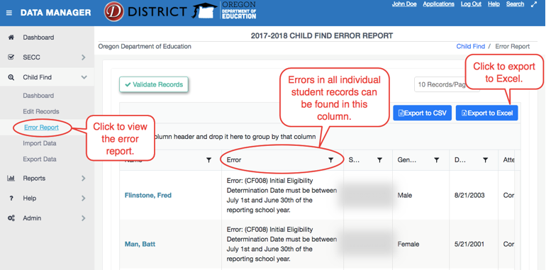
The Error Reports page will show each error or warning. If a student has multiple errors, that student will be listed once for each error or warning. From this screen, users can sort or filter by error, group by a column, export to CSV, and/or export to Excel.
Users can export the Error Report to an Excel Spreadsheet from the Error Report page, by clicking on the Export to CSV button or Export to Excel button.
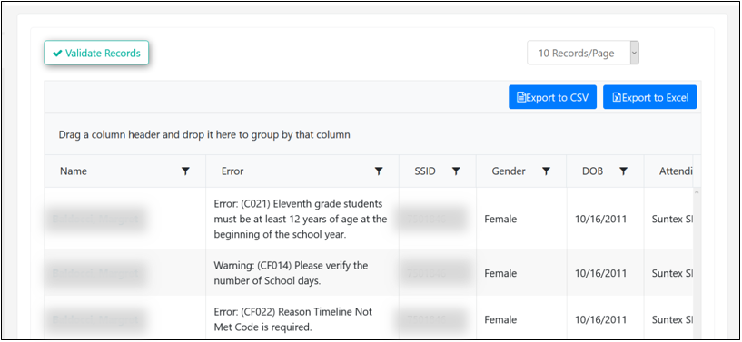

Grouping
Users can group by columns in the Error Report. By doing this, you can view records grouped by the same error type. Users can also export the grouped list to Excel.

Grouping Step 1
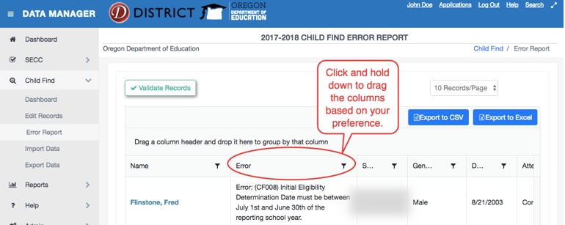

Grouping Step 2
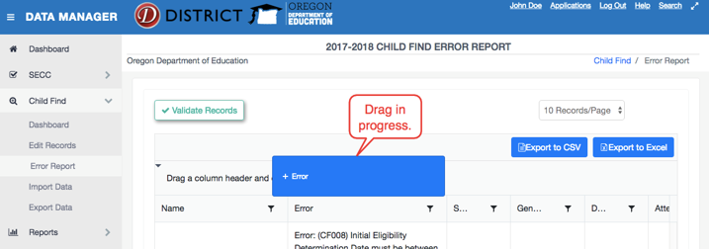

Grouping Step 3
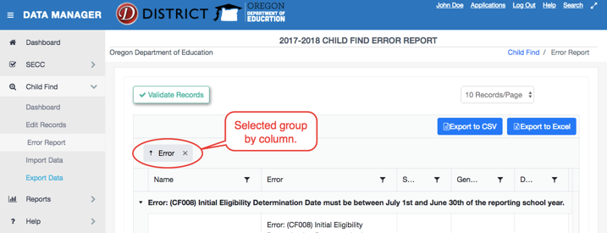

Exporting Errors
Users have two options when exporting errors: Export to CSV and Export to Excel. Exporting to Excel maintains the visual appearance of the grouping in an Excel file. Exporting to CSV sorts the records by error type in a CSV file. Because it’s a CSV file, the user does not need to change the file type/extension when importing after fixing the records.

Grouped Report in Excel
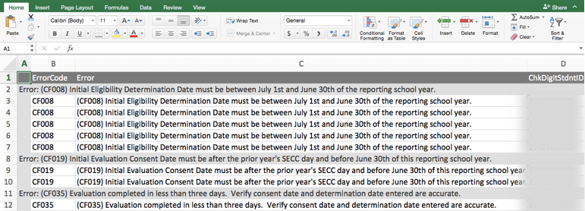

Exporting Data
Use the Export Data page to download a submission file for Special Education Child Find to import into the ODE Consolidated Collections application. Users can also create a backup file of all Child Find data.
To export a file, click on the Export Data link from the Export Data link in the left sideboard navigation menu or the Export Records button from the Child Find Dashboard.
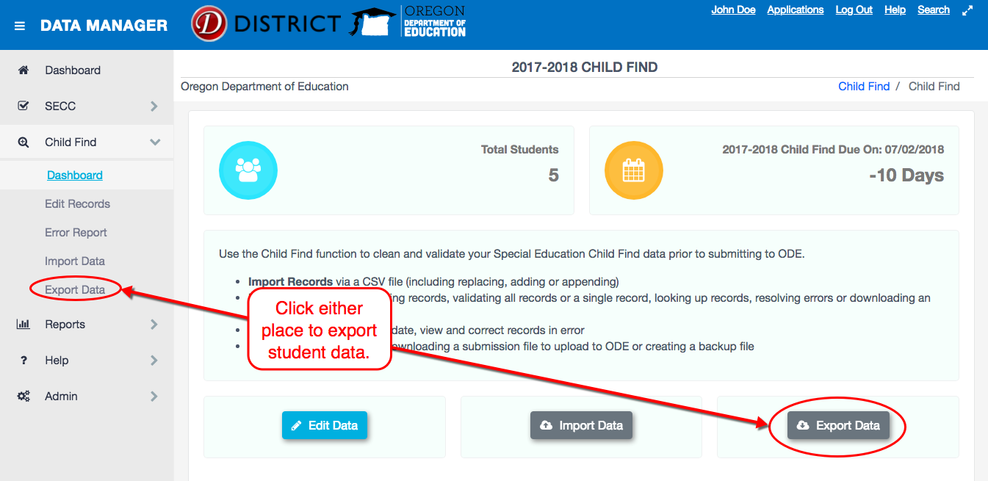
When on the Export Data screen, select the file type needed to be downloaded, and then click on the coordinating button. Note that each download option will include different records.
- Submission File – A warning will pop up if there are any records that either have not been validated, or still have errors or warnings. The files will download with the un-validated records, as well as the records with errors and/or warnings.
- Backup File – Will ignore the validation status of records.
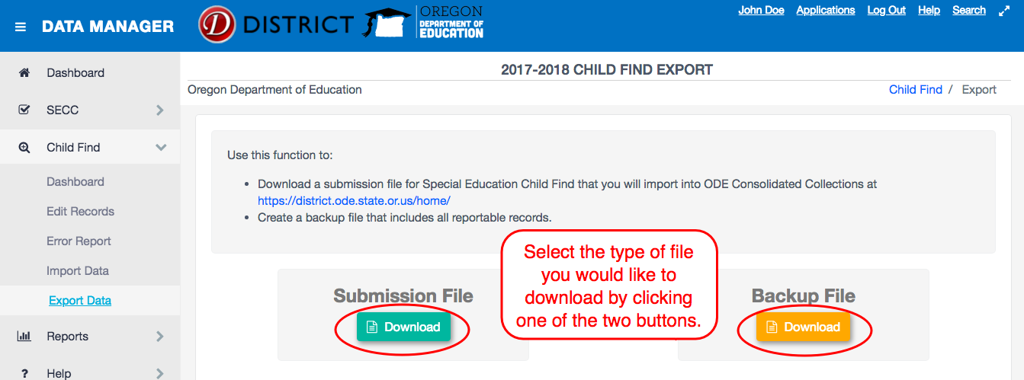
For instructions on uploading the Submission File to Consolidated Collections, please refer to the OSS Consolidated Collections User Guide.

Reports

Reports Background
After selecting a report in the list, users can manipulate data by grouping, filtering and/or sorting.
To view a report, either click Reports on the sidebar menu under Reports button from the main Dashboard page.
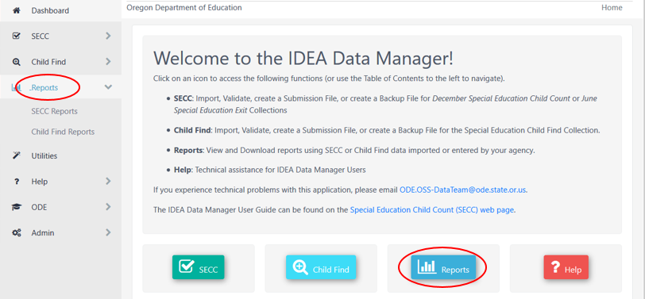

Grouping
Users can group by columns in the Reports. An example of this is if you want to look at results grouped by Record Type. This will let users see all records with like types grouped together. Users can also export the grouped list to Excel.

Grouping Step 1
Click and hold down to drag any column based on preference.
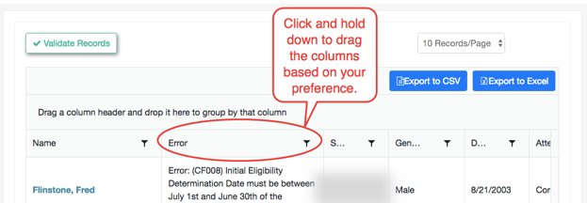

Grouping Step 2
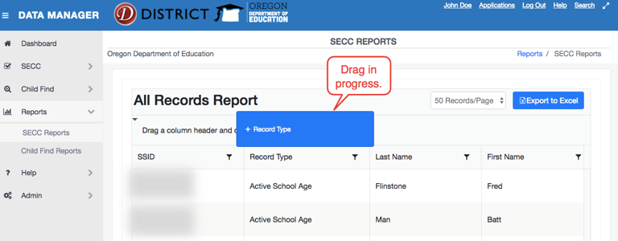

Grouping Step 3
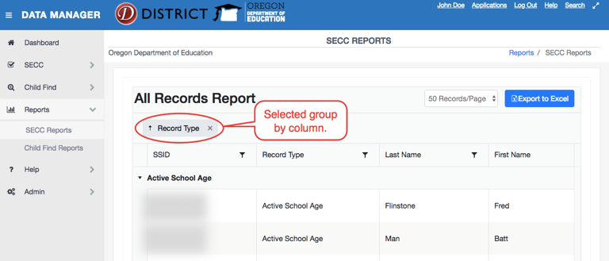

Exporting Reports
Users have the option of exporting reports as an Excel file. Exporting to Excel maintains the visual appearance of grouping.
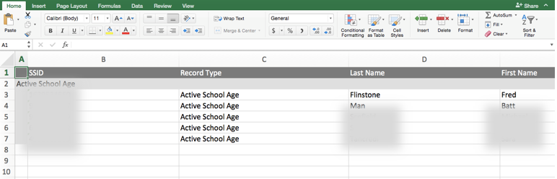

Filtering Reports
For records in the report list, there are tools available on the list to help find or filter records.
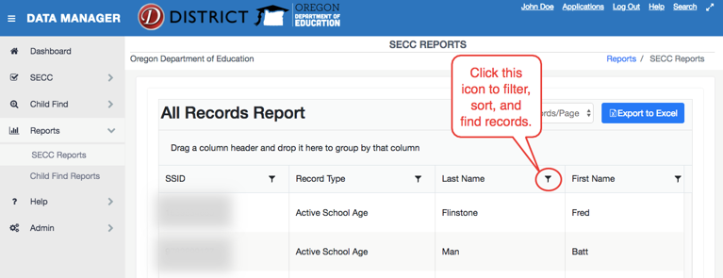

Sorting
Users can sort records by clicking the column headers. Clicking the column header once sorts ascending (A-Z, 0-9, smallest to largest, etc.). Clicking the column header again sorts descending (Z-A, 9-0, largest to smallest, etc.). Clicking the column header a third time reverts to the original sorting.
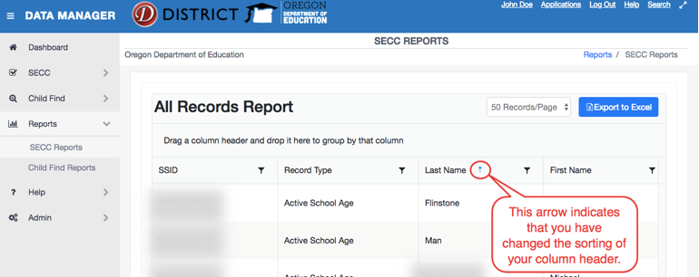

SECC Reports
A variety of reports using SECC or Exit data entered into the IDEA Data Manger are offered on the Reports page. Reports can be exported to Excel and altered to meet the needs of the user.
The reports listed below contain IDEA Data Manager records for December Child Count and/or June Exit. Navigate to SECC Reports by clicking SECC Reports beneath Reports in the sidebar menu or clicking the Reports button from the main Dashboard then clicking SECC Reports.
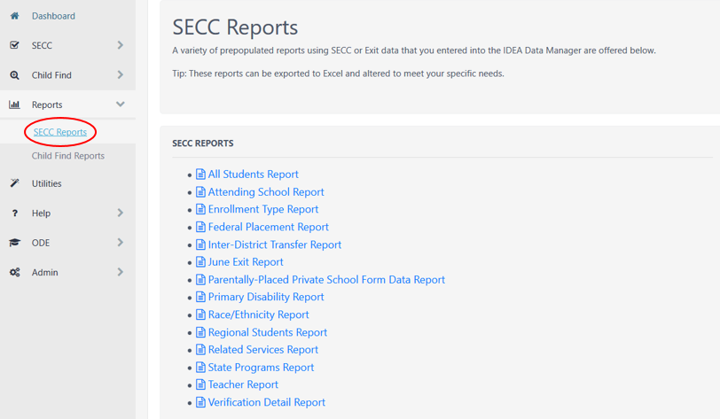
- All Students Report 39
- Attending School Report 39
- Enrollment Type Report 40
- Ethnicity Report 40
- Federal Placement Report 41
- Inter-District Transfer Report 41
- June Exit Report 42
- Primary Disability Report 42
- Regional Students Report 43
- Related Services Report 43
- State Programs Report 44
- Teacher Report 44
- Verification Detail Report 45

All Students Report
This report displays all records in the SECC Dashboard in alphabetical order by Student Last Name.
Data Source – Child Count
Fields Included in the report:
- SSID
- Record Type
- Last Name
- First Name
- Birth Date
- Gender
- Ethnicity
- Race
- Primary Disability
- Federal Placement
- Grade
- Eligibility Date
- IEP Date
- Agency Serving
- Resident District
- Attending School

Attending School Report
This report will group records by Attending School.
Data Source – Child Count
Fields Included in the report:
- SSID
- Record Type
- Last Name
- First Name
- Birth Date
- Gender
- Ethnicity
- Race
- Primary Disability
- Federal Placement
- Secondary Federal Placement
- Grade
- Eligibility Date
- IEP Date
- Agency Serving
- Resident District
- Attending School
- Teacher Name

Enrollment Type Report
This report will group records by Enrollment Type, indicating the type of enrollment setting for the student.
Data Source – Child Count
Fields Included in the report:
- SSID
- Record Type
- Last Name
- First Name
- Birth Date
- Gender
- Ethnicity
- Race
- Enrollment
- Primary Disability
- Federal Placement
- Grade
- Eligibility Date
- IEP Date
- Agency Serving
- Resident District
- Attending School
- Teacher Name

Ethnicity Report
This report will group records by Race/Ethnicity Code, indicating race and ethnicity.
Data Source – Child Count
Fields Included in the report:
- Ethnicity
- Race
- Record Status
- SSID
- Last Name
- First Name
- Birth Date
- Gender
- Primary Disability
- Federal Placement
- Grade
- Eligibility Date
- IEP Date
- Agency Serving
- Resident District
- Attending School
- Teacher Name

Federal Placement Report
This report will group records by Federal Placement Code. The Federal Placement Code indicates the location where a student receives special education services.
Data Source – Child Count
Fields Included in the report:
- Federal Placement Code
- SSID
- Record Type
- Last Name
- First Name
- Birth Date
- Gender
- Ethnicity
- Race
- Primary Disability Code
- Grade
- Eligibility Date
- IEP Date
- Agency Serving Code
- Resident District
- Attending School Name
- Teacher Name

Inter-District Transfer Report
This report identifies students with disabilities residing in one district and attending school in another district. All students with an Enrollment Type Code I (Inter-District Transfer Agreement) are included in the report. The Resident District, Attending District and Attending School will be displayed for each student.
Data Source – Child Count
Fields Included in the report:
- SSID
- Record Type
- Last Name
- First Name
- Birth Date
- Gender
- Ethnicity
- Race
- Primary Disability
- Federal Placement
- Grade
- Eligibility Date
- IEP Date
- Agency Serving
- SECC Resident District
- Resident District
- Attending School
- Teacher Name

June Exit Report
This report will group records by exit status. The Exit Date indicates when the student exited the special education program. The Exit Code indicates the reason the student exited that special education program. Zero or NULL is a valid Exit Code and will be included in the grouping. Not Exited will appear last in the grouping.
Data Source – Child Count
Fields Included in the report:
- Exit Reason
- SSID
- Record Type
- Last Name
- First Name
- Birth Date
- Gender
- Ethnicity
- Race
- Primary Disability Code
- LEP Status
- Grade
- Exit Date
- Age at Exit
- Agency Serving Code
- Resident District
- Attending School Name

Primary Disability Report
This report will group records by primary disability.
Data Source – Child Count
Fields Included in the report:
- Primary Disability
- SSID
- Record Type
- Last Name
- First Name
- Birth Date
- Gender
- Ethnicity
- Race
- Federal Placement
- Grade
- Eligibility Date
- IEP Date
- Agency Serving
- Resident District
- Attending School

Regional Students Report
This report will display records with an Agency Serving Code 33.
Data Source – Child Count
Fields Included in the report:
- SSID
- Record Type
- Last Name
- First Name
- Birth Date
- Gender
- Ethnicity
- Race
- Primary Disability
- Federal Placement
- Grade
- Eligibility Date
- IEP Date
- Agency Serving
- Agency Serving
- Resident District

Related Services Report
This report will display students receiving a related service or a supplemental service.
Data Source – Child Count
Fields Included in the report:
- Services Provided Count
- SSID
- Record Type
- Last Name
- First Name
- Birth Date
- Gender
- Ethnicity
- Race
- Primary Disability
- Federal Placement
- Grade
- Eligibility Date
- IEP Date
- RS 1
- RS 2
- RS 3
- RS 4
- RS 5
- RS 6
- SS 1
- SS 2
- SS 3
- SS 4
- SS 5
- SS 6
- Agency Serving
- Resident District
- Attending School

State Programs Report
This report displays students served by a State Program with an Agency Serving Code of 11, 21, 31, 34, 35, 36, or 37.
Data Source – Child Count
Fields Included in the report:
- Agency Serving
- SSID
- Record Type
- Last Name
- First Name
- Birth Date
- Gender
- Ethnicity
- Race
- Primary Disability
- Federal Placement
- Grade
- Eligibility Date
- IEP Date
- Resident District

Teacher Report
This report groups records by teacher name.
Data Source – Child Count
Fields Included in the report:
- Teacher Name
- SSID
- Record Type
- Last Name
- First Name
- Birth Date
- Gender
- Ethnicity
- Race
- Primary Disability
- Federal Placement
- Grade
- Eligibility Date
- IEP Date
- Agency Serving
- Resident District
- Attending School
- User Field 1
- User Field 2

Verification Detail Report
This report groups records by Agency Serving Code.
Data Source – Child Count
Fields Included in the report:
- Agency Serving
- SSID
- Record Type
- Last Name
- First Name
- Birth Date
- Gender
- Ethnicity
- Race
- Primary Disability
- Federal Placement
- Grade
- Eligibility Date
- IEP Date
- Resident District
- Attending District
- Attending School

Parentally –Placed Private School Form Data Report
This report was used for the 2018-2019 collection year to provide data for the Private School Data Collection. It is no longer in use.

Child Find Reports
A variety of reports using Child Find data entered into the IDEA Data Manger are offered on the Reports page. Reports can be exported to Excel and altered to meet the needs of the user.
The reports listed below contain IDEA Data Manager records for Child Find. Navigate to Child Find Reports by clicking Child Find Reports beneath Reports in the sidebar menu or clicking the Reports button from the main Dashboard then clicking Child Find Reports.
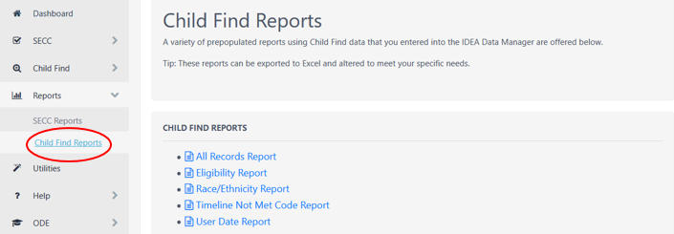
- All Records Report 47
- Eligibility Report 47
- Ethnicity Report 48
- Timeline Not Met Code Report 48
- User Date Report 49

All Records Report
This report displays all records in the Child Find Dashboard and will display in alphabetical order by Student Last Name.
Data Source – Child Find
Fields Included in the report:
- SSID
- Last Name
- First Name
- Eligibility
- Birth Date
- Gender
- Disability
- Grade
- Resident District
- Attending School
- Ethnicity
- Race
- Consent Data
- Determination Date
- Timeline Days

Eligibility Report
This report displays records based on the Eligibility Flag, which indicates whether the child was found eligible for special education services.
Data Source – Child Find
Fields Included in the report:
- Eligibility
- SSID
- Last Name
- First Name
- Birth Date
- Gender
- Ethnicity
- Race
- Disability
- Grade
- Consent Date
- Determination Date
- Resident District
- Attending School

Ethnicity Report
This report groups records by Race/Ethnicity Code, indicating the race and ethnicity.
Data Source – Child Find
Fields Included in the report:
- Ethnicity
- Race
- SSID
- Last Name
- First Name
- Birth Date
- Gender
- Disability
- Grade
- Consent Date
- Determination Date
- Eligibility
- Resident District
- Attending School

Timeline Not Met Code Report
This report displays the number of elapsed school days from the initial Evaluation Consent Date to the Special Education Eligibility Determination Date. All records over the 60-day timeline will be displayed, as well as the comment for timeline not met.
Data Source – Child Find
Fields Included in the report:
- SSID
- Last Name
- First Name
- Birth Date
- Gender
- Ethnicity
- Race
- Disability
- Grade
- Consent Date
- Determination Date
- Eligibility
- Resident District
- Attending School
- Timeline Not Met
- Timeline Not Met Comments

User Date Report
This report displays records based on the User Date field.
Data Source – Child Find
Fields Included in the report:
- SSID
- Last Name
- First Name
- Birth Date
- Grade
- Consent Date
- User Date
- Eligibility Date
- Eligibility
- Resident District
- Attending School
- User Comment

CEIS Reports
The CEIS Reports page has a Use of Funds Report, which is a prepopulated report that shows Flow Through Estimates and 15% cap for CEIS. This report can be exported to Excel.
The report does not show what districts entered into the CEIS submission. For information on prior year CEIS data, see Coordinated Early Intervening Services.
Data elements for this report:
- Total IDEA Part B Flow Through Final Award
- Total IDEA Funds for CEIS 15% Cap

Private School Reports
The Private School Reports page has a Proportionate Share Report, which is a prepopulated report that shows Child Count data and any prior year carry over funds that districts reviewed and entered into the IDEA Data Manager, as well as Flow Through Estimates, per student Allocation, and total Proportionate Share for 611 and 619. This report can be exported to Excel.
Data elements for the report (PPPS is Parent Placed Private School):
- PPPS SpEd Ages 3-5 Total Counts
- Public SpEd Ages 3-5 Total Counts
- PPPS SpEd Ages 6-21 Total Counts
- Public SpEd Ages 6-21 Total Counts
- 611 Prior Year Carry Over
- 611 IDEA Part B Flow Through Final Award
- 611 Average Allocation
- 611 Total Without Carryover
- Total 611 Proportionate Share With Carryover
- 619 Prior Year Carry Over
- 619 IDEA Part B Flow Through Final Award
- 619 Average Allocation
- 619 Total Without Carryover
- Total 619 Proportionate Share With Carryover

Coordinated Early Intervening Services

Getting Access for CEIS
The Coordinated Early Intervening Service (CEIS) collection is accessed within the IDEA Data Manager. If you do not already have access, please contact your district’s Security Administrator. If you do not know who your District Security Administrator is, go to the Getting Access section of this guide. Users will need Primary and Modify rights to CEIS to view, edit, save and submit/verify. For information on logging into the District site, see Login Information.
Once in the IDEA Data Manger, select CEIS in the Left Navigation Menu to access the data entry tabs.
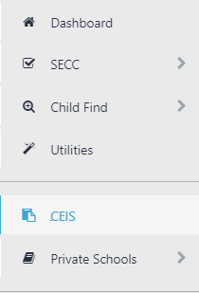

Collection Overview
All districts must complete, submit and verify a submission for the Coordinated Early Intervening Services (CEIS) Collection. The CEIS collection contains three tabs:
Tab 1. OVERVIEW. This provides an overview of the collection.
Tab 2. CEIS DATA. Data entry for the PRIOR school year.
Tab 3. USE OF IDEA FUNDS FOR CEIS. Data entry for the CURRENT school year.
Note: the information reported on this tab will tie to the data your district will collect and report in Tab 2 (CEIS Data) next year.
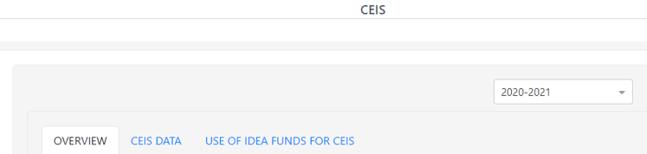
Both tabs 2 and 3 must be submitted and verified for your submission to be considered complete.
To see prior year data, use the School Year drop menu on the top right. Click the drop arrow to expand the menu.
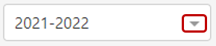
After clicking the arrow, the drop menu will display the prior years available to view. These prior year screens are view only and are not editable as the collection windows are closed.
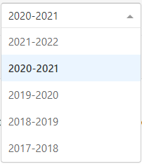

Submission Steps

Step 1: CEIS DATA
This tab collects information concerning CEIS during the prior year.
If Voluntary CEIS:
- Indicate if your district voluntarily used up to 15% of its IDEA funds for CEIS. If your district indicated it would reserve funds in prior year collection, “Yes” will be preselected for your district.
- If No, click the Save button in the bottom right, then the Submit & Verify Button. Proceed to Step 2: Use of IDEA Funds for CEIS.
- If Yes, answer questions A through C (see below).
If Required CEIS:
- If your district was identified for significant disproportionality for the respective school year, “Yes” will be preselected for your district.
- Answer questions A through C (see below).
The data entry screen is hidden when No is selected, and is not hidden when Yes is selected. If changing selection to Yes, the data entry screen will appear.
A. Enter CEIS Student Count. This is the total number of students who received CEIS from your district during the prior school year. This is an unduplicated count. Note that this count cannot be zero if funds were used for CEIS. Count each student who received CEIS using IDEA funds.
B. Enter Special Education Student Count. This is the total number of students who received special education services under Part B of IDEA in the prior AND CEIS during the current and/or preceding two-years. This is an unduplicated count. Count each student only once.
The example below is for the 2019-2020 collection, where the total number of special education students is from the 2018-2019 school year, and the three prior years for receiving CEIS were 2016-2017, 2017-2018 and 2018-2019.
C. Enter Actual Expenditures For CEIS. This is the total amount of prior year IDEA Funds your district expended/is expending. This amount can be expended in one year or over two years. Note the exact amount your district is expending for CEIS is required for the federal reporting purposes.
The example below is for the 2019-2020 collection, regarding the 2018-2019 IDEA Funds expenditures, which can be expended during 2018-2019 or during 2018-2019 and 2019-2020.
- Enter Total Amount of 2018-2019 IDEA Funds Reserved For CEIS (C1). This is the total amount of 2018-2019 IDEA Flow-Through Funds that your district set aside for voluntary or required CEIS.
- Enter Actual Expenditures for 2018-2019 (C1a). This the total amount that your district expended in 2018-2019. It can be the total indicated in C1 or a portion if your district is expending these funds over two years.
- Enter Actual Expenditures for 2019-2020. Enter “0” if total amount was expended in 2018-2019 only (C1b). If expending the funds over two years, enter the remainder to be expended. C1a plus C1b must equal C1.
- Check the Total Amount of 2018-2019 IDEA Funds Reserved For CEIS. If a red bar with a note appears, an incorrect value was entered. Verify and correct amounts entered for C1, C1a or C1b.
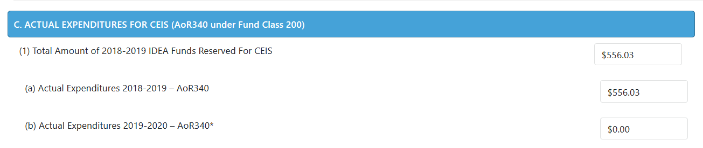
- Click the Save button in the bottom right, and if no errors are displayed in red in the top right, click the Submit & Verify button.
- Proceed to Step 2. Use of IDEA Funds for CEIS.

Step 2: USE OF IDEA FUNDS FOR CEIS
This tab collects information concerning the district’s planned use of IDEA funds for CEIS during the current school year. The IDEA Flow-Through Estimates and 15% cap are shown at the top of this tab during the main collection window. During the review window, the Final awards will replace the Estimates.
Like the CEIS Data tab, this screen is hidden when No is selected, and is not hidden when Yes is selected.
A. IDEA Funds Reserved For CEIS
If Voluntary CEIS:
- If “No, Not Required” click the Save button in the bottom right, and if no errors are displayed in red in the top right, click on the Submit & Verify button.
- If “Yes, Voluntary” answer questions B through C.
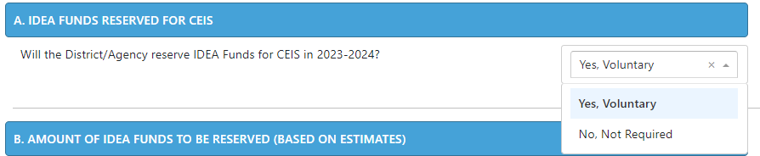
If Required CEIS:
- If your district was identified for significant disproportionality, “Yes, Required” will be preselected and not editable by your district.
- Answer questions B through C.
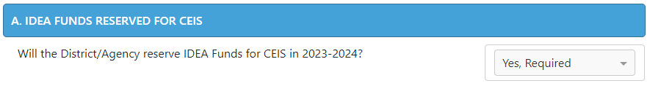
B. Enter the Total amount of IDEA Funds the District/Agency will reserve for CEIS.
If Voluntary CEIS, this cannot exceed the capped amount shown, which is 15% of your IDEA Funds. The district will need to determine how much of the 15% they will reserve for CEIS. Note the capped amount will be updated for the review window. Please adjust actual expenditures for CEIS accordingly.
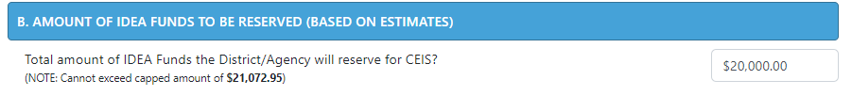
If Required CEIS, the district must expend the entire capped amount shown, which is 15% of your IDEA Funds.
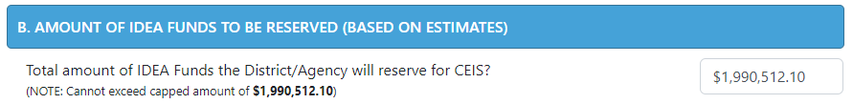
C. Enter information for CEIS Activities Planned.
- Grade levels: Select low grade from dropdown then select high grade from dropdown. This is the grade range that will be the focus of the CEIS Activities planned.
- Group served: Select Group to be served from dropdown. Note if Voluntary/CEIS, “Students without Disabilities” must be selected. If Required/CCEIS, either can be selected.
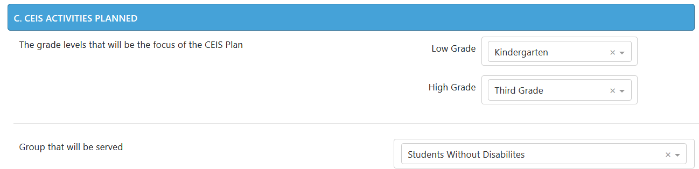
- Select Academic/behavioral area or areas that will be the focus of the CEIS Plan. Note that up to four areas may be selected.
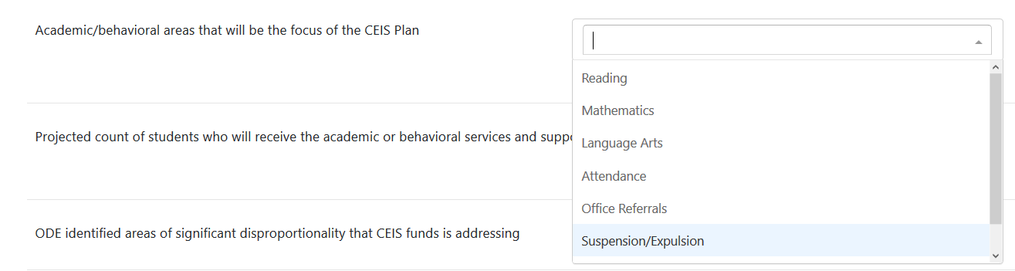
- Enter Projected Count of Students. This is an estimate and not expected to be the exact count of students receiving services and supports. The exact count will be reported the following year on the CEIS Data tab.
        - Districts that are Voluntarily spending IDEA funds for CEIS will enter their projected count in the “Students without disabilities (allowed for CEIS and CCEIS)” field.
          - The “Count of students with disabilities (allowed for CCEIS only)” field will be grey and defaulted to zero. This field is not editable for Voluntary/CEIS.
          - The “projected count of students” field will populate a total for both fields. This field is not editable.
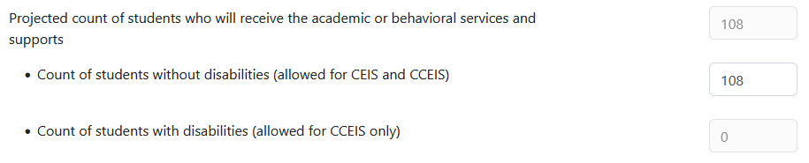
        - Districts that are Required to spend IDEA funds for CCEIS will enter their projected count in the both fields.
          - The “Count of students with disabilities (allowed for CCEIS only)” field is required. If the district projects zero students, then enter 0.
          - The “projected count of students” field will populate a total for both fields. This field is not editable.
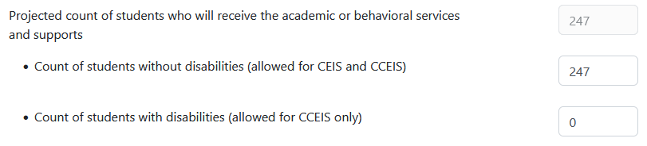
- Enter Activity Type and Description. You may enter up to five activities. Select the activity type and then provide a general description of the activity. Descriptions should be brief but descriptive enough to convey the activity to be implemented using CEIS funds. Note: If Required/CCEIS, the activities should relate to identified area(s) of significant disproportionality that CEIS funds is addressing.
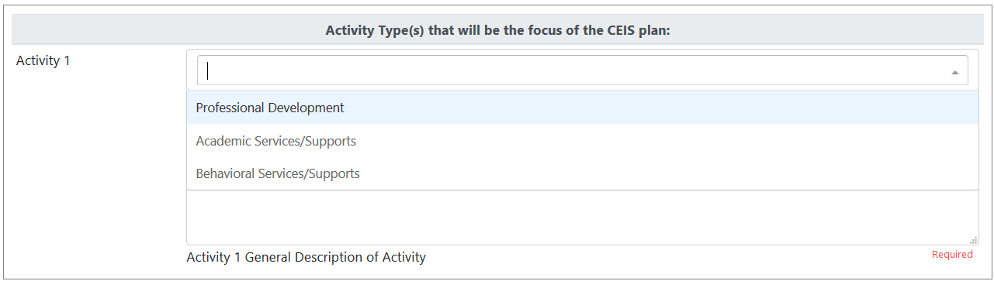
- Click the Save button in the bottom right, and if no errors are displayed in red in the top right, click on the Submit & Verify button.
- Proceed to Step 3. Review

Step 3: Review
Check your responses to all questions on both tabs.
- If there are no errors, your submission is now complete.
- If errors, correct, then click on the Save and Submit & Verify buttons again.
Printing. Your submission information may be printed by clicking on the Print button.

Contact Information
For further assistance, please contact:
- Cynthia Garton, 503-508-7492 or cynthia.garton@ode.oregon.gov
- Jackie McKim, 971-240-0234 or jackie.mckim@ode.oregon.gov

Private School Data

Getting Access for Private School
The Private School Data, or Parent Placed Private School (3PS) Data, collection is accessed within the IDEA Data Manager. If you do not already have access, please contact your district’s Security Administrator. If you do not know who your District Security Administrator is, go to the Getting Access section of this guide. Users will need Primary and Modify rights to CEIS to view, edit, save and submit/verify. For information on logging into the District site, see Login Information.
Once in the IDEA Data Manger, select Private Schools in the Left Navigation Menu. From there, select Private Schools – Enrollment or Private Schools – Proportionate Share.
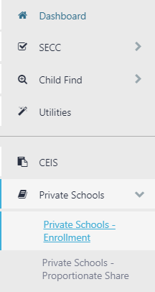

Collection Overview
All districts must complete, submit and verify a submission for the Private School Data (Parent Placed Private School Data or 3PS) Collection. The Private School collection contains two separate menus:
Menu 1. Private Schools – Enrollment. Data entry for the current school year.
Menu 2. Private Schools – Proportionate Share. Review of average allocation and total proportionate share for the current school year.
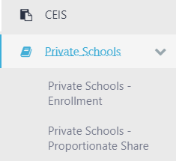
For both Enrollment and Proportionate Share screens, the current collection year will be defaulted to Not Yet Submitted.
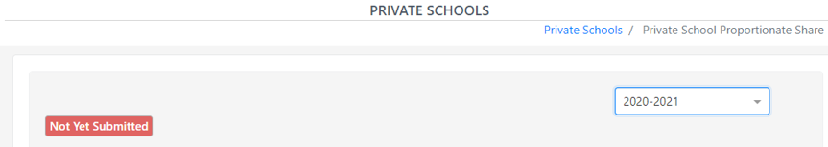
To see prior year data, use the School Year drop menu on the top right. Click the drop arrow to expand the menu.
After clicking the arrow, the drop menu will display the prior years available to view. These prior year screens are view only and are not editable as the collection windows are closed.

Submission

Private School – Enrollment
This menu collects information concerning Parent Placed Private School enrollment and consultation for the current school year. Enrollment is an annual snapshot of total parent placed private school students as of October 1. Consultation is held with both private school representatives and parent representatives of parent placed private school children ages 3-21 with disabilities.
The Private Schools – Enrollment menu will first ask if the district has private school(s) within its boundaries. All districts are expected to answer this question.
This screen will default based on how districts answered the prior year, and will roll this response year to year.
- If No, click the Save button in the bottom right, then the Submit & Verify button. Proceed to menu 2, Private Schools – Proportionate Share.
- If Yes, enter information regarding the private schools, consultation, and enrollment counts before clicking the Save and Submit & Verify buttons. Then proceed to menu 2.
The data entry screen is hidden when No is selected, and is not hidden when Yes is selected. If changing selection to Yes, the data entry screen will appear.

Overview
The Private School – Enrollment data entry screen contains fields for school information, enrollment counts, age range totals, a total school enrollment, and consultation process. This screen will default a school list based on what districts provided the prior year, and school information will roll year to year.
Enrollment is a snapshot of October 1 of all parent placed students ages 3-21 (not just special education students) in private schools located in the district’s boundaries. Include enrollments for Pre-Kindergarten (ages 3-5), Kindergarten (age 5), and ages 6-21 Note that schools for 3-4 year olds must be in combination with any elementary grades, K-8.
Do not include specialized facilities such as corrections or detentions, long term care or treatment, hospitals, state schools, public alternative schools, or public charter schools. Do not include district placed students.
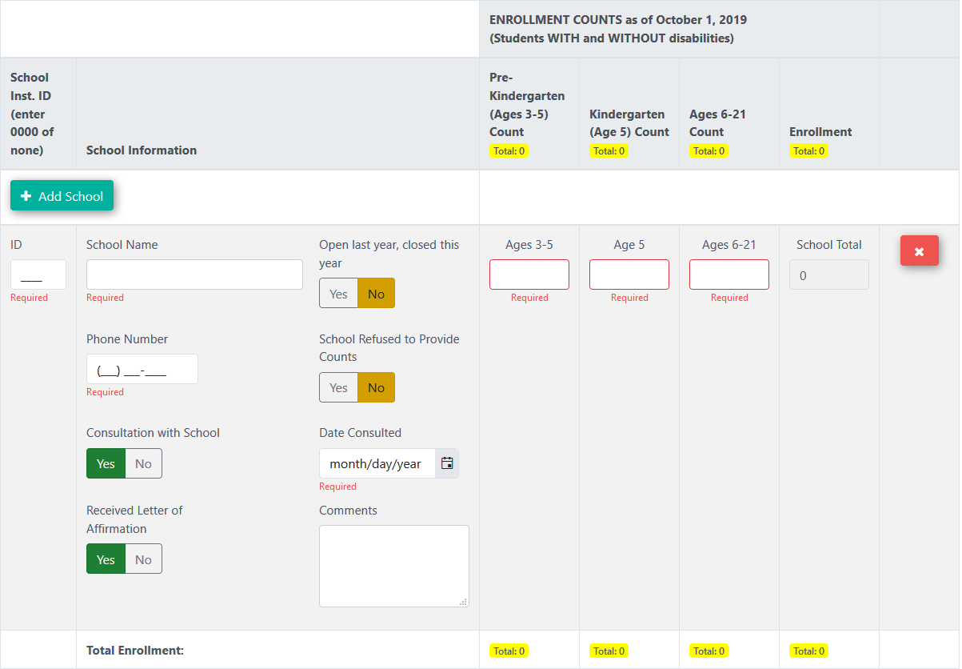
The Enrollment and Consultation header for the data entry screen contains column titles for School ID, School Information, Enrollment counts by age group and a total enrollment. As private school enrollment counts are entered, a count of total enrollment will populate in this header.
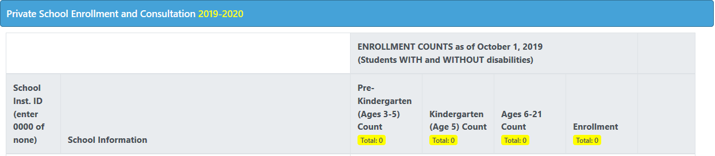

School Information
If a school is not listed, or a new school opens within the district boundaries, click the Add School button. This will add the new school to the list.
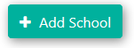
There are three required school information fields: ID, Name and Phone.
- ID: private schools that are registered or approved will have an Institution ID number. If there is no number, enter four zeros (0000).
- School Name: the private school name.
- Phone Number: the private school’s telephone number.
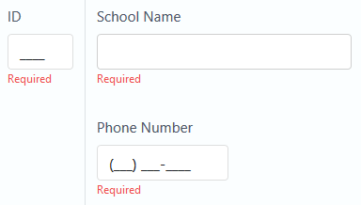
If a school closed during the prior school year, use the “Open Last year, closed this year” flag. The default is set to No. When the Yes flag is selected, the school will not roll the following collection year.
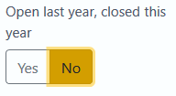
When Yes is selected, data entry fields become hidden, except for ID, School Name and Comments.
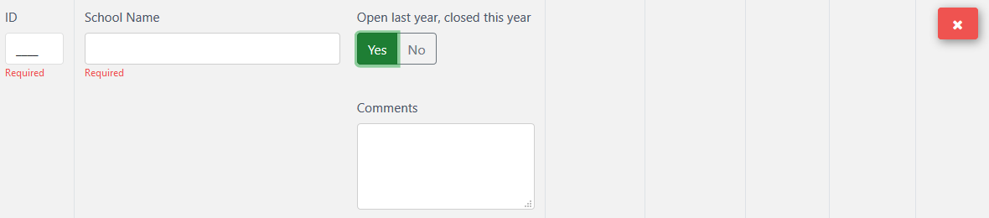

Enrollment Counts
If a school refuses to provide enrollment counts, users can use the “School Refused to Provide Counts” flag. The default is set to No.
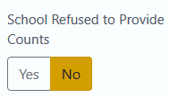
When Yes is selected, the enrollment fields become hidden.
There are three required fields to enter enrollment counts: Pre-Kindergarten (Ages 3-5), Kindergarten (Age 5), and Ages 6-21. Enter the enrollment counts of parent placed students in the district boundaries.
- Enter the total enrollment of the private school as of October 1 (students with and without disabilities).
- Include enrollments for Pre-Kindergarten (ages 3-5), Kindergarten (age 5), and ages 6-21.
  - Schools for 3-4 year olds must be in combination with any elementary grades, K-8. OAR 581-015-2475 through 581-015-2483.
- If the count is zero for any field, enter zero (0).
- Exclude any students placed in a private school by public school districts.
- If a school is missing from the list or a new school opened in the last year, use the New School button to add the school.
- If a school refuses to provide and enrollment count, change the “School Refused to Provide Counts” selection to Yes.
The data screen provides a School Total field, which calculates that school’s total enrollment, based on counts entered in the three required enrollment fields.
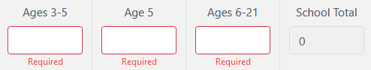
If users need to remove a school due to inaccurate information or testing the data entry fields, there is a delete button. Do not use for closed schools. If a school has closed, change the “Open last year, closed this year” selection to Yes.
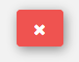
When clicked, a warning message will appear. Click Delete School to remove the school from the list, or Cancel to back out.
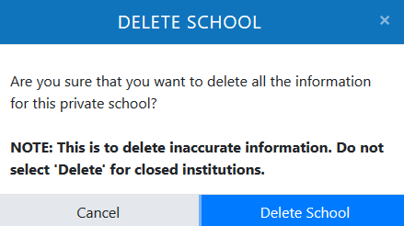

Consultation
The Consultation with School flag is to indicate if a consultation meeting was held with the private school. This flag does not have a default selection. It is a required field and users must select either Yes or No.
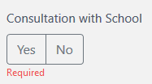
The district is required to consult with both private school representatives and parent representatives of parent placed private school children ages 3-21 with disabilities. Topics include, but are not limited to the Child Find process, determination of the Proportionate Share of federal IDEA funds, and special education and related services provided.
Participation in consultation and affirmation processes applies only to non-profit private schools, including religious schools, that meet the state’s definition of an elementary or secondary school. P-K schools (3-5) must be in a combination with any elementary grades (K-8).
If No is selected, users may move on to the next school in the list. If on the last school, click the Save and Submit & Verify buttons.
If Yes is selected, additional required consultation fields will appear.
- Date Consulted: the date consulted with the private school.
- Received Letter of Affirmation flag: if the school submitted a signed letter to the district regarding the consultation and the determined services for the school year.
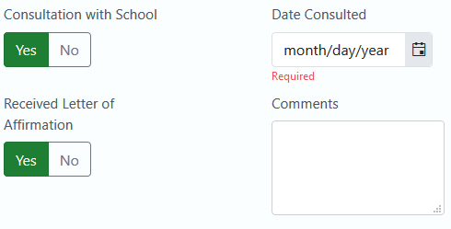

Final Steps
The data entry screen also includes an optional comment field, for any comment the district would like to provide.
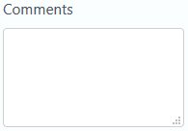
As with the Enrollment screen header, a count of total enrollment will populate in the screen’s footer, as the private school enrollment counts are entered.
Click the Save button in the bottom right, and if no errors are displayed in red in the top right, click the Submit & Verify button.

Private School – Proportionate Share
This menu shows funds to expend for the current school year. Child Count data, IDEA Part B Flow Through Funds and the calculations for average allocation and total proportionate share are displayed for districts to review. This screen will load the estimates and calculations annually. During the main collection window, the IDEA Flow-Through Estimates will be displayed.
The Private School – Proportionate Share menu allows districts without private schools and those with no eligible parent placed students to view the average allocation per child. This will give an idea of what districts would expend per student, if a private school were to open or a child be found eligible for special education.
All districts with private schools should review this menu. While clicking the Save and Submit & Verify buttons is not required, all the buttons are still active.

Overview
The Private School – Proportionate Share screen contains three sections: student population as submitted on the Special Education Child Count; average allocation and total proportionate share of 611 funds; and average allocation and total proportionate of 619 funds.
This menu screen displays Child Count data based on the district’s submission the prior collection year. The data is a snapshot of special education students as of December 1. This screen also displays the IDEA Part B Flow Through Estimates. This amount is the total LEA gross amount before adjustments are made. The Child Count data and IDEA Funds are used to calculate the allocation per eligible student and/or total proportionate share of federal IDEA funds available to serve parent placed private school children. The application will recalculate proportionate share and average allocation for the review window.
Proportionate share tells a district, private schools officials, and parents how much of the IDEA Part B funds that must be expended in the current school year to provide equitable special education and related services for eligible parent placed private school children.

Section I: Student Population
The student population is used with the IDEA Funds to calculate funding for parent placed special education students.
This section will display what the district submitted on the prior year’s Child Count Collection, broken down into two areas: Ages 3-5 and Ages 6-21.
Age 3-5 will display:
- Total Age 3-5 Special Education Parentally Placed Private School Count (served and not served)
  - Pre-K Age 3-5 (ECSE)
  - Kindergarten Age 5
- Total Age 3-5 December Special Education Child Count (SECC) Enrolled in Public School
  - Pre-K Age 3-5 (ECSE)
  - Kindergarten Age 5
Age 6-21 will display:
- Total Age 6-21 Special Education Parentally Placed Private School Count (served and not served)
- Total Age 6-21 December Special Education Child Count (SECC) Enrolled in Public School
In this section, the fields appear gray because they are locked. Counts included in Sections A and B only include students with disabilities.
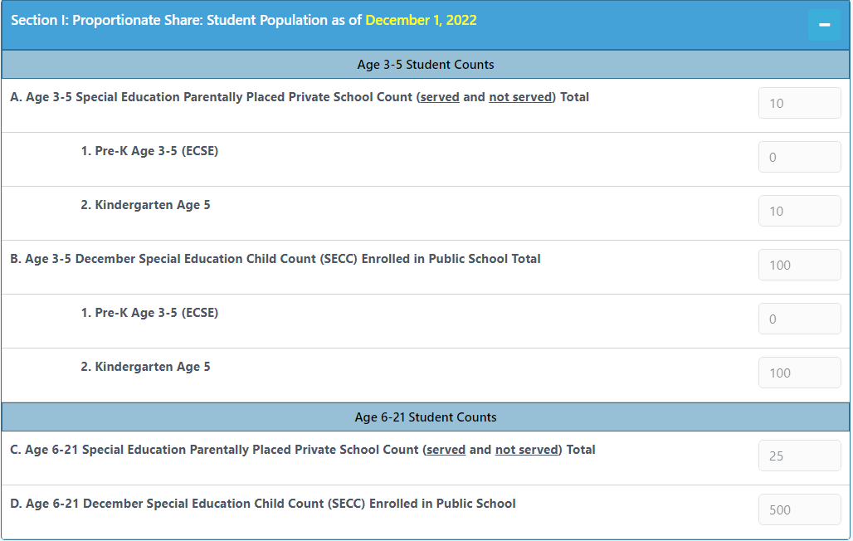
If a district needs to make edits, contact the data team.

Section II: IDEA Part B 611 Funds (Age 3-21)
The IDEA Funds are used with the student population to calculate funding for parent placed special education students.
This section will display current year IDEA Funds and prior year’s Child Count:
- Unexpended Part 611 Funds - Prior Year Carry Over from prior year
- Total Federal Gross IDEA Part B 611 Funds for current year
- Total Eligible Public & Private Ages 3-21
- Average 611 Allocation per Eligible Child (Public & Private)
- Total Current Year 611 to be expended on Parentally Placed Private Ages 3-21
- Total 611 Proportionate Share Funds to Expend (Age 3-21)
In this section, all but one of the fields appear gray because they are locked. The IDEA Funds and calculation fields are not open for editing. The only field open for editing is the Unexpected 611 Prior Year Carry over field.
Field E is the total 611 (proportionate share) funds before any carryover is entered into Field A, and Field F is the total 611 proportionate share funds after carryover is entered. If there is no carryover from the prior year, these fields will display the same information.
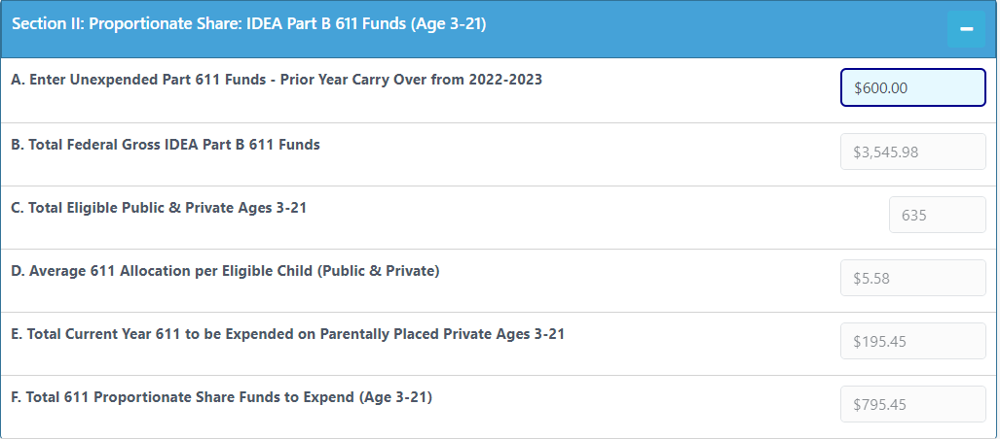
If a district needs to enter carryover funds from the prior year, this screen will re-calculate the Total Proportionate Share (Field F) for Section II.
Reminder! This section is for review. The only field that is editable is the Prior Year Carryover

Section III: IDEA Part B 619 Funds (Age 3-5)

The IDEA Funds are used with the student population to calculate funding for parent placed special education students.
This section will display current year Estimates and prior year’s Child Count:
- Unexpended Part 619 Funds - Prior Year Carry Over from prior year
- Total Federal Gross IDEA Part B 619 Funds for current year
- Total Eligible Public & Private Ages 3-5
- Average 619 Allocation per Eligible Child (Public & Private)
- Total Current Year 619 to be expended on Parentally Placed Private Ages 3-5
- Total 611 Proportionate Share Funds to Expend (Age 3-5)
In this section, all but one of the fields appear gray because they are locked. The IDEA Funds and calculation fields are not open for editing. The only field open for editing is the Unexpected 619 Prior Year Carry over field.
Field E is the total 619 (proportionate share) funds before any carryover is entered into Field A, and Field F is the total 619 proportionate share funds after carryover is entered. If there is no carryover from the prior year, these fields will display the same information.
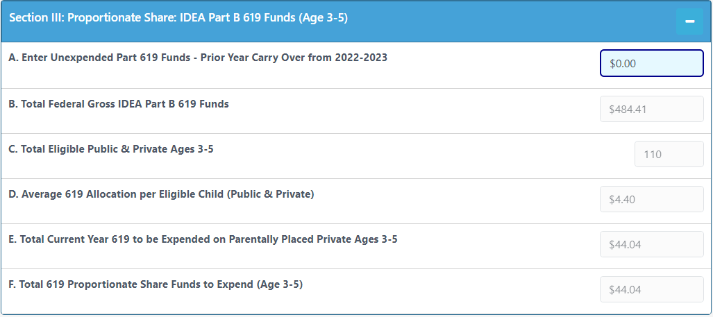
If a district needs to enter carryover funds from the prior year, this screen will re-calculate the Total Proportionate Share (Field F) for Section III.

Final Steps
If making changes, click the Save button in the bottom right. There should be no errors displayed in red in the top right. If not making changes, no action is needed.
Optional: Click the Submit & Verify button. Districts are not required to submit and verify Proportionate Share. However, as required by 34 C.F.R. § 300.134(b), the consultation process must include a determination of the proportionate share of Federal funds available to serve parentally-placed private school children with disabilities, including how the proportionate share of funds is calculated.

Review
Check your responses to all questions on both menus.
- If no errors, your submission is now complete. If desired, click the Save and Submit & Verify buttons.
- If errors, correct, then click the Save and if desired, Submit & Verify buttons.
Your submission information may be printed by clicking on the Print button. This is located on both menus.

Contact Information
For further assistance, please contact Cynthia Garton at 503-508-7492 or cynthia.garton@ode.oregon.gov.

Utilities
The Utilities tab allows districts to advance the enrolled grades of active SECC records, remove June Exit records and migrate eligible Child Find records to SECC.
Utilities is located in the Left Navigation Menu under Agency.
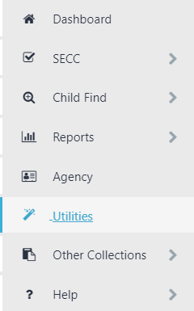
The Data Manager Utility Actions contains Advance SECC Grade, Remove Exited Records, and Migrate Child Find Records.
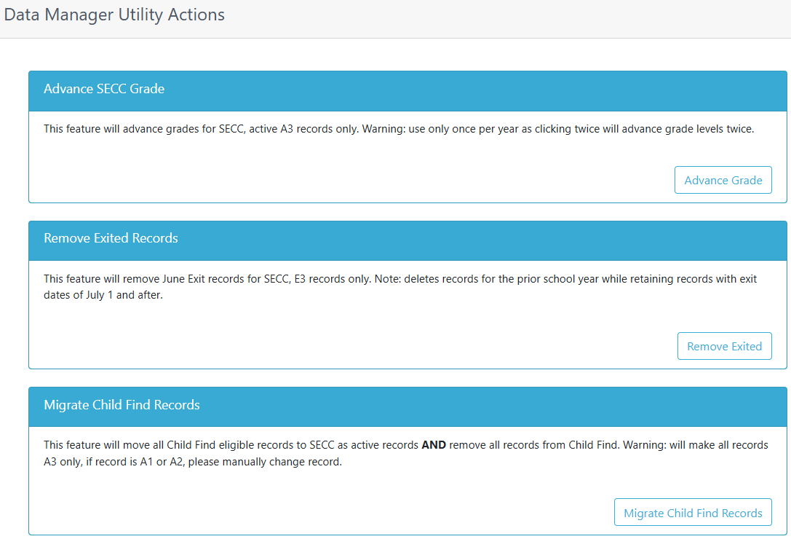

Advance SECC Grade
Advance SECC Grade allows users to advance the enrolled grades of only A3 records that are in SECC. This utility does not advance A1, A2, E1, E2 or E3 records.
Click the Advanced Grade button to advance the enrolled grades of A3 records up one grade level. Warning: This action cannot be undone.
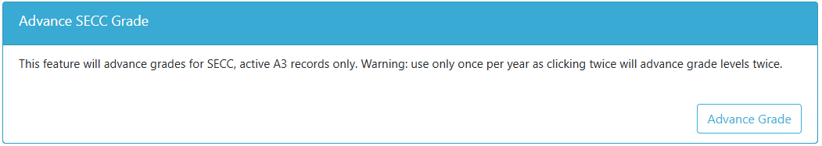
A confirmation message will pop up. Click Cancel to back out. Click Advance Grades to continue.
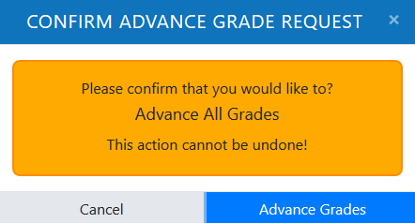
Note that PK records will remain PK and users will need to advance them manually. Grade 12 records also remain grade 12.

Remove Exited Records
Remove Exited Records allows users to remove E3 records that are in SECC, with an exit date prior to July 1 only. This utility does not remove E1 or E2 records and records with exit date of July 1 and after. This function works the day after the June Exit Review Window closes.
Click the Remove Exited button to remove each E3 record from SECC. Warning: This action cannot be undone.
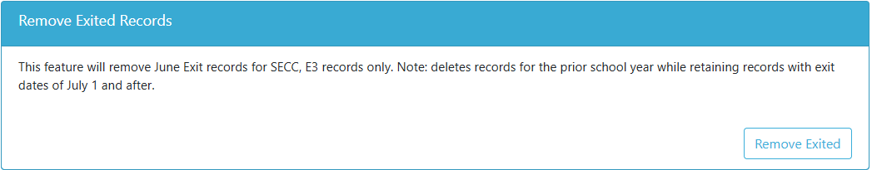

A confirmation message will pop up. Click Cancel to back out. Click Remove Exited Records to continue.
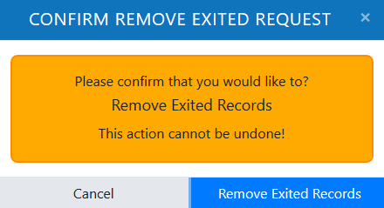
Note that E1 and E2 records will not be deleted, and users will need to delete them manually.

Migrate Child Find Records
Migrate Child Find Records allows users to migrate all Child Find eligible records in the IDEA Data Manager to SECC as A3 records. This utility will not make A1 or A2 records irrespective of age and as of January 2023, will delete all records when migrating.
Click the Migrate Child Find Records button to move each eligible record into SECC as an A3 record. Warning: This action cannot be undone.
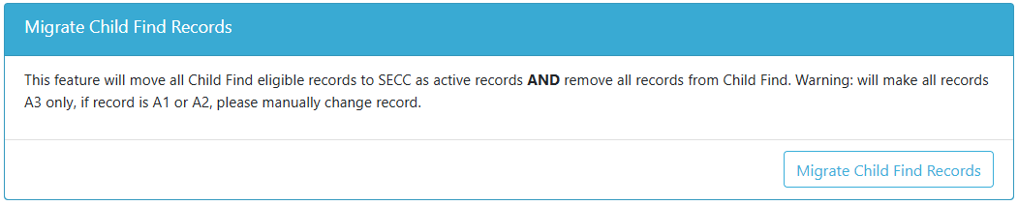
A confirmation message will pop up. Click Cancel to back out. Click Migrate Records to continue.
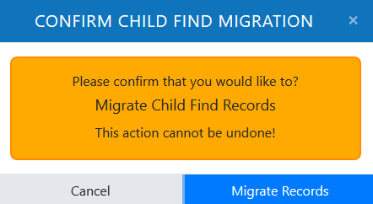
Note that the system makes all records A3 only. If a record should be A1 or A2, users will need to change them manually.

Agency
The Agency menu option launched in the IDEA Data Manager in the 2019-2020 school year. This screen allows districts to update information such as address and phone, staff contacts, and SECC Consortium status, and view Late & Inaccurate information and State Program contractor status. For this screen and tabs within, “current school year” refers to the timeframe of July 1 through June 30, unless otherwise noted. For example, if a user viewing or editing on January 5, 2020, the current school year is July 1, 2019 through June 30, 2020.
The Agency and Staff Contacts tab are static, with the verification button resetting on July 1. SECC Consortium, Late & Inaccurate and State Programs have drop menus with four school year selections, also ranging from July 1 through June 30. The drop menus default to current school year, which resets on July 1.
Agency is located in the Left Navigation Menu under Reports.
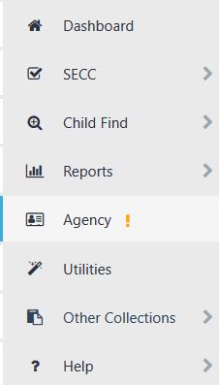
An orange exclamation point next to the menu name Agency means the agency’s information has not been verified for the current school year. Hover over the exclamation point to see the warning message.
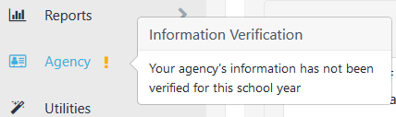

Instructions
The Instructions tab gives an overview for the tabs in the Agency screen. It contains a verification status list for Agency, Staff Contacts and SECC Consortium. If a tab has not been verified for the current school year, “Not Yet Verified” will display in a red box; a yellow triangle will also display in the corresponding tab header.
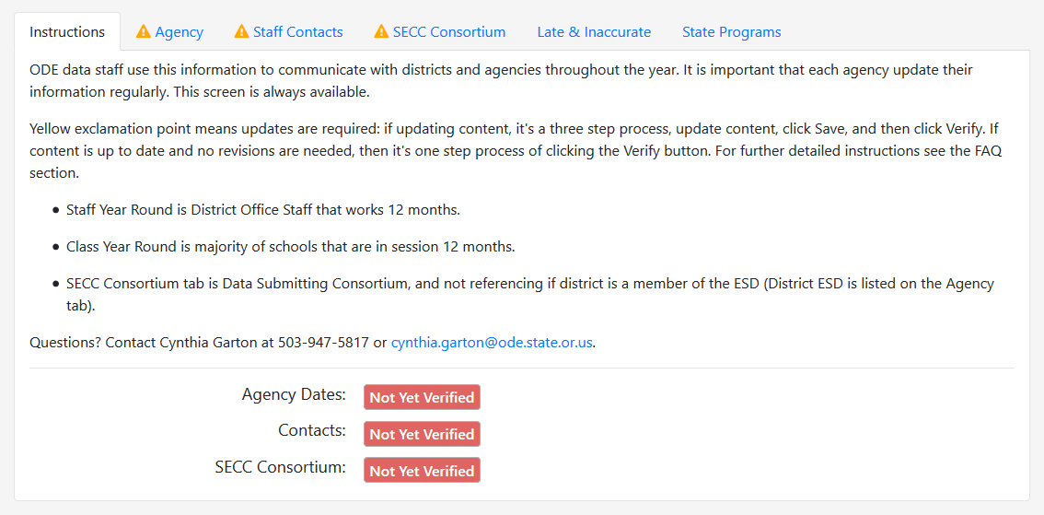
If any of the three tabs is updated and verified for the current school year, a verification message will display in a green box at the bottom of the screen, as well as a green check mark next to the tab name. The verification message will contain the date of verification and staff name.
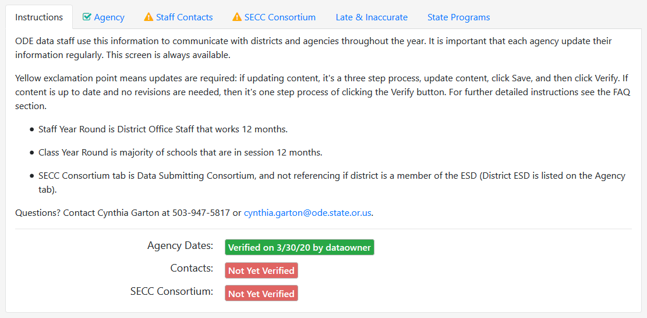

Agency
The Agency tab contains information populated from the Institution Database and information users can enter. Information on this tab is static and retained year to year until there is a user update.
The top portion of the tab contains address and agency information. If there is an error with the address, submit an Institution Request Change form, which is located on the Institution Identification webpage. If there is an error with the area ESD or EI/ECSE, contact a member of the Data Team.
If the tab has not been verified for the current school year, there will be a yellow triangle in the tab heading. The Agency tab needs to be updated and/or verified annually.
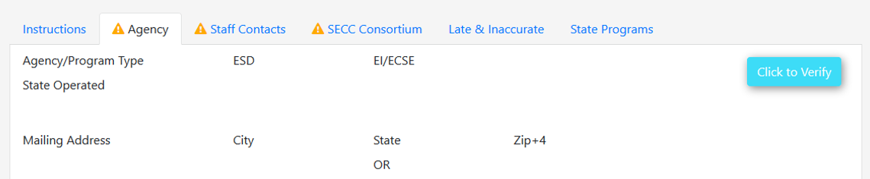
The bottom portion of the tab contains data entry boxes for users to enter phone numbers, business days, additional information, and more. Fields with an asterisk are required.
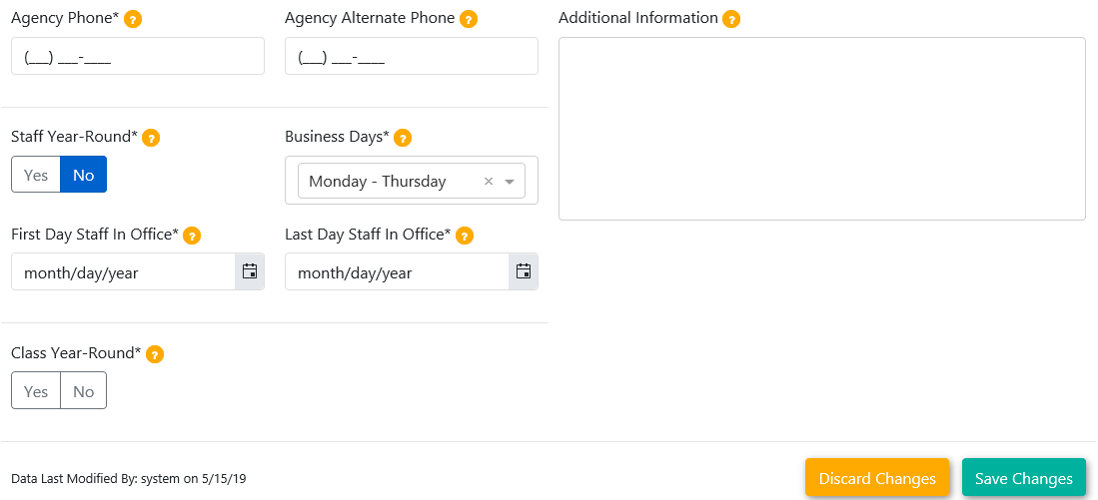
Starting with 2019-2020, users should update these fields in the IDEA Data Manager annually, or if not accurate.

Agency Phone
The first two editable fields are Agency Phone and Agency Alternate Phone. Enter the main phone number for the agency in Agency Phone. If there is an alternate or secondary phone line, enter that into the optional Alternate Phone field (not required).
The user only needs to type numbers, as the application automatically tabs through the phone number parts, for ease in entering the 10 digits.
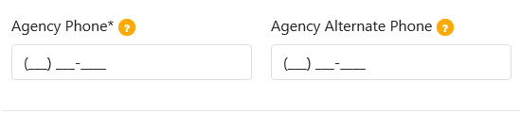

Additional Information
Additional Information can be used to provide information that users want ODE staff to know, such as additional contacts and upcoming staff changes. Information entered into this field will also display on the Staff Contacts tab.
Each editable field has orange question mark bubble next to it. Hover over this bubble with the mouse cursor to see fly out text, explaining the purpose of the field. For example, the Additional Information text box is for information users feel may be helpful to ODE staff.
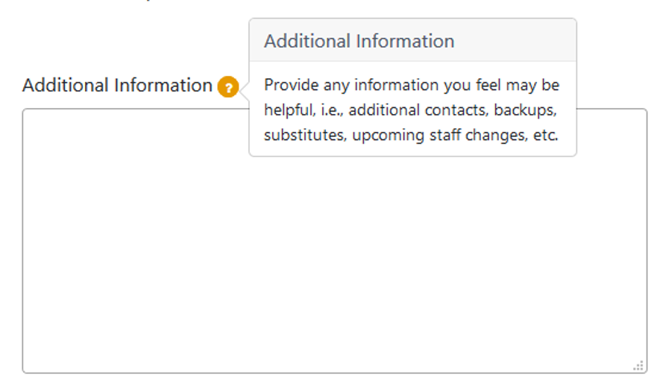

Staff Year-Round/Business Days
The Staff Year-Round and Business Days fields were pre-populated by ODE for the 2019-2020 year, based on the most current information submitted to ODE via the discontinued paper Agency Contact Form. Users should update these fields in the IDEA Data Manager annually, or if not accurate.
Staff Year-Round is a Yes/No toggle. If Yes is selected, no further action is needed. If No, see instructions for First Day and Last Day Staff in Office below (page 74).
Business Days is a drop menu. Click the down arrow to display the selections for Monday through Thursday and Monday through Friday.

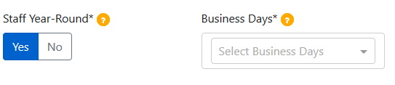
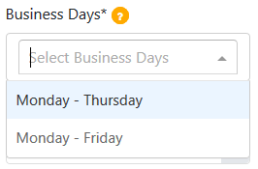

If No is selected, date fields will appear: First Day Staff in Office and Last Staff Day in Office. These fields are the first and last day staff on the Staff Contacts tab are in office, e.g., data submitters. The purpose is to let ODE know data submitters’ last day of availability, which is useful during the spring collections (such as June Special Education Exit and Special Education Child Find).
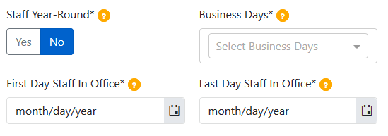
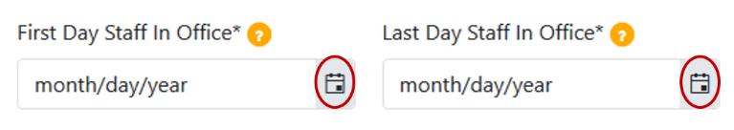
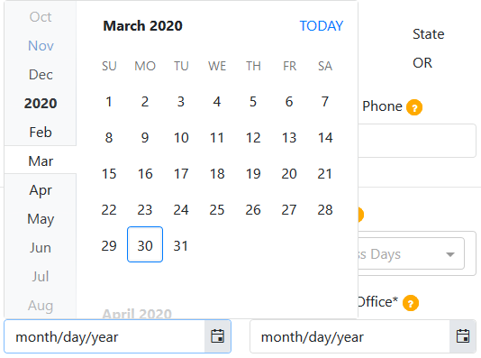
Both the First and Last day in Office fields have a drop menu for date selection. Click the calendar icon to access the calendar menu. This calendar menu has the same appearance for both Staff in Office fields.
Another option is to type the dates using one or two digit month, two-digit day and four-digit year. Month: one digit for January through September, and two digits for October through December. Day: dates at the start of the month, such as 1-9, will begin with zero: 01, 02, etc.

Class Year-Round
The Class Year-Round field was introduced starting with the 2019-2020 school year. The functionality is the same as the Staff Year-Round fields; it is also a Yes/No toggle and when No is selected, date fields will appear for First Day and Last Day in School.

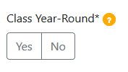
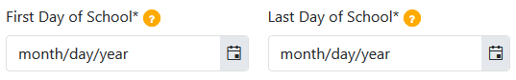

Saving/Discarding Changes
At the bottom of the screen are buttons for Discard Changes and Save Changes. They appear in grey if no changes have been made to the tab. Once users enter or change data in any field, the buttons appear in color, which means they are active and clickable.
When done modifying agency information, be sure to click the Save Changes button. The Last Modified By note displays the last time data was saved, either by a system upload or by a user clicking the Save Changes button.
If a user clicks Discard Changes, and pop up message will ask the user to confirm.

Verify
The final step is verifying. There is a Verify button in the top left corner of the screen. Click this button to verify that the content on the tab is accurate. This button will appear grey if changes are made but the Save button has not been clicked.
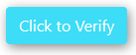
The Verify button will appear in color after users click the Save button. The Verify button is also clickable at the start of the school year on July 1 for agencies to verify there are no updates.
Once the Agency tab is updated and verified for the current school year, the yellow exclamation point in the tab heading will change to a green check mark. The Verify button will also change to a green message box that contains the date of verification and staff name.

Staff Contacts
The Staff Contacts tab is updated by users. Information on this tab is static and retained year to year, until there is a user update. Each contact is required, and need to be updated and/or verified annually.
Superintendent, Special Education Director, SECC Data Submitter, Child Find Data Submitter and IDEA Excess Cost Data Submitter were pre-populated by ODE for the 2019-2020 year, and was based on the most current information submitted to ODE via the discontinued paper Agency Contact Form. CEIS Data Submitter, Private School Data Submitter, Discipline Data Submitter, Restraint/Seclusion Data Submitter, Medically Fragile Data Submitter and Dental Screening Data Submitter are new as of the 2019-2020 year. Agency/Staff Contacts Updater is new as of January 2023. Business Manager added August 2023.
Starting with 2019-2020, contacts are based on role and not title, except for Superintendent and Special Education Director. Users will also see IDEA Excess Cost Data Submitter and CEIS Data Submitter in lieu of Business Manager.
If the Staff Contacts have not been verified for the current school year, there will be a yellow triangle in the tab heading. This tab needs to be checked, updated and/or verified annually.
There are six editable fields per contact type, as well as a Yes/No toggle. The editable fields are Last Name, First Name, Phone, Ext, Alt Phone and Email.

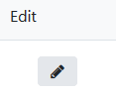
Edit
To edit or update staff contact information, click the Edit button in the Edit column. The Edit button has a pen icon; there is an edit button next to each contact type.
Clicking on the icon opens the editable fields. Required are Last Name, First Name, Phone and Email. Optional are Ext (Extension) and Alt Phone (Alternate Phone). The phone number fields have parentheses and dashes pre-populated. The user only needs to type numbers, as the application automatically tabs through the phone number parts, for ease in entering the 10 digits.

ListServ
Add to ListServ is set to Yes for Special Education Director, SECC Data submitter and Child Find Data Submitter, and is not editable. For all other contact types, the screen is defaulted to No and the user can change to Yes. This lets the Data Team know that this staff member wants to be on the Special Education Data Submitter Listserv.

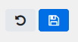
Save/Restore
While modifying a contact, the Save button and the Restore button replace the Edit button in the Edit column. The Save button has a diskette save icon and the Replace button has an undo icon. Save will save changes made while Restore will remove changes made and revert to the prior status. When done modifying contact information, click Save to move on to the next contact.
There are two final columns for each contact: Updated and Updated By. These display the last update date and who updated the row, either user edit based on login or system upload.

Additional Information
The Additional Information box at the bottom of the screen contains information entered into the Additional Information field on the Agency tab.

Verify
When done entering staff contact information, or if the data was already up-to-date, click the Verify button in the top left corner of the screen. This will verify that the content on the tab is accurate. If there are no changes to make, the Verify button will be clickable at the start of the school year, on July 1. If not all required information is provided, a red warning box will appear in the top left corner, showing the missing required information.
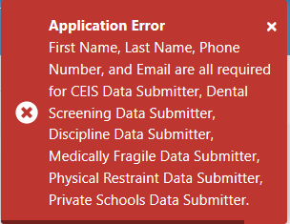
Once the Staff Contacts tab is updated and verified for the current school year, the yellow exclamation point in the tab heading will change to a green check mark. The Verify button will also change to a green message box that contains the date of verification and staff name.

SECC Consortium
The SECC Consortium tab is the final editable tab for users. Consortium information was pre-populated by ODE for the 2019-2020 year, and was based on the most current information submitted to ODE via the discontinued paper Agency Contact Form. There is a drop menu for districts to view current and prior years’ status. The SECC Consortium tab needs to be updated and/or verified annually.
If your district is in a consortium, as a member or manager, it should be displayed on this screen. Note that the consortium manager is responsible for edits to this tab, including adding and removing consortium members.
Districts that are not a consortium manager or member will see “Your agency is not a member of a consortium” and No in the Yes/No toggle.
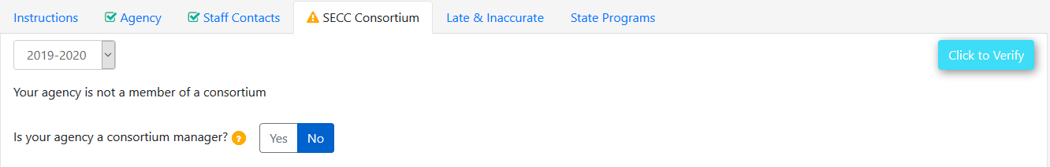

Consortiums
Agencies that are consortium members will see “Your agency has been identified as a consortium member” and the name of the managing agency.
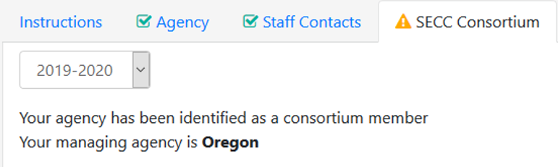
Agencies that are consortium managers will have Yes in the Yes/No toggle and a list of member districts. If an agency has newly become a manager, change the toggle from No to Yes.
When Yes is selected, a drop menu for selecting member directs appear, as well as an Add Member button and grid list of member districts.
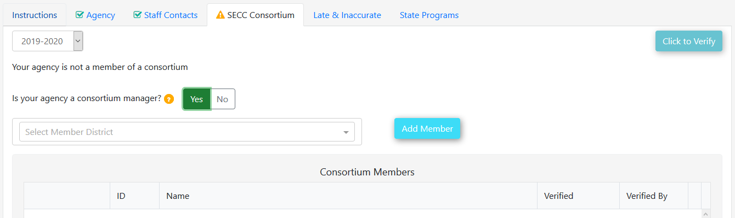

Add a Member
When adding member districts, users can scroll through the list, or start typing the district name. The application will filter based on parameters typed. To add the selected member district, click the Add Member button.

Remove a Member
To remove a member district, click on the Remove button for the particular member from the Consortium Member list.
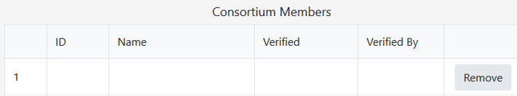
A pop up message will ask the user to confirm deletion of member district. Click Remove to delete the district, or Cancel to undo the removal.

Verify
When done entering or reviewing SECC Consortium information and if it is up-to-date, click the Verify button in the top left corner of the screen. This will verify that the content on the tab is accurate. If there are no changes to make during the annual review, the Verify button will be clickable at the start of the school year, on July 1.
Once the SECC Consortium tab is updated and verified for the current school year, the yellow exclamation point in the tab heading will change to a green check mark. The Verify button will also change to a green message box that contains the date of verification and staff name.
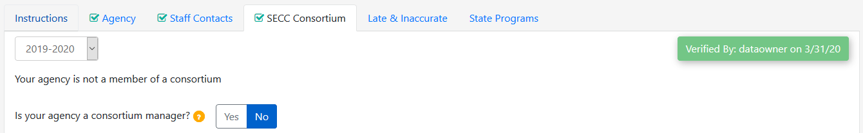

Late & Inaccurate
The Late & Inaccurate tab is viewable only. ODE updates the information on this tab throughout the year. This tab contains late and inaccurate information for December Child Count, June Exit and Child Find, and their review windows. Important: For the Late & Inaccurate tab, the “current year” cycle is November through September, based on review windows for spring collections. It resets on November 1 with every selection set to No. There is a drop menu for collection years, so districts and ESDs can see prior year late and inaccurate information.
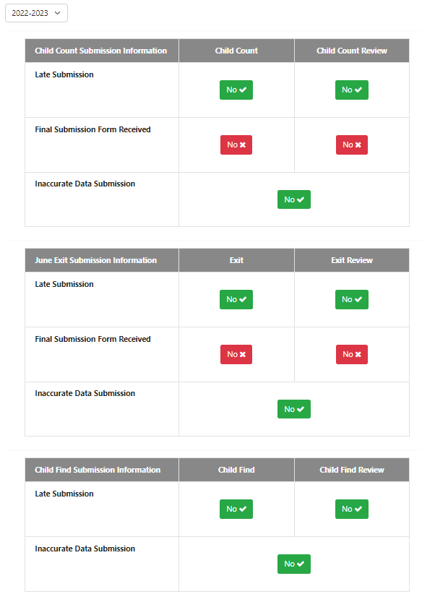
The Late & Inaccurate tab will display Late Submission status, Final Submission Form Received status, and Inaccurate Data Submission Status. After the Final Submission Form has been received, the tab then displays Late Final Submission Form status (Yes/No). This tab will indicate No for all fields until ODE updates them – after receipt and process a district’s Final Submission Form, or until after the collection is closed.
This tab displays these statuses for both the regular collection and the Review Window. The layout for Child Count and June Exit tables are identical. The Child Find table does not show Final Submission Form information because it does not have a Final Submission Form.

Timely and Accurate
In the example for Child Count Submission Information, both the regular collection and Review Window were submitted timely and accurately, so the screen displays the Yes and No boxes in green. Late Submission No, Late final Submission Form No, and Inaccurate Data Submission No are in green because this indicates timely and accurate submission. Final Submission Form received Yes indicates ODE has received and processed the agency’s Final Submission Form.
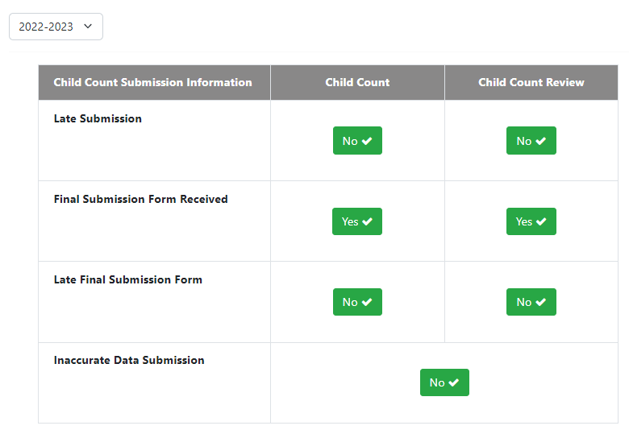
In the example for Child Find Submission Information both the regular collection and Review Window were submitted timely and accurately, so the screen displays the No boxes in green. Late Submission No and Inaccurate Data Submission No are in green because this indicates timely and accurate submission. There is no Final Submission Form for the Child Find collection.
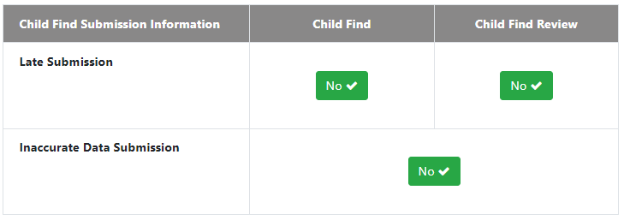

Late and Accurate
This example for Child Count Submission Information, data was submitted accurately but not timely, and a Final Submission Form was not received. The screen displays the Yes and No boxes in red and green.
Late Submission Yes for original collection in the Child Count column is red, indicating untimely submission. When a submission is late, a Late Submission Date field will appear, showing the date the collection was completed. Final Submission Form Received No is in red in the Child Count Review column because ODE has not received the Review Final Submission Form.
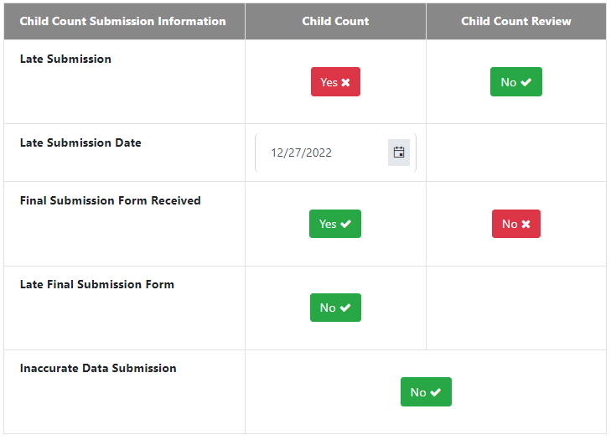
This example for June Exit Submission Information, data was submitted timely and accurately, except a Final Submission From was late. The screen displays the Yes and No boxes in red and green. Late Final Submission Form Received Yes in the Child Count Review column is red, indicating untimely submission of the Review Window Final Submission Form. When a form is late, a Late Final Submission Date field will appear, showing the date ODE received the form.
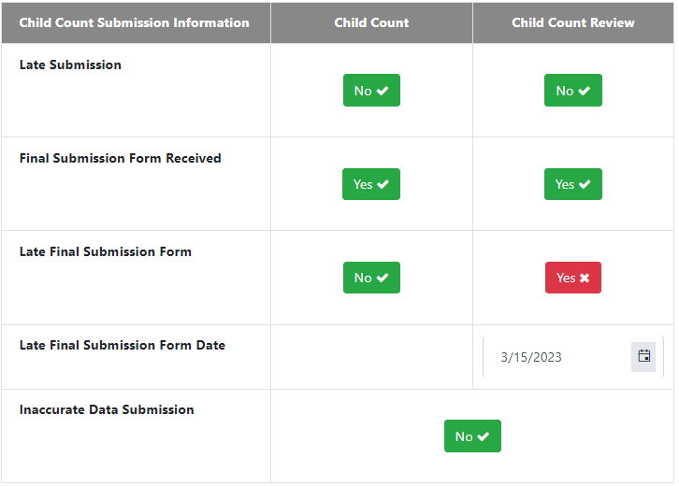

Timely and Inaccurate
In this example for Child Find Submission Information, data was submitted timely, but a record was submitted with inaccurate data. The screen displays the Yes and No boxes in red and green. Inaccurate Data Submission Yes is red, indicating inaccurate data was submitted. When inaccurate data is submitted, a Comments box will appear. ODE staff will enter a comment explaining how a record or records were inaccurate.
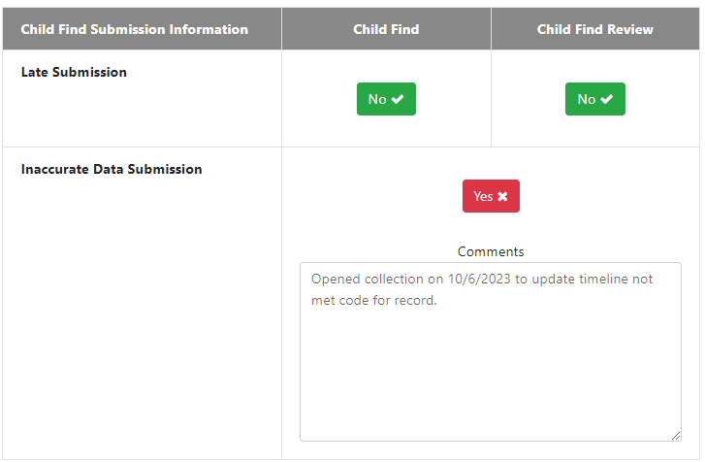

What Do the Colors Mean?
For the Late & Inaccurate tab, a green message box is desirable, indicating timely and accurate data; there were no late submissions of data or forms, nor inaccurate data submitted. A red box is undesirable, indicating untimely or inaccurate data; there were late submissions of data or forms, or inaccurate data was submitted.
If users have questions on late or inaccurate submissions for Child Count, June Exit or Child Find, please contact a member of the Data Team.

State Programs
The State Programs tab is viewable only. ODE updates this tab before the start of the school year and throughout the year if there are any changes. There is a drop menu to view current and prior years’ status.
Agencies that are not a State Program contractor will see “This agency has not been identified as a State Program or State Contractor.”
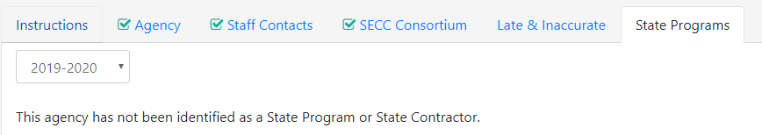
Most districts and some ESDs will see this message. If there will be a state contractor change, or there has been a change, and it has not been reflected in this tab, please contact a member of the Data Team.
Agencies that are a State Program contractor, will see a grid list of member programs.
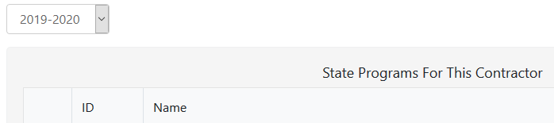

Help

Help Background
The Help section provides users with technical assistance documents and resources for the IDEA Data Manager and related data collections through the FAQs (Frequently Asked Questions) section and the Resources page.
To access the Help section dashboard, click the Help button from the main dashboard page.
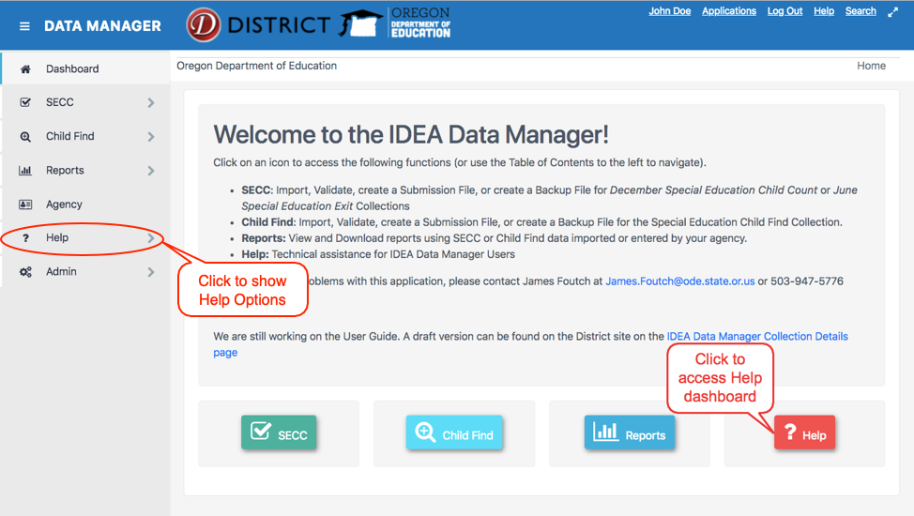

FAQs
To access the FAQs section, click the FAQs button on the Help dashboard page or through the sidebar menu.
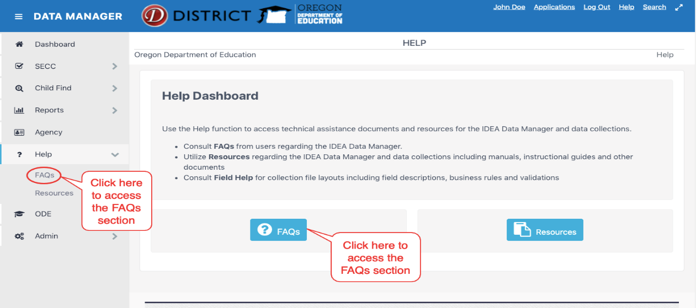

The Frequently Asked Questions (FAQs) section will have a list of questions that are most commonly asked. You can scroll through to find answers to questions you may have.
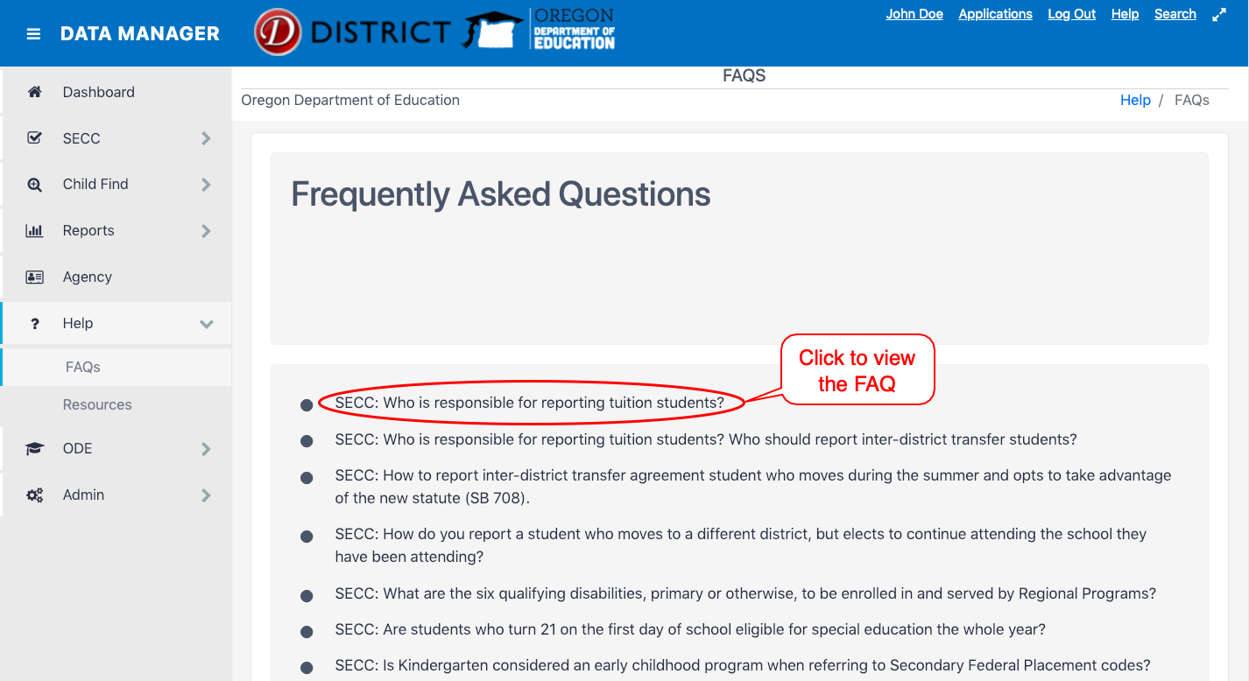

Resources
To access the Resources page, click Resources on the main Help dashboard page or through the side bar menu.
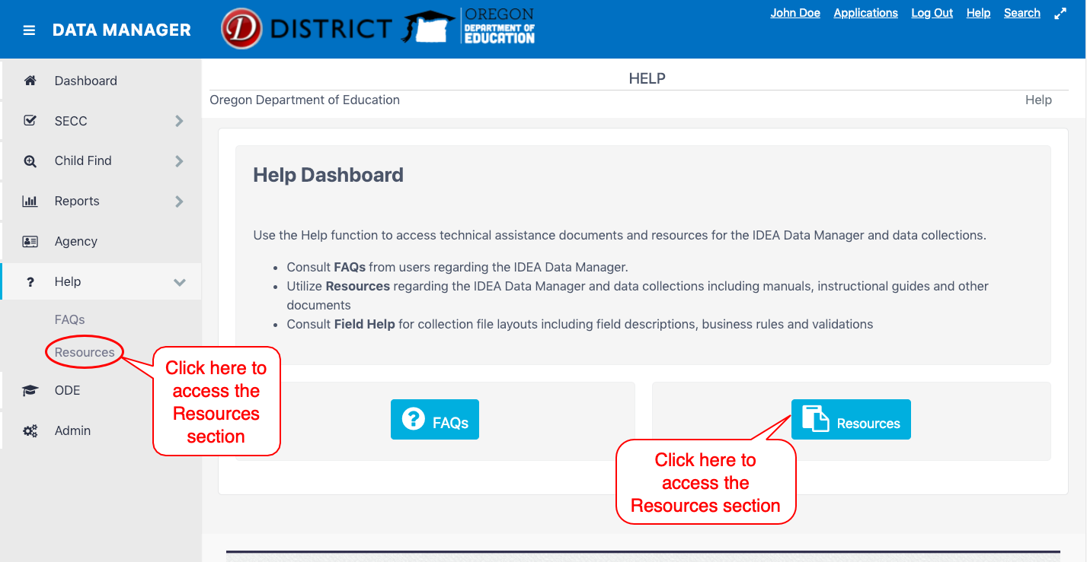

To access each resource provided, click the link under each resource title. This will open a new tab/page in your browser.
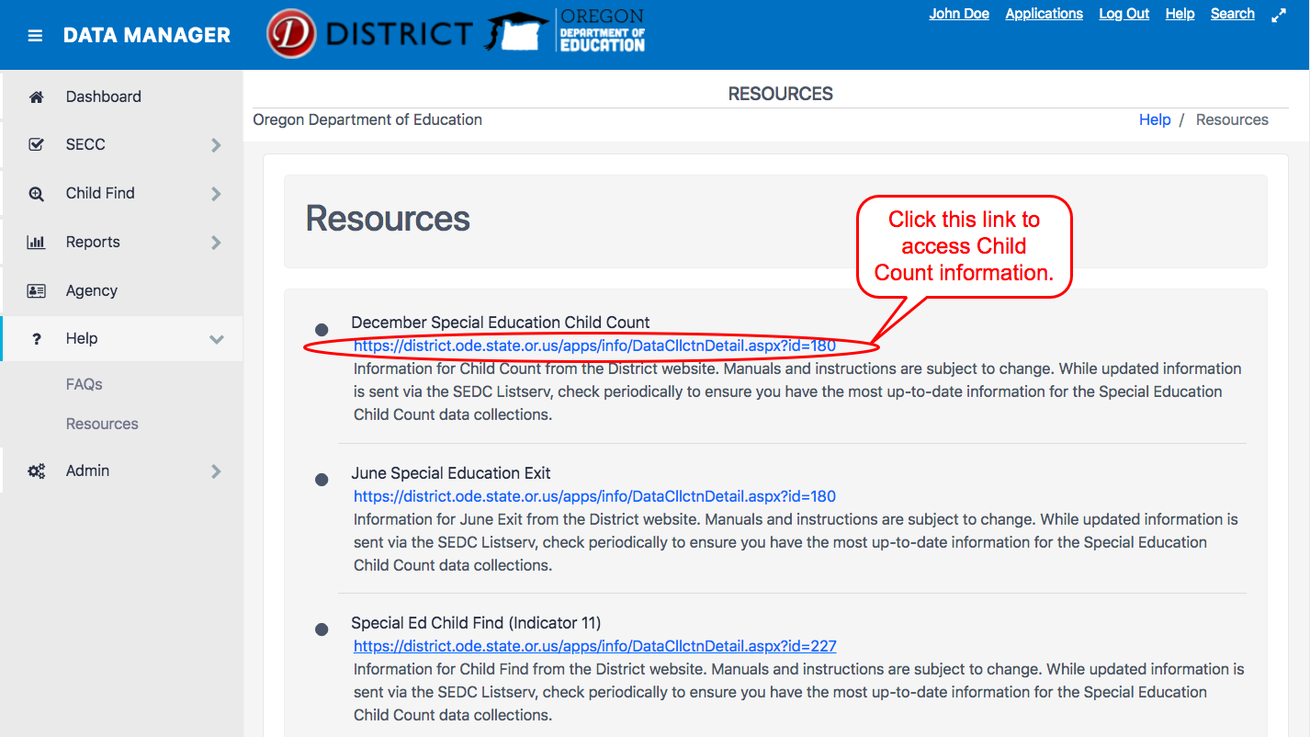

ODE Help Desk & Data Security and Privacy Overview

Contact Information
ODE Helpdesk ODE.Helpdesk@ode.state.or.us (503) 947-5715

Services
ODE Help Desk can
- Provide technical assistance with how to submit your data
- Check to see if your data has submitted
- Provide assistance with questions about access rights and permissions
ODE Help Desk can not
- Submit your data for you
- Make changes to your data
- Answer content area questions

Help Desk vs. Data Team – who to call?
Question | Answer
How to report a student? | Data Team
Why won’t my data submit? | Data Team (will refer to HelpDesk if needed)
Audit/Error Corrections? | Data Team
How can I get a new user added? | ODE Help Desk

ODE Help Desk: What to Expect
When you call or email ODE Help Desk, the best way to contact the ODE Help Desk is at ODE.helpdesk@state.or.us or (503) 947-5715.

Data Security and Privacy
The student data that you collect, handle, and submit is protected student data governed by:
- Family Educational Rights and Privacy Act (FERPA) (34 CFR Part 99)
- Oregon Identity Theft Protection Act
- And in some cases, the Health Insurance Portability and Accountability Act (HIPAA), such as the transfer of records between agencies
Consequences: Loss of protected data can have financial impact to your school, district, or ESD, including fines and cost of remediation!

Student Data Security: Handle with Care
Basic tips to protect student level data
- Use Secure File Transfer. Never send information that would identify an individual student via email, not even to the ODE Help Desk or a member of the Data Team. Emails sent to and from the ODE are considered public record.
  - In order to provide information to ODE, it is advisable to send only the student’s SSID number
  - Never send student’s name, birth date, telephone number, grade or anything else that could be used to identify a specific student.
  - On ODE’s Secure File Transfer users can send secure documents to ODE Staff.
  - The Consolidated Collections manual has instructions how to send a Secure File Transfer.
- Never share your username and password
  - You are responsible for everything done in the system using your username and password
  - Avoid storing your password in an obvious place (desk drawers, under keyboards, sticky notes on monitors are all bad places to store passwords)
- Use a Passphrase instead of a Password
  - Passphrases are sentences you can remember and include spaces and punctuation.
  - Example: Trust the force, Luke!
  - Example: Scotty, beam us up.
- Lock your computer monitor (Window key +L) when you leave your desk
  - Avoid leaving your monitor open and unattended
- Never store or transport student data on an unencrypted thumb drive/flash drive
  - Portable drives are one of the biggest risk factors for losing large volumes of data
The privacy and security of student data depends upon you.
People are the most important part of information security

ODE Policies
Handling Confidential Information
Information Asset Classification

Information Security Questions
Contact ODE Chief Information Security Officer and Team at ODE.Infosec@ode.state.or.us.

Secure File Transfer
To send personally identifiable information to ODE staff, use Secure File Transfer. Go to the District Home page, and in the center right-hand side beneath Applications, select Secure File Transfer.
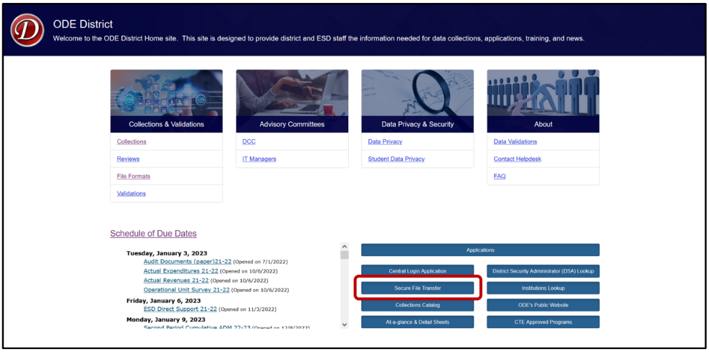
On the Secure File Transfer page, select the desired email(s) from the ODE Email List on the left. Users can select one email at-a-time, or by holding the Ctrl key, users can select multiple emails at once. Once selected, they will highlight in a blue hue.
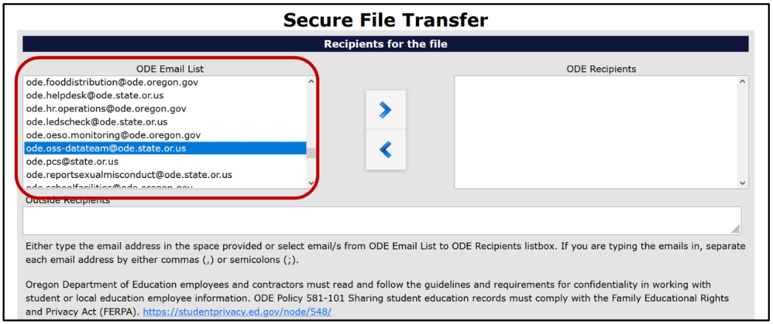
Once users select their desired ODE email(s), they can add them to the ODE Recipients list by selecting the right pointing arrow in the center of the application page.
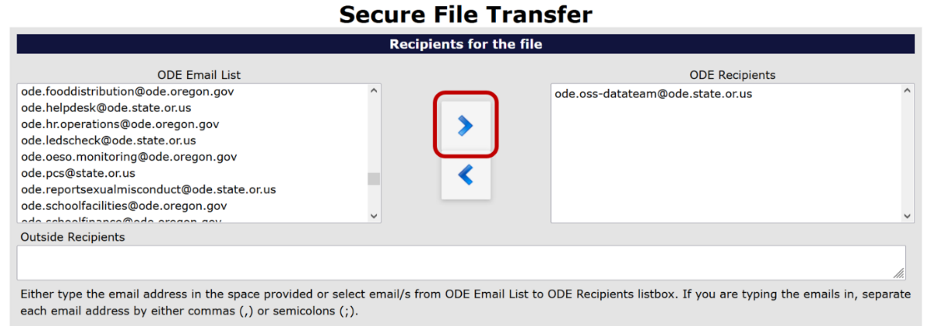
If the wrong email was added to the ODE Recipients list, users can select the incorrect email(s) in the ODE Recipients column and then select the left pointing arrow to remove them.
If an intended recipient is not found in the ODE Email list, or to send to a non-ODE employee, users can write their email into the Outside Recipients textbox. Warning: emails written in this textbox require commas (,) or semicolons (;) to separate them. The system will read emails not separated in this manner as one singular email.
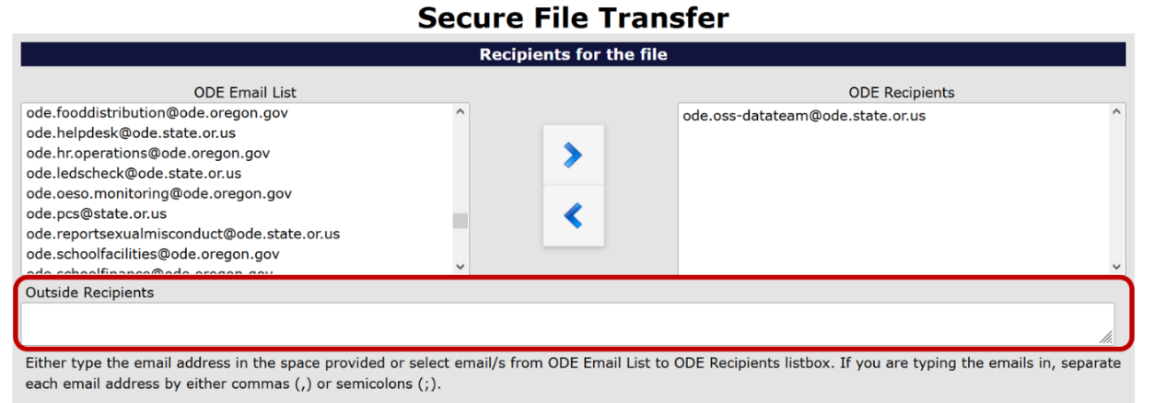
With all recipients selected, users must type their email address into the “Enter your email address” textbox.
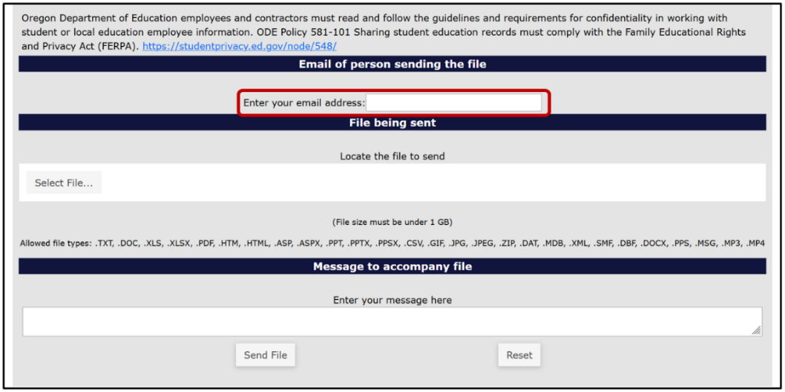
To add the file to be sent, select the Select File button.
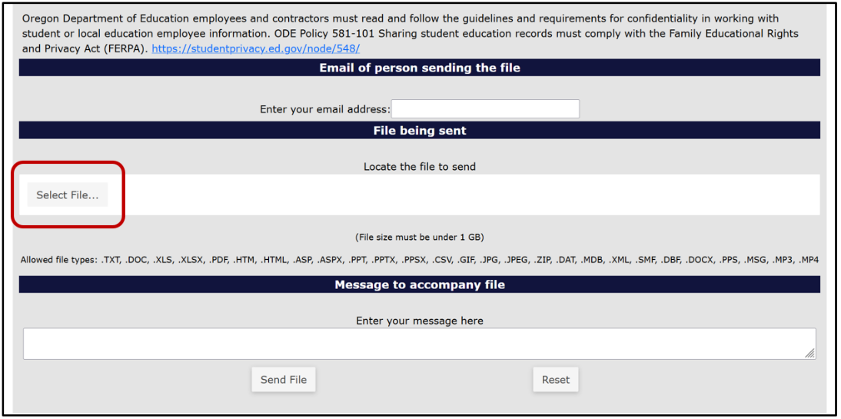
Find the desired file and select it. To select the file there are two methods. For the first method, users select the desired file, and then select the Open button in the window. For the second method, users double click the desired file.
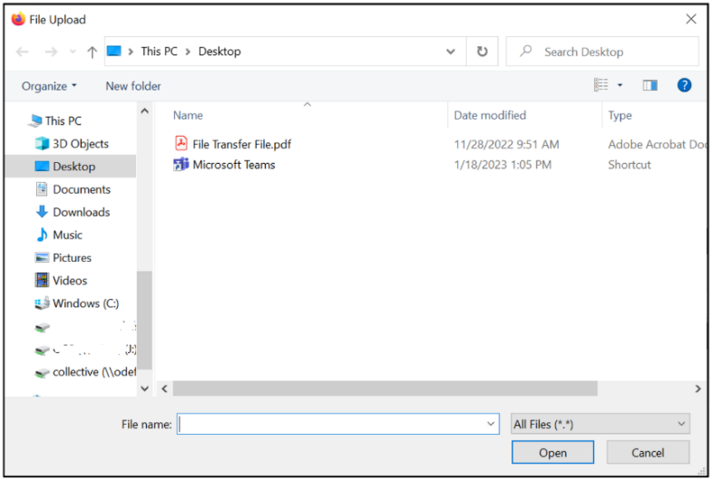
Users can type a message at the bottom of the page to add context and or anything else necessary for the recipients to know. This section is best thought of as the body of an email.
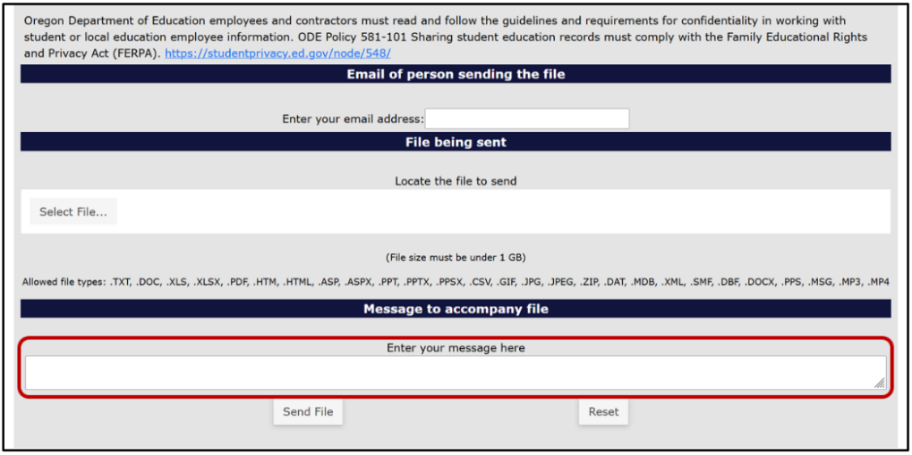
Finally, to send the file, select the Send File button at the bottom of the webpage.
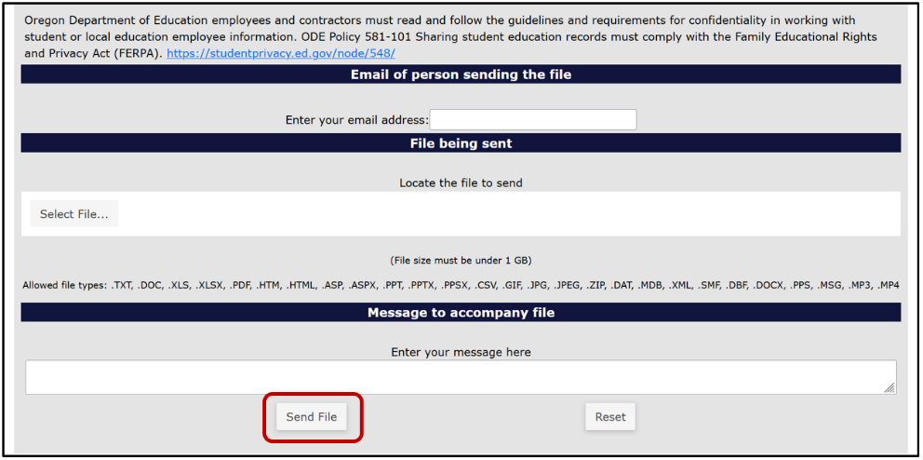
The recipient will receive an email with a web link. This link will take the recipient to a Secure File Transfer page on the ODE District website. They will enter their email address, the same address the user selected, and click the Submit Email Address button. The page will generate a Download button for the recipient to click, which downloads a zip file of the document the user sent.

OAR 581-015-2475 through 581-015-2483

