Enhancing Student Opportunities

Consolidated Collections Application

User Guide
Revised – October 2023
OREGON DEPARTMENT OF EDUCATION
Office of Enhancing Student Opportunities
255 Capitol Street NE
Salem, OR 97310-0203

Table of Contents
What’s New 1
September 2023 1
October 2023 1
Introduction 2
Acronyms 2
Contact List 2
Login Information 3
ODE Help Desk & Data Security and Privacy Overview 5
Contact Information 5
Services 5
Help Desk vs. Data Team – who to call? 5
ODE Help Desk: What to Expect 5
Data Security and Privacy 6
Student Data Security: Handle With Care 6
ODE Policies 6
Information Security Questions 6
Consolidated Collections Data Submission 7
Submitting Data to ODE 7
File Upload 8
Add a Single Record 12
Delete a Record 17
Correcting Errors in Consolidated Collections 19
Fix One Record at a Time 21
Fix Multiple Errors at Once 23
Verifying Submissions in Consolidated Collections 26
Verifying Special Education Collections 26
Verifying Discipline Collections 31
Correcting Audits in Consolidated Collections 33
View Charts and Export Data 37
Production Download Reports 38
Help 42
Getting Access to Applications on the District Website 42
Secure File Transfer 43

What’s New

September 2023
- Added ODE HelpDesk & Data Security and Privacy Overview section.
- Added instructions for Secure File Transfer.

October 2023
- Updates to the instructions and screenshots for Production Download Report in yellow.

Introduction
The Consolidated Collections Application is used for special education and other Enhancing Student Opportunities data collections. Access to the Consolidated Collections Application is restricted to authorized users only and controlled by your District Security Administrator. Use the District Security Administrator Lookup Tool to locate your District Security Administrator. For more information, see Getting Access to Applications on the District Website. The Data Team provides support and technical assistance for these collections and the Application (see contact information below). The ODE Helpdesk can provide support and technical assistance for the Application.
This manual serves as a guide to assist data submitters with submitting and managing special education and discipline data in the Consolidated Collections Application. It is not intended to replace but rather serve as an additional resource to the Consolidated Collections Student Collections - SSID User Guide.

Acronyms
Abbreviations frequently used throughout this document include:
Acronym | Name
CSV | Comma Separated Values
IDEA | Individuals with Disabilities Education Act
ODE | Oregon Department of Education
ESO | Office of Enhancing Student Opportunities
SECC | Special Education Child Count
SIS | Student Information System

Contact List
For assistance, please contact us at the information below.
Jackie McKim Research Analyst 971-240-0234 jackie.mckim@ode.oregon.gov
Cynthia Garton Research Analyst 503-508-7492 cynthia.garton@ode.oregon.gov
Maxwell Swope Research Analyst 971-208-0259 maxwell.swope@ode.oregon.gov

Login Information
Access your applications list from the ODE District site at https://odedistrict.oregon.gov/Pages/default.aspx. Click on the Central Login Application color block link.
Warning: Applications is a link to the list of ODE’s applications and not a link the applications assigned to a user.
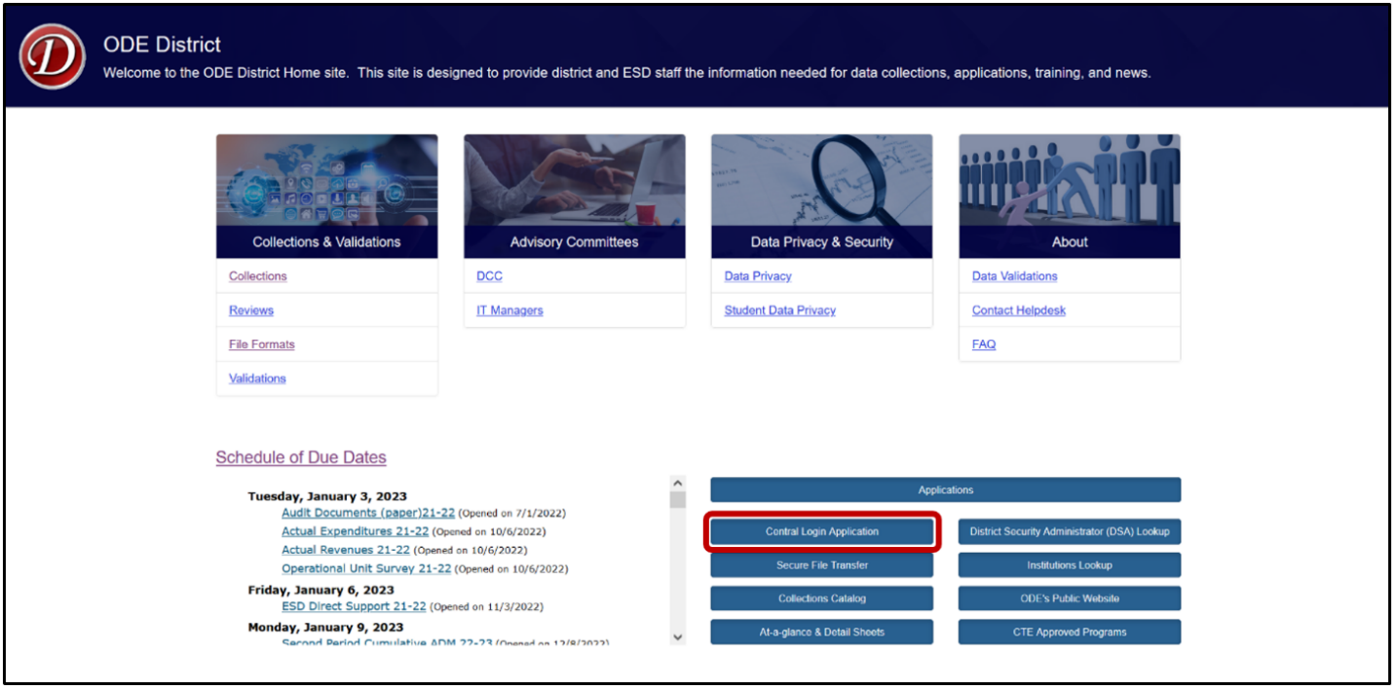
Logging in takes Users to their Applications List, (yours might appear differently).
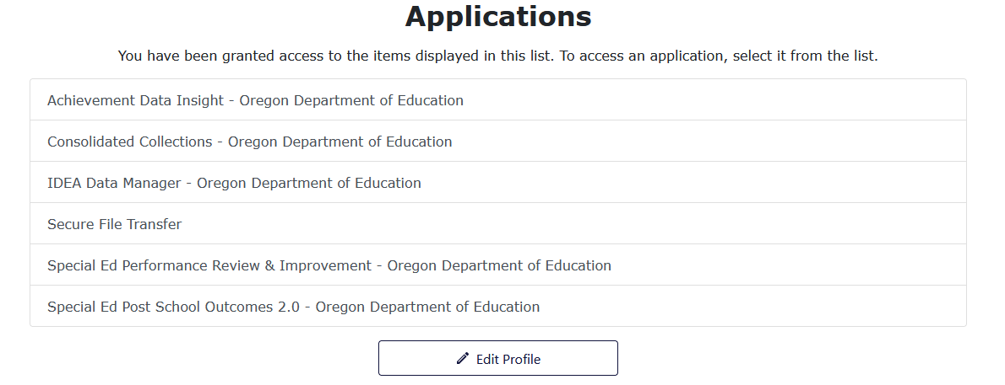

From the Applications list, click on either Consolidated Collections or IDEA Data Manager.
Consolidated Collections is ODE’s data submission site for December Special Education Child Count, June Special Education Exit and Special Education Child Find, as well as Discipline Incidents, Restraint and Seclusion Incidents and Seclusion Rooms. IDEA Data Manager is a tool for cleaning special education data prior to submission to ODE via Consolidated.
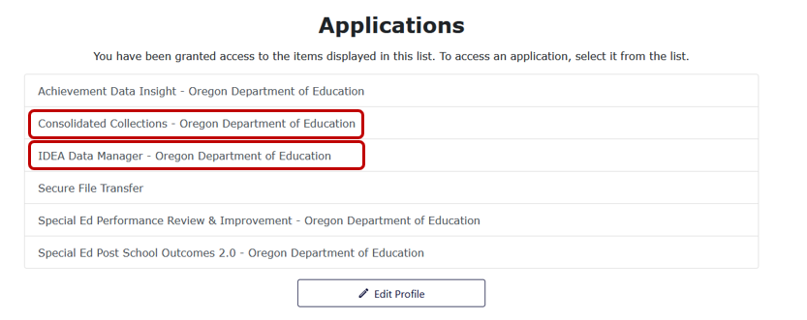

ODE Help Desk & Data Security and Privacy Overview

Contact Information
ODE Helpdesk ODE.Helpdesk@ode.state.or.us (503) 947-5715

Services
ODE Help Desk can
- Provide technical assistance with how to submit your data
- Check to see if your data has submitted
- Provide assistance with questions about access rights and permissions
ODE Help Desk can not
- Submit your data for you
- Make changes to your data
- Answer content area questions

Help Desk vs. Data Team – who to call?
Question | Answer
How to report a student? | Data Team
Why won’t my data submit? | Data Team (will refer to HelpDesk if needed)
Audit/Error Corrections? | Data Team
How can I get a new user added? | ODE Help Desk

ODE Help Desk: What to Expect
When you call or email ODE Help Desk, the best way to contact the ODE Help Desk is at ODE.helpdesk@state.or.us or (503) 947-5715.

Data Security and Privacy
The student data that you collect, handle, and submit is protected student data governed by:
- Family Educational Rights and Privacy Act (FERPA) (34 CFR Part 99)
- Oregon Identity Theft Protection Act
- And in some cases, the Health Insurance Portability and Accountability Act (HIPAA), such as the transfer of records between agencies
Consequences: Loss of protected data can have financial impact to your school, district, or ESD, including fines and cost of remediation!

Student Data Security: Handle With Care
Basic tips to protect student level data
- Use Secure File Transfer. Never send information that would identify an individual student via email, not even to the ODE Help Desk or a member of the Data Team. Emails sent to and from the ODE are considered public record.
  - In order to provide information to ODE, it is advisable to send only the student’s SSID number
  - Never send student’s name, birth date, telephone number, grade or anything else that could be used to identify a specific student.
  - On ODE’s Secure File Transfer users can send secure documents to ODE Staff.
- Never share your username and password
  - You are responsible for everything done in the system using your username and password
  - Avoid storing your password in an obvious place (desk drawers, under keyboards, sticky notes on monitors are all bad places to store passwords)
- Use a Passphrase instead of a Password
  - Passphrases are sentences you can remember and include spaces and punctuation.
  - Example: Trust the force, Luke!
  - Example: Scotty, beam us up.
- Lock your computer monitor (Window key +L) when you leave your desk
  - Avoid leaving your monitor open and unattended
- Never store or transport student data on an unencrypted thumb drive/flash drive
  - Portable drives are one of the biggest risk factors for losing large volumes of data
The privacy and security of student data depends upon you.
People are the most important part of information security

ODE Policies
Handling Confidential Information
Information Asset Classification

Information Security Questions
Contact ODE Chief Information Security Officer and Team at ODE.Infosec@ode.state.or.us.

Consolidated Collections Data Submission

Submitting Data to ODE
Once users have created a submission file in either the IDEA Data Manager or their own Student Information System (SIS), or will enter single records via Web Submission, the data will be submitted to Consolidated Collections. For information on downloading a submission file from the IDEA Data Manager, see the IDEA Data Manager User Guide.
The Consolidated Collections application is available in the Applications List (see the instructions in Login Information for details). From the Applications List, click Consolidated Collections.
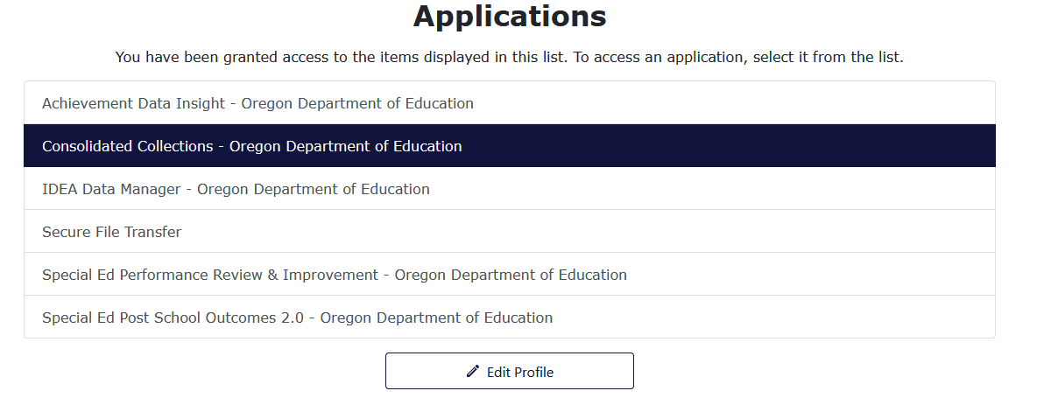
Users should see a screen that looks similar to this:
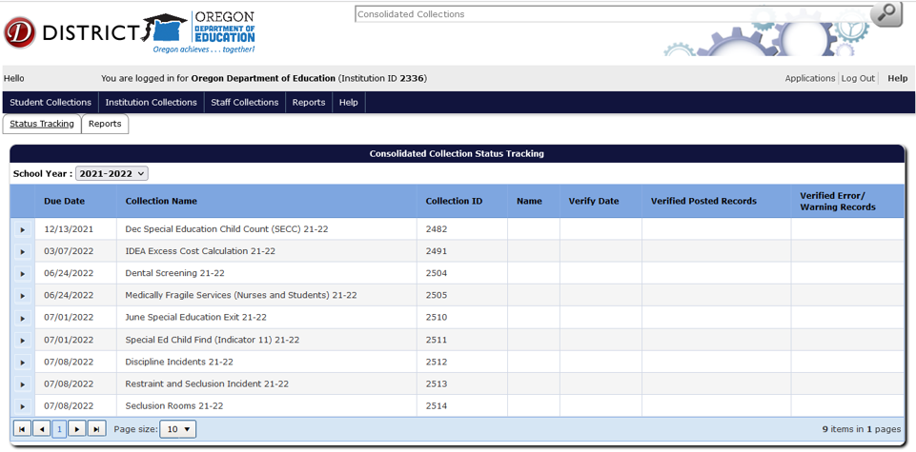
The list of collections users see will depend on the collections they have permissions to view and/or modify. If a user does not see the specific collection for which they are submitting data, they will need to contact their District Security Administrator. See the Help section, Getting Access to Applications on the District Website for instructions.

File Upload
To upload a submission file, hover your mouse over Student Collections in the top menu bar.
For this example, screenshots show December Special Education Child Count. The process is the same for June Special Education Exit, Special Education Child Find, Discipline Incidents, and Restraint and Seclusion Incidents. Note for Seclusion Rooms the process is the same, except it is accessed via the Institution Collections drop menu.
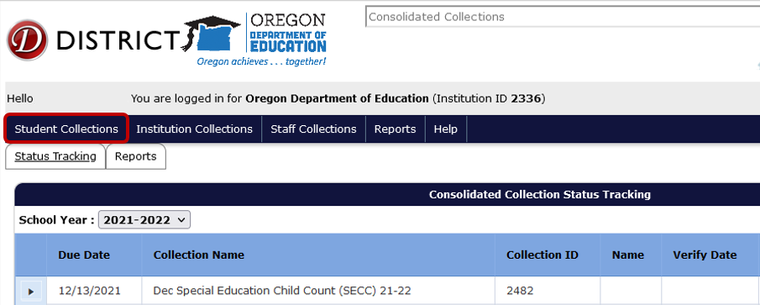
A drop menu will appear, containing a list of open collections. To submit a file, hover over the collection name. In this case, Dec Special Education Child Count (SECC) 21-22.
A fly out menu will appear with three options. Hover over Data Submission to access the next fly out menu.
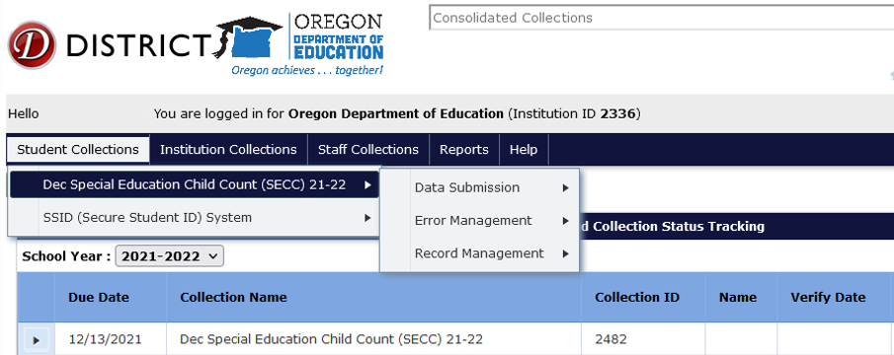

The final fly out menu will have two options. Here users will click File Upload.
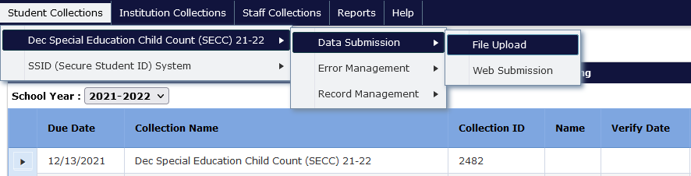
Next, click the Browse button to locate the submission file from the IDEA Data Manager or district SIS. Depending on the browser, the Browse button will be a Choose File button.
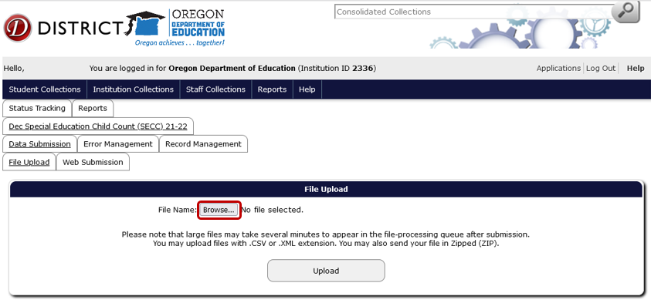
A File Upload dialog box will appear. Select the submission file and then click the Open button.
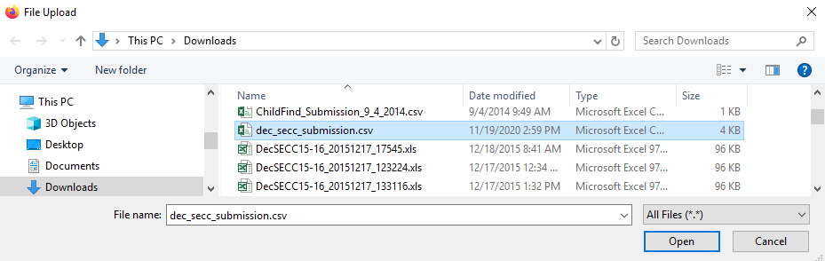
Finally, click the Upload button to submit the file to ODE.
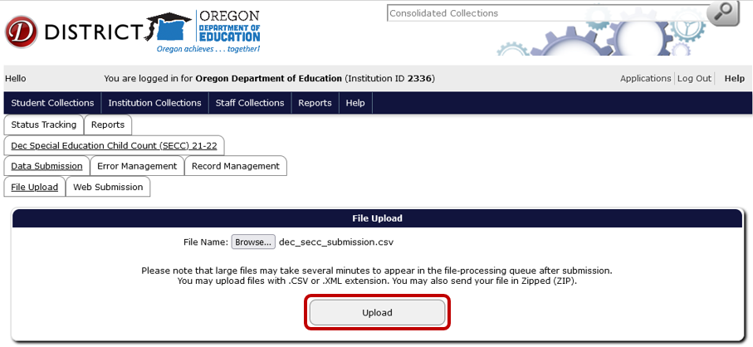
If the upload is successful, the screen will display information boxes with information on the file and processing status. Consolidated Collections will notify users by email when the validation processing is complete.
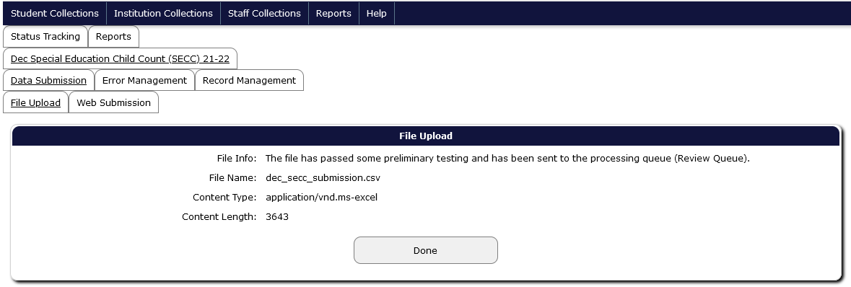
Please note: users are not finished submitting data to ODE until all errors are corrected AND the verification reports have been verified. Please see the sections Correcting Errors in Consolidated Collections and Verifying Submissions in Consolidated Collections.

Check the Status of your Submission File
To check the status of the submission file, hover over Student Collections. From the drop menu of currently open collections, hover over the needed collection name to access the fly out menus. Then hover over Error Management, and click Review Queue.
The fly out menu pathway can be used from both the File Upload page and Status Tracking page.
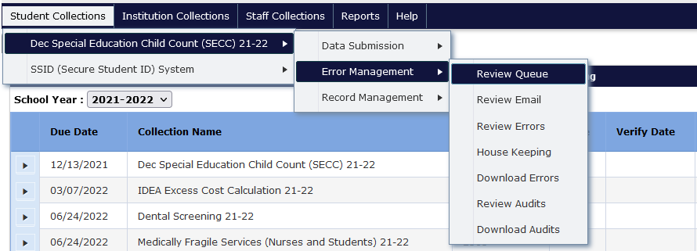
The Review Queue displays a list of all district files that have posted in the past 24 hours. Users may have to wait for their upload if another district is uploading at the same time.
The file has been loaded when the screen states 100% under the Percentage Posted column.
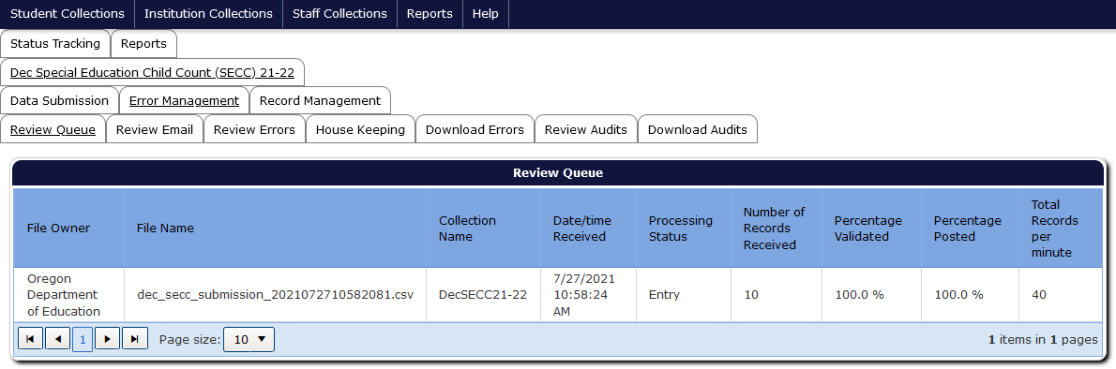
Once the file has been posted, users will receive an automated email from ODE Helpdesk with information about the file processing. This email will also inform users about the number of errors.

Add a Single Record
To add a single record, hover over Student Collections. For this example, screenshots show December Special Education Child Count. The process is the same for June Special Education Exit, Special Education Child Find, Discipline Incidents, and Restraint and Seclusion Incidents. For instructions for Seclusion Rooms, see Add a Single Record for Seclusion Rooms.
From the drop menu of currently open collections, hover over the needed collection name to access the fly out menus. Then hover over Data Submission, and finally click Web Submission.
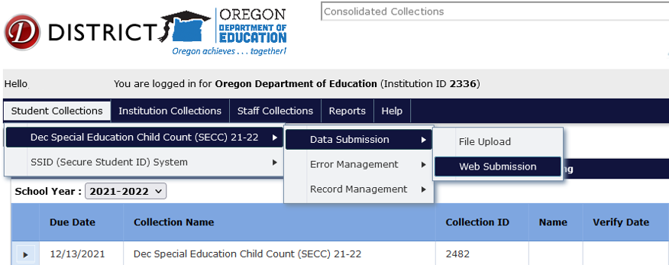
This screen allows users to enter one record at a time. Enter a student’s SSID and click Search.
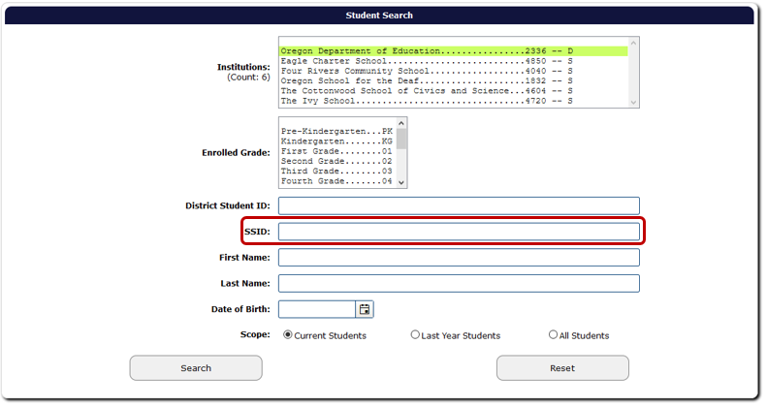

Select the applicable student by clicking on the green check mark to the left of the record, located in the Edit column, next to SSID column.
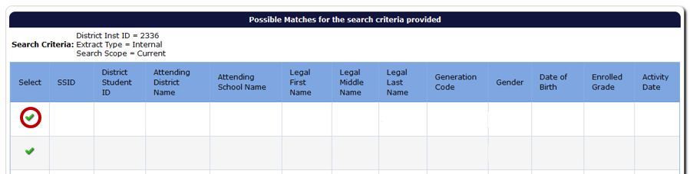
Enter the student information and then click the Save button, located at the top and bottom of the record screen.
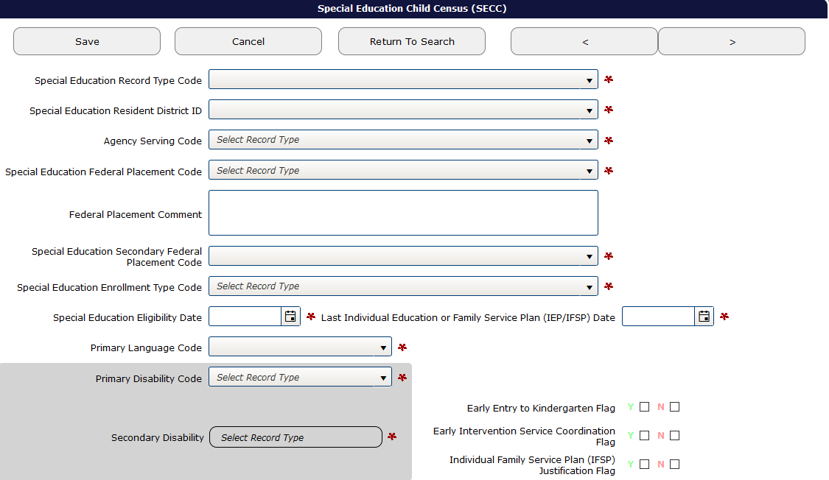
After clicking Save, if there are any required fields not completed, the system will generate pre-check error messages at the top of the record screen. The corresponding fields also will have a red outline around them.
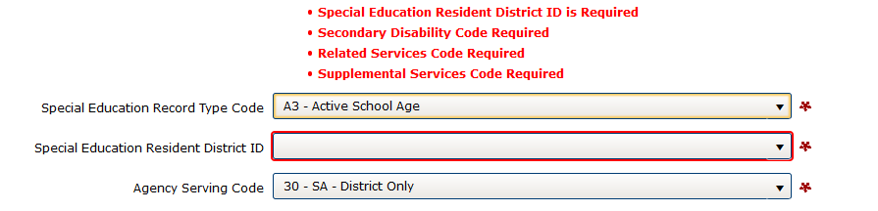
After filling in the fields, be sure to check for validation errors. See Correcting Errors in Consolidated Collections.
Warning: if any required field is not completed and pre-check error warnings are present when the user exits the record screen, the record will not save. Be sure to clear all pre-check errors before leaving the record. If there are no validation errors, the student record will post to Record Management, Record Maintenance. If there are any validation errors, the record will post to Error Management, Review Errors.

Add a Single Record for Seclusion Rooms
To add a single record, hover over Institution Collections. From the drop menu of currently open collections, hover over the needed collection name to access the fly out menu, then click Submission/Maintenance.
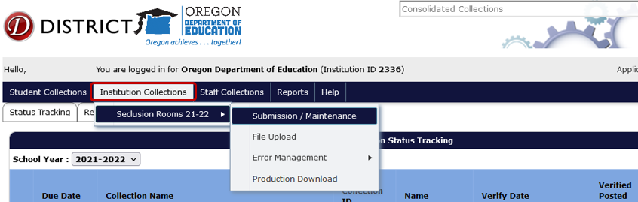
This screen allows users to enter one record at a time. Click Add New Record.
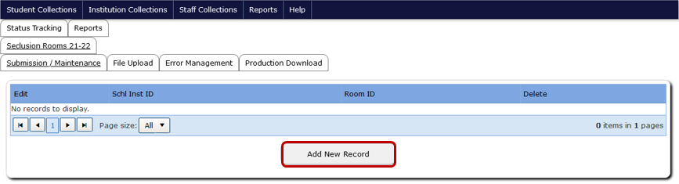
Enter the Seclusion Room information and then click the Save button, located at the top and bottom of the record screen.
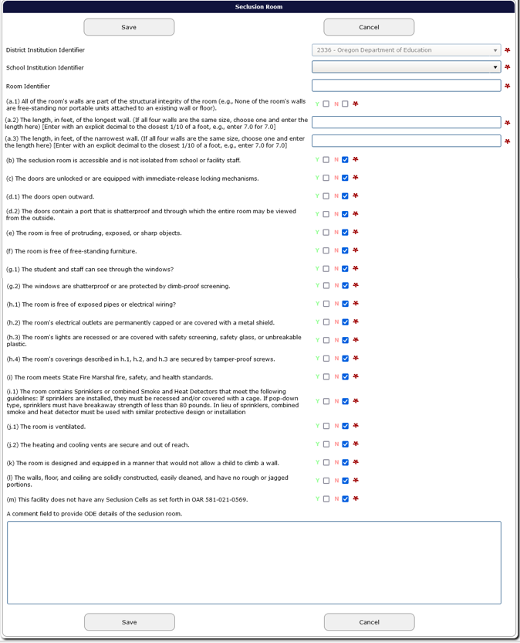
After clicking Save, if there are any required fields not completed, the system will generate pre-check error messages at the top of the record screen. The corresponding fields also will have a red outline around them.
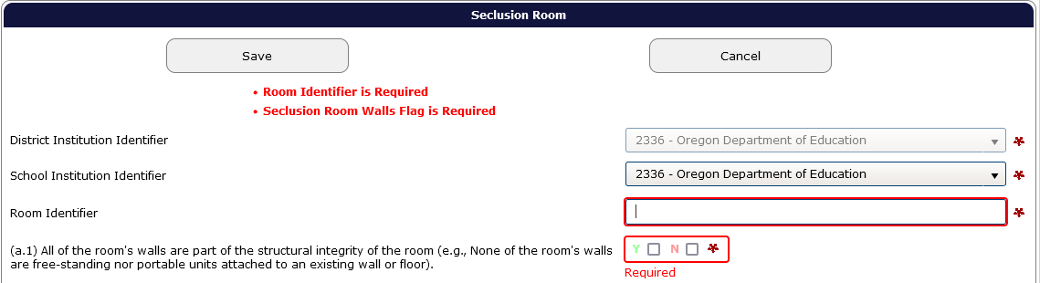
After filling in the fields, be sure to check for validation errors. See Correcting Errors in Consolidated Collections.
Warning: if any required field is not completed and pre-check error warnings are present when the user exits the record screen, the record will not save. Be sure to clear all pre-check errors before leaving the record. If there are no validation errors, the record will post to Submission/Maintenance. If there are any validation errors, the record will post to Error Management.
If there are no errors or empty required fields and record successfully saves, the application will go to the Submission Maintenance screen with the note Record Saved in green. Users can continue to add new records, or delete records.
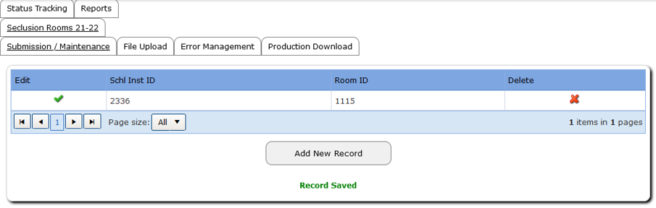

Delete a Record
To delete a record, hover over Student Collections. The process is the same for June Special Education Exit, Special Education Child Find, Discipline Incidents, and Restraint and Seclusion Incidents. For instructions for Seclusion Rooms, see Delete a Record for Seclusion Rooms.
From the drop menu of currently open collections, hover over the needed collection name to access the fly out menus. Then hover over Record Management, and finally click Record Maintenance.
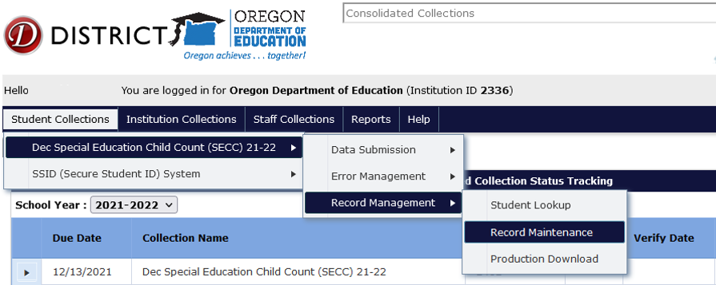
This screen allows users to search for student records. Enter a student SSID and select Search.

The system will generate a table with the student record. To delete, click the red X to the right of the record. If deleting duplicate record(s), click green check mark to the left of the record, located in the Edit column, next to SSID column. This will allow users to double check they are deleting applicable record.
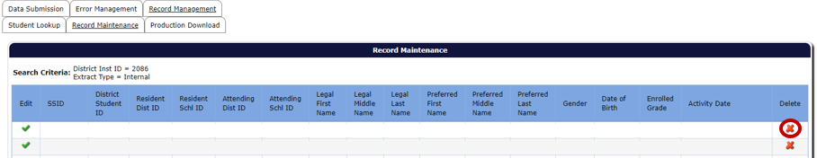
Users can double check the record has been successfully deleted by searching for the record in the search screen located under Record Management, Record Maintenance.

Delete a Record for Seclusion Rooms
To delete single record, hover over Institution Collections. From the drop menu of currently open collections, hover over the needed collection name to access the fly out menu, then click Submission/Maintenance.
The system will generate a table with the institution’s Seclusion Rooms. To delete, click the red “X” to the right of the record. If deleting duplicate record(s), click green check mark to the left of the record, located in the Edit column, next to School Inst ID column. This will allow users to double check they are deleting the applicable record.
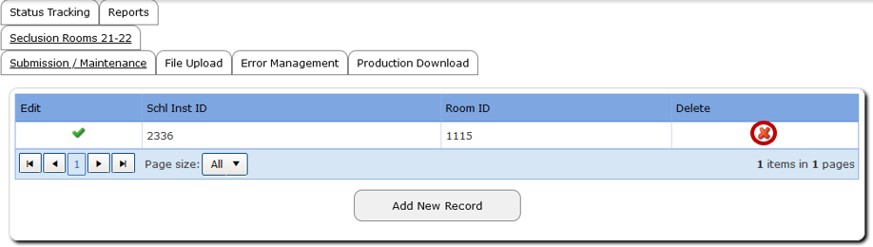
Users can double check the record has been successfully deleted by searching for the record in the search screen located under Submission/Maintenance.

Correcting Errors in Consolidated Collections
Once all data has been loaded into the applicable collection, the next step is to correct errors. When Consolidated Collections completes its validation checks, the system sends an email with information to the email address associated with the user’s account. If you don’t receive an email, please contact the ODE Helpdesk, (503) 947-5715.
For this example, screenshots show December Special Education Child Count. The process is the same for June Special Education Exit, Special Education Child Find, Discipline Incidents, and Restraint and Seclusion Incidents. Note for Seclusion Rooms the process is the same, except it is accessed via the Institution Collections drop menu.
To view and correct errors, hover your mouse over Student Collections in the top menu bar.
A drop menu will appear, containing a list of open collections. To check errors, hover over the collection name. In this case, Dec Special Education Child Count (SECC) 21-22.
A fly out menu will appear with a three options. Hover over Error Management to access the next fly out menu.
The final fly out menu will have seven options. Here users will click Review Errors. If users are in the Record Management screen, the same fly out menu pathway can also be used.
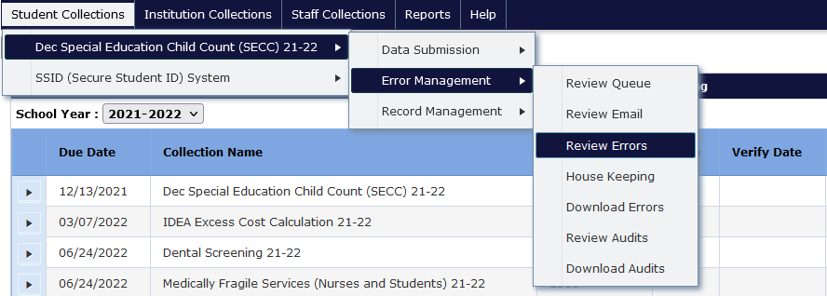
The Error Screen shows a list of errors by type, count and description. The Error Count is the number of records with the Error Type.
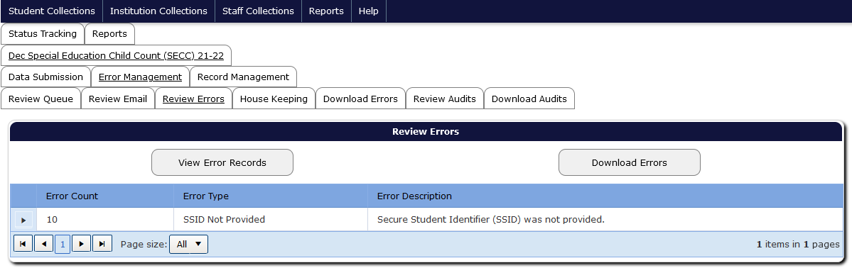
A single student record may have multiple errors and could appear under more than one Error Type.
Consolidated Collections provides two options to fix errors. First option is to click the triangle expand button on the left, for the applicable error type. This expands the screen to show the list of all records within that error type. This screen provides options to fix or delete individual records. The second option is to click the Download Errors button at the bottom of the screen. This will take users to the Download Errors tab, where users can download a file containing all the errors into either a CSV or a XML format.
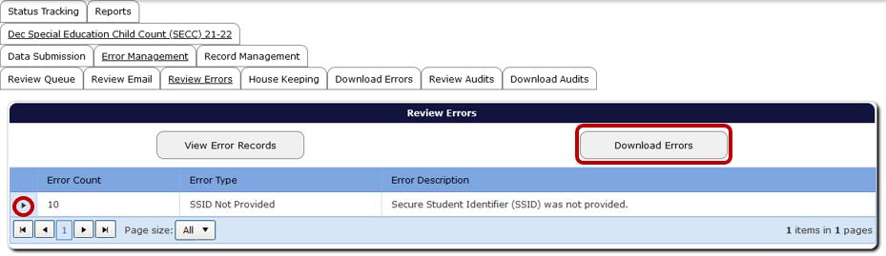
Download Errors can be used when there is a large number of the same type of error. This option allows users to download only those records with that error, fix those within the file, and then re-upload the file to Consolidated. This overwrites the information previously submitted for those records only.
The triangle expand button can be used when users want to fix one record at a time. To view details, click the View Error Records button and then the triangle expand button of the error type.
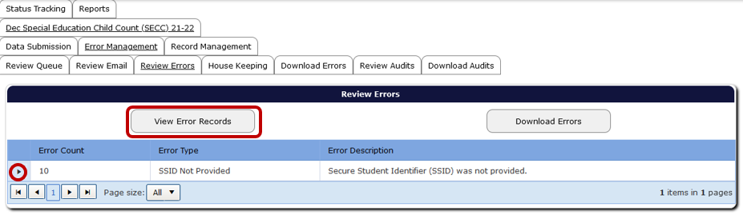
Consolidated Collections will display a grid of each record under the respective error type. Included in the grid are SSID, District ID, First Name, Middle Name, Last Name, Gender, Ethnic Code(s), Enrolled Grade, Phone, Address, City and Zip, and Generational Code, which is not used for special education collections. To sort, click any field type in the header row.
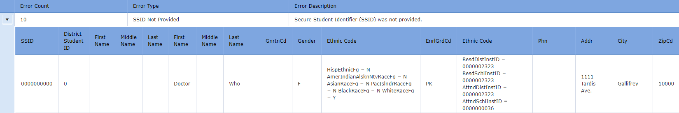

Fix One Record at a Time
From the Review Errors screen, click the triangle expand button, in the row of the Error Type you wish to correct.
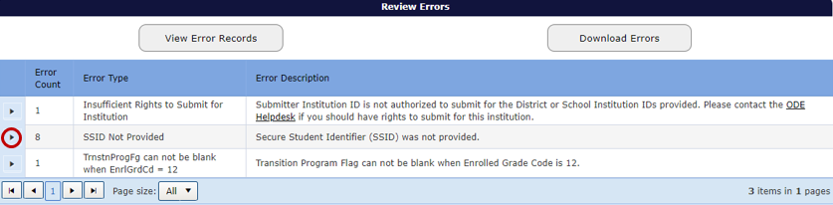
Clicking the triangle expand button link expands the Error Details, which lists any errors for the applicable Error Type.
The Error Details page displays the Error Type. The page also contains a table with student demographic information, a green check mark to access the record, a red “X” to delete the record, the values causing the error, and the column names for these values.
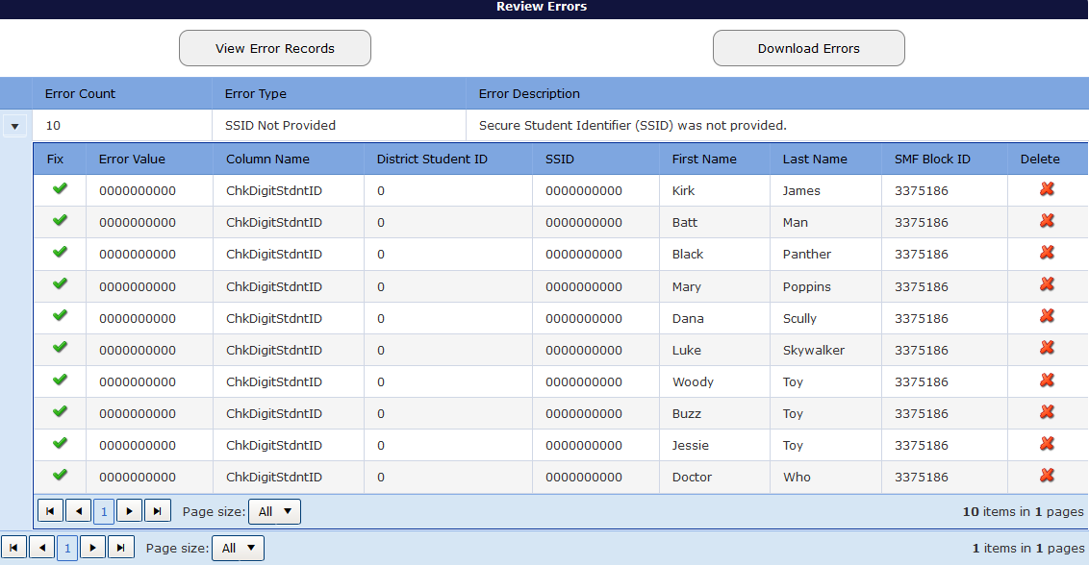
After clicking on the triangle expand button, the records with that error will display in a grid. The other error types are still accessible by clicking the corresponding triangle expand button. To edit a record from the list, click on the green checkmark for the applicable student record.
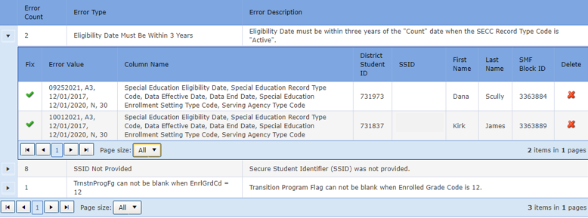
Clicking the green check mark opens the record. The top of the record will display each validation error for the record.
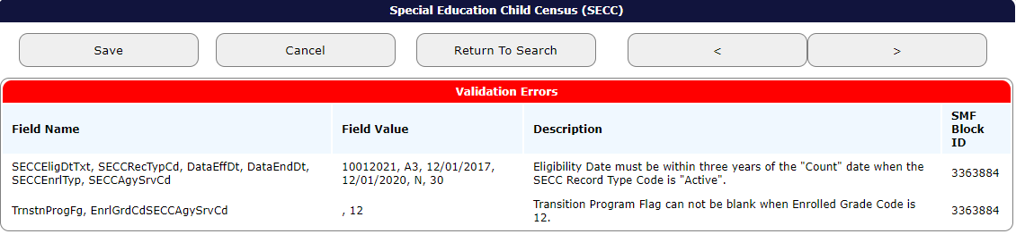
Consolidated Collections puts a red outline around the field that contains a validation error. If there is more than one validation error, each field that is in error will be outlined in red.
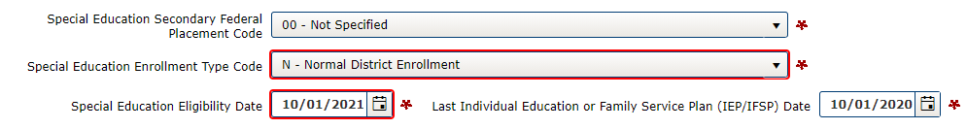
After fixing each error, click the Save button, located at the top and bottom of the record, which will clear the error. After clicking Save, the system will produce a green “Record Saved” message. The system also will revalidate the entire record, to check for any further errors.
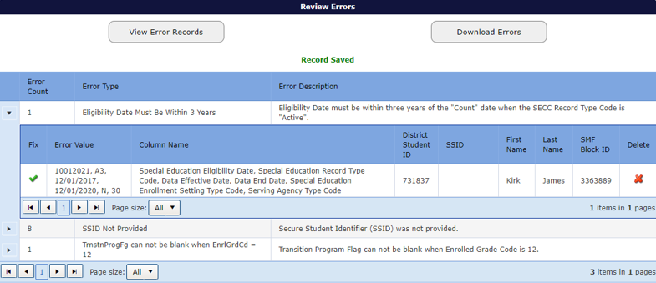
Once all errors are fixed, the record will post to Record Management. If there is more than one error in the Error Type, the system will keep that Error Type expanded.

Fix Multiple Errors at Once
ODE suggests fixing single record, or low-frequency errors, first so that the error file only contains multiple records with the same error type (aka, high-frequency error).
To download the high-frequency records in error, if on the Review Errors screen, click the Download Errors button or the Download Errors tab. Download Errors also can be accessed via the fly out menus.
Unless instructed otherwise, users should always select the CSV button then click the Submit button.
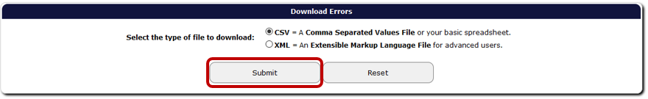
After selection, the webpage will display the message below.
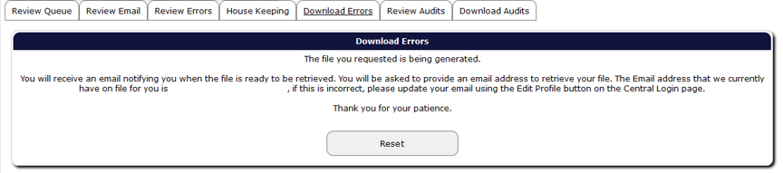
Consolidated Collections will send the user an email, using the email address associated with the users login/account. Click the link in this email.
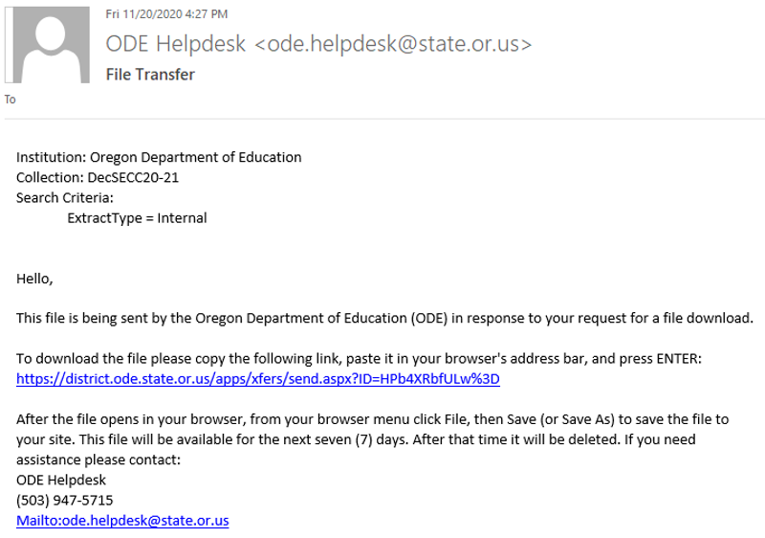

This link will take the user to ODE’s Secure File Transfer page. Enter the email address associated with the user account into the space provided.
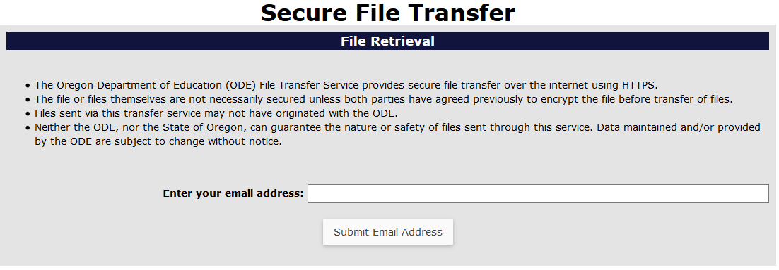
Once the system verifies the email address, access to the Download icon is provided. Click on the Download button to open and save the file.
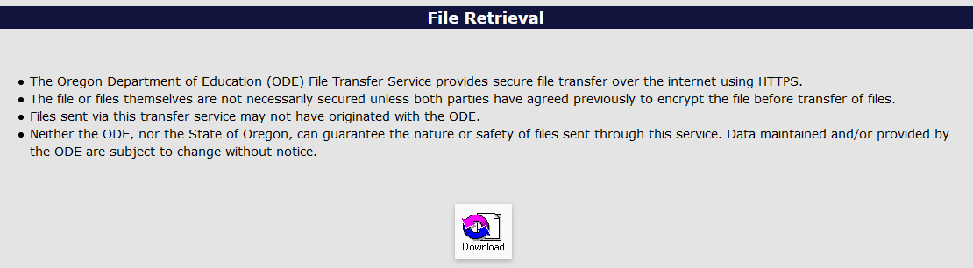
Next, make the necessary changes to all records, then save the file. Finally, upload this file using the same process as Submitting to ODE.
If this fix resolves the issue, the system will clear this Error Type, and the records will no longer be on the Review Errors page.

Verifying Submissions in Consolidated Collections

Verifying Special Education Collections
Final steps is verifying the submission. ODE cannot consider the collection complete until the submitting district verifies it as complete. This includes the main window and the Review Window. If districts do not verify their submission, ODE will consider that district late and/or inaccurate.
From anywhere in the Consolidated Collections application, click the Status Tracking tab to go to the list of collections.
Make sure the School Year dropdown displays the correct school year. This dropdown will automatically advance to the next school year on July 1. If the 2023-2024 June Exit collection closes on July 10 and is verified after June 30, 2023, when users arrive at the Status Tracking page, the dropdown will show 2023-2024 and all the collection names will end with “23-24.” The example below is for the 2021-2022 collection.
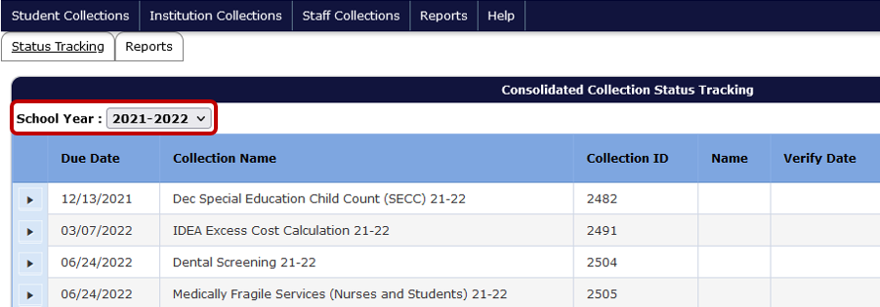
Click the black expand arrow next to the collection to be verified. This example uses December Special Education Child Count. The process is the same for June Special Education Exit and Special Education Child Find.
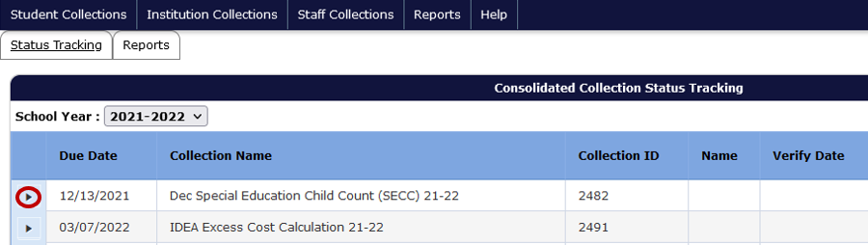

If all errors have not been cleared, the below message will appear. See Correcting Errors in Consolidated Collections before continuing.
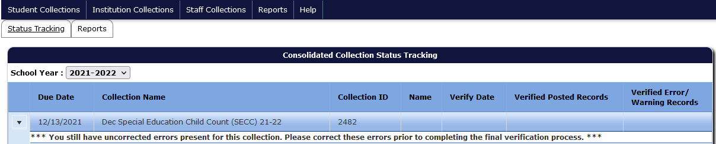
Similarly, if all audits have not been cleared, the below message will appear. See Correcting Audits in Consolidated Collections before continuing.
Each collection has different verification reports. Each report displays aggregated data in tables.
- December Special Education Child Count (SECC):
  - Federal Placement
  - Primary Disability
  - Race/Ethnicity
  - Agency Serving
  - Enrollment Type
- June Special Education Exit:
  - Age at Exit By Exit Reason
  - Disability Type by Exit Reason
  - Race/Ethnicity by Exit Reason
  - Leaver Verification (does not show any data)
- Special Ed Child Find (Indicator 11):
  - Initial Referrals
  - Initial Referrals By Race/Ethnicity
  - Initial Referrals By PHC
  - Range of Days Over the 60 day Timeline by Reason Timeline Not Met
  - Initial Referrals By Grade

After clicking on the black expand arrow next to the collection, users will see the following screen. Clicking the checkboxes next to each verification report displays the data tables to be reviewed and verified by the user. The red “X” in the Current Status column indicates the report has not been verified. Review each verification report to ensure the count of records is correct.
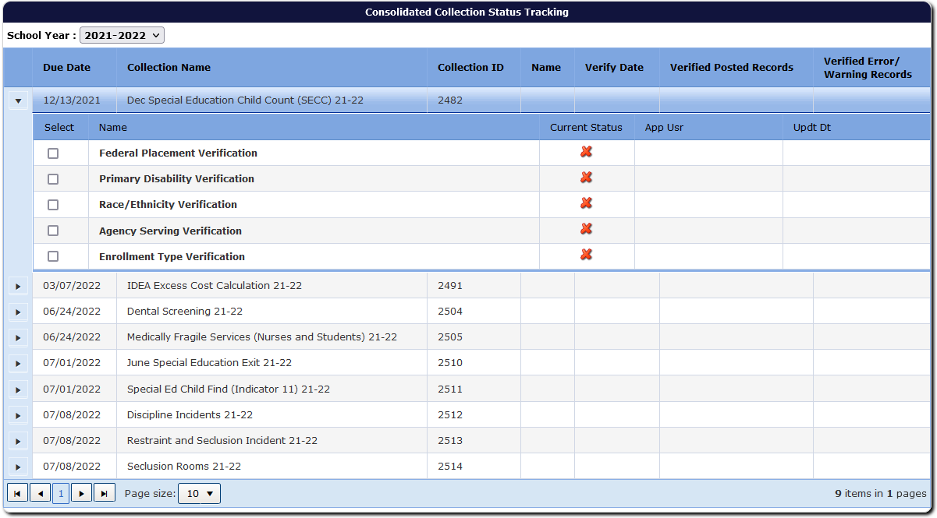
After selecting the checkbox, the screen will display the aggregated data with options for approving the report and exporting the data to Excel. Next, click the Approve Report button. Users verify each report one at a time.
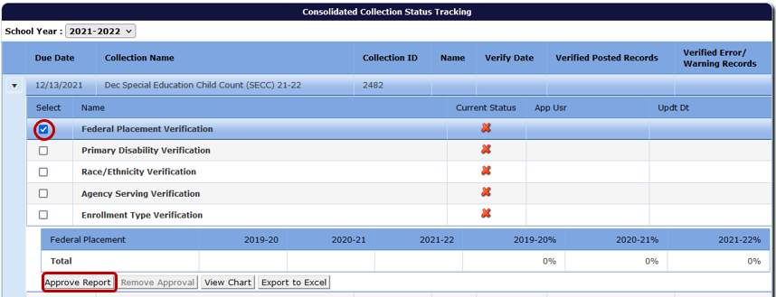
Once the user clicks approves the report, the approved report’s status changes from the red “X” to a green checkmark and gives users the option of removing the approval. Removing the approval changes the green checkmark back to a red “X.”
As users verify, the system adds the user name and date of verification in the row for each report. The system also displays the user name and date in the row for the collection name, but there is a delay and it may display after the second report. Warning: system will display name and time in the collection name row, even when not all reports are verified.
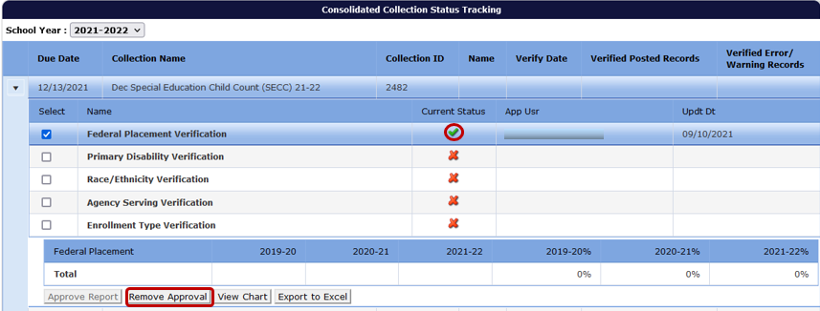
Continue through the list of reports until all Verification Reports are approved.
Once all reports are approved, the Final Submission Form button becomes available. When this button is clicked, the system generates a PDF file for submitting agencies (School District, ESD and EI/ECSE) to sign, date, and return to ODE.
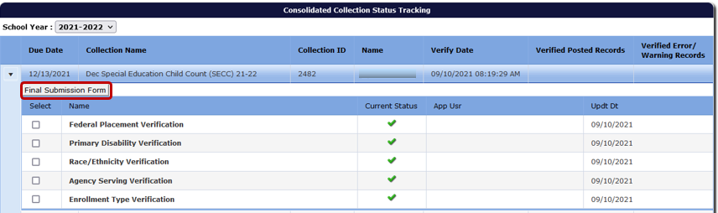
Print the form, have it signed and either email or mail it as indicated on the form. Please pay attention to when the Final Submission Form is due, and check that the agencies listed on the form are accurate and complete.
Once the Final Submission Form has been received by ODE, the collection is complete. Note, there is no Final Submission Form for Special Education Child Find. This is only applicable to December Special Education Child Count and June Special Education Exit.
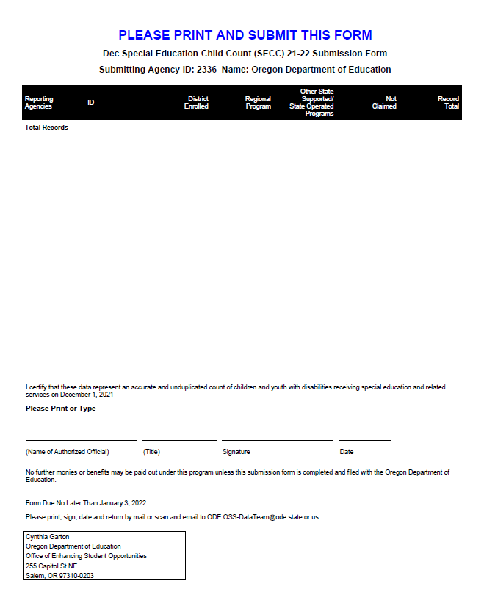
The submission process is not final until ODE receives the signed Final Submission Form. Agencies will be marked late if forms are not received by the end of the day of the due date. Email is preferred. Faxed forms will not be accepted.

Verifying Discipline Collections
Final steps is verifying the submission. ODE cannot consider the collection complete until the submitting district verifies it as complete. All districts (even districts with no student incidents or seclusion rooms during the school year) are required to complete the verification process on the Status Tracking tab.
From anywhere in the Consolidated Collections application, click the Status Tracking tab to go to the list of collections. Make sure the School Year dropdown displays the correct school year. This dropdown will automatically advance to the next school year on July 1. If the 2023-2024 Discipline Incidents collection closes on July 10 and is verified after June 30, 2023, when users arrive at the Status Tracking page, the dropdown will show 2023-2024 and all the collection names will end with “23-24.” The example below is for the 2021-2022 collection.
Click the black arrow next to the collection to be verified. This example uses Discipline Incidents. The process is the same for Restraint and Seclusion Incidents and Seclusion Rooms.
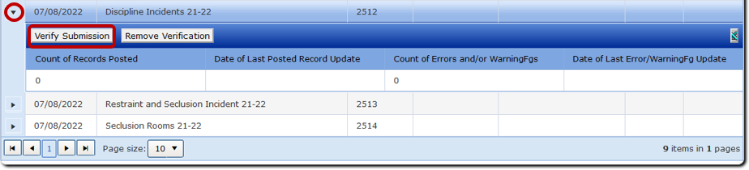
Under the Verify Submission button is a table grid with count of records posted, date of last update, count of errors and warnings, and date of last error/warning update. Review the grid to ensure accuracy and that the data is error free.
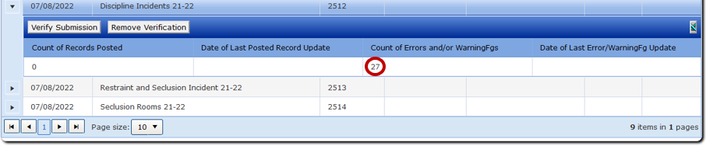
When the Verify Submission button is clicked, a popup message will appear indicating that the submission has been verified. The following will display in the columns to the right of the collection ID: the staff name and date of verification, as well as the number of records that posted and if there are any errors.
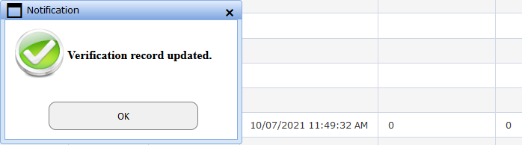
When these final steps have been completed, districts attest that they submitted accurate and complete data and that submission is considered complete.

Verifying Zero Records
If a district has zero incidents to report for Discipline and/or Restraint and Seclusion, or has zero rooms to report for Seclusion Rooms, then users will click the Verify Submission button. Districts with zero incidents and/or rooms do not need to submit data, as clicking the Verify Submission button with zero posted records indicates to ODE that there were zero incidents and/or rooms.

Correcting Audits in Consolidated Collections
The Review Window for each collection is an opportunity for users to clean up their data without penalty. The respective Review Windows are as follows:
- December Child Count – Mid Winter (January/February)
- Child Find and June Exit – Late Summer (August/September)
- Discipline Incidents, Restraint/Seclusion Incidents and Seclusion Rooms – Late Summer (August/September)
During the Review Window, users can add records, delete records, or make revisions to records. In addition, ODE screens data for potential issues and errors, and provides audit messages, or comments, to help with data clean up. Users have about four weeks for data clean up, including reviewing and addressing ODE audits.
To review and address audits during the Review Window, login to the District site (see the instructions under Login Information). Once logged in, the navigation process is similar to Submitting Data to ODE.
For this example, screenshots show December Special Education Child Count. The process is the same for June Special Education Exit, Special Education Child Find, Discipline Incidents, and Restraint and Seclusion Incidents. There are no audits for Seclusion Rooms, as Institution Collections are not set up to have audits. If ODE has a question for an Institution Collection, you will receive an email or phone call.
To view and correct audits, hover your mouse over Student Collections in the top menu bar.
A drop menu will appear, containing a list of open collections. To review audits, hover over the collection name. In this case, Dec Special Education Child Count (SECC) 21-22. A fly out will appear with a three options. Hover over Error Management to access the next fly out menu.
The final fly out menu will have seven options. Here users will click Review Audits.
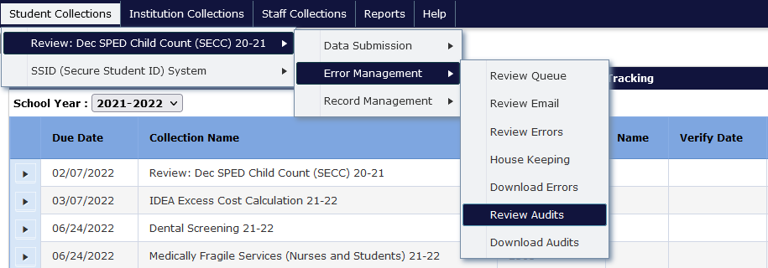
The Audit Screen shows a list of audits by type, the count of each type, and an audit description. The Audit Count is the number of records that have that respective audit type. Audit Type indicates the type of potential error. Audit Description provides a broad description of the audit. A student’s record may have multiple audits and appear under more than one audit type.
To access the audits, click on the expand triangle button to see the audit details.
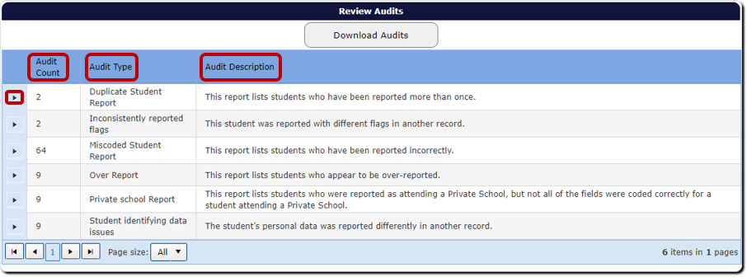
In audit details, the Comment is a message from the Data Team, indicating why the record is flagged as an error or warning. If the record needs a correction, click on the green checkmark under the Fix column. This will allow users to review the record.
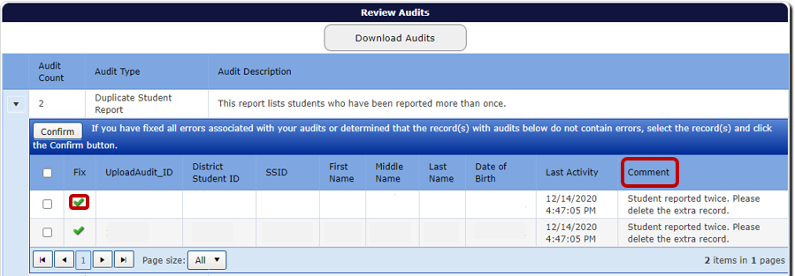
Once corrected, click the Save and Confirm button. This will save the corrections, and the system will remove the record from the audit list. The Last Activity column will reflect the date and time the last change was made.
The Cancel button will undo any changes made to the record. The Return to Search takes the user back to the audit list, with the respective Audit Type expanded.
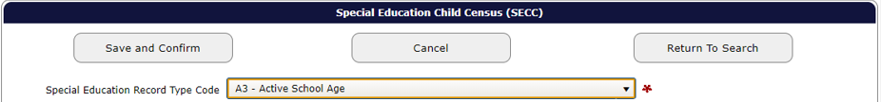
If the record is correct, users can confirm the record by clicking the Save and Confirm button while in the record. If on the Audit List page, users can click on the box for the record, to the left of the Fix column, and then click the Confirm button. Users should not confirm any record(s) until they are sure it is not an error. When users Confirm a record, it disappears from the audit report permanently.
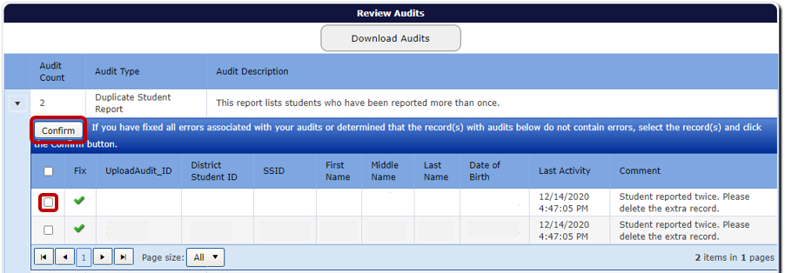

Users can also confirm all audits for the Audit Type, by clicking on the Select All box next to the Fix column, and then clicking the Confirm button. Do not Save and Confirm any records until you are sure there are no errors. When records are confirmed, they will disappear from the audit report.
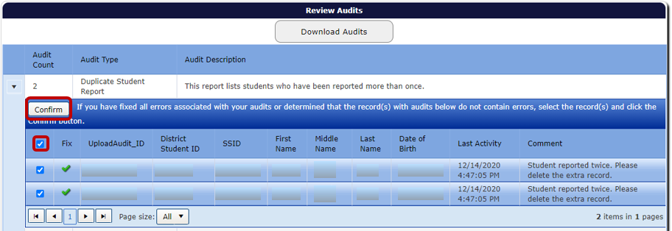
If the audit comment is unclear or the user is unsure how to resolve it, please contact a member of the Data Team for assistance. It is best not to confirm an audit if the user is unsure what it is. If the audit is regarding an error, this could lead to being flagged for inaccurate data in SPR&I.
After clearing all audits, users will go to the Status Tracking page to verify the reports. See Verifying Submissions in Consolidated Collections.

View Charts and Export Data
When reviewing and approving the verification reports, users can view each report as a chart, by clicking on the View Chart button.
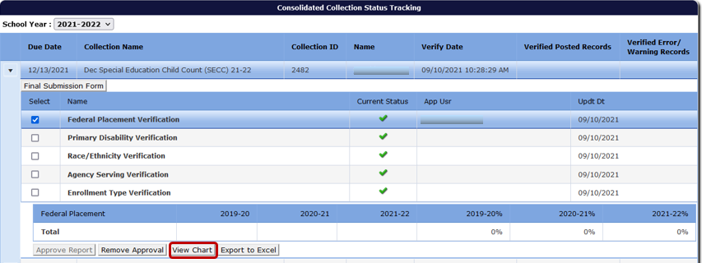
When this link is clicked, the system will generate a bar graph that can be downloaded as a PDF.
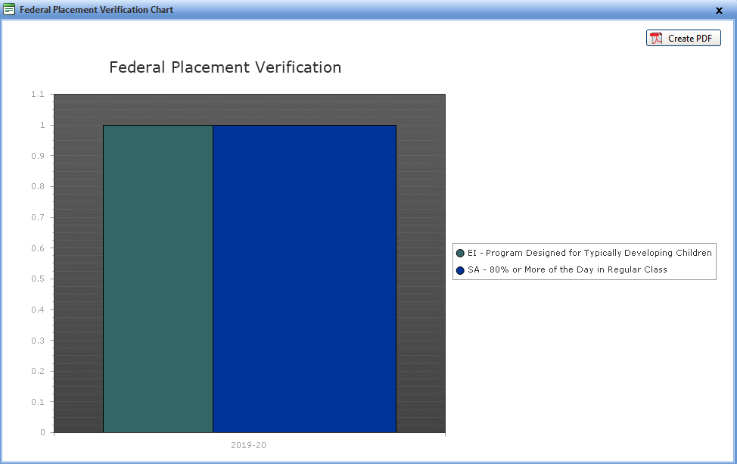
Users can download each report as an Excel Spreadsheet, by clicking on the Export to Excel button.
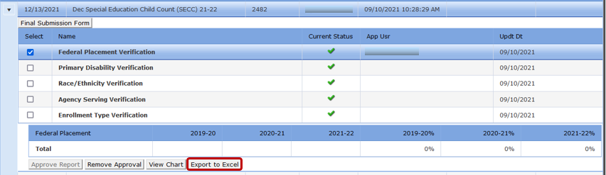
The system will generate a dialog box to either save or open the file.

Production Download Reports
A Production Download Report is a report of all data submitted to Consolidated Collections for a given collection. It is located in the Reports tab, which contains a list of various reports that can be download for collections assigned to the user. The list includes Production Download Report, Regional Report and OSD Report.
These steps will use December Special Education Child Count, downloading the Production Download Report. The steps are the same for June Special Education Exit, Special Education Child Find, Discipline Incidents, Restraint and Seclusion Incidents, and Seclusion Rooms. Steps are also the same for the other report types in the list.
Select Reports tab, located next to Status Tracking tab.
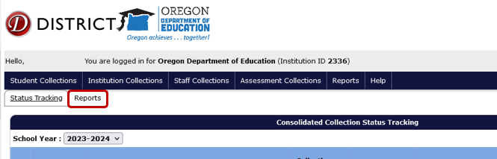
From the Collection menu, select Special Education Child Census (SECC).
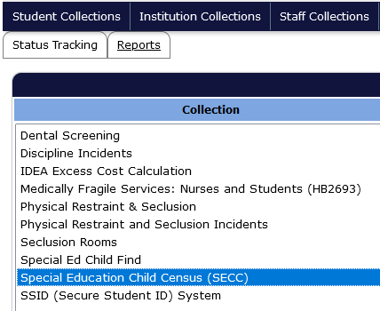
In the Report Year menu that appears below or to the right, select the DecSECC Report from the collection year needed.
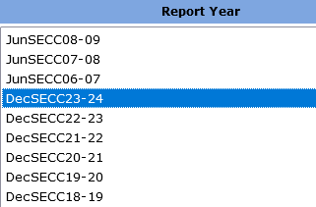
In the Report menu that appears below or to right, select Production Download Report.
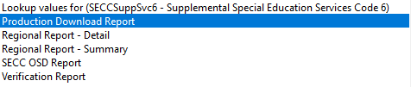
A new tab will open notifying which report was selected, and identifying the collection and year requested.
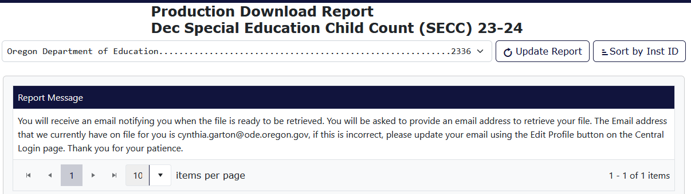

Consolidated Collections will send the user an email, using the email address associated with the users login/account. Click the link in this email.
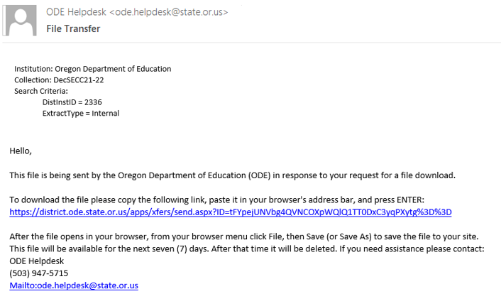
The link will take users to a Secure File Transfer page on the ODE District website. Enter the user’s email address, the same address the email was sent to, and click the Submit Email Address button. On this webpage, the user’s email address is used as a password to access the Production Download Report.
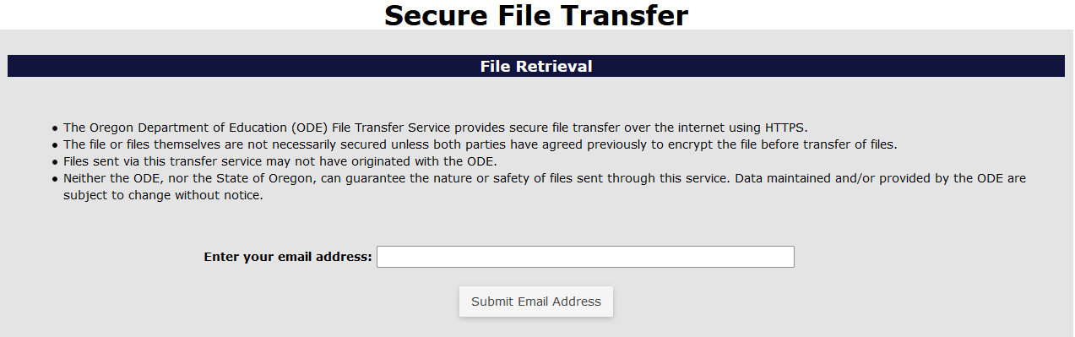
After the Submit Email Address button is clicked, the page will generate a Download button. Click the Download button to download the zip file of the Production Download Report.
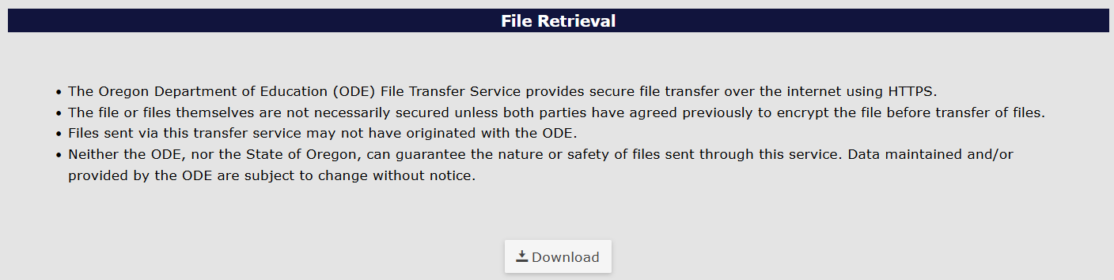
The system will generate a download box in the top right of the bowser. Users can click on the file name or the folder icon. Clicking the file name will open a zip folder containing a CSV workbook. Clicking the folder icon will open the Downloads folder where the file has been saved.
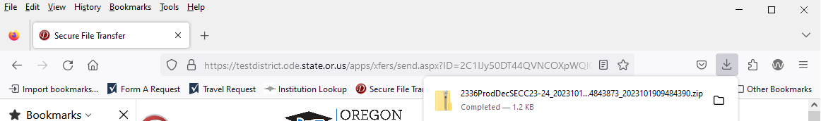

Help

Getting Access to Applications on the District Website
When requesting access to one of the District Applications, contact your district’s Security Administrator.
If you do not know who your District Security Administrator is, go to the District Home page, and on the center right-hand side beneath FAQ, click District Security Administrator (DSA) Lookup.
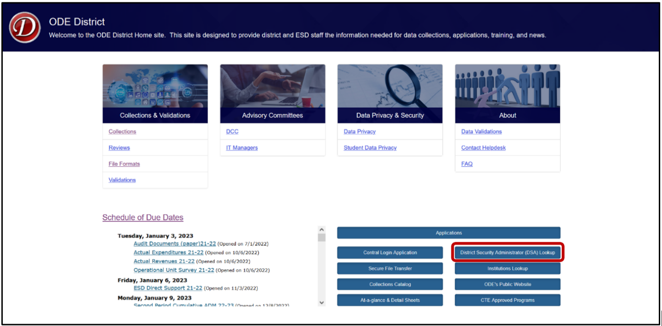
On the Search for Security Administrator page, enter an institution ID or District Name, then click the Search button.
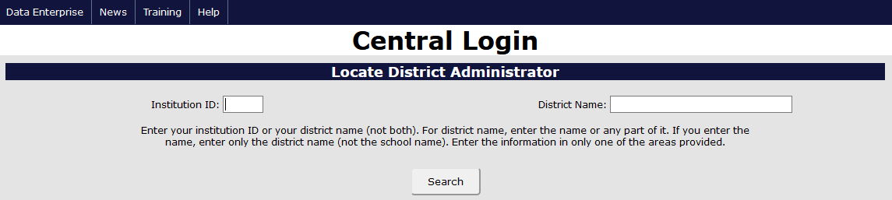
When requesting access to applications such as Consolidated Collections or the IDEA Data Manager, data submitters must request Primary Submitter rights and Modify rights. Users should verify with their District Security Administrator that they have both permissions. Without both, users will not have the ability to view, submit, edit and verify data.

Secure File Transfer
To send personally identifiable information to ODE staff, use Secure File Transfer. Go to the District Home page, and in the center right-hand side beneath Applications, select Secure File Transfer.
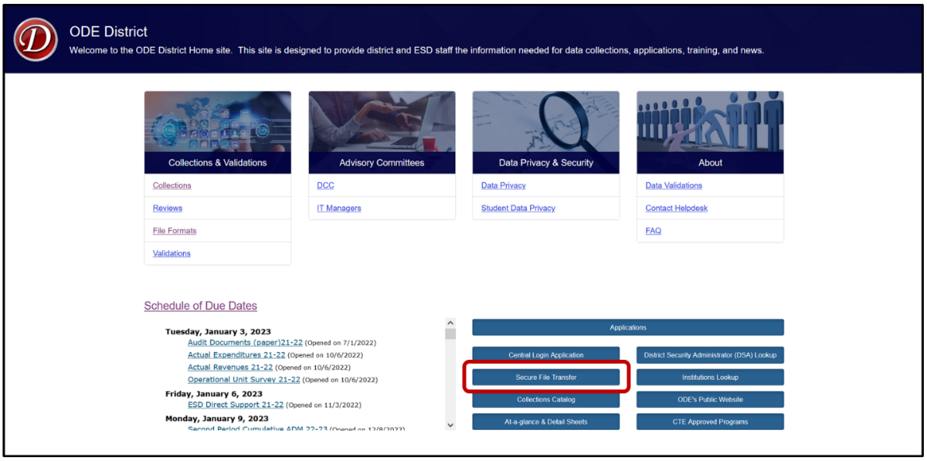
Secure File Transfer is behind a secure log in. Clicking the link will take users to the login screen.
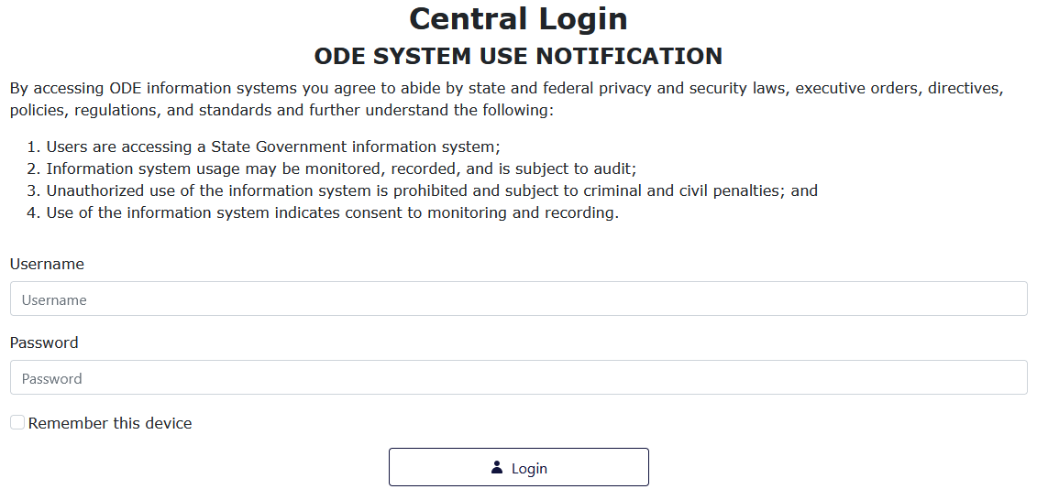
After signing in, users will be taken to their Applications List. Select Secure File Transfer.
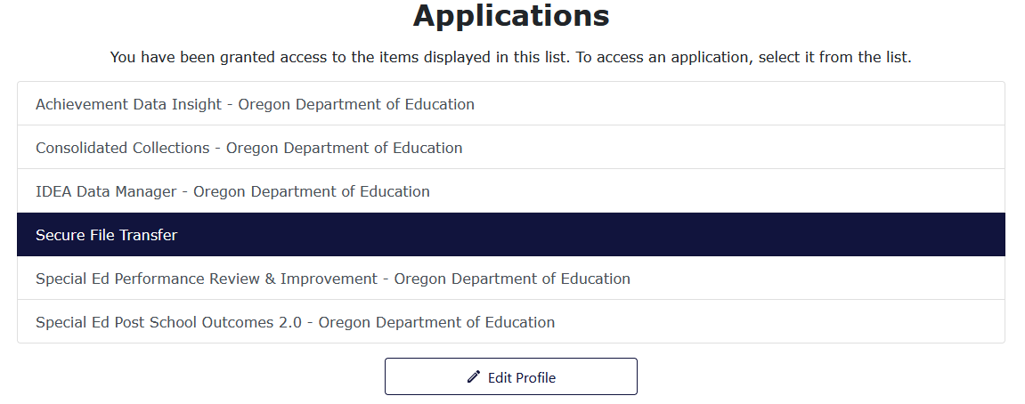
On the Secure File Transfer page, type the recipient’s email address. Click the To button to search the list of recipients. To select an email to add to the recipient list, click on the name or email address, then click Add Email.
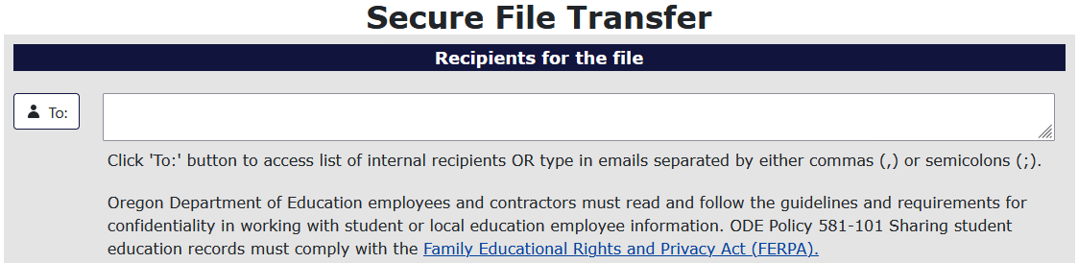To add the file to be sent, select the Select File button.
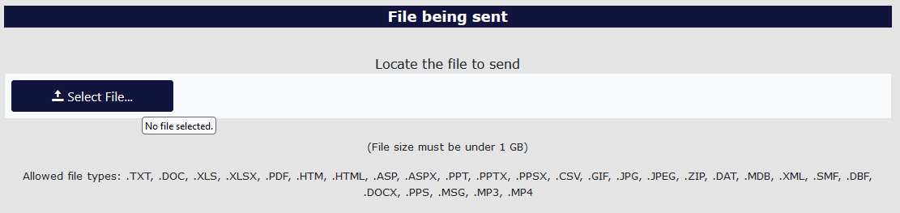
Find the desired file and select it. To select the file there are two methods. For the first method, users select the desired file, and then select the Open button in the window. For the second method, users double click the desired file.
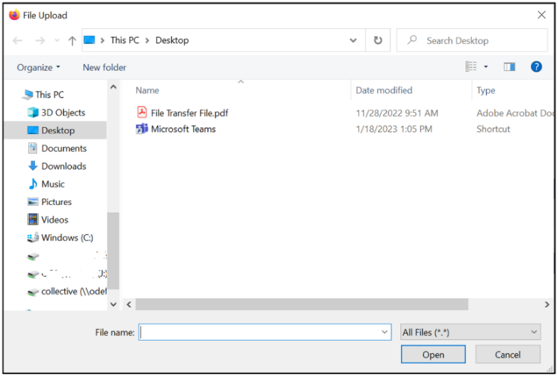
Users can type a message at the bottom of the page to add context and or anything else necessary for the recipients to know. This section is best thought of as the body of an email.
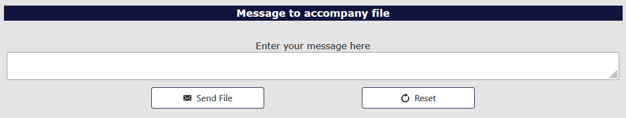
Finally, to send the file, select the Send File button.
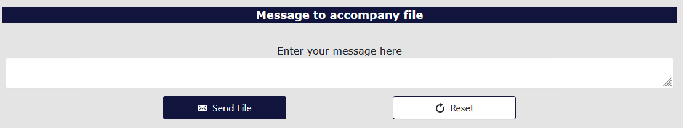
The recipient will receive an email with a web link. This link will take the recipient to a Secure File Transfer page on the ODE District website. They will enter their email address, the same address the user selected, and click the Submit Email Address button. The page will generate a Download button for the recipient to click, which downloads a zip file of the document the user sent.
If the recipient does not have a Central Login account, use the Link to external users section at the bottom of the screen.
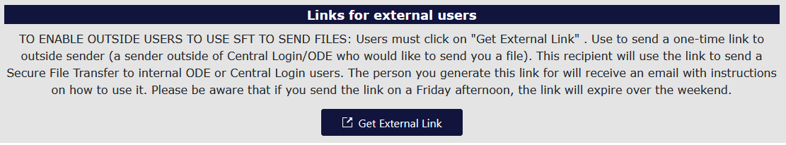
The system will generate a popup for users to enter the external repent email and message. Click the Generate External Link to send the secure file.
