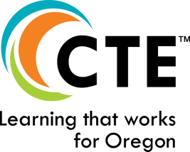
CTE Student Leadership Organizations
Criteria for Student Leadership/CTSOs
(Part of the Student Support Services for an
Oregon Approved CTE POS)

October 2021

Student leadership opportunities are an integral piece of the secondary component of Career Technical Education Programs of Study. A student leadership structure within a CTE Program of Study provides leadership development opportunities that meet the following expectations:

Instruction, Career Development, and Assessment
  - Integrates Career and Technical Education curriculum, academics, and career connected learning with leadership development activities and provides documented evidence of that integration.
  - Engages students in personalized/flexible learning that extends individual student interests beyond the traditional classroom, and goes beyond a single event, and may include opportunities for entrepreneurship.
  - Uses student leadership activities as capstone learning/assessment experiences.
  - Provides opportunities for students to network with other students having similar career interests beyond their local school site.
  - Provides a student reward and incentive system to recognize and document student achievement related to career connected learning projects and experiences, academic proficiency, and technical skill proficiency.
  - Provides the context and multiple opportunities for students to address the personal learning requirements of Oregon’s diploma:
    - Education Plan and Profile
    - Personalized/Flexible Learning
    - Essential Employability Skills

Community-Based
  - Provides opportunity for and documentation of active community and business partnerships.
  - Demonstrates activities related to community involvement including service learning, mentoring, internships, and other career connected learning opportunities related to the context of the leadership opportunity.

Organizational Administration/Management
  - Engages students in the process of planning, designing, conducting and evaluating the success of career connected learning activities.
  - Operates with a planned program of work for the school year.
  - Advised and managed by an appropriately licensed professional technical education teacher.
  - Uses a school or organization supervised accounting system for student funds.
  - Maintains records of student participation that may be accessed by the state.

* CTSO Charters are to be held by the Oregon Department of Education

