INTRODUCTION

One of the most significant changes in the Strengthening Career and Technical Education (CTE) for the 21st Century Act (Perkins V) is the requirement for local applicants to conduct a Comprehensive Local Needs Assessment (CLNA) and update it at least every two years. The next CLNA results, for all Perkins grant recipients, will be reported with the 2025-26 Perkins Basic/Reserve Grant Applications.

The CLNA is designed as the foundation of Perkins V implementation. At the local level, it drives the local application development and future spending decisions. It should be seen as a chance to take an in-depth look at your entire local and regional CTE system and identify areas where targeted improvements can lead to increased opportunities for student success. The CLNA, if implemented thoughtfully, can also be a powerful opportunity to engage partners in a common understanding and vision for the future of CTE in your community.

The Oregon CTE State Plan requires a strong tie between local and regional needs and the allocation of funds, based on data and community partner’s input. CTE/Perkins grant funds require a process to identify priorities and needs in partnership with a range of collaborative partners.

The goals of the CLNA include:
- Regularly engage in conversation with collaborators around the quality, impact, alignment, and equity of CTE Programs
- Set strategic goals and priorities to ensure equity, systematic improvement, and innovation
- Support CTE Programs and opportunities that ensure participation and success for Oregonians that lead to high-wage, high-skill, and in-demand occupations
- Ensure CTE Programs of Study are aligned to local, regional, and statewide workforce needs and economic priorities
- Coordinate and align work of K-12, higher education, workforce and economic development, and community groups serving our focal students.
- Align local and regional priorities

This guide is intended to give Perkins V applicants a framework from which to structure their approach to the CLNA efforts by translating the legal language into action steps. As with all improvement efforts, strengths and needs must be constantly assessed. The needs assessment submitted for Perkins V application purposes will be a snapshot in time of the ever-changing landscape of each institution.

This guide is divided into the following sections:
- Introduction
- Getting Started
  - Identify a leadership team
  - Identify required collaborators
  - Plan for ongoing consultation
- Process, Response, and Resources
- Appendix A: Completing the CLNA

GETTING STARTED

To gain a robust assessment of the current status of CTE in Oregon’s community colleges, each institution, whether a direct Perkins recipient or consortium member, is required to conduct the CLNA. Direct Perkins recipients will use the information to inform the Strategic Plan, two-year application, and two-year budget. Perkins consortium members will take the information gained through the CLNA to the CTE Regional Coordinator and consortium leadership and use that information to develop regional outcomes, strategies, activities, and expenditures for the Regional Strategic Plan, two-year application, and two-year budget.
Under Perkins V, the CLNA requires consultation with a variety of collaborators throughout the initial needs assessment process and then in an ongoing fashion. This is an expansion of what was required for Perkins IV regarding partner involvement in the local application. The following steps will help lay the groundwork for a rigorous and meaningful needs assessment through clear preparation and organization.

Identify a Leadership Team

Consultation with a diverse body of collaborative partners is required for the CLNA. As you review the list of minimum required participants, it will be important to assemble a leadership team to help guide the work and set and maintain priorities. The team should be small and include people who can leverage systems to assist in the task ahead. Leadership team participants may include but are not limited to, secondary and postsecondary administrators and educators, local workforce agency staff, local economic development board members, parents, and students as appropriate for your size and location.

One person should serve as the project manager by coordinating meeting times, ensuring deadlines are met, and making sure the work continues to move forward.

Identify Required Collaborative Partners

Perkins V requires, at a minimum, the following participants be engaged in the needs assessment and the local application development, and ongoing engagement:
- CTE instructors, advisors, and administrators from secondary and postsecondary institutions
- State or local workforce development board representatives and staff
- Representatives from Native American tribes or tribal organizations
- Representatives from a range of local businesses and industries, particularly those representing the area labor market needs
- Students and parents (use multiple avenues such as existing meetings, surveys, focus groups)
- Representatives of focal student groups, including students of color, students with disabilities, emerging bilingual students, students navigating poverty, homelessness, and foster care, and other students who have historically experienced disparities in our schools (non-traditional by gender, single parents, pregnant individuals, out of workforce individuals, members of the armed forces), migrant students, immigrants, refugees, incarcerated and detained youth, and LGBTQ2SIA+
- Representatives from agencies serving at-risk, homeless, and out-of-school youth and adults, foster youth, military families, disability services, STEM Hubs, and Regional Educator Networks

Awareness of Regional Engagement
Aligning for Student Success, an ODE K-12 initiative, includes CTE/Perkins with other K-12 grants and funding in a statewide effort to streamline processes for local and regional communities. Each school district is required to work with their collaborative partners to discuss questions at the K-12 level that are similar to those in the CLNA. To support these efforts, every Education Service District (ESD) has a liaison charged with coordinating collaboration across the different initiatives. The regional ESD Liaison is valuable in streamlining community engagement efforts and the CTE Regional Coordinators are valuable in coordinating resource development.
Approach engagement in a broad fashion. There are resources to help engage the required partners, and there is ongoing work within schools, districts, colleges, and regions that can be leveraged.

Avoid Duplication

If the college has recently completed another self-assessment, use the information gained through that process in the CLNA. Other assessments that may provide useful information include the Alliance for Quality Career Pathway Local/Regional Partnership Self-Assessment, a recent NWCCU Accreditation self-assessment, the Guided Pathways adoption template, and the Performance Measures Certification for WorkSource Oregon. Be sure, however, to address all of the questions listed in the following pages to meet the CLNA requirements for the Perkins grant recipients.

Requirement for Ongoing Consultation

The CLNA is not intended to be a single process but should be part of a continuous improvement process. Perkins V requires recipients to continue to consult with the collaborative partners on an ongoing basis. The consultation provides input into the annual update to the needs assessment and grant application, as well as the continuous improvement and relevance of the CTE Programs of Study.

PROCESS, RESPONSE, AND RESOURCES

The CLNA has five required parts:
- Evaluation of student performance
- Evaluation of CTE Program quality and alignment to industry need
- Description of recruitment and retention of staff
- Description of career exploration and guidance
- Description of progress on access to high-quality CTE Programs for all students

Many of these parts are interwoven and it is important to remember that insights gained in one part may help address another part. Use of the following pages is not required for CLNA; however, the information requested will be used in the college’s Strategic Plan, two-year application, and two-year budget.

Identifying Need, Setting Priorities, and Identifying Action Steps:

As needs are identified and priorities are set, think about strategies to address these priorities. Identify appropriate goals for the Perkins Basic and Reserve Grant, and where there may be opportunities to braid funding with other initiatives.
Consortia members will take the results of the CLNA to regional meetings to assist in setting the regional Basic and Reserve Grant priorities.

The CLNA is a federal requirement for Perkins funds; any records should be retained for five years.

Application Preview:
When the CLNA is complete, the following information is representative of what will be included in the Strategic Plan and two-year application regarding your needs assessment process:

Needs Assessment Summary
(500 WORDS OR LESS total)
- Offer a description of the process used to synthesize the information gained through your engagement and comprehensive local needs assessment process. Discuss any issues or barriers uncovered in the process of synthesizing the information.
- What strengths do you see in your institution’s CTE Programs of Study in terms of program quality, equity, and student access?
- What needs were identified in your institution’s CTE Programs of Study in terms of program quality, equity, and student access?

Evidence of Engagement
(250 WORDS OR LESS for each bullet)
Upload assurances that all members were engaged.
- If the goal is meaningful, and authentic and includes ongoing community engagement, where is your institution in that process? What barriers, if any, were experienced and how might you anticipate and resolve those issues in future engagement efforts?
- Perkins-eligible CTE Programs of Study require strong collaboration with high school programs in your region. Describe how high school instructors, administrators, counselors, and the CTE Regional Coordinator were engaged in your process.

You will be asked to upload your top three artifacts of engagement showing evidence of engaging with the required partners to develop this application.
- Why did you select these particular artifacts to upload with your application? How do they show evidence of engaging focal student populations, their families, and the community? How do they show evidence of engaging other required partners?

Affirmation of Tribal Consultation
- If you are required to conduct a formal consultation, upload the assurance document and describe how this requirement was met and any outcomes of the process as it relates to CTE.

APPENDIX A – Completing the CLNA

Engagement of focal student groups (throughout the CLNA, the term “focal students” will be used to replace the Federal Perkins V (CTE) term, “special populations”) presents a unique opportunity and vital resource for collecting high impact community data to inform the practices that impact those same populations. Students from focal populations and their families must be engaged in planning and there must be demonstrated evidence and artifacts in the application for how engagement strategies/activities impacted chosen outcomes, priorities, strategies, and activities.

Focal student groups are defined as:
- students of color
- students with disabilities
- emerging bilingual students
- students navigating poverty, homelessness, and foster care
- migrant students
- recent arrivers
- incarcerated and detained students
- LGBTQ2SIA+ students
- other students who have historically experienced disparities in our schools, such as students exploring non-traditional fields by gender, single parents and pregnant individuals, out-of-workforce individuals, and individuals who are members of the armed forces.

Information gleaned from focal student groups brings depth, humanity, and reality to laws and rules, and to how and why programs are designed.

Timeline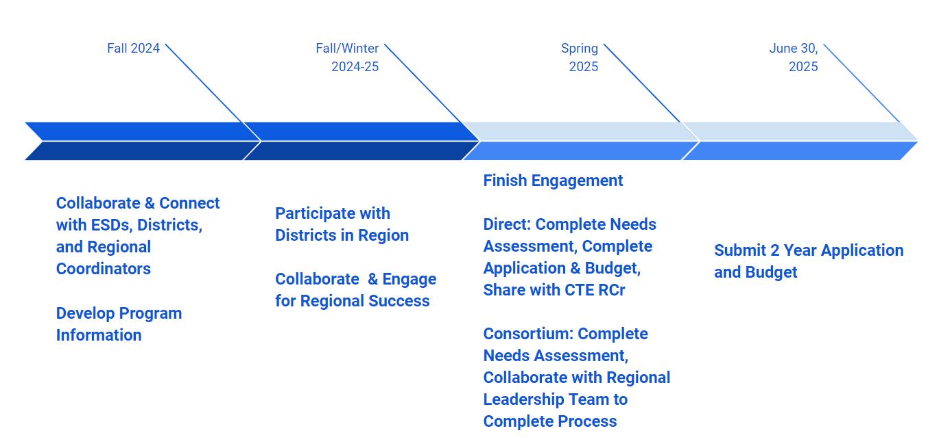

Instructions for completing Parts 1-5:
Gather the resources and collaborative partners in the table below. In addition, parts 1-5 of this planning guide may identify more resources/partners to consult.
Information for Parts 1-5 | Collaborative Partners
For all sections, collect and use the best data available.  Perkins performance data for the past three years, disaggregated by CTE program area and focal student groups, including:  - students of color  - students with disabilities  - emerging bilingual students  - students navigating poverty, homelessness, and foster care  - migrant students  - recent arrivers  - incarcerated and detained students,  - LGBTQ2SIA+ students  - other students who have historically experienced disparities in our schools, such as students exploring non-traditional fields by gender, single parents and pregnant individuals, out of workforce individuals, and individuals who are members of the armed forces. CTE Participation Explorer (https://public.tableau.com/app/profile/amy.arneson/viz/CTEParticipationExplorer/AnnualParticipation) | All collaborative partners required by law:  - Administrators  - Secondary teachers  - Postsecondary faculty  - Academic/ career advisers  - Tribal representatives  - Students from focal populations  - Students and their families  - Data staff  - Navigators

Process and resources for identifying needs, identifying action steps, rating program strengths and weaknesses, and setting priorities:

Strengths and Needs
- Identifying Strengths and Needs
- Use the information in the table above to identify programmatic strengths and needs
- Identifying Causes
- NAPE Root Cause Analysis: provides a description of the process for finding a root cause
- 5 Whys Guide and Template to identify root causes
- Setting Priorities and Goals
- What strategies may be employed to reduce inequities?
- What do community partners say are potential solutions to the need?
- What would be achievable goals to close seen in these data?
- Rating the program – which statement best describes each section?
- Significant gaps and/or multiple gaps exist
- Some gaps exist and/or we do not have a concrete plan to address them
- Very few gaps exist, and we have a plan in place to close the remaining gaps
- No gaps exist
- Establish priorities – what needs to be done first? What’s essential?
- Critical
- High priority
- Medium priority
- Low priority

Artifacts of good community engagement
The Community Engagement Toolkit provides several Oregon specific examples of what good community engagement looks like, sounds like, and feels like in practice. Good engagement may include some discomfort or disequilibrium for school, college, or district leaders as they stretch into new roles and processes. In submitting integrated guidance and direct recipient plans, applicants are required to demonstrate evidence from community engagement efforts, including key artifacts that indicate connections between these efforts and the plans that were created. Suggestions of good artifacts or evidence include:
- Artifacts that indicate the content of the engagement effort. For example, a sign-up sheet only indicates who attended an event, while meeting minutes indicates what was shared and discussed during that event.
- Artifacts that were created by partners beyond the applicant team, including being created by students, families, employers, and communities themselves. For example, if the engagement event is a gallery walk, artifacts from this could be the posters the community creates for each other to examine key issues.
- Artifacts that provide a realistic sense of the level of community engagement that exists - artifacts that are truthful in where the community engagement efforts exist along the community engagement spectrum and do not suggest a higher level than what is happening.
- Artifacts that create clear connections between your engagement efforts and the ways they informed your integrated guidance and advising plans.
- Artifacts that provide evidence of strengths-based, trauma-informed, equity-centered practices. For example, make certain that engagement spaces and processes are safe and inclusive, provide adequate nutrition, childcare, and translation/ASL services, and that meetings are held when a majority of employers, students, and families can attend.

Additionally, consider the following while collecting these artifacts of engagement:
- Always ask for consent that includes the purposes by which you are creating an artifact of the engagement (e.g., if you are taking pictures, share how you will use them and offer to share them for the community to also own). Communities should not be tokenized for their value or extracted from because they are required to be engaged.

Rubric for Parts 1-5 self-evaluation:
1 – Does Not Meet - revision required | 2 – Minimally Meets – some revision required | 3 – Meets Requirement | 4 – Exceeds Requirement
The response is deficient in one or more of these issues:  - The response doesn’t address how or why this requirement was attempted or met  - The response is off topic  - The response is incomplete or missing | The response provides a partial response but needs elaboration, such as:  - More detail is needed  - The response is tangential to the topic  - Elements are incomplete or missing | The response provides a thorough evaluation of the entire question | The response exceeds the requirements of the question in:  - Understanding of the issues  - Analysis of underlying issues  - Innovative solutions  - Vision or scope of the response

Part 1: Evaluation of Student Performance

The Comprehensive Local Needs Assessment (CLNA) must include an evaluation of student performance, including focal student groups. The CLNA must contain an evaluation of CTE concentrators’ performance on each of the core performance indicators.

Section 134(c)(2)(A) states that the CLNA must include:
An evaluation of the performance of the students served with respect to State determined and local levels of performance, including an evaluation for special populations (focal student groups) and each subgroup described in section 1111 of the ESEA.

Additional data needed for Part A
- Postsecondary comparative data for credential attainment and placement by department or POS
- Strategies used to address performance gaps for specific student groups along with outcomes for the strategies attempted
- CTE Participation Explorer (https://public.tableau.com/app/profile/amy.arneson/viz/CTEParticipationExplorer/AnnualParticipation)
- Traffic Light Reports

Evaluation of Student Performance
Questions
- How are students in each CTE Program performing on federal accountability indicators compared to non-CTE students?
- How are students from focal populations and students from different genders, races, and ethnicities performing in each CTE Program?
- Where do the biggest performance gaps exist between groups of students? Why might these gaps exist?
- Which CTE Programs overall have the highest outcomes, and which have the lowest? What are the potential barriers to outcomes that the school/institution could change?
- Are there certain CTE Programs where students from focal populations are performing above average? Below average?
- Is there a trend across all CTE Programs?
- What prerequisites exist that may create barriers to enrollment in the CTE Program?

Information to build Perkins grant application responses
Once the analysis and priority setting with collaborative partners is complete, each applicant will be required to share the results of the needs assessment as part of the Perkins Strategic Plan and Local Application process. This information will be used in the Perkins Grant Application.

For each question: | Response
Statement of Strength(s) and Need(s)
Who was consulted in this discussion?

What artifacts of this consultation could be included in the application?

Discussion of process to identify this need. Include:

- A detailed discussion of the data examined in determining strength and need

- A detailed discussion of above average and below average students from focal populations and historically underserved students

- A discussion of potential root causes and strategies to address inequities in performance

For every bullet above:
- Evaluate where the program is now

- Determine the priority

Part 2: Evaluation and Implementation of High-Quality Programs

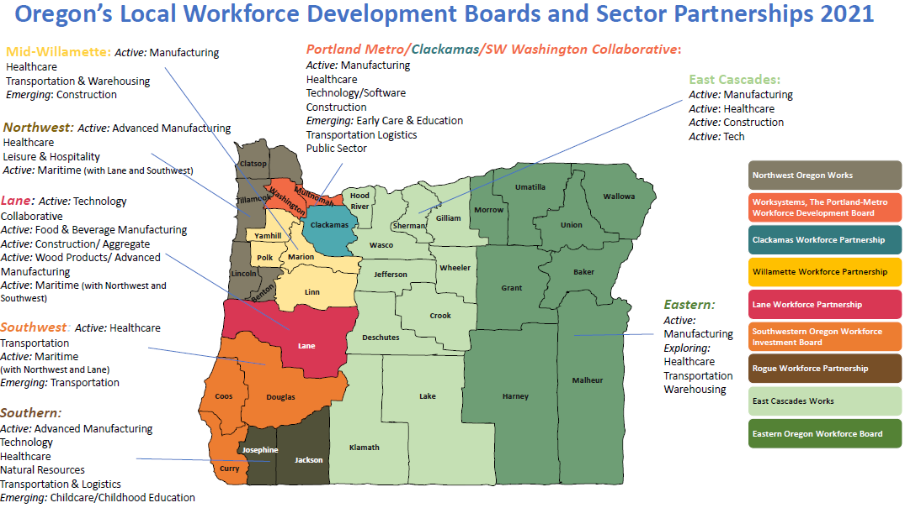
Perkins V focuses on aligning CTE programs of study to high wage, high skill, or in-demand occupations. In the CLNA, eligible recipients will provide an analysis of how CTE Programs are meeting workforce and economic development needs. The assessment will also look at how different resources are used to determine which CTE Programs of Study are made available for students.

The second part of the CLNA examines implementation of high quality CTE Programs. Participants will examine programs to describe how local CTE programs are:
- sufficient in size, scope, and quality to meet the needs of all students served
- aligned to State, regional, tribal, or local in-demand industry sectors identified by State and local workforce development board
- designed to meet local education or market needs not identified by the state boards or local workforce development boards.

Section 134(c)(2)(B)(i) states the CLNA must include:
A description of how career and technical programs offered are sufficient in size, scope, and quality to meet the needs of all students served.

Section 134(c)(2)(B)(ii) states the needs assessment must include:
A description of how career and technical education programs are aligned to State, regional, Tribal or local in-demand industry sectors or occupations identified by the State workforce development board or are designed to meet local education or economic needs not identified by the local workforce development boards.

Section 134(c)(2)(C) states the needs assessment must include:
An evaluation of progress toward the implementation of career and technical education programs and programs of study.
Continued on following page….

Sec 3(41): Program of Study
A coordinated, non-duplicative sequence of academic and technical content at the secondary and postsecondary level that:
- Incorporates challenging State academic standards;
- Addresses both academic and technical knowledge and skills, including employability skills;
- Progresses in specificity (beginning with all aspects of an industry or career cluster and leading to more occupation-specific instruction);
- Has multiple entry and exit points that incorporates credentialing; and
- Culminates in the attainment of a recognized postsecondary credential.

Questions
After assessing the programs using the High Quality Program of Study Rubric:
- What patterns emerge around which elements from the HQPOS Rubric are consistently scoring high or low? What patterns emerge around which departments/disciplines are consistently scoring high or low?
- What patterns emerge around which Career Areas are consistently scoring high or low?
- Throughout the Rubric there are elements addressing equity and access to High Quality Programs of Study – in which programs can you identify strengths and/or needs in equity and access?
- What patterns emerge around actual or perceived barriers that may keep students from accessing high-quality CTE Programs?
- How are the college’s Programs of Study meeting or not meeting labor market needs in the region?

Information to build Perkins grant application responses
Once the analysis and priority setting with partners is complete, each applicant will be required to share the results of the needs assessment as part of the Perkins Strategic Plan and Local Application process.
This information will be used in the Perkins Grant Application.

For each question: | Response
Statement of Strength(s) and Need(s)
Who was consulted in this discussion?

Are there artifacts of this consultation that may be included in the application?

Discussion of process to identify this need

Include:
- A discussion of the data examined in determining strength and need

- A discussion of the identified strength and need

- A discussion of potential (root) causes and strategies to improve program quality

For every bullet above:

- Evaluate where the program is now

- Determine the priority

Part 3: Recruitment, Retention, and Training of CTE Educators

The CLNA will assess the educator workforce needs in CTE programs. This is not just about instructors, but also includes instructional support personnel, paraprofessionals, and navigators, career guidance and advising professionals. An important part of this assessment asks participants to look at the diversity of faculty and staff and how closely they match the diversity of the education system in the local or regional community.

Section 134(c)(2)(D) states the CLNA must include:
A description of how the eligible recipient will improve recruitment, retention, and training of career and technical education teachers, faculty, specialized instructional support personnel, paraprofessionals, and career guidance and academic counselors, including individuals in groups underrepresented in such professions.

Additional information needed for Part 3
- Data on faculty, staff, administrators, and advisor preparation, credentials, salaries and benefits, and demographics
- Student demographic data
- Description of recruitment process
- Description of the retention process
- Description of professional development, mentoring, and externship opportunities
- Data on educator participation in professional development, mentoring, and externships
- Findings from educator evaluations or other resources about the impact of professional development, mentoring, and externships
- Survey/focus group results conducted with educators regarding needs and preferences
- Trend data on educator and staff shortages in terms of CTE discipline and demographics (past 5-10 years)
- Trend data on educator and staff retention in terms of CTE area and demographics (past 5-10 years)

Questions
- How diverse are faculty, staff, administrators, and advisers? Do they reflect the demographic makeup of the student body?
- How are new faculty, staff, administrators, and advisers recruited and hired?
- What onboarding processes are in place to bring new professionals into this system?
- Are these processes efficient and effective, especially for educators coming from industry?
- Are all educators teaching in CTE adequately credentialed?
- Is regular, substantive, and effective professional development available to CTE faculty based on need? Are administrators, staff, and advisers included?
- What has been the impact of mentoring and onboarding processes for new instructors, especially instructors coming from industry?
- What professional development offerings are most highly rated by staff? Does this differ when looking at factors such as length of time in position, certification, discipline, etc.?
- In what subject areas is there a need to recruit and hire more educators?

Information to build Perkins grant application responses
Once the analysis and priority setting with partners is complete, each applicant will be required to share the results of the CLNA as part of the Perkins Strategic Plan and Local Application process.
This information will be used in the Perkins Grant Application.

For each question: | Response
Statement of Strength(s) and Need(s)
Who was consulted in this discussion?

Are there artifacts of this consultation that may be included in the application?
Discussion of process to identify this need. Include:
- Evidence that faculty, staff, administrators, and advisers were included in data examination and determination of strength and need.

- A discussion of the data examined in determining need for educator recruitment, retention, and training

- A discussion of the need for educator recruitment

- A discussion of the need for educator retention

- A discussion of the need for educator training/onboarding

- A discussion of possible root causes and strategies to improve educator recruitment, retention, and training

For every bullet above:

- Evaluate where the program is now

- Determine the priority

Part 4: Career Guidance and Exploration

As stated in Perkins 134(b)(3), local eligible recipients must describe their organized system of Career Connected Learning that will allow students to fully engage in the domains of awareness, exploration, preparation, and education/training before and while participating in CTE.

Additional resources for Part 4
- Strategic Plan sections related to career awareness and exploration
- List of existing secondary and postsecondary CTE Related Student Leadership/Engagement and other opportunities
- Results of student interest interviews and focus groups
- Regional collaborative action plan around Career Awareness and Exploration
- Work-Based Learning and CTE related career learning and work experience data
- Regional data from local partners who provide Career Connected Learning opportunities and additional supports
- Data around transition services available to students leaving/entering homelessness, foster care, youth detention/corrections, and modified and extended diploma

Questions
- Are there transition services or programs available to students wishing to enter a career or pursue college opportunities?
- Do all CTE students take a career and college exploration course sometime during their educational experience?
- Do all students participate in career related learning experiences that are aligned to their goals?
- How well does the college provide equitable access to Career Connected Learning opportunities? How could the region have a broader range of CTE students participate?
- How well does the college support an organized system of career counseling and advising before and while participating in CTE?
- How well does the college provide training, information, and support to CTE educators, students, families, advisers, and administrators?
- How does the college collaborate to offer services through the regional One-Stop Center?
- What opportunities exist in the region to improve communication and information flow to create a more coherent and inclusive process?

Information to build Perkins grant application responses
Once the analysis and priority setting with partners is complete, each applicant will be required to share the results of the needs assessment as part of the Perkins Strategic Plan and Local Application process.
This information will be used in the Perkins Grant Application.

For each question: | Response
Statement of Strength(s) and Need(s)
Who was consulted in this discussion?
Are there artifacts of this consultation that may be included in the application?
Discussion of process to identify this need. Include:
- Evidence that faculty, staff, administrators, and advisers were included in data examination and determination of strengths and need

- A discussion of the data identifying need in Career Connected Learning for students

- A discussion of the Career Connected Learning opportunities available to students in CTE Programs of Study

- A discussion of Career Connected Learning resources, assets, and challenges

- A discussion of how work-based learning opportunities support transitions to career

- A discussion of possible root causes and strategies to improve Career Connected Learning opportunities.

For every discussion above:
- Evaluate where the program is now
- Determine the priority

Part 5: Progress toward Improving Equity and Access

Additional resources for Part 5
- Discussion notes, gap analysis, root cause, and priority information from prior parts of the needs assessment
- List of services and supports for students from focal populations
- Copies of complaints made regarding limited equitable access to CTE Programs
- Recruitment activities for students from focal populations
- Procedures/opportunities for work-based learning and CTE related CWE for students from focal populations

The Comprehensive Local Needs Assessment requires participants to assess progress toward providing equal access to all CTE programs. There should also be an examination of any barriers (real or perceived) that may prevent students from focal populations from entering and thriving in these programs.

Section 134(c)(2)(E) states the CLNA must include:
A description of progress toward implementation of equal access to high-quality career and technical education courses and programs of study for all students including:
- Strategies to overcome barriers that result in lower rates of access to, or performance gaps in, the courses and programs for students from focal populations.
- Providing programs that are designed to enable students from focal populations to meet the local levels of performance; and
- Providing activities to prepare students from focal populations for high-skill, high-wage, or in demand industry sectors or occupations in competitive, integrated settings that will lead to self-sufficiency.

The law identifies equity and access as a separate component of the CLNA, but student access and equity are embedded throughout Oregon’s CLNA. Review the discussions already held and make sure that equity is infused throughout, as reflected in the three bullets in the above passage.

Questions
Please consider each of the questions below through the lens of students from focal populations, race/ethnicity, and gender:
- Which population groups are underrepresented in your CTE programs overall?
- How effective have you been in recruiting diverse populations of learners into your programs?
- Which recruitment efforts have been most and least effective?
- What are the additional enrollment discrepancies related to high-wage, high-skill and in-demand occupations?
- What barriers currently exist that prevent certain populations of learners from accessing your programs?
- How effective are your current differentiated accommodations, modifications, and support services to ensure success of focal student groups?
- What accommodations, modifications, and supportive services would help ensure access and equity for all students within your programs?
- How well do you involve students in improving equitable practices in CTE Programs?

Information to build Perkins grant application responses
Once the analysis and priority setting with partners is complete, each applicant will be required to share the results of the needs assessment as part of the Perkins Strategic Plan and Local Application process.
This information will be used in the Perkins Grant Application.
For each question: | Response
Statement of Strength(s) and Need(s)
Who was consulted in this discussion?

Are there artifacts of this consultation that may be included in the application?
Discussion of process to identify this need. Include:
- A discussion of the data to determine the need to improve equal access to high quality programs

- A discussion of the need for student recruitment to improve equal access to high quality programs

- A discussion of the needs regarding barriers that may limit equal access to high quality programs

- A discussion of the need for accommodations and differentiation for students from focal populations and historically marginalized students to ensure access and success

- A discussion of potential (root) causes and possible solutions regarding student access to high quality CTE experiences

For every discussion above:

- Evaluate where the program is now
- Determine the priority

The term focal student groups replaces the term “special populations” from Perkins legislation. Focal students in Oregon include Students of color, students with disabilities, LGBTQ2SIA+ students, emerging bilingual students, students navigating poverty, homelessness, and foster care, migrant students, recent arrivers, incarcerated and detained youth/adults, non-traditional (by gender) students, single parents, pregnant students, out of workforce individuals, members of the Armed Forces.

