Oregon Perkins V Data and Accountability Workgroup Virtual Meeting Notes
August 5, 2019

Workgroup Objectives
- Prioritize data necessary to support Oregon’s CTE system, determining what is already available and what new data is needed.
- Review and provide input on draft definitions of CTE concentrator at the secondary and postsecondary level.
- Develop recommendations on the secondary program quality indicator.
- Review and provide input into draft definitions of numerators and denominators for secondary and postsecondary measures.
- Develop recommendations for secondary and postsecondary state determined levels of performance.
- Review and provide input into other Perkins accountability related requirements, such as required state plan elements.
- Develop recommendations for state activities around data technical assistance and guidance to local recipients, use of leadership funds, and data-driven decision-making.

Highlights from First Meeting
- Key strengths and challenges of CTE data identified
  - Significant challenge was connecting data across secondary, postsecondary and placement in workforce
- Discussion of secondary program quality indicator
  - Earning postsecondary credit got significant interest
  - It, along with WBL (top answer on survey), were pulled for deeper dive survey
- Brief preview of concentrator definition
  - Follow-up questionnaire on secondary concentrator definition

Secondary Program Quality Indicator
Secondary Program Quality Indicator
- Not less than one indicator of program quality:
  - Attainment of recognized postsecondary credentials
  - Attainment of postsecondary credit in the CTE program
  - Participation in work-based learning
- Additional, optional quality indicators:
  - Any other measure that is statewide, valid, and reliable, and comparable
  - This is where technical skills assessment would fit

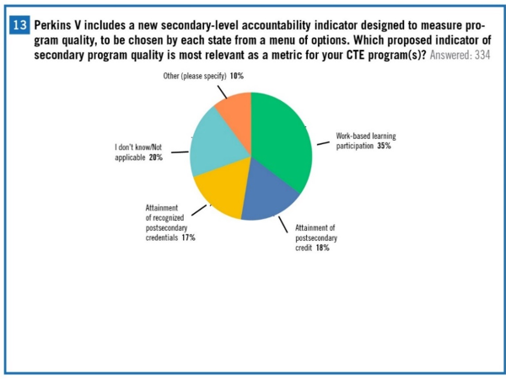

Oregon Secondary Program Quality Measure Survey
- 55 respondents to survey

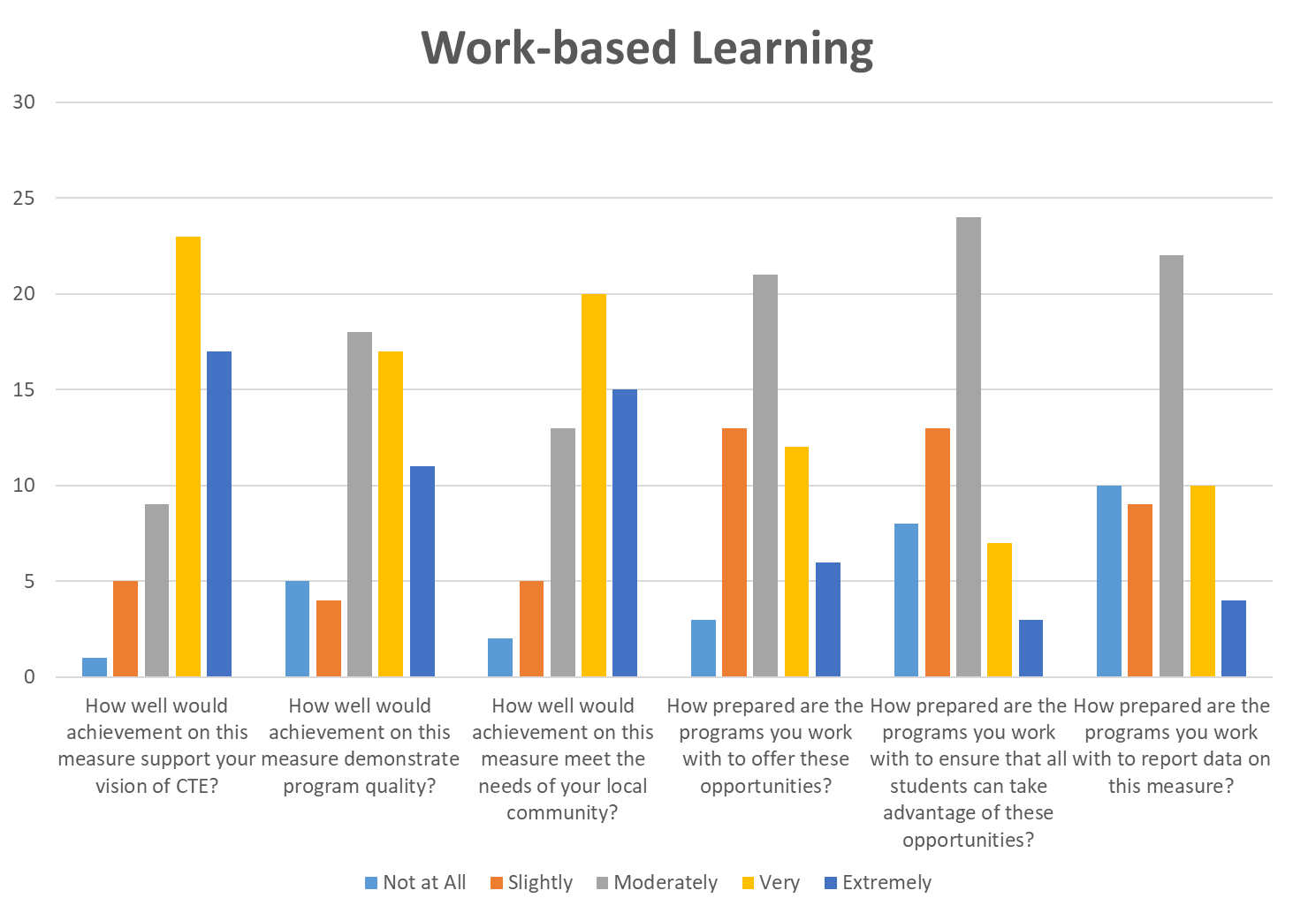

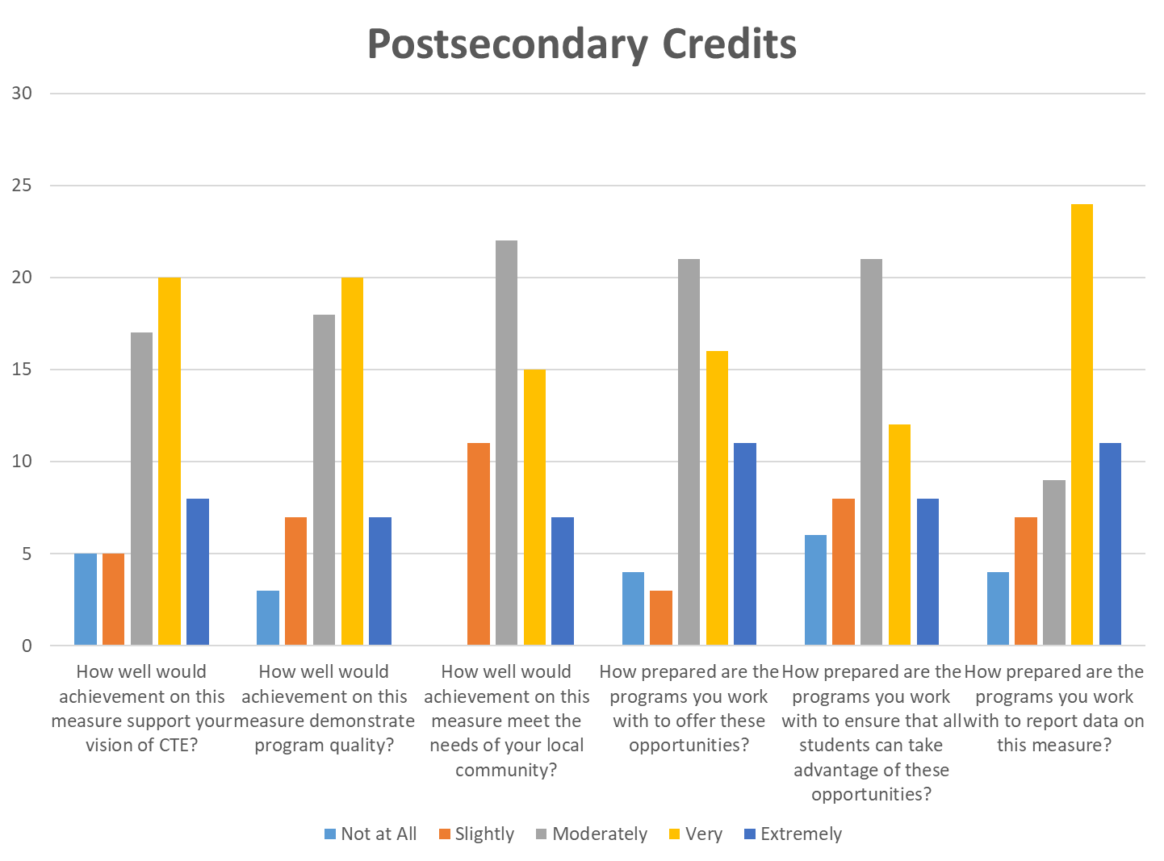

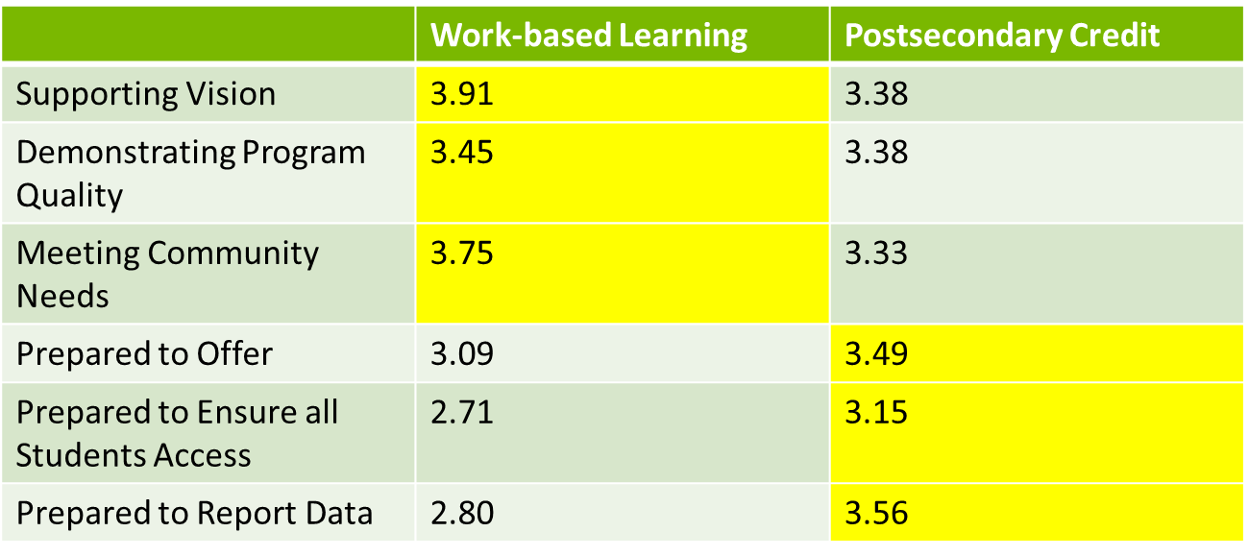

If you had to choose today, which of these measures would you like the state to adopt to meet federal data reporting requirements?
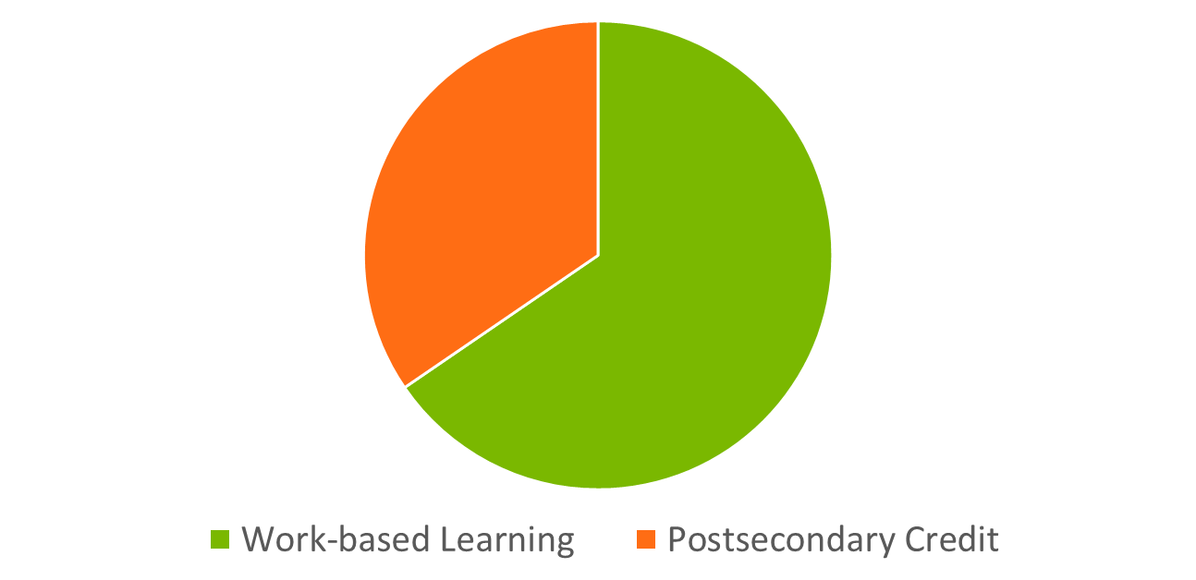

Summary of Survey Comments
- Concern about WBL in rural schools/small communities
- Opportunities limited in some fields for WBL
- Skills provided by WBL very useful
- Postsecondary credit only valuable for college-bound (although can be problematic then too)
- Teacher credentials an issue for postsecondary credit
- Neither are great option

Discussion
- Oregon needs to focus on what will support Oregon’s vision for CTE over the next ten plus years and not just on what would be the easiest indicator to collect
- “Putting the cart before the horse”- Oregon needs a clear program of study definition before decisions can be made
- Concerns that the workgroups are siloed
- Concerns about equity and access
  - Will learners have access to the opportunities that the indicator requires?
- Regardless of the indicator chosen, Oregon must have a way to collect accurate data
- Suggestion that Oregon reaches out to schools to see how schools are obtaining and tracking information
- Postsecondary credit indicator
  - Postsecondary credit indicator will promote secondary/postsecondary alignment
  - Concerns that K-12 cannot collect data on postsecondary credits earned
    - Concerns that K-12 will have to rely on whether students choose to claim college credits
    - However, a significant percentage of respondents said that they were prepared to report data on the postsecondary credit
  - Concerns that the postsecondary credit indicator will lead to “random acts” of dual credit
    - Oregon has moved away from having dual-credit be the “end all” for POS
- Work-based learning indicator
  - Work-based learning indicator will promote a secondary focus
  - Work-based learning indicator may have been chosen because there aren’t financial obligations
    - How Oregon allocates resources will be affected by whether the submitted federal levels for an indicator are met
  - Who would be responsible for tracking the work-based learning indicator?
  - Who will determine what constitutes work-based learning?
  - Meaningfulness of choosing work-based learning as an indicator depends on the decision of different workgroups and on what the definition of work-based learning will be
- Mini-survey
  - Concerns that there was not a clear definition of work-based learning when people responded to the survey
  - Concerns that the indicator options were narrowed down too quickly
  - Large gap exists between which indicator respondents feel prepared to report data on
    - Small gap in preference, but a large gap exists in preparation to adopt
What next?
- More interest in WBL – seems to be support for it based on value to students
- Measurement/reporting and access a concern
- How could we address?
  - Clear definitions
  - State TA
  - Reasonable targets

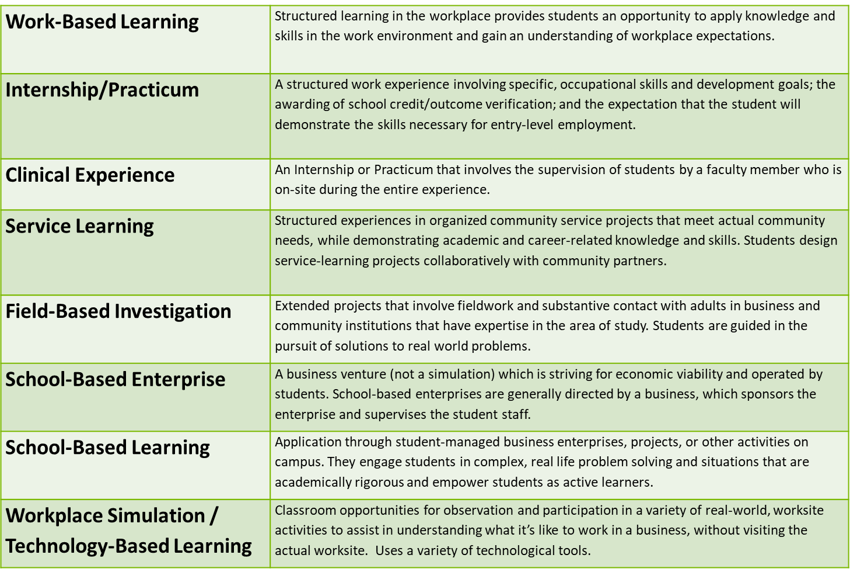

New Concentrator Definitions
Secondary Definition
Current Oregon Definition
- A student who has earned a minimum of 1 credit in CTE courses, with at least .5 credit being designated by the school as required
  - Note: In this use, required means that this course curriculum and instruction is based on industry-recognized standards approved for the applicable CTE program and may be addressed by the technical skill assessment used to measure student achievement.
Perkins V Definition
- A student served by an eligible recipient who has completed at least two courses in a single career and technical education program or program of study
New Proposed Concentrator Definition
- A CTE Concentrator must take a least two courses in an approved CTE Program of Study, of which at least one course must be deemed as intermediate.
Proposed Perkins V Course Definition
- A course is a single semester or trimester course equating to either .5 credits or .33 credits respectively.
Additional Definitions Needed
- Introductory Course
- Intermediate Course
- Advanced Course

Secondary Definition
- What questions does the new definition raise?
  - Do we really want students to be concentrators after less than a year?
  - Who/How will define intermediate for each program? (Maybe second year)
- What concerns does the new definition raise?
  - New course labels (not in current data system)
  - Hard to understand for public
  - Is this enough CTE?
- Does the operationalized version of this definition capture the “right” population of students?
  - May be too many students

Postsecondary Definition
Current Oregon Definition
- A student who is enrolled for credit and has completed 18+ program credits, of which 9+ credits are CTE core credits, within a single program of study that terminates in the award of a degree, a certificate of completion or an industry-recognized credential.
Perkins V Definition
- A student enrolled in an eligible recipient who has:
  - Earned at least 12 credits within a CTE program or program of study; or
  - Completed such a program if the program encompasses fewer than 12 credits or the equivalent in total.

Discussion
- Proposed Perkins V Course Definitions
  - “.33 credits respectively” exists in the definition because 19 schools in the state use a trimester system
- New Proposed Concentrator Definition
  - Intermediate course definition suggestions:
    - A course where some of the standards that were agreed upon between the college and the high school are delivered
    - Second-year course
- Most secondary CTE programs provide a minimum of three credits

Next Steps
Virtual Meeting, August 19, 9:00 am
Virtual Meeting, September 9, 9:00 am
In-person Meeting, October 8 or 9

GOAL: Performance targets out for public comment by mid-September

