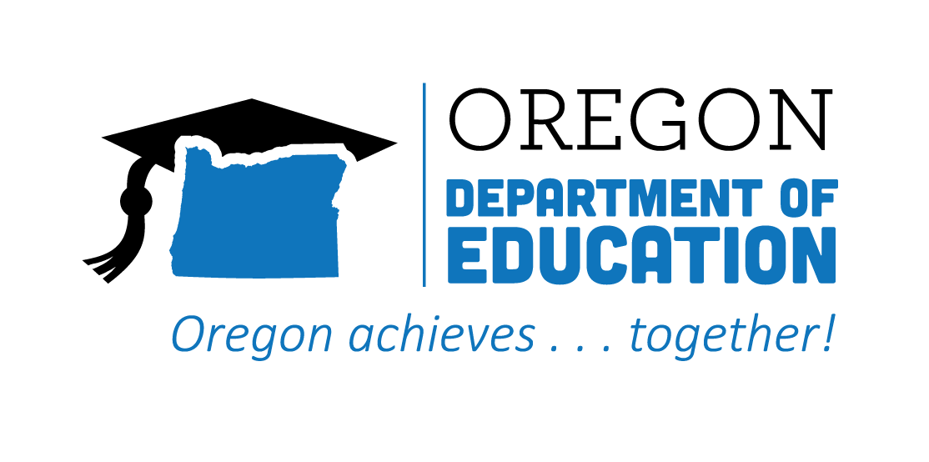

Statewide Advisory Council

Date: January 18, 2023
Time: 9:00 AM - 11:00 AM via Zoom

List of Attendees
Group Norms

Meeting Minutes
Please note: Meetings will be recorded for those that are unable to attend

Time | Topic | Notes
9:00 | First Welcome  (Malinda) | Partner check in:  - Hop into the Advisory Council Slides and read about your partner(s). Share a story behind your fun fact or one of your pictures  Welcome to new Ex Officio Member: Shalee Hodgson from HECC/CCWD!
9:05 | Second Welcome and State Director Updates  (Jennell and Celia) | Jennell:  - New Governor’s Education Priorities and  CTEOregon Lottery and CTE Month Communication Plan  - Legislative Update: CTE Teacher Licensure, Dental Professionals, Funding for CTE program, financial literacy  - ODE Director Colt Gill will be resigning at the end of the current legislative session.  Celia: Governor Kotek named her education advisors: Melissa Goff and Poojah Bhatt. CCWD is following the Dental Professional Bill, Apprenticeship opportunities, computer science, and student services bills.  Future Ready Oregon staff is expanding.  https://www.oregonlegislature.gov/committees
9:15 | Charter Review | Current Charter
9:20 | Vision Conversation | Purpose of this Council: To provide ongoing, equity-focused advice, guidance and feedback on  strategies and progress being made throughout the implementation of CTE State Plan and its goals.  Council Leadership Team (Charlie, Carla & Whitnie) met with CTE Leadership from ODE and HECC  - Role of Council  - Realities of rate of change in State Government Systems (Constraints)  - What we control  - Legislative process  What is done with Council/Subcommittee advice and recommendations?  - Legislative Report process (Final Report Link in Good of the Order Section)  - Feed into existing structures/systems  - State Plan Implementation Team (SPIT)  Examples of things that have already come out of this work:  - Alignment Subcommittee  - Career Connect Oregon Alignment Subcommittee  - Xplane (interactive map Oregon STEM is exploring to help with alignment)  - Equity Subcommittee  - Small/Rural Task Force - to increase support, additional funding  - System of Communication/Sharing  - Sharing recommendations / suggestions with the CTE Communication Team  - Youth Advisory Team  - Collaboration with HECC Workforce and Talent Development Board and Youth Workforce Development  - Advance CTE Technical Assistance Cohort  Leadership hopes for the Council:  - Communication Flow: State staff inform Council of the ODE/HECC CTE various initiatives that are of interest to council members  - Council members will:  - Share their learning with their constituents (students teachers business and industry)  - Help to promote CTE across the state  - Provide information for legislators and/or governor  - Advise on how to position CTE within the state  - Identify alignment opportunities across the state  - Lobby for CTE initiatives  Breakout Room Discussions:  NOTES SLIDES  - What do you hope to get out of your participation on the CTE Advisory Council?  - What CTE initiatives do you want to know more about?  - What additional support would help you communicate about CTE initiatives to your constituents?  - Ideas to get more workforce development and Business and Industry participation/feedback/guidance around CTE initiatives  - Ideas for communication and gathering feedback in between quarterly meetings  Please designate a note taker and someone to share out to the larger group!
10:00 | BREAK
10:10 | Vision Conversation Cont’d | Group Share Out Notes:  - Incarcerated youth - using the network for more info  - Communication - additional support  - Growing alignment - for better stronger partnerships  - What to get out of this? Finding out what people know - flow of communication  - Making participation worthwhile for industry partners  - CCL work can be very helpful  - Engaged in the legislative process sooner  - Tips and guidance working with the process  - Integrate Essential Employability Skills into CTE  - Especially Entrepreneurship  - Oregon ASK is doing some work around Entrepreneurship: https://oregonask.org/entrepreneurship/  - More data and information on Labor Market Demand for programs  - Continuing Updates; balance of too much and not enough information  - Making sure conversations include discovery of interests of youth and students of all abilities and interests  - Making sure parents are informed  - Broaden conversations beyond Perkins and HS students. Emphasize the multiple entry points and funding opportunities to expand access for underrepresented students  - More applied learning (career exploration) in middle school  - Overcoming outdated perceptions and understanding of “what CTE is”.  - Do a better job of presenting data  - 1-pagers - data, updates - consolidate information to create overview  - More opportunity for advisory council to share  - Can we connect w/Semiconductor Task Force?  Next Steps:  - Update Charter  - Create a Strategic Plan  - Including Legislative timeline
10:30 | Charter Revisions | Editable Version of the Charter  What revisions might need to be made to the charter to be more in line with what Council Members and Leadership envisions?  Hop in and make comments/suggestions where needed
10:35 | Refining the CTE State Plan | Oregon’s CTE State Plan is through 2024. This means we have an opportunity next year to refine our priorities. We have not yet received any guidance from the Federal Government about requirements for updating our state plan.  Will have listening sessions, engagement opportunities, and a survey to help inform our work  Hope you will participate and serve as advisors in this process
10:40 | Council Membership Updates and New Member Recruitment | Current Open Positions based on representation:  - Postsecondary Equity/Diversity Staff Member  - CTE Administrator  - Community Organization Member  - Industry Partner  Timeline:  - February: Current Membership Survey  - March - April: Recruitment/Promotion  - April - May: Application and Selection  Please be thinking of Nominations!
10:45 | Announcements/Good of the Order  (ALL) | ODE Seeks Volunteers to serve on Quality Assurance & Learning Panels  ======================================  Supporting Gender Expansive Student: Guidance For Schools  - Survey - Let us know if you have any LC0463_DRAFT_2023_Regular_Session.pdfquestions or would like additional support as this guidance is rolled out  ======================================  Advance CTE Technical Assistance Cohorts:  - ODE was selected to be part of the Leveraging Learner Voice to Strengthen CTE  - Partnership with HECC/CCWD, Youth Development to create a Career Connected Learning Youth Advisory Team  - HECC/CCWD was selected to the Building Sustainable State Recruitment and Communication Systems to Reach Diverse Learners  - Partnership with ODE  ======================================  Legislative Report Link - From November Email
 | Public Comment
 | 2023 Meeting Schedule | - January 18  - April 19  - July 19  - October 18

