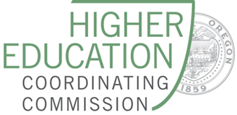
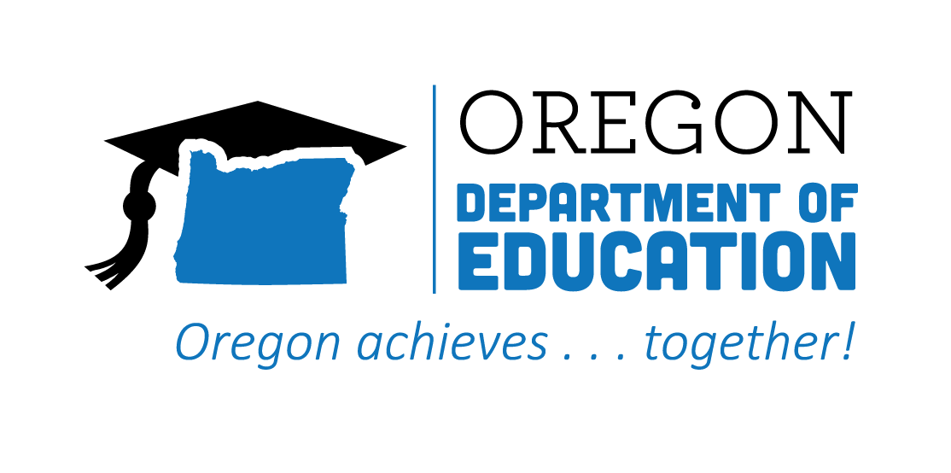

Statewide Advisory Council

Rolling Meeting Minutes

Date: January 19, 2022
Time: 9:00 AM - 11:00 AM

Zoom Link

Google Folder

Working Agenda
Please note: Meetings will be recorded for those that are unable to attend

Time | Topic | Notes
9:00 | First Welcome & Meeting Business  (Leadership Team) | Membership updates since July meeting:  Additions  - Lisa Ransom, Bureau of Labor and Industries (BOLI)  - Clay Martin, Workforce and Talent Investment Board  - Pete Sansone, Secondary Student Representative; Oregon Future Business Leaders of America  Change  - Julia Steinberger, Director of STEM Council changed positions at the HECC. TBD on a successor  Check out the Advisory Council Slides to learn more about our membership!  Final Charter Document  Leadership Team will review periodically  Summary of Group Norms/Community Standards
 | Second Welcome and State Director Updates  (Jennell and Donna)  Group Brainstorming - 1/19/22 | Secondary updates:  - ESSER III Set Aside ($12million for Career Connected Learning - CCL)  - CCL Navigators at the Community Colleges  - Expanding Career Exploration in Middle Schools  - Open access to all Oregonians to Career Exploration Tools  - CTE Liaison to facilitate CCL and workforce development relationships with our Tribes  - 3-years of funding  - CTE Communications Plan Timeline (Targeting expanding diversity of students and families aware of CTE  - District Planning Integration  - CTE is part of this intentional planning process  Post-secondary updates:  - Governor proposed investment in Future Ready Oregon  - $200 million investment in workforce and education  - Local workforce strategies and services  - Community College Career Pathways (17 mil)  - Registered Apprenticeship and youth re engagement  - Credit for prior learning  - There is one remaining FRO Stakeholder briefing session on Friday 1/21 @ 12-1.3. RSVP to attend:Friday, January 21, 12:00 – 1:30 pm: https://docs.google.com/forms/d/1XgKkQCff6ssCoAI38Uk7W-6AozCCNovf8GdRAA11bW8/edit  - Stay tuned for more information on Applied Baccalaureate degrees - next level of CTE Pathways
 | Equity Presentation  (Karin Moscon, ODE) | Presentation Slides
10:15 ish | BREAK
 | Equity Discussion  (ALL) | Slide Deck for Discussion Notes
 | Subcommittee Workflow  (Leadership Team) | - Issues/Concerns & Root Causes  - What’s currently being done  - Areas for growth  - Best practices/strategies  - Recommendations  - Implementation team  Reach out to Ex officio Council members; they can be a great resource!
 | Break into Subcommittees  (if time allows) | - Equity  - Alignment  - System of Sharing/Communication  For Reference: Subcommittee Lists
 | Announcements/Good of the Order  (ALL) | NEW: Statewide CTE Advisory Council Website  Portland Public School’s Future You 2 Go sessions are open to all Oregon high school students, high school teachers, high school counselors and high school career center staff at no cost. Students do not need to register-just click and learn. Please share with your contacts. For more information, go to this link: https://www.pps.net/futureyou2go  National Skills Coalition: National Skills Virtual Summit. February 15-17. FREE Registration
 | Next Meeting(s) | Wednesday April 20, 2022; 9:00 - 11:00 AM  Wednesday, July 20, 2022; 9:00 - 11:00 AM  Wednesday, October 19, 2022: 9:00 - 11:00 AM

