Appendix H: Performance Targets

Secondary Indicators
Indicators | Baseline Level* | FY 2020 Performance Levels | FY 2021  Performance Levels | FY 2022  Performance Levels | FY 2023  Performance Levels
1S1: Four-Year Graduation Rate | 91.00% | 91.00%  89.50% | 91.50%  90.00% | 92.00%  90.50% | 92.50%  91.00%
1S2: Extended Graduation Rate | 92.00%. | 92.00%  90.00% | 92.50%  90.50% | 93.00%  91.00% | 93.50%  91.50%
2S1: Academic Proficiency in Reading Language Arts | 80.00% | 80.00%  68.00% | 80.50%  64.40% | 81.00%  72.90% | 81.50%  77.43%
2S2: Academic Proficiency in Mathematics | 42.00% | 42.00%  35.70% | 43.00%  34.40% | 44.00%  39.60% | 45.00%  42.75%
2S3: Academic Proficiency in Science | 54.00% | 54.00%  45.90% | 55.00%  44.00% | 56.00%  50.40% | 57.00%  54.15%
3S1: Postsecondary Placement | 58.00% | 58.00%  49.30% | 59.00%  47.20% | 62.00%  55.80% | 63.00%  59.85%
4S1: Nontraditional Program Enrollment | 27.50% | 27.50% | 28.00% | 28.50% | 29.00%
5S3: Program Quality – Participated in Work-Based Learning | 10.00% | 10.00%  5.00% | 15.00%  12.00% | 23.00%  20.00% | 31.00%  25.00%

Postsecondary Indicators
Indicators | Baseline Level* | FY 2020 Performance Levels | FY 2021  Performance Levels | FY 2022  Performance Levels | FY 2023  Performance Levels
1P1: Postsecondary Retention and Placement | 78.50% | 78.50%  62.80% | 79.00%  63.20% | 79.50%  67.60% | 80.00%  72.00%
2P1: Earned Recognized Postsecondary Credential | 48.75% | 48.75%  39.00% | 49.25%  39.40% | 49.75%  42.30% | 50.25%  45.20%
3P1: Nontraditional Program Enrollment | 18.00% | 18.00%  16.00% | 18.50%  16.40% | 19.00%  17.90% | 19.50%  19.40%

*Note: The Baseline Levels represent the initial baselines for each metric regardless of adjustments made due to COVID-19.
Adjusted Performance Levels and Rationale in RED

Oregon experienced unprecedented challenges over the last year and a half that have significantly disrupted learning, including COVID-19 and statewide fires. Due to these challenges, access to CTE and other learning experiences has been inconsistent; as a result, Oregon has adjusted the state determined performance targets accordingly.

The following steps were taken to ensure community partner feedback and buy-in:
- The Data and Accountability workgroup convened to address any questions or concerns they had. These community partners expressed gratitude for the adjustments and appreciated the understanding and flexibility provided by the proposed target adjustments.
- An announcement was posted to the ODE website, and was emailed to community partners that were involved in the development of the original Oregon CTE State Plan. The announcement stated the proposed changes and notification for the process to provide public comment.
- At public meetings, the new proposed target was discussed in order to gain public comment on our revised performance targets.
- The Public Comment period was open from March 19-April 19, 2021.
- A Public Hearing was held on April 14, 2021, from 3:00-4:00 PM. Neither the public comment period nor the hearing yielded further responses.

Overview of Secondary Performance Indicators
Data collection and reporting has been part of CTE since 1998. Specific indicators have changed over time, but the importance of using data to inform decisions has been consistent. Both secondary and postsecondary institutions routinely report student data as a required component of their CTE programs. ODE and HECC report that data for statewide accountability and planning.

Perkins V requires annual reporting of eight performance indicators at the secondary level. Five of the indicators are equivalent to what was required under Perkins IV. Extended Graduation Rate, Academic Proficiency in Science, and Program Quality are new indicators under Perkins V. Technical Skill Attainment, an indicator under Perkins IV, is no longer required.

This document includes the proposed indicator targets for the next four years. Targets reflect analysis of previous data, when available, factoring in a change in the definition for a secondary CTE concentrator. As part of the federal requirements, Oregon does not have the option to change the performance indicators, but we may choose our targets.

Secondary CTE Concentrator
The Perkins V legislation defines a secondary CTE concentrator as a student who has taken at least two courses in a single CTE Program of Study. Oregon proposes the following operational definition:

A secondary CTE concentrator is a student who earns at least two credits in a single CTE Program of Study. One of those credits must be earned through a course or courses identified as intermediate or advanced.

This definition, recommended by a workgroup of employers and educators, uses the term “credits” as a proxy for courses to allow for parity in schools using different grading periods (e.g., trimester and semester). The definition significantly changes the student count in Perkins V as compared to Perkins IV by doubling the number of credits needed to become a concentrator from one to two. The number of secondary CTE concentrators using the new definition will decrease by 45 to 55 percent, but will also reflect students who have more intentional participation in CTE, in line with congressional intent.

For the last four years, the number of credits contained within a CTE Program of Study has increased. The primary driver of the trend has been the Secondary Career Pathways incentive funding. To receive that funding, a program must have at least three credits available to students. Programs receive funding based on the number of students who earn at least three credits, making the Perkins V concentrator definition a solid intermediate measure. Research related to course-taking patterns in CTE demonstrates that an increased number of CTE credits earned by students in a single program increases the likelihood of graduation and future earnings. As a result of the incentive funds, about 93% of all approved programs have at least three credits.

Course-Level Descriptors
The secondary CTE concentrator definition includes a course-level descriptor. The descriptor emphasizes the importance of creating a course sequence within a CTE Program of Study. National research has demonstrated the positive impact of CTE on student outcomes when taught through a sequence of courses rather than a number of loosely connected electives. Under Perkins V, course-level descriptors will be:

- Introductory Course – A course that focuses on raising career awareness and learning basic professional and technical skills associated with the CTE Program of Study. The course helps develop student interest rather than technical proficiency in a CTE Program of Study.
- Intermediate Course – A course that focuses on exploring careers and learning specific technical and professional skills. The course builds on basic skills and moves toward technical proficiency in preparation for a career.
- Advanced Course – A course that focuses on preparing for a career and refining specific technical and professional skills. The course integrates multiple skills through project-based instruction and/or work-based learning. These courses focus on preparing students for entry-level work or postsecondary programs.

Attention to Equity
Perkins V requires disaggregation of data to reveal any impact on different student groups. Initial data analysis indicated that reducing the number of students captured in the data had no significant impact on demographic distribution. Our statewide Perkins performance targets have the opportunity to provide information to local education entities to identify gaps that may exist for historically and currently marginalized students so these students can engage in CTE and benefit from career education training. Currently, at the state level CTE concentrators mirror the demographic distribution of all students. We do not see a significant change in demographics of CTE concentrators when we shift to a more rigorous definition.

The change in the secondary CTE concentrator definition has the potential to make it more difficult for students with disabilities and English learners who might have scheduling conflicts with other support courses to become CTE concentrators. The state will need to ensure training and support for local education providers to create schedules and CTE courses that are accessible to all students, particularly those who have been historically excluded from quality career education opportunities.

Performance Indicators and Targets

Each of the performance indicators that follow includes:
- A brief summary of the indicator
- The data definition of the numerator and denominator used to calculate the indicator
- The proposed targets
- A rationale for the chosen targets

1S1: Four-Year Graduation Rate
The percentage of secondary CTE concentrators who graduate within four years—This indicator uses the same definition for a high school graduate as the one used to determine overall state four-year graduation rates.

Numerator: # of CTE concentrators who graduate high school (regular diploma, modified diploma, or post-graduate scholars), as measured by the four-year adjusted cohort graduation rate.

Denominator: # of CTE concentrators in the state adjusted four-year cohort in the reporting year. The adjusted four-year cohort includes students who were first enrolled in high school four years prior to August of the reporting year, plus those students who transferred into the cohort within those four years and minus those students who transferred out of the cohort within those four years.

Proposed Targets

School Year | Target
2019-2020 | 91.00%  89.50%
2020-2021 | 91.50%  90.00%
2021-2022 | 92.00%  90.50%
2022-2023 | 92.50%  91.00%

Rationale
The four-year graduation rate for CTE concentrators has consistently exceeded the statewide average for all students. Historically, the four-year graduation rate has hovered around 90%. The impact of a change in the definition for a secondary CTE concentrator under Perkins V appears to be about a 1.5% increase. The expectation is that increases in graduation rate will slow as it approaches 100%. For these reasons the targets start near current levels with small increases each year.

Rationale for adjusted targets: Oregon anticipates CTE concentrators to continue to graduate at high rates; however, due to disruptions in Oregon’s education system there may be a slight reduction.

1S2: Extended Graduation Rate
The percentage of secondary CTE concentrators who graduate within five years—This indicator uses the same definition for a high school graduate as the one used to determine overall state five-year graduation rates.

Numerator: # of CTE concentrators who graduate high school (regular diploma, modified diploma, or post-graduate scholars), as measured by the five-year adjusted cohort graduation rate

Denominator: # of CTE concentrators in the state adjusted five-year cohort in the reporting year. The adjusted five-year cohort includes students who were first enrolled in high school five years prior to August of the reporting year, plus those students who transferred into the cohort within those five years and minus those students who transferred out of the cohort within those five years.

Proposed Targets

School Year | Target
2019-2020 | 92.00%  90.00%
2020-2021 | 92.50%  90.50%
2021-2022 | 93.00%  91.00%
2022-2023 | 93.50%  91.50%

Rationale
This is a new measure under Perkins V; however, it is reported as part of ESSA. This graduation rate for all students typically exceeds the four-year rate by about 1%. The proposed target for this indicator reflects that 1% increase.

Rationale for adjusted targets: Oregon anticipates CTE concentrators to continue to graduate at high rates; however, due to disruptions in Oregon’s education system there may be a slight reduction.

2S1: Academic Proficiency in Reading/Language Arts
The percentage of secondary CTE concentrators who demonstrate proficiency in reading/language arts as measured by the statewide assessment—This data is reported in the year that the student takes the assessment. In Oregon, statewide assessments are administered during the 11th grade.

Numerator: # of CTE concentrators who have met the proficient or advanced level on Oregon’s reading/language arts assessment administered under Section 111(b)(3) of the Elementary and Secondary Education Act (ESEA) as amended by the No Child Left Behind Act.

Denominator: # of CTE concentrators who took the ESEA assessment in reading/language arts.

Proposed Targets

School Year | Target
2019-2020 | 80.00%  68.00%
2020-2021 | 80.50%  64.40%
2021-2022 | 81.00%  72.90%
2022-2023 | 81.50%  77.43%

Rationale
The most recent data for this target increases by 2.5% when the new secondary CTE concentrator definition is applied. However, over the last three years this indicator has decreased by approximately the same amount for both CTE concentrators and the general student population. In addition, Oregon is experiencing a reduction in the number of students who take the statewide assessment. Consequently, the proposed target starts at the same level used in Perkins IV, increasing by 1.5 percentage points after four years.
Rationale for adjusted targets: These metrics are tied to state assessments. Oregon received a waiver for the statewide assessments, and while learning continues, performance on these state assessments is uncertain.

2S2: Academic Proficiency in Mathematics
The percentage of secondary CTE concentrators who demonstrate proficiency in mathematics as measured by the statewide assessment—This data is reported in the year that the student takes the assessment. In Oregon, statewide assessments are administered during the 11th grade.

Numerator: # of CTE concentrators who have met the proficient or advanced level on Oregon’s mathematics assessment administered under Section 111(b)(3) of the Elementary and Secondary Education Act (ESEA) as amended by the No Child Left Behind Act.

Denominator: # of CTE concentrators who took the ESEA assessment in mathematics.

Proposed Targets

School Year | Target
2019-2020 | 42.00%  35.70%
2020-2021 | 43.00%  34.40%
2021-2022 | 44.00%  39.60%
2022-2023 | 45.00%  42.75%

Rationale
The most recent data for this target increases by 2.5% when the new secondary CTE concentrator definition is applied. However, over the past three years this indicator has decreased significantly for secondary CTE concentrators and the general student population. In addition, Oregon is experiencing a reduction in the number of students who take the statewide assessment. Consequently, the proposed target starts at the previous actual value, increasing by 3.0 percentage points after four years.
Rationale for adjusted targets: These metrics are also tied to state assessments. Oregon received a waiver for the statewide assessments, and while learning continues, performance on these state assessments is uncertain.

2S3: Academic Proficiency in Science
The percentage of secondary CTE concentrators who demonstrate proficiency in science as measured by the statewide assessment—This data is reported in the year that the student takes the assessment. In Oregon, statewide assessments are administered during the 11th grade.

Numerator: # of CTE concentrators who have met the proficient or advanced level on Oregon’s science assessment administered under Section 111(b)(3) of the Elementary and Secondary Education Act (ESEA) as amended by the No Child Left Behind Act.

Denominator: # of CTE concentrators who took the ESEA assessment in science.

Proposed Targets

School Year | Target
2019-2020 | 54.00%  45.90%
2020-2021 | 55.00%  44.00%
2021-2022 | 56.00%  50.40%
2022-2023 | 57.00%  54.15%

Rationale
This is a new performance indicator under Perkins V using data from a new statewide assessment. In addition, the statewide assessment in science is new. The initial target is set at a level equal to the high school performance in 2018-2019. CTE Programs of Study in Career Clusters such as Agriculture and Health Sciences have significant connections to science content, justifying the proposed growth.
Rationale for adjusted targets: These metrics are tied to state assessments. Oregon received a waiver for the statewide assessments, and while learning continues, performance on these state assessments is uncertain. We are adjusting by 15-20%.

3S1: Postsecondary Placement
The percentage of CTE concentrators who, in the second quarter after exiting from secondary education, are in postsecondary education; are in advanced training, military service, or a service program; or are employed.

Numerator: # of CTE concentrators who, in the second quarter after exiting from secondary education, are in postsecondary education; are in advanced training, military service, or a service program that receives assistance under Title I of the National and Community Services Act of 1990 (42 U.S.C. 12511 et sec.); are volunteers as described in section 5(a) of the Peace Corps Act (22 U.S.C. 2504(a)); or are employed

Denominator: # of CTE concentrators who exited secondary education during the reporting year.

Proposed Targets

School Year | Target
2019-2020 | 60.00%  49.30%
2020-2021 | 61.00%  47.20%
2021-2022 | 62.00%  55.80%
2022-2023 | 63.00%  59.85%

Rationale
ODE is currently able to collect data only on education and employment for students who have exited high school. Under Perkins IV, employment data was not available. ODE is working with the Oregon Employment Department to gain access to that data. The proposed targets are an increase from Perkins IV, since the data will include employment. Under Perkins V, ODE will explore data sources that will allow inclusion of advanced training, military service, and service programs. The changes in targets reflect two years of collecting and incorporating employment data followed by increases resulting from improved data collection and a focus on work-based learning.
Rationale for adjusted targets: Economic uncertainty and high unemployment due to COVID may have a significant impact on students’ placement in this target by 15%.

4S1: Nontraditional Program Enrollment
The percentage of CTE concentrators in CTE programs and Programs of Study that lead to fields that are nontraditional for the gender of the concentrator—These programs are identified using national data.

Numerator: # of CTE concentrators who concentrated in a state-approved Program of Study that leads to a nontraditional field

Denominator: # of CTE concentrators who concentrated in a state-approved Program of Study

Proposed Targets

School Year | Target
2019-2020 | 27.50%
2020-2021 | 28.00%
2021-2022 | 28.50%
2022-2023 | 29.00%

No adjustments to proposed targets. There is no expectation that nontraditional by gender enrollment is to be impacted by COVID.

Rationale
This indicator replaces two similar indicators used for Perkins IV. The previous indicators differed from each other by the number of CTE credits earned by students. The initial target for this measure falls between the targets for the two previous measures.

5S1: Program Quality—Participated in Work-Based Learning
All three measures under program quality are important and measured to some degree in Oregon. The workgroup recommended using work-based learning, as it is the most versatile measure because it can be done in any community regardless of zip code, diversity, or program offerings. Work-based learning is defined as:

Proposed: Structured learning in the workplace or simulated environment that provides opportunities for sustained interactions with industry or community professionals that foster in-depth firsthand experience of the expectations and application of knowledge and skills required in a given career field.

Examples include: Clinical/practicum/internships, school-based enterprises, workplace simulation/technology-based learning, service-learning, and cooperative work experiences.

Numerator: # of CTE concentrators who participated in work-based learning during high school, and who graduated from high school during the reporting year

Denominator: # of CTE concentrators who graduated from high school during the reporting year.

Proposed Targets
School Year | Target
2019-2020 | 10.00%  5.00%
2020-2021 | 15.00%  12.00%
2021-2022 | 23.00%  20.00%
2022-2023 | 31.00%  25.00%

Rationale
This is a new indicator under Perkins V. Some high schools in Oregon have been reporting data on career related learning experiences (CRLE). That data is not used currently by ODE, and there has been no technical assistance on what should be recorded. Even without that support, ODE determined that 49% of CTE concentrators had a CRLE before graduating. The initial target is set lower to reflect uncertainty in the validity of existing data. Projected increases are based on increased technical assistance on work-based learning for schools and districts.

Rationale for adjusted targets: Work-based learning is a new performance target for Oregon and slower growth is expected due to challenges around COVID-19.

Overview of Postsecondary Performance Measures

Overview
Perkins V requires annual reporting of three performance indicators at the postsecondary level, similar to those required under Perkins IV. Postsecondary Technical Skill Attainment, an indicator under Perkins IV, is no longer required.

This document includes the proposed indicator targets for the next four years. Targets reflect analysis of previous data, when available, factoring in the change in the postsecondary CTE concentrator definition under Perkins V.

Postsecondary CTE Concentrator
The Perkins V legislation defines a postsecondary CTE concentrator as a student who has earned at least 12 credits within a CTE program or Program of Study, or has completed the program if it is fewer than 12 credits. Oregon proposes the following definition (additional language italicized and bolded):

A student who has earned at least 12 credits, of which nine program credits are CTE specific, within a CTE program or Program of Study; or completed the program if it is fewer than 12 credits.

This definition, recommended by a workgroup of employers and educators, refines the Perkins V concentrator definition to align closely with the definition under Perkins IV with only one difference: Perkins V requires a concentrator to have earned at least 12 credits in a CTE program or Program of Study; Perkins IV required a concentrator to have earned at least 18 credits in a CTE program or Program of Study. This was done in the hopes of having consistent data over the course of the two grant programs. Using Oregon’s proposed definition, the number of postsecondary CTE concentrators will increase by approximately 18 percent.

Attention to Equity
Perkins V requires disaggregation of data to reveal any impact on different student groups. Initial data analysis indicated that an increase in the number of CTE concentrators under Perkins V was reflected by a decrease in the number of male concentrators, an increase in female students considered CTE concentrators, and a small increase in the number of concentrators not identified as either male or female.

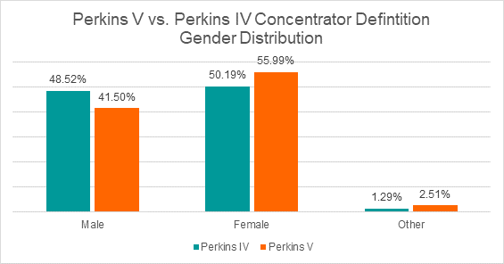

Distribution of Perkins VI and Perkins V concentrators with two exceptions: a decrease in the Hispanic/Latino concentrator population and an increase in the unknown race/ethnicity concentrator population.

In preparing to implement Perkins V, intentional examination of policies is needed to ensure that the new concentrator definition does not adversely impact student progress toward meeting the concentrator credit requirements, especially among the Hispanic/Latino student population.

Performance Indicators and Targets

Each of the performance indicators that follow includes:
- Analysis of historical performance and a brief summary of the new indicator
- The data definition of the numerator and denominator used to calculate the indicator
- The proposed targets
- A rationale for the chosen target

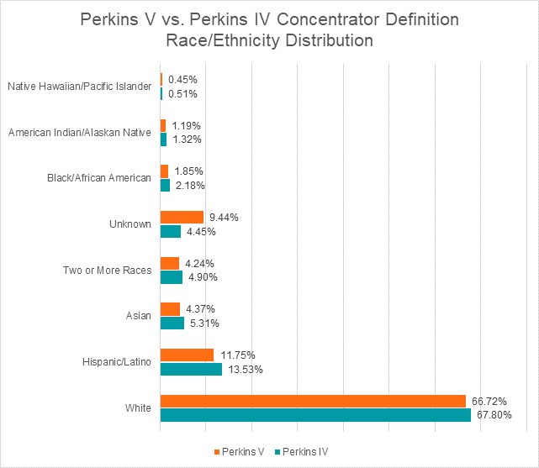

1P1: Postsecondary Placement

Analysis and Summary
Under Perkins IV, placement in postsecondary education, training, military service, employment, or service programs was measured in two performance indicators: 3P1: “Student Retention or Transfer,” which measured the percentage of CTE concentrators who remained enrolled in either the original postsecondary institution or transferred to another two- or four-year postsecondary institution, and 4P1: “Student Placement,” which captured the number of CTE completers who were placed or retained in employment, military service, or an apprenticeship program in the second quarter following postsecondary education exit. Oregon’s performance in these indicators for the past three program years is shown in Figures 1 and 2, respectively.

Figure 1: 3P1: Student Retention or Transfer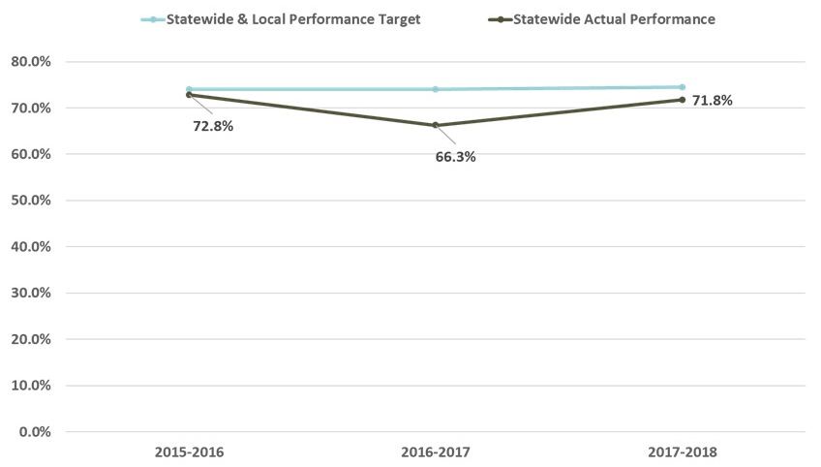

Figure 2: 4P1: Student Placement
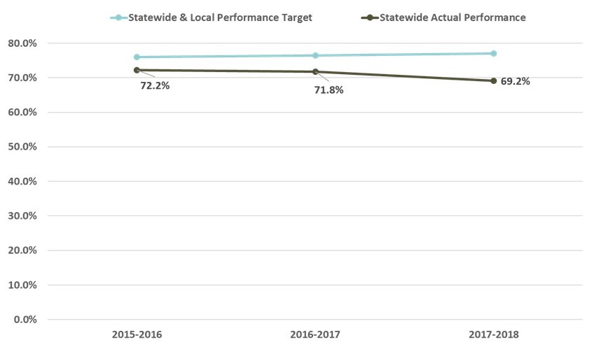

In Perkins V, these outcomes are combined and measured in the 1P1 performance indicator, “Postsecondary Placement,” which measures the percentage of CTE concentrators who complete a program and then continue in postsecondary education; are in advanced training, military service, or a service or volunteer program; or are placed or retained in employment.
Numerator: # of CTE concentrators who, in the second quarter after exiting from secondary education, are in postsecondary education; are in advanced training, military service, or a service program that receives assistance under Title I of the National and Community Services Act of 1990 (42 U.S.C. 12511 et sec.); are volunteers as described in section 5(a) of the Peace Corps Act (22 U.S.C. 2504(a)); or are employed

Denominator: # of CTE concentrators who exited secondary education during the reporting year.

In analyzing the most recent data available, performance in placement outcomes for the 2016-17 CTE completers cohort would be 79.70%, using the new concentrator definition under Perkins V. Further analysis of historical data using Perkins V definitions is indicated in Table 1.

Table 1: Perkins V Analysis with Historical Perkins IV Data
Indicators | 2016-2017  Perkins V | 2015-2016  Perkins V | 2014-2015  Perkins V | 2-year average
Numerator | 5,116 | 5,308 | 5,292 | 5,239
Denominator | 6,419 | 6,701 | 6,875 | 6,555
Performance | 79.70% | 79.21% | 76.97% | 78.60%

Proposed Targets
Program Year | Proposed Target
2020-2021 | 78.50%  62.80%
2021-2022 | 79.00%  63.20%
2022-2023 | 79.50%  67.60%
2023-2024 | 80.00%  72.00%

Rationale
The recommended targets for the Perkins V 1P1: “Postsecondary Placement” performance indicator for program years 2020-2021 through 2023-2024 are based on preliminary results of the three-year average performance using Perkins V definitions. In the 2017-2018 program year, 7,814 students completed a CTE program and would, therefore, make up the denominator for 2017-2018. Using the three-year average for the numerator calculation, an additional 895 students would need to be placed in postsecondary, advanced training, military, or a service or volunteer program, or be employed at the second quarter after completing the program, in order to meet the proposed target for 2020-2021 (78.50%). It is important to note that placement in advanced training, military service, or service or volunteer programs was not included in the preliminary analysis as the data is not readily accessible at this point in time. The state is in negotiations with service and volunteer programs to expand available data.

Rationale for adjusted targets: Oregon anticipates CTE concentrators to continue to remain enrolled in postsecondary education, in advanced training, military service, a service or volunteer program, or be placed or retained in employment at high rates; however, due to disruptions in the education system, economic uncertainty, and high unemployment due to COVID, there may be a slight reduction.

2P1: Earned Recognized Postsecondary Credential

Analysis and Summary
Under Perkins IV, performance in earning postsecondary credentials was measured with the 2P1 performance indicator, “Credential, Certificate, or Degree Completion.” Oregon’s performance in this indicator for the past three program years is shown in Figure 3.

Figure 3: 2P1: Credential, Certificate, or Degree Completion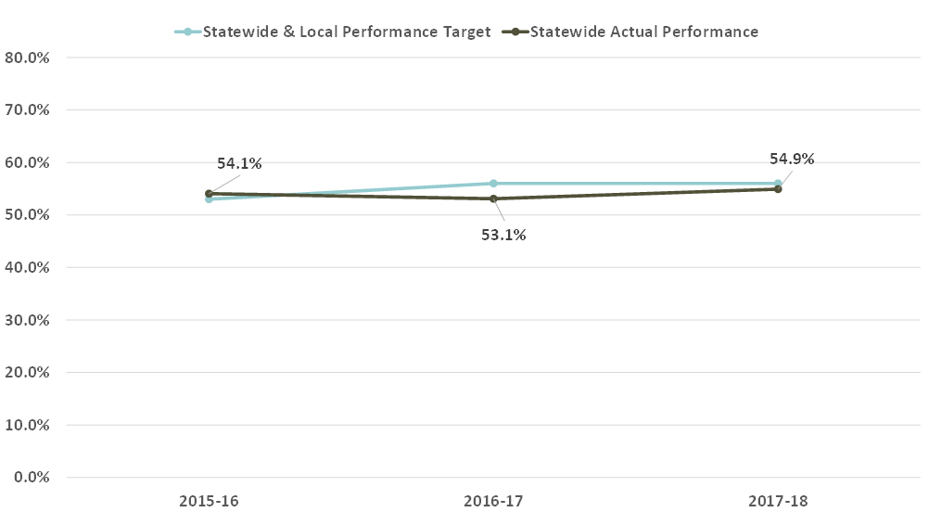
In Perkins V, this outcome is measured with the 2P1 performance indicator, “Earned Recognized Postsecondary Credential,” which calculates the percentage of CTE concentrators who receive a recognized postsecondary credential during participation in or within one year of program completion.
Numerator: # of CTE concentrators who received a recognized postsecondary credential during participation in or within one year of program completion
Denominator: # of CTE concentrators who left postsecondary education in the prior reporting year
In analyzing 2016-2017 federal reporting data using the new concentrator definition under Perkins V and current interpretation of the indicator components, preliminary results indicate that Oregon performance would be 54.91%. Further analysis of historical data using Perkins V definitions is indicated in Table 2.

Table 2: Perkins V Analysis with Historical Perkins IV Data
Indicator | 2016-2017  Perkins V | 2015-2016  Perkins V | 2-year average
Numerator | 8,162 | 7,511 | 7,837
Denominator | 14,864 | 14,082 | 14,473
Performance | 54.91% | 53.34% | 54.15%

Proposed Targets
Program Year | Proposed Target
2020-2021 | 48.75%  39.00%
2021-2022 | 49.25%  39.40%
2022-2023 | 49.75%  42.30%
2023-2024 | 50.25%  45.20%

Rationale
The recommended targets for Perkins V 2P1: “Earned Recognized Postsecondary Credential” performance indicator for program years 2020-2021 through 2023-2024 are based on preliminary results using Perkins V definitions. Due to constraints with historical data, a two-year average was used to determine proposed targets. Proposed targets are calculated using 90% of the two-year average performance to factor in a transition period for implementing new Perkins V definitions and to ensure performance targets can be met.

Rationale for adjusted targets: Oregon anticipates CTE concentrators to continue to receive a recognized postsecondary credential at high rates; however, due to disruptions in the education system because of COVID, there may be a slight reduction.

3P1: Nontraditional Program Concentration

Analysis and Summary
Under Perkins IV, performance in the number of CTE students from underrepresented gender groups participating in a program that led to employment in nontraditional fields was measured with the 5P1: “Nontraditional Participation” and 5P2: “Nontraditional Completion” performance indicators. There is an important distinction between these two indicators: 5P1 measured CTE participants, defined as individuals who earned one or more CTE credits in a Program of Study; 5P2 measured CTE concentrators who completed a program. Oregon’s performance in these indicators for the past three program years is shown in Figure 4.

Figure 4: 5P1: Nontraditional Participation and 5P2: Nontraditional Completion
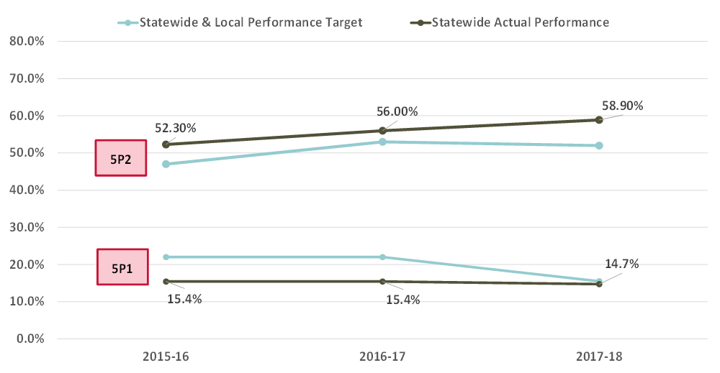
In Perkins V, this outcome is measured in the 3P1 performance indicator, “Nontraditional Program Concentration,” which calculates the percentage of CTE concentrators from underrepresented gender groups who participate in CTE programs and Programs of Study that lead to nontraditional fields. This revised indicator does not measure CTE “participants” or “completers” as in Perkins IV, but it measures CTE concentrators as defined.
Numerator: # of CTE concentrators from underrepresented gender groups who participated in nontraditional programs
Denominator: # of CTE concentrators who participated in nontraditional programs
In analyzing 2017-2018 federal reporting data using the Perkins V revised concentrator definition, preliminary results indicate that Oregon performance would be 18.62%. Unlike the other two Perkins V performance indicators, this indicator is not comparable with Perkins IV data and past performance because nontraditional concentrator involvement in CTE was not measured under Perkins IV. Further analysis of historical data using Perkins V definitions is indicated in Table 3.

Table 3: Perkins V Analysis with 2017-2018 Perkins IV Data
Indicator | 2017-2018  Perkins V | 2016-2017  Perkins V | 2015-2016  Perkins V | 3–Year Average
Numerator | 1,752 | 2,482 | 2,749 | 2,328
Denominator | 9,409 | 12,304 | 13,185 | 11,633
Performance | 18.62% | 20.17% | 20.85% | 20.01%

Proposed Targets
Program Year | Proposed Target
2020-2021 | 18.00%  16.00%
2021-2022 | 18.50%  16.40%
2022-2023 | 19.00%  17.90%
2023-2024 | 19.50%  19.40%

Rationale
The proposed targets for Perkins V 3P1: “Nontraditional Program Concentration” performance indicator for program years 2020-2021 through 2023-2024 are calculated using 90% of the three-year average performance to factor in a transition period for implementing new Perkins V definitions and to ensure performance targets can be met.

Rationale for adjusted targets: Oregon anticipates the number of CTE concentrators from underrepresented gender groups who participate in career and technical programs and programs of study that lead to nontraditional fields to be impacted by COVID because there have been declines in enrollment from traditionally underserved populations, which will have a direct correlation to nontraditional student enrollments within programs of study.

This performance indicator was adjusted February 2020 based on public comment. The targets were lowered to allow for guidance to be more broadly disseminated and ensure a fidelity of measurement across the state that focused on quality work-based learning experiences.
Community partners gave positive feedback on making the CTE concentrator definition more rigorous.
There was a vigorous discussion about the denominator for the academic proficiency indicators for secondary students. The consensus is that reporting the data in the year the student takes the assessment leads to actionable data and better captures the influence of CTE on academic achievement. If there is a need to look more broadly beyond the ESSA required testing to include state-required demonstration of essential skills, ODE will pull and share this data separately.
We had questions about how to include students that do not identify as either male or female. In Oregon, we have a third reported gender field. We will be working with the federal agency to determine how we can include this data in 4S1.
During public comment, 2P1 was defined as always 100%. Based on feedback from other states and community partners, the definition was adjusted to provide more useful data on program performance.

