Executive Numbered Memo 002-2023-24
Implementation of New Tribal Affiliation Code for 2024-25
To: Superintendents, Principals, State Reporting Staff and IT Managers
From: Dr. Charlene Williams, Director of the Oregon Department of Education
Date: May 16, 2024
Re: Implementation of American Indian/Alaska Native (AI/AN) Student Data Collection
Dear School Administrators and Information Technology Managers,
As we prepare for the upcoming 2024-25 school year, the Oregon Department of Education (ODE) is embarking on a transformative journey to deepen our commitment to equity and inclusion, particularly for our American Indian/Alaska Native (AI/AN) students and families. The department is implementing changes to enhance the accuracy of our data collections, particularly regarding Tribal Affiliation and inclusion in district and state reporting. This communication provides important information and outlines the necessary steps and information regarding the Tribal Affiliation Code.
Change in Data Collections
Beginning with the 2024-25 school year, ODE will collect Tribal Affiliation for students. This information has already been shared with District Data Collection staff to support implementation. This code signifies a student's affiliation through their own, their parent's or their grandparent's enrollment in a federally recognized tribe. This addition will be included within Secure Student Identifier (SSID) collections, and therefore all student level collections containing those core fields, to allow for a Tribal Affiliation option, in association with race and ethnicity fields – represented by the code in the tribal affiliation field. However, it will only be required in the ADM collection.
- Definition of Tribal Affiliation Code: This field signifies a student's connection to an AI/AN Tribal Affiliation through their own enrollment, their parent's or their grandparent's enrollment, regardless of ethnicity and primary, secondary or multiple race categorization.
- This code indicates Tribal Affiliation with a federally recognized tribe and aligns with the United States Bureau of Indian Affairs, Federal Register. This ensures accurate assessment of Tribal Affiliation across races and ethnicities, supporting a more comprehensive representation of Oregon's AI/AN population.
Collections Updated: Required in ADM, available and optional in the SSID, and all other student level collections.
Effective Date: 2024-25 school year.
District Actions
Districts are required to incorporate the collection of Tribal Affiliation into their student registration systems for the 2024-25 school year. This code is crucial for addressing the underrepresentation of AI/AN students, enhancing the accuracy of our data collections, specifically concerning Tribal Affiliation, and its inclusion within district and state measurements and reports.
We extend our sincere gratitude to all districts in advance for upholding the unique state and federal Tribal Trust Treaty responsibilities around education. Your commitment to these responsibilities is invaluable in fostering an inclusive and respectful educational environment. We appreciate your cooperation in implementing this change, which is vital for providing an accurate representation of Oregon's AI/AN population in educational spaces as well as academic outcomes. Additionally, districts will have access to planned training and learning opportunities to support the integration of Tribal Affiliation collection into their student registration systems for the 2024-25 school year.
Implementation Details
Beginning with the 2024-25 school year, the Oregon Department of Education will revise the student data collections by replacing the “Tribal Membership” code field with “Tribal Affiliation”. This inclusion will help the agency support Tribes in addressing AI/AN student count erasure and acknowledgment of State and Federal Tribal Trust Treaty responsibilities.
Our Responsibility
The implementation of a new Tribal Affiliation Code heralds a pivotal moment in our agency’s educational progression. It signifies more than just a bureaucratic adjustment—it symbolizes a commitment to healing, acknowledgment and reconciliation. By centering the voices and experiences of AI/AN students and families, we reaffirm our allegiance to the trust treaties that bind us to Oregon tribal communities and governments. This initiative stands as a testament to our dedication to data justice, ensuring that every Tribally Affiliated AI/AN student is counted, heard and valued across race and ethnicity categorizations.
Background
Our mission at the Oregon Department of Education is to foster excellence for every learner through innovation, collaboration, leadership and service to our education partners. We stand as custodians of an educational landscape where every voice matters, where every identity is celebrated and where every student finds support and affirmation. Yet, we cannot overlook the shadows of history that have
obscured the presence of AI/AN students within our educational narratives. The adjustment in data collection procedures stands as a testament to our shared commitment to breaking down systemic barriers and respecting the individual political and cultural identities of AI/AN students. For students, teachers and staff to be successful, they must be visible and accounted for in their school.
This change in data collection practice is a step toward healing historic and contemporary harms perpetuated through continued misidentification and undercounting of AI/AN individuals by federal race and ethnic definitions that fail to take into account the unique political designation and subsequent rights and responsibilities afforded to AI/AN individuals made available through federal and state treaties. Additionally, meeting the state's obligation to measure outcomes for AI/AN students per the Student Success Act (ORS 327.001) and the AI/AN 20-25 Student Success Plan Goal 1, Objective one.
This action is essential to address the discrepancies and decline of AI/AN student counts, a direct result of the way the Office of Management and Budget (OMB) currently prioritizes and assigns identity demographics. The ODE Fall Membership below illustrates a steady longitudinal AI/AN student count decline.
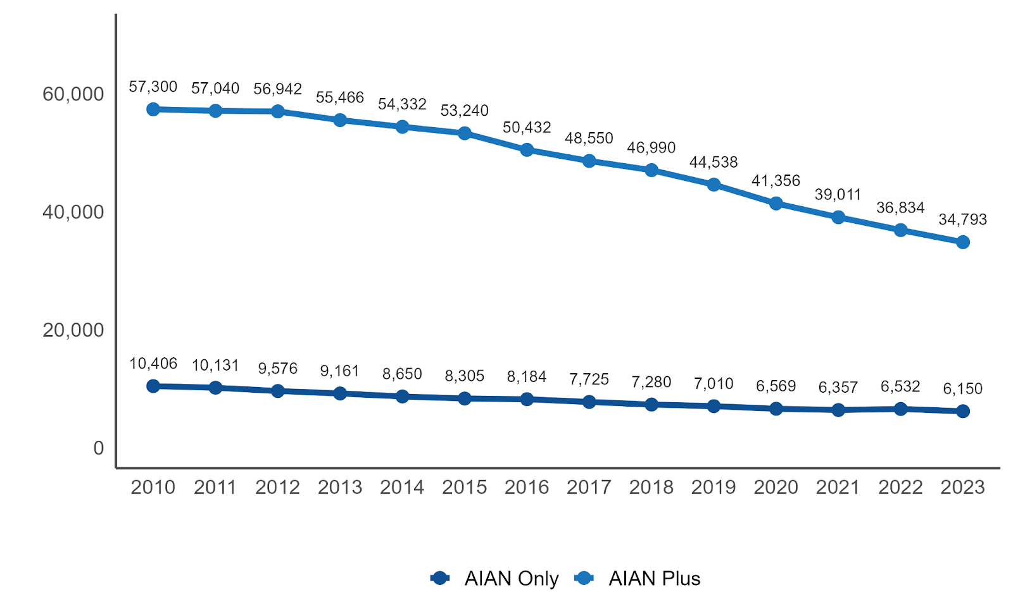
Such reductions undermine the Oregon Department of Education’s ability to measure AI/AN student outcomes accurately, potentially jeopardizing adequate district and state level funding, and perpetuating a cycle of erasure, misidentification and underservice for AI/AN students and staff.

Why This Matters
At the core of our educational mission lies a fundamental truth: every student, every family, every community must feel safe, seen and valued within our educational system. This imperative extends beyond mere data collection—it is a mandate to uphold the heart of our responsibilities as educators and stewards to fulfill our responsibilities with care and dedication.
Should you have any questions or require further clarification, please do not hesitate to contact our offices. Thank you for your dedication to supporting a diverse and inclusive educational environment.

Sincerely,
Dr. Charlene Williams
Director, Oregon Department of Education

Oregon Department of Education Executive Numbered Memo: 002-2023-24
For questions about the implementation of this change in SSID, ADM and district data collection practices, please contact Jon Wiens, Director of Reporting, Accountability & Data.
For programmatic questions, please contact April Campbell, Assistant Superintendent, Office of Indian Education.

