Publicity Toolkit: Requests for Applications for the Next Round of Workforce Ready Grants

The Higher Education Coordinating Commission (HECC) is accepting applications for the next round of Workforce Ready Grants from May 31 to July 31, 2024. The HECC will award a combined total of approximately $40 million to recruit and retain a diverse workforce in key sectors of Oregon’s economy—healthcare, manufacturing, and technology—through three sector-focused Requests for Applications (RFAs).
This publicity toolkit provides key messaging about the RFAs that we invite you to share with your contacts. Our objective is to ensure that eligible organizations are made aware of the RFAs and have the opportunity to apply.
The kit includes:
- Links to HECC resources for more information
- Talking points
- Sample emails
- Sample newsletter articles
- Sample social media posts

Links to HECC Resources for More Information
- Workforce Ready Grant Requests for Applications (RFAs) and related resources: https://www.oregon.gov/highered/about/pages/grants-contracts.aspx
- Higher Education Coordinating Commission (HECC) press release announcing the RFAs:
  - English version: https://content.govdelivery.com/accounts/ORHECC/bulletins/39fefce
  - Spanish version: https://content.govdelivery.com/accounts/ORHECC/bulletins/39e94ec
- Future Ready Oregon web page: https://www.oregon.gov/highered/about/pages/future-ready.aspx
- HECC resources for current and prospective Future Ready Oregon grantees: https://www.oregon.gov/highered/about/pages/future-ready-grant-resources.aspx
- Contact for more information: FutureReadyOregon@hecc.oregon.gov
- Subscribe to HECC news, including the Future Ready Oregon Update newsletter, for updates: https://public.govdelivery.com/accounts/ORHECC/subscriber/new

Talking Points
- Three sector-focused Requests for Applications (RFAs) are now open for the Higher Education Coordinating Commission’s (HECC’s) third round of Future Ready Oregon Workforce Ready Grants.
- Approximately $40 million is available, including:
  - $18 million for healthcare ($9 million for nursing career pathways and $9 million for community-identified healthcare workforce needs),
  - $12 million for manufacturing projects that focus on outreach, awareness, and career exploration, and/or on earn-and-learn education and training opportunities, and
  - $10 million for technology projects that focus on upskilling and retraining incumbent workers (adult learners, dislocated workers, and individuals employed in high-tech and other industries), and/or on transferrable technology skills, training, and career awareness.
- Workforce service providers and community-based organizations are invited to apply by July 31, 2024.
- Applicants are invited to access free support and technical assistance during the grant application period. Support includes information sessions and answers to frequently asked questions—as well as access to technical assistance providers who can help applicants understand the terms and requirements of the RFAs, and provide feedback on application materials.
- RFA materials and supporting documents are available in English and Spanish; additional language translation and support is available upon request.
- Visit the HECC Grant and Contract Opportunities web page to view the RFAs, apply, and access resources for application support.
- This is the final round of competitive grant funding available through the Oregon Legislature’s 2022 investment known as Future Ready Oregon. Learn more about Future Ready Oregon at: https://www.oregon.gov/highered/about/pages/future-ready.aspx
- Workforce Ready Grants advance a diverse workforce in healthcare, manufacturing, and technology, specifically advancing opportunities for priority populations, which include: communities of color, women, low-income communities, rural and frontier communities, veterans, persons with disabilities, incarcerated and formerly incarcerated individuals, members of Oregon’s tribes, older adults, and individuals who identify as members of the LGBTQ+ community.
- Workforce Ready Grants invest in new and innovative education and training programs that center partnerships that include employers, education providers, and community-based organizations, and that provide for culturally specific and responsive education and training, coupled with wraparound services.
- Building on the foundational principles of Future Ready Oregon, the sector-specific priorities of the RFAs were informed by the Healthcare, Manufacturing, and Technology Industry Consortia. Industry Consortia were established by Future Ready Oregon; they convene industry, education, labor, and community partners to identify and address sector-specific workforce development challenges and opportunities.
- These grants are funded by the federal American Rescue Plan Act (ARPA).
- Successful applicants will be notified in late 2024.

Sample Emails

Brief Email
Subject Line: Apply for Future Ready Oregon Workforce Ready Grants by July 31, 2024
The Oregon Higher Education Coordinating Commission (HECC) is now accepting applications for the next round of Future Ready Oregon Workforce Ready Grants. The HECC will award a combined total of approximately $40 million to recruit and retain a diverse workforce in key sectors of Oregon’s economy—healthcare, manufacturing, and technology—through three sector-focused Requests for Applications (RFAs). Workforce service providers and community-based organizations are invited to apply by July 31, 2024, and may submit multiple applications.
The available funding includes approximately:
- $18 million for healthcare projects—specifically, $9 million for projects that advance nursing career pathways and $9 million for projects that address community-identified healthcare workforce needs,
- $12 million for manufacturing projects that focus on outreach, awareness, and career exploration, and/or on earn-and-learn education and training opportunities, and
- $10 million for technology projects that focus on upskilling and retraining incumbent workers (adult learners, dislocated workers, and individuals employed in high-tech and other industries), and/or on transferrable technology skills, training, and career awareness.
To view the RFAs, apply, and access free resources for support, visit the HECC’s Grant and Contract Opportunities web page. You can also read the HECC press release here and learn more about Future Ready Oregon on the HECC website.
Please direct any questions to FutureReadyOregon@hecc.oregon.gov.

Detailed Email
Subject Line: Apply for Future Ready Oregon Workforce Ready Grants by July 31, 2024
The Oregon Higher Education Coordinating Commission (HECC) is now accepting applications for the third round of Future Ready Oregon Workforce Ready Grants. The HECC will award a combined total of approximately $40 million to recruit and retain a diverse workforce in key sectors of Oregon’s economy—healthcare, manufacturing, and technology—through three sector-focused RFAs. Workforce service providers and community-based organizations are invited to apply by July 31, 2024, and may submit multiple applications. Read the HECC press release here.
Future Ready Oregon is a comprehensive $200 million investment package that supports the education and training Oregonians need for good-paying jobs, prioritizing equitable program participation by individuals from underserved and underrepresented communities. You can learn more about Future Ready Oregon on the HECC website. Workforce Ready Grants are the largest component of the Future Ready Oregon investment package.
Workforce Ready Grant funding focuses on innovative and collaborative workforce development programming in the healthcare, manufacturing, and technology industry sectors. Grant-funded projects will build or expand collaborative and innovative partnerships that actively engage employers, education and training providers, and community-based organizations. These partnerships will advance a diverse workforce by identifying barriers to participation, program completion, and career advancement, and connecting priority populations with the training and resources they need for good-paying jobs and meaningful careers.
The available funding includes approximately:
- $18 million for healthcare projects—specifically, $9 million for projects that advance nursing career pathways and $9 million for projects that address community-identified healthcare workforce needs,
- $12 million for manufacturing projects that focus on outreach, awareness, and career exploration, and/or earn-and-learn education and training opportunities, and
- $10 million for technology projects that focus on upskilling and retraining incumbent workers (adult learners, dislocated workers, and individuals employed in high-tech and other industries), and/or transferrable technology skills, training, and career awareness.
Who is Eligible
The HECC welcomes applications from workforce service providers and community-based organizations that administer workforce programs in the healthcare, manufacturing, or technology sectors and prioritize equitable program participation by individuals from priority populations.
How to Apply
The RFA documents—which detail eligible activities, timelines, guidelines, and requirements for applications—can be found on HECC’s Grant and Contract Opportunities web page. The RFAs have been posted in both English and Spanish and can be made available in additional languages upon request. The application deadline is July 31, 2024.
Support for Applicants
Potential applicants have access to technical assistance providers who can help them understand the terms and requirements of the RFAs, as well as provide feedback on application materials, free of charge. Contact information for technical assistance providers is included in the RFAs.
Additionally, the HECC will host six virtual information sessions. These sessions are free, and participation is optional but encouraged. To register, click on the session below that works best for your schedule:
- Healthcare RFA: Session 1, Monday, June 10, 12:30–1:30 PM
- Healthcare RFA: Session 2, Monday, June 17, 2:00–3:00 PM

- Manufacturing RFA: Session 1, Monday, June 10, 2:00–3:00 PM
- Manufacturing RFA: Session 2, Friday, June 21, 11:00 AM–12:00 PM

- Technology RFA: Session 1, Monday, June 10, 11:00 AM–12:00 PM
- Technology RFA: Session 2, Thursday, June 20, 3:00–4:00 PM
Once you have registered, you will receive an email with the meeting link. Please email FutureReadyOregon@hecc.oregon.gov if you do not receive the link. Recordings of these sessions will also be made available on the HECC’s YouTube channel.
If you would like to receive updates on the implementation of Future Ready Oregon, please subscribe to the HECC Future Ready Oregon listserv.

Sample Newsletter Articles

Brief Article (84 words)
The Oregon Higher Education Coordinating Commission (HECC) is now accepting applications for the next round of Future Ready Oregon Workforce Ready Grants. The HECC will award a combined total of approximately $40 million to recruit and retain a diverse workforce in key sectors of Oregon’s economy—healthcare, manufacturing, and technology—through three sector-focused Requests for Applications (RFAs). Workforce service providers and community-based organizations are invited to apply by July 31, 2024. Visit www.oregon.gov/highered/about/pages/grants-contracts.aspx to view the RFAs, apply, and access free resources for support.

Detailed Article (265 words)
The Oregon Higher Education Coordinating Commission (HECC) invites workforce service providers and community-based organizations to apply for the next round of Future Ready Oregon Workforce Ready Grants by July 31, 2024. The HECC will award a combined total of approximately $40 million to recruit and retain a diverse workforce in key sectors of Oregon’s economy—healthcare, manufacturing, and technology—through three sector-focused Requests for Applications (RFAs). Visit www.oregon.gov/highered/about/pages/grants-contracts.aspx to view the RFAs, apply, and access support. The available funding includes approximately:
- $18 million for healthcare projects—specifically, $9 million for projects that advance nursing career pathways and $9 million for projects that address community-identified healthcare workforce needs,
- $12 million for manufacturing projects that focus on outreach, awareness, and career exploration, or earn-and-learn education and training opportunities, and
- $10 million for technology projects that focus on upskilling and retraining adult learners, dislocated workers, and individuals employed in high-tech and other industries, or on transferrable technology skills, training, and career awareness.
Future Ready Oregon is a $200 million investment package that supports the education and training Oregonians need for good-paying jobs, prioritizing equitable program participation by individuals from underserved and underrepresented communities. Workforce Ready Grants, the largest component of the Future Ready Oregon investment package, advance innovative and collaborative workforce development programming. Grant-funded projects will build or expand collaborative and innovative partnerships that actively engage employers, education and training providers, and community-based organizations. Successful partnerships will advance a diverse workforce by identifying barriers to participation, program completion, and career advancement, and connecting priority populations with the training and resources they need for good-paying jobs and meaningful careers.

Sample Social Media Posts
Use the following text and graphics to create social media posts announcing the Requests for Applications (RFAs).

X
- Text:
@OregonHECC is now accepting applications for approx. $40M in Healthcare, Manufacturing, and July 31! https://www.oregon.gov/highered/about/pages/grants-contracts.aspx
#FutureReadyOregon #workforce
- Download graphic or see below.
- ALT text for graphic: Teal, blue, and white poster with text announcing that the Requests for Applications are open.

Facebook
- Text:
Calling workforce service providers and community-based organizations: the #Oregon Higher Education Coordinating Commission (HECC) is now accepting applications for the next round of Future Ready Oregon Workforce Ready Grants. The HECC will award a combined total of approximately $40 million to recruit and retain a diverse workforce in key sectors of Oregon’s economy—healthcare, manufacturing, and technology—through three sector-focused Requests for Applications (RFAs). Applications are due July 31, 2024. Visit www.oregon.gov/highered/about/pages/grants-contracts.aspx to view the RFAs, apply, and access free resources for support.
Learn more about Future Ready Oregon here: https://www.oregon.gov/highered/about/pages/future-ready.aspx
#WorkforceReady #FutureReadyOregon
- Download graphic or see below.
- ALT text for graphic: Teal, blue, and white poster with text announcing that the Requests for Applications are open.

LinkedIn
- Text:
The Oregon Higher Education Coordinating Commission (HECC) is now accepting applications for the third and final round of Future Ready Oregon Workforce Ready Grants. The HECC will award a combined total of approximately $40 million to recruit and retain a diverse workforce in key sectors of Oregon’s economy—healthcare, manufacturing, and technology—through three sector-focused Requests for Applications (RFAs). Workforce service providers and community-based organizations are invited to apply by July 31, 2024.
Visit www.oregon.gov/highered/about/pages/grants-contracts.aspx to view the RFAs, apply, and access free resources for support.
#Oregon #WorkforceReady #FutureReadyOregon
- Download graphic or see below.
- ALT text for graphic: Teal, blue, and white poster with text announcing that the Requests for Applications are open.

Graphic for X:
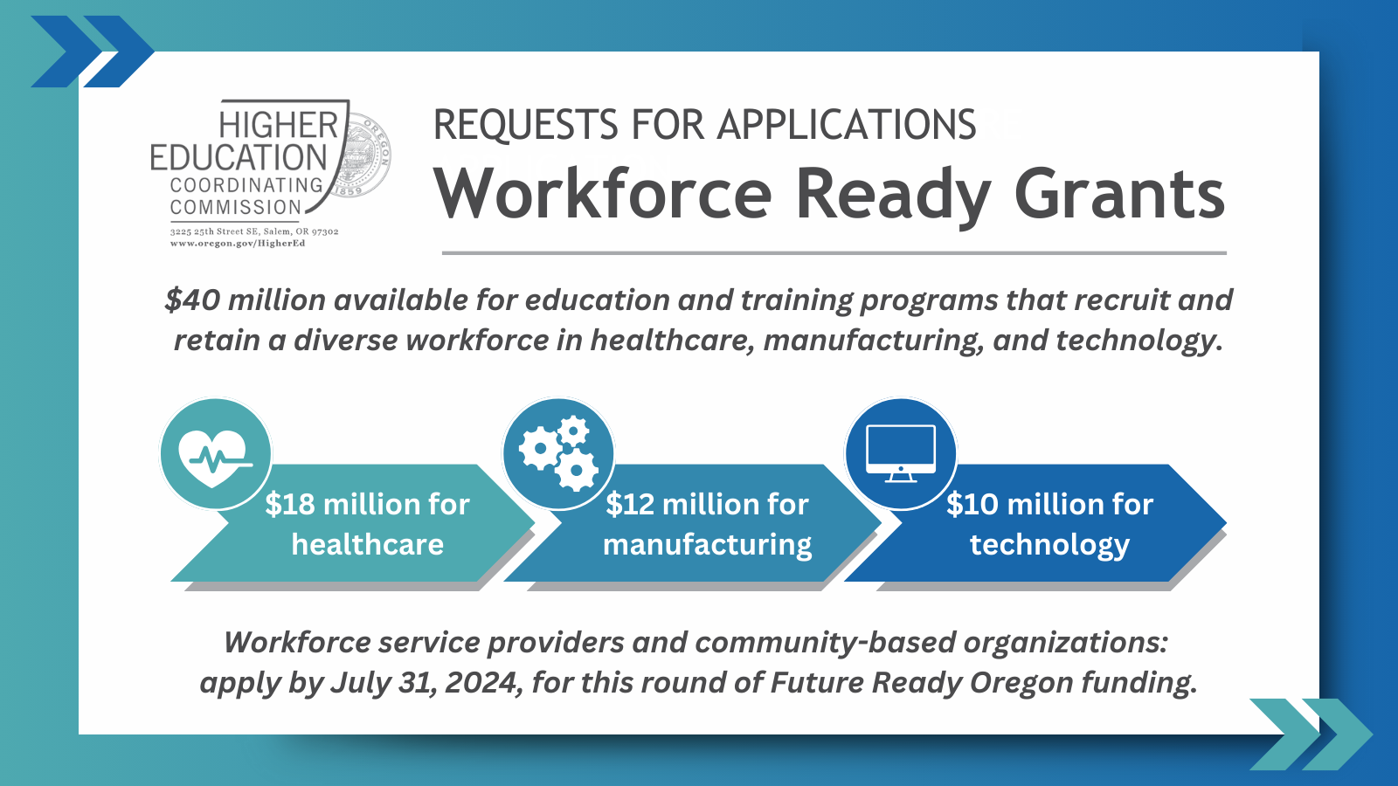

Graphic for Facebook / LinkedIn (see next page):
