State of Oregon

Contract for Services

|  |
| --- |
| Insert Agency Specific Information Here |

This Contract for Services (this “Contract”) is by and between the State of Oregon, acting through its [_________], (“Agency)” and ________, a [_______][doing business as _____] (“Contractor”) and is effective as of the Effective Date.

|  |  |
| --- | --- |
| Contractor’s Contract Administrator for this Contract is:  Name and Title  **Address  **City, State ZIP  Phone: (xxx) xxx-xxxx  Fax: (xxx) xxx-xxxx  [anyname@yahoo.com](mailto:anyname@yahoo.com) | Agency's Contract Administrator for this Contract is:  Contract Administrator Name, Title  Agency-Division  **Address  **City, State ZIP  Phone: (xxx) xxx-xxxx  Fax: (xxx) xxx-xxxx  [anyname@oregon.gov](mailto:anyname@oregon.gov) |

Either party may change its Contract Administrator by providing the other notice in compliance with Section 17.6 of this Contract.

1. Contract Term.

*[OPTION 1]* The “Effective Date” of this Contract is the later of (i) ____, or (ii) the date this Contract has been fully executed by each party and approved as required by applicable law. Unless extended or terminated earlier in accordance with its terms, this Contract terminates when Agency accepts Contractor's completed performance. The termination of this Contract will not extinguish or prejudice Agency’s right to enforce this Contract with respect to any default by Contractor that has not been cured.

***[OPTION 2]*** The “Effective Date” of this Contract is the later of (i) ____, or (ii) the date this Contract has been fully executed by each party and, approved as required by applicable law. Unless extended or terminated earlier in accordance with its terms, this Contract terminates on _____. The termination of this Contract will not extinguish or prejudice Agency’s right to enforce this Contract with respect to any default by Contractor that has not been cured.

1. Contract Documents. This Contract consists of the following documents, which are listed in descending order of precedence:
   1. this Contract less all exhibits;
   2. Exhibit D, (Federal Terms and Conditions);
   3. Exhibit C (Special Terms and Conditions);
   4. Exhibit A (Statement of Work);
   5. Exhibit B (Required Insurance), and
   6. Exhibit E (Independent Contractor Certification)
   7. Exhibit F [AGENCY SPECIFIC EXHIBIT-IF NEEDED]

The foregoing documents and Exhibits are attached hereto and made a part of the Contract by this reference.

1. Services.
   1. **Performance of Services.** Contractor shall perform the services (the “Services”) and deliver to agency the deliverables (“Deliverables”) set forth in Exhibit A, the Statement of Work (the “Statement of Work”). The Statement of Work includes the delivery schedule for the Deliverables and Services. Contractor shall perform the Services in accordance with the terms and conditions of this Contract.
   2. **Submission and Acceptance of Deliverables.** When the Statement of Work requires Contractor to deliver Deliverables to Agency, then Contractor shall deliver Deliverables that comply with the requirements and acceptance criteria set forth in the Statement of Work. Contractor shall provide written notice to Agency upon delivery of a completed Deliverables to Agency. By no later than (i) 15 business days after receipt of such notice, or (ii) the date or period for review set forth in the Statement of Work, Agency will determine whether the Deliverables has the characteristics and otherwise meets the acceptance criteria set forth in the Statement of Work. If Agency determines that the Deliverables has the characteristics and meets acceptance criteria set forth in the Statement of Work in all material respects, Agency will notify Contractor in writing of Agency’s acceptance of the Deliverables.
   3. **Rejection of Deliverables; Corrections.** If Agency determines that a Deliverables does not have the characteristics or otherwise meet the acceptance criteria set forth in the Statement of Work in all material respects, Agency will notify Contractor in writing of Agency’s rejection of the Deliverables, and describe in reasonable detail in such notice the Agency’s basis for rejection of the Deliverables. Upon receipt of notice of non-acceptance, Contractor shall, within a 15 business day period, modify or improve the Deliverables at Contractor’s sole expense so that the Deliverables has the characteristics described in the Statement of Work and meets, in all material respects, the acceptance criteria, and notify the Agency in writing that it has completed such modifications or improvements and re-tender the Deliverables to Agency. Agency will thereafter review the modified or improved Deliverables within 15 business days of receipt of the Contractor's delivery of the Deliverables. Failure of the Deliverables to have the characteristics or meet in all material respects the acceptance criteria set forth in the Statement of Work after the second submission will constitute a default by Contractor. In the event of such default, Agency may either, (i) notify Contractor of such default and instruct Contractor to modify or improve the Deliverables as set forth in this Section, or (ii) notify Contractor of such default and pursue its remedies for default provided for by law or the terms of this Contract.
2. Compensation.
   1. **Not to Exceed Compensation**. The maximum, not-to-exceed compensation payable to Contractor under this Contract, which includes any allowable expenses, is $***,***.**. Agency will not pay Contractor any amount in excess of the not-to-exceed compensation of this Contract, and will not pay for Services performed before the Effective Date or after the expiration or termination of this Contract. If the maximum compensation is increased by amendment of this Contract, the amendment must be fully effective before Contractor performs Services subject to the amendment.
   2. **Payments**. Payments, including interim payments, to Contractor are subject to ORS 293.462, will be made only for completed and accepted Deliverables and Services, and will be made in accordance with the payment schedule and requirements set forth in Exhibit A.
   3. **Invoices**. Contractor shall submit invoices to Agency as set forth in the Statement of Work or, if not set forth therein, to Agency’s Contract Administrator. Contractor may submit invoices in accordance with the payment schedule set forth in the Statement of Work or, if no payment schedule is set forth therein, then no more frequently than once per month for accepted Deliverables and Services The invoices must describe all Services performed with particularity, including the dates Contractor performed the Services for which it is requesting payment, and by whom the Services were performed and shall itemize and explain all expenses that this Contract requires Agency to pay and for which Contractor claims reimbursement. [OPTIONAL: *Each invoice must also include the total amount invoiced to date by Contractor prior to the current invoice. Contractor will specifically note in the appropriate invoice when it has requested payment for one-third and two-thirds of the maximum, not-to-exceed compensation.]*
   4. **Expenses.** Agency will not pay or reimburse any expenses incurred by Contractor during the completion of the Services except as authorized in the Statement Work or elsewhere in this Contract. Any such authorized travel expenses must comply with the Oregon Travel Policy available on the Internet at: <http://www.oregon.gov/das/cfo/sars/policies/oam/40.10.00.pdf>
   5. **Funds Available and Authorized**. Contractor will not be compensated for Services performed under this Contract by any agency or department of the State of Oregon other than Agency. Agency believes it has sufficient funds currently available and authorized for expenditure to make payments under this Contract within Agency’s biennial appropriation or limitation. Contractor understands and agrees that Agency’s payments under this Contract are contingent on Agency receiving appropriations, limitations, or other expenditure authority sufficient to allow Agency, in the exercise of its reasonable administrative discretion, to continue to make payments under this Contract.
3. Contractor’s Personnel.
   1. **Key Persons**. Contractor acknowledges and agrees that Agency selected Contractor, and is entering into this Contract, because of the special qualifications of Contractor's key persons identified in the Statement of Work (each a “Key Person” and, together, “Key Persons”). Neither Contractor nor a Key Person may delegate performance of the powers and responsibilities that a Key Person is required to provide under this Contract to another Contractor employee, subcontractor or agent without first obtaining the written consent of Agency. Further, Contractor may not re-assign or transfer a Key Person to other duties or positions such that the Key Person is no longer available to provide the Agency with the required expertise, experience, judgment, and personal attention, without first obtaining Agency's written consent to such re-assignment or transfer, which Agency will not unreasonably withhold or delay. Notwithstanding the foregoing, Contractor may replace a Key Person in the event the Key Person is no longer available due to circumstances beyond Contractor’s reasonable control, such as death, illness, or termination of employment with Contractor. In the event Contractor requests that Agency approve a re-assignment or transfer of a Key Person, or if Contractor must replace a Key Person, Agency may interview, review the qualifications of, and approve or reject the proposed replacement for the Key Person. Any such replacement must have substantially equivalent or better qualifications than the Key Person being replaced. Any replacement personnel approved by Agency in writing (email acceptable) will thereafter be deemed a Key Person for purposes of this Contract, and the Statement of Work will be deemed amended to include such Key Person.
   2. **Payment for Replacement Key Personnel.** If Agency is paying Contractor on an hourly or other periodic basis, then Contractor will not charge Agency, and Agency will not pay, for a replacement Key Person while such replacement acquires the project knowledge and skills necessary to perform the Services. Such period of non-charge will be agreed upon by the parties.
   3. **State Premises**. Contractor and Contractor staff shall comply with all policies, rules, procedures, and regulations established by Agency and the State for access to and activities in and around premises controlled by Agency or any other agency of the State.
4. Independent Contractor; Responsibility For Taxes And Withholding
   1. **Independent Contractor.** Contractor shall perform all Services as an independent contractor. Agency reserves the right (i) to determine and modify the delivery schedule for the Services and (ii) to evaluate the quality of the Services; however, Agency may not and will not control the means or manner of Contractor's performance. Contractor is responsible for determining the appropriate means and manner of performing the Services.
   2. **No Conflicts**. Contractor, by signature to this Contract, represents and warrants that Contractor’s performance of the Services under this Contract creates no potential or actual conflict of interest as defined by ORS 244; and no statutes, rules or regulations of any State of Oregon or federal agency for which Contractor currently performs work would prohibit Contractor from performing the Services under this Contract.
   3. **Affiliation**. Contractor understands and agrees that it is not an "officer," "employee," or "agent" of the State of Oregon, as those terms are used in ORS 30.265 or otherwise.
   4. **Taxes and Benefits**. Contractor is responsible for all federal or state taxes applicable to compensation or payments paid to Contractor under this Contract and, unless required by applicable law, Agency will not withhold from such compensation or payments any amount to cover Contractor's federal or state tax obligations. Contractor is not eligible for any social security, unemployment insurance or workers' compensation benefits from compensation or payments paid to Contractor under this Contract, except as a self‑employed individual.
5. Subcontracts, Successors, And Assignments
   1. **Subcontracts.** Contractor shall not enter into any subcontracts for any of the Services required by this Contract without Agency's prior written consent. In addition to any other provisions Agency may require, Contractor shall include in any permitted subcontract under this Contract provisions to ensure that Agency will receive the benefit of subcontractor’s performance as if the subcontractor were Contractor. Agency’s consent to any subcontract does not relieve Contractor of any of its duties or obligations under this Contract.
   2. **Successors and Assigns.** The provisions of this Contract are binding upon and inure to the benefit of the parties to this Contract, their respective successors, and permitted assigns, if any.
   3. **No Assignment.** Contractor shall not assign or transfer any of its rights or delegate its obligations under this Contract without Agency’s prior written consent.
6. Representations and Warranties.
   1. **Contractor’s General Representations and Warranties.** Contractor represents and warrants to Agency that:
      1. Contractor has the power and authority to enter into and perform this Contract;
      2. This Contract, when executed and delivered, is a valid and binding obligation of Contractor enforceable in accordance with its terms;
      3. Contractor shall, at all times during the term of this Contract, be qualified, professionally competent, and duly licensed to perform the Services;
      4. Contractor prepared its proposal related to this Contract, if any, independently from all other proposers, and without collusion, fraud, or other dishonesty; and
      5. Contractor (to the best of Contractor’s knowledge, after due inquiry), for a period of no fewer than six calendar years preceding the Effective Date, faithfully has complied with:
         1. All tax laws of this state, including but not limited to ORS 305.620 and ORS chapters 316, 317, and 318;
         2. Any tax provisions imposed by a political subdivision of this state that applied to Contractor, to Contractor’s property, operations, receipts, or income, or to Contractor’s performance of or compensation for any work performed by Contractor;
         3. Any tax provisions imposed by a political subdivision of this State that applied to Contractor, or to goods, services, or property, whether tangible or intangible, provided by Contractor;
         4. Any rules, regulations, charter provisions, or ordinances that implemented or enforced any of the foregoing tax laws or provisions; and
      6. Contractor has no undisclosed liquidated and delinquent debt owed to the State or any department or agency of the State.
   2. **Contractor’s Performance Warranties.**
      1. Contractor has the skill and knowledge possessed by well-informed members of its industry, trade or profession and Contractor shall apply that skill and knowledge with care and diligence to perform the Services in a professional manner and in accordance with the highest standards prevalent in Contractor’s industry, trade or profession;
      2. The Services and each Deliverables delivered by Contractor pursuant to the Services will materially comply with any service descriptions, specifications, standards or requirements set forth in this Contract;
      3. Except as otherwise provided in this Contract (including Section 9), Contractor shall transfer all Deliverables to Agency free and clear of any and all restrictions on or conditions of transfer, modification, licensing, sublicensing, direct or indirect distribution, or assignment, and free and clear of any and all liens, claims, mortgages, security interests, liabilities, and encumbrances of any kind; and
      4. Except as otherwise set forth in this Contract, any subcontractors performing work for Contractor under this Contract have assigned all of their rights in the Deliverables to Contractor or Agency and no third party has any right, title or interest in any Deliverables supplied to Agency under this Contract.
   3. **Warranties cumulative**. The warranties set forth in Section 8 are in addition to, and not in lieu of, any other warranties set forth elsewhere in this Contract.
7. Ownership of Work Product.
   1. **Definitions**. As used in this Section 9, and elsewhere in this Contract, the following terms have the meanings set forth below:
      1. “Contractor Intellectual Property” means any intellectual property owned by Contractor and developed independently from the Services.
      2. “Third Party Intellectual Property” means any intellectual property owned by parties other than Agency or Contractor.
      3. “Work Product” means everything that is originally made, conceived, discovered, or reduced to practice by Contractor or Contractor’s subcontractors or agents (either alone or with others) pursuant to this Contract, including every invention, modification, discovery, design, development, customization, configuration, improvement, process, work of authorship, documentation, formula, datum, technique, know how, secret, or intellectual property right whatsoever or any interest therein (whether patentable or not patentable or registerable under copyright or similar statutes or subject to analogous protection).
   2. **Original Works**. All Work Product created by Contractor pursuant to the Services, including derivative works and compilations of Work Product, and whether or not such Work Product is considered a work made for hire or an employment to invent, is the exclusive property of Agency. Agency and Contractor agree that such Work Product is “work made for hire” of which Agency is the author within the meaning of the United States Copyright Act. If for any reason the Work Product is not “work made for hire,” Contractor hereby irrevocably assigns to Agency any and all of its rights, title, and interest in all Work Product, whether arising from copyright, patent, trademark, trade secret, or any other state or federal intellectual property law or doctrine. Upon Agency’s reasonable request, Contractor shall execute such further documents and instruments necessary to fully vest such rights in Agency. Contractor forever waives any and all rights relating to Work Product, including without limitation, any and all rights arising under 17 USC §106A or any other rights of identification of authorship or rights of approval, restriction or limitation on use or subsequent modifications.
   3. **License in Contractor Intellectual Property**. In the event that a Deliverables delivered by Contractor under this Contract is or is a derivative work based on Contractor Intellectual Property, or is a compilation that includes Contractor Intellectual Property, Contractor hereby grants to Agency an irrevocable, non-exclusive, perpetual, royalty-free license to use, reproduce, prepare derivative works based upon, distribute copies of, perform and display the pre-existing elements of the Contractor Intellectual Property employed in the Deliverables, and to authorize others to do the same on Agency’s behalf.
   4. **License in Third Party Intellectual Property**. In the event that a Deliverables delivered by Contractor under this Contract is or is a derivative work based on Third Party Intellectual Property, or is a compilation that includes Third Party Intellectual Property, Contractor shall secure on the Agency’s behalf and in the name of the Agency an irrevocable, non-exclusive, perpetual, royalty-free license to use, reproduce, prepare derivative works based upon, distribute copies of, perform and display the pre-existing elements of the Third Party Intellectual Property employed in the Deliverables, and to authorize others to do the same on Agency’s behalf.
   5. **No Rights**. Except as expressly set forth in this Contract, nothing in this Contract may be construed as granting to or conferring upon Contractor any right, title, or interest in any intellectual property that is now owned or subsequently owned by Agency. Except as expressly set forth in this Contract, nothing in this Contract may be construed as granting to or conferring upon Agency any right, title, or interest in any Contractor Intellectual Property that is now owned or subsequently owned by Contractor.
   6. **Marks**. Neither party grants the other the right to use its trademarks, trade names, service marks or other designations in any promotion or publication without prior written consent. Each party grants only the licenses and rights specified in this Contract.
   7. **Competing Services**. Subject to the provisions of this Section 9, and Contractor’s obligations with respect to Confidential Information, including as defined in Section 10, nothing in this Contract precludes or limits in any way the right of Contractor to: (i) provide services similar to those contemplated in this Contract, or consulting or other services of any kind or nature whatsoever to any individual or entity as Contractor in its sole discretion deems appropriate, or (ii) develop for Contractor or for others, Deliverables or other materials that are competitive with those produced as a result of the Services provided hereunder, irrespective of their similarity to the Deliverables delivered pursuant to this Contract. Each party is free to utilize any concepts, processes, know-how, techniques, improvements or other methods it may develop during the course of performance under this Contract free of any use restriction or payment obligation to the other.
8. Confidential Information.
   1. **Confidential Information**. Contractor acknowledges that it and its employees, officers, directors, agents or subcontractors (collectively, “Contractor Staff”) may, in the course of performing the Services under this Contract, be exposed to or acquire information that is confidential to Agency or Agency’s clients. Any and all information of any form (including but not limited to records, files, papers, materials, documents, and communications in written, verbal, oral and electronic form) that Contractor or any Contractor Staff may come into contact with or that is obtained by Contractor or Contractor Staff in the performance of this Contract shall be considered for the purposes of this Contract the confidential information of Agency (“Confidential Information”). Contractor shall, and shall cause Contractor Staff to treat any reports or other documents or items (including software) that result from the use of the Confidential Information in the same manner as the Confidential Information. Confidential Information does not include information that (i) is or becomes (other than by disclosure by Contractor or Contractor Staff acquiring such information) publicly known or is contained in a publicly available document except to the extent applicable law still restricts disclosure; (ii) is furnished by Agency to others without restrictions similar to those imposed by this Contract; (iii) is rightfully in Contractor’s possession without the obligation of nondisclosure prior to the time of its disclosure under this Contract; (iv) is obtained from a source other than Agency without the obligation of confidentiality, (v) is disclosed with the written consent of Agency, or; (vi) is independently developed by Contractor or Contractor Staff who can be shown to have had no access to the Confidential Information.
   2. **Non-Disclosure**. Contractor shall hold, and shall cause Contractor Staff to hold, all Confidential Information in confidence, using the highest standard of care applicable, and shall not copy, reproduce, sell, assign, license, market, transfer, distribute, or otherwise dispose of, give, make available or disclose, in whole or in part, directly or indirectly, Confidential Information to third parties (other than its authorized subcontractors), or use Confidential Information for any purposes whatsoever other than the provision of Services to Agency hereunder, and shall advise Contractor Staff of their obligations to keep Confidential Information confidential. Contractor shall assist Agency in identifying and preventing any unauthorized use or disclosure of any Confidential Information. Without limiting the generality of the foregoing, Contractor shall advise Agency immediately in the event Contractor learns or has reason to believe that any person who has had access to Confidential Information has violated or intends to violate the terms of this Contract, and Contractor will at its expense cooperate with Agency in seeking injunctive or other equitable relief in the name of Agency or Contractor against any such person. Contractor shall not at any time during or after the term of this Contract, except as directed by Agency, disclose, directly or indirectly, any Confidential Information to any person, except in accordance with this Contract. Upon expiration or termination of this Contract or at Agency’s request, Contractor shall deliver to Agency all documents, papers, and other matter in Contractor's possession that embody Confidential Information. Notwithstanding the foregoing and unless otherwise specified in this Contract, Contractor may keep one copy of such Confidential Information necessary for quality assurance, audits and evidence of performance of the Services.
   3. **Confidentiality Policies**. Contractor shall, upon Agency’s request, provide its policies and procedures for safeguarding Confidential Information to Agency for Agency’s review and consent. Such policies must address information conveyed in oral, written, and electronic format and include procedures for how Contractor will respond when a violation or possible violation occurs.
   4. **Injunctive Relief**. Contractor acknowledges that breach of this Section 10, including disclosure of any Confidential Information, will cause irreparable injury to Agency that is inadequately compensable in damages. Accordingly, Agency may seek and obtain injunctive relief against the breach or threatened breach of the foregoing undertakings, in addition to any other legal remedies that may be available. Contractor acknowledges and agrees that the covenants contained herein are necessary for the protection of the legitimate business interests of Agency and are reasonable in scope and content.
   5. **Publicity**. Contractor agrees that it will not disclose the form, content or existence of this Contract or any Deliverables in any advertising, press releases or other materials distributed to prospective customers, or otherwise attempt to obtain publicity from its association with Agency or the State of Oregon, whether or not such disclosure, publicity or association implies an endorsement by Agency or the State of Oregon of Contractor’s services, without the prior written consent of Agency.
9. Indemnity by Contractor.
   1. **Claims**. Contractor shall defend, save, hold harmless, and indemnify the State of Oregon and Agency and their officers, employees and agents from and against all third party claims, suits, actions, losses, damages, liabilities, costs (including attorneys’ fees) and expenses (collectively, "Claims") of any nature whatsoever resulting from, arising out of, or relating to the activities of Contractor or its officers, employees, subcontractors, or agents under this Contract, including but not limited to, unauthorized disclosure of Confidential Information, professional malfeasance, infringement of intellectual property rights, intentional, willful, or wanton wrongful acts, and acts outside the scope of Services set forth in this Contract.
   2. **Legal Counsel**. If Contractor is required to defend the State of Oregon or Agency or their officers, employees or agents under Section 11.1, then Contractor shall select legal counsel reasonably acceptable to the Oregon Attorney General to act in the name of, or represent the interests of, the State of Oregon, Agency or their officers, employees and agents. Such legal counsel must accept appointment as a special assistant attorney general under ORS chapter 180 before such action or representation. Further, the State of Oregon, acting by and through its Department of Justice, may assume its own defense, including that of its officers, employees and agents, at any time when in the State of Oregon's sole discretion it determines that (i) proposed counsel is prohibited from the particular representation contemplated; (ii) counsel is not adequately defending the interests of the State of Oregon or its officers, employees and agents; (iii) important governmental interests are at stake; or (iv) the best interests of the State of Oregon are served thereby. Contractor's obligation to pay for all costs and expenses includes those incurred by the State of Oregon in assuming its own defense or that of its officers, employees, and agents under (i) and (ii) above.
   3. **Damages to State Property and Employees**. Contractor is liable for all Claims for personal injury, including death, damage to real property and damage to tangible and intangible personal property of the State of Oregon or any of its employees, subcontractors or agents resulting from, arising out of, or relating to the intentional, reckless or negligent acts or omissions of Contractor or its officers, employees, subcontractors, or agents under this Contract
   4. CONTRACTOR IS NOT AUTHORIZED TO SETTLE OR COMPROMISE ANY CLAIM REFERENCED IN THIS SECTION WITHOUT THE EXPRESS WRITTEN CONSENT OF AGENCY.
10. Limitation of Liabilities.
    1. EXCEPT FOR LIABILITY ARISING OUT OF OR RELATED TO (i) SECTION 10, OR (ii) SECTION 11, CONTRACTOR’S LIABILITY FOR DAMAGES FOR ANY CAUSE WHATSOEVER SHALL BE LIMITED TO ONE AND ONE HALF TIMES THE MAXIMUM-NOT-TO-EXCEED AMOUNT OF THIS CONTRACT.
    2. EXCEPT FOR LIABILITY TO THIRD PERSONS ARISING OUT OF OR RELATED TO (i) SECTION 10, OR (ii) SECTION 11, NEITHER PARTY WILL BE LIABLE TO THE OTHER FOR ANY LOST PROFITS, LOST SAVINGS, OR PUNITIVE, INDIRECT, EXEMPLARY, CONSEQUENTIAL, OR INCIDENTAL DAMAGES.
11. Insurance. Contractor shall maintain insurance as set forth in Exhibit B.
12. Default; Remedies; Termination.
    1. **Default by Contractor**. Contractor will be in default under this Contract if:
       1. Contractor institutes or has instituted against it insolvency, receivership or bankruptcy proceedings, makes an assignment for the benefit of creditors, or ceases doing business on a regular basis; or
       2. Contractor no longer holds a license or certificate that is required for Contractor to perform its obligations under the Contract and Contractor has not obtained such license or certificate within 14 calendar days after Agency’s notice or such longer period as Agency may specify in such notice; or
       3. Contractor commits any material breach or default of any covenant, warranty, obligation, certification, or agreement under this Contract, fails to perform the Services under this Contract within the time specified herein or any extension thereof, or so fails to pursue the Services as to endanger Contractor's performance under this Contract in accordance with its terms, and such breach, default or failure is not cured within 14 calendar days after Agency's notice, or such longer period as Agency may specify in such notice; or
       4. Contractor has liquidated and delinquent debt owed to the State of Oregon or any department or agency of the State.
    2. **Agency’s Remedies for Contractor’s Default**. In the event Contractor is in default under Section 14.1, Agency may, at its option, pursue any or all of the remedies available to it under this Contract and at law or in equity, including, but not limited to:
       1. Termination of this Contract under Section 14.6.2; or
       2. Withholding all monies due for Services and Deliverables that Contractor has failed to deliver within any scheduled completion dates or has performed inadequately or defectively; or
       3. Initiation of an action or proceeding for damages, specific performance, or declaratory or injunctive relief; or
       4. Exercise of its right of setoff, and withholding of amounts otherwise due and owing to Contractor, without penalty; or
       5. Undertaking collection by administrative offset, or garnishment if applicable, of all monies due for Services and Deliverables to recover liquidated and delinquent debt owed to the State of Oregon or any department or agency of the State. Offsets or garnishment may be initiated after the Contractor has been given notice if required by law.
    3. **Remedies Cumulative**. The remedies set forth in Section 14.2 are cumulative to the extent the remedies are not inconsistent, and Agency may pursue any remedy or remedies singly, collectively, successively or in any order whatsoever. If a court determines that Contractor was not in default under Sections 14.1, then Contractor will be entitled to the same remedies as if this Contract was terminated pursuant to Section 14.6.1.
    4. **Default by Agency**. Agency will be in default under this Contract if:
       1. Agency fails to pay Contractor any amount pursuant to the terms of this Contract, and Agency fails to cure such failure within 30 calendar days after Contractor’s notice or such longer period as Contractor may specify in such notice; or
       2. Agency commits any material breach or default of any covenant, warranty, or obligation under this Contract, and such breach or default is not cured within 30 calendar days after Contractor’s notice or such longer period as Contractor may specify in such notice.
    5. **Contractor’s Remedies**. In the event Agency terminates this Contract under Section 14.6.1, or is in default under Section 14.4, and whether or not Contractor elects to exercise its right to terminate the Contract under Section 14.6.3, Contractor’s sole monetary remedy will be (i) with respect to Services compensable at a stated rate, a claim for unpaid invoices, time worked within any limits set forth in this Contract but not yet invoiced and authorized expenses incurred and interest, subject to ORS 293.462, and (ii) with respect to Deliverables-based Services, a claim for the sum designated for completing the Deliverables multiplied by the percentage of Services completed and accepted by Agency, less previous amounts paid and any claim(s) that Agency has against Contractor. In no event will Agency be liable to Contractor for any expenses related to termination of this Contract or for anticipated profits. If previous amounts paid to Contractor exceed the amount due to Contractor under this Section 14.5, Contractor shall pay immediately any excess to Agency upon written demand.
    6. **Termination.**
       1. **Agency’s Right to Terminate at its Discretion**. Agency may terminate this Contract**:**
          1. Upon 30 calendar days’ prior written notice by Agency to Contractor;
          2. Immediately upon written notice by Agency to Contractor if Agency fails to receive funding, appropriations, limitations, allotments or other expenditure authority at levels sufficient to pay for the Services or Work Products; or
          3. Immediately upon written notice by Agency to Contractor if federal or state laws, regulations, or guidelines are modified or interpreted in such a way that the Agency’s purchase of the Services or Work Products under this Contract is prohibited or Agency is prohibited from paying for such Services or Work Products from the planned funding source.
       2. **Agency’s Right to Terminate for Cause.** In addition to any other rights and remedies Agency may have under this Contract, Agency may terminate this Contract immediately upon written notice by Agency to Contractor, or at such later date as Agency may establish in such notice, if Contractor is in default under Section 14.1.
       3. **Contractor’s Right to Terminate for Cause.** Contractor may terminate this Contract immediately upon written notice to Agency, or at such later date as Contractor may establish in such notice, if Agency is in default under Section 14.4.
    7. **Return of Property**. Upon termination of this Contract for any reason whatsoever, Contractor shall immediately deliver to Agency all of Agency’s property (including without limitation any Services or Work Products for which Agency has made payment in whole or in part) that is in the possession or under the control of Contractor in whatever stage of development and form of recordation such Agency property is expressed or embodied at that time.
    8. **Effect of Termination**. Upon receiving a notice of termination of this Contract, Contractor shall immediately cease all activities under this Contract, unless Agency expressly directs otherwise in such notice of termination. Upon Agency's request, Contractor shall surrender to anyone Agency designates, all documents, research or objects or other tangible things needed to complete the Services and the Deliverables.
13. Compliance with Law.
    1. **Compliance with Law Generally.** Contractor shall comply, and cause all subcontractors to comply with all federal, state and local laws, regulations, executive orders and ordinances applicable to this Contract and the performance of the Services. Without limiting the generality of the foregoing, Contractor expressly agrees to comply with the following laws, regulations and executive orders to the extent they are applicable to this Contract: (i) Titles VI and VII of the Civil Rights Act of 1964, as amended; (ii) Title V and Sections 503 and 504 of the Rehabilitation Act of 1973, as amended; (iii) the Americans with Disabilities Act of 1990 and ORS 659A.142, as amended; (iv) Executive Order 11246, as amended; (v) the Health Insurance Portability and Accountability Act of 1996, as amended by the Health Information Technology for Economic and Clinical Health (HITECH) Act portion of the American Recovery and Reinvestment Act of 2009 (ARRA), including the Privacy and Security Rules found at 45 CFR Parts 160 and 164, as the law and its implementing regulations may be updated from time to time; (vi) the Age Discrimination in Employment Act of 1967, as amended, and the Age Discrimination Act of 1975, as amended; (vii) the Vietnam Era Veterans’ Readjustment Assistance Act of 1974, as amended; (viii) Section 188 of the Workforce Investment Act (WIA) of 1998, as amended; (ix) ORS Chapter 659, as amended; (x) all regulations and administrative rules established pursuant to the foregoing laws; and (xi) all other applicable requirements of federal and state civil rights and rehabilitation statutes, rules and regulations. These laws, regulations and executive orders are incorporated by reference herein to the extent that they are applicable to the Contract and required by law to be so incorporated. Agency’s performance under the Contract is conditioned upon Contractor's compliance with the provisions of ORS 279B.220, 279B.225, 279B.230, 279B.235 and 279B.270 which are incorporated by reference herein. Contractor shall, to the maximum extent economically feasible in the performance of this Contract, use recycled paper (as defined in ORS 279A.010(1)(gg)), recycled PETE products (as defined in ORS 279A.010(1)(hh)), and other recycled products (as “recycled product” is defined in ORS 279A.010(1)(ii)).
    2. **Compliance with Oregon Tax Laws**.
       1. Contractor shall, throughout the duration of this Contract, comply with all tax laws of this state and all applicable tax laws of any political subdivision of this state. For the purposes of this section, “tax laws” includes the tax laws described in Section 8.1.5.1 through 8.1.5.4.
       2. Any violation of Section 15.2.1 constitutes a material breach of this Contract. Further, any violation of Contractor’s warranty in Section 8.1.5 of this Contract that Contractor has complied with the tax laws of this state and the applicable tax laws of any political subdivision of this state also constitutes a material breach of this Contract. Any violation entitles Agency to terminate this Contract, to pursue and recover any and all damages that arise from the breach and the termination of this Contract, and to pursue any or all of the remedies available under this Contract, at law, or in equity, including but not limited to:
          1. Termination of this Contract, in whole or in part;
          2. Exercise of the right of setoff, or garnishment if applicable, and withholding of amounts otherwise due and owing to Contractor without penalty; and
          3. Initiation of an action or proceeding for damages, specific performance, declaratory or injunctive relief. Agency is entitled to recover any and all damages suffered as the result of Contractor's breach of this Contract, including but not limited to direct, indirect, incidental and consequential damages, costs of cure, and costs incurred in securing replacement Services.
       3. These remedies are cumulative to the extent the remedies are not inconsistent, and Agency may pursue any remedy or remedies singly, collectively, successively, or in any order whatsoever.
    3. **Compliance with Federal Law**. Contractor shall comply with all applicable federal laws, including, without limitation, those set forth in Exhibit D, which is attached and incorporated into this Contract by this reference.
    4. **Pay Equity.** As required by [ORS 279B.235 or ORS 279C.520], Contractor shall comply with ORS 652.220 and shall not unlawfully discriminate against any of Contractor’s employees in the payment of wages or other compensation for work of comparable character on the basis of an employee’s membership in a protected class. “Protected class” means a group of persons distinguished by race, color, religion, sex, sexual orientation, national origin, marital status, veteran status, disability or age. Contractor’s compliance with this section constitutes a material element of this Contract and a failure to comply constitutes a breach that entitles Agency to terminate this Contract for cause.

Contractor may not prohibit any of Contractor’s employees from discussing the employee’s rate of wage, salary, benefits, or other compensation with another employee or another person. Contractor may not retaliate against an employee who discusses the employee’s rate of wage, salary, benefits, or other compensation with another employee or another person.

1. Governing Law; Venue and Jurisdiction.
   1. **Governing Law**. This Contract is governed by and construed in accordance with the laws of the State of Oregon without regard to principles of conflicts of law.
   2. **Venue and Jurisdiction**. Any claim, action, suit or proceeding between Agency (or any other agency or department of the State of Oregon) and Contractor that arises from or relates to this Contract must be brought and conducted solely and exclusively within the Circuit Court of Marion County for the State of Oregon. CONTRACTOR, BY EXECUTION OF THIS CONTRACT, HEREBY CONSENTS TO THE IN PERSONAM JURISDICTION OF SAID COURTS. In no event may this section be construed as (i) a waiver by the State of Oregon of any form of defense or immunity, whether it is sovereign immunity, governmental immunity, immunity based on the Eleventh Amendment to the Constitution of the United States or otherwise, from any claim, action, suit or proceeding, or (ii) consent by the State of Oregon to the jurisdiction of any court.
2. Miscellaneous Provisions.
   1. **Records Maintenance; Access**. Contractor shall maintain all financial records relating to this Contract in accordance with generally accepted accounting principles. In addition, Contractor shall maintain any other records, books, documents, papers, plans, records of shipments and payments and writings of Contractor, whether in paper, electronic or other form, that are pertinent to this Contract (“Records”) in such a manner as to clearly document Contractor's performance. Contractor acknowledges and agrees that Agency and the Oregon Secretary of State's Office and the federal government and their duly authorized representatives will have access to such financial records and other Records that are pertinent to this Contract, whether in paper, electronic or other form, to perform examinations and audits and make excerpts and transcripts. Contractor shall retain and keep accessible all such financial records and other Records for a minimum of 6 years, or such longer period as may be required by applicable law, following final payment and termination of this Contract, or until the conclusion of any audit, controversy or litigation arising out of or related to this Contract, whichever date is later.
   2. **Foreign Contractor**. If Contractor is not domiciled in or registered to do business in the State of Oregon, Contractor shall promptly provide to the Oregon Department of Revenue and the Secretary of State Corporation Division all information required by those agencies relative to this Contract. Contractor shall demonstrate its legal capacity to perform the Services under this Contract in the State of Oregon prior to entering into this Contract.
   3. **Force Majeure**. Neither Agency nor Contractor may be held responsible for delay or default caused by fire, riot, acts of God, terrorist acts, or other acts of political sabotage, or war where such cause was beyond the reasonable control of Agency or Contractor, respectively. Contractor shall, however, make all reasonable efforts to remove or eliminate such a cause of delay or default and shall, upon the cessation of the cause, diligently pursue performance of its obligations under this Contract.
   4. **Survival.** All rights and obligations cease upon termination or expiration of this Contract, except for the rights and obligations and declarations which expressly or by their nature survive termination of this Contract, including without limitation this Section 17.4, and provisions regarding Contract definitions, warranties and liabilities, independent Contractor status and taxes and withholding, maximum compensation, Contractor’s duties of confidentiality, ownership and license of intellectual property and Deliverables, confidentiality and non-disclosure, Contractor’s representations and warranties, control of defense and settlement, remedies, return of Agency property, dispute resolution, order of precedence, maintenance and access to records, notices, severability, successors and assigns, third party beneficiaries, waiver, headings, and integration.
   5. **Time is of the Essence**. Contractor agrees that time is of the essence under this Contract.
   6. **Notice.** Except as otherwise expressly provided in this Contract, any communications between the parties hereto or notices to be given hereunder must be given in writing by email, personal delivery, facsimile, or mailing the same, postage prepaid, to Contractor or Agency at the email address, postal address or telephone number set forth in this Contract, or to such other addresses or numbers as either party may indicate pursuant to this Section 17.6. Any communication or notice so addressed and mailed is effective five business days after mailing. Any communication or notice delivered by facsimile is effective on the day the transmitting machine generates a receipt of the successful transmission, if transmission was during normal business hours, or on the next business day, if transmission was outside normal business hours of the recipient. To be effective against Agency, any notice transmitted by facsimile must be confirmed by telephone notice to Agency’s Contract Administrator. Any communication or notice given by personal delivery is effective when actually delivered. Any notice given by email is effective when the sender receives confirmation of delivery, either by return email, or by demonstrating through other technological means that the email has been delivered to the intended email address.
   7. **No Third Party Beneficiaries**. Agency and Contractor are the only parties to this Contract and are the only parties entitled to enforce the terms of this Contract. Nothing in this Contract gives, is intended to give, or may be construed to give or provide any benefit or right not held by or made generally available to the public, whether directly, indirectly or otherwise, to third persons unless such third persons are individually identified by name herein and expressly described as intended beneficiaries of the terms of this Contract.
   8. **Severability**. The parties agree that if any term or provision of this Contract is declared by a court of competent jurisdiction to be illegal or otherwise invalid, the validity of the remaining terms and provisions will not be affected, and the rights and obligations of the parties will be construed and enforced as if the Contract did not contain the particular term or provision held to be invalid.
   9. **Merger Clause; Waiver**. This Contract and attached exhibits constitute the entire agreement between the parties on the subject matter hereof. There are no understandings, agreements, or representations, oral or written, not specified herein regarding this Contract. No waiver, consent, modification or change of terms of this Contract will bind the parties unless in writing and signed by both parties and all necessary State approvals have been obtained. Such waiver, consent, modification or change, if made, will be effective only in the specific instance and for the specific purpose given. The failure of Agency to enforce any provision of this Contract in one instance will not constitute a waiver by Agency of its right to enforce that or any other provision.
   10. **Amendments**. Agency may amend this Contract to the extent permitted by applicable statutes and administrative rules. No amendment to this Contract is effective unless it is in writing signed by the parties, and has been approved as required by applicable law.
   11. **Counterparts**. This Contract may be executed in several counterparts, all of which when taken together constitute one agreement binding on all parties, notwithstanding that all parties are not signatories to the same counterpart. Each copy of the Contract so executed constitutes an original.
   12. **Oregon False Claims Act.** Contractor acknowledges the Oregon False Claims Act, ORS 180.750 to 180.785, applies to any action by Contractor pertaining to this Contract, including the procurement process relating to this Contract, that constitutes a "claim" (as defined by ORS 180.750(1)). By its execution of this Contract, Contractor certifies the truthfulness, completeness, and accuracy of any statement or claim it has made, it makes, it may make, or causes to be made that pertains to this Contract. In addition to other penalties that may be applicable, Contractor further acknowledges that if it makes, or causes to be made, a false claim or performs a prohibited act under the Oregon False Claims Act, the Oregon Attorney General may enforce the liabilities and penalties provided by the Oregon False Claims Act against Contractor. Contractor understands and agrees that any remedy that may be available under the Oregon False Claims Act is in addition to any other remedy available to the State or Agency under this Contract or any other provision of law.
   13. **Certifications**. The individual signing on behalf of Contractor hereby:
       1. Certifies and swears under penalty of perjury to the best of the individual’s knowledge that: (a) Contractor is not subject to backup withholding because (i) Contractor is exempt from backup withholding, (ii) Contractor has not been notified by the IRS that Contractor is subject to backup withholding as a result of a failure to report all interest or dividends, or (iii) the IRS has notified Contractor that Contractor is no longer subject to backup withholding; (b) s/he is authorized to act on behalf of Contractor, s/he has authority and knowledge regarding Contractor’s payment of taxes, and to the best of her/his knowledge, that Contractor is not in violation of any Oregon tax laws and that for a period of no fewer than six (6) calendar years preceding the Effective Date of this Contract, Contractor faithfully has complied with: (i) all tax laws of this state, including but not limited to ORS 305.620 and ORS chapters 316, 317, and 318; (ii) any tax provisions imposed by a political subdivision of this state that applied to Contractor, to Contractor’s property, operations, receipts, or income, or to Contractor’s performance of or compensation for any work performed by Contractor; (iii) any tax provisions imposed by a political subdivision of this state that applied to Contractor, or to goods, services, or property, whether tangible or intangible, provided by Contractor; and (iv) any rules, regulations, charter provisions, or ordinances that implemented or enforced any of the foregoing tax laws or provisions; (c) Contractor is an independent contractor as defined in ORS 670.600; and (d) the supplied Contractor tax identification numbers are true and accurate;
       2. Certifies that, to the best of the undersigned’s knowledge, Contractor has not discriminated against and will not discriminate against any disadvantaged business enterprise, minority-owned business, woman-owned business, business that service-disabled veteran owns or emerging small business certified under ORS 200.055 in obtaining any required subcontracts;
       3. Certifies that Contractor has a written policy and practice that meets the requirements, described in ORS 279A.112, of preventing sexual harassment, sexual assault, and discrimination against employees who are members of a protected class. Contractor agrees, as a material term of the Contract, to maintain the policy and practice in force during the entire Contract term.
       4. Certifies that the information provided on the attached Exhibit E, Independent Contractor Certification, is true and correct as of the Effective Date; and
       5. Certifies that Contractor and Contractor’s employees and agents are not included on the list titled “Specially Designated Nationals and Blocked Persons” maintained by the Office of Foreign Assets Control of the United States Department of the Treasury and currently found at <https://www.treasury.gov/ofac/downloads/sdnlist.pdf>.

[SIGNATURE BLOCKS]Exhibit A

Statement of Work

Exhibit B

Required Insurance

To complete a risk assessment and access the insurance requirement templates,   
go to the DAS Risk website at:

<http://www.oregon.gov/das/Risk/Pages/CntrctrInsReq.aspx>

Exhibit C

Special Terms and Conditions

Exhibit D

Federal Terms and Conditions

[See DOJ for Federal Terms appropriate for your Agency/Use]

Exhibit E

Independent Contractor Certification

**Contractor certifies he/she meets the following standards**:

1. I am registered under ORS chapter 701 to provide labor or services for which such registration is required.

2. I have filed federal and state income tax returns in the name of my business or a business Schedule C as part of the personal income tax return, for the previous year, or expect to file federal and state income tax returns, for labor or services performed as an independent contractor in the previous year.

3. I will furnish the tools or equipment necessary for the contracted labor or services.

4. I have the authority to hire and fire employees who perform the labor or services.

5. I represent to the public that the labor or services are to be provided by my independently established business as four (4) or more of the following circumstances exist. (**Please check four or more of the following**):

____ A. The labor or services are primarily carried out at a location that is separate from my residence or is primarily carried out in a specific portion of my residence, which is set aside as the location of the business.

____ B. Commercial advertising or business cards are purchased for the business, or I have a trade association membership.

____ C. Telephone listing used for the business is separate from the personal residence listing.

____ D. Labor or services are performed only pursuant to written contracts.

____ E. Labor or services are performed for two or more different persons within a period of one year.

____ F. I assume financial responsibility for defective workmanship or for service not provided as evidenced by the ownership of performance bonds, warranties, errors and omission insurance or liability insurance relating to the labor or services to be provided.

Contractor Signature: Date: Exhibit F

[Agency Specific Exhibit-If Needed]

APPENDIX 1-INFORMATION BOX

DHS

Services provided under this Contract are for [Child name] (OR-Kids participant ID number: [insert number]; OR-Kids case number: [insert number]), hereinafter referred to as “Child”.

**ODOT**

|  |  |  |
| --- | --- | --- |
| Contract includes federal funds: Y  N | No DBE Goal Assigned | |
| Certified Small Business Aspirational Target (for State-only funded and will exceed $100,000, including as amended; see **Exhibit H**) | | **12**% [OR] N/A |
| Expenditure Account (EA) #: ____________ | **ODOT Key #** : N/A | |

APPENDIX 2-ENTITY INFORMATION

To determine entity status go to: <http://egov.sos.state.or.us/br/pkg_web_name_srch_inq.login>

Type in Business Name:

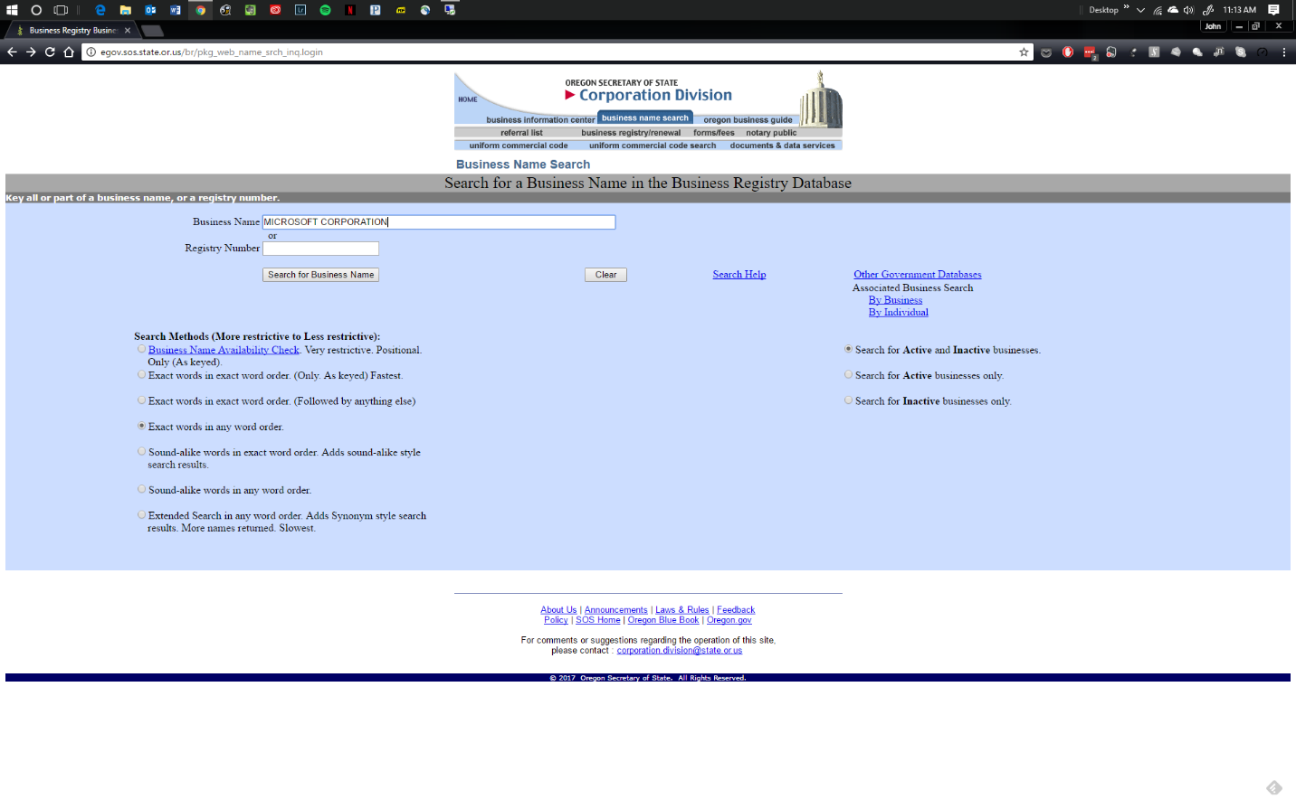

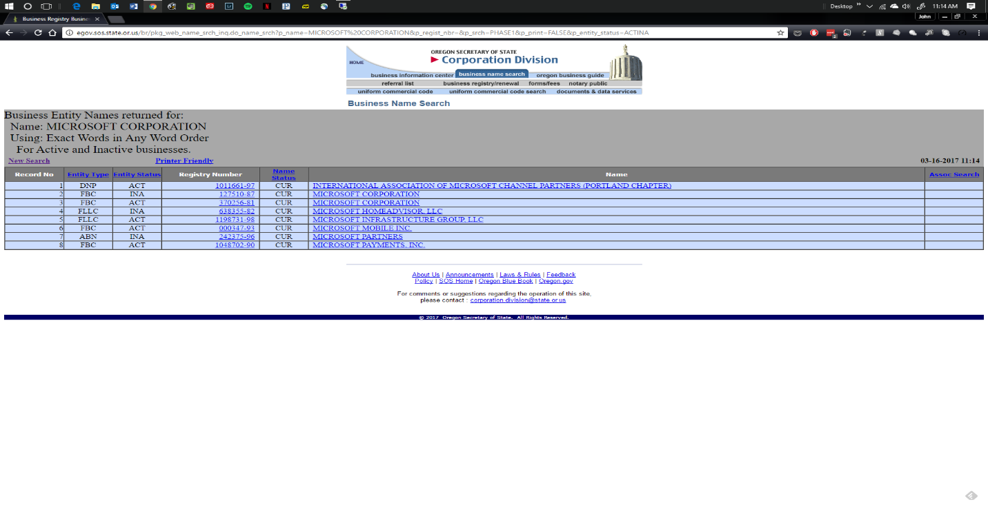

Choose Entity. Be sure that entity is Active (“ACT” in “Entity Status” Column.

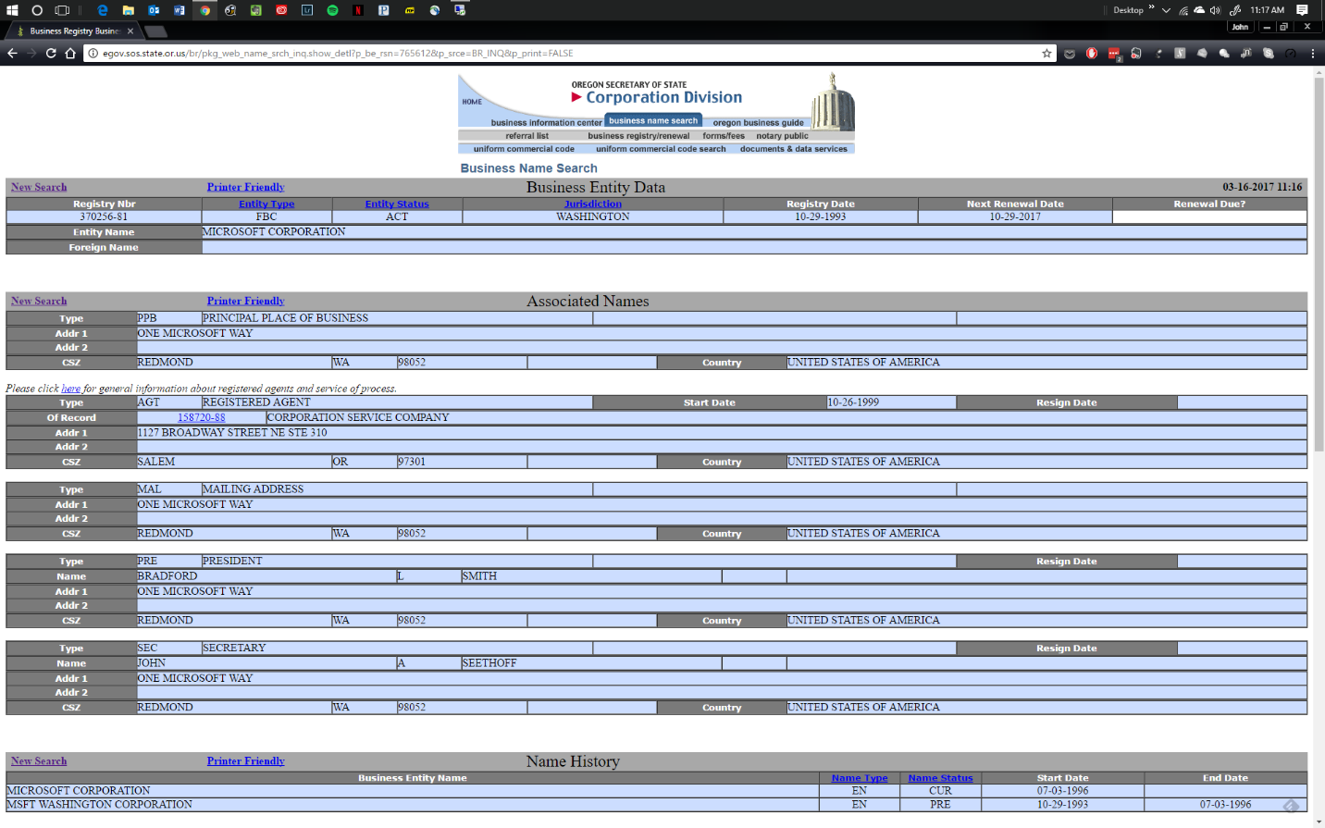

Review information in “Business Entity Data” Table to determine type of entity (e.g., corporation, LLC, etc.) and state in which organized. APPENDIX 3-ALTERNATIVE TERMS [See DOJ before use or for assistance with drafting]

Section 1

Option to Extend

Suspension/stop work order

Section 4

**4.5 Federal Funds.**

4.5.1 When specified below that Agency’s payments to Contractor under this Contract will be paid in whole or in part by funds received by Agency from the United States Federal Government. If so specified then Contractor, by signing this Contract, certifies that neither it nor its employees or subcontractors who will perform the Services are not currently employed by an agency or department of the federal government.

Payments  will  will not be made in whole or in part with federal funds

4.5.2 In accordance with the State Controller’s Oregon Accounting Manual, policy 30.40.00.102, Agency has determined that:

Contractor is a sub-recipient  Contractor is a vendor  Not applicable-No Federal Funds

Catalog of Federal Domestic Assistance (CFDA) #(s) of federal funds to be paid through this Contract:______

**Expenses**

Section 5

Drug Testing/Background checks

Contractor Conduct

Obligation to report abuse

Equal access

Media disclosure

Non-discrimination

Federal whistleblower.

**5.4 Agency Training Requirements**. Contractor must comply with Agency Training Requirements described in Exhibit F, which is attached hereto and incorporated by this reference.

[DOC SPECIFIC]

**5.3 State Premises**. Contractor and Contractor staff shall comply with all policies, rules and regulations established by Agency and the State for access to and activities in and around premises controlled by Agency or any other agency of the State. Prior to entering any DOC correctional facility, Contractor’s staff shall participate in a facility orientation provided by (Institution). Access to any DOC facility is subject to the provisions of OAR 291-016, DOC Rule on Facility Access. Upon request by DOC, Contractor shall provide (at its own expense) DOC with sufficient personal information about its agents or employees, and the agents and employees of its subconsultants (if any), who will enter upon premises controlled, held, leased, or occupied by DOC during the course of performing this Contract to facilitate DOC’s criminal record check of such personnel, at state expense.

**5.4 Contractor Conduct**. When providing Services under this Contract, whether inside or outside Agency facilities, Contractor and its employees and representatives shall conduct themselves in a civil, polite, courteous, and professional manner at all times in their interactions with inmates, Agency staff and volunteers, and the public.  Contractor and its employees and representatives shall not under any circumstances fraternize with inmates.  Contractor and its employees and representatives shall immediately report to the Contract Administrator and the DOC Inspector General, telephone number 503-945-0954, any conduct they observe or any information they receive in the course of providing Services under this Contract regarding inappropriate or unlawful conduct by any Contractor employee or representative, inmate, Agency staff or volunteer.

Section 7

Subcontracts allowed without approval.

Section 10

Mutual Confidentiality Provisions

Client Services Confidentiality Provisions

Section 14

Immediate termination of Client Services contracts under certain circumstances.

Section 17

Agency termination following force majeure