2024 Succession Plan
Agency Name
Insert date

Additional text (optional)

503-XXX-XXXX
Email (optional)
Agency Webpage (optional)

TABLE OF CONTENTS

Assessment | Mission, Vision, Values 1

Progress Made | Previous Plan Year to Current 1

Identification | Highly Critical and Critical Positions 2

Development | Competency Development Plans 3

Evaluation | Competencies, Employee Goals, Recruitment Strategies 4

Retirement Eligibility | One Year Forecast 5

Action Plan 5

Assessment | Mission, Vision, and Values

Mission
Include supporting text further defining the mission and how it relates to the employees of the agency.
Use this box to highlight any information (if any).

Vision
Agency Vision.

Values
Agency Values.

Changes/Challenges
Highlight any changes or challenges to your Mission, Vision, Values, and/or workforce that has occurred since the initial submission of your 2023 Succession Plan.
Factors that can help inform where your agency is currently at include vacancies, turnover, new or increased workloads, eliminated work, and trends.

Progress Made | Previous Plan Year to Current

Summary of gains made from previous plan
- Steps taken based on Development Concepts
- Based on development efforts identified in the previous plan, has your agency been able to reduce the number of critical/highly critical positions?

Example: Agency ABC has made significant gains in the last 12 months. Development concepts have been utilized and focused on to reduce the criticality of our positions.

In 2024 we have reduced our critical positions from twenty-seven to fifteen and reduced one of our highly critical positions to critical.

As we move into 2025, we anticipate a stronger focus on cross-training of the critical positions by refining our training approach related to identified competencies.

Use this space to provide a review of your critical/highly critical positions and development progress from 2023.

Position Identified in 2023 | Critical/Highly Critical | Progress/Adjustments Made Based on 2023 Development Concepts

2024 Identification | Critical/Highly Critical Positions

Use this space to capture positions identified as Highly Critical and/or Critical. Also include any identified positions from 2023 that are still considered Highly Critical/Critical.

Explain the direct business impact of not having the staff and competencies the agency needs in this position (consider the immediate impact as well as future impact). Specifically detail the consequences.

Highly Critical
- Position Number One
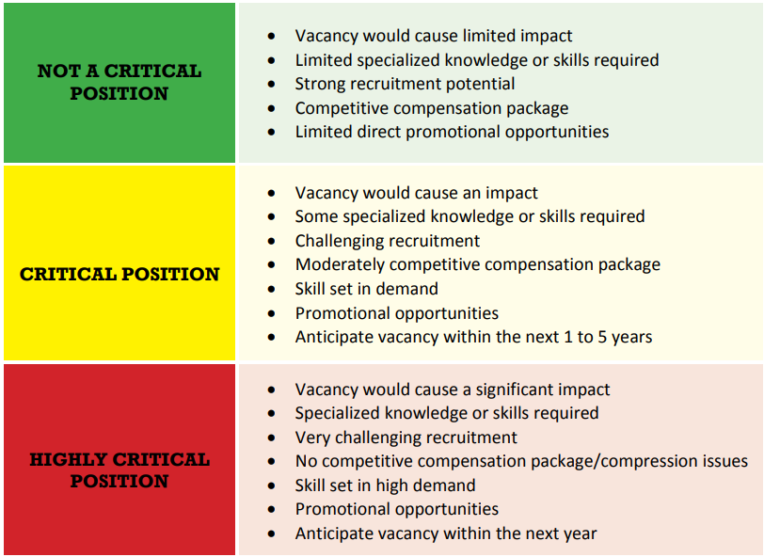
  - Competencies of Position
  - Why identified as Highly Critical (see factors)
  - Was this position identified on your 2023 Succession Plan
- Position Number Two
  - Competencies of Position
  - Why identified as Highly Critical
  - Was this position identified on your 2023 Succession Plan
- Position Number Three
  - Competencies of Position
  - Why identified as Highly Critical
  - Was this position identified on your 2023 Succession Plan

Critical
- Position Number One
  - Competencies of Position
  - Why identified as Critical
  - Was this position identified on your 2023 Succession Plan
- Position Number Two
- Competencies of Position
- Why identified as Critical
- Was this position identified on your 2023 Succession Plan
- Position Number Three
  - Competencies of Position
  - Why identified as Critical
  - Was this position identified on your 2023 Succession Plan

2024 Development | For Critical and Highly Critical Positions

Use this space to explore how you plan to develop competencies in the Highly Critical and Critical positions to build the bench strengths of the position. If the position is a carry over from 2023, explain how your development plans have changed (if applicable).

Highly Critical
- Position Number One
  - Development plan for competency development (how are you going to build the bench strength for this position).
  - What are potential recruitment/retention challenges for this position and how do you plan to overcome them?
  - What are the skill development challenges in relation to the existing and future workforce (i.e., current employees need to develop new skills, specialized skills/degree/license are required, etc.) and how do you plan to overcome them?
- Position Number Two
  - Development plan for competency development (how are you going to build the bench strength for this position).
  - Gaps: what are potential recruitment/retention challenges for this position?
  - What are the skill development challenges in relation to the existing and future workforce (i.e., current employees need to develop new skills, specialized skills/degree/license are required, etc.) and how do you plan to overcome them?
- Position Number Three
  - Development plan for competency development (how are you going to build the bench strength for this position)
  - Gaps: what are potential recruitment/retention challenges for this position?
  - What are the skill development challenges in relation to the existing and future workforce (i.e., current employees need to develop new skills, specialized skills/degree/license are required, etc.) and how do you plan to overcome them?

Critical
- Position Number One
  - Development plan for competency development (how are you going to build the bench strength for this position).
  - Gaps: what are potential recruitment/retention challenges for this position?
  - What are the skill development challenges in relation to the existing and future workforce (i.e., current employees need to develop new skills, specialized skills/degree/license are required, etc.) and how do you plan to overcome them?
- Position Number Two
  - Development plan for competency development (how are you going to build the bench strength for this position).
  - Gaps: what are potential recruitment/retention challenges for this position?
  - What are the skill development challenges in relation to the existing and future workforce (i.e., current employees need to develop new skills, specialized skills/degree/license are required, etc.) and how do you plan to overcome them?
- Position Number Three
  - Development plan for competency development (how are you going to build the bench strength for this position).
  - Gaps: what are potential recruitment/retention challenges for this position?
  - What are the skill development challenges in relation to the existing and future workforce (i.e., current employees need to develop new skills, specialized skills/degree/license are required, etc.) and how do you plan to overcome them?

Agency-wide plans for competency development
Use this space to include any additional plans for competency development of positions outside of or in addition to Highly Critical and Critical. This section can include new/upcoming recruitment/retention efforts, training efforts, etc.

2024 Evaluation | Competencies, Goals, and Recruitment Strategies

What are the agency’s plans to evaluate and revisit this plan to ensure the agency is on track (i.e. “The agency’s leadership team will evaluate this succession plan quarterly and make adjustments as necessary”)? Further areas to refine your evaluation strategies are included below.

Overall Plan Review
How will the agency review the plan in its entirety (i.e. quarterly/annually and by whom)?

Highly Critical/Critical Positions
Has the work changed, has how the work is done changed or new programs added?

Competency Adjustment
How will the agency evaluate and adjust competencies?

Employee Goals
How will the agency evaluate employee goals (i.e., PAF guidelines to discuss employee interest and cross-training/promotional opportunities)?

Recruitment Strategies
What is the evaluation process to determine if the current and future recruitment and retention strategies are working and how will they be adjusted as needed?

2024 Retirement Eligibility | One Year Forecast (Optional)

Utilizing the Workday report HCM Retirement Eligibility Summary, identify the number and percentage of your agencies workforce that is currently eligible to retire and is eligible to retire within one year.

Position | Eligible to Retire Now | Eligible to Retire < 1 Year

2024 Action Plan | (Optional)

This section will help the agency outline the actions needed to align the agency’s strategic and succession plans. List the specific activities the agency will use, steps for completion and timeline to ensure agency’s performance. Agencies should include metrics where appropriate.

ACTIVITY #1:
Objective: (example) Improve recruitment process by reducing number of days an applicant is in the pipeline.

Targeted Completion Date: June 2024

Intermediate Milestones: 50% of applications at a 30-day turnaround by January 2024

Contingencies (if any): Potential staffing/funding changes

Metric Target: Baseline = 78 days, Target = 30 days

Metric Definition: 30 days from receipt of application to conclusion

ACTIVITY #2:
Objective:

Targeted Completion Date:

Intermediate Milestones:

Contingencies (if any):

Metric Target:

Metric Definition:

ACTIVITY #3:
Objective:

Targeted Completion Date:

Intermediate Milestones:

Contingencies (if any):

Metric Target:

Metric Definition:

Conclusion
Use this space to conclude any final thoughts about your succession plan. Explain how your plan supports the agency’s strategic plan, affirmative action and/or diversity plan(s).

