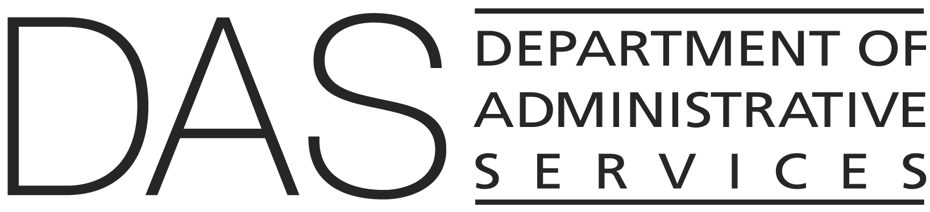  STATEWIDE POLICY | NUMBER  20.005.05 | SUPERSEDES  20.005.05  01/01/2024
 | EFFECTIVE DATE  DRAFT | PAGE NUMBER  Pages 1 of 2
 | REVIEWED DATE
Division  Chief Human Resources Office | Authority  ORS 240.145; 240.235; 240.240; 240.250; 240.430
Policy Owner

CHRO Policy Unit
SUBJECT  Merit Pay System | APPROVED SIGNATURE  Signature on file with the Chief Human Resources Office

POLICY STATEMENT
Oregon state government maintains a merit pay system to encourage outstanding individual performance among employees. The merit pay system provides for monetary increases to employees based on meritorious service, contribution to the agency’s mission and goals, and organizational accomplishments.

APPLICABILITY
Classified unrepresented, management service, unclassified executive service, and unclassified unrepresented employees.

ATTACHMENTS
None

DEFINITIONS
Refer to State HR Policy 10.000.01, Definitions.

POLICY
- This policy represents the state standard for the orderly progression of an employee's pay from the established minimum to the maximum of the salary range based on documented meritorious performance.

- Appointing authorities must document merit pay increases (also known as step increases) demonstrating employees’ work performance and organizational accomplishments and enter such increases into the state human resources information system.

- Agency heads must ensure merit pay increases are within budgeted salary parameters, and funding and legislatively approved salary policies.

- Policy Clarification:

- Salary rates generate from the salary range assigned to each employee’s job under the state’s compensation plan. Increases to salaries advance employees one step, or the equivalent thereof, in the salary range. Refer to State HR Policy 20.005.10, Pay Practices, for increases due to an equal pay adjustment.

- Generally, eligibility for merit pay increases follows a 12-month cycle and, if warranted, employees receive a merit pay increase on their annual salary eligibility date. Benefit service dates are also discussed in State HR Policy 20.005.10, Pay Practices.

- An appointing authority may grant a one-step special merit increase, which is an unscheduled increase for exceptional individual performance or other valid reasons. A special merit increase shall not exceed the top step of the employee’s salary range. An employee shall not receive more than one special merit increase in a two-year period unless the employee changes agency or position. A special merit increase normally does not affect the employee's eligibility for a six month or annual merit increase.

- An agency must report to the CHRO when granting special merit increases. The report must include the employee’s name and OR number, classification, working title, benefit service date, any prior special merit increases awarded, and a statement of justification. Multiple employees’ special merit increases may appear in the same report to the CHRO.

- Leave without pay resulting from job-incurred time loss, military leave covered by State HR Policy 60.000.25, Military Leave, or other qualifying family and medical leave covered by State HR Policy 60.000.15, Family and Medical Leave, does not affect an employee's benefit service date for merit pay increases.

