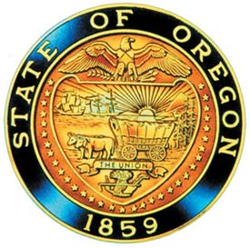

**Alcohol and Drug Policy Commission**

**Recovery Committee meeting**

**November 21, 2024 1:00 PM – 2:30 PM**

**ZOOM Meeting link:** [**CLICK HERE TO JOIN MEETING**](https://www.zoomgov.com/j/1619342467?pwd=a0NIcWltN2ZrWlUwd1hPMEVWSktXUT09)

**Find your local number**:[**https://www.zoomgov.com/u/abuVBqduSe**](https://www.zoomgov.com/u/abuVBqduSe)

**Note: The Subcommittee may choose to take agenda items out of order, pull, defer, or shorten presentation time of agenda item(s) to accommodate unscheduled business needs. Anyone wishing to be present for an item should arrive when the meeting begins to avoid missing an item of interest.**

**The meeting location is accessible to persons with disabilities. A request for an interpreter for the hearing impaired or for other accommodations for persons with disabilities should be made at least 48 hours before the meeting to: Corina Vasquez at** [**corina.vasquez@oha.oregon.gov**](mailto:corina.vasquez@oha.oregon.gov)**.**

|  |  |  |  |
| --- | --- | --- | --- |
| **#** | **Item** | **Time** | **Presenter** |
| 1 | * Introductions | 1:00pm-1:05pm | Monta |
| 2 | * ADPC Director and Staff Updates | 1:05pm-1:15pm | Annaliese, Stephanie, and staff |
| 3 | * RFI update | 1:15pm-1:20pm | Monta |
| 4 | * Membership vote & discussion | 1:20pm-1:55pm | Committee |
| 5 | * Public Comment | 1:55pm | Monta |