|  |  |
| --- | --- |
| library | LITERATURE REVIEW  Factors Affecting the Service Life of Culverts |
| **ODOT Library**  555 13th Street NE  Salem, OR 97301  (503) 986-3280  laura.e.wilt@odot.state.or.us | Prepared for: Kira Glover-Cutter  April, 2020 |
|  |  |

When considering the placement of drainage structures, it is important to determine the length of service life expected and needed for any given application. Local and regional environmental conditions impact the durability of culverts, and the chemical conditions of an area are influenced by the soils, vegetation, rainfall, and drainage characteristics of the given watershed (Beaton and Stratfull 1962). These in turn have an impact on the amount of degradation to the structure caused by corrosion and abrasion.

Corrosion destroys pipe material through chemical reactions, returning the metal to its native state of oxides or salts. This process generally affects metal pipes or the metal reinforcement in concrete pipe, although concrete culverts can also undergo a similar reaction if exposed to highly alkaline soils or very harsh environments. Corrosion can occur either on the inside or the outside of a pipe, or both (AASHTO 2007). Electric current flows from the metal in the pipe, which typically serves as both the cathode and anode, through ions in the surrounding soil or water, which serve as the electrolyte. The extent of the resulting corrosion is proportional to the current produced (Gabriel, Moran 1998).

The seriousness of underground corrosion was being studied in the US by the early 1900s, although up to that point, it was generally believed that such corrosion was always produced by stray electric currents. Early testing showed that serious corrosion could also occur without the presence of stray current. Test methods began to be introduced by 1928, when the Bureau of Standards published a paper by K.H. Logan stating that “soil corrosion tests indicated that the structure and chemical properties of the soils as well as the nature of the contact between the soil and the pipe must be considered.”(Chaker 1990). In the 1950s, California Dept. of Transportation surveyed over 7000 culverts and developed a chart to predict the time to first perforation of corrugated galvanized steel pipe culverts based on pH and soil resistivity (CalTrans 1978).

According to Maher, Hebeler et al. (2015), the most important factors associated with corrosion in culverts include the following:

**pH**

The pH measures the hydrogen ion concentration of the surrounding soil and water. It indicates the level of acidity or alkalinity of the environment. The pH of water generally ranges between 4 and 10. Values of less than 5.5 are considered strongly acidic, while values of 8.5 or greater are considered strongly alkaline.

**Resistivity**

Resistivity is the measure of the ability of the soil to conduct electrical current. Measured in ohm-centimeters, resistivity is affected primarily by the temperature, moisture content and compactness of the surrounding soil, and the presence of such materials as stones and gravel. Higher levels of soil resistivity and/or lower levels of soil moisture content limit the capability of the soil to conduct electricity, decreasing the potential for corrosion. While corrosion occurrence is generally the result of the influence of more than one factor, the American Water Works Association standard uses resistivity as a key measurement for determining whether or not additional corrosion protection is called for (Beben 2014), and Chaker (1990) indicated that resistivity is probably the single best indicator of the aggressiveness of the soil. The following tables show the corrosion potential for various levels of resistivity, and common levels of resistivity in various conditions and mediums:

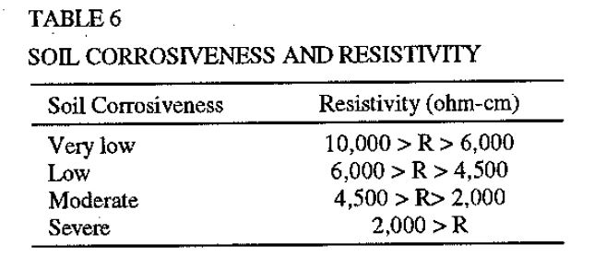

Table: Gabriel, Moran et al. 1998

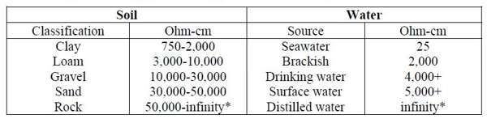

Typical resistivity values for soil and water (Gabriel, Moran et al. 1998)

The moisture level of the soil strongly affects the conductivity of the soil; the largest fluctuations of soil resistivity occur as a result of winter freezing and summer desiccation (Beben 2014). The softness of the water in the environment also has an effect on resistivity. In areas where the calcium carbonate concentration in the effluent measures below 50 ppm, the water is considered soft, leading to higher resistivity values. Soft water has a significant impact on galvanized coatings, but little influence on the service life of aluminized or polymer coated corrugated steel pipe. (NCSPA Pipe Selection). Chaker (1990) showed the relationship of temperature and moisture to resistivity:

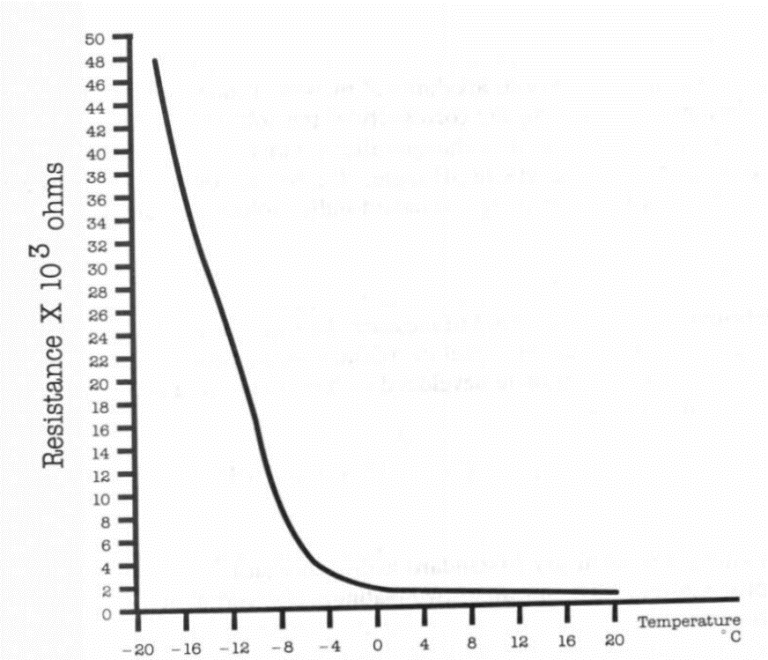

Effect of temperature on resistivity

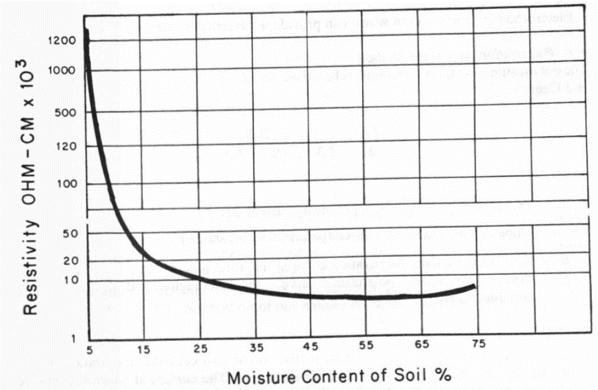

Effect of moisture content on resistivity of a clay soil.

**Chlorides**

Dissolved salts containing chlorides can be present in either the soil or water surrounding culverts. Negative chloride ions generally decreases the soil or water resistivity, leading to increased destruction of unprotected metal in culverts and exposed reinforcing steel in concrete culverts.

**Sulfates**

High concentrations of sulfates can lower pH and cause damage in culverts. Concrete culverts are particularly susceptible, and concentrations greater than 1000 parts per million may require special coating on concrete surfaces. Sulfates may occur naturally, or be the result of industrial run-off, such as mining activities.

**Other**

Other conditions impacting corrosion include soil moisture content, dissolved gases, and bacterial activity. The size, shape, hardness and volume of the bed load, as well as the volume, velocity and frequency of the streamflow in the culvert can also be factors, as can anticipated changes in the watershed upstream of the culvert from such activities as development, logging and industry (AASHTO 2007)

Corrosion can occur in a number of forms, including pitting corrosion, crevice corrosion, stress corrosion and cracking, and microbiologic corrosion (Gabriel, Moran 1998). While pitting corrosion is initiated by oxygen concentration cells, aggressive ions including chlorides can accelerate the process. Gabriel and Moran (1998) showed the following representation of the process:

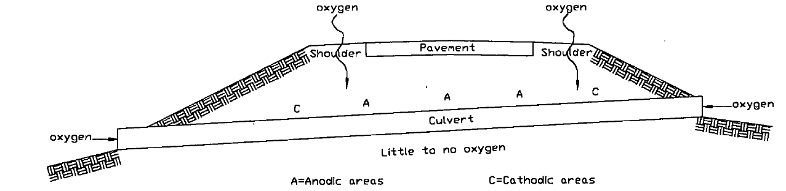

Oxidation corrosion cells in pavement drainage structures

In areas where de-icing salts are used, cracks in the pavement can allow the salts to leach through to culverts below, leading to premature pitting corrosion. Beaver, Bass et al. (2019) suggest isolating the metal from contact with chloride-containing salts in such situations through either the use of isolation membranes embedded in the backfill material over the culvert or bonded coatings applied directly to the culvert surface – a process generally applied at the factory. The authors note that isolation membranes tend to have a lower cost than factory-applied coatings. They also point out that pitting corrosion is rarely seen in tidal or brackish areas with dissolved salts as long as culverts are located in free-draining soil and subject to flushing (Beaver, Bass et al. 2019).

In their 30-day simulated corrosion experiment, Han Yi and San (2010) charted the general relationship between corrosion rate and levels of various corrosion factors:

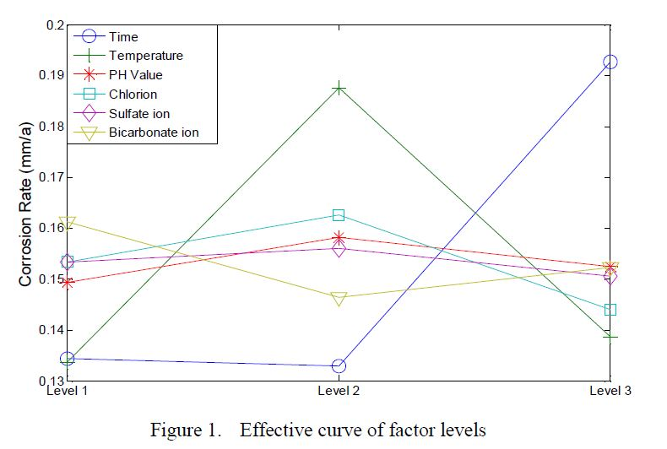

Other sources of corrosion in metal culverts include soil-side corrosion brought on by humidity and moisture, the chemical composition of backfill, the level of compaction of the backfill, the soil oxygen content, as well as differences in electric potential between the soil and culvert. Waterline corrosion occurs when the area is subject to repeated cycles of wetting and drying, and is often a problem in aluminum culverts lacking protective coating. Flowside corrosion is generally only seen in metal culverts located in particularly aggressive environments, such as mining runoff, or where heavy abrasion is found (Beaver, Bass et al. 2019).

Maher, Hebeler et al. (2015) included the following chart describing different types of corrosion and potential control measures based on an ASM International publication:

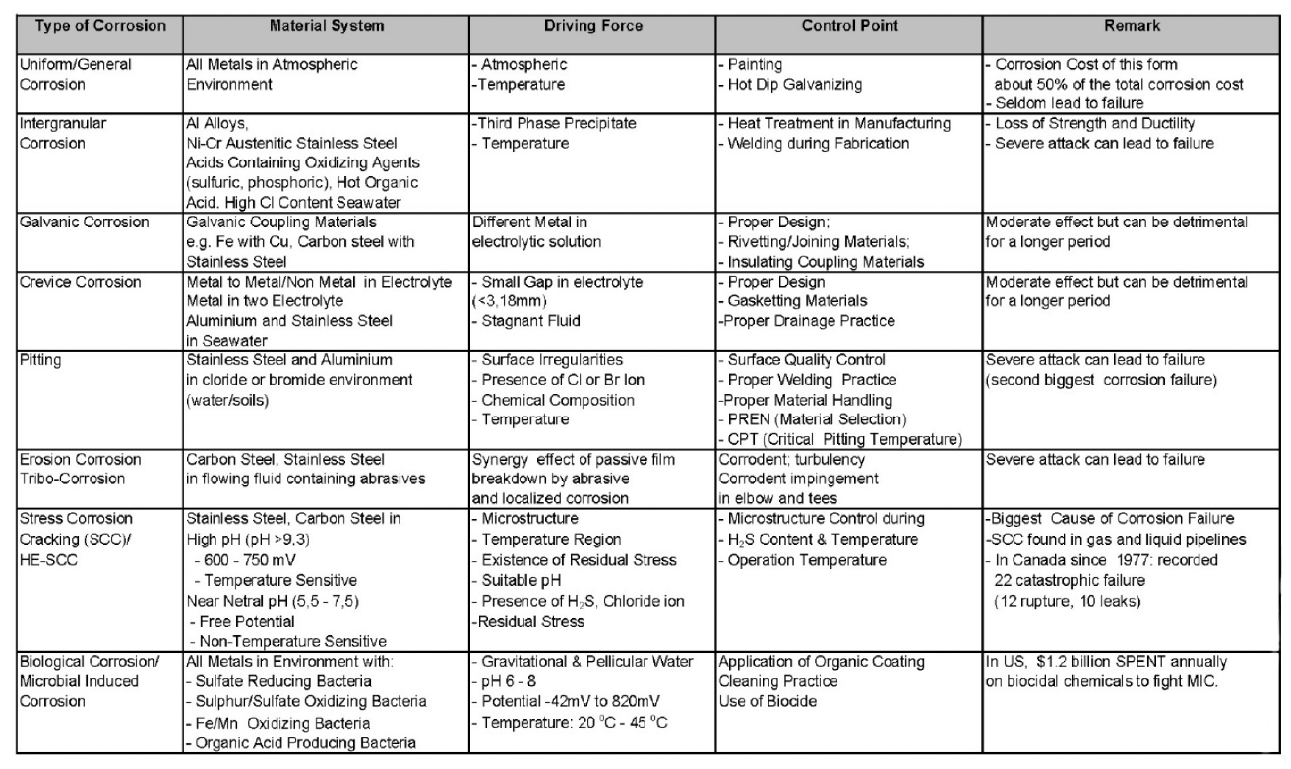

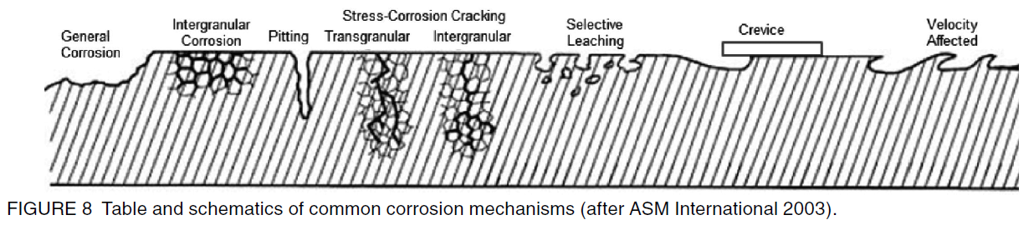

Maher, Hebeler et al. (2015) also lists general mitigation measures to counteract corrosion, including increased wall thickness in metal culverts, increasing the cover over steel reinforcement of concrete culverts, coatings or protective pavings applied to the culvert, electrical grounding/cathodic protection, and placement of the culvert in a nonaggressive backfill. Some states have made effective use of controlled low-strength material (CLSM) as backfill for galvanized steel culverts rather than native soil. This material generally consists of Portland cement, fine aggregates, supplementary cementing materials (SCMs) and water. (Halmen, Trejo, 2008). When backfill consists of this material, traditional models for estimating service life of the culverts are not accurate. Halmen and Trejo (2008) developed a model based on the CLSM ingredients – particularly the type of fly ash used – to model service life of galvanized steel culverts embedded in this type of backfill.

As early as the 1960s, studies were looking at mapping environmental conditions in relation to culvert studies. Haviland, Bellair et al. (1968) showed a composite pH map of stream flow data compared to locations of culverts in a New York study:

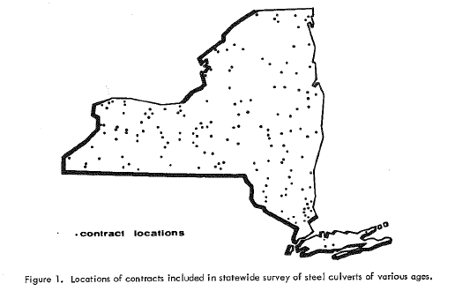

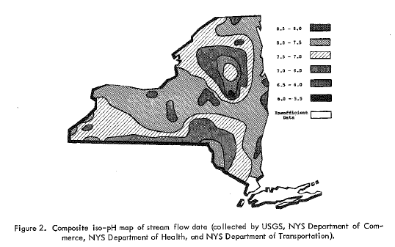

Haviland, Bellair et al. 1968

More recently, efforts have applied available soil data to create GIS based mapping to identify corrosion zones in the coastal areas of Louisiana (Tewari 2017; Tewari, Manning 2018). The study used data obtained from field surveys provided by Louisiana Dept. of Transportation & Development, as well as the Web Soil Survey Data from the Natural Resource Conservation Service covering an area of 21,877 square miles. Using an ArcGIS platform, along with pH and resistivity data, a spatial representation of corrosion zones was created.

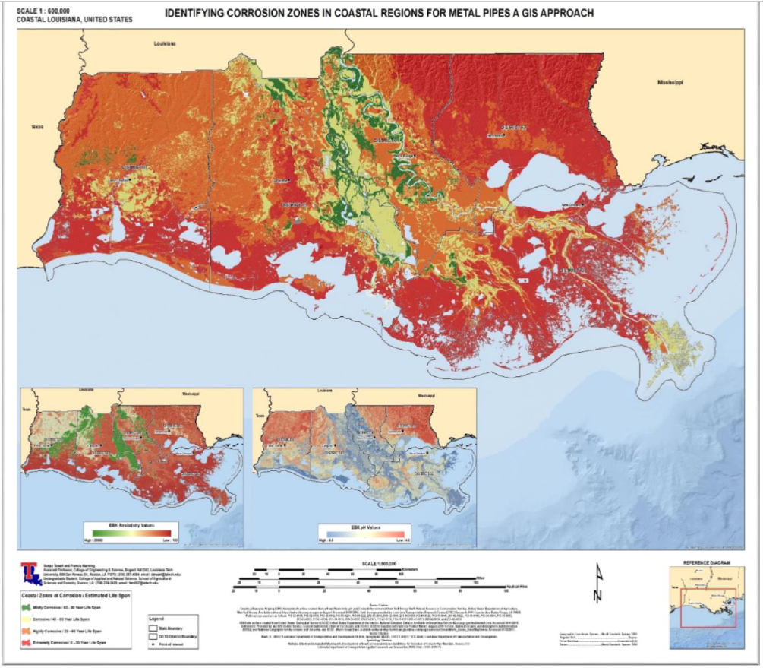

Tewari, 2017

Arkansas used similar techniques to predict the corrosion potential of metal culverts through neural network (NN) models. Using data from soil samples collected by the Arkansas Department of Transportation (ARDOT), and survey data from the United States Department of Agriculture (USDA) and Arkansas Department of Environmental Quality, corrosion risk maps were developed for three types of metal pipes:



Hossian, Elsayed et al. 2019

Minnesota used data and applied the California method to develop six predictive service life zones, with zone 1 generally yielding a higher service life (greater than 45 years), to zone 5 having predominantly lower service life estimates (16-20 years). Zone 6 showed a large spread of service-life estimates, with very low estimates (<10 years) often adjacent to areas of higher service life (16-20 years). This study did not consider abrasion or other local environmental conditions in their conclusions. The results were mapped in the following representation (Heitkamp, Marr 2015):

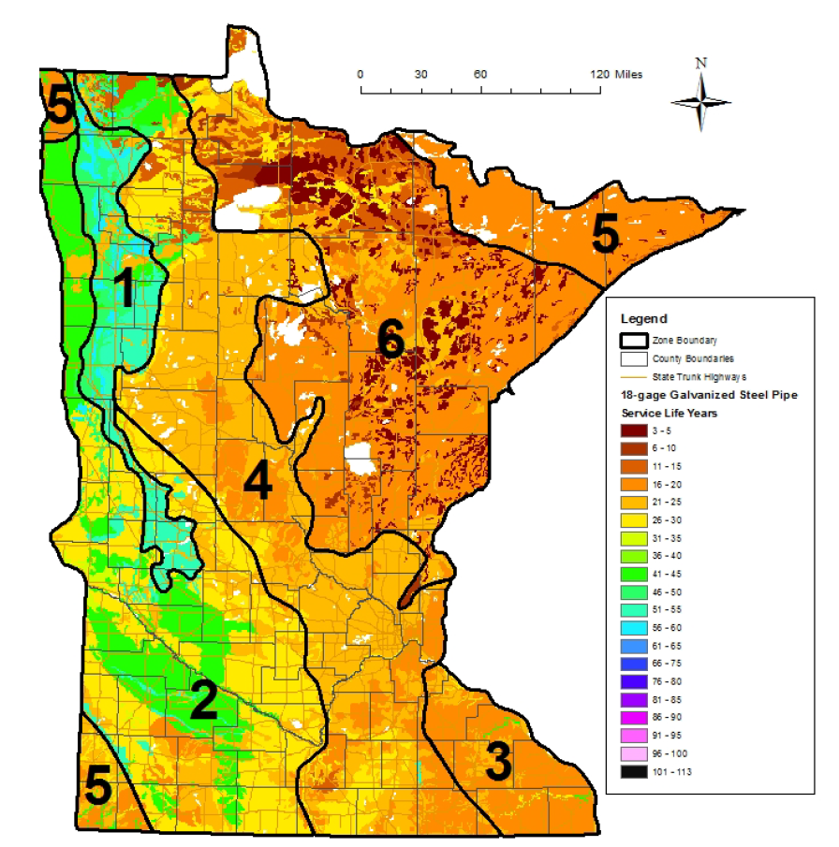

**Abrasion**

Abrasion involves the wearing or grinding away of material by water containing sand, gravel, or stones (Molinas, Mommandi et al. 2009). It is generally considered separately from pH and resistivity (corrosion factors) when estimating the durability of metal culverts. (Maher, Hebeler et al. 2015). However, when corrosion and abrasion operate jointly, they produce much greater deterioration than either would separately. Abrasion breaks down protective coating, thus accelerating the process of corrosion. (Gabriel, Moran 1998)

FHWA developed a classification system defining abrasion levels:

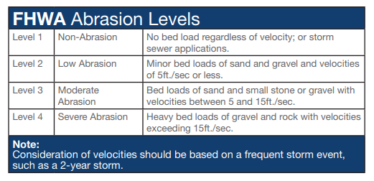

Chart from NCSPA Pipe Selection Guide (2010)

If the bed load is abrasive and velocities exceed 6.5 ft/sec., abrasion can be a factor in metal pipes. (AZDOT, 1996). Abrasion is a function of the square of the velocity; when the velocity doubles, abrasion will be increased four-fold (Gabriel, Moran, 1998).

**Service Life of Culverts**

**Concrete Pipes**

Theservice life of concrete pipes varies depending on the class of pipe and the environment it is installed in. However, concrete pipes are able to withstand a wide range of environmental and loading conditions, and with proper selection of pipe class and design, a service life of 100 years is achievable in almost any environment. (Maher, Hebeler et al. 2015).

Most corrosion concerns with these structures involve corrosion of the reinforcing steel within them, which is caused when moisture, oxygen and chlorides reach the steel. Florida DOT graphed the corrosion deterioration of concrete culverts over time:

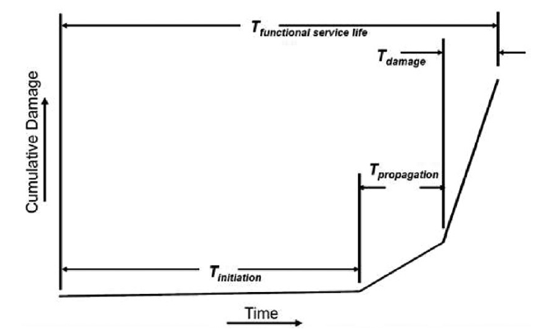

Steel-reinforced corrosion service life diagram. (FDOT 2014b)

Other factors influencing the service life of concrete pipes include pipe cracking (allowing for steel corrosion), sulfate damage, acid attack and abrasion. (Maher, 2015) Pre-cast concrete is generally immune to freeze-thaw and chloride corrosion problems that can cause problems in other types of concrete pipes. (Potter, 1988)

The following tables offer guidelines for the use of concrete pipes under various conditions:

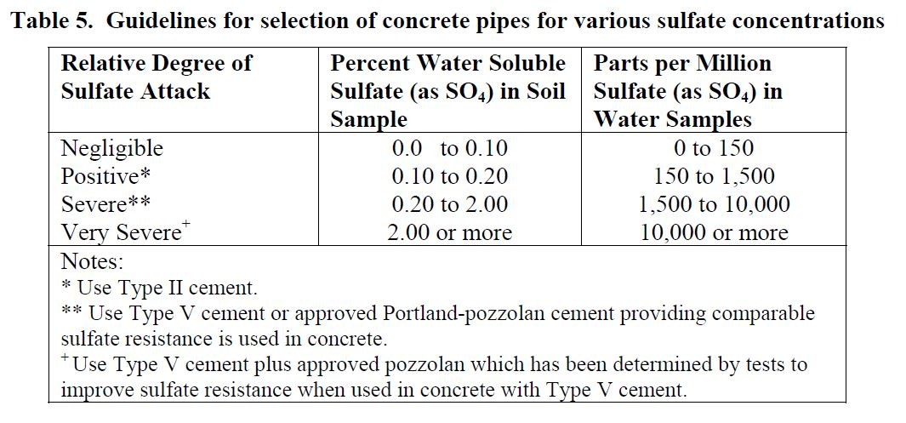

Potter, 1988

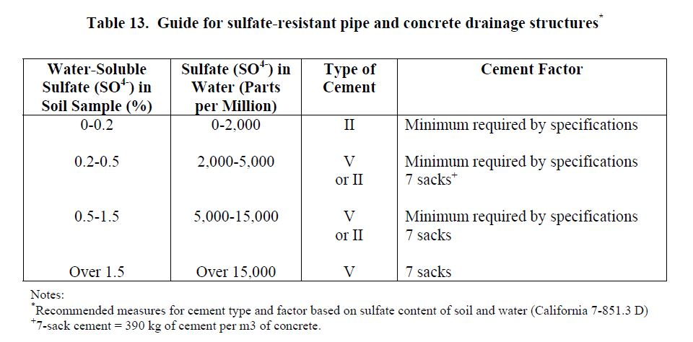

Gabriel, Moran 1998

When especially harsh environments are encountered, protection can be added with the addition of sacrificial concrete – at least 2 inches where severe abrasion is anticipated – over the reinforcing steel (Maher, Hebeler et al. 2015).

Several states have developed for determining the estimated material service life (EMSL) of concrete culverts. Potter (1990) identified three methods of estimating the service life of concrete culverts:

* The Hurd Method, for use at sites with pH of 7 or lower; this method contains an abrasion component:



Where:

*EMSL* = estimated material service life in years

*pH* = pH of the water

*Slope* = pipe invert slope ($0/0)$

*Sediment* – sediment depth in pipe invert in inches

*Rise* = vertical pipe diameter in inches

* The Hadipriono Model, for sites with pH values between 2.5 and 9



Where:

*EMSL* = estimated material service life in years

*pH* = pH of the water

*Slope* = pipe invert slope ($0/0)$

*Rise* = vertical pipe diameter in inches

* Ohio DOT Model

For pH values between 2.5 and 7:

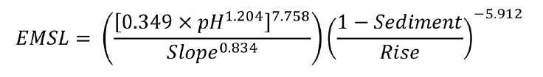and

For pH values greater than or equal to 7:

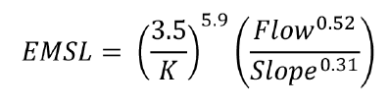

Where:

*EMSL* = estimated material service life in years

*pH* = pH of the water

*Slope* = pipe invert slope ($0/0)$

*Sediment* – sediment depth in pipe invert in inches

*Rise* = vertical pipe diameter in inches

*Flow* = velocity rating number (1 – rapid, 2 – moderate, 3 – slow, 4 – negligible, 5 – none)

*K* = abrasive constant (0.9 – without abrasive flow, 1.19 – with abrasive flow

**Metal Pipes**

Several definitions for the design service life of metal culverts have been suggested and used over the years, most relating to the loss of wall section. At one end of the spectrum, the California method defines service life as the time to first perforation (CalTrans 1978), while AASHTO’s *Highway Drainage Guidelines* (2007) takes a more conservative approach, identifying it as the period of service without need of major repair. Typically, depending on wall thicknesses and environmental conditions, metal culverts can be expected to have a service life of 25 – 50 years or longer (Maher, Hebeler et al. 2015).

Protective coatings can also extend the service life of drainage structures, especially when under harsh environmental conditions. Gabriel and Moran (1998) gave recommendations for protective treatments for galvanized steel pipe based on resistivity:

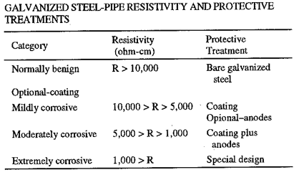

AISI (1993) offered information on metallic and non-metallic coatings for corrugated steel pipe, stating that galvanized steel is the most common material used in the CSP industry. Bituminous coating and paving has been in use as added protection for nearly a century and adds to the service life in the following manner:

|  |  |  |
| --- | --- | --- |
| Slope of Pipe | Abrasion | Added Years |
| Less than 1% | Mild | 35 |
|  | Significant | 25 |
| 1% - 2% | Mild | 30 |
|  | Significant | 20 |
| 3% - 4% | Mild | 25 |
|  | Significant | 20 |
| Greater than 4% | Mild | 20 |
|  | Significant | 15 |

The National Corrugated Steel Pipe Association also showed the effect of protective coating in extending service life:

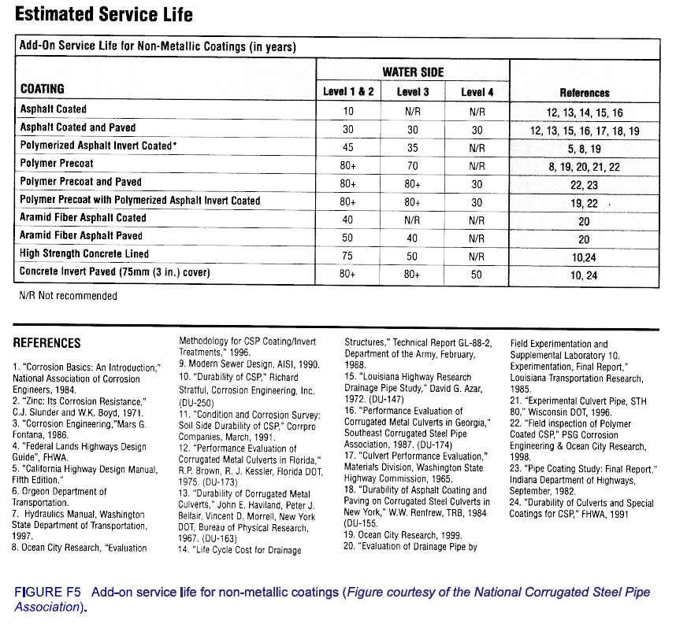

**Steel Culverts**

Corrugated steel culvert pipes (CSP) are easily transported, cheaper and more easily assembled than other culvert materials, making them poplar choices for stream crossings and providing drainage on roadways. (Meegoda, Juliano et al. 2004). With proper corrosion protection for the environment, studies by the Corrugated Steel Pipe Institute show the service life of CSP to be in excess of 100 years. Galvanized zinc coatings are a standard practice because plain steel is vulnerable to corrosion. (Maher, Hebeler et al. 2015)

As noted earlier in this report, a California survey of culverts throughout the states in the 1950s let to a method of estimating material service life of galvanized steel culverts based on pH and resistivity. This method still serves as the basis for most metal pipe service models. The California method defines service life to the time of first perforation and uses the following equations:

For pH values greater than 7.3:

*EMSL* = 1.47 x *R*0.41

For pH values less than 7.3:

*EMSL* = 13.79(log *R* – log[2160 – 2490 x log *pH*])

These equations were applied to the following chart:

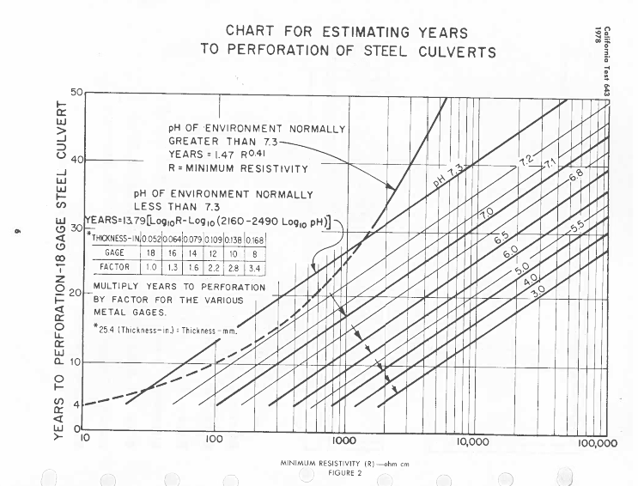

The EMSL value must be multiplied by a factor depending on the gauge thickness as follows:

|  |  |  |  |  |  |  |
| --- | --- | --- | --- | --- | --- | --- |
| Gauge | 18 | 16 | 14 | 12 | 10 | 8 |
| Factor | 1.0 | 1.3 | 1.6 | 2.2 | 2.8 | 3.4 |

Caltrans, 1978

The AISI method of predicting service life is very similar to the California method, although this method defines service life to the point where 25% of the invert thickness has been lost. The formulas for this method:

For pH values greater than 7.3:



For pH values less than 7.3:



Where *R* is the minimum resistivity (ohm-cm)

The resulting EMSL value must be multiplied by a factor depending on the gauge thickness as indicated below:

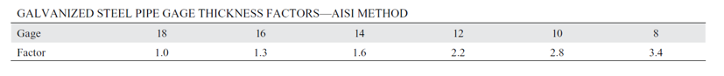

Chart for estimating average invert life using AISI method (AISI 1993)

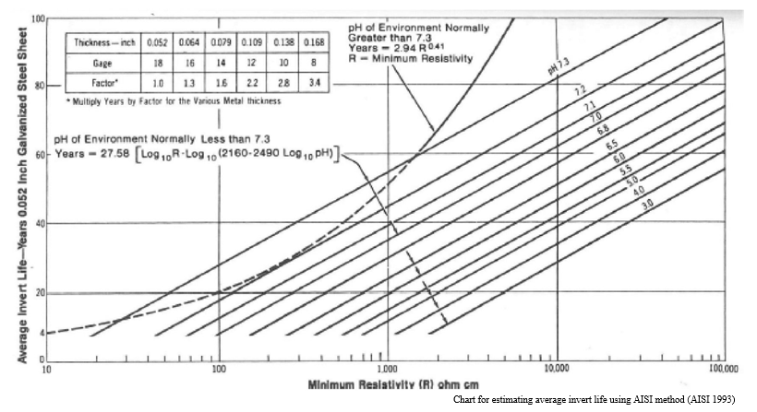

In its report developed for NCSPA, Corrpor (2016?) found that the ANSI Method of service life prediction was more accurate than the California Method, but both tended to be conservative.

Federal Lands and Highways (2008) also developed a modification of the California method:

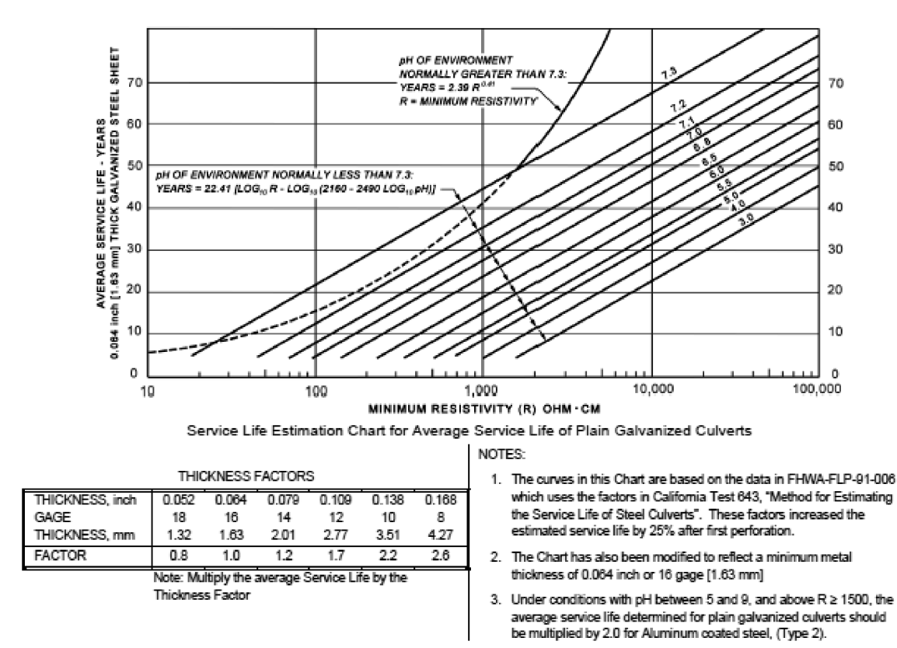

Estimated service life of plain galvanized steel using Federal Lands and Highways method (FHWA 2008)

Florida DOT created a slightly different modification of the California method:

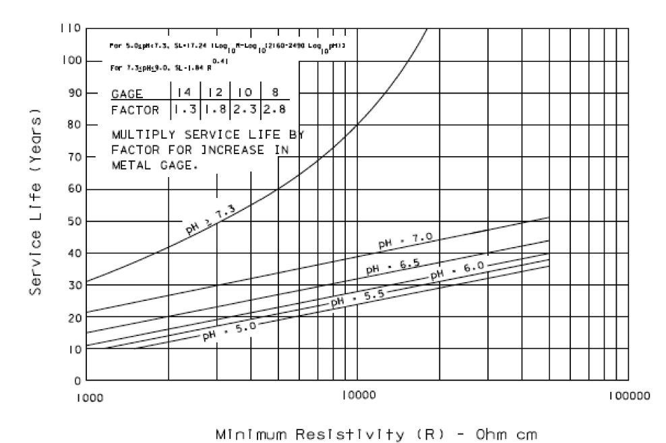

FDOT 2012

National Corrugated Steel Pipe Association (NCSPA) (2010) made material recommendations based on pH, resistivity and abrasion levels:

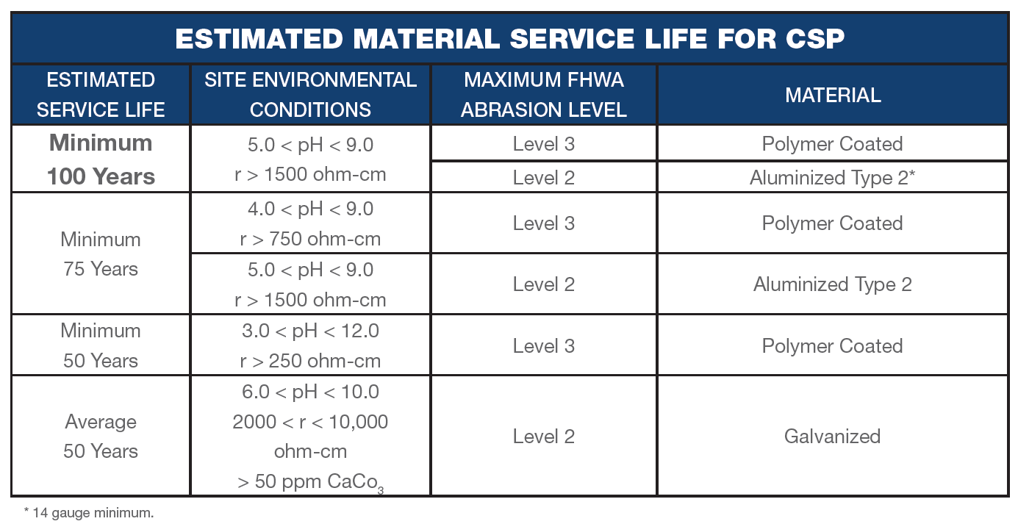

NCSPA also offers an interactive service life calculator based on conditions: <https://ncspa.org/resources/calculators-charts-tools/service-life-calculator/>

Beaton and Stratford (1962) determined that a linear relationship existed between service life and the thickness of the metal used in the pipe. According to their model, an 8-gauge metal culvert would last approximately three times longer than a culvert made from 16-gauge metal in similar environments.

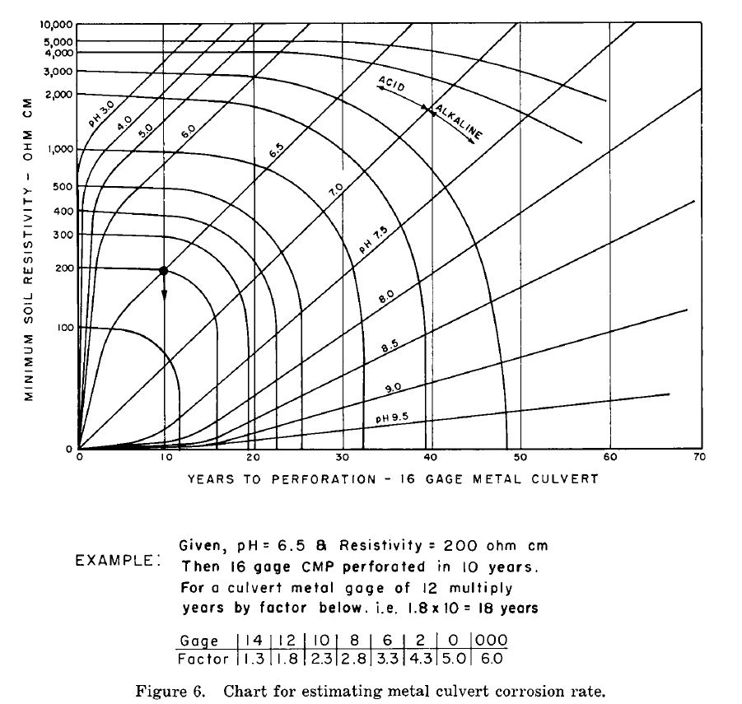

Beaton, Stratford 1962

Taylor and Marr (2012) indicated that Aluminized Corrugated Steel Pipe (CAS) might be recommended over CSP for use in Minnesota. While the authors noted that it is not widely used, and not as well stocked by suppliers, they found that it had a predicted service life of 3 to 8 times longer that galvanized CSP. Additionally, they saw less abrasion and installation damage in the CAS pipes. Florida DOT developed a model to predict service life of CAS, modifying the California method with a 2.9 adjustment factor, and a recognition that aluminum is affected by both basic and acidic flows (White, 2011).

Heitkamp and Marr (2015) offered the following table that offers comparison between galvanized and aluminized steel pipe as far as service life estimates of various gauges of each:

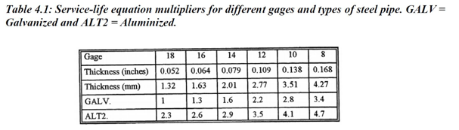

**Corrugated Aluminum Pipe**

Corrosion on aluminum pipes occurs in either general corrosion or localized pitting (Beaver, Bass et al. 2019). Most US policies deal with general corrosion when discussing the usage of aluminum pipes. Aluminum forms a durable aluminum oxide protective film on the outer surfaces when the metal is exposed to oxygen, giving these culverts a high resistance to general corrosion. Optimum conditions for the use of aluminum culverts generally call for non-abrasive or low-abrasive sites with a pH between 4.5 and 9.0, and with soil and water resistivity values greater than 500 ohm-cm. Under such conditions, and in the absence of other corrosion influences such as contact with chloride-based roadway deicing salts, aluminum culverts generally have a minimum service life of 50 – 75 years. (Beaver, Bass et al. 2019.) Some states require a higher minimum resistivity (1,000 - 1,500 ohm-cm) for uncoated aluminum pipe application (Gabriel, Moran 1998).

When used within these guidelines, aluminum pipe can offer a significant advantage in terms of corrosion over plain, galvanized steel pipe, thus making it possible to use aluminum pipe in lieu of a thicker-walled or coated steel pipe. However, aluminum is softer than steel, so these pipes may be more affected by abrasion. When high-velocity flows (15 ft./s or greater) carrying a bedload are present, the use of aluminum pipes may not be appropriate. (Maher, Hebeler et al. 2015).

Florida DOT mapped the estimated service life of aluminum using the following chart and table:

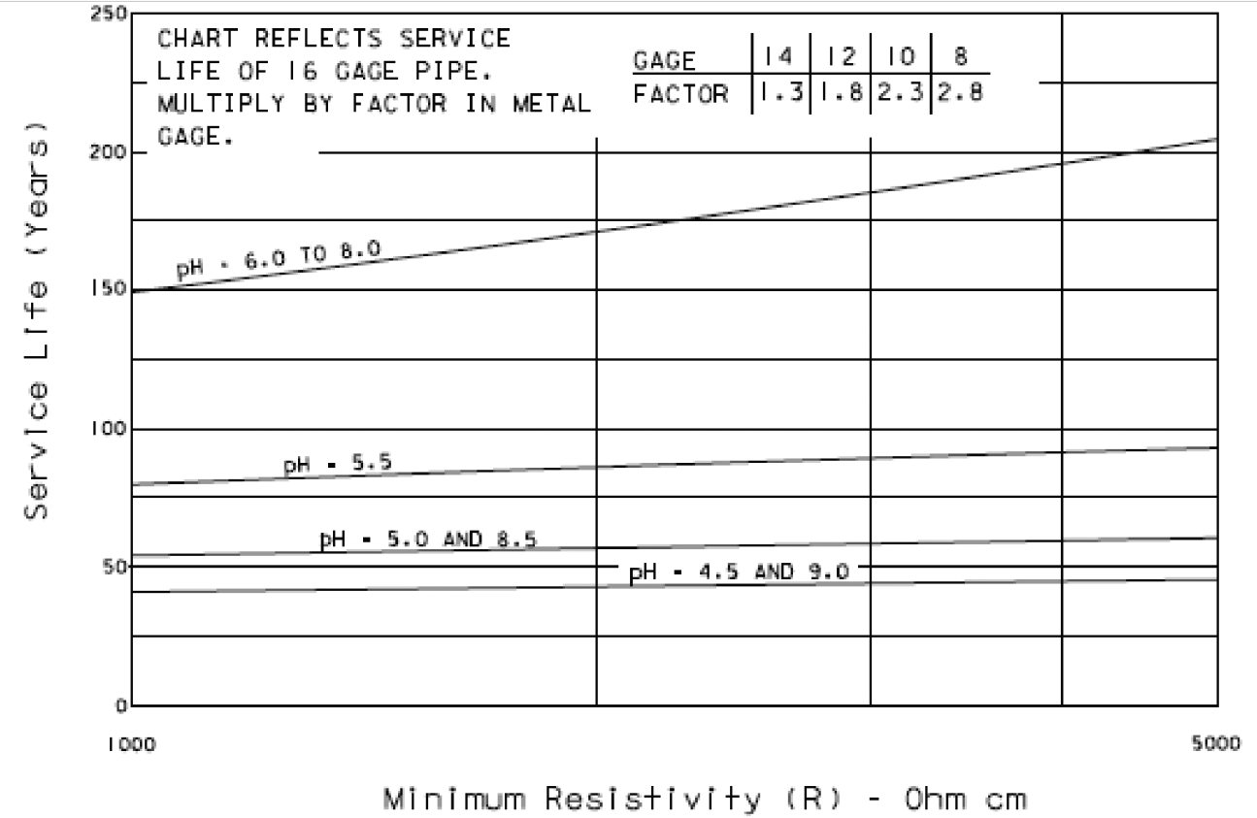

Estimated service life versus pH and resistivity for aluminum using FDOT method (FDOT 2012)

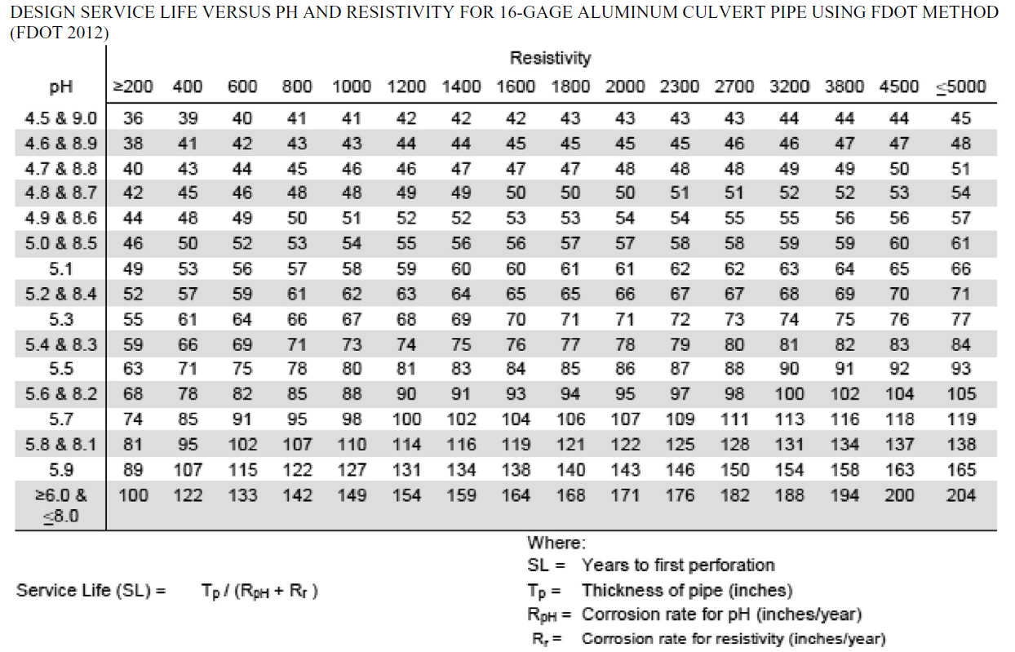

Design service life versus pH and resistivity for 16-gauge aluminum culvert pipe using FDOT method (FDOT, 2012)

**Corrugated Polyethylene Plastic Pipe**

Plastic pipes are vulnerable to ultra-violet light, so must be buried or protected from exposure (Potter, 1988). However, if designed and installed properly, they can be quite durable, with service life well beyond 50 years. One study showed that corrugated high-density polyethylene plastic pipe that has been installed in areas where the pH ranged between 1.25 and 14 could be expected to have a service life of 75 years. (AZDOT, 1996). A Minnesota study found that HDPE pipes are capable of having a 100-year service life, with less susceptibility to freeze/thaw damage than many other types of pipe (Taylor, Marr, 2012). In addition, this type of pipe has been shown to have resistance to abrasion three to five times greater than mild steel. (Potter 1988).

PVC pipe becomes brittle in temperatures below 37 degrees and is not recommended for use in colder climates (Taylor, Marr 2012). However, under milder conditions, estimates of EMSL between 50 and 100 years have been established for this material. (Maher, Hebeler et al. 2015).

Predictive durability studies are lacking for all types of plastic pipe, and models used by states generally use one constant value for the EMSL. (Maher, 2015). Louisiana Department of Transportation and Development has a current research project underway to determine optimum conditions for the use of plastic pipes in that state: <https://trid.trb.org/view/1647851>.

**Conclusions**

While research on the conditions affecting the service life of drainage structures has been ongoing since the 1950s, no perfect model to predict estimated service life has been developed. Because maintenance and replacement of culverts can be costly, both from the standpoint of expense and time – not to mention disruption of traffic in many cases – it is important to be able to match a culvert material to the environmental conditions for optimum service life. Studies continue to adapt the California method to include local conditions and additional factors, and other methods are being developed. In addition to the Louisiana study on plastic pipes, there are at least two other current research projects:

* *Corrugated Steel Culvert & Abrasion Performance* being conducted by CalTrans: <https://trid.trb.org/view/1440847>
* *Durability of Pipe Materials in Soils*, being conducted in North Carolina: <https://trid.trb.org/view/1651416>

**REFERENCES**

American Association of State Highway and Transportation Officials (AASHTO). (2007). Highway drainage guidelines. (4th ed.). Washington, D.C.

American Iron and Steel Institute. (1993). *Handbook of Steel Drainage & Highway Construction Products*. Washington, D.C.

Arizona Department of Transportation (AZDOT). (1996). *Pipe Selection Guidelines and Procedures*. Retrieved from Phoenix, AZ: https://azdot.gov/sites/default/files/2019/06/pipe-selection-guidelines-and-procedures.pdf

Beaton, J., & Stratfull, R. (1962). *Field Test for Estimating Service Life of Corrugated Metal Pipe Culverts.* Highway Research Board Proceedings, Vol. 41.

Beaver, J. L., Bass, B. J., Simpson, G., Heger, I. (2019). *Performance and Policy Related to Aluminum Culverts in Wisconsin*. Retrieved from https://wisconsindot.gov/documents2/research/0092-17-05-final-report.pdf

Beben, D. (2014). Backfill corrosivity around corrugated steel plate culverts. *Journal of Performance of Constructed Facilities, 29*(6).

California Department of Transportation, Division of Construction (CalTrans). (1978). *Method for Estimating the Service Life of Steel Culverts: California Test 643*. Sacramento, CA.

Chaker, V. (1990). Corrosion testing in soils—Past, present, and future. In *Corrosion Testing and Evaluation: Silver Anniversary Volume* (pp. 95-111): ASTM International.

Colorado Urrea, G. J. (2014). *Service Life of Concrete and Metal Culverts Located in Ohio Department of Transportation Districts 9 and 10.* Ohio University,

Corrpro. (2016?). *Service Life Evaluation of Corrugated Steel Pipe: Storm Water detention Systems in the Metropolitan Washington, DC Area*. Retrieved from Washington, DC: https://ncspa-4977.kxcdn.com/wp-content/uploads/2016/07/servlifeeval.pdf

Federal Highway Administration (FHWA). (2008). *Federal Lands Highway Project Development*. Washington, D.C.

Florida Department of Transportation (FDOT). (2012). *Drainage Manual - Optional Pipe Material Handbook*. Tallahassee, FL.

Gabriel, L. H., Moran, E. T. (1998) *Service Life of Drainage Pipe*. Transportation Research Board, Washington, D.C.

HanYi, W., & San, H. (2010). *Predict Soil Corrosion Rate of Pipeline Steel Using ANFIS*. Paper presented at the 2010 International Conference on Computational and Information Sciences, Chengdu, Sichuan, China.

Haviland, J. E., Bellair, P. J., & Morrell, V. D. (1968). Durability of Corrugated metal culverts (with discussion and Closure). *Highway Research Record* (242), pp 41-66.

Heitkamp, B., Marr, J. (2015). *Minnesota Steel Culvert Pipe Service-Life Map*. Retrieved from http://www.dot.state.mn.us/research/TS/2015/201531.p

Hossain, Z., Elsayed, A., Hasan, M. (2019). *Development of Metals Corrosion Maps of Arkansas and Maintenance of Cross-drains.*

Hyde, L. W., Shamburger, V. M., Ellard, J. S., Survey, U. S. G., Alabama State Highway, D., & Bureau of Public Roads, U. S. (1968). *Effects of Water and Soil on Drainage Structures in Alabama.* Retrieved from https://trid.trb.org/view/125235

Maalouf, S. (2019). *Performance and Service-Life of Corrugated Steel Pipe Culverts: a Framework for Field Inspection and Life Cycle Analysis.* Paper presented at the World Environmental & Water Resources Congress 2019.

Maher, M., Hebeler, G., & Fuggle, A. (2015). *Service Life of Culverts* (9780309271745). Transportation Research Board, Washington, D.C. Retrieved from http://www.trb.org/Main/Blurbs/172633.aspx

Meegoda, J. N., Juliano, T. M., Ayoola, M., & Dhar, S. (2004). *A Methodology to Predict the Remaining Service Life of CSCPs*. Paper presented at the Fifth International Conference on Case Histories in Geotechnical Engineering, New York, NY.

Molinas, A., Mommandi, A. (2009). *Development of New Corrosion/Abrasion Guidelines for Selection of Culvert Pipe Materials*. Retrieved from http://www.coloradodot.info/programs/research/pdfs/2009/culvetrpipes.pdf/view

National Steel Pipe Association (NSPC). (2010). *Pipe Selection Guide*. Retrieved from https://ncspa-4977.kxcdn.com/wp-content/uploads/2016/07/resource_guide_electronic.pdf

Potter, J. C. (1988). *Life Cycle Cost for Drainage Structures*. Retrieved from https://apps.dtic.mil/dtic/tr/fulltext/u2/a191569.pdf

Potter, J. C. (1990). Aluminum-coated corrugated steel-pipe field performance. *Journal of transportation engineering, 116*(2), 145-152.

Taylor, C. A., & Marr, J. (2012). *A Research Plan and Report on Factors Affecting Culvert Pipe Service Life in Minnesota*. Retrieved from https://conservancy.umn.edu/handle/11299/136776

Tewari, S. (2017). *Corrosion Map for Metal Pipes in Coastal Louisiana*. Retrieved from http://www.ltrc.lsu.edu/pdf/2017/FR_585.pdf

Tewari, S., & Manning, F. (2018). *Spatial Delineation of Corrosion Zones for Metal Culverts Based on Coastal Louisiana Soil Characteristics*.

White, K. (2011). *Guidance for Design and Selection of Pipes*. Retrieved from http://sp.design.transportation.org/Documents/NCHRP20-07(264)_Final%20Report%20for%20AASHTO.pdf