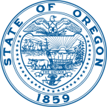 | PUBLIC HEALTH DIVISION  Center for Health Protection, Drinking Water Services | 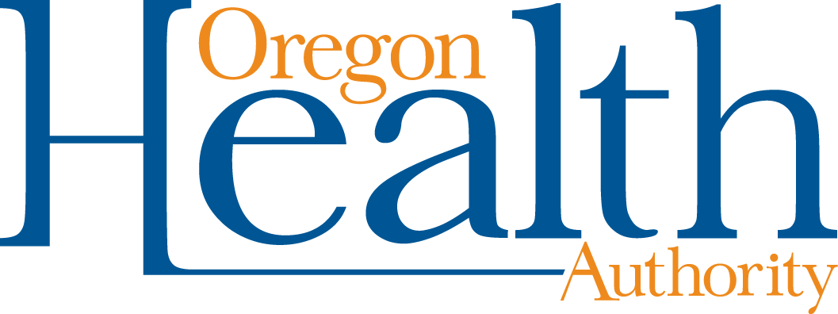
 | Tina Kotex, Governor
800 NE Oregon Street, Suite #640
Portland, OR 97232-2162
(971) 673-0405
(971) 673-0694 – FAX
http://healthoregon.org/dwp

Drinking Water Advisory Committee
Meeting Minutes
January 18, 2023
Virtual (Teams) and In-Person

Members Present
Greg DeBlase, Oregon Environmental Health Association
Lacey Goeres-Priest, Vice Chair, League of Oregon Cities
Jason Green, Chair, Oregon Association of Water Utilities
Michael Grimm, Special Districts Association of Oregon
Cheyenne Holliday, Water Consumers
Adam Jackson, Privately Owned Water Systems
Ben Klayman, Pacific NW Section, American Water Works Association
Ann Levy (for Yone Akagi), Large Water Systems
Karen Lewotsky, Environmental Advocacy Groups
Chris MacQuarrie, Plumbers/Backflow Testers
Beth Myers, Oregon Environmental Lab Association
Zach Roberts, Conference of Local Health Officials
Travis Tormanen, American Council of Engineering Companies-Oregon

Members Absent
Amelia Nestler, League of Women Voters of Oregon

Guests
Nicole Bailey, Business Oregon
Charles Dice, Falcon Cove Beach Water District
Matt Johnson, Oregon Association of Water Utilities
Kim Ramsay, Oregon Environmental Lab Association

Staff
Adam DeSemple Samina Panwar
Tony Fields Kari Salis
Paula Rich

Welcome/Roll Call
Jason Green welcomed the group and roll call was taken.

Agenda Check
Suggestions for additional discussions:
- New domestic well testing program and relationship to DEQ’s real estate transaction program
- Program manager recruitment process
- Effect of new legislative session on budget
- Strategic plan updates
- Pipeline newsletter

October Meeting Minutes
Beth Myers made motion to approve the minutes, Mike Grimm seconded. They were voted on and approved.

Member Update/Public Input

Falcon Cove Beach Water District

Charles Dice, system operator and president of the board for Falcon Cove Beach Water District, reported on an incident at the water system. Falcon Cove serves 95 homes. The board includes five elected commissioners. Last September they conducted their routine lead and copper sampling as instructed and as they have done for the past 20 years (five sites, homeowners take sample). Two homes were abnormally high, one for lead, one for copper. The two homeowners had not followed instructions. The system operator retested the two homes, at the suggestions of staff at OAWU, OHA, and the Tillamook sanitarian Jamie Craig. Results were typical of past years’ results and within limits of the rules. Evan Hofeld provided a procedure for invalidating the two original samples.

Later, the system received a letter from Charles Michael stating that a system cannot invalidate samples when they allowed homeowners to pull those samples; the system is required to follow a protocol required after an exceedance that includes many tests and notices to customers. Customers are irate. Board members have stated they will not run for re-election. The situation is “catastrophic” for the water system.

Kari Salis explained the four criteria (one must be met) for invalidating sample results. Incorrect sampling procedure by customers is not one of the criteria. Operators should verify that the protocol was followed before submitting sample to the lab. Kari explained the two 6-month rounds of sampling that will be required this year.

Mr. Dice said that their system will now require the system operator to take all samples. He plans to pursue this issue with SDAO and SDA Water caucus and try to change the OAR.

Kim Ramsay and Beth Myers expressed interest in hearing what the difference was in sampling procedure that resulted in the high results. They plan to contact Mr. Dice.

Jason Green believes that the water pipes were sampled after water was not used for weeks or months. In the rules, there is no maximum number of hours that water should sit in the pipes before sampling. Michael Grimm thinks OHA should consider ways to enable systems to re-do sampling when procedures aren’t followed.

Domestic well program

Kim Ramsay: Sellers of homes must report drinking water test results to state, but they are not doing so because real estate agents are aware that the program currently lacks funding to manage it. Kari Salis and Tony Fields explained that domestic well water falls under Environmental Public Health, not DWS. The program is dependent on grants. The staff position has been vacant for a year or more.

Kim Ramsay: Legislature is drafting a bill to have DEQ take over program. Draft states that labs should report data to state whenever it is related to a property sale. Kim does not think labs should have to ask clients why they want to test. If a lab inadvertently does not report data, they have violated a rule and may be shut down. Labs are opposed to the draft change to rules about domestic well testing.

Karen Lewotsky: DEQ has policy option packages (POPS) in their budget for supporting the OHA’s domestic well program, specifically to find a way to get more data reported to buyers and the state and into a database so that tracking contaminant hotspots is possible. Only about 20% of home sales were reported when program was running.

Beth Myers: The 90-day reporting period between when the seller knows, and the buyer is told the test results, means that property with arsenic is sold and no drinking water treatment is installed. Labs typically get samples from pump companies, so they do not know who the buyers or sellers are.

Kim Ramsay: Enforcing the original OAR rule would be better than the proposed new rule that involves labs in reporting. Labs should not be legally responsible for reporting.

Karen Lewotsky: Conversation with OHA, DEQ, DWAC needed to figure out enforcement.

Water justice report

Beth Myers: Statement on page 36 of the report says, “DEQ says 33% of rural wells contain at least one pesticide.” DEQ could not find the study that said that, although it is on the DEQ web page. The statement is not true.

Program Update

Kari Salis reported that the new section manager, who has not yet been announced, will start February 1.

Program funding: State revolving fund (allocated to fund PWS infrastructure projects) 58%; primacy (from EPA, funds the data unit) 23%; general fund (federal monies plus some state match monies) 10%; fees 9%.

Discussion about the difficulty a new section manager might have during the new legislative session with thousands of new bills. Other agencies might have an advantage. But DWS funds are stable. DWS has never had an issue getting general funds. Kari explained that DWS does not take all set-aside monies available every year. The money DWS does not take is banked for future use so there is some flexibility.

Current vacancies in DWS: section manager, data entry, office support. BIL will provide money for research analyst (RA3), natural resources specialist 4 (NRS4), program analyst 3 (PA3). Two of those positions are being asked for up front so those hires can help with application for BIL, announcements are going out soon. Fiscal analyst will also be hired, but the hiring is not handled by DWS. The positions are considered permanent.

DWS anticipates that the application for BIL money will be ready this summer. The four positions are in OHA. Business Oregon will fill an additional position to help with BIL work.

Review of funding and estimated allocations for Oregon: SRF (base program) plus three new BIL funds: 1) supplemental (similar to SRF base, for infrastructure projects and requires state match), 2) emerging contaminants, and 3) lead service line replacement. Each has different criteria. Supplemental and lead service line money: 49% forgiveness to disadvantaged communities. DWS has defined disadvantaged as those having less than the median statewide household income. Emerging contaminant: grant money.

SRF set-asides (up to 31% of allocation)
- 15% state program management (core work)
- 10% source water protection
- 4% capacity development (core work)
- 2% circuit rider and training
Reduction in base SRF due to congressionally directed spending (earmarks)

BIL issues:
- Workload and staffing
- Project development for Emerging Contaminants
- No Lead Service Line Replacement projects in pipeline
- Equity issues, priority, incentive levels, etc.

Legislative bills of interest so far:
- HB2988: creates community water infrastructure grants
- SB23: $23 million for Carlton Water transmission line, etc.
- HB3045: $15 million for Grants Pass WTP
- HB2248: WRD and DEQ to study wildfire impacts on WQ
- HB2813: establishes a source protection grant program (appropriate for land acquisition)

PFAS
- DWS to support DEQ lab for purchase of a new PFAS analysis machine. Lower reporting level
- Pending EPA actions on PFAS
  - Proposed MCLS for PFOA and PFOS are past due; Final MCLs by fall 2023?
  - UCMR 5 monitoring for 29 PFAS 2023-25

Lead and Copper Rule Revisions
Lead service line inventories
- Include both public and privately owned sides
- Must identify lead, nonlead, galvanized requiring replacement, and unknowns
- Should be evidence-based but does not require excavation
- Rules effective January 2023
- In Oregon (new language in OAR)
  - Presume service lines after January 1986 and 2” or greater are nonlead
  - If no lead found through other methods, statistical sampling of unknowns, sample size sufficient for 95% confidence interval
  - 1200 PWS must complete
  - Customer data is allowed (but customer can’t determine material type for statistical approach)
- Methodologies should be on website soon.
- Contractor assistance for completing inventories (may need to prioritize smaller systems), training is planned
- Funded by base set-asides
  - Cannot use LSL set-aside since haven’t applied and may not have any projects

DWS workload (includes county and ag) 2022
- 545 surveys conducted
- 1830 water quality alerts
- 17 priority noncompliers
- 200 documents advisories
- 8 systems exceeded lead action level

Pipeline newsletter
Question – should we increase frequency? DWAC seemed to think quarterly is fine, one person suggested that more frequent Pipelines would be welcome but not essential.

Email address: new format is first.mi.last@oha.oregon.gov

Revolving Fund Update

DWAC assistance will be needed to get the word out about availability of funding. PPL list includes 70 projects so far, asking for over $500 million in total.

BIL (aka Infrastructure Investment and Jobs Act) passed 11/15/2021. Provides funding for drinking water and wastewater infrastructure through existing EPA funded programs: SDWRLF (BIZOR/OHA) and CWSRF (DEQ’s shop).

Three buckets of funding: general supplemental fund, lead service line fund, emerging contaminants fund

BIL general supplemental grant allotment
- 2022 BIL general supplemental grant from EPA: $23,673,000 – 49% ($11,599,770) required to be provided as subsidy to disadvantaged communities. State match contribution: $2,367,300
- OHA retained set-asides: $4,787,680
- Total available to SDWRLF projects: $21,252,620 (BIL loan: $9,652,850; BIL forgivable loan: $11,599,770)
- Funding targets have been identified using OHA’s DWSRF Project Priority List (PPL)
- May be six months to a year before funds are received, which could affect water systems’ project planning
- 2023 funding: 29 new projects submitted on 9/15/2022 have been vetted, rated, and ranked. Will include projects submitted in March 2023 when selecting projects for 2023.

BIL emerging contaminants
- Up to $9.94 million annually
- A workgroup has developed a draft 13-step process.
- Plan to apply for 2022 EC funding in June/July

BIL lead service line replacement
- Up to $37.3 million annually
- Workgroup not yet formed.
- OWS service line inventory is top priority.
- No potential projects currently, so no plan to apply yet.

Base program SDWRLF
- Current commitments and balances included in board packet
- 29 new LOIs submitted 9/15/2022
- While monitoring fund availability, BizOR will be starting from the top of the health and compliance PPL to ensure that systems with projects determined by OHA to address health risks and compliance issues are contacted first, if not already in pipeline.

Intended Use Plan: SRF program is combined with BIL in 2022 BIL general supplemental IUP. Eventually will incorporate emerging contaminants and lead service line info. BIL general supplemental is $23,673,000. Draft IUP currently being reviewed. Hope to be ready to apply in February.

New Project Ranking and Disadvantaged Status web page, now live.

New improved LOI form coming soon.

Next Meeting

April 19, 2023 – In person/virtual meeting — will plan for three hours

Potential topic: Water quality at camps (e.g., Boy Scout camp, 4H camp). What assistance is available to them?

