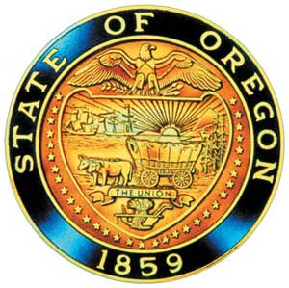
Kate Brown, Governor

AI/AN Advisory Committee Members
Angie Morrill
Beverly Youngman
Brandon Culbertson
Bridgett Wheeler
Chris Mansayon
Jesse Beers
Julie Bettles
Kelly LaChance
Leilani Sabzalian
Mandy Smoker-Broaddus
Mercedes Jones
Modesta Minthorn
Robin Butterfield
Sally Kosey
Sandy Henry
Scott Minthorn
Sonya Moody-Jurado
Tamara Henderson
Tammie Hunt
Valerie Switzler
Will Hess

Office of Indian Education
Colt Gill
Director

April Campbell,
Indian Education Advisor

Ramona Halcomb
Indian Education Specialist

Trinity Minahan
Education Specialist

Debbie Green
Executive Support

2019-20 Meeting Dates
January 7, 2020
March 10, 2020
May 5, 2020
June 30, 2020
September 1, 2020

American Indian/Alaska Native Advisory Committee
Novemeber 5th, 2019 | 9:30 a.m. - 4:00 p.m.
Oregon Department of Education- Room 251 B
255 Capitol Street NE | Salem, OR 97310
Conference call: 888-363-4734, Access code 231-8909

AGENDA

9:30 1.0 Welcome / Networking All
9:40 2.0 CTE Plan Information Laura Foley
10:00 3.0 Tribal History Shared History Update April Campbell
10:30 4.0 Gray Family Foundation Nell Tessman
11:00 5.0 Office of Indian Education Update ODE Staff
12:00 Working Lunch (Updates from Members)
12:45 6.0 Review AI/AN Education Plan Draft Members
2:45 7.0 Language Use Survey Suzy Merkarski
3:30 8.0 Other Business April Campbell
3:45 9.0 Next Meeting Agenda Items Members
4:00 Adjourn

ADA accommodations: Please e-mail Debbie Green / Debbie.green@state.or.us

“ODE-Guest”

