Gold Star Foods – Northwest Distribution Division

Online Ordering System

Instruction Manual

Access to the Gold Star Foods Online Ordering System can be completed in two (2) ways:

1. Direct access to the website at <https://northwestonline.goldstarfoods.com>. We recommend saving this link to your computers “favorites” for future use.

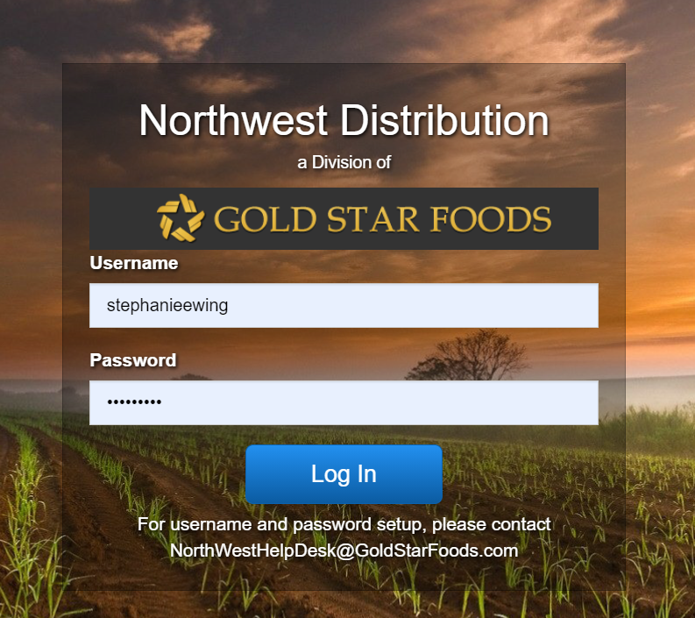

1. Linked access through the Oregon Department of Education’s USDA Foods Web page at <https://www.oregon.gov/ode/students-and-family/childnutrition/USDAFoods/Pages/default.aspx>. Once on the page, scroll down to Application Login and select Gold Star Foods Login.

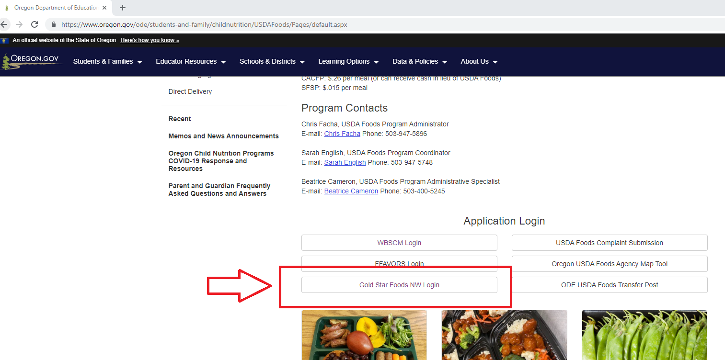

Enter your Username and Password. The first time you log-in you will be prompted to change your password. Passwords require the following criteria:

* A minimum of eight (8) characters
* Contain at least one Capital letter
* Contain at least one Number
* Contain one special character (@m, #, $, etc.)

If you forget your Username and/or Password or need technical assistance with ordering, please contact our dedicated Help Desk via email at [NorthwestHelpDesk@goldstarfoods.com](mailto:NorthwestHelpDesk@goldstarfoods.com).

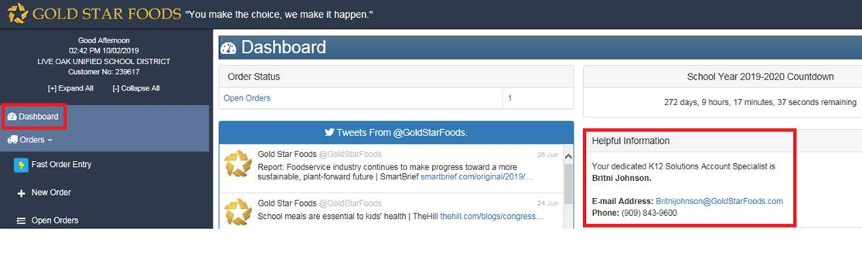Once logged in, the first screen is your district’s Dashboard.

**Ordering USDA Direct Delivery and Further Processed from the State Contracted Warehouse**

1. Select “New Order” in the left blue pane as shown in red

below.

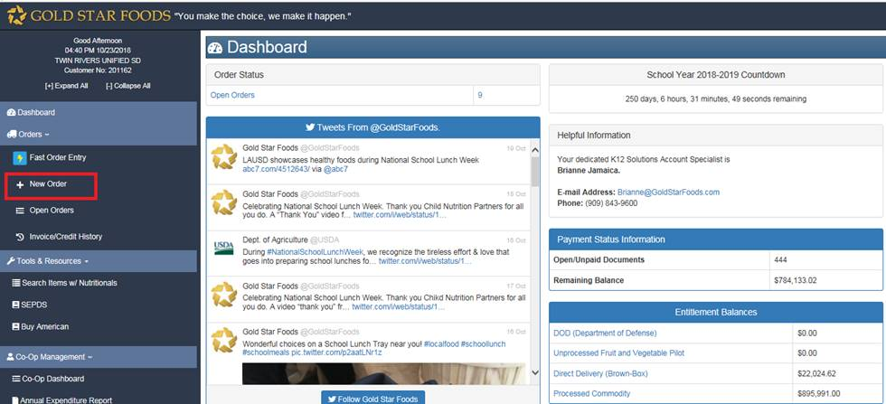

1. Select your Site.
2. Select USDA from the Order Type dropdown.
3. Enter your name to designate who is entering USDA Direct Delivery/Further Processed orders.
4. Select the Delivery Date. (All orders are entered for Monday – your specific delivery will be routed and your K12 Account Specialist will call you seven (7) days in advance to confirm your specific delivery date and time.)
5. Then select “Continue.”

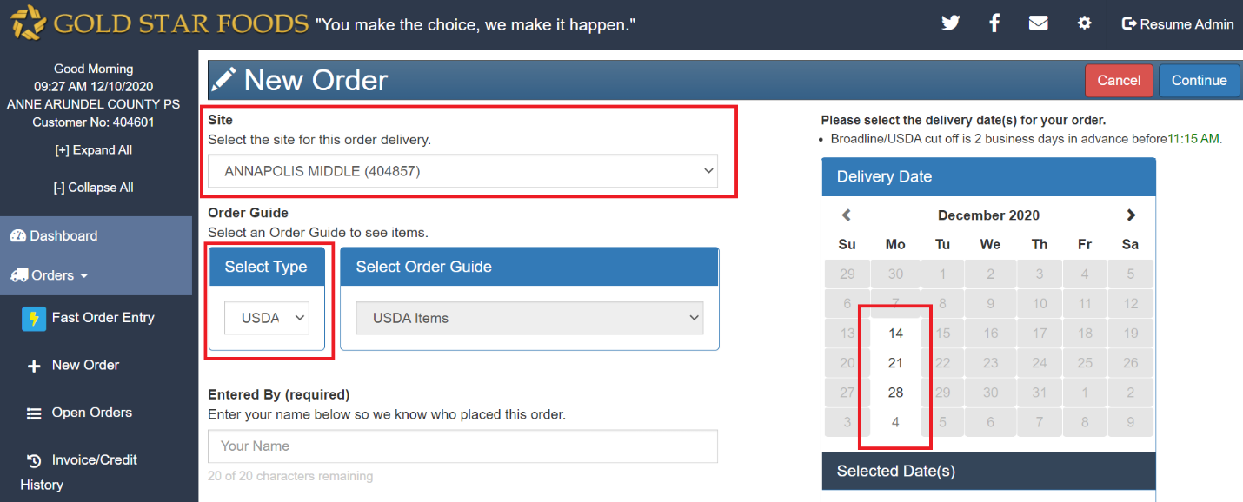

1. Enter the quantities you need in the white “Qty” boxes.
2. Refer to the USDA/BB Qty. Avail to see the total amount of USDA Direct Delivery/Further Processed allocated to your district and the maximum quantity available to order.

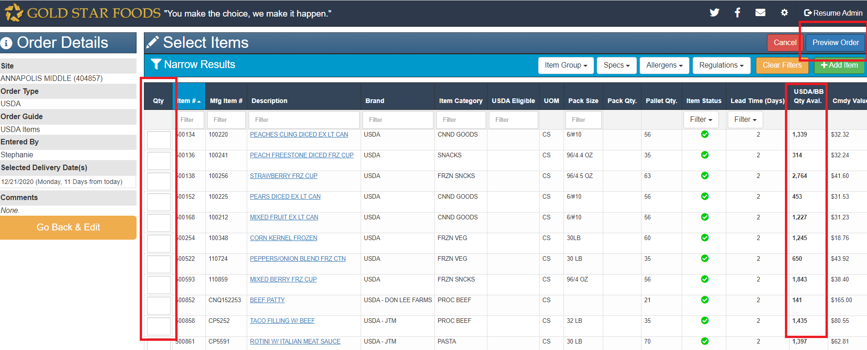

1. When you have finished entering in your quantities select Preview Order. The Preview Order button is located both the top and bottom of the release page.

**Preview Order**

1. Review the order to ensure that you have all the items you need. If you need to modify anything, select the “Go Back and Edit” button. Once you are done, select the “Submit Order” button as shown below. After an order is submitted you will receive a

confirmation via email for your assigned site(s).

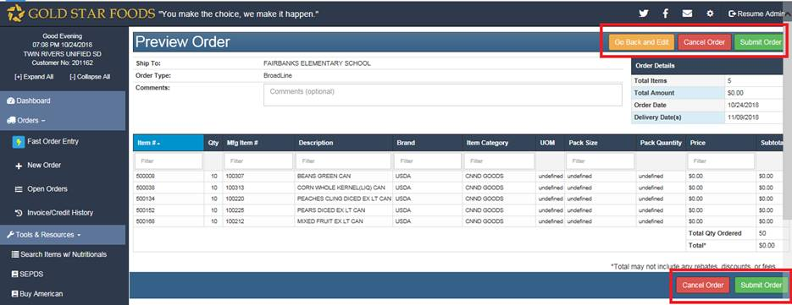

If your district holds a commercial contract with Gold Star Foods – Northwest Distribution Division for the purchase of commercial food items and/or further processed utilizing a Net Off Invoice Value Pass Through System, you can also order these items using the same ordering system.

**Placing New Orders for Broadline (Commercial Items)**

1. To place a new order for Broadline (Commercial) items, select “New Order” in the left blue pane as shown in red below.



1. Select your Site.
2. Select Broadline from the Order Type dropdown.
3. Select your Order Guide from the Order Guide dropdown
4. Enter your name to designate who is placing the order.
5. Select the Delivery Date.
6. Then select “Continue.”

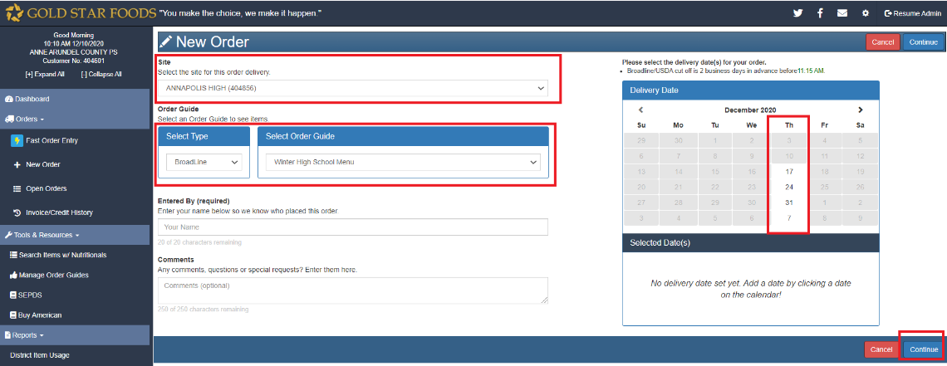

1. Enter the quantities you need in the white “Qty” boxes.
2. When you have finished entering in your quantities select Preview Order. The Preview Order button is located both the top and bottom of the order page.

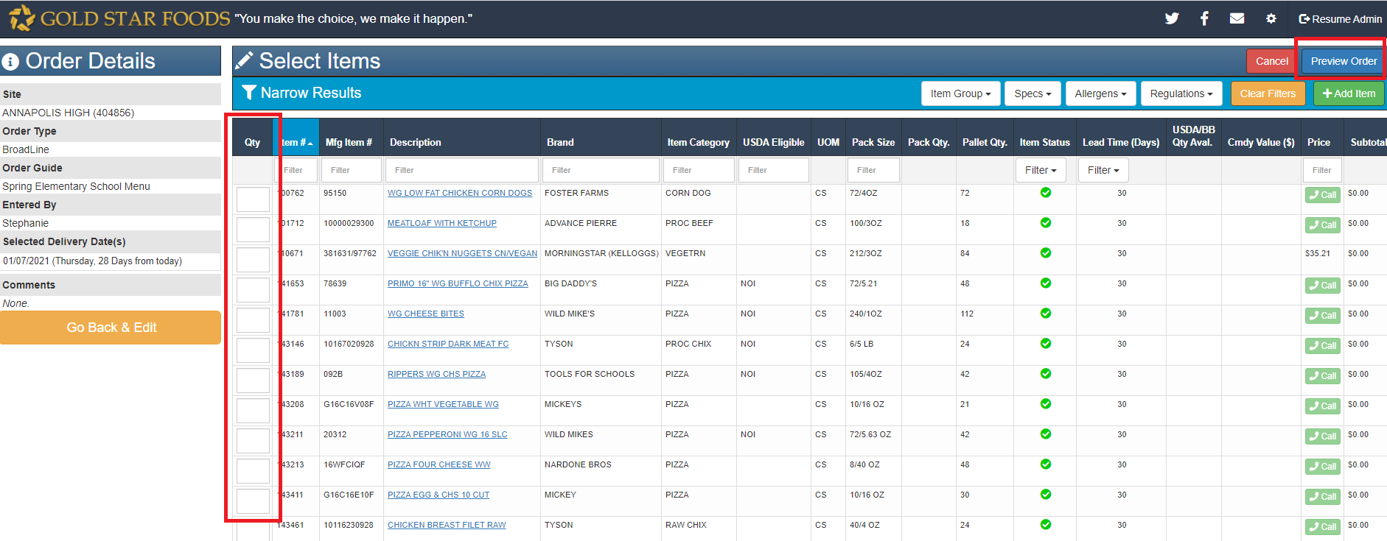

**Preview Orders**

1. Review your order to ensure that you have all the items you need. If you need to modify anything, select the “Go Back and Edit” button. Once you are done, select the “Submit Order” button as shown below. Once an order is submitted you will receive an order

confirmation via email for your assigned site(s).



**Order Confirmations**

After submitting your order(s), you will get a green bar, up at the top, that says Order was Successfully Submitted. You can choose to Print a copy of your order here or you can print it from your order confirmation email.

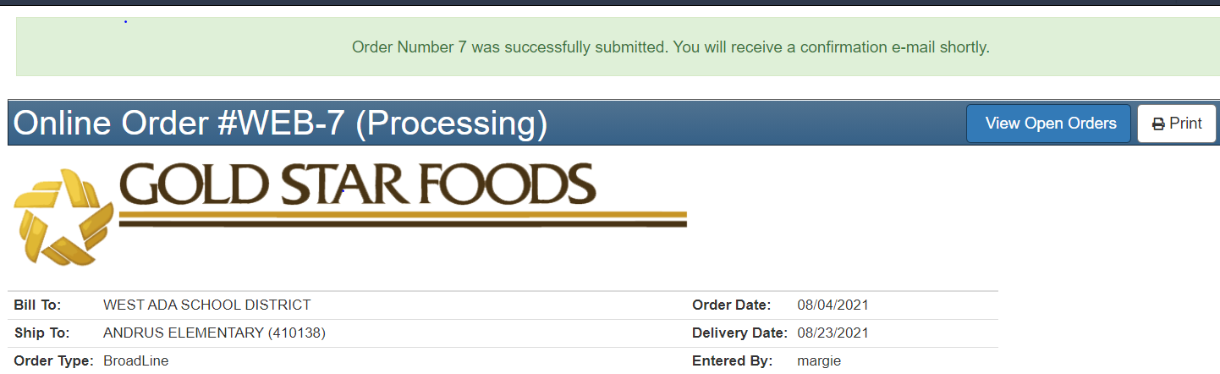

That’s it! If you need to make any changes or need additional assistance, please contact your K12 Solutions Team Member as reflected on your customer Dashboard.